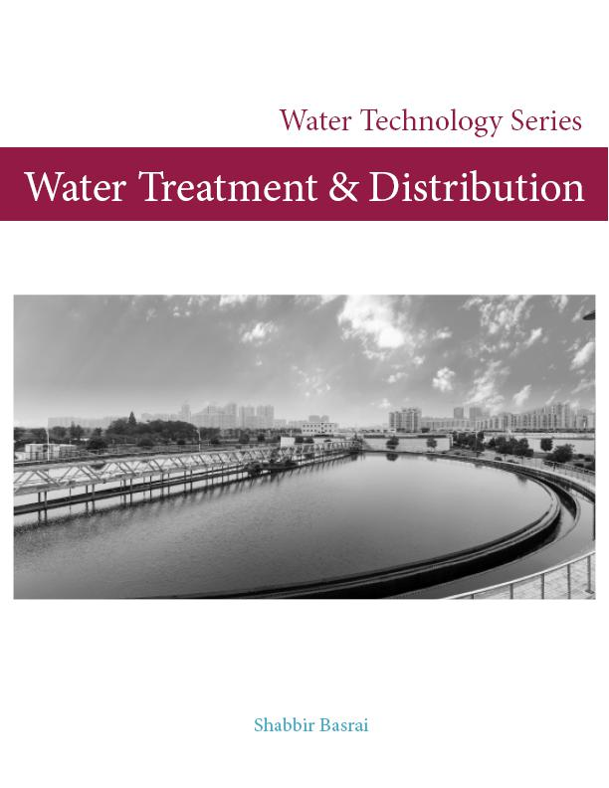

This book is for educational purposes and includes material synthesized from various sources. It is primarily designed for individuals preparing for the California State Water Resources Control Board’s Water Treatment and Distribution License Examinations. It is also intended to serve as a resource for anyone interested in understanding the technical aspects of drinking water treatment and distribution.

Copyright © 2024 Shabbir Basrai

Revision Date: March 2024



Contents

I Chapter 1

1 Water Systems Operator Certifications . . . . . . . . . . . . . . . . . . . . . . . . . 21

1.1 Operational Activities 22

1.1.1 Drinking Water Treatment: . . . . . . . . . . . . . . . . . . . . . . . . . . . . . . . . . . . . . . . . . 22

1.1.2 Water Distribution: . . . . . . . . . . . . . . . . . . . . . . . . . . . . . . . . . . . . . . . . . . . . . . . 22

1.1.3 Wastewater Treatment: . . . . . . . . . . . . . . . . . . . . . . . . . . . . . . . . . . . . . . . . . . . 23

1.1.4 Advanced Treatment/Water Reuse: . . . . . . . . . . . . . . . . . . . . . . . . . . . . . . . . . 23

1.2 Qualifications and Eligibility 24

1.2.1 Treatment . . . . . . . . . . . . . . . . . . . . . . . . . . . . . . . . . . . . . . . . . . . . . . . . . . . . . 24

1.2.2 Distribution . . . . . . . . . . . . . . . . . . . . . . . . . . . . . . . . . . . . . . . . . . . . . . . . . . . . . 25

1.2.3 Wastewater . . . . . . . . . . . . . . . . . . . . . . . . . . . . . . . . . . . . . . . . . . . . . . . . . . . . 26

1.2.4 Advanced Water Treatment or Water Recycle . . . . . . . . . . . . . . . . . . . . . . . . . 27

1.3 Expected Range of Knowledge 27

1.3.1 Treatment . . . . . . . . . . . . . . . . . . . . . . . . . . . . . . . . . . . . . . . . . . . . . . . . . . . . . 27

1.3.2 Distribution . . . . . . . . . . . . . . . . . . . . . . . . . . . . . . . . . . . . . . . . . . . . . . . . . . . . . 27

1.3.3 Wastewater . . . . . . . . . . . . . . . . . . . . . . . . . . . . . . . . . . . . . . . . . . . . . . . . . . . . 28

1.4 Certification Requirements 28

1.4.1 Treatment . . . . . . . . . . . . . . . . . . . . . . . . . . . . . . . . . . . . . . . . . . . . . . . . . . . . . 28

1.4.2 Distribution . . . . . . . . . . . . . . . . . . . . . . . . . . . . . . . . . . . . . . . . . . . . . . . . . . . . . 29

1.4.3 Wastewater . . . . . . . . . . . . . . . . . . . . . . . . . . . . . . . . . . . . . . . . . . . . . . . . . . . . 30

1.4.4 Advanced Water Treatment . . . . . . . . . . . . . . . . . . . . . . . . . . . . . . . . . . . . . . . 31

1.5 Certification Renewal 31

II Chapter 2

2 Water Properties and Sources . . . . . . . . . . . . . . . . . . . . . . . . . . . . . . . . . 35

2.1 Properties of water 38

2.2 Water use 39

2.3 Water Supplies 40

2.4 Water Sources 44

2.4.1 Groundwater . . . . . . . . . . . . . . . . . . . . . . . . . . . . . . . . . . . . . . . . . . . . . . . . . . . 45

2.4.2 Groundwater Under the Direct Influence of Surface Water . . . . . . . . . . . . . . . 50

2.4.3 Surface Water . . . . . . . . . . . . . . . . . . . . . . . . . . . . . . . . . . . . . . . . . . . . . . . . . . 51

2.4.4 Advantages and Disadvantages of Surface Water vs Groundwater . . . . . . . . 52

2.4.5 Recycled Water . . . . . . . . . . . . . . . . . . . . . . . . . . . . . . . . . . . . . . . . . . . . . . . . . 53

2.5 Water Rights in California 54

III Chapter 3

3 Water Quality & Laboratory Procedures . . . . . . . . . . . . . . . . . . . . . . . . 63

3.1 Organics 66

3.2 Inorganics 67

3.2.1 Metals . . . . . . . . . . . . . . . . . . . . . . . . . . . . . . . . . . . . . . . . . . . . . . . . . . . . . . . . 67

3.2.2 Salts . . . . . . . . . . . . . . . . . . . . . . . . . . . . . . . . . . . . . . . . . . . . . . . . . . . . . . . . . . 67

3.2.3 Nutrients . . . . . . . . . . . . . . . . . . . . . . . . . . . . . . . . . . . . . . . . . . . . . . . . . . . . . . . 68

3.3 Trace Constituents 69

3.4 Radionuclides 70

3.5 Microbial contaminants 70

3.6 Physicochemical tests 71

3.6.1 Turbidity . . . . . . . . . . . . . . . . . . . . . . . . . . . . . . . . . . . . . . . . . . . . . . . . . . . . . . . 71

3.6.2 Color . . . . . . . . . . . . . . . . . . . . . . . . . . . . . . . . . . . . . . . . . . . . . . . . . . . . . . . . . 72

3.6.3 Taste and odor . . . . . . . . . . . . . . . . . . . . . . . . . . . . . . . . . . . . . . . . . . . . . . . . . . 72

3.6.4 Temperature . . . . . . . . . . . . . . . . . . . . . . . . . . . . . . . . . . . . . . . . . . . . . . . . . . . 72

3.6.5 Total dissolved solids . . . . . . . . . . . . . . . . . . . . . . . . . . . . . . . . . . . . . . . . . . . . . . 73

3.6.6 Alkalinity . . . . . . . . . . . . . . . . . . . . . . . . . . . . . . . . . . . . . . . . . . . . . . . . . . . . . . . 74

3.6.7 Hardness . . . . . . . . . . . . . . . . . . . . . . . . . . . . . . . . . . . . . . . . . . . . . . . . . . . . . . 74

3.6.8 pH . . . . . . . . . . . . . . . . . . . . . . . . . . . . . . . . . . . . . . . . . . . . . . . . . . . . . . . . . . . 75

3.6.9 Langelier Index . . . . . . . . . . . . . . . . . . . . . . . . . . . . . . . . . . . . . . . . . . . . . . . . . 76

3.6.10 Chlorine Residual . . . . . . . . . . . . . . . . . . . . . . . . . . . . . . . . . . . . . . . . . . . . . . . . 76

3.6.11 Density . . . . . . . . . . . . . . . . . . . . . . . . . . . . . . . . . . . . . . . . . . . . . . . . . . . . . . . . 77

3.6.12 Specific Gravity . . . . . . . . . . . . . . . . . . . . . . . . . . . . . . . . . . . . . . . . . . . . . . . . . 77

3.7 Microbial testing 78

3.7.1 The Multiple-Tube Fermentation technique . . . . . . . . . . . . . . . . . . . . . . . . . . . . 78

3.7.2 Presence - Absence (P-A) Method . . . . . . . . . . . . . . . . . . . . . . . . . . . . . . . . . . 81

3.7.3 Heterotrophic Plate Count (HPC) . . . . . . . . . . . . . . . . . . . . . . . . . . . . . . . . . . . 81

3.7.4 Other Coliform quantification tests . . . . . . . . . . . . . . . . . . . . . . . . . . . . . . . . . . 82

3.8 Sampling 82

3.8.1 Sampling methods . . . . . . . . . . . . . . . . . . . . . . . . . . . . . . . . . . . . . . . . . . . . . . . 84

3.8.2 Sampling Precautions and Protocols . . . . . . . . . . . . . . . . . . . . . . . . . . . . . . . . . 84

3.8.3 Microbial sampling . . . . . . . . . . . . . . . . . . . . . . . . . . . . . . . . . . . . . . . . . . . . . . 85

3.8.4 Summary of sampling requirements . . . . . . . . . . . . . . . . . . . . . . . . . . . . . . . . . 87

IV Chapter 4

4 Drinking Water Regulations . . . . . . . . . . . . . . . . . . . . . . . . . . . . . . . . . . . . 95

4.1 Drinking Water Regulations 97

4.1.1 National Primary Drinking Water Regulations . . . . . . . . . . . . . . . . . . . . . . . . . . 98

4.1.2 Secondary Drinking Water Regulations . . . . . . . . . . . . . . . . . . . . . . . . . . . . . . 100

4.1.3 Unregulated Contaminant Monitoring Rule . . . . . . . . . . . . . . . . . . . . . . . . . . 100

4.1.4 Community Confidence Reports . . . . . . . . . . . . . . . . . . . . . . . . . . . . . . . . . . . 100

4.2 Surface Water Treatment Rules 100

4.2.1 Surface Water Treatment Rule . . . . . . . . . . . . . . . . . . . . . . . . . . . . . . . . . . . . . 101

4.2.2 Interim Enhanced Surface Water Treatment Rule . . . . . . . . . . . . . . . . . . . . . . 102

4.2.3 Long-Term 1 Enhanced Surface Water Treatment Rule . . . . . . . . . . . . . . . . . . 102

4.2.4 Long-Term 2 Enhanced Surface Water Treatment Rule . . . . . . . . . . . . . . . . . . 102

4.3 Summary of Requirements under Surface Water Treatment Rules 102

4.4 Total Coliform Rule 106

4.4.1 Revised Total Coliform Rule . . . . . . . . . . . . . . . . . . . . . . . . . . . . . . . . . . . . . . . 106

4.4.2 Filter Backwash Recycle Rule . . . . . . . . . . . . . . . . . . . . . . . . . . . . . . . . . . . . . . 108

4.5 Ground Water Rules 108

4.6 Microbial and Disinfection Byproducts Rules 110

4.7 Other Drinking Water Rules 111

4.7.1 Lead and Copper Rule . . . . . . . . . . . . . . . . . . . . . . . . . . . . . . . . . . . . . . . . . . 111

4.7.2 Radionuclides Rule . . . . . . . . . . . . . . . . . . . . . . . . . . . . . . . . . . . . . . . . . . . . . 112

4.7.3 Arsenic Rule . . . . . . . . . . . . . . . . . . . . . . . . . . . . . . . . . . . . . . . . . . . . . . . . . . . 113

4.7.4 Vulnerability Assessment . . . . . . . . . . . . . . . . . . . . . . . . . . . . . . . . . . . . . . . . . 113

4.7.5 Public Notification Rule . . . . . . . . . . . . . . . . . . . . . . . . . . . . . . . . . . . . . . . . . . 114

4.7.6 Sanitary Survey . . . . . . . . . . . . . . . . . . . . . . . . . . . . . . . . . . . . . . . . . . . . . . . . 115

4.7.7 SDWA Monitoring, Reporting and Recordkeeping Requirements . . . . . . . . . . 115

4.8 Recycled Water Regulations 118

4.9 State and Local Drinking Water Regulations 118

V Chapter 5

5 Water Treatment . . . . . . . . . . . . . . . . . . . . . . . . . . . . . . . . . . . . . . . . . . . . . 131

5.1 Background 133

5.2 Categories of Treatment Methods 134

5.3 Source Management 135

5.4 Surface Water Treatment Processes 135

5.4.1 Typical surface water treatment process . . . . . . . . . . . . . . . . . . . . . . . . . . . . 135

5.4.2 Source Water Treatment . . . . . . . . . . . . . . . . . . . . . . . . . . . . . . . . . . . . . . . . . 135

5.4.3 Screening . . . . . . . . . . . . . . . . . . . . . . . . . . . . . . . . . . . . . . . . . . . . . . . . . . . . . 136

5.4.4 Coagulation and Flocculation . . . . . . . . . . . . . . . . . . . . . . . . . . . . . . . . . . . . 137

5.4.5 Clarification/Sedimentation . . . . . . . . . . . . . . . . . . . . . . . . . . . . . . . . . . . . . . 139

5.4.6 Filtration . . . . . . . . . . . . . . . . . . . . . . . . . . . . . . . . . . . . . . . . . . . . . . . . . . . . . . 141

5.5 Other Treatment Processes 147

5.5.1 Pre-chlorination . . . . . . . . . . . . . . . . . . . . . . . . . . . . . . . . . . . . . . . . . . . . . . . . 147

5.5.2 Packed Tower Air Stripping . . . . . . . . . . . . . . . . . . . . . . . . . . . . . . . . . . . . . . . 147

5.5.3 Aeration . . . . . . . . . . . . . . . . . . . . . . . . . . . . . . . . . . . . . . . . . . . . . . . . . . . . . . 148

5.5.4 Iron and Manganese Sequestration . . . . . . . . . . . . . . . . . . . . . . . . . . . . . . . . 148

5.5.5 Fluoridation and Defluoridation . . . . . . . . . . . . . . . . . . . . . . . . . . . . . . . . . . . . 149

5.5.6 Hardness Removal . . . . . . . . . . . . . . . . . . . . . . . . . . . . . . . . . . . . . . . . . . . . . . 150

5.5.7 Corrosion Control . . . . . . . . . . . . . . . . . . . . . . . . . . . . . . . . . . . . . . . . . . . . . . . 152

5.6 Best Available Technology (BAT) 154

5.6.1 BATs for Inorganics . . . . . . . . . . . . . . . . . . . . . . . . . . . . . . . . . . . . . . . . . . . . . . 154

5.6.2 BATs for Microbiological Contaminants . . . . . . . . . . . . . . . . . . . . . . . . . . . . . . 156

5.6.3 BATs for Radionuclides . . . . . . . . . . . . . . . . . . . . . . . . . . . . . . . . . . . . . . . . . . . 157

5.7 Chemical Feed Systems 157

5.7.1 Key Components of a Chemical Feed System . . . . . . . . . . . . . . . . . . . . . . . . 157

VI Chapter 6

6 Disinfection . . . . . . . . . . . . . . . . . . . . . . . . . . . . . . . . . . . . . . . . . . . . . . . . . 169

6.1 Background 172

6.2 Chlorination 173

6.2.1 Chlorine properties . . . . . . . . . . . . . . . . . . . . . . . . . . . . . . . . . . . . . . . . . . . . . 173

6.2.2 Chlorine storage and safety . . . . . . . . . . . . . . . . . . . . . . . . . . . . . . . . . . . . . . 174

6.2.3 Forms of chlorine . . . . . . . . . . . . . . . . . . . . . . . . . . . . . . . . . . . . . . . . . . . . . . . 176

6.2.4 Chlorine reactions related to disinfection . . . . . . . . . . . . . . . . . . . . . . . . . . . . 176

6.2.5 Factors affecting chlorine disinfection . . . . . . . . . . . . . . . . . . . . . . . . . . . . . . . 176

6.2.6 Chlorine Application . . . . . . . . . . . . . . . . . . . . . . . . . . . . . . . . . . . . . . . . . . . . 177

6.2.7 Chlorination Byproducts . . . . . . . . . . . . . . . . . . . . . . . . . . . . . . . . . . . . . . . . . 177

6.2.8 Chloroamination . . . . . . . . . . . . . . . . . . . . . . . . . . . . . . . . . . . . . . . . . . . . . . . 178

6.2.9 Advantages of Chloramines . . . . . . . . . . . . . . . . . . . . . . . . . . . . . . . . . . . . . . 179

6.2.10 Disadvantages of Chloramines . . . . . . . . . . . . . . . . . . . . . . . . . . . . . . . . . . . . 180

6.2.11 Breakpoint Chlorination . . . . . . . . . . . . . . . . . . . . . . . . . . . . . . . . . . . . . . . . . . 180

6.2.12 Chlorine dosing terms . . . . . . . . . . . . . . . . . . . . . . . . . . . . . . . . . . . . . . . . . . . 181

6.2.13 Contact Time . . . . . . . . . . . . . . . . . . . . . . . . . . . . . . . . . . . . . . . . . . . . . . . . . . 182

6.3 Chlorine Dioxide 184

6.3.1 Advantages of Chlorine Dioxide . . . . . . . . . . . . . . . . . . . . . . . . . . . . . . . . . . . 185

6.3.2 Disdvantages of Chlorine Dioxide . . . . . . . . . . . . . . . . . . . . . . . . . . . . . . . . . . 185

6.4 Ultraviolet (UV) disinfection 185

6.4.1 Advantages of UV disinfection . . . . . . . . . . . . . . . . . . . . . . . . . . . . . . . . . . . . 185

6.4.2 Disadvantages of UV disinfection . . . . . . . . . . . . . . . . . . . . . . . . . . . . . . . . . . 186

6.5 Ozonation 186

6.5.1 Advantages of ozonation . . . . . . . . . . . . . . . . . . . . . . . . . . . . . . . . . . . . . . . . 186

6.5.2 Disadvantages of ozonation . . . . . . . . . . . . . . . . . . . . . . . . . . . . . . . . . . . . . . 186

6.6 Summary of Disinfectants’ Attributes 187

VII Chapter 7

7 Pumping Systems . . . . . . . . . . . . . . . . . . . . . . . . . . . . . . . . . . . . . . . . . . . . 195

7.1 Background 197

7.2 Rotodynamic Pumps 198

7.2.1 Centrifugal pumps . . . . . . . . . . . . . . . . . . . . . . . . . . . . . . . . . . . . . . . . . . . . . . 198

7.2.2 Axial-flow Pumps . . . . . . . . . . . . . . . . . . . . . . . . . . . . . . . . . . . . . . . . . . . . . . . 201

7.2.3 Mixed-flow Pumps . . . . . . . . . . . . . . . . . . . . . . . . . . . . . . . . . . . . . . . . . . . . . . 201

7.3 Positive Displacement Pump 201

7.3.1 Turbine Pumps . . . . . . . . . . . . . . . . . . . . . . . . . . . . . . . . . . . . . . . . . . . . . . . . . 204

7.3.2 Choosing Between Positive Displacement and Centrifugal Pumps . . . . . . . . 205

7.3.3 Mechanical Parts of Rotodynamic Pumps . . . . . . . . . . . . . . . . . . . . . . . . . . . 206

7.4 Pump Calculations 208

7.4.1 Glossary of Pump Calculations Terms . . . . . . . . . . . . . . . . . . . . . . . . . . . . . . . 208

VIII Chapter 8

8 Water Distribution . . . . . . . . . . . . . . . . . . . . . . . . . . . . . . . . . . . . . . . . . . . . 221

8.1 Introduction 225

8.2 Pipelines 226

8.2.1 Transmission Mains . . . . . . . . . . . . . . . . . . . . . . . . . . . . . . . . . . . . . . . . . . . . . . 226

8.2.2 Distribution Mains . . . . . . . . . . . . . . . . . . . . . . . . . . . . . . . . . . . . . . . . . . . . . . . 226

8.2.3 Service Laterals . . . . . . . . . . . . . . . . . . . . . . . . . . . . . . . . . . . . . . . . . . . . . . . . 228

8.2.4 Piping Material . . . . . . . . . . . . . . . . . . . . . . . . . . . . . . . . . . . . . . . . . . . . . . . . . 228

8.2.5 Basic Water Main Installation . . . . . . . . . . . . . . . . . . . . . . . . . . . . . . . . . . . . . . 231

8.3 Water storage 233

8.4 Valves Used in Water Distribution 234

8.4.1 Flow Control and Isolation Valves . . . . . . . . . . . . . . . . . . . . . . . . . . . . . . . . . . 235

8.4.2 Air Valves . . . . . . . . . . . . . . . . . . . . . . . . . . . . . . . . . . . . . . . . . . . . . . . . . . . . . 238

8.4.3 Backflow Prevention . . . . . . . . . . . . . . . . . . . . . . . . . . . . . . . . . . . . . . . . . . . . 241

8.5 Fire Hydrants 244

8.6 Water Meters 245

8.7 Distribution System Operation and Maintenance Elements 247

8.7.1 Maintaining distribution system pressure . . . . . . . . . . . . . . . . . . . . . . . . . . . . . 247

8.7.2 System Disinfection Program . . . . . . . . . . . . . . . . . . . . . . . . . . . . . . . . . . . . . . 247

8.7.3 Disinfecting Water Storage Tanks . . . . . . . . . . . . . . . . . . . . . . . . . . . . . . . . . . . 248

8.7.4 System Flushing Program . . . . . . . . . . . . . . . . . . . . . . . . . . . . . . . . . . . . . . . . . 249

8.7.5 Valves Operation and Maintenance . . . . . . . . . . . . . . . . . . . . . . . . . . . . . . . . 249

8.7.6 Distribution System Map . . . . . . . . . . . . . . . . . . . . . . . . . . . . . . . . . . . . . . . . . 251

8.7.7 Distribution System Record keeping . . . . . . . . . . . . . . . . . . . . . . . . . . . . . . . . 251

8.7.8 Water Usage Records . . . . . . . . . . . . . . . . . . . . . . . . . . . . . . . . . . . . . . . . . . . 251

8.7.9 Storage Tank Maintenance . . . . . . . . . . . . . . . . . . . . . . . . . . . . . . . . . . . . . . . 251

8.7.10 Lead and Copper Sampling . . . . . . . . . . . . . . . . . . . . . . . . . . . . . . . . . . . . . . 252

8.7.11 Computer Based Controls and Monitoring . . . . . . . . . . . . . . . . . . . . . . . . . . . 252

8.7.12 Corrosion Control . . . . . . . . . . . . . . . . . . . . . . . . . . . . . . . . . . . . . . . . . . . . . . . 253

IX Chapter 9

9 Safety . . . . . . . . . . . . . . . . . . . . . . . . . . . . . . . . . . . . . . . . . . . . . . . . . . . . . . . 263

9.1 Hazard Control Approaches 265

9.2 Water Treatment Hazards 265

9.2.1 Hazardous Chemicals . . . . . . . . . . . . . . . . . . . . . . . . . . . . . . . . . . . . . . . . . . . 265

9.2.2 Falls . . . . . . . . . . . . . . . . . . . . . . . . . . . . . . . . . . . . . . . . . . . . . . . . . . . . . . . . . 267

9.2.3 Noise . . . . . . . . . . . . . . . . . . . . . . . . . . . . . . . . . . . . . . . . . . . . . . . . . . . . . . . . 267

9.2.4 Electrical Hazards . . . . . . . . . . . . . . . . . . . . . . . . . . . . . . . . . . . . . . . . . . . . . . 267

9.2.5 Trenching & Excavation Hazards . . . . . . . . . . . . . . . . . . . . . . . . . . . . . . . . . . . 268

9.2.6 Rotating and Moving Equipment . . . . . . . . . . . . . . . . . . . . . . . . . . . . . . . . . . 269

9.2.7 Heat Stress . . . . . . . . . . . . . . . . . . . . . . . . . . . . . . . . . . . . . . . . . . . . . . . . . . . . 270

9.2.8 Fire Safety . . . . . . . . . . . . . . . . . . . . . . . . . . . . . . . . . . . . . . . . . . . . . . . . . . . . 270

9.3 Safety Practices 270

9.3.1 Lockout - Tagout (LOTO) . . . . . . . . . . . . . . . . . . . . . . . . . . . . . . . . . . . . . . . . . 270

9.3.2 Personal Protective Equipment (PPE) . . . . . . . . . . . . . . . . . . . . . . . . . . . . . . . 272

9.3.3 Confined Space Entry . . . . . . . . . . . . . . . . . . . . . . . . . . . . . . . . . . . . . . . . . . . 272

9.3.4 Material Handling Ergonomics . . . . . . . . . . . . . . . . . . . . . . . . . . . . . . . . . . . . . 273

X Chapter 10

10 Water Math . . . . . . . . . . . . . . . . . . . . . . . . . . . . . . . . . . . . . . . . . . . . . . . . . . 281

10.1 Fractions 283

10.2 Decimals and Powers of Ten 284

10.3 Rounding and Significant Digits 284

10.4 Working with Percent 287

10.5 Averages 288

10.6 Ratio and Proportion 288

10.7 Area and Volume 290

10.8 Flow and Velocity 291

10.9 Unit Conversions 292

10.9.1 Temperature Conversion . . . . . . . . . . . . . . . . . . . . . . . . . . . . . . . . . . . . . . . . . 294

10.10 Concentration 294

10.11 Density and Specific Gravity 296

10.11.1 Density . . . . . . . . . . . . . . . . . . . . . . . . . . . . . . . . . . . . . . . . . . . . . . . . . . . . . . . 296

10.11.2 Specific Gravity . . . . . . . . . . . . . . . . . . . . . . . . . . . . . . . . . . . . . . . . . . . . . . . . 296

10.12 Contaminant Removal Efficiency 297

10.13 Pounds Formula 298

10.13.1 Chemical Dosing . . . . . . . . . . . . . . . . . . . . . . . . . . . . . . . . . . . . . . . . . . . . . . . 299

10.14 Blending and Dilution Calculations 301

10.15 Force, Pressure and Head 303

10.16 Pumping Calculations 305

10.16.1 Glossary of Pump Calculations Terms . . . . . . . . . . . . . . . . . . . . . . . . . . . . . . . 305

10.16.2 Pumping Rate Calculations . . . . . . . . . . . . . . . . . . . . . . . . . . . . . . . . . . . . . . . 308

10.16.3 Power Requirements for Pumping . . . . . . . . . . . . . . . . . . . . . . . . . . . . . . . . . . 309

|  |  |  |
| --- | --- | --- |
| 10.17 | Well Hydraulics Calculations | 310 |
| 10.18 | Sedimentation | 311 |
| 10.19 | Filtration | 313 |

XI Chapter Assessment Solutions

11 Assessments Solutions . . . . . . . . . . . . . . . . . . . . . . . . . . . . . . . . . . . . . . . 329

11.1 Chapter 2 - Properties and Sources 329

11.2 Chapter 3 - Water Quality and Laboratory Procedures 333

11.3 Chapter 4 - Regulations 335

11.4 Chapter 5 - Treatment 338

11.5 Chapter 6 - Disinfection 341

11.6 Chapter 7 - Pumping 344

11.7 Chapter 8 - Distribution 348

11.8 Chapter 9 - Safety 352

11.9 Chapter 10 - Math 354

XII Appendix

A Treatment Exam - ROK . . . . . . . . . . . . . . . . . . . . . . . . . . . . . . . . . . . . . . . 381

B Distribution Exam - ROK . . . . . . . . . . . . . . . . . . . . . . . . . . . . . . . . . . . . . . 393

C Wastewater Exams . . . . . . . . . . . . . . . . . . . . . . . . . . . . . . . . . . . . . . . . . . . 409

D Water Treatment Facilities Classification . . . . . . . . . . . . . . . . . . . . . . . 415

E California Code of Regulations Drinking Water Regulations TOC 419

F Primary and Secondary Contaminant Levels . . . . . . . . . . . . . . . . . . 433

G CCR Drinking Water Regs - TOC . . . . . . . . . . . . . . . . . . . . . . . . . . . . . . 441

H SDS Content - OSHA Guidance . . . . . . . . . . . . . . . . . . . . . . . . . . . . . . . 455

I Sample SDS . . . . . . . . . . . . . . . . . . . . . . . . . . . . . . . . . . . . . . . . . . . . . . . . . 463

XIII Index



List of Figures

2.1 Water Molecule . . . . . . . . . . . . . . . . . . . . . . . . . . . . . . . . . . . . . . . . . . . . . 38

2.2 Water Cycle . . . . . . . . . . . . . . . . . . . . . . . . . . . . . . . . . . . . . . . . . . . . . . . . 41

2.3 Distribution of Earth’s Water . . . . . . . . . . . . . . . . . . . . . . . . . . . . . . . . . . . . 42

2.4 Water Supply Sources . . . . . . . . . . . . . . . . . . . . . . . . . . . . . . . . . . . . . . . . 44

2.5 Illustration of Southern California Water Supply Systems . . . . . . . . . . . . . . 45

2.6 Los Angeles Area Source Water Summary . . . . . . . . . . . . . . . . . . . . . . . . 46

2.7 Well terms . . . . . . . . . . . . . . . . . . . . . . . . . . . . . . . . . . . . . . . . . . . . . . . . . . 49

2.8 Well construction . . . . . . . . . . . . . . . . . . . . . . . . . . . . . . . . . . . . . . . . . . . . 50

2.9 Lake/Reservoir Stratification . . . . . . . . . . . . . . . . . . . . . . . . . . . . . . . . . . . . 52

2.10 Sources of Water Contamination . . . . . . . . . . . . . . . . . . . . . . . . . . . . . . . 54

3.1 Metals in Drinking Water - Health Hazards . . . . . . . . . . . . . . . . . . . . . . . . . 68

3.2 Multiple Tube Fermentation . . . . . . . . . . . . . . . . . . . . . . . . . . . . . . . . . . . . 79

3.3 Multiple Tube Fermentation . . . . . . . . . . . . . . . . . . . . . . . . . . . . . . . . . . . . 83

3.4 Quanti-trays test . . . . . . . . . . . . . . . . . . . . . . . . . . . . . . . . . . . . . . . . . . . . . 83

4.1 Summary of Water Regulations . . . . . . . . . . . . . . . . . . . . . . . . . . . . . . . . 101

4.2 SWTR Auto Removal Credits . . . . . . . . . . . . . . . . . . . . . . . . . . . . . . . . . . . 104

4.3 Summary of Total Coliform Rule Requirements . . . . . . . . . . . . . . . . . . . . 106

4.4 Radionuclide MCLs . . . . . . . . . . . . . . . . . . . . . . . . . . . . . . . . . . . . . . . . . 113

5.1 Conventional Water Treatment . . . . . . . . . . . . . . . . . . . . . . . . . . . . . . . . 136

5.2 Trash Rake . . . . . . . . . . . . . . . . . . . . . . . . . . . . . . . . . . . . . . . . . . . . . . . . 137

5.3 Band Screen . . . . . . . . . . . . . . . . . . . . . . . . . . . . . . . . . . . . . . . . . . . . . . 137

5.4 Coagulation-Flocculation Schematic . . . . . . . . . . . . . . . . . . . . . . . . . . . 139

5.5 Jar Testing . . . . . . . . . . . . . . . . . . . . . . . . . . . . . . . . . . . . . . . . . . . . . . . . 139

5.6 Direct Filtration . . . . . . . . . . . . . . . . . . . . . . . . . . . . . . . . . . . . . . . . . . . . . 141

5.7 Conventional Filtration . . . . . . . . . . . . . . . . . . . . . . . . . . . . . . . . . . . . . . . 142

5.8 Rapid Filtration by Pretreatment Level . . . . . . . . . . . . . . . . . . . . . . . . . . . 143

5.9 Filter Types . . . . . . . . . . . . . . . . . . . . . . . . . . . . . . . . . . . . . . . . . . . . . . . . 144

5.10 Membrane Processes . . . . . . . . . . . . . . . . . . . . . . . . . . . . . . . . . . . . . . . 146

5.11 Air Stripper . . . . . . . . . . . . . . . . . . . . . . . . . . . . . . . . . . . . . . . . . . . . . . . 148

5.12 Precipitation Softening . . . . . . . . . . . . . . . . . . . . . . . . . . . . . . . . . . . . . . 153

5.13 Air Operated Double Diaphragm Pump . . . . . . . . . . . . . . . . . . . . . . . . 158

5.14 Peristaltic Pump . . . . . . . . . . . . . . . . . . . . . . . . . . . . . . . . . . . . . . . . . . . 158

5.15 Dry Chemical Feeders . . . . . . . . . . . . . . . . . . . . . . . . . . . . . . . . . . . . . . 159

5.16 Flash Mixers . . . . . . . . . . . . . . . . . . . . . . . . . . . . . . . . . . . . . . . . . . . . . . 160

6.1 Vacuum Chlorinator . . . . . . . . . . . . . . . . . . . . . . . . . . . . . . . . . . . . . . . . 178

6.2 EPA - CT Table . . . . . . . . . . . . . . . . . . . . . . . . . . . . . . . . . . . . . . . . . . . . . 184

7.1 Pump Types . . . . . . . . . . . . . . . . . . . . . . . . . . . . . . . . . . . . . . . . . . . . . . . 197

7.2 Types of Rotodynamic Pumps . . . . . . . . . . . . . . . . . . . . . . . . . . . . . . . . . 198

7.3 Impeller Types . . . . . . . . . . . . . . . . . . . . . . . . . . . . . . . . . . . . . . . . . . . . . 199

7.4 Horizontal Split-case pumps Radial and Axial . . . . . . . . . . . . . . . . . . . . . 200

7.5 Axial flow pump . . . . . . . . . . . . . . . . . . . . . . . . . . . . . . . . . . . . . . . . . . . . 201

7.6 Gear Pumps . . . . . . . . . . . . . . . . . . . . . . . . . . . . . . . . . . . . . . . . . . . . . . . 202

7.7 Lobe Pump . . . . . . . . . . . . . . . . . . . . . . . . . . . . . . . . . . . . . . . . . . . . . . . 202

7.8 Screw pump - Twin-screw type . . . . . . . . . . . . . . . . . . . . . . . . . . . . . . . . 203

7.9 Reciprocating Pumps Design . . . . . . . . . . . . . . . . . . . . . . . . . . . . . . . . . . 204

7.10 Turbine Pumps . . . . . . . . . . . . . . . . . . . . . . . . . . . . . . . . . . . . . . . . . . . . 205

7.11 Centrifugal Pump Components . . . . . . . . . . . . . . . . . . . . . . . . . . . . . . . 206

7.12 Shaft sleeve threaded to shaft . . . . . . . . . . . . . . . . . . . . . . . . . . . . . . . . 207

7.13 Pumping heads illustration . . . . . . . . . . . . . . . . . . . . . . . . . . . . . . . . . . . 213

8.1 Typical Service Lateral Installation . . . . . . . . . . . . . . . . . . . . . . . . . . . . . . 228

8.2 Typical reservoir piping . . . . . . . . . . . . . . . . . . . . . . . . . . . . . . . . . . . . . . 234

8.3 Summary of air valve applications . . . . . . . . . . . . . . . . . . . . . . . . . . . . . 240

8.4 Types of fire hydrants . . . . . . . . . . . . . . . . . . . . . . . . . . . . . . . . . . . . . . . . 244

8.5 Valve Cavitation . . . . . . . . . . . . . . . . . . . . . . . . . . . . . . . . . . . . . . . . . . . 250

8.6 Tuberculation . . . . . . . . . . . . . . . . . . . . . . . . . . . . . . . . . . . . . . . . . . . . . . 253

8.7 External Corrosion . . . . . . . . . . . . . . . . . . . . . . . . . . . . . . . . . . . . . . . . . . 254

8.8 Corrosion Coupon . . . . . . . . . . . . . . . . . . . . . . . . . . . . . . . . . . . . . . . . . . 254

8.9 Cathodic Protection . . . . . . . . . . . . . . . . . . . . . . . . . . . . . . . . . . . . . . . . 255

9.1 Trench Slope . . . . . . . . . . . . . . . . . . . . . . . . . . . . . . . . . . . . . . . . . . . . . . 268

9.2 Trench Protection Systems . . . . . . . . . . . . . . . . . . . . . . . . . . . . . . . . . . . . 269

10.1 Davidson Pie . . . . . . . . . . . . . . . . . . . . . . . . . . . . . . . . . . . . . . . . . . . . . 299



List of Tables

1.1 Water Treatment License Exams - Qualifications and Eligibility . . . . . . . . . 24

1.2 Distribution License Exams - Qualifications and Eligibility . . . . . . . . . . . . . . 25

1.3 Wastewater Operator License Exams Requirements . . . . . . . . . . . . . . . . . 26

1.4 Advanced Water Treatment Certification Requirements . . . . . . . . . . . . . 27

1.5 Exam and application fees . . . . . . . . . . . . . . . . . . . . . . . . . . . . . . . . . . . . 27

1.6 Water Treatment Facility Class Designations . . . . . . . . . . . . . . . . . . . . . . . 28

1.7 Minimum Certification Requirements for Chief and Shift Operators . . . . . 28

1.8 Distribution Systems Class Designations . . . . . . . . . . . . . . . . . . . . . . . . . . . 29

1.9 Minimum Certification Requirements for Chief and Shift Operators . . . . . 29

1.10 Wastewater Treatment Plant Classification . . . . . . . . . . . . . . . . . . . . . . . 30

1.11 Certificate Requirements for Water Recycling Treatment Plants . . . . . . . 31

1.12 Certificate renewal contact hours requirements . . . . . . . . . . . . . . . . . . . 31

1.13 Certificate renewal fees . . . . . . . . . . . . . . . . . . . . . . . . . . . . . . . . . . . . . . 32

2.1 Distribution of Earth’s Water . . . . . . . . . . . . . . . . . . . . . . . . . . . . . . . . . . . . 43

3.1 Salts constituents . . . . . . . . . . . . . . . . . . . . . . . . . . . . . . . . . . . . . . . . . . . . 68

3.2 Salts found in water and/or used in water treatment . . . . . . . . . . . . . . . . 69

3.3 Density and specific gravity examples . . . . . . . . . . . . . . . . . . . . . . . . . . . 78

3.4 Summary of sampling requirements for key parameters . . . . . . . . . . . . . . 87

4.1 Sampling and testing schedules for surface water and GUDISW . . . . . . 105

4.2 Sampling and testing schedules for groundwater . . . . . . . . . . . . . . . . . . 109

4.3 Disinfectant MRDLs . . . . . . . . . . . . . . . . . . . . . . . . . . . . . . . . . . . . . . . . . . 110

4.4 Disinfectant By-products MCLs . . . . . . . . . . . . . . . . . . . . . . . . . . . . . . . . 111

4.5 Lead and Copper Tap and WQP Tap Monitoring . . . . . . . . . . . . . . . . . . 112

4.6 Summary of regulatory record-keeping requirements . . . . . . . . . . . . . . 116

4.7 Summary of SDWA Monitoring Requirements . . . . . . . . . . . . . . . . . . . . . 117

4.8 Public Health Goals Levels - Table 1 of 2 . . . . . . . . . . . . . . . . . . . . . . . . . 119

4.9 Public Health Goals Levels - Table 2 of 2 . . . . . . . . . . . . . . . . . . . . . . . . . 120

4.10 Public Health Goals Levels - Table 3 of 3 . . . . . . . . . . . . . . . . . . . . . . . . 121

4.11 Notification Levels . . . . . . . . . . . . . . . . . . . . . . . . . . . . . . . . . . . . . . . . . 122

4.12 Response Levels . . . . . . . . . . . . . . . . . . . . . . . . . . . . . . . . . . . . . . . . . . . 123

5.1 Summary of Water Treatment Methods . . . . . . . . . . . . . . . . . . . . . . . . . . 155

6.1 Theoretical Baffling Factors . . . . . . . . . . . . . . . . . . . . . . . . . . . . . . . . . . . 183

8.1 Types of Distribution Systems . . . . . . . . . . . . . . . . . . . . . . . . . . . . . . . . . . 227

8.2 Pipe Material of Construction - 1 of 2 . . . . . . . . . . . . . . . . . . . . . . . . . . . 229

8.3 Pipe Material of Construction - 2 of 2 . . . . . . . . . . . . . . . . . . . . . . . . . . . 230

8.4 Flow control and isolation valves - Table 1 of 2 . . . . . . . . . . . . . . . . . . . . 236

8.5 Flow control and isolation valves - Table 2 of 2 . . . . . . . . . . . . . . . . . . . . 237

8.6 Air valves in water system . . . . . . . . . . . . . . . . . . . . . . . . . . . . . . . . . . . . 239

8.7 Backflow prevention devices - Table 1 of 2 . . . . . . . . . . . . . . . . . . . . . . . 242

8.8 Backflow prevention devices - Table 2 of 2 . . . . . . . . . . . . . . . . . . . . . . . 243

8.9 Types of water meters . . . . . . . . . . . . . . . . . . . . . . . . . . . . . . . . . . . . . . . 246

9.1 Fires Classifications . . . . . . . . . . . . . . . . . . . . . . . . . . . . . . . . . . . . . . . . . . 271

10.1 Common units in water calculations . . . . . . . . . . . . . . . . . . . . . . . . . . . 293

|  |  |  |
| --- | --- | --- |
| I | Chapter 1 |  |
|  |  |

1 Water Systems Operator Certifications 21

1.1 Operational Activities

1.2 Qualifications and Eligibility

1.3 Expected Range of Knowledge

1.4 Certification Requirements

1.5 Certification Renewal



1. Water Systems Operator Certifications

This chapter summarizes the elements of the water operator certifications including, the legal requirements (drivers), operational activities, levels of certifications, qualifications and eligibility requirements, exams and certification renewals.

* Regulations established based upon the 1996 Amendments to the Safe Drinking Water Act stipulates any person operating a water treatment plant to be certified. Additionally, water systems are required to utilize only certified distribution operators to make decisions related to activities in the water distribution systems.
* California’s State Water Resources Control Board’s (SWRCB’s) Drinking Water Operator Certification Program (DWOPCP) is responsible for under its Drinking Water Operator Certification Program (DWOCP) is responsible for the testing and certification of water treatment and water distribution operators throughout the state of California. The test-ing and certification requirements meet the guidelines established by the United States Environmental Protection Agency (EPA) as required by the Safe Drinking Water Act.
* Clean Water Act related regulations require persons operating a wastewater treatment plant to hold a valid, unexpired, State Water Board-issued operator, provisional operator, or operator-in-training certificate at a grade level appropriate for the class of wastewater treatment plant being operated.
* Similar to the drinking water operator certification,SWRCB’s Wastewater Operator Certifi-cation program (WWOCP) administers Wastewater Treatment Plant Certification examina-tions, certifications (Grades I to V), and certification renewals.
* Per California Law under Title 23 no person can operate a water recycling treatment plant unless that person has been certified by the division as a wastewater treatment plant oper-ator or operator-in-training at a grade appropriate for the class of plant being operated or

22 Chapter 1. Water Systems Operator Certifications

certified by the Department of Health Services as a water treatment plant operator.

* Only licensed water and wastewater treatment operators can operate a water recycling/ad-vanced water treatment plant. The CA-NV AWWA currently offers voluntary Advanced Water Treatment Operator (AWTO) certifications for water and wastewater operators to meet the demand for highly skilled and certified advanced water treatment operators con-tinues to grow as more advanced treatment facilities come online.
* The California State Water Quality Control Board is responsible for the testing and certifi-cation of water treatment and water distribution operators throughout the state of Califor-nia.

1.1 Operational Activities

California laws stipulate that water systems shall utilize only certified operators to make deci-sions addressing the following operational activities:

1.1.1 Drinking Water Treatment:

Water treatment operators work in water treatment plants where water from wells, rivers, streams, and reservoirs is treated and distributed to customers. Water treatment plant operators typically do the following:

* Add chemicals, such as ammonia, chlorine, or lime, to disinfect water or other liquids.
* Inspect equipment on a regular basis.
* Monitor operating conditions, meters, and gauges.
* Collect and test water and sewage samples.
* Record meter and gauge readings, and operational data.
* Operate equipment to purify and clarify water, or to process or dispose of sewage.
* Clean and maintain equipment, tanks, filter beds, and other work areas.
* Stay current on environmental laws and regulations.
* Ensure safety standards are met.

1.1.2 Water Distribution:

* Water distribution operators are responsible for the safe and efficient operation of water pumps, valves, and other equipment. They monitor gauges and meters to ensure that water is being distributed in a timely manner and at appropriate pressures.
* Water distribution operators may also be tasked with maintaining or repairing any equip-ment that breaks down during their shift. This could include anything from replacing parts on pumps to fixing leaks in pipes or hoses.
* Water distribution operators typically do the following:

– Install, tap, re-line, disinfect, test and connect water mains and appurtenances.

– Shutdown, repair, disinfect and test broken water mains.

– Oversee the flushing, cleaning, and pigging of existing water mains.

|  |  |
| --- | --- |
| 1.1 Operational Activities | 23 |
|  |  |

– Pull, reset, rehabilitate, disinfect and test domestic water wells.

– Stand-by emergency response duties for after hours distribution system operational emergencies.

– Drain, clean, disinfect, and maintain distribution reservoirs.

Water systems shall utilize either certified distribution operators or treatment operators that have been trained to make decisions addressing the following operational activities:

* Operate pumps and related flow and pressure control and storage facilities manually or by using a system control and data acquisition (SCADA) system.
* Maintain and/or adjust system flow and pressure requirements, control flows to meet con-sumer demands.
* Determine and control proper chemical dosage rates for wellhead disinfection and distribu-tion residual maintenance.
* Investigate water quality problems in the distribution system.

1.1.3 Wastewater Treatment:

Wastewater operators typically do the following as part of their job responsibilities:

* Operate and maintain the wastewater treatment plant and collection systems.
* Operate and adjust controls on treatment plant equipment and machinery, such as valves, pumps, and motors.
* Read and interpret meters and gauges.
* Regulate plant effluent.
* Monitor, repair, and maintain wastewater system lift stations; remove debris; disassemble and clean pumps; perform minor repairs when necessary. Locate problems and operate sewer cleaning equipment to clear blockages.
* Performs routine maintenance and minor repairs on plant equipment, system equipment, facilities, distribution system, and collection system.
* Maintaining plant records and preparing monthly and quarterly reports.
* Perform all aspects of sampling, monitoring, and testing required to maintain compliance with Federal, State, and Local regulations governing the wastewater treatment process, stormwater, and sludge management.

1.1.4 Advanced Treatment/Water Reuse:

The Advanced Water Treatment Operators (AWTO) perform a full range of duties associated with operating and maintaining water treatment systems and equipment used for Advanced Water Treatment for water reuse. AWTO typically do the following as part of their job responsibilities:

* Operate, monitor, and maintain AWT processes, such as membrane systems and advanced oxidation.
* AWTOs have an advanced understanding of technologies and regulations pertinent to the end uses of treated water; such as recycled water, potable water, and potable water reuse.
* At the supervisor and management level, maintain regular communication with regulatory

24 Chapter 1. Water Systems Operator Certifications

agencies and ensure permit compliance.

• Responsibility for preparing and submitting regulatory reports.

1.2 Qualifications and Eligibility

1.2.1 Treatment

|  |  |  |  |
| --- | --- | --- | --- |
| Grade | Minimum Qualifications for Examination | Eligibility Criteria for Certification |  |
|  |  |  |  |
| T1 | High School Diploma / GED Equivalency*. | Successful completion of the Grade T1 examination within |  |
|  |  | the three years prior to submitting certification application. |  |
|  | High School Diploma / GED Equivalency* |  |  |
| T2 | AND | Successful completion of the Grade T2 examination within |  |
| One 3-unit (or 36-hour) course of specialized training covering | the three years prior to submitting certification application. |  |
|  |  |
|  | the fundamentals of drinking water treatment. |  |  |
|  |  | Successful completion of the Grade T3 examination within the |  |
|  |  | three years prior to submitting certification application |  |
|  | High School Diploma / GED Equivalency* | AND |  |
|  | AND | At least one year of operator experience working as a certified |  |
| T3 | Two 3-unit (or 36-hour) courses of specialized training | T2 operator at a T2 facility or higher. This may be substituted |  |
| that include at least one course in drinking water treatment and a | with (3) below. |  |
|  |  |
|  | second coursein either drinking water treatment, distribution, | AND |  |
|  | or wastewater treatment. | At least one additional year of operator experience working as a |  |
|  |  | certified treatment operator. This may be substituted with |  |
|  |  | (1), (2), or (4) below. |  |
|  |  |  |  |
|  |  | Successful completion of the Grade T4 examination within the |  |
|  |  | three years prior to submitting the certification application |  |
|  | Current T3 certification | AND |  |
|  | AND | At least one year of operator experience working as shift |  |
| T4 | Three 3-unit (or 36-hour) courses of specialized training that | or chief operator, while a certified T3 operator at a T3 |  |
| include at least two courses in the fundamentals of drinking | facility or higher. This may be substituted with (3) below. |  |
|  |  |
|  | water treatment and a third course in either | AND |  |
|  | drinking water treatment, distribution, or wastewater treatment. | At least three additional years of operator experience |  |
|  |  | working as a certified treatment operator. This may be |  |
|  |  | substituted with (1) or (4) below. |  |
|  |  |  |  |
|  |  | Successful completion of the Grade T5 examination within the |  |
|  | Current T4 certification | three years prior to submitting the application for certification |  |
|  | AND |  |
|  | AND |  |
|  | At least two years of operator experience working as a shift or |  |
|  | Four 3-unit (or 36-hour) courses of specialized training that |  |
|  | chief operator, while a certified T4 operator at a T4 facility or |  |
| T5 | include |  |
| higher. There are no substitutions. |  |
|  | at least two courses in drinking water treatment and two |  |
|  | AND |  |
|  | additional courses in either drinking water treatment, |  |
|  | At least three additional years of operator experience working |  |
|  | distribution,or wastewater treatment. |  |
|  | as a certified treatment operator. This may be substituted with |  |
|  |  |  |
|  |  | (1) or (4) below. |  |
|  |  |  |  |

Table 1.1: Water Treatment License Exams - Qualifications and Eligibility

High School Diploma/GED equivalency for Grades 1 and 2 ONLY can be fulfilled with either successful completion of Basic Small Water Systems Operations course provided by the Department OR 1 year as an operator of a facility that required an understanding of a chemical feeds, hydraulic systems, and pumps." Experience substitutions for certification, as referenced above.

1. A relevant degree earned at an accredited academic institution may be substituted as follows:
   1. Associate’s Degree or Certificate in Water or Wastewater Technology that includes at least 15 units of physical, chemical, or biological science may be used to fulfill 1 year of operator experience.
   2. Bachelor’s Degree in engineering or in physical, chemical, or biological sciences (e.g Biology, Chemical Engineering, Chemistry, Civil Engineering, Environmental Engineering, Microbiology, Public Health, or Sanitary Engineering) may be used to fulfill 1.5 years of operator experience.
   3. Master’s Degree in the above mentioned fields in (b) may be used to fulfill 2 years of operator experience.
2. A certified operator may substitute, on a day-for-day basis, experience gained while working with lead responsibility for water quality related projects of research.
3. If an applicant has a Bachelor’s or Master’s of Science degree, completion of a comprehensive operator training program, may be substituted for the required experience.
4. Experience gained as a certified wastewater treatment operator may be used to substitute up to 2 years of the experience requirement. Wastewater treatment operator experience is credited on a two-for-one basis (i.e. 2 months in wastewater=1 month in drinking water).

|  |  |
| --- | --- |
| 1.2 Qualifications and Eligibility | 25 |
|  |  |

1.2.2 Distribution

|  |  |  |  |  |  |
| --- | --- | --- | --- | --- | --- |
| Grade | Minimum Qualifications for |  | Eligibility Criteria for |  |  |
| Examination |  | Certification |  |  |
|  |  |  |  |
|  |  |  |  |  |  |
|  |  |  | Successful completion of the Grade D1 examination within |  |  |
| D1 | High School Diploma / GED Equivalency* |  | the three years prior to |  |  |
|  |  |  | submitting certification application. |  |  |
|  | High School Diploma / GED Equivalency* |  | Successful completion of the Grade D2 examination within |  |  |
|  | AND |  |  |  |
| D2 |  | the three years prior to submitting certification | . |  |
| One 3-unit (or 36-hour) course of specialized training covering |  |  |
|  |  | application |  |  |
|  | the fundamentals of water supply principles. |  |  |  |
|  |  |  |  |  |
|  |  |  | Successful completion of the Grade D3 examination within |  |  |
|  | Current D2 Certification |  | the three years prior to submitting certification application |  |  |
|  |  | AND |  |  |
|  | AND |  |  |  |
|  |  | At least one year of operator experience working as a certified | |  |
|  | Two 3-unit (or 36-hour) courses of specialized training that |  |  |
| D3 |  | D2 operator for a D2 system or higher |  |  |
| includes at least one course in the fundamentals of water supply |  |  |  |
|  |  | AND |  |  |
|  | principles and a second course in either drinking water |  |  |  |
|  |  | At least one additional year of operator experience working |  |  |
|  | distribution, treatment, or wastewater treatment. |  |  |  |
|  |  | as a distribution operator. This may be substituted with (1) |  |  |
|  |  |  |  |  |
|  |  |  | or (2) below. |  |  |
|  |  |  | Successful completion of the Grade D4 examination within the | |  |
|  | Current D3 certification |  | three years prior to submitting the application for certification | |  |
|  |  | AND |  |  |
|  | AND |  |  |  |
|  |  | At least one year of operator experience working as a |  |  |
|  | Three 3-unit (or 36-hour) courses of specialized training |  |  |  |
| D4 |  | certified D3 operator for a D3 system or higher |  |  |
|  |  |  |  |
|  | that includes at least two courses in the fundamentals of water supply | | |  |  |
|  | principles and a third course in either drinking water distribution, | | AND |  |  |
|  | treatment, or wastewater treatment. | | At least three additional years of operator experience working | |  |
|  | as a distribution operator. This may be substituted with (1) |  |  |
|  |  |  |  |  |
|  |  |  | or (2) below. |  |  |
|  |  |  |  |  |  |
|  |  |  | Successful completion of the Grade D5 examination within |  |  |
|  |  |  | the three years prior to submitting the application for |  |  |
|  | Current D4 certification | | certification |  |  |
|  | AND | | AND |  |  |
| D5 | Four 3-unit (or 36-hour) courses of specialized training | | At least two years of operator experience working as a |  |  |
| that includes at least two courses in the fundamentals of water | | certified D4 operator for a D4 or D5 system |  |  |
|  |  |  |
|  | supply principles and two additional courses in either | | AND |  |  |
|  | drinking water distribution, treatment, or wastewater treatment. | | At least three additional years of operator experience |  |  |
|  |  |  | working as a distribution operator. This may be substituted |  |  |
|  |  |  | with (1) or (2) below. |  |  |

Table 1.2: Distribution License Exams - Qualifications and Eligibility

High School Diploma/GED equivalency for Grades 1 and 2 ONLY can be fulfilled with either successful completion of Basic Small Water Systems Operations course provided by the Department OR 1 year as an operator of a facility that required an understanding of a piping system that included pumps, valves, and storage tanks. Experience substitutions for certification, as referenced above.

1. A relevant degree earned at an accredited academic institution may be substituted as follows:
   1. Associate’s Degree or Certificate in Water or Wastewater Technology that includes at least 15 units of physical, chemical, or biological science may be used to fulfill 1 year of operator experience.
   2. Bachelor’s Degree in engineering or in physical, chemical, or biological sciences (e.g. Biology, Chemical Engineering, Chemistry, Civil Engineering, Environmental Engineering, Microbiology, Public Health, or Sanitary Engineering) may be used to fulfill 1.5 years of operator experience.
   3. Master’s Degree in the above mentioned fields in (b) may be used to fulfill 2 years of operator experience.
2. A certified operator may substitute, on a day-for-day basis, 1 additional year of operator experience working as a distribution operator with experience gained while working with lead responsibility for water quality or quantity related projects or research.

26 Chapter 1. Water Systems Operator Certifications

1.2.3 Wastewater

|  |  |  |  |  |
| --- | --- | --- | --- | --- |
| PATH | EXAMINATION EDUCATION REQUIREMENTS |  | CERTIFICATION QUALIFYING EXPERIENCE |  |
|  | REQUIREMENTS |  |
|  |  |  |  |
|  |  |  |  |  |
| GRADE I |  |  |  |  |
| 1 | High school diploma or equivalent and 6 educational pts | and | 1 year of full-time qualifying experience |  |
| GRADE II |  |  |  |  |
| 1 | High school diploma or equivalent and 9 educational pts | and | 18 months of full-time qualifying experience as a Grade I |  |
|  |  |  | operator |  |
| 2 | High school diploma or equivalent and 12 educational pts | and | 2 years of full-time qualifying experience |  |
|  | Associate’s degree, a higher degree, or a minimum of |  |  |  |
| 3 | 60 college semester units, including a minimum of 15 | and | 1 year of full-time qualifying experience |  |
|  | semester units of science courses |  |  |  |
| GRADE III |  |  |  |  |
| 1 | High school diploma or equivalent and 12 educational pts | and | 3 years of full-time qualifying experience as a Grade II |  |
|  |  |  | operator |  |
| 2 | High school diploma or equivalent and 18 educational pts | and | 4 years of full-time qualifying experience |  |
|  | Associate’s degree or a minimum of 60 college semester |  |  |  |
| 3 | units,including a minimum of 15 semester units of | and | 2 years of full-time qualifying experience |  |
|  | science courses |  |  |  |
| 4 | Bachelor’s degree or a higher degree, including a | and | 1 year of full-time qualifying experience |  |
| minimum of 30 semester units of science courses |  |
|  |  |  |  |
| GRADE IV |  |  |  |  |
| 1 | High school diploma or equivalent and 32 educational | and | 6 years of full-time qualifying experience |  |
|  | points |  |  |  |
|  | Associate’s degree or a minimum of 60 college semester |  |  |  |
| 2 | units, including a minimum of 15 semester units of science | and | 4 years of full-time qualifying experience |  |
|  | courses |  |  |  |
|  |  |  |  |  |
| 3 | Bachelor’s degree or a higher degree, including a minimum | and | 3 years of full-time qualifying experience |  |
| of 30 semester units of science courses |  |
|  |  |  |  |
|  |  |  |  |  |
|  | Valid registration as a chemical, civil, |  |  |  |
| 4 | or mechanical engineer issued by the California Board | and | 2 years of full-time qualifying experience |  |
| for Professional Engineers and Land Surveyors or by |  |
|  |  |  |  |
|  | another state, territory, or Indian tribe |  |  |  |
| GRADE V |  |  |  |  |
| 1 | High school diploma or equivalent and 48 educational | and | 10 years full-time qualifying experience |  |
|  | points |  |  |  |
|  | Associate’s degree or a minimum of 60 college semester |  |  |  |
| 2 | units, including a minimum of 15 semester units of science | and | 6 years of full-time qualifying experience |  |
|  | courses |  |  |  |
|  |  |  |  |  |
| 3 | Bachelor’s degree or a higher degree, including a mini- | and | 5 years of full-time qualifying experience |  |
|  | mum of 30 semester units of science courses |  |  |  |
|  | Valid registration as a chemical, civil, or mechanical |  |  |  |
| 4 | engineer issued by the California Board for Professional | and | 4 years of full-time qualifying experience |  |
| Engineers and Land Surveyors or by another state, a |  |
|  |  |  |  |
|  | territory, or an Indian tribe |  |  |  |

Table 1.3: Wastewater Operator License Exams Requirements

* 1,800 hours of qualifying experience as an Operator-In-Training (OIT) at a wastewater treatment plant (WWTP) is required to become a certified operator. The 1,800 OIT hours counts as one year of full-time qualifying experience.
* OIT applicants must submit a copy of a high school diploma or equivalent and six educational points.
* Volunteer, part-time, full-time and overtime hours qualify.
* OIT hours are not grade level specific and OIT experience does NOT expire.
* OIT certificates are good for three years from the date of issuance and can be renewed. To renew an OIT certificate, an applicant must have taken and passed a Wastewater Exam within the last four years.

|  |  |
| --- | --- |
| 1.3 Expected Range of Knowledge | 27 |
|  |  |

1.2.4 Advanced Water Treatment or Water Recycle

Grade 3

|  |  |  |  |  |  |  |  |
| --- | --- | --- | --- | --- | --- | --- | --- |
| • Possess a current state issued Drinking Water Treat- | | |  | • Successful completion of AWTO Grade 3 Exam | | |  |
| ment Operator Certification or Wastewater Treatment | | |  | (AWT3TM) |  |  |  |
| Plant Operator Certification, Grade III or higher | | |  |  |  |  |  |
|  |  |  |  |  |  |  |  |
| Grade 4 | |  |  |  |  |  |  |
| • Possess a current AWT3 certification | |  |  | • Successful completion of AWTO Grade 4 Exam | | |  |
| • 2 years of experience with one or more AWT pro- | | |  | (AWT4TM) |  |  |  |
| cesses (see Table 1). Retroactive experience prior to | | |  |  |  |  |  |
| AWT3 certification may be included | |  |  |  |  |  |  |
|  |  |  |  |  |  |  |  |
| Grade 5 | |  |  |  |  |  |  |
| • Possess a current AWT4 certification | |  |  | • Successful completion of AWTO Grade 5 Exam | | |  |
| • 3 years of experience to include 2 years of experience | | |  | (AWT5TM) |  |  |  |
| in at least one AWT process and 1 additional year | | |  |  |  |  |  |
| with at least 2 AWT processes in a single treatment | | |  |  |  |  |  |
| train (see Table 1). Retroactive experience prior to | | |  |  |  |  |  |
| AWT4 certification may be included. | |  |  |  |  |  |  |
|  |  |  |  |  |  |  |  |
|  | Table 1.4: Advanced Water Treatment Certification Requirements | | | | | |  |
|  |  |  | |  |  |  |  |
|  |  | Exam Fee | | Reexamination | Application Fee |  |  |
|  |  |  |  | Fee |  |  |  |
|  |  |  |  |  |  |  |  |
|  | D1 & T1 | $50 |  | $30 | $70 |  |  |
|  | D2 & T2 | $65 |  | $45 | $80 |  |  |
|  | D3 & T3 | $100 |  | $70 | $120 |  |  |
|  | D4 & T4 | $130 |  | $95 | $140 |  |  |
|  | D5 & T5 | $155 |  | $120 | $140 |  |  |
|  | WW Grade I | $50 |  | $30 | $95 |  |  |
|  | WW Grade II | $65 |  | $45 | $125 |  |  |
|  | WW Grade III | $100 |  | $70 | $170 |  |  |
|  | WW Grade IV | $130 |  | $95 | $190 |  |  |
|  | WW Grade V | $155 |  | $120 | $190 |  |  |
|  | AWWA - AWTO Grades III - V | $250 - for Members | | of CA-NV AWWA, | CWEA or both |  |  |
|  | $350 - for Non-Members of either association | | | |  |  |
|  |  |  |  |

Table 1.5: Exam and application fees

1.3 Expected Range of Knowledge

1.3.1 Treatment

The Expected Range of Knowledge for Drinking Water Treatment Exam is provided in Appendix A.

1.3.2 Distribution

The Expected Range of Knowledge for Drinking Water Distribution Exam is provided in Ap-pendix B.

28 Chapter 1. Water Systems Operator Certifications

1.3.3 Wastewater

Details for each of the Grades I-V Wastewater Operator License Exams is provided in Appendix C.

1.4 Certification Requirements

1.4.1 Treatment

* Treatment systems are classified as T1-T5, according to a point system that takes into account various source water characteristics, maximum capacity and treatment techniques. Appendix D provides details on the classification of water treatment facilities.

|  |  |
| --- | --- |
| Total Points | Class |
| Less than 20 | T1 |
| 20 through 39 | T2 |
| 40 through 59 | T3 |
| 60 through 79 | T4 |
| 80 or more | T5 |

Table 1.6: Water Treatment Facility Class Designations

* Any person operating a water treatment plant is required to possess a valid, unexpired water treatment operator certificate of appropriate grade.
* The certification requirements of the Chief Treatment Plant Operator and that of the Shift Operator - persons in responsible charge of the water treatment plant, are required to pos-sess a valid, unexpired water treatment operator certificate equal to or greater than the classification of the water treatment plant.

|  |  |  |
| --- | --- | --- |
| Total Points | Minimum Certification of | Minimum Certification |
| Class | Chief Operator | of Shift Operator |
|  |  |  |
| T1 | T1 | T1 |
| T2 | T2 | T1 |
| T3 | T3 | T2 |
| T4 | T4 | T3 |
| T5 | T5 | T3 |

Table 1.7: Minimum Certification Requirements for Chief and Shift Operators

|  |  |
| --- | --- |
| 1.4 Certification Requirements | 29 |
|  |  |

1.4.2 Distribution

* Distribution systems are classified as D1 to D5 by population served and system complex-ity. The population categories are:

|  |  |
| --- | --- |
| Class | Population Served |
| D1 | ≤1,000 |
| D2 | 1,001 - 10,000 |
| D3 | 10,001 - 50,000 |
| D4 | 50,001 - 5 million |
| D5 | ≥5 million |

Table 1.8: Distribution Systems Class Designations

* Distribution systems can be upgraded one level due to complexity, using a point system which takes into account: number of pressure zones, storage reservoirs and uncovered storage reservoirs, treatment, the size of the largest pump utilized, and customers with a nonpotable water supply connection.
* A person who operates a water distribution system shall possess a valid, unexpired water distribution operator certificate of the appropriate grade in accordance with the regulations.
* A person who is in responsible charge of the water distribution system shall possess a valid, unexpired water distribution operator certificate equal to or greater than the classifi-cation of the water distribution system.

|  |  |  |
| --- | --- | --- |
| Distribution System | Minimum Certification of | Minimum Certification |
| Classification | Chief Operator | of Shift Operator |
| D1 | D1 | D1 |
| D2 | D2 | D1 |
| D3 | D3 | D2 |
| D4 | D4 | D3 |
| D5 | D5 | D3 |

Table 1.9: Minimum Certification Requirements for Chief and Shift Operators

30 Chapter 1. Water Systems Operator Certifications

1.4.3 Wastewater

* All wastewater plant operators are required to possess at least a valid Grade I certificate, a valid provisional operator certificate, or a valid operator-in-training certificate.
* Wastewater treatment plants are classified as Class I to V based upon the plant design flow and treatment process.

|  |  |  |  |
| --- | --- | --- | --- |
| Class | Treatment Process | Design Flow (MGD) |  |
| I | Pond | All |  |
| Primary | 1 or less |  |
|  |  |
|  | Primary | Greater than 1 through 5 |  |
| II | Biofiltration | 1 or less |  |
|  | Extended Aeration | All |  |
|  | Primary | Greater than 5 through 20 |  |
| III | Biofiltration | Greater than 1 through 10 |  |
| Activated Sludge | 5 or less |  |
|  |  |
|  | Tertiary | 1 or less |  |
|  | Primary | Greater than 20 |  |
| IV | Biofiltration | Greater than 10 through 30 |  |
| Activated Sludge | Greater than 5 through 20 |  |
|  |  |
|  | Tertiary | Greater than 1 through 10 |  |
|  | Biofiltration | Greater than 30 |  |
| V | Activated Sludge | Greater than 20 |  |
|  | Tertiary | Greater than 10 |  |

Table 1.10: Wastewater Treatment Plant Classification

* For each plant class, WWOCP sipulates that the Chief plant operator and designated operator-in- charge shall possess a valid operator certificate at a grade level at least equiva-lent as provided to the following:

|  |  |  |  |
| --- | --- | --- | --- |
| Wastewater | Minimum Grade Level of | Minimum Grade Level of |  |
| Treatment Plant |  |
| Chief Plant Operator | Designated Operator-in-Charge |  |
| Classification |  |
|  |  |  |
|  |  |  |  |
| I | I | I |  |
| II | II | I |  |
| III | III | II |  |
| IV | IV | III |  |

|  |  |
| --- | --- |
| 1.5 Certification Renewal | 31 |
|  |  |

1.4.4 Advanced Water Treatment

* Per California laws, a water treatment plant operator may operate a water recycling treat-ment plant at a grade level appropriate for the class of wastewater treatment plant being operated.

|  |  |  |
| --- | --- | --- |
| Wastewater Treatment | Water Treatment Plant | Wastewater Treatment Plant |
| Plant Classification | Operator Certificate | Operator Certificate |
|  |  |  |
| I | T1 | Grade I |
| II | T2 | Grade II |
| III | T3 | Grade III |
| IV | T4 | Grade IV |
| V | T5 | Grade V |

Table 1.11: Certificate Requirements for Water Recycling Treatment Plants

1.5 Certification Renewal

* Certification must be renewed every 3 years, or at least 120 days, but not more than 180 days, before the expiration date.
* Operators are expected to complete required number of continuing education contact hours during their renewal period. The continuing education requirements to renew a California water operator certificate are as follows:
* Continuing education are courses, classes or seminars that present “information related to the operation of a drinking water treatment facility and/or distribution system.” Continuing education hours can be earned by attending water industry meetings, conferences, work-shops, in-house training, college courses, correspondence courses and internet classes.
* There are no continuing education requirements for wastewater operator certification renewal.

|  |  |
| --- | --- |
| Exam | Required Continuing Education Contact Hours |
|  |  |
| D1, T1 | 12 hours |
| D2, T2 | 16 hours |
| D3, T3 | 24 hours |
| D4, T4 | 36 hours |
| D5, T5 | 36 hours |

Up to 25% of contact hours can be fulfilled by completing safety training.

Table 1.12: Certificate renewal contact hours requirements

|  |  |  |  |  |  |
| --- | --- | --- | --- | --- | --- |
| 32 |  | Chapter 1. Water Systems Operator Certifications | | | |
|  |  |  |  |  |  |
|  |  |  |  |  |  |
|  |  |  | Triennial renewal | Discounted |  |
|  |  |  |  | certification and |  |
|  |  |  |  | renewal |  |
|  |  |  |  |  |  |
|  | D1 & T1 |  | $70 | $551 |  |
|  | D2 & T2 |  | $80 | $601 |  |
|  | D3 & T3 |  | $120 | $901 |  |
|  | D4 & T4 |  | $140 | $1051 |  |
|  | D5 & T5 |  | $140 | $1051 |  |
|  | WW Grades I - V | | $150 | $1152 |  |
|  | 1 For operators with | | both a water treatment | and water |  |
|  | distribution certificates | | |  |  |
|  | 2 For operators with both a wastewater and water | | | |  |
|  | treatment/distribution certificate | | |  |  |

Table 1.13: Certificate renewal fees

II Chapter 2

* Water Properties and Sources . . . . . . . . 35

2.1 Properties of water

2.2 Water use

2.3 Water Supplies

2.4 Water Sources

2.5 Water Rights in California

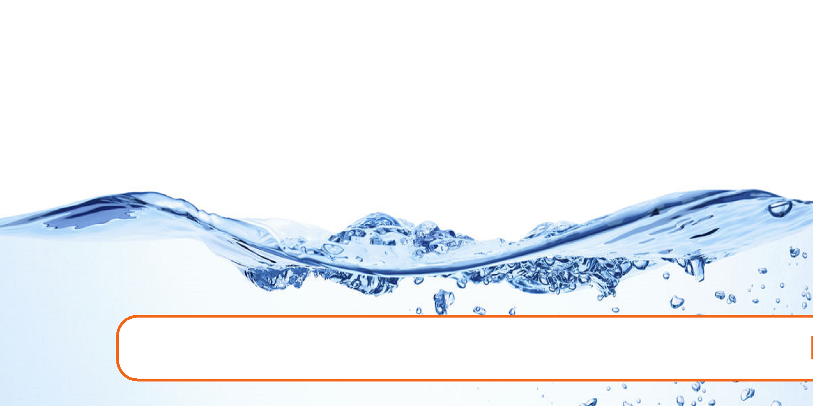36 Chapter 2. Water Properties and Sources

2. Water Properties and Sources

Expected Range of Knowledge for Water Properties and Sources Water Distribution System Operator License Exams

|  |  |
| --- | --- |
| D1 | Ability to measure well depth |
| D1 | Ability to recognize potential sources of contamination |
| D1 | Knowledge of the hydrologic cycle |
| D1 | Knowledge of security procedures/measures |
| D1 | Ability to calculate draw down |
| D1 | Ability to recognize abnormal pH levels of water in a distribution system |
| D1 | Ability to recognize abnormal turbidity levels in a distribution system |
| D1 | Knowledge of normal pH range in drinking water |
| D1 | Knowledge of the impacts of high nitrate concentrations in a distribution system |
| D1 | Knowledge of the meaning of high levels of turbidity in a distribution system |
| D1 | Knowledge of contamination sources in a well |
| D1 | Knowledge of water storage contamination sources |
| D1 | Ability to measure the water depth in a well |
| D1 | Knowledge of water depth measurement techniques |
| D2 | Knowledge of cone of depression |
| D2 | Knowledge of recovery time |
| D2 | Knowledge of static and pumping water level |
| D2 | Knowledge of water table fluctuations |
| D2 | Knowledge of well components and terms |
| D2 | Knowledge of well protection |
| D2 | Knowledge of zone of influence |
| D2 | Knowledge of proper installation of a sanitary seal on a well |
| D3 | Knowledge of the vulnerability assessment |
| D3 | Knowledge of well location requirements |
| D3 | Knowledge of the chemical components of groundwater |
| D3 | Ability to calculate specific yield |

37

Expected Range of Knowledge for Water Properties and Sources Water Distribution System Operator License Exams (Continued)

D4 Knowledge of long-term water availability

D4 Knowledge of sanitary survey requirements

D4 Knowledge of the characteristics of aquifers

D4 Knowledge of proper gravel packing and screen depth

D4 Knowledge of well abandonment procedures and permit requirements

D4 Ability to estimate future water needs

D4 Knowledge of capital improvement/capital replacement requirements

D5 Knowledge of permit requirements

Water Treatment System Operator License Exams

T1 Ability to recognize abnormal well operations

T1 Ability to recognize potential security risks

T1 Ability to recognize potential sources of contamination in surface water

T1 Ability to recognize the influence of surface water on a groundwater source

T1 Knowledge of flow measurement devices

Knowledge of potential microbial and chemical contamination sources in groundwater and sur-

T1

face water

T1 Knowledge of the characteristics of aquifers

T1 Knowledge of the hydrologic cycle

T1 Knowledge of visual signs of contamination in a surface water reservoir

T1 Knowledge of well components

T1 Knowledge of well depth measurement procedures

T1 Knowledge of well disinfection procedures

T1 Knowledge of well drawdown measurement techniques

T1 Knowledge of waterborne pathogens

T1 Ability to interpret water quality reports

T2 Ability to discriminate between normal and abnormal conditions of a surface water reservoir

T2 Ability to recognize hydrological changes

T2 Knowledge of how reservoir intake level effects water quality

T2 Knowledge of the effects of seasonal changes on water reservoirs

T3 Knowledge of surface water reservoir stratification

T3 Ability to recognize head loss across an intake screen

T3 Knowledge of groundwater treatment procedures

T4 Ability to interpret historical water use data

38 Chapter 2. Water Properties and Sources

2.1 Properties of water

* Water is one of the most abundant and common materials on earth. It covers 70 per- cent of the surface of the earth as water and ice.
* Water makes up 60-75% of human body weight. A loss of just 4% of total body water leads to dehydration, and a loss of 15% can be fatal. A person could survive a month without food but wouldn’t survive 3 days without water .
* Even though most other planets have water in some form, the earth is the only planet in the solar system that contains water in all its common forms (gas, liquid, solid). Others have ice, but only the earth has an abundance of this miraculous substance in the proper temperature range to support life.
* Its chemical formula, H2O, indicates that each of its molecules contains one oxygen and two hydrogen atoms. The much larger oxygen atom is connected by covalent bonds to each of the two hydrogen atome. The hydrogen atoms are attached to the oxygen atom at an angle of 104.45◦
* Even though the water molecule is overall neutral, its bent shape results in the accumula-tion of positive charge near the oxygen end and negative charge near the hydrogen. This differential in charges makes the water molecule polar - like a magnet and bestows it unique properties.
* The polarity and molecule size of water imparts it a unique property of being able to dis-solve a very wide range of minerals, chemicals and gases which makes it indispensable for the existence of lifeforms and a very critical element of our day-to-day life. However, many of the substances dissolved in water must be removed during treatment to make water safe to drink.
* Nonpolar substances such as oils, fats, and many organic compounds do not dissolve as easily in water.

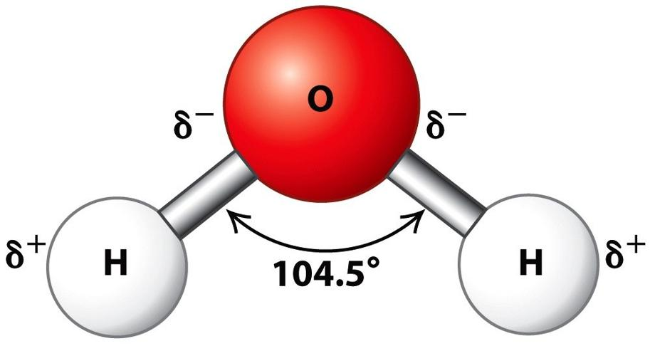

Figure 2.1: Water Molecule

* Pure water will not conduct electrical current. But when soluble salts such as sodium chloride (NaCl), calcium carbonate (CaCO3) are present in water, water will conduct electricity as these salts ionize - break into its constituent positive and negative charged

|  |  |
| --- | --- |
| 2.2 Water use | 39 |
|  |  |

particles the water, and the charged ions make water to conduct electrical current.

NaCl ↔ Na+ +Cl−

* The more ions there are in a solution, the more easily the current flows. The ability to conduct electrical current is called conductivity and can be used to indirectly estimate the amount of total dissolved solids in the water.
* The boiling of water - 100◦C or 212◦F and its melting/freezing point - 0◦C or 32◦F is very high compared to similar molecules and it is the only natural substance found in all three physical states at the temperatures that naturally occur on Earth.
* Most other substances become more dense as they cool. However, ice is less dense than water which makes ice float on water.
* Ice on the water surface insulates the water below preventing it from freezing and allowing for fish and other life form to survive and allows for the movement of animals who live in these cold habitats.
* As water cools, its density increases upto 4◦C after which it gets less dense as it is cooled further.
* The changing density of water is responsible for turnover of a lake during fall. When the surface water cools, the cold water becomes more dense than the warm water below so the cold water sinks to the bottom and warm water rises to the top. When lakes are used as the source water for water treatment plants, turnover can cause abrupt changes in the quality of raw water.
* It needs a lot of energy to make the water warmer or cooler (high Specific Heat) which allows for keeping the temperature of water bodies such as oceans, rivers, ponds more or less constant despite the heat from the sun.
* Water molecules stick together well because of its high surface tension - which allows for water to rise up in tubes through capillary action. This capillary action allows for plants to draw water along with nutrients from the ground.

2.2 Water use

* Besides it being needed for basic sustenance of all living beings, water is vital element for the world economy and sustenance of the human society in various ways including:

– As a food source - fishing

– For commerce - shipping, trade and transportation

– For recreation - swimming, skiing, surfing etc.

* Breakdown of global freshwater use: 70% is used for agriculture

19% is used by industries, and

11% is for municipal use

40 Chapter 2. Water Properties and Sources

2.3 Water Supplies

* Civilizations have always formed near water sources - on the banks of rivers. Ancient Egyptians - on the Nile, Mesopotamians in the Fertile Crescent on the Tigris/Euphrates rivers, Ancient Chinese on the Yellow River, and the Ancient India on the Indus.
* The water on our Earth today is the same water that has been here for nearly 5 billion years.
* Water molecules were formed in interstellar space by chemical reactions between hydro-gen molecules and oxygen-bearing molecules such as carbon monoxide and the Earth inherited its water from asteroids and comets crashing into it.
* The only thing that changes is the form that water takes as it travels through the water cycle.
* On Earth, water is the only substance that can occur naturally in its three states of matter - gas, liquid and solids, circulates naturally through its five principal realms:

– Oceans

– Atmosphere

– Lakes and rivers

– Icecaps and glaciers

– Underground

* Elements of the water cycle include:

– Transpiration - process by which plants lose water as vapor out of their leaves.

– Evaporation - conversion of water in oceans, rives and lakes into vapor by the heat from the sun

– Evapotranspiration is the combined processes of evaporation and transpiration - the movement of water from oceans or land to the atmosphere.

– Condensation - cooling of water vapor in the upper layer of earths atmosphere into liquid water in the form of clouds

– Precipitation - discharge of the water bearing clouds as rain, hail, sleet or snow.

– Infiltration - movement of water from surface to soil.

* Life on earth is dependent on the Earth’s water cycle
* A watershed is the area of land, where all of the water that falls in it and drains off of it into to a common outlet which could be a one or combination of water bodies such as a river, lake or underlying ground water.
* The natural features including - mountains, trees, shrubs, grasses, and man-made features such as urban area, industries, wastes and water discharges affect the quality of the water in or from the watershed.
* Watersheds are important sources of drinking water, as well as a habitat for many aquatic species. Healthy watersheds with intact native vegetation and wetlands provide important functions such as water purification, flood control, nutrient recycling, and groundwater

|  |  |
| --- | --- |
| 2.3 Water Supplies | 41 |
|  |  |

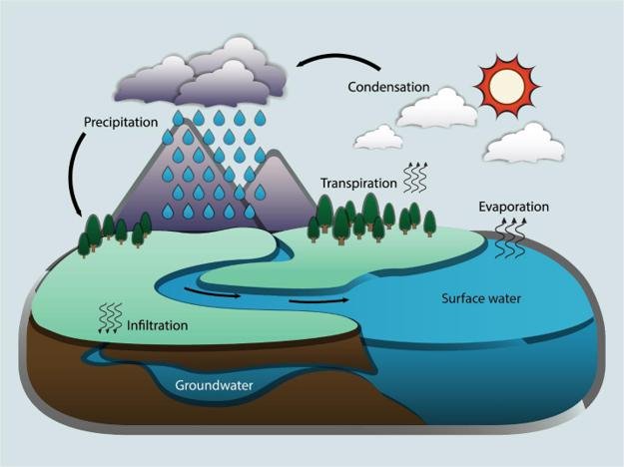

Figure 2.2: Water Cycle

(Credit:David Cain/NWS)

recharge.

* Water covers about 71% of Earth’s surface. The distribution of Earth’s water is provided in the below table.
* 97% of the Earth’s water can be found in our ocean and freshwater is only 2.5% of all the water on earth
* Most of the fresh water is in form of ice in glaciers, ice caps and permafrost.
* A very very small fraction - about 0.006% of the total water is the freshwater in lakes and rivers. Most of the remaining freshwater is in groundwater - about 0.75% of the total water or about 30% of the total freshwater.
* Clean water is vital to our health, communities, and economy.
* There is no universally accepted definition of “safe drinking water.” Generally speaking, safe drinking water, is defined as the water that does not represent any significant risk to health over a lifetime of consumption.
* Water scarcity can be caused by a mix of hydrological, infrastructural, political and social issues.
* In developing countries, water supply and sanitation related factors cause more than 20 percent of deaths of people under age 14. Nearly half of all people in developing countries have infections or diseases associated with inadequate water supply and sanitation.
* Chemical contaminants in drinking water arise including arsenic, fluoride or nitrate, emerg-

42 Chapter 2. Water Properties and Sources

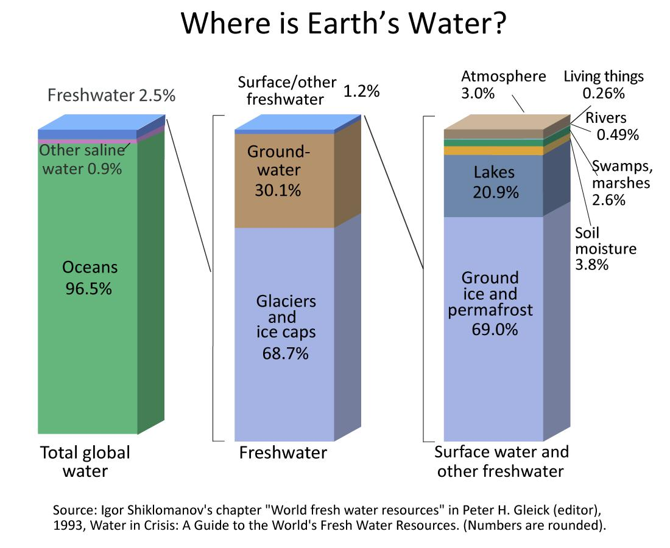

Figure 2.3: Distribution of Earth’s Water

(From: Igor Shiklomanov’s chapter "Worlds fresh water resources" in Peter H. Gleick (editor),

1993, Water in Crisis: A guide to the world’s Fresh water resources)

|  |  |  |  |  |  |  |  |  |
| --- | --- | --- | --- | --- | --- | --- | --- | --- |
| 2.3 Water Supplies | |  |  |  |  | 43 | |  |
|  |  |  |  |  |  |  |  |  |
|  |  |  |  |  |  |  |  | |
|  |  |  |  |  | Atmosphere |  | 3.00% | |
|  |  |  |  |  | Living things |  | 0.26% | |
|  |  |  |  |  | Rivers |  | 0.49% | |
|  |  |  | Surface water | 1.20% | Swamps, marshes |  | 2.60% | |
| Fresh water |  | 2.50% |  |  | Soil moisture |  | 3.80% | |
|  |  |  |  |  | Lakes |  | 20.90% | |
|  |  |  |  |  | Ground ice and permafrost |  | 69.00% | |
|  |  |  | Ground water | 30.10% |  |  |  |  |
|  |  |  | Glaciers and ice caps | 68.70% |  |  |  |  |
| Other saline water |  | 0.90% |  |  |  |  |  |  |
| Oceans |  | 96.50% |  |  |  |  |  |  |

Table 2.1: Distribution of Earth’s Water

(From: Igor Shiklomanov’s chapter "Worlds fresh water resources" in Peter H. Gleick (editor),

1993, Water in Crisis: A guide to the world’s Fresh water resources)

ing contaminants such as pharmaceuticals, pesticides, per- and polyfluoroalkyl substances (PFASs) and microplastics generate public concern.

* Microbiologically contaminated drinking water can transmit diseases such as diarrhoea, cholera, dysentery, typhoid and polio and is estimated to cause 485 000 diarrhoeal deaths each year.
* The amount of water that is available for sustenance including agriculture, sanitation and hygiene is limited in many areas of the world. Billions of people throughout the world are battling daily against enormous difficulties accessing the most basic services.
* Some 1.1 billion people worldwide lack access to water, and a total of 2.7 billion find water scarce for at least one month of the year.
* Inadequate sanitation is also a problem for 2.4 billion people—they are exposed to dis-eases, such as cholera and typhoid fever, and other water-borne illnesses. Two million people, mostly children, die each year from diarrheal diseases alone.
* Many of the water systems that keep ecosystems thriving and feed a growing human pop-ulation have become stressed. Rivers, lakes and aquifers are drying up or becoming too polluted to use. More than half the world’s wetlands have disappeared.
* Climate change is altering patterns of weather and water around the world, causing short-ages and droughts in some areas and floods in others, changing large-scale hydrological cycle.
* At the current consumption rate, this situation will only get worse. By 2025, two-thirds of the world’s population may face water shortages. And ecosystems around the world will suffer even more
* Historical rates of progress would need to double for the world to achieve universal cover-age with basic drinking water services by 2030.
* To achieve universal safely managed services, rates would need to quadruple. Climate change, increasing water scarcity, population growth, demographic changes and urbaniza-

44 Chapter 2. Water Properties and Sources

tion already pose challenges for water supply systems.

* Over 2 billion people live in water-stressed countries, which is expected to be exacerbated in some regions as result of climate change and population growth.
* Re-use of wastewater to recover water, nutrients or energy is becoming an important strat-egy.
* Increasingly countries are using wastewater for irrigation; in developing countries this represents 7% of irrigated land. While this practice if done inappropriately poses health risks, safe management of wastewater can yield multiple benefits, including increased food production.

Options for water sources used for drinking-water and irrigation will continue to evolve, with an increasing reliance on groundwater and alternative sources, including wastewater. Climate change will lead to greater fluctuations in harvested rainwater. Management of all water resources will need to be improved to ensure provision and quality.

2.4 Water Sources

* Source waters refers to the sources of water - the water bodies or means, which provide water needed for domestic, agricultural and industrial uses.

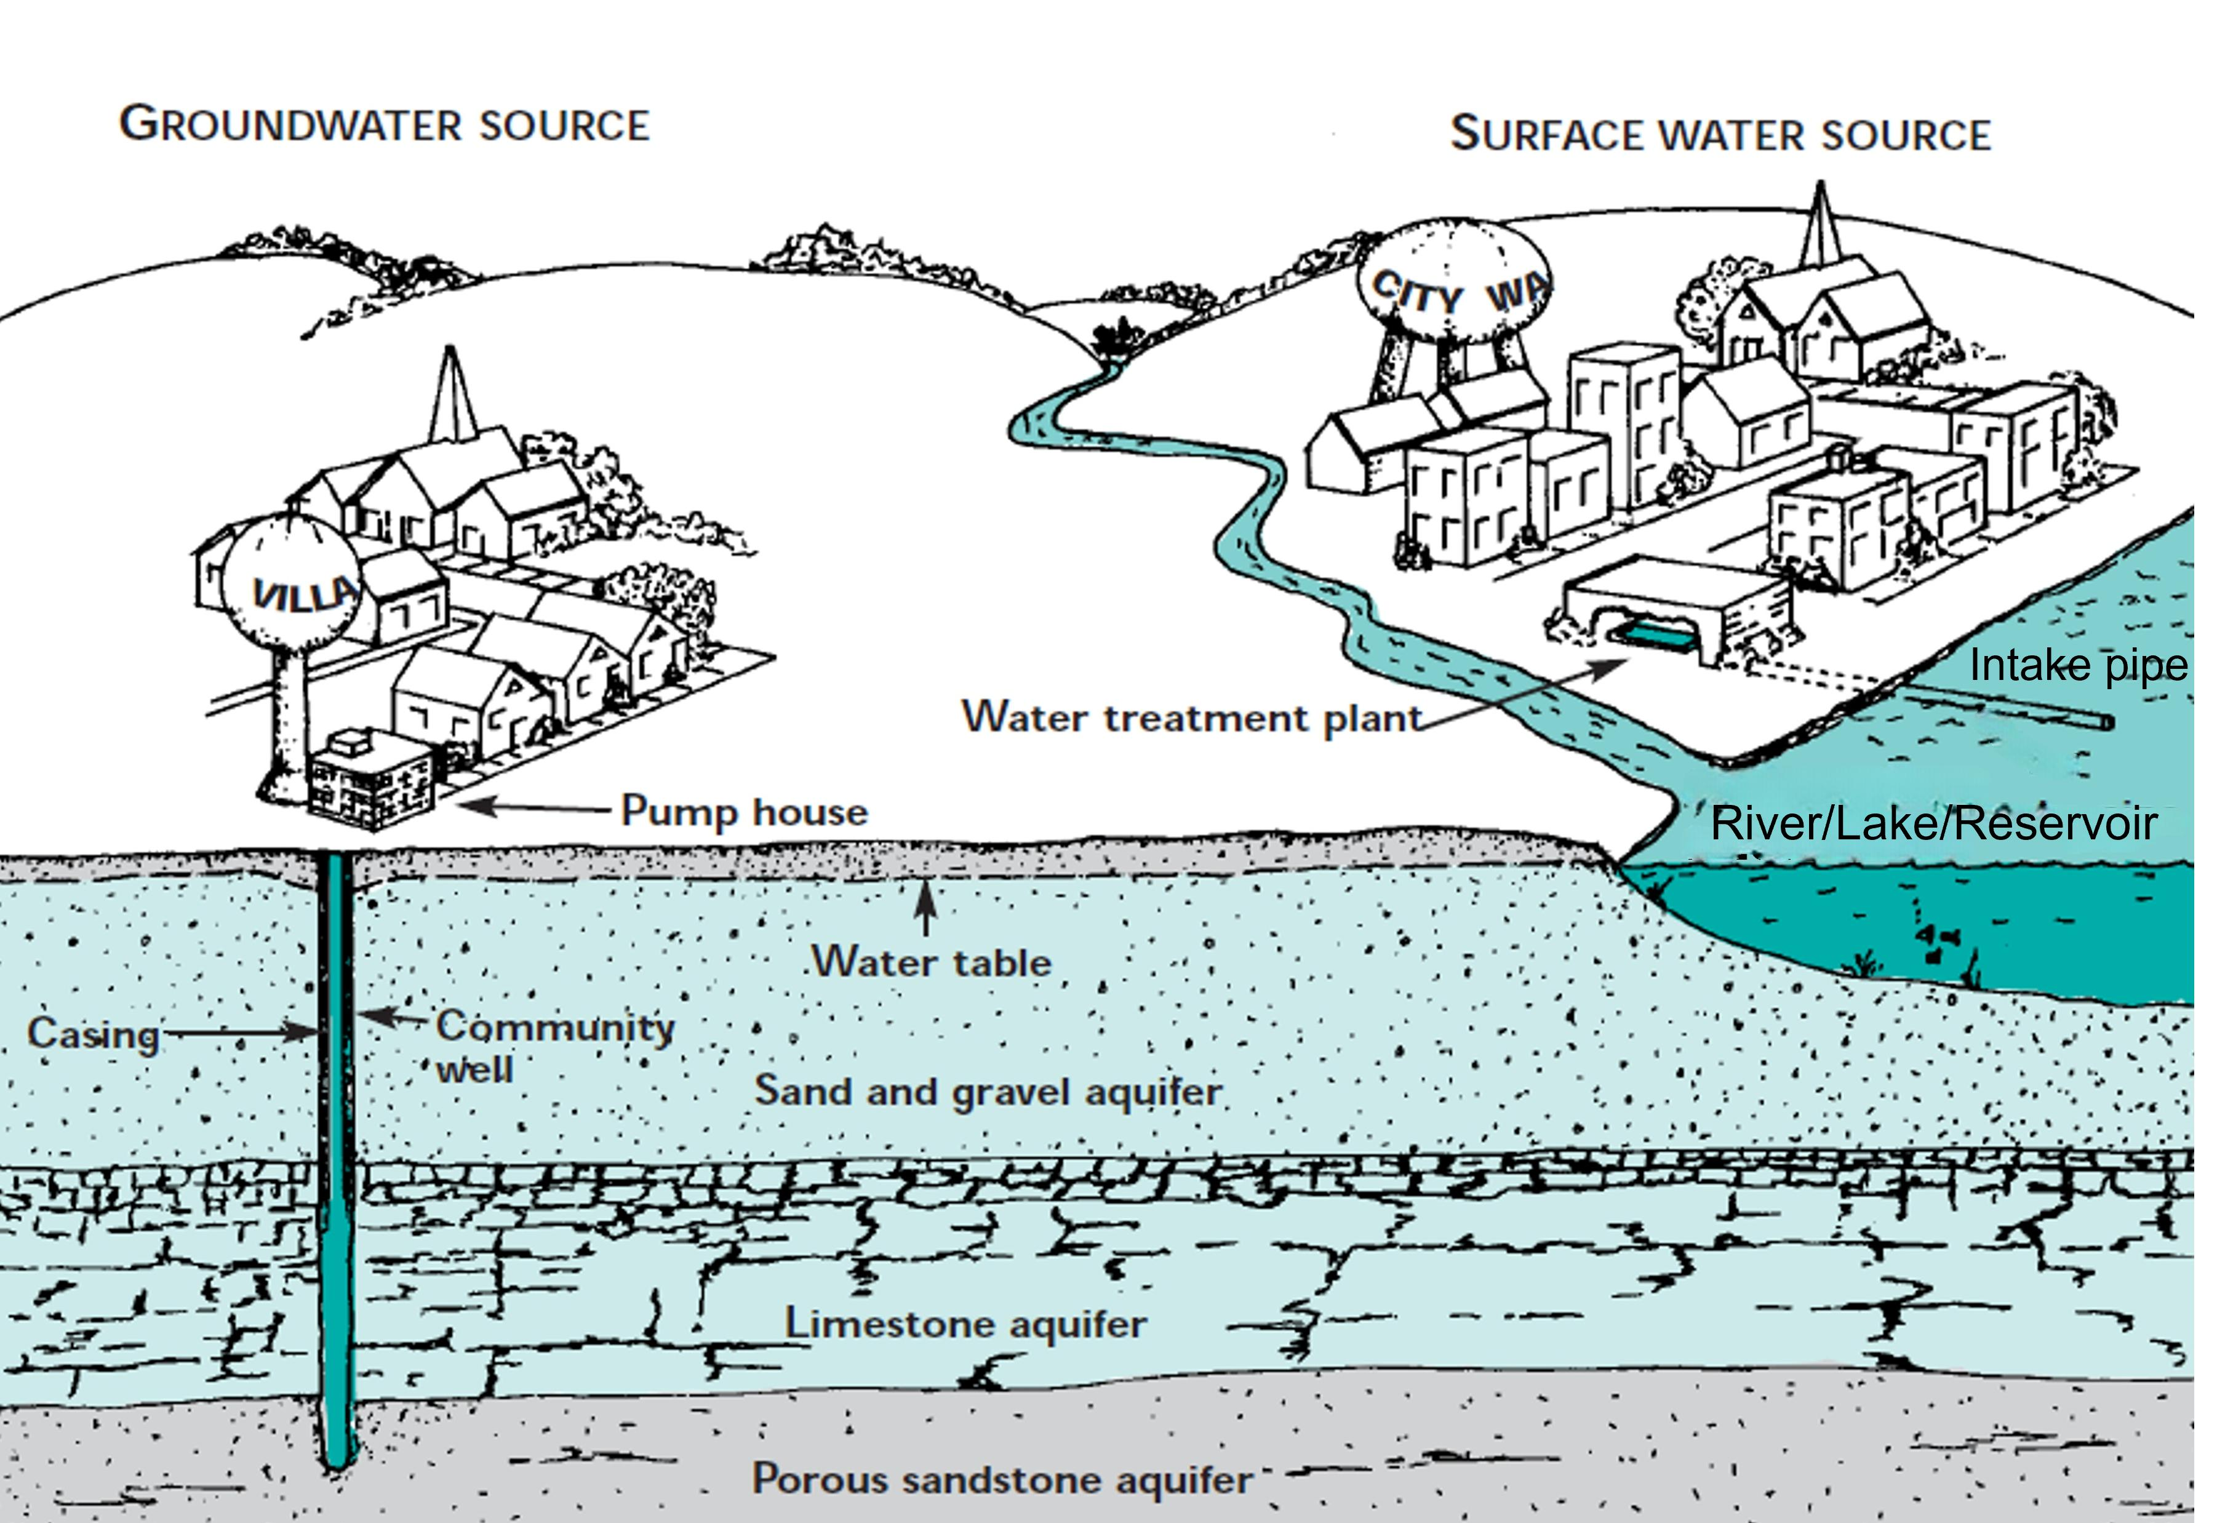

Figure 2.4: Water Supply Sources

* Water sources include:
  1. Surface water (for example, a lake, river, or reservoir)

|  |  |
| --- | --- |
| 2.4 Water Sources | 45 |
|  |  |

1. Groundwater (for example, an aquifer)
2. Recycled water - also called reused water

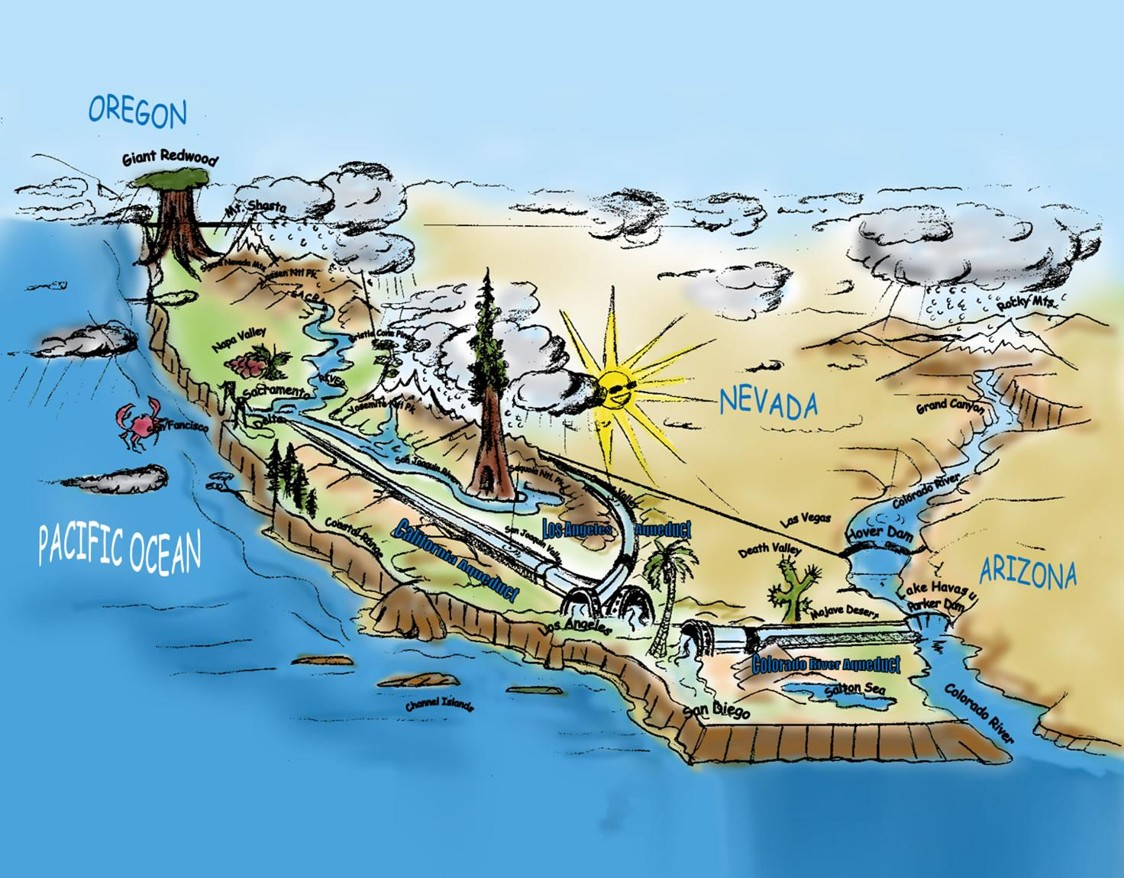

Figure 2.5: Illustration of Southern California Water Supply Systems

2.4.1 Groundwater

* Groundwater is the water found underground in spaces between sand, rock and soil.
* Groundwater is stored in aquifers - water-bearing formations underneath the surface that readily transmit water.
* Aquifers are underground layers of very porous water-bearing soil or sand with enough groundwater that it can be pumped to the surface and used for drinking water, irrigation, industry, or other uses.
* Water from precipitation, such as rain or snow, naturally filters through the soil, and is held within the aquifer.
* Groundwater can move through the aquifer and resurface through springs and wells. The rate at which groundwater moves through an aquifer varies depending on the permeability of the layer.
* Groundwater is extracted from aquifers via well pumping.

46 Chapter 2. Water Properties and Sources

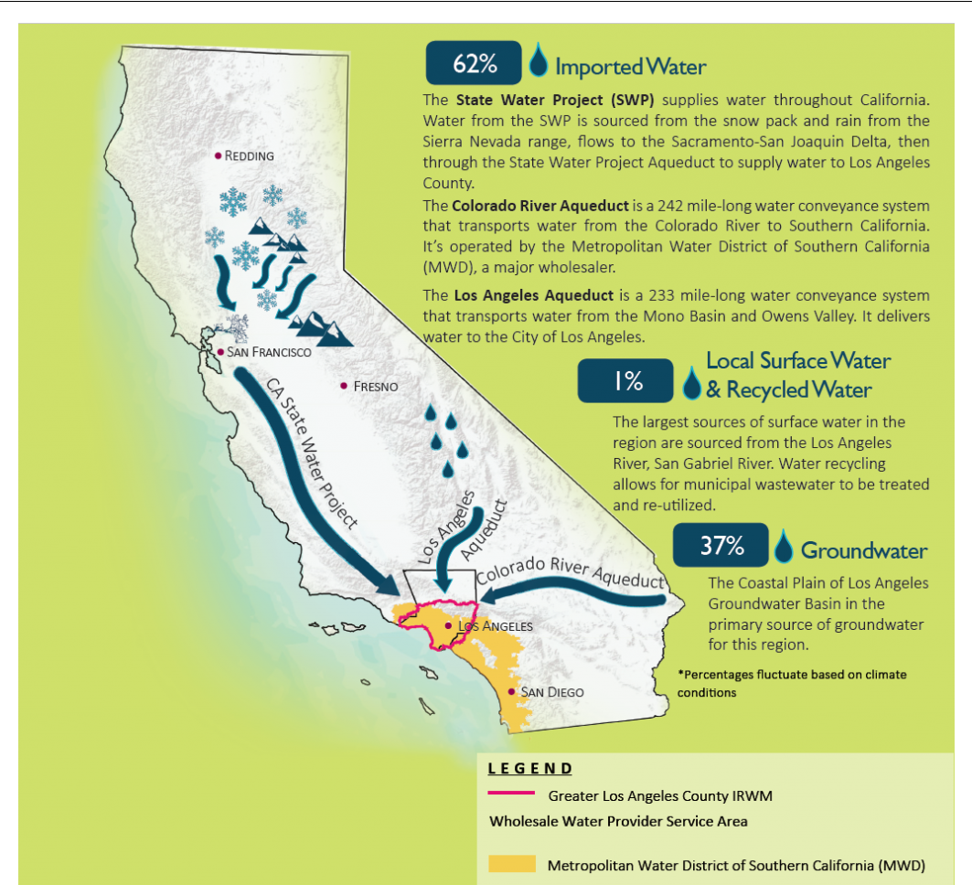

Figure 2.6: Los Angeles Area Source Water Summary

* Groundwater moves from higher elevations to lower elevations and from areas of higher pressure to areas of lower pressure.
* Groundwater is not stored in huge underground caverns, groundwater fills the pores of the various kinds of rocks that form the earth below us. Hydrogeology is the study of groundwater.
* The presence of the groundwater depends largely on the geology of a specific area and the variable porosity of the upper portion of the earth’s crust.
* Access to groundwater is through:
  1. Wells - an ordinary well is essentially an a hole in the ground to access the water in the aquifer.
  2. Artesian Well - as the groundwater moves in a aquifer, in certain areas of poor per-meability, the water is pressurized. In a well dug in this area, the water level will rise above the top of the aquifer and may even flow onto the land surface - flowing artesian well

|  |  |
| --- | --- |
| 2.4 Water Sources | 47 |
|  |  |

1. Springs - which is the flow of groundwater onto the earth’s surface through a natu-ral opening. Springs occur when the contact between an upper aquifer and a lower aquitard intersects the ground surface

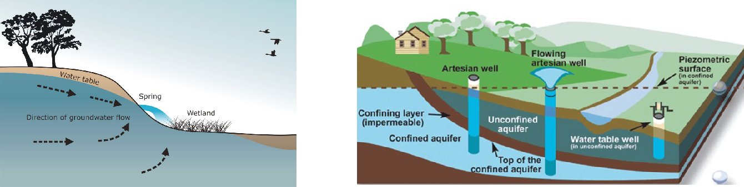

Springs Groundwater

* There are two general types of aquifers: confined and unconfined. Confined Aquifers have a layer of impenetrable rock or clay above them, while Unconfined Aquifers lie below a permeable layer of soil.
* The layers of earth which hold the groundwater include a spectrum of layer with porous layer through which the ground water could through easily in the downward direction, at one end of that spectrum to an Aquiclude which is a geological material through which zero flow occurs. Then there is the Aquitard in the middle, which is compacted layers of clay, silt or rock that retards the water flow.
* The replenishment of aquifers by precipitation is called recharging .
* Aquifers naturally filter groundwater by forcing it to pass through small pores and between sediments, which helps to remove substances from the water. This natural filtration pro-cess, however, may not be enough to remove all of the contaminants. Safe yield is the maximum quantity of water which can be extracted from an aquifer, yet still maintain the supply unimpaired.
* The water table is the surface of the water level in an unconfined aquifer at which the pressure is atmospheric. The water table fluctuates due to recharge or outflow from the aquifer,
* Perched water table is a small water body separated from the main groundwater by a relatively small impermeable stratum.
* A piezometeric surface or a potentiometric surface is an imaginary surface to which the water level would rise if a piezometer - an instrument used for measuring the pressure of groundwater, is inserted in a well drilled in a confined aquifer. A piezometeric surface is the water table equivalent of a confined aquifer.
* Groundwater can become depleted if used at a faster rate than it can be replenished.
* Groundwater can become contaminated when an excessive amount of pesticides and herbi-cides are sprayed on agricultural fields, septic tanks leak, or landfills are improperly lined

48 Chapter 2. Water Properties and Sources

or managed and toxic materials seep through the soil into the aquifer.

* Groundwater can be found at nearly every point in the Earth’s shallow subsurface to some degree, although aquifers do not necessarily contain fresh water.
* Most land areas on Earth have some form of aquifer underlying them, sometimes at sig-nificant depths. In some cases, these aquifers are rapidly being depleted by the human population.
* Many parts of the world are heavily dependent on groundwater due to low levels of rain-fall.
* The United States relies on groundwater for 23 percent of its freshwater needs. In Califor-nia, that number is significantly higher – groundwater provides nearly 40% of the water used by California’s farms and cities, and significantly more in dry years.

Water Wells

Background

* A well is basically a hole in the ground, held open by a pipe (or casing) that extends to an aquifer.
* A pump draws water from the aquifer for distribution through the plumbing system.
* Factors dictating the siting of a well include:

– Amount of water needed

– Quality of available water

– Meet minimum isolation distances required by state rules to ensure safety, and mini-mize any contamination potential.

* The depth to which wells are constructed is determined by factors including:

1. depth to groundwater
2. groundwater quality, and
3. geological conditions at the well site

* Static level is the water level in a well when the pump is not operating.
* Pumping level is the water level in the well when it is producing.
* Drawdown is the difference in elevations between the static level and the pumping level. The amount of water produced is approximately proportional to the drawdown.
* Cone of depression is the depression in the water table formed as the pump draws down the water level.
* Zone of influence is the area included in the cone of depression. Any contamination in this zone will be drawn into the well.
* Radius of influence is the farthest distance from the well that the cone of depression affects the water table.
* Specific capacity is the relationship between the yield of a well and the amount of drawdown in the well. It can be expressed as a ratio of the yield, in terms of gallons per minute, to the drawdown in feet. A well producing 100 gpm with a drawdown of 20 feet would have a

|  |  |
| --- | --- |
| 2.4 Water Sources | 49 |
|  |  |

specific capacity of 5 gpm per foot of drawdown.

* Recovery time is the amount of time required for the aquifer to stabilize at its static water level once pumping has stopped.

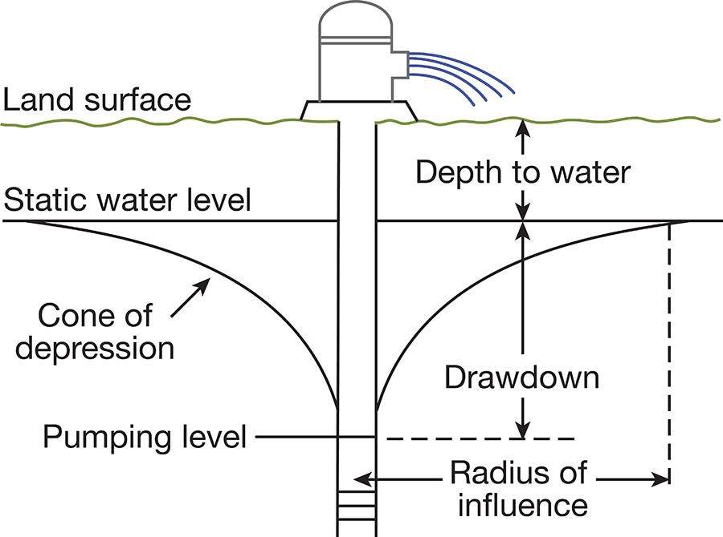

Figure 2.7: Well terms

Well types

* Wells are classified by method of construction of the well.
* Well types include:

– Dug wells : These wells are typically:

* large diameter
* 10-30 ft deep
* hand-dug to the top layer of the aquifer.
* lined with stone or bricks

Dug wells levels fluctuate with seasonal variation of water table and has a high risk of contamination from nearby land activities.

– Driven wells: These wells are for reaching shallow waters about 30-50 feet deep and are made by driving a small diameter pipe. Although the well is cased, it has a moderate to high evel of risk of contamination from nearby land activities.

– Drilled wells: Drilled well is the most common type of well used by public water sys-tems. These wells are constructed using a rotary-drilling machine and are hundreds of feet deep. These wells have a continuous casing, which is commonly six-inches in diameter. These wells are ideally suited to deep water bearing formations where larger yields are available. This type of well, when properly constructed offers good protection against contamination from the surface.

* Borehole is the narrow shaft drilled to extract water from the aquifer. item Well casing is the watertight plastic or steel tube lining of the borehole. It is generally 4-6" diameter and it is primarily to protect the borehole from caving in and to prevent surface water from entering

50 Chapter 2. Water Properties and Sources

the well. The casing should extend at least 6 to 12 inches above the well pad, depending on whether the well is located in a well house or out in the open, to prevent standing water from entering the well.

* Well screen is installed on the end of a well casing. It supports the bore hole, and it reduces the amount of sand that enters the casing and the pump.
* Gravel packer is a layer of gravel placed around the screen to reduce the amount of fine material from entering the well through the screen. The gravel packing is usually three times the diameter of the well screen or a minimum of 4" thick.
* Grout is cement or bentonite packing around the well casing to protect the well from sur-face water. The grout is applied continuously from the surface upto the bottom where the borehole passes into the impermeable layer or upto the gravel packer.
* Ground seal is typically a reinforced concrete slab. This concrete is usually connected to the grout that extends down the well.
* Sanitary seal it seals the top of the casing and its primary function is to prevent well con-tamination. The type of seal varies depending upon the type of pump being used. For a well using a submersible pump, the sanitary seal is typically composed of a rubber-like material placed between two pieces of metal. When bolts are tightened on the sanitary seal, the rubber is compressed and expands to seal against the casing and the pump discharge pipe.

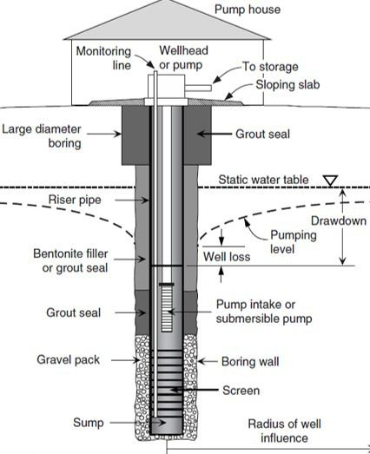

Figure 2.8: Well construction

2.4.2 Groundwater Under the Direct Influence of Surface Water

* Groundwater under the direct influence of surface water (GWUDISW) is the water which may be subject to contamination with pathogenic organisms from surface waters.

|  |  |
| --- | --- |
| 2.4 Water Sources | 51 |
|  |  |

* GWUDISW is defined as:

Any water beneath the surface of the ground with significant occurrence of:

– Insects

– Other macroorganisms

– Algae

– Large diameter pathogens such as Giardia lamblia

or as:

– Any water beneath the surface of the ground with significant and relatively rapid shifts in water characteristics such as:

* Turbidity
* Temperature
* Conductivity, or
* pH

that closely correlates to climatological or surface water conditions.

2.4.3 Surface Water

* Surface water is water that is open to the atmosphere and results from overland flow. It is also said to be the result of surface runoff. These are two ways of saying the same thing.
* Examples of surface water include:

– Streams, Rivers, Lakes

– Man-made impoundments - Reservoirs

– Wells drilled next to or in a stream or river

– Rain catchments

* Surface waters are classified as either: running waters which include streams, rivers and brooks; and quiescent waters which include lakes and reservoirs.
* A lake is where surface-water runoff (and maybe some groundwater seepage) have accu-mulated in a low spot, relative to the surrounding countryside. Whereas a reservoir is a man-made lake that is created when a dam is built on a river.
* The exposure of surface waters to the atmosphere results in exposure to precipitation events, surface water runoff and contamination with micro and macroorganisms resulting from activities in their surrounding areas.
* Changes in weather cause the natural flow of streams and rivers to vary greatly with time. Periods of excess flows and valley flooding may alternate with low flows or droughts.
* The role of water-storage reservoirs, also known as impoundments is to store water during periods of higher flows, thus preventing flood disasters, and then permit gradual release of water during periods of lower flows.
* Lakes and reservoirs can be classified into three categories based upon their nutrient con-tent:

– Eutrophic - rich in nutrient

52 Chapter 2. Water Properties and Sources

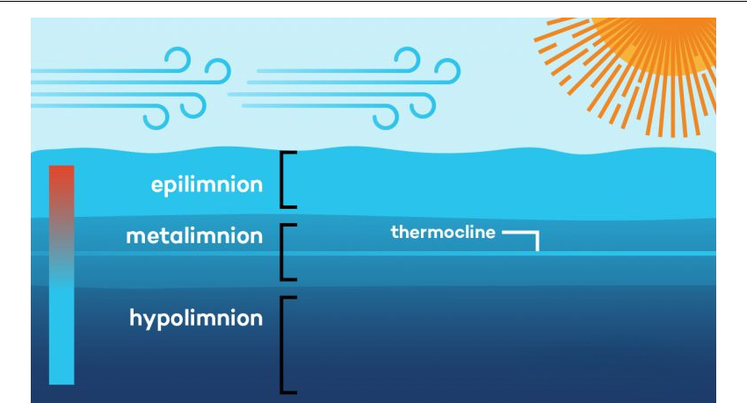

Figure 2.9: Lake/Reservoir Stratification

– Mesotrophic - moderate amount of nutrient

– Oligotrophic - little or no nutrient

* In many locations, as the water temperatures decrease with increasing water depth, thermal stratification - formation of distinct thermal layers, of lakes and reservoirs occur due to temperature related density changes which prevents the vertical mixing of water.

1. Epilimnion - Suface layer of warm, light water (mixed by wind)

2. Thermocline or Metalimnion- Middle layer with rapidly changing temperature

3. Hypolimnion - Lowest layer of coldest and densest water. Hypolimnion usually has depletion of dissolved oxygen (DO) leading to fish kills for fish living at that depth. ·

* Destratification - can be natural by change in weather or by means such as aeration or mechanical agitation and mixing.
* Lake turnover - During autumn and winter, top layer of water gets colder and denser and sink to the bottom, water from bottom comes to the top causes the bottom sediments to be stirred causing high turbidity in the water. It can also cause the heav metals (such as mercury and lead from the bottom of the reservoir become dispersed in the water.
* Thus, water intakes are located at various levels in the reservoir to get the best possible quality of raw intake water possible at different times of the year.

2.4.4 Advantages and Disadvantages of Surface Water vs Groundwater

* Advantages of surface water with respect to groundwater:

– It is easily located. It takes no sophisticated equipment to find a surface water source.

– In many parts of the US, considerable data is available on quantity and quality of existing surface water supplies.

– Surface water is generally softer than groundwater, which makes treatment much

|  |  |
| --- | --- |
| 2.4 Water Sources | 53 |
|  |  |

simpler.

* Disadvantages of surface water with respect to groundwater:

– Surface waters can be easily contaminated with microorganisms that cause water-borne diseases and chemicals that enter the stream from surface runoff and upstream discharges.

– The turbidity of a surface water source often fluctuates with the amount of precipita-tion. Increases in turbidity increase treatment cost and operator time.

– The temperature of surface water fluctuates with the ambient temperature. This makes it difficult to produce consistent water quality at a water treatment plant.

* Advantages of groundwater with respect to surface water:

– Groundwater is not as easily contaminated as surface water.

– The quality of groundwater, while not always as good as would be preferred, is stable throughout the year.

– Groundwater sources are generally lower in bacteriological count than surface water sources.

– Groundwater is available in most locations throughout the continental US and Alaska.

* Disadvantages of groundwater with respect to surface water:

– Groundwater usually contains more minerals than surface water, including increased levels of hardness. Because groundwater is in contact longer with minerals, there is more time to bring them into solution.

– Removal of groundwater normally requires a pump, thus increasing operation cost.

– Groundwater is more susceptible to long-term contamination from fuel spills.

– Groundwater supplies often have high levels of iron and manganese, thus increasing treatment cost and/or causing stains on plumbing and the clothing of customers.

– Wells in the coastal areas are subject to salt water intrusion into the aquifer and well. This contamination is difficult to predict and costly to treat.

– Once a groundwater source is contaminated, it is difficult for it to recover. There is no easy way to remove the contaminants. Sources of contamination can be hidden from sight.

2.4.5 Recycled Water

* Water reuse (also commonly known as water recycling or water reclamation) reclaims water from a variety of sources then treats and reuses it for beneficial purposes such as agriculture and irrigation, potable water supplies, groundwater replenishment, industrial processes, and environmental restoration.
* Water reuse can provide alternatives to existing water supplies and be used to enhance water security, sustainability, and resilience.
* Unplanned or de facto reuse refers to situations in which a source of water is substantially composed of previously-used water. An example of unplanned water reuse occurs when communities draw their water supplies from rivers, such as the Colorado River and the

54 Chapter 2. Water Properties and Sources

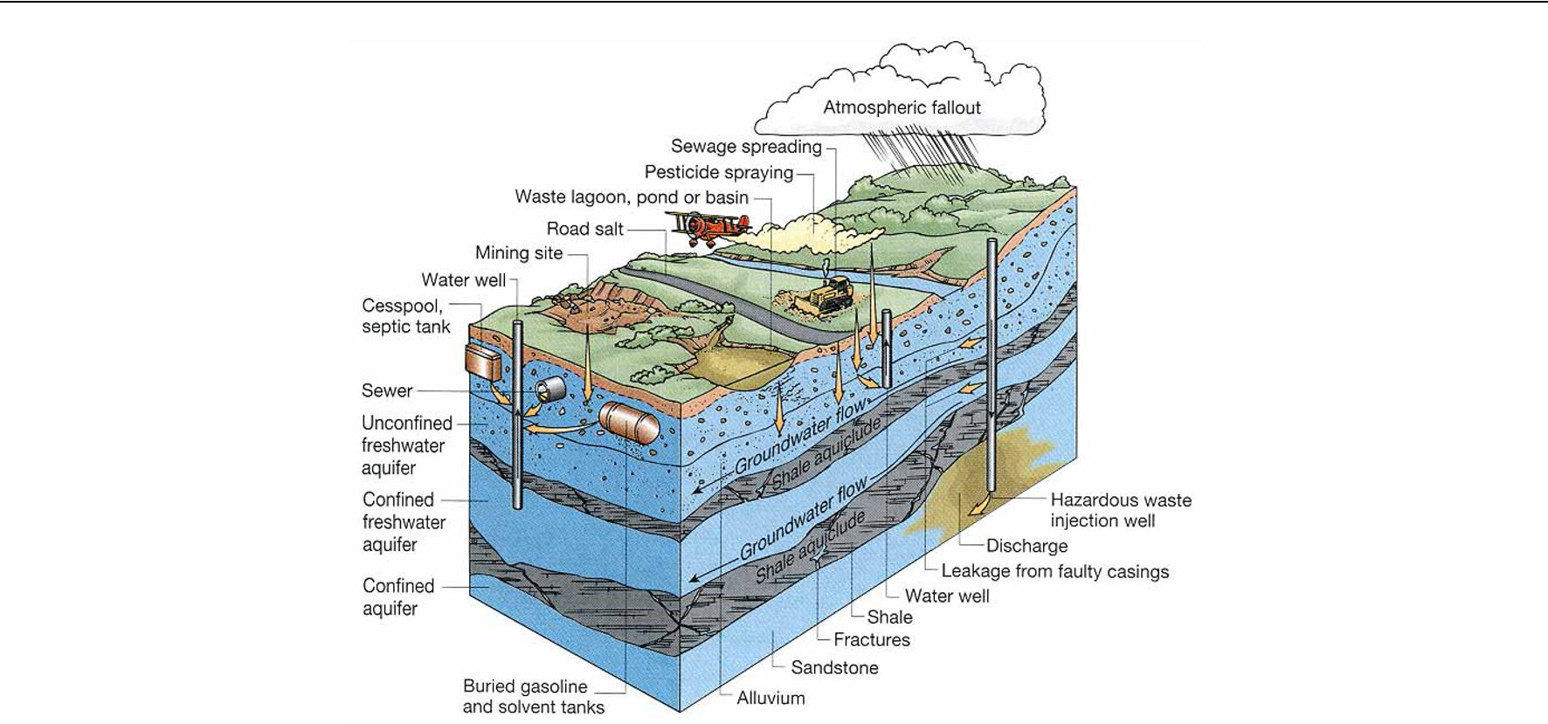

Figure 2.10: Sources of Water Contamination

Mississippi River, that receive treated wastewater discharges from communities upstream.

2.5 Water Rights in California

* If one takes water from a lake, river, stream, or creek, or from underground supplies for a beneficial use, California law requires that person to have a water right. The term “benefi-cial use” can refer to agricultural, mining, urban, industrial, or environmental uses.
* In California, water rights law is administered by the State Water Resources Control Board (often called simply the State Water Board).
* A water right holder is entitled to a “reasonable” amount of water, which not only consid-ers the purpose for which the water is being used but also the relative consumption of the water with regard to other water users in the system.
* Two types of water are recognized by law in water with regard to the law: groundwater and surface water.
* Groundwater is considered a local supply and there is little state regulation of its use,and consequently a state water right permit is not required for use of this water.
* Primarily, landowners in California are entitled to pump and use a reasonable amount of groundwater from a basin underlying their land to put it to a beneficial, nonwasteful use.
* The use of surface water is subject to state laws and regulations that control its develop-ment and use.
* Most common surface water rights include:
  1. Riparian rights :

– Riparian rights are rights to the “reasonable and beneficial use of water on land that is adjacent to a watercourse - a lake, river, stream, or creek.

– A riparian right allows the landowner to take as much water as can be reasonably and beneficially used on the riparian property.

|  |  |
| --- | --- |
| 2.5 Water Rights in California | 55 |
|  |  |

– Riparian owners must share with other riparian owners along the same water body, and they cannot waste water or unreasonably affect public trust resources.

1. Appropriative Rights :

– Appropriative water rights are legal rights to use water from a water source, such as a river or stream, for beneficial purposes.

– Someone who takes water for use on non-riparian land or who uses water that would not be there under natural conditions on riparian land, appropriates water.

– These rights are typically granted based on the principle of "first in time, first in right," meaning that the first person or entity to beneficially use the water for a specific purpose has priority over later users.

– Appropriative water rights are common in regions where water is scarce and are often subject to regulations and permitting processes to ensure fair and sustain-able allocation of water resources.

– Water right permits and licenses issued by the State Water Board are appropria-tive water rights.

– Appropriative water may be stored for later use, or held for diversion and benefi-cial use.

1. Prescriptive Rights :

– A prescriptive right is a right that is acquired through adverse possession of someone else’s water right. It is similar to a “squatter’s right” to land.

– Prescriptive rights originated in the context of conflicts between competing riparian users.



Chapter 2 Assessment

Chapter 2 Assessment

1. Groundwaters generally have consistent water quality that include
   1. having a higher total dissolved solids content than surface water
   2. having a lower mineral content than surface waters
   3. having lower pH values than surface waters
   4. having a higher amount of bacteria than surface waters
2. When underground water is under pressure greater than atmospheric pressure and could rise above the its confining space and above the ground level is referred to as a(n)
   1. aquifer
   2. anaerobic condition
   3. artesian effect
   4. drawdown
   5. pressure gradient
3. The gradual flow or movement of water into and through the pores of the soil is called
   1. percolation
   2. run-off
   3. precipitation
   4. impermeable flow
   5. evapotranspiration
4. Water that has been used to carry solids away from a home or office into a treatment facil-ity is referred to as
   1. wastewater or sewage

58 Chapter 2. Water Properties and Sources

* 1. potable
  2. seawater intrusion injection water
  3. riparian water

1. The water right to put it to beneficial use of the surface water adjacent to your land is called water.
   1. wastewater
   2. riparian
   3. filter ripening
   4. infiltration
   5. run-off
2. The difference between static level and pumping level in a well is called:
   1. drawdown.
   2. cone of depression
   3. zone of saturation
   4. radius of influence
3. Which one of the following best defines the term aquifer?
   1. A low lying area where water pools
   2. Water-bearing stratum of rock, sand, or gravel
   3. Impervious stratum near the ground surface
   4. Treated water leaving the water system
4. The height to which water will rise in wells located in an artesian aquifer is called the
   1. Pumping water level
   2. Water table
   3. Piezometric surface
   4. Drawdown
   5. Radius of influence
5. To prevent the entry of surface contamination into a well is the purpose of
   1. The well casing
   2. The water table
   3. The louvers or slots
   4. Well development
   5. The annular grout seal
6. An aquifer that is located underneath an aquiclude is called
   1. An unconfined aquifer
   2. A confined aquifer
   3. A water table
   4. Unreachable groundwater
   5. An Artesian spring
7. The process by which water changes from the gas to the liquid phase is termed
   1. Condensation ·

|  |  |
| --- | --- |
| 2.5 Water Rights in California | 59 |
|  |  |

* 1. Evaporation
  2. Percolation
  3. Precipitation
  4. Runoff

1. The free surface of the water in an unconfined aquifer is known as the
   1. Pumping water level
   2. Artesian spring
   3. Water table
   4. Drawdown
   5. Percolation
2. The transfer of liquid water from plants and animals on the surface of the earth into water vapor in the atmosphere is called
   1. Transpiration
   2. Evaporation
   3. Condensation
   4. Runoff
   5. Percolation
3. The elevation of water in the casing of an operating well is called the
   1. Piezometric surface
   2. Water table
   3. Pumping water level
   4. Drawdown
   5. Radius of influence
4. An aquifer under pressure is often termed
   1. Unconfined
   2. Pacific
   3. Artesian
   4. Alluvial
   5. Elevated
5. An aquifer is usually composed of
   1. Sand and gravel
   2. Clays and silts
   3. Bedrock
   4. Large voids in the soil, resembling underground lakes
   5. None of the above
6. Which of the following best defines the term specific capacity?
   1. Amount of water a given volume of saturated rock or sediment will yield to gravity
   2. Amount of water a given volume of saturated rock or sediment will yield to pumping
   3. Rate at which water would flow in an aquifer if the aquifer were an open conduit
   4. Amount of water a well will produce for each foot of drawdown

60 Chapter 2. Water Properties and Sources

1. The most common type of well used for public water supply systems is a
   1. Jetted well
   2. Driven well
   3. Drilled well
   4. Bored well
2. An aquifer that is underneath a layer of low permeability is known as
   1. Confined aquifer
   2. Water Table aquifer
   3. Unconfined aquifer
   4. Unreachable groundwater
3. What is the middle layer of a stratified lake known as?
   1. Hypolimnion
   2. Benthic Zone
   3. Thermocline
   4. Epilimnion
4. The amount of water that can be pulled from a aquifer without depleting
   1. Drawdown
   2. Safe yield
   3. Overdraft
   4. Subsidence

III Chapter 3

* Water Quality & Laboratory Procedures 63

3.1 Organics

3.2 Inorganics

3.3 Trace Constituents

3.4 Radionuclides

3.5 Microbial contaminants

3.6 Physicochemical tests

3.7 Microbial testing

3.8 Sampling

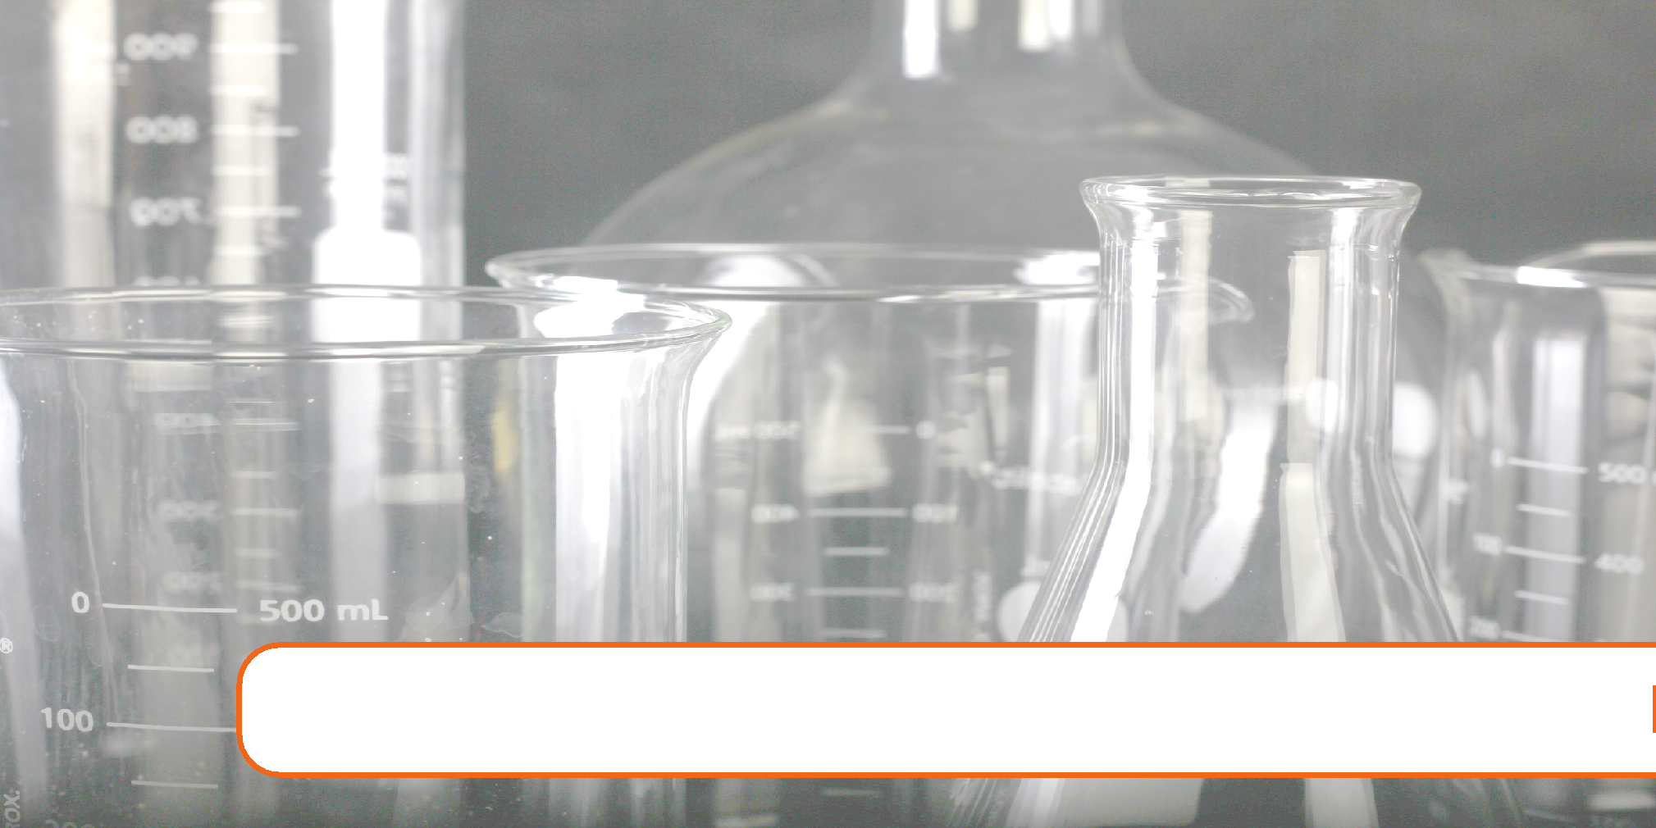

3. Water Quality & Laboratory Procedures

Expected Range of Knowledge for Water Properties and Sources Water Distribution System Operator License Exams

|  |  |  |
| --- | --- | --- |
| D1 | Ability to read a graduated cylinder |  |
| D1 | Ability to interpret coliform test results |  |
| D1 | Knowledge of coliform analysis methods |  |
| D1 | Knowledge of coliform bacteria types |  |
| D1 | Knowledge of the definition of pathogenic organisms |  |
| D1 | Knowledge of holding times (e.g. preservatives) |  |
| D1 | Knowledge of water sampling techniques for bacteriological, organic, and inorganic constituents |  |
| D2 | Knowledge of the use of coliform as a surrogate |  |
| D2 | Ability to distinguish between presumptive and confirmed results |  |
| D2 | Knowledge of nitrate formation in a distribution system |  |
| D2 | Knowledge of potential waterborne diseases |  |
| D2 | Knowledge of the effects of abnormal pH levels in a distribution system |  |
| D2 | Knowledge of the effects of hardness in a distribution system |  |
| D2 | Knowledge of the effects of heterotrophic bacteria in a distribution system |  |
| D3 | Knowledge of the galvanic series |  |
| D3 | Knowledge of the Langelier Index |  |
| D3 | Knowledge of common inorganic contaminant compounds pH, Conductivity, Hardness, and |  |
| Turbidity |  |
|  |  |
|  |  |  |
| D3 | Knowledge of common organic contaminant compounds |  |
| D3 | Knowledge of sources of inorganic contaminants in a distribution system |  |
| D3 | Knowledge of sources of organic contaminants in a distribution system |  |
| D4 | Ability to interpret a Langelier Index |  |

64 Chapter 3. Water Quality & Laboratory Procedures

Expected Range of Knowledge for Water Properties and Sources Water Treatment Operator License Exams

|  |  |
| --- | --- |
| T1 | Ability to recognize abnormal chemical characteristics of water |
| T1 | Ability to recognize abnormal odors or colors |
| T1 | Knowledge of chemicals that contribute alkalinity and hardness to water |
| T1 | Knowledge of common chemical and microbial contaminants in raw water |
| T1 | Knowledge of problems caused by hard water |
| T1 | Knowledge of the chemical components of groundwater and surface water |
| T1 | Ability to interpret turbidity information |
| T1 | Knowledge of turbidity causing matter |
| T1 | Knowledge of chemicals that contribute hardness to water |
| T1 | Ability to recognize corrosion problems |
| T1 | Knowledge of pH adjustment procedures |
| T1 | Knowledge of corrosion causes |
| T1 | Knowledge of abnormal taste and odors |
| T1 | Knowledge of chemicals that contribute taste and odor |
| T1 | Knowledge of taste and odor treatment processes |
| T1 | Ability to recognize an iron and manganese problem |
| T1 | Knowledge of health effects of lead and copper |
| T1 | Knowledge of adverse health effects caused by common contaminants |
| T1 | Ability to collect a water sample |
| T1 | Ability to determine a proper sampling site |
| T1 | Ability to follow chain of custody |
| T1 | Knowledge of appropriate sample containers and sample sizes |
| T1 | Knowledge of maximum holding times |
| T1 | Knowledge of proper sampling and preservation techniques |
| T1 | Knowledge of well sampling techniques |
| T1 | Knowledge of chemical hazards |
| T1 | Ability to analyze a water sample for free and total chlorine |
| T1 | Ability to read and interpret a colorimeter |
| T1 | Knowledge of approved analytical procedures for chlorine analysis |
| T1 | Ability to read and interpret a pH meter |
| T1 | Knowledge of acids and bases |
| T1 | Knowledge of acceptable water pH range |
| T1 | Knowledge of chemicals that affect the pH of water |
| T1 | Knowledge of the effects of pH on water quality |
| T1 | Knowledge of the pH scale |
| T1 | Ability to analyze a water sample for pH |
| T1 | Ability to analyze a water sample for turbidity |
| T1 | Ability to read and interpret a turbidimeter |
| T1 | Knowledge of the Nephelometric Turbidity Unit (NTU) scale |
| T1 | Knowledge of turbidimeter instrumentation |
| T1 | Knowledge of turbidity level requirements |
| T1 | Ability to identify an objectionable taste or odor in water |
| T1 | Knowledge of chemicals that contribute taste and odor to water |
| T1 | Knowledge of the presence/absence test method |
| T1 | Knowledge of approved analytical procedures for coliform analysis |
| T1 | Knowledge of common microbial contaminants in raw water |
| T1 | Ability to interpret water quality characteristics (hardness, turbidity, pH ) |

65

Expected Range of Knowledge for Water Properties and Sources Water Treatment System Operator License Exams (Continued)

|  |  |
| --- | --- |
| T1 | Ability to recognize abnormal chemical characteristics of water |
| T2 | Ability to prepare and calibrate turbidimeter with Primary Standard (Formazin) |
| T2 | Ability to analyze a water sample for water hardness |
| T2 | Ability to recognize abnormal colors in water |
| T2 | Knowledge of Heterotrophic Plate Count (HPC) |
| T3 | Knowledge of the Langelier Index |
| T3 | Knowledge of corrosion control chemical reactions |
| T3 | Knowledge of iron and manganese oxidation chemistry |
| T3 | Knowledge of chemicals that contribute alkalinity to water |
| T3 | Ability to use a titrator |
| T3 | Ability to recognize a titration endpoint |
| T3 | Knowledge of abnormal alkalinity levels |
| T3 | Ability to analyze a water sample for specific conductance |
| T3 | Ability to read and interpret a specific conductance meter |
| T3 | Knowledge of abnormal color levels |
| T3 | Ability to distinguish between presumptive and confirmed coliform results |
| T3 | Knowledge of the multiple tube fermentation method |
| T3 | Knowledge of the membrane filtration method |
| T4 | Knowledge of the health effects of fluoride |
| T4 | Ability to calculate a TDS value from a specific conductance reading |
| T4 | Knowledge of EC/TDS ratio |
| T4 | Ability to calibrate a specific conductance meter |
| T4 | Ability to operate an Ion Specific Electrode (ISE) |
| T4 | Knowledge of optimal fluoride level range |
| T4 | Knowledge of color analysis scale |
| T4 | Knowledge of true and apparent color |
| T4 | Knowledge of odor analysis protocol |

66 Chapter 3. Water Quality & Laboratory Procedures

Water occurring in nature will have other elements dissolved or suspended in it. A "contaminant" is a physical, chemical, biological, or radiological substance or matter, in water. The type and amount of these contaminants will affect the property and safety of that water, if it is to be used as drinking water. Some drinking water contaminants may be harmful if consumed at certain levels in drinking water while others may be harmless. The presence of contaminants does not necessarily indicate that the water poses a health risk. Contaminants in drinking water can be broadly categorized as:

* Chemical contaminants which may be naturally occurring or man-made elements or com-pounds. Examples of chemical contaminants include nitrogen, bleach, salts, pesticides, metals, and human or animal drugs.
* Biological contaminants which are also refered as micorbes or microbiological contaminants which include bacteria, viruses, protozoa and parasites. organisms
* Radiological contaminants which are chemical compounds or elements which contain unstable atoms that emit ionizing radiation. Example of radiological contaminants include, cesium, plutonium and uranium.

3.1 Organics

* Organics – are carbon based material can originate from lifeforms or can be man-made.
* Only few carbon compounds such as carbonates, cyanides are not classified as organic.
* In water they originate from decaying plant and animal life and wastes.
* Amount present in natural waters is usually low.
* Many organic compounds are soluble in water, and surface waters are more prone to con-tamination by natural organic compounds than are groundwaters.
* Synthetic organic compounds, such as polychlorinated biphenyls (PCBs), dioxin, and dichlorodiphenyl-trichloroethane (DDT), all of which are toxic, often persist and accumu-late because they do not readily break down in natural ecosystems.
* Many of the organic compounds found in water are known to cause cancer and birth de-fects in people.
* Organic matter in water is responsible for:

– Color formation

– Taste and odor problems

– Oxygen depletion in streams

– Interference with water treatment processes, and

– Formation of halogenated compounds when chlorine is added to disinfect water.

* The quantity of oxygen-consuming organics in water is usually determined by measuring its biochemical oxygen demand( BOD )
* BOD is the amount of dissolved oxygen required by aerobic decomposers to break down

the organic materials in a given volume of water over a 5-day incubation period at 20◦C (68◦F).

|  |  |
| --- | --- |
| 3.2 Inorganics | 67 |
|  |  |

3.2 Inorganics

Inorganic elements do not contain carbon and are not derived from living material. The inorgan-ics include metals, acids, bases, salts, oxides, sulfate, phosphates, etc.

3.2.1 Metals

* Iron and Magnesium:

– Although iron and manganese are most commonly found metals in groundwaters, surfacewaters may also contain significant amounts at times.

– Non-pathogenic bacteria feed on iron and manganese in water to form red-brown (iron) or black-brown (manganese) slime which accumulates on spouts and inside toilet tanks.

– Iron is a secondary or aesthetic contaminant and dissolved iron gives water a disgree-able metallic taste.

– An iron concentration of 0.3 mg/l can cause water to turn a reddish brown color and leave reddish brown stains which are very hard to remove.

* Calcium and magnesium: indexCalcium

– The metals most often found in the highest concentrations in natural waters are cal-cium and magnesium. These are usually associated with a carbonate anion and come from the dissolution of limestone rock.

– Calcium and magnesium are nontoxic and normally absorbed by living organisms more readily than the other metals; therefore, if the water is hard, the toxicity of a given concentration of a toxic metal is reduced.

– Conversely, in soft, acidic water, the same concentrations of metals may be more toxic.

– In natural water systems, other nontoxic metals are generally found in very small quantities. Most of these will cause taste problems well before they reach toxic lev-els.

* Heavy metals:

– Even in small quantities, toxic metals including: arsenic, barium, cadmium,chromium, lead, mercury, and silver in drinking water are harmful to humans and other organ-isms. Arsenic, cadmium, lead and mercury, all cumulative toxins, are particularly hazardous.These particular metals are concentrated by the food chain, thereby posing the greatest danger to organisms near the top of the chain.

3.2.2 Salts

* A salt is formed when a metal ion (cation - because it has a positive charge) combines with a nonmetal ion (anion - because it has a negative charge). For instance, when a metal like sodium combines with a non-metal ion like chloride to form sodium chloride, NaCl, or table salt.

68 Chapter 3. Water Quality & Laboratory Procedures

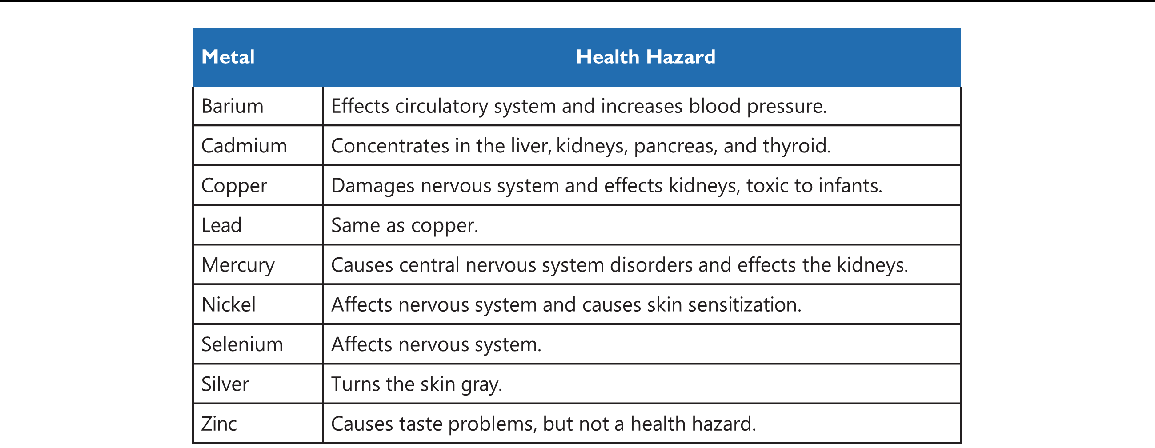

Figure 3.1: Metals in Drinking Water - Health Hazards

* Common metal anions and cations that combine to form salts which are commonly found in drinking water supplies or used in Water treatment are listed in the table below.

|  |  |  |  |  |  |
| --- | --- | --- | --- | --- | --- |
| METAL ION (CATION) | NON-METAL ION (ANION) | | | |  |
| Calcium - Ca+2 | Carbonate - CO3 | | −1 | −1 |  |
| Magnesium - Mg+2 | Bicarbonate - HCO3 | | |  |
| Manganese - Mn+2 | Hydroxide - OH−1 | | |  |  |
| Iron - Fe+2/+3 | Sulfate - SO4 | −2 |  |  |  |
| Aluminum - Al+3 | Chloride - Cl−1 | |  |  |  |

Sodium - Na+1

Copper - Cu+2/+3

Table 3.1: Salts constituents

3.2.3 Nutrients

* Plant nutrients - nitrogen and phosphorous, present in water promote growth of plant and algal matter in the receiving waters causing destruction of the normal aquatic life mainly due to oxygen depletion - eutrophication.
* Major sources of nitrogen include runoff from animal feedlots, fertilizer runoff from agri-cultural lands, municipal wastewater discharges, and certain bacteria and blue-green algae than can obtain nitrogen directly from the atmosphere In addition,certain forms of acid

rain can also contribute nitrogen to surface waters. Nitrogen in water is commonly found in the form of nitrate (NO3)

* Nitrate in drinking water can lead to serious problems, specifically nitrate poisoning which

can lead to death. Bacteria commonly found in the intestinal tract of infants can convert nitrate to highly toxic nitrites (NO2). Nitrite can replace oxygen in the bloodstream and result in oxygen starvation, which causes a bluish discoloration of the infant known as

|  |  |  |  |  |
| --- | --- | --- | --- | --- |
| 3.3 Trace Constituents | |  | 69 | |
|  |  |  |  |  |
|  |  |  |  |  |
|  | CHEMICAL NAME | FORMULA | COMMON NAME |  |
|  | Aluminum sulfate | Al2(SO4)3 | Alum |  |
|  | Calcium oxide | CaO | Quicklime |  |
|  | Calcium hydroxide | Ca(OH)2 | Slaked/hydrated lime |  |
|  | Calcium carbonate | CaCO3 | Limestone |  |
|  | Calcium hydroxide | Ca(OH)2 | Slaked/hydrated lime |  |
|  | Magnesium carbonate | Mg(CO3)2 |  |  |
|  | Magnesium bicarbonate | Mg(HCO3)2 |  |  |
|  | Sodium hydroxide | NaOH | Caustic soda |  |
|  | Sodium carbonate | Na2CO3 | Soda ash |  |
|  | Ferrous sulfate | FeSO4 | Copperas |  |
|  | Ferric chloride | FeCl3 |  |  |
|  | Ferrous chloride | FeCl2 |  |  |
|  | Copper sulfate | CuSO4 |  |  |

Table 3.2: Salts found in water and/or used in water treatment

Infant Methemoglobinemia or blue-baby syndrome .

* Major sources of phosphorous include phosphates in detergents, fertilizers and feedlot runoff, as well as municipal wastewater discharges.
* Phosphate is added as part of the water treatment for corrosion control and for improving taste and odor by sequestering iron and magnesium.

3.3 Trace Constituents

* Trace Constituents are chemicals found in extremely low concentrations.
* Trace constituents include:

– B - Boron

– Miscellaneous metals

– Hormones

– EDCs - Endocrine-disrupting compounds are synthetic and natural compounds that mimic, block, stimulate, or inhibit natural hormones in the endocrine systems of animals, including humans. The origins include pesticides, pharmceutically active chemicals (PhACs), personal care products (PCPs), herbicides, industrial chemicals, and disinfection byproducts (DBPs).

– PCPs - Personal Care Products are products such as shampoo, hair conditioner, de-odorants, and body lotion.

– Pharmaceuticals - aspirin, ibuprofen, caffeine, etc.

– CECs - Constituents of Emerging Concern is a general term applied to constituents that have relatively recently become known as a potential concern and likely have little to no information available to fully comprehend and establish safe and realistic

70 Chapter 3. Water Quality & Laboratory Procedures

standards, such as PFAS/PFOA.

3.4 Radionuclides

* Radioactive materials, also called radionuclides, are both naturally occurring and human-made.
* Radionuclides such as radium, radon and uranium can get into groundwater and surface waters from natural sources and also potentially from human sources such as active nuclear power plants or other facilities that make or use radioactive substances.
* When radionuclides break down (decay), they emit radioactive particles such as alpha-particles, beta-particles and gamma-rays radiation which could present a risk to human health.
* Most water systems have no detectable radionuclide activities, some areas of the United States have significantly higher levels than the national averages.
* People who are exposed to relatively high levels of radionuclides in drinking water for long periods may develop serious health problems, such as cancer, anemia, osteoporosis, cataracts, bone growths, kidney disease, liver disease and impaired immune systems.
* The health risks associated with radionuclides are normally small compared with the risks from microorganisms and chemicals that may be present in drinking-water.
* The amount of radionuclides in drinking water is quantified and regulated under the EPA’s Radionuclide Rule, by standards based upon both, the radioactivity levels as measured by the radiation of alpha and beta particles and the amount of commonly found radioactive elements - radium and uranium, quantified in terms of their radioactivity.
* For drinking water, radiation/radioactivity levels is measured as pCi/L (picocuries per liter)

3.5 Microbial contaminants

* Many types of pathogenic - disease-causing germs can be found in contaminated drinking water, including bacteria, viruses and parasites.
* Common virus in drinking water source and their associated diseases include:

– Adenoviruses - tonsillitis, conjunctivitis, the common cold and other illnesses.

– Reoviruses - colds, flu, diarrhea, chicken pox, measles and mumps.

– polioviruses - polio

– hepatitis A virus

* Some of the water borne pathogenic bacteria and their associated disease include:

– Salmonella typhi - Typhoid fever

– Vibrio cholerae - cholera

– Yersinia enterocolitica - gastroenteritis

* Common intestinal parasites and their associated disease include :

– Entamoeba histolytica - Amoebic Dysentery.

– Giardial lamblia (Giardiasis) .

|  |  |
| --- | --- |
| 3.6 Physicochemical tests | 71 |
|  |  |

– Ascaris lumbricoides (Giant Roundworm).

– Cryptosporidium (Cryptosporidiosis) .

3.6 Physicochemical tests

* The aesthetic quality aspects of drinking water include: taste, odor, color, turbidity, hard-ness, and temperature.
* The aesthetics are generally not health-related. However, consumers can easily detect them, so they can have significant effects on perceptions of water quality and acceptability.
* These attributes are the source of most complaints to water suppliers and frequently lead consumers to choose home treatment or bottled water.

3.6.1 Turbidity

* Measures cloudiness of water due to suspended particles.
* Higher turbidity levels are often associated with higher levels of disease-causing microor-ganisms.
* Turbidity affects both the acceptability of water to consumers
* Harmful pollutants such as heavy metals and pesticides are easily absorbed by suspended solids
* Turbidity affects disinfection as suspended particles in water act as a protective shield for micro-organisms and provide an excellent substrate for bacteria growth. Higher disinfec-tion doses or contact times are required to ensure adequate treatment.
* Suspended solids represent a risk for the main water distribution systems, pumps and other equipment where tend to deposit and block pipes and nozzles.
* Turbidity is an optical measurement of water’s ability to scatter and absorb light rather than transmit it in straight lines. It is commonly measured in the unit of Nephelometric Turbidity Units (NTU).
* "Crystal-clear” water has a turbidity of <1 NTU; at 4 NTU and above, water becomes visibly cloudy at 25 NTU it is murky.
* An average person is able to see turbidity with the naked eye at NTU level of 5 and above.
* Sources of turbidity:
  1. In source water, turbidity can be attributed to:

– Inorganic particles released by weathering of rocks, soils and clays

– Human, livestock and industrial wastes

– Biological growth (e.g. algae, zooplankton and cyanobacteria) in source waters

– Natural organic matter including decomposing plant material

* 1. Introduction of turbidity during treatment can be due to:

– Poor control of treatment chemical dosing (e.g. coagulants, settling aids and pH adjustment chemicals)

– Precipitates from insoluble components of treatment chemicals, or formed dur-

72 Chapter 3. Water Quality & Laboratory Procedures

ing processes such as pH correction

– Oxidation products of natural chemicals such as arsenic, iron and manganese

* 1. Turbidity can also be introduced in the distribution system by:

– Intrusion of soils and sewage through mains breaks

– External contamination from backflow or cross connections

– Resuspension of accumulated silts and sediments, or detachment of corrosion chemicals and scales and detachment of biofilms

* Formazin - a chemical, is used for preparing solutions of known turbidities.

3.6.2 Color

* Color may affect the turbidity value but is distinct from turbidity as color is due to or-ganic material that has dissolved into solution, while turbidity consists of tiny particles suspended in the water column.

3.6.3 Taste and odor

* Odor and taste are useful indicators of water quality even though odor and taste-free water is not necessarily safe to drink nor water with some odors or taste is necessarily harmful.
* Taste and odors are often grouped with odor because of their common origin factors.
* The cause of taste and odor issues can be from water fixtures, plumbing materials, water heaters, water treatment, pressure tanks and/or the source (the well).
* Taste and odors are generally attributed to the presence of organic and some inorganic chemicals which come from the decaying organic matter, runoffs, industrial wastes, and municipal sewage discharges.
* Geosmin and methyl-isoborneol (MIB) are often the cause of earthy-musty odors occuring in fall due to the turnover of lakes and reservoirs. They are produced by bacteria, particu-larly actinomycetes and cause odor issues at a very low concentrations.
* In the groundwater, the tastes and odors can be due to iron, manganese, and hydrogen sulfide (H2S).
* Often, identifying the exact origin of taste and odor is usually very expensive and often impossible, and removal of the causative substance is even harder.
* Current methods of measuring taste and odor are still fairly subjective. Standards related to odor and taste: Chloride, Copper, Foaming Agents, Iron, Manganese pH, Sulfate, Thresh-old Odor Number (TON) which is the greatest dilution of a sample with odor-free water that still yields a just-detectable odor.

3.6.4 Temperature

* Temperature affects the solubility of oxygen in water, the rate of bacterial activity, and the rate at which gases are transferred to and from the water.
* Cool water is generally more palatable than warm water, and temperature will have an impact on the acceptability of a number of other inorganic constituents and chemical

|  |  |
| --- | --- |
| 3.6 Physicochemical tests | 73 |
|  |  |

contaminants that may affect taste.

* High water temperature enhances the growth of microorganisms and may increase prob-lems related to taste, odor, color and corrosion.
* Water temperature determines, in part, how efficiently certain water treatment processes operate. For example, temperature has an effect on the rate at which chemicals dissolve and react. When water is cold, more chemicals are required for efficient coagulation and flocculation to take place. When water temperature is high, the result may be a higher chlorine demand because of the increased reactivity, as well as an increased level of algae and other organic matter in raw water.
* Heat is added to surface and groundwater from natural and man-made sources. Surface waters in particular are potentially subject to great temperature variations.
* Other sources of increased temperatures in running water result from forest clearing and return of irrigation flows to a body of running water.

3.6.5 Total dissolved solids

* Total dissolved solids (TDS) is a part of total solids (TS) in water and are the material remaining in water after filtration.
* Components of water TDS include:

– Minerals from rocks and soil as water passes over and through them.

– Pesticides and herbicides from agricultural runoff

– Lead and copper from plumbing pipes

– Chemicals added during water treatment

– Human and animal wastes

– Biological decay products

* Water has an equilibrium state with respect to dissolved portion; thus, if water is under saturated, it will aggressively dissolve materials it comes into contact with. Because of this problem, certain soluble substances, typically calcium and magnesium based sub-stances are added post water treatment to minimize its corrosivity effects in the distribution system.
* Dissolved solids can be removed from water by distillation, electro-dialysis, reverse osmo-sis, or ion exchange.
* TDS is measured in mg/L or ppm.
* As water will conduct electricity due to the presence of dissolved inorganic ions, higher the concentration of these ions, the higher is the conductivity. Thus, specific conductance - conductivity measurement, provides a good estimate of the water’s TDS.
* The terms “specific conductance,” “specific electrical conductance,” and “electrical con-ductivity” are used interchangeably and its unit of measurement is in siemens per centime-ter (S/cm) or mhos per centimeter (mhos/cm).
* The TDS concentration is considered a Secondary Drinking Water Standard, which means that it is not a health hazard.

74 Chapter 3. Water Quality & Laboratory Procedures

* EPA has established a Secondary Drinking Water Standard of a maximum concentration of 500 mg/l of TDS in drinking water and recommends treatment when TDS concentrations exceed 500 mg/L, or 500 parts per million (ppm).

3.6.6 Alkalinity

* Alkalinity is a measure of the ability of water to neutralize acid, or an expression of its buffering capacity.
* Constituents of alkalinity are: Bicarbonate – HCO3, Carbonate - CO3 , Hydroxide - OH−
* Measured in equivalent of mg/L CaCO3
* Alkalinity levels can be classified as:

– Low Alkalinity - < 20 mg CaCO3/L

– Moderate Alkalinity - 20 to 160 mg CaCO3/L

– High Alkalinity - > 160 mg CaCO3/L

* High alkalinity indicates the scaling (deposit forming) potential and salty taste
* Low alkalinity implies undersaturation of water (absence of dissolved content) and thus would exhibit higher corrosion potential - tendency to dissolve metals.
* Alkalinity originates naturally as water moves through rocks dissolving minerals.
* Alkalinity is important for fish and aquatic life because it protects or buffers against rapid pH changes. In addition, alkalinity levels affect the efficiency of certain water treatment processes, especially the coagulation process.

3.6.7 Hardness

* Hardness is due to the presence of multivalent metal ions, which come from minerals dissolved in water. The dissolution of these minerals is aided by the carbonic acid formed by the dissolution of naturally occuring carbon dioxide in water.
* Domestic use of hard water is marked by lack of foam formation with soap solutions due to the formation of a white precipitate (soap scum) instead of producing lather and formation of noticeable limescale in kettles and water heaters.
* Calcium (Ca) and Magnesium (Mg) are the two metals that dissolve the most easily in water. They are considered to be the main cause of hardness.
* Hardness causing compounds are broken into two groups:

– Carbonate hardness or temporary hardness which is the hardness that can be removed

by boiling water.

* Carbonate hardness is formed when calcium or magnesium combines with a form of alkalinity (carbonate, bicarbonates, or hydroxides.)

– Non-carbonate hardness cannot be removed by boiling water.

* + Non-carbonate hardness is formed when calcium and magnesium combine with anything other than alkalinity. Chlorides and sulfates are the two most common forms of non-carbonate hardness.
* Hard water when used in industrial applications forms deposits - scale composed mainly

|  |  |
| --- | --- |
| 3.6 Physicochemical tests | 75 |
|  |  |

of calcium carbonate (CaCO3), magnesium hydroxide (Mg(OH)2), and calcium sulfate (CaSO4)on the inside surfaces of pipes and heat exchangers. The scale formed restricts the flow of water, heat transfer causing metal boiler components to overheat.

* Water hardness has not be found to cause adverse health effects in humans.
* Generally speaking, groundwaters are harder than surface waters. In freshwater, the pri-mary ions are calcium and magnesium; however, iron and manganese may also contribute.
* Hardness is classified as carbonate hardness or non carbonate hardness. Carbonate hard-ness is equal to alkalinity but a non-carbonate fraction may include nitrates and chlorides.
* Hardness values are expressed as an equivalent amount or equivalent weight of calcium carbonate.
* Water with a hardness of less than 50 ppm is soft. Above 200 ppm, domestic supplies are usually blended to reduce the hardness value.
* The grain per gallon is a unit of water hardness defined as 1 grain (64.8 milligrams) of calcium carbonate dissolved in 1 gallon of water. It translates into 17.1 parts per million (ppm).
* Hardness of water is determined by titrating with a standard solution of ethylene diamine tetra acetic acid (EDTA) which is a complexing agent .

Note: Alkalinity and hardness can be seen as two sides of the same coin. Typical minerals found in water include - CaCO3, Ca(HCO3)2, CaSO4, MgCO3, Mg(HCO3)2 - the cations of these min-erals - Ca+2 and Mg+2 contribute to hardness while the anions - CO−32,SO−42 HCO−3 contribute to the alkalinity. These dissolved minerals are measured as part of the TDS. Thus, in natural waters - TDS, alkalinity and hardness are typically correlated.

3.6.8 pH

pH is a measure of the hydrogen ion (H+) content or the acidity or basicity of a solution. pH impacts the chemical and microbiological elements of water treatment processes and thus pH measurement and control is critical.

* Pure water dissociates into equal concentration of hydrogen ions and hydroxide ions: H2O → H+ + OH−.
* The H+ are responsible for acidic properties and the OH− ions for the basic properties.
* pH is the inverse of H+ concentration; pH increases when the concentration of H+ de-creases relative to the concentration of OH-.
* pH scale ranges from 0 – 14. When the concentration of both H+ and OH− are equal, as in pure water, it is considered neutral and its pH is 7.0.
* If the pH of a sample solution is below 7.0, the sample is termed acidic and is alkaline or basic if its pH is above 7.0.
* Each change of 1 pH unit represents a 10 fold change in concentration. For example, a sample with a pH of 2.0 is 1000 times more acidic than a sample with a pH of 5.0.
* The affects of drinking water pH include:

– Taste and odor impacts.

76 Chapter 3. Water Quality & Laboratory Procedures

– Solubility and biological availability of chemical constituents such as nutrients - phosphorus, nitrogen, and carbon.

– Solubility and toxicity of heavy metals. Metals tend to be more toxic at lower pH because they are more soluble.

* pH is measured by an electrode that is sensitive only to H+ or using a pH strip which is essentially an adsorbent paper which is pre-impregnated with chemicals which change color under different H+ concentrations.
* It is important to measure pH at the same time as chlorine residual since the efficacy of disinfection with chlorine is highly pH-dependent; where the pH exceeds 8.0, disinfection is less effective. To check that the pH is in the optimal range for disinfection with chlorine (less than 8.0), simple tests may be conducted in the field using comparators such as that used for chlorine residual. With some chlorine comparators, it is possible to measure pH and chlorine residual simultaneously.
* Alternatively, portable pH electrodes and meters are available. If these are used in the laboratory, they must be calibrated against fresh pH standards at least daily; for field use, they should be calibrated immediately before each test. Results may be inaccurate if the water has a low buffering capacity.

3.6.9 Langelier Index

* The Langelier Index is an approximate indicator of the degree of saturation of calcium carbonate in water.
* It is calculated using the pH, alkalinity, calcium concentration, total dissolved solids, and water temperature of a water sample collected at the tap.
* The sign and magnitude of the Langelier index show the water’s tendency to form or dis-solve scale and thus to inhibit or encourage corrosion:

– A negative Langelier Index indicates calcium carbonate under-saturation and water will have a higher corrosion potential.

– Positive Langelier Index indicates calcium carbonate over-saturation and indicates scaling potential of that water.

– Water with a Langelier Index of close to zero, indicates water which is not corrosive nor scale forming.

* Langelier index can be utilized to identify the water supply systems’ leakage potential.

3.6.10 Chlorine Residual

* Chlorine in one form or another is the principal disinfecting agent employed.
* An important additional advantage over some other disinfectants is that chlorine leaves a disinfectant residual that assists in preventing recontamination during distribution, trans-port, and household storage of water.
* The absence of a chlorine residual in the distribution system may, in certain circumstances, indicate the possibility of post-treatment contamination.

|  |  |
| --- | --- |
| 3.6 Physicochemical tests | 77 |
|  |  |

* Three types of chlorine residual may be measured:
  1. Free chlorine - the most reactive form, which is the chlorine present as hypochlorite (OCl−), hypochlorous (HOCl) or a combination of the two.
  2. Combined chlorine - the less reactive but more persistent form, consisting of chlo-rine that is combined with ammonia, nitrogen, or nitrogenous compounds (chlo-ramines). This is the amount of chlorine that has reacted with nitrates and is unavail-able for disinfection.
  3. Total chlorine - which is the sum of the free and combined chlorine residuals.
* Free chlorine is unstable in aqueous solution, and the chlorine content of water samples may decrease rapidly, particularly at warm temperatures. Also, exposure to strong light or agitation will accelerate the rate of loss of free chlorine. Water samples should be analyzed for free chlorine immediately on sampling and not stored for later testing.
* DPD - N,N-diethyl-p-phenylenediamine , is a commonly used method of measuring the chlorine residual in water. DPD reacts directly with disinfectants (e.g. chlorine, chlo-ramines etc.) to produce a pink colored solution. The intensity of this colored solution is proportional to the concentration of disinfectant in the sample.
* Residual chlorine analysis of a water sample is preferably to be conducted immediately, but must be done within 15 minutes of sampling.
* Amperometric sensors are also used for chlorine measurements.
* Advantages of amperometric method include:

– Chemical reagents are not required

– Sensors are relatively free from interference from color, turbidity, and interference from iron, manganese, nitrate and chromates present in the sample.

3.6.11 Density

* Density is defined as the weight of a substance per a unit of its volume.
* Density is typically measured in units of lb/ft3, lb/gal, or mg/L.
* Density of water = 62.4 lb/ft3 or 8.34 lb/gal.

3.6.12 Specific Gravity

* Specific gravity is a relationship of the density of a particular liquid or solid to water.
* Specific gravity for any substance is calculated by dividing the weight of a certain volume of that substance to the weight of the same volume of water.
* A substance that is heavier than water will have a specific gravity greater than one and it will sink in water; if the specific gravity is less than one, it will float.
* Specific gravity has no units.
* Specific gravity of water = 1.0

|  |  |  |  |  |  |
| --- | --- | --- | --- | --- | --- |
| 78 | Chapter 3. Water Quality & Laboratory Procedures | | | |  |
|  |  |  |  |  |  |
|  |  |  |  |  |  |
|  | Substance | Density | Specific Gravity |  |
|  | Alum (8% @60°F) | 11.1 lbs/gal | 1.33 |  |  |
|  | Hydrogen peroxide (35%) | 9 lbs/gal | 1.13 |  |  |
|  | Concrete | 130 lbs/ft3 | 2.08 |  |  |
|  | Iron | 491 lbs/ft3 | 7.85 |  |  |

Table 3.3: Density and specific gravity examples

3.7 Microbial testing

* It is not practical to monitor for every pathogen that may potentially be present in drinking water source, thus an “indicator organism approach” to assess the microbiological quality of drinking water is adopted.
* “Coliform” bacteria-particularly Escherichia coli (better known as E. coli) are used as the indicator organims.
* These coliform bacteria originate from feces and indicate fecal contamination and thus serve as an indicator organisms for pathogens of wastewater origin
* They are also abundant, potentially less harmful, and easy to detect
* The methods for water bacteriological tests include: multiple-tube fermentation (MTF) technique, membrane filtration (MF), Presence - Absence Method, and quanti-tray testing.
* When using the MTF and MF methods, it is not possible to exactly quantify the number of bacteria present, a statistical based - Most Probable Number (MPN) approach is utilized

3.7.1 The Multiple-Tube Fermentation technique

Stage 1 Presumptive Test:

Step 1. Multiple-Tube Fermentation (MTF) technique involves adding three volumes – 10 ml, 1 ml and 0.1 ml of the sample, each to a set of five tubes containing Lauryl Tryp-tose broth and an inverted tube (Durham tube),

Step 2. The tubes are incubated for 24 hours and after incubation the tubes are checked for positive results. The Lauryl Tryptose broth produces color and/or turbidity change due to the growth of the target bacteria and the inverted tube collects the gas pro-duced by the bacterial respiration.

Stage 2 Confirmed Test:

Step 1. Each positive is innoculated into bacteria specific broth and observed for positive results after incubating the innoculated samples for 24 hours.

Step 2. The number of tubes showing bacterial growth are counted for each volume of sam-ple and using this information the concentrations of organisms in the original sample are established using Statistical Tables.

Stage 3 Completed Test:

Step 1. An innoculum from the Confirmed positive is streaked on agar plates and incubated Step 2. The colonies from the agar plate are innoculated on an agar slant and nutrient broth

and incubated.

Step 3. The above incubated samples are observed for positive results.

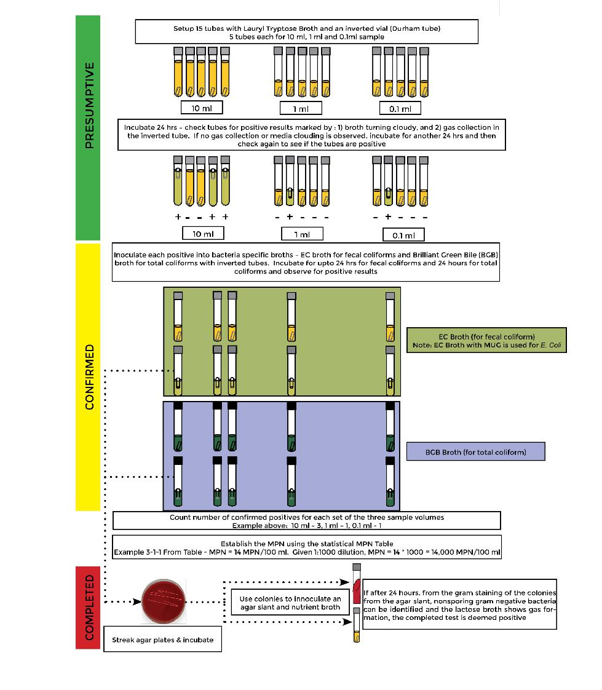

Figure 3.2: Multiple Tube Fermentation

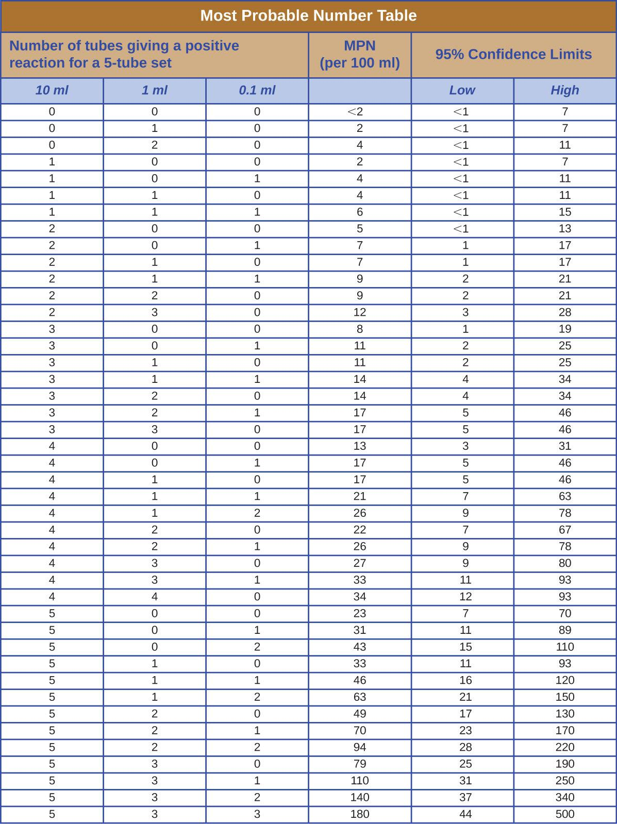

|  |  |
| --- | --- |
| 3.7 Microbial testing | 81 |
|  |  |

3.7.2 Presence - Absence (P-A) Method

* Presence - Absence Method below is to assess the presence or absence of bacteria as re-quired by the Revised Total Coliform Rule.
* The Presence - Absence (P-A) Method for total coliform is based on two premises:
  + 1. No coliform bacteria should be present in 100 mL of drinking water, and
    2. If one viable cell is present it will multiply to give a population of cells that will ferment lactose to produce acid and gas.
* P-A Method is a simple modification of the multiple tube (MPN) method. P-A broth con-tains lactose and a pH indicator, which will change from purple to yellow if lactose is fermented and acid is produced. To this P-A broth, the compound MUG has been added. This initially colorless compound can be hydrolyzed by the E. coli to form a compound that fluoresces under long UV light (336 nm). Observing for fluorescence emission using a long-wave (e.g., 365 nm) UV lamp is a sensitive way to confirm the presence of E. coli in water samples.
* The procedure involves addition of 100 ml of sample to 50 ml of sterile P-A broth and

then incubating the inoculated broth at 35◦C and inspected after 24 and 48 hours. Upon incubation, a positive result is indicated by the formation of a distinct yellow coloration of the media and/or gas formation which is indicated by foaming of the media upon gentle shaking of the bottle.

* Besides the P-A broth, the Colilert test enzymes (used in the above Quanti-Tray test) can be used to test for the Presence-Absence of coliforms. The colilert enzyme is added to

100 ml water sample in a sterile, non-fluorescing vessel and incubated at 35◦C for 24 h. The results are read at 24 h (before 28 h) and compared against the comparator. If no yellow color, the test is negative, If the sample has a yellow color equal to or greater than the comparator, the presence of total coliforms is confirmed. If yellow, check for blue fluorescence by placing a 6W, 365 nm UV light within 5 inches of the sample. If blue fluorescence is greater or equal to the fluorescence of the comparator the presence of E. coli is confirmed.

3.7.3 Heterotrophic Plate Count (HPC)

* HPC test - also known as Standard Plate Count is used to measure the overall bacteriologi-cal quality of drinking water.
* It measures colony formation of heterotrophic bacteria present on culture media. HPC testing indicates the culturable organisms present, which could be as low as 1% of the total bacteria present.
* Heterotrophs are a group of microorganisms including bacteria, molds and yeasts, that use organic carbon sources to grow and can be found in all types of water. Majority of bacteria found in drinking water systems are considered heterotrophs.
* As all heterotrophic organisms are not pathogens and all pathogens are not heterotrophic,

82 Chapter 3. Water Quality & Laboratory Procedures

HPC results are not an indicator of water safety.

* There is no maximum acceptable concentration of HPC in drinking water. However, in-creases in HPC concentrations above baseline levels are considered undesirable.
* High HPC counts indicate ideal conditions for bacterial regrowth and should be corrected. Bacterial regrowth can lead to pipe corrosion, encourage slime growth, increase the need for disinfectants, cause foul-tasting water, and harbor secondary respiratory pathogens (ex. Legionella). Thus, HPC can be used as a marker for the underlying causes of some aesthetic problems
* Methods used for routine testing of heterotrophic bacteria are
  1. Pour plate method: In this method, the liquid sample is poured into the petri dish before the solidification of the agar medium. After solidification, colonies grow both inside and on the surface of the medium.
  2. Spread plate method : Here the water sample is spread evenly over the surface of an agar plate medium. A successful spread plate will have a countable number of isolated bacterial colonies evenly distributed on the plate.
  3. Membrane filtration method : This test uses a membrane filter is used to capture the bacteria as the water sample is filtered through it. The filter is placed on an ab-sorbent pad (in a petri dish) saturated with a culture medium suitable for heterotrophe growth.

3.7.4 Other Coliform quantification tests

Membrane Filtration Method Membrane filtration (MF) is a faster way to estimate bacterial populations in water. In this method, an appropriate sample volume is passed through a mem-brane filter with a pore size small enough (0.45 micron) to retain the bacteria present. The filter is placed on an absorbent pad (in a petri dish) saturated with a culture medium that is selective for coliform growth. The petri dish containing the filter and pad is incubated, upside down, for 24 hours at the appropriate temperature. After incubation, the colonies that have grown are iden-tified and counted using a low power microscope. A MUG medium is used for E- Coli. If E. Coli is present, it will make the MUG fluorescent when viewed in UV light.

Quanti-trays tests

This test used for the detection and quantification of specific microorganisms is being used in-creasingly mainly because it is a quicker test than the MTF. Colilert and Enterolert are the quanti tray based tests for E. Coli and Enterococcus. This method involve the use of specific enzymes and overcomes the drawbacks of the MTF which include false positives and negatives due to the more generic nature of the media used.

3.8 Sampling

* Field or laboratory measurement of a certain parameter is critical in water treatment and distribution operations to obtain information about characteristics of water.

|  |  |
| --- | --- |
| 3.8 Sampling | 83 |
|  |  |

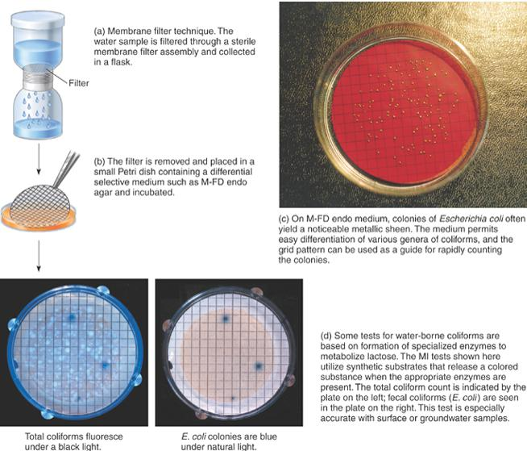

Figure 3.3: Multiple Tube Fermentation

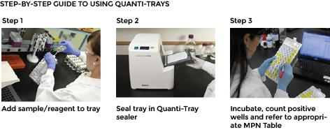

Figure 3.4: Quanti-trays test

* A sample is a small part of the whole representing the whole. Thus, a sample needs to be such that it truly represents the entire population – which could be either a treatment process stream or what is provided to the end user.

84 Chapter 3. Water Quality & Laboratory Procedures

* As not all water is analyzed, a sample obtained for analysis must “represent” varying:

– Locations: Locations should be representative of the majority of their portion of the Distribution System. Unusual locations should be avoided, as they are not indicative of the system as a whole. Such locations are often monitored, but not as part of the routine plan.

– Time periods: Time period samples include:

* Grab: Sample taken in a single moment of time.
* Composite: Several portions collected over time and/or space.
* Continuous

3.8.1 Sampling methods

Grab samples

* A grab sample is a sample collected at a specific spot at a site over a short period of time.
* Grab sampling allows for instantaneous analysis of parameters such as pH, dissolved oxygen, chlorine residual, temperature and other parameters which change rapidly with time.
* A grab sample represents a snapshot of space and time of a process stream.

Composite Samples

* A composite sample is a collection of discrete samples are combined over a certain period or space and therefore represent the average performance of a treatment plant or a process during the collection period.
* Composite sampling can be either based on:
  1. constant time interval (time proportioned sampling)
     1. constant volume interval (flow-proportioned sampling), and
     2. treatment process space - includes samples taken at different depths
* Composite samples are typically collected using automated samplers which can be pro-grammed to collect samples at preset time intervals – for time proportional sampling.
* Time and space composite samples are collected by adding equal volumes of samples collected from different times or locations.
* Flow proportional composite samples comprise of volume of each subsample based on flow.

3.8.2 Sampling Precautions and Protocols

* Samples should represent the major portion of the process or the process stream and should be taken from places where the mixing is thorough, avoiding dead spots and ar-eas of heavier or lighter loadings.
* The collected sample is invariably exposed to conditions very different from the original source and is subject to change due to chemical and microbiological activity.
* Thus, in order to ensure integrity of sample, sample preservation techniques specific to the

|  |  |
| --- | --- |
| 3.8 Sampling | 85 |
|  |  |

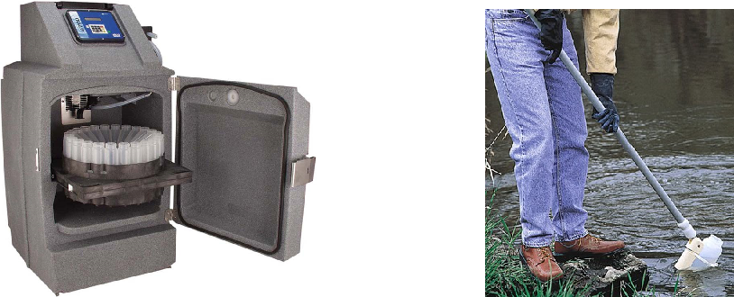

Automated Sampler Grab Sampling Using a Long Handle Dipper

analysis to be performed is needed.

– The preservation technique should not only allow for stabilizing the parameter to be analyzed, it should also not interfere with the analyses.

– The common preservation techniques involve use of proper containers, temperature control, addition of chemical preservatives, and observance of the recommended maximum sample holding time.

* Samples cannot be held indefinitely prior to lab analysis
* Labs must be approved by ELAP: Environmental Laboratory Accreditation Program Labs must use Standard Methods
* Chain-of-Custody ensures sample integrity from collection to data reporting Important for sample control when litigation is involved Must be under a person’s physical possession, within sight, or secured in a restricted area Receipt and logging of sample at lab Complete documentation from collection to report
* Sample Containers:

– Typically plastic or glass

– Use proper material for analysis

– Use glass for all organic and odor analyses

– Use plastic for metals

– Bacteriological sample containers must be sterile

3.8.3 Microbial sampling

* Always collected as a grab.
* The sample is obtained from a steady, pencil-width stream from a cold water fixture, only after it has been in a wide open setting and water to run a minimum of five minutes to flush out the bacteria from the surface.
* A clean, sterile borosilicate glass or plastic bottle containing sodium thiosulfate is used. Sodium thiosulfate is added to remove residual chlorine which will kill the microorgan-isms during transit. If the sample is not preserved or maintained under proper conditions until the test is conducted in the laboratory, the test would provide erroneous results
* Samples must be refrigerated if they cannot be analyzed within 1 hour of collection

86 Chapter 3. Water Quality & Laboratory Procedures

* Samples must be handled with care to prevent contamination and adverse conditions such as prolonged exposure to direct sunlight
* Maximum holding time for state or federal permit reporting purposes is 6 hours
* Number of samples collected depends on number of customers served/and is according to the approved sample siting plan.
* The volume for coliform compliance sample must be at least 100ml and no more than 120ml.
* Sealed and sterilized sampling bottles - typically, 120 ml with 100 ml marked to provide space for air is used.
* Sodium thiosulfate or some other de-chlorinator is pre-added to the sampling bottle. A dechlorinator is critical to ensure any chlorine residual is removed from the sample col-lected.
* The faucet is opened to obtain a continuous flow of the size of a pencil, the faucet should not be opened under a strong flow as that could potentially dislodge loose particles/slime growth in the mains.
* When the cap is opened to collect the sample, care needs to be taken to ensure the cap is not contaminated.
* Fill the bottle to the marked fill-line leaving an air gap - do not overfill.
* The capped bottle should be placed in an iced container and transported to the laboratory as soon as possible.
* Follow chain of custody and send the bottles to the lab with paperwork.
* In the laboratory, the samples must be kept at 4◦C or 39◦F and must be analyzed preferably within 8 hours and never to exceeding 24 hours.
* The analytical results shall be reported in terms of the presence or absence of total col-iforms and E. coli, in the sample, whichever is appropriate.
* Monthly sampling results must be submitted to the regulatory agency per established scheduled.
* Records of bacteriological sampling must be kept for five years.
* Repeat sampling: If the result is positive a minimum three samples need to be taken, one from the original point, one up-stream and one from downstream of the original sample collection site within 24 hours after the result notification from the laboratory.
* False positive means that the sample when tested is found to be contaminated but actually the water is safe.
* False negative means samples are found to be safe; even though the water is - unsafe to drink. This can lead to outbreak of diseases and cause customers to lose confidence in their drinking water supplier. This harms the customer.

|  |  |
| --- | --- |
| 3.8 Sampling | 87 |
|  |  |

3.8.4 Summary of sampling requirements

|  |  |  |  |  |
| --- | --- | --- | --- | --- |
| Parameter | Container | Preservative | Holding Time |  |
| Coliform, total or fecal, | Sterile container w/ | Cool to <10 °C. Do not | 8 hrs for source |  |
| in chlorinated water | thiosulfate |  |
| freeze | water compliance |  |
|  |  |  |
|  |  |  | and 30 hours for |  |
|  |  |  | drinking water |  |
|  |  |  |  |  |
| Giardia and Cryptosporid- | 10 L plastic con- | Cool to <10 °C . Do not | 96 hours |  |
| ium | tainer | freeze |  |  |
|  |  |  |  |  |
| Alkalinity, turbidity, | Plastic or Glass | Cool to < 4 °C | Method dependent |  |
| solids , fluoride |  |  |  |  |
|  |  |  |  |  |
| Metals, general | Plastic or Glass, | Nitric acid to pH <2 | 6 Months |  |
|  | Rinsed w/ 1:1 |  |  |  |
|  | HNO3 |  |  |  |
| Hardness | Plastic or Glass | Nitric acid to pH <2 | 6 Months |  |
| pH | Plastic or Glass | None | Analyze in 15 min |  |
| Nitrogen and phospho- | Plastic or Glass | Sulfuric acid to pH<2 | 28 days |  |
| rous compounds |  |  |  |  |
|  |  |  |  |  |
| VOCs, TTHMs | Glass bottle | Sodium thiosulfate or | 14 days |  |
|  |  | ascorbic acid if sample |  |  |
|  |  | is chlorinated and hy- |  |  |
|  |  | drochloric acid (HCl) to |  |  |
|  |  | pH <2 and cool to <4 °C |  |  |
|  |  | but do not freeze |  |  |
|  |  |  |  |  |

Table 3.4: Summary of sampling requirements for key parameters



Chapter 3 Assessment

Chapter 3 Assessment

1. Hard water contains an abundance of
   1. sodium
   2. iron
   3. lead
   4. calcium carbonate
2. A specific class of bacteria that only inhibit the intestines of warm-blooded animals is referred to as?
   1. Eutrophic
   2. Grazing
   3. Salmonella
   4. Fecal coliform
   5. pathogenic
3. Water with a pH of 8.0 is considered to be
   1. acidic
   2. basic or alkaline
   3. neutral
   4. undrinkable
4. Over which water quality indicator do operators have the greatest control?
   1. alkalinity
   2. pH
   3. temperature

90 Chapter 3. Water Quality & Laboratory Procedures

* 1. turbidity

1. Which piece of laboratory equipment is used to titrate a chemical reagent?
   1. graduated cylinder
   2. burette
   3. pipet
   4. Buchner funnel
2. Which pH range is generally accepted as most palatable (drinkable)?
   1. 6.5 to 8.5
   2. 4.5 to 6.5
   3. 8.5 to 9.5
   4. 9.5 and above
   5. all of the above
3. Which of the following conditions is favorable for the rapid growth of algae?
   1. plant nutrients
   2. high pH and water hardness
   3. low temperatures and low dissolved oxygen
   4. high alkalinity and water hardness
4. Which of the following is the name given for a turbidity meter that has reflected or scat-tered light off suspended particles as a measurement?
   1. Hach colorimeter
   2. spectrophotometer
   3. Wheaton bridge
   4. Nephelometer
5. Water hardness is the measure of the concentrations of and dissolved in the water sample.
   1. iron, manganese
   2. nitrates, nitrites
   3. sulfates, bicarbonates
   4. calcium & magnesium carbonates
   5. ferric chlorides and polymers
6. The electrical potential required to transfer electrons from one compound or element to another is commonly referred to as
   1. oxidation-reduction potential (ORP)
   2. voltage potential (OHM/P)
   3. resistance-impedance potential
   4. microMho differential
7. Water has physical, chemical, and biological characteristics. Which of the following is a physical characteristic?
   1. Coliform
   2. Turbidity
   3. Hardness

|  |  |
| --- | --- |
| 3.8 Sampling | 91 |
|  |  |

d. All the above

1. Tastes and odors in surface water are most often caused by:
   1. clays
   2. hardness
   3. algae
   4. coliform bacteria
2. Which of the following elements cause hardness in water?
   1. sodium and potassium
   2. calcium and magnesium
   3. iron and manganese
   4. turbidity and suspended solids
3. When measuring for free chlorine residual, which method is the quickest and simplest?
   1. DPD color comparator
   2. Orthotolidine method
   3. Amperometric titration
   4. 1, 2 nitrotoluene di-amine method

IV Chapter 4

4 Drinking Water Regulations . . . . . . . . . . . 95

4.1 Drinking Water Regulations

4.2 Surface Water Treatment Rules

4.3 Summary of Requirements under Surface Water

Treatment Rules

4.4 Total Coliform Rule

4.5 Ground Water Rules

4.6 Microbial and Disinfection Byproducts Rules

4.7 Other Drinking Water Rules

4.8 Recycled Water Regulations

4.9 State and Local Drinking Water Regulations



4. Drinking Water Regulations

Expected Range of Knowledge for Water Properties and Sources Water Distribution System Operator License Exams

|  |  |
| --- | --- |
| D1 | Ability to read a sample siting plan |
| D1 | Ability to take a lead and copper sample |
| D1 | Knowledge of acute violations |
| D1 | Knowledge of CDPH Water Quality regulations |
| D1 | Knowledge of the definition of MCL |
| D1 | Knowledge of the major components of the SDWA |
| D1 | Knowledge of the purpose of the SDWA |
| D1 | Knowledge of Total Coliform Rule reporting requirements |
| D1 | Knowledge of Total Coliform Rule sampling requirements |
| D1 | Knowledge of when public notification is required |
| D2 | Ability to differentiate between a primary and secondary MCL |
| D2 | Ability to recognize MCL violations |
| D2 | Knowledge of AWWA disinfection standards |
| D2 | Knowledge of Disinfection By-Product Rule sampling requirements |
| D2 | Knowledge of maximum disinfectant residual level for chlorine |
| D2 | Knowledge of reporting and recordkeeping requirements |
| D3 | Knowledge of the relationship between corrosion and lead/copper concentrations |
| D3 | Knowledge of Disinfection By-Product Rule MCL requirements |
| D3 | Knowledge of Disinfection By-Product Rule reporting requirements |
| D3 | Knowledge of lead and copper rule reporting requirements |
| D3 | Knowledge of lead and copper sampling requirements |
| D3 | Knowledge of public notification requirements |
| D3 | Ability to perform damage assessment and recovery planning |
| D3 | Ability to train personnel on emergency response procedures |
| D3 | Knowledge of non-compliance penalties |

96 Chapter 4. Drinking Water Regulations

Expected Range of Knowledge for Water Properties and Sources Water Distribution System Operator License Exams (Continued)

D4 Ability to recognize a lead and copper rule violation

D4 Knowledge of notification paths (e.g. newspaper, electronic)

D4 Knowledge of required language to use

D5 Knowledge of Air Quality Management regulations

Knowledge of O&M budget components (e.g. labor, professional services, supplies, energy,

D5

water, capital improvement)

D5 Knowledge of RWQCB discharge requirements

Knowledge of the components of a budget (e.g. revenues, expenditures, risk management, insur-

D5

ance costs, depreciation)

Water Treatment System Operator License Exams

T1 Knowledge of disinfection residual requirements

T1 Knowledge of MCLs and MRDLs of disinfectants

T1 Knowledge of drinking water monitoring and reporting requirements

T1 Knowledge of drinking water regulations

T1 Knowledge of notification protocol and procedures

T1 Knowledge of NSF Standards

T1 Knowledge of operator certification requirements

T1 Knowledge of Primary and Secondary Drinking Water Standards

T1 Knowledge of public notification procedures

T1 Knowledge of record keeping requirements

T1 Knowledge of California Waterworks Standards

T1 Knowledge of the Consumer Confidence Report (CCR)

T1 Knowledge of the Disinfectants and Disinfection Byproduct Rule and amendments

T1 Knowledge of the Groundwater Rule

T1 Knowledge of the Lead and Copper Rule

T1 Knowledge of the Surface Water Treatment Rule and amendments

T1 Knowledge of the Total Coliform Rule and amendments

T1 Ability to research and interpret Maximum Contaminant Levels (MCLs)

T2 Knowledge of cryptosporidium action plan

T2 Knowledge of pending regulations

T2 Knowledge of performance standards and removal requirements for surface water treatment

T2 Knowledge of the Filter Backwash Rule

T2 Knowledge of routine sampling requirements

T3 Ability to administer a regulatory compliance program

T3 Knowledge of permit requirements for water operations

T3 Knowledge of pump to waste discharge environmental regulations

T3 Knowledge of regulatory primacy issues

T3 Knowledge of source water replenishment processes

T3 Knowledge of the Sanitary Survey process

T4 Knowledge of the role of Regional Boards in managing contamination sources

T4 Knowledge of the Source Water Assessment Program

T4 Knowledge of the Watershed Survey process

T4 Knowledge of the vulnerability assessment process

|  |  |
| --- | --- |
| 4.1 Drinking Water Regulations | 97 |
|  |  |

4.1 Drinking Water Regulations

* Drinking water sources which include surface and groundwater sources have inherent vulnerabilities to contamination and regulations have been established to protect public health and safety.
* Federal Safe Drinking Water Act (SDWA) enacted in 1974 established national enforce-able standards for drinking water quality and to guarantee that public water systems moni-tor water to ensure that it meets national standards.
* The SDWA prescribes enforceable primary standards for five major categories of drinking water contaminants consisting of Inorganic Chemicals, Organic Chemicals, Radionuclides, Microorganisms, Disinfectants and Disinfection Byproducts.
* The SDWA delegates responsibility for administering the provisions of the act to the US Environmental Protection Agency (USEPA) .
* The enforcement of SDWA requirements is delegated by the USEPA to individual states
* Individual states are provided the opportunity to set and enforce their own drinking water standards for public water systems if the standards are at a minimum as stringent as EPA’s national standards.
* A primacy agencyis the agency with primary responsibility for implementing the SDWA. Most states and the U.S. territories have been approved to exercise primary responsibility in their jurisdictions. Exceptions are the state of Wyoming and the District of Columbia, which are implemented by EPA.
* In the SDWA, a Public Water System is defined as a system that supplies piped water for human consumption and has at least 15 service connections or serves 25 or more persons for 60 or more days of the year.

Community Water System

A community water system is a public water system that has 15 or more service connections and is used by year-round residents or serves 25 or more residents year round. These include city, county, regulated utilities where people live.

Non-Community Water System

Non-community water system means a public water system that is not a community water system. These are systems with 15 or more connections used by travelers or intermittent users at least 60 days of a year or serves a daily average of at least 25 persons at least 60 days a year. A non-community water system can be either:

Transient Non-Community Water System

Include entities like rural gas stations and National parks that provide their own potable water source. Here most people that consume the water neither reside nor regularly spend time there.

OR

Non-Transient Non-Community Water System

98 Chapter 4. Drinking Water Regulations

Non-transient non-community water system means a public water system that is not a com-munity water system and that regularly serves at least 25 of the same persons over six months per year. These include places schools and businesses that provide their own water and the same people have a regular opportunity to consume the water, but do not reside there.

* Water systems operated by private homes, groups of fewer than 15 homes using the same well, and summer camps that operate for fewer than 60 days per year are not covered under the purview of the SDWA but are generally under some degree of supervision by a local, area, or state health department.
* Water treatment standards are set and enforced by the state’s nine regional water quality control boards in consultation with the California Department of Public Health. The nine regional boards are part of the State Water Board.

4.1.1 National Primary Drinking Water Regulations

* National Primary Drinking Water Regulations (NPDWR) is for contaminants – chemicals and microorganisms - found in drinking water and known to present adverse health effects to humans.
* The contaminants are divided into two groups based upon its effect on human health:
  1. : Acute - effects occur within hours or days of the time a person consumes a contami-nant
  2. Chronic - effects occur over the course of many years after people consume a con-taminant at levels over EPA’s safety standards.
* NPDWR are legally enforceable drinking water standards.
* The NPDWR standard can be either:
  1. Maximum Contaminant Levels (MCLs) - the maximum permissible level of a con-taminant in water which is delivered to any user of a public water system, or
  2. Treatment technique which is a drinking water treatment requirement typically used when setting an MCL would be too difficult or when compliance with an MCL would be too costly.
* Additionally, Maximum Contaminant Level Goal (MCLG) - the maximum level goal is set at a level where there are no known, or anticipated health effects. For suspected carcinogens and other similar contaminants, the MCLG is set at zero.
* Drinking water must be monitored to ensure that it meets all applicable MCLs. Recurring sampling every three-years is stipulated.
* The 90 Primary Contaminants identified by the EPA are grouped into three major cate-gories:
  1. Chemical contaminants

– Inorganic chemicals

* These contaminants are mostly heavy metals.
* They may enter the water supply naturally through ground water formations

|  |  |
| --- | --- |
| 4.1 Drinking Water Regulations | 99 |
|  |  |

or from mining runoff and industrial discharges.

* + - Nitrates are the only chemical contaminant that represent an immediate health risk. Pregnant mothers and infants under 18 months can develop infant methemoglobinemia, commonly known as “Blue Baby Syndrome”

. The presence of nitrates in the bloodstream reduces oxygen uptake that gives the skin a blue tint.

– Organic chemicals

* + - These contaminants include herbicides and insecticides that are primarily used in agriculture applications, organic solvents used in industrial applica-tions, organic by-products of industrial processes, and chemical by- prod-ucts from chlorination of drinking water.
    - Runoff from agricultural spraying or improper application techniques can be a major source of these contaminants in a surface water supply.
    - Industrial discharges, accidental spills and improper disposal of hazardous wastes can also become sources of contamination.
    - These compounds are grouped together under the headings of Volatile Or-ganic Compounds (VOCs) and Synthetic Organic Compounds (SOCs).
    - There are currently 21 regulated VOCs and 30 SOCs that must be analyzed.

– The chemical contaminants were promulgated in phases collectively called the Phase II/V Rules or the Chemical Contaminant Rules.

1. Radioactive chemicals

– Most radioactive substances occur naturally in ground water and in some surface supplies.

– Some man-made substances may also enter drinking water supplies from pro-cessing facilities, mining areas, and nuclear power plants.

1. Bacteriological contaminants

– The coliform group of bacteria represents the indicator organisms used in deter-mining bacteriological contamination. Their presence indicates the possibility that some pathogenic (disease causing) organisms may also be present.

– A public water system is in violation of the E. coli MCL when any of the follow-ing occurs:

(a) The system has an E. coli-positive repeat sample following a total coliform-positive routine sample;

(b) The system has a total coliform-positive repeat sample following an E. coli-positive routine sample;

(c) The system fails to take all required repeat samples following an E. coli-positive routine sample; or

(d) The system fails to test for E. coli when any repeat sample tests positive for total coliform.

– The MCL is exceeded when 5% of the required monthly routine (M/R) samples

100 Chapter 4. Drinking Water Regulations

indicate the presence of Coliform bacteria.

– The presence of coliform in any sample will require three repeat samples be taken. These repeat samples must be taken within 24 hrs of notification of posi-tive results.

* Turbidity - Measure of the cloudiness of water.

– Although turbidity does not represent a health risk by itself, it can shield harmful bacteria from disinfection processes.

– Turbidity is measured in Nephelometric Turbidity Units (NTU) .

– The device used to measure NTU’s is called a nephelometer or turbidimeter.

4.1.2 Secondary Drinking Water Regulations

* National Secondary Drinking Water Regulations (NSDWRs) (or secondary standards) are non-enforceable guidelines regulating contaminants that may cause cosmetic effects (such as skin or tooth discoloration) or aesthetic effects (such as taste, odor, or color) in drinking water.
* NSDWRs are recommended standards and water systems are not required to comply with the established standard. However, states may choose to adopt them as enforceable stan-dards.
* While secondary standards are not federally enforceable, EPA requires a special notice for exceedance of the fluoride secondary standard of 2.0 mg/L.

Summary of the contaminants in the primary and secondary standards is provided in Appendix F.

4.1.3 Unregulated Contaminant Monitoring Rule

* Unregulated Contaminant Monitoring Rule (UCMR) is established by the EPA to collect data for contaminants that are suspected to be present in drinking water and do not have health-based standards set under the SDWA.
* Data are collected through UCMR is to support the determination of whether to regulate particular contaminants in the interest of protecting public health.

4.1.4 Community Confidence Reports

Every public water system or community water supplier must provide an annual report, some-times called a Consumer Confidence Report (CCR), to its customers. The report provides infor-mation on local drinking water quality, including the water’s source, contaminants found in the water, and how consumers can help protect their drinking water

4.2 Surface Water Treatment Rules

* Surface Water Treatment Rules (SWTRs) are a suite of rules.
* SWTR applies to all public water systems (PWSs) using surface water sources or ground water sources under the direct influence of surface water (GWUDI)

|  |  |
| --- | --- |
| 4.2 Surface Water Treatment Rules | 101 |
|  |  |

* GWUDI is located close enough to nearby surface water to receive direct surface water recharge. Such groundwater source is considered at risk to certain contaminants which are not normally found in true ground waters, but are often found in surface waters.
* GWUDI is also called Subpart H systems.
* The purpose of SWTRs is to reduce illnesses caused by pathogens in drinking water. The disease-causing pathogens include Legionella, Giardia lamblia, and Cryptosporidium. The regulations also protect against contaminants that can form during drinking water treatment.
* The SWTRs requires water systems to filter and disinfect surface water sources. Some water systems are allowed to use disinfection only for surface water sources that meet criteria for water quality and watershed protection.
* SWTRs include the following rules:

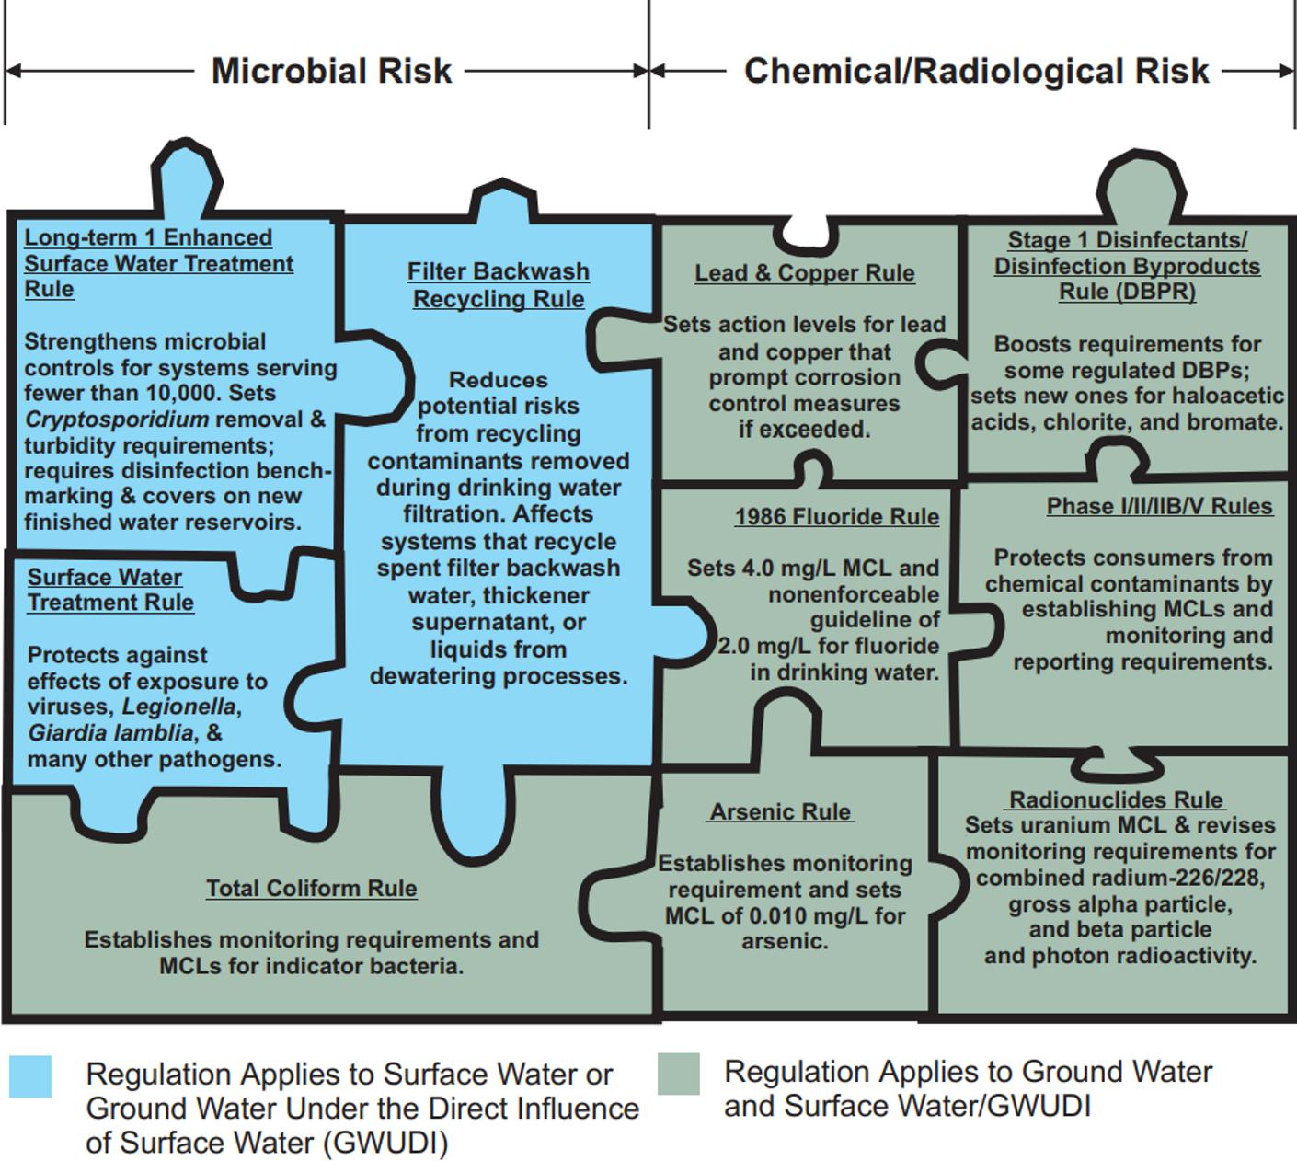

Figure 4.1: Summary of Water Regulations

4.2.1 Surface Water Treatment Rule

* Adopts a "Multiple Barriers" approach which relies on:

– Pathogen removal Requires systems to filter unless specific avoidance criteria is met

.

102 Chapter 4. Drinking Water Regulations

– Pathogen inactivation Requires all systems to disinfect.

* Awards "Credits" for both above.
* Requires most water systems to filter and disinfect water from surface water sources or

GWUDISW

* Establishes maximum contaminant level goals (MCLGs) for viruses, bacteria and Giardia lamblia
* Included treatment technique (TT) requirements for filtered and unfiltered systems to protect against adverse health effects of exposure to pathogens

4.2.2 Interim Enhanced Surface Water Treatment Rule

* The 1998 Interim Enhanced Surface Water Treatment Rule (IESWTR) increased the level of protection from exposure to Cryptosporidium and other pathogens in drinking water supplies through improvements in filtration at water systems, provided under the original SWTR.
* IESWTR applies to all public water systems using surface water, or GWUDI, that serve 10,000 or more persons
* The SWTR and the Interim ESWTR includes the following general requirements in order to minimize human exposure to microbial contaminants in drinking water:

4.2.3 Long-Term 1 Enhanced Surface Water Treatment Rule

* The Long-Term 1 Enhanced Surface Water Treatment Rule (LT1ESWTR) applies to all public water systems using surface water, or GWUDISW, serving fewer than 10,000 persons
* The LT1ESWTR builds upon the framework established for systems serving a population of 10,000 or more in the Interim Enhanced Surface Water Treatment Rule (IESWTR).
* While there are small differences between the LT1ESWTR and IESWTR, these differences reflect an effort to reduce burden for small systems while still maintaining a comparable level of health protection.

4.2.4 Long-Term 2 Enhanced Surface Water Treatment Rule

* The Long-Term 2 Enhanced Surface Water Treatment Rule (LT2ESWTR) applies to all PWSs that use surface water or GWUDISW
* Targets additional Cryptosporidium treatment requirements to higher risk systems
* Requires provisions to reduce risks from uncovered finished water storage facilities
* Provides provisions to ensure that systems maintain microbial protection as they take steps to reduce the formation of disinfection byproducts

4.3 Summary of Requirements under Surface Water Treatment Rules

• Utilities are required to achieve at least:

|  |  |
| --- | --- |
| 4.3 Summary of Requirements under Surface Water Treatment Rules | 103 |
|  |  |

– 99.9% removal and/or inactivation of Giardia lamblia cysts (3-log removal)

– Minimum 99.99% removal and/or inactivation of viruses (4-log removal)

– A 2-log removal of Cryptosporidium.

* Control of Cryptosporidium :

– The maximum contaminant level goal (MCLG) is set at zero.

– Filtered systems must physically remove 99% (2-log) of Cryptosporidium.

– Unfiltered systems must update their watershed control programs to minimize the potential for contamination by Cryptosporidium oocysts

* Removal credit:

– The level of removal credit given a utility for both Giardia lamblia and viruses is determined by the type of treatment process used.

– For a conventional water treatment plant the SWTR provides a 2.5-log removal credit for Giardia lamblia and a 2.0-log removal credit for viruses.

– water treatment plants meeting the turbidity performance standard of 0.3 NTU in 95% of the monthly measurements also get credit for a 2-log reduction in Cryp-tosporidium.

* Disinfection credit:

– Disinfection during conventional treatment (assuming all operational criteria and performance standards are met), must achieve 0.5-log inactivation of Giardia lamblia and 2.0-log inactivation of viruses.

– As a substitute to actually measuring the inactivation of Giardia lamblia and viruses achieved at a treatment plant, the SWTR established the concept of CT to evaluate inactivation. CT is the product of the concentration of disinfectant remaining at the end of a treatment process (“C” in milligrams per liter) and the contact time in which 10% of the water passes through the treatment process (“T” or “T10” in minutes). The SWTR provides tables which identify the log removal of both Giardia lamblia and viruses achieved for a calculated CT value based on the type of disinfectant, the water temperature, and pH.

* Turbidity monitoring requirements include:

– For treatment plants using conventional treatment or direct filtration, a turbidity per-formance standard for the combined filter effluent (CFE) of 1 NTU as a maximum, and 0.3 NTU as a maximum in 95 percent of monthly measurements, based on 4-hour monitoring.

– Continuous monitoring of individual filter effluent (IFE) turbidity in conventional and direct filtration plants and recording of IFE turbidity readings every 15 minutes.

* Reporting and recordkeeping requirements include :

– PWSs must report turbidity measurements related to CFE monitoring to the state within 10 days after the end of each month the PWS serves water to the public.

104 Chapter 4. Drinking Water Regulations

– PWSs must keep CFE turbidity monitoring records and any other turbidity analyses, with the exception of IFE monitoring records, for at least 5 years.

– PWSs must keep records from IFE turbidity monitoring for at least 3 years.

* If a system meets the turbidity performance standard of 0.3 NTU in 95% of the samples taken each month (never to exceed 1 NTU) than the system gets credit for achieving the 2-log reduction in Cryptosporidium.
* PWSs using alternative filtration techniques [defined as filtration other than conventional, direct, slow sand, or diatomaceous earth (DE)] must demonstrate to the state the ability to consistently achieve 2-log removal of Cryptosporidium and comply with specific state-established CFE turbidity requirements.
* The required level of removal/inactivation must occur between the point where the raw water is not longer subject to surface water runoff and the point at which the first customer is served.
* The disinfectant residual entering the distribution system must not fall below 0.2 mg/L for more than 4 hr during any 24- hr period.
* A disinfectant residual must be detectable in 95% of distribution system samples. A het-erotrophic plate count (HPC) concentration of less than 500 colonies per milliliter can serve as a detectable residual if no residual is measured.
* Each utility must perform a watershed sanitary survey at least every 5 years.

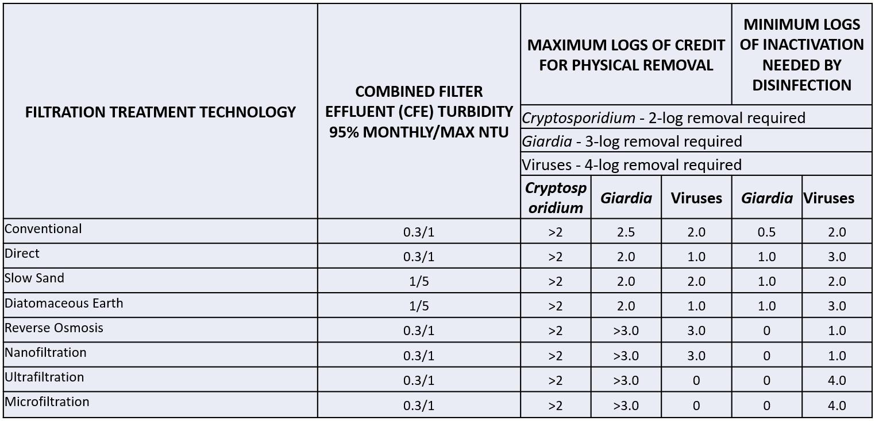

Figure 4.2: SWTR Auto Removal Credits

|  |  |  |  |  |  |  |
| --- | --- | --- | --- | --- | --- | --- |
| TCR/ Nitrate/Nitrite | | CWS | NTNCWS |  | TNCWS |  |
| Sanitary Survey | | Every 3 years | Every 5 years |  | Every 5 years |  |
| Total Coliform Bacteria1 | | Monthly | Monthly |  | Monthly |  |
| Nitrate (NO3) | | Quarterly2 | Quarterly2 |  | Annually |  |
| Nitrite (NO2) | | 1 sample record | 1 sample record |  | 1 sample record |  |
| Reporting | | CWS | NTNCWS |  | TNCWS |  |
|  |  | Continuous or grab samples | Continuous or grab samples |  | Continuous or grab samples |  |
| Turbidity | | (Frequency determined by | population and filtration type.) |  |  |  |
| Fluoride – if added | | Daily | Daily |  |  |  |
| Entry Point Chlorine – if chlorine is added | | Continuous or grab samples | Continuous or grab samples |  | Continuous or grab samples |  |
| (Pop determines how many times a day chlorine is measured.) | | |  |  |
|  |  |  |  |
| Distribution System Chlorine3 | | Monthly | Monthly |  | Monthly |  |
| Consumer Confidence Report | | Annually | Annually |  |  |  |
| Disinfection/Disinfectant Byproducts | | CWS | NTNCWS |  | TNCWS |  |
|  | Pop <500 | Annually | Annually |  | Annually |  |
| Total Trihalomethanes (TTHM/HAA5) | Pop 500 - 9,999 | Quarterly | Quarterly |  | Quarterly |  |
|  | Pop 10,000 | Quarterly | Quarterly |  | Quarterly |  |
| TOC and Alkalinity |  | Monthly2 | Monthly2 |  |  |  |
| Bromate (Ozone plants only) | | Monthly | Monthly |  |  |  |
| Inorganic Chemicals | | CWS | NTNCWS |  | TNCWS |  |
| All Primary | | Annually | Annually |  |  |  |
| Arsenic | | Annually | Annually |  |  |  |
| Asbestos | | Once per period | Once per period |  |  |  |
| Lead and Copper1 | | Every 6 months2 | Every 6 months2 |  |  |  |
| Organic Chemicals | | CWS | NTNCWS |  | TNCWS |  |
| Pesticides (SOCs) and Other Organics | | Quarterly2 | Quarterly2 |  |  |  |
| Volatile Organic Chemicals (VOCs) | | Quarterly | Quarterly |  |  |  |
| Annually | Annually |  |  |  |
|  |  |  |  |  |
| Radionuclides | | CWS | NTNCWS |  | TNCWS |  |
| Gross Alpha Radioactivity | | Quarterly |  |  |  |  |
| Radium 226, Radium 228, Uranium | | Quarterly |  |  |  |  |
| 1 Number of samples is based on population. | |  |  |  |  |  |
| 2 May be reduced if certain criteria are met. | |  |  |  |  |  |

3 Distribution point chlorine test is required at the same time and location as total coliform samples are collected

Cycle - 3 years

Period – 9 years

Table 4.1: Sampling and testing schedules for surface water and GUDISW

106 Chapter 4. Drinking Water Regulations

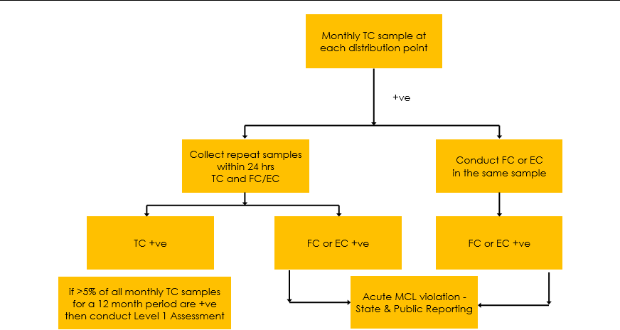

Figure 4.3: Summary of Total Coliform Rule Requirements

4.4 Total Coliform Rule

* The 1989 Total Coliform Rule (TCR)promotes surveillance of distribution system water quality targeting fecal matter and/or pathogens.
* Rule requires collection of monthly samples that are representative of water throughout the distribution system as identified in its approved Sample Siting Plan.
* For systems serving >1,000 people, number of monthly samples that need to be collected is based upon the population served.
* The presence of total coliforms is a warning sign that the system is vulnerable to contami-nation. It does not necessarily mean that the system is contaminated.
* If sample is total coliform (TC) positive:
  1. Conduct follow up testing:
     1. In the same sample, determine fecal coliform (FC) or E. Coli (EC).
     2. Collect a second sample within 24 hours, and reanaylze TC and FC/EC.
  2. The system is not in compliance if:
* The analysis and reanalysis of a given sampling location are TC positive (TC[+]) both times and FC[/EC+] at least one of these times. OR
* More than 5 percent of all monthly samples for a 12-month period are TC[+].

4.4.1 Revised Total Coliform Rule

* The 2013 Revised Total Coliform Rule (rTCR)revises the 1989 Total Coliform Rule (TCR) and is applicable to all PSWs.
* Establishes a zero MCL and MCLG for EC and eliminated MCLG and MCL for TC. EC being a more specific indicator of fecal contamination and potentially harmful pathogens

|  |  |
| --- | --- |
| 4.4 Total Coliform Rule | 107 |
|  |  |

than TC and also many of the organisms detected by total coliform methods are not of fecal origin and do not have any direct public health implication.

* The revised rule changes total coliform detection from a MCL to a Treatment Technique Trigger, requiring the PWS to perform a system review and fix any potential breaches in the microbiological barriers. Detection of E. coli during sampling indicates the exceedance of the MCL. These detections also trigger an inspection and correction of any sanitary defects found. The rTCR also increases monitoring for many systems experiencing compli-ance issues or that do not have a microbiologically protected source.
* Requirements for monitoring TC and EC according to a sample siting plan and schedule specific to the PWS.
* Requires sampling site representative of the entire distribution system.
* Eliminated TCR’s public notification requirements based only on the presence of TC and instead requires public notification when:
  + When an an EC MCL violation occurs OR
  + When a PWS fails to conduct the required assessment and corrective action.
* Uses vulnerable PWS to initiate a "find and fix" approach to address fecal contamination that could enter the distribution system.
* rTCR requires PWS to perform assessments to identify sanitary defects - that could pro-vide a pathway of entry for microbial contamination, or those that indicate failure (existing or potential) of protective barriers against microbial contamination, and subsequently take action to correct them.
* There are two levels of assessments based on the severity or frequency of the problem:
  + A Level 1 assessment is required if:

– For systems taking 40 or more samples per month, the utility exceeds 5.0 per-cent total coliform-positive samples for the month; or

– For systems taking fewer than 40 samples per month, the utility has two or more total coliform-positive samples in the same month; or

– The Utility fails to take every required repeat sample after any single routine total coliform-positive sample.

* + Level 2 which is an in-depth examination of the distribution system, water sources, treatment facilities, storage facilities and relevant operational practices at a public water system (PWS) conducted by an assessor - state or state-approved entity. Level 2 assessment is triggered by an E.Coli MCL violation or a second Level 1 assessment in a 12-month period or in two consecutive years.
  + When sanitary defects are identified during a Level 1 or Level 2 Assessment, they should be corrected as soon as possible to protect public health.
* A public water system will receive a Treatment Technique violation when any of the fol-lowing occur:

– Failure to conduct a Level 1 or Level 2 Assessment within 30 days of a trigger.

– Failure to correct all sanitary defects from a Level 1 or Level 2 Assessment within 30

108 Chapter 4. Drinking Water Regulations

days of a trigger or in accordance with the state-approved time frame.

– Failure of a seasonal system to complete state-approved start-up procedures prior to serving water to the public.

4.4.2 Filter Backwash Recycle Rule

* Filter Backwash Recycle Rule (FBRR)applies to all public water systems using conven-tional or direct filtration to treat surface water, or GWUDI, regardless of size
* Requires PWSs to review their backwash water recycling practices to ensure that they do not compromise microbial control
* Requires recycled filter backwash water to go through all processes of a system’s conven-tional or direct filtration treatment.

4.5 Ground Water Rules

* The Federal Ground Water Rules (GWR) rule applies to public water systems that use ground water as a source of drinking water.
* Goal of the GWR is increased protection against microbial pathogens.
* Ground water systems that are at risk of fecal contamination must take corrective action. Corrective action reduces potential illness from exposure to microbial pathogens. The
* The GWR relies on four major components:
  1. Routine sanitary surveys of systems that require the evaluation of critical elements of a public water system and the identification of significant deficiencies (e.g., a well located near a leaking septic system);
  2. Triggered source water monitoring for a system that (not treating drinking water to remove 99.99 percent (4-log) of viruses) identifies a positive sample during regu-lar Total Coliform monitoring or assessment monitoring (at the option of the state) targeted at high-risk systems
  3. Corrective action is required for any system with a significant deficiency or source water fecal contamination; and
  4. Compliance monitoring to ensure that treatment technology installed to treat drinking water reliably achieves 99.99 percent (4-log) inactivation or removal of viruses.
* In California, the Sustainable Groundwater Management Act (SGMA)sets a timeline to identify responsible local agencies – which will work as a team – the means to reverse overdrafted conditions in certain areas and to ensure the 127 “high and medium priority” groundwater basins or sub-basins not in overdraft reach sustainability by 2040.

|  |  |  |  |  |  |  |
| --- | --- | --- | --- | --- | --- | --- |
| TCR/ Nitrate/Nitrite | |  | CWS | NTNCWS | TNCWS |  |
| Sanitary Survey | |  | Every 5 years | Every 5 years | Every 5 years |  |
| Total Coliform Bacteria1 | |  | Every month | Every month | Every quarter |  |
| Nitrate (NO3) | |  | Annually | Annually | Annually |  |
| Nitrite (NO2) | |  | 1 sample record | 1 sample record | 1 sample record |  |
| Reporting | |  | CWS | NTNCWS | TNCWS |  |
| Fluoride – if added | |  | Daily | Daily | Daily |  |
| Entry Point Chlorine – if chlorine is added | |  | Continuous or grab samples | Continuous or grab samples | Continuous or grab samples |  |
|  | (Pop determines how many times a day chlorine is measured.) | | |  |
| Distribution Chlorine2 – if chlorine is added | | |  |
| Monthly | Monthly |  |  |
| Consumer Confidence Report | |  | Annually |  |  |  |
| Disinfection/Disinfectant Byproducts | |  | CWS | NTNCWS | TNCWS |  |
| Total Trihalomethanes1 (TTHM/HAA5) |  | Pop <500 – 9,999 | Annually | Annually |  |  |
|  | Pop ≥ 10,000 | Quarterly | Quarterly |  |  |
|  |  |  |  |
| Bromate (Ozone plants only) |  |  | Monthly | Monthly |  |  |
| Inorganic Chemicals | |  | CWS | NTNCWS | TNCWS |  |
| All Primary | |  | Once per period | Once per period |  |  |
| Arsenic | |  | Once per period | Once per period |  |  |
| Asbestos | |  | Once per cycle | Once per cycle |  |  |
| Lead and Copper1 | |  | Every 6 months3 | Every 6 months3 |  |  |
| Organic Chemicals | |  | CWS | NTNCWS | TNCWS |  |
| Pesticides (SOCs) and Other Organics | |  | Every quarter3 | Every quarter3 |  |  |
| Volatile Organic Chemicals (VOCs) | |  | Every quarter | Every quarter |  |  |
|  | Annually | Annually |  |  |
|  |  |  |  |  |
| Radionuclides | |  | CWS | NTNCWS | TNCWS |  |
| Gross Alpha Radioactivity | |  | Every quarter |  |  |  |
| Radium 226, Radium 228, Uranium | |  | Every quarter |  |  |  |
| 1 Number of samples is based on population. | | |  |  |  |  |

2 Distribution point chlorine test is required at the same time and location as total coliform samples are collected.

3 May be reduced if certain criteria are met.

Cycle – 3 years

Period – 9 years

Table 4.2: Sampling and testing schedules for groundwater

110 Chapter 4. Drinking Water Regulations

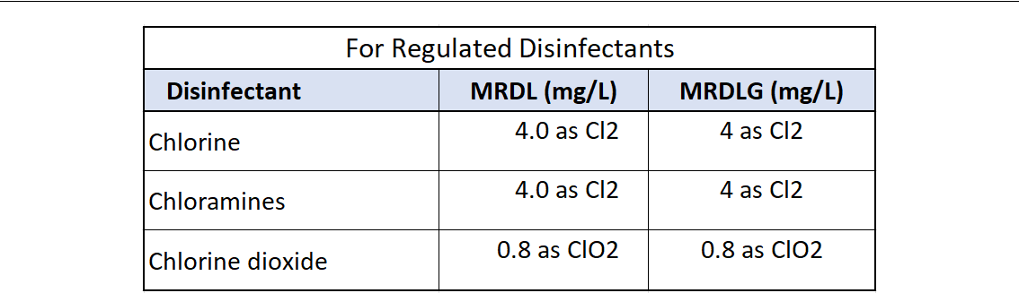

Table 4.3: Disinfectant MRDLs

4.6 Microbial and Disinfection Byproducts Rules

1. The Microbial and Disinfection Byproducts Rules (MDBPs) include Stage 1 and Stage 2 Disinfectants and Disinfection Byproducts Rules (DBPRs)
2. As disinfectants can react with naturally-occurring materials in the water to form byprod-ucts including:

– Trihalomethanes (THM),

– Haloacetic acids (HAA),

– Chlorite, and

– Bromate.

1. The Stage 1 and Stage 2 DBPRs are intended to minimize the public health risk from DBPs and disinfectants that are used to control pathogens.
2. Under these rules, EPA established:

– Maximum residual disinfectant levels (MRDLs) for chlorine, chloramines and chlo-rine dioxide, and

– MCLs for DBPs - chlorite, bromate, TTHM and HAA5.

1. These Rules apply to all Community Water Systems (CWS) and Non-Transient Non-Community Water Systems (NTNCWS) that add/deliver a primary or residual disinfectant, and TNCWs that use chlorine dioxide.
2. This Rule does not apply to water systems that use ultraviolet (UV) light.
3. The maximum residual disinfectant levels (MRDLs), and maximum residual disinfectant level goals (MRDLGs) for the three chemical disinfectants are listed in Table 4.3 .
4. The MCLs for DBPs are listed in Table 4.4.
5. Compliance is based on a running annual average (RAA) calculated quarterly, locational running annual average (LRAA) calculated quarterly, a single sample result or an aver-age of a selected number of samples, depending on which disinfectant or DBP is being monitored.
6. If the creation of these by-products causes the system to exceed the MCL for Total TTHMs (0.1 mg/l or 100 ppb), the system will be required to change to a different means of disin-fection.

|  |  |
| --- | --- |
| 4.7 Other Drinking Water Rules | 111 |
|  |  |

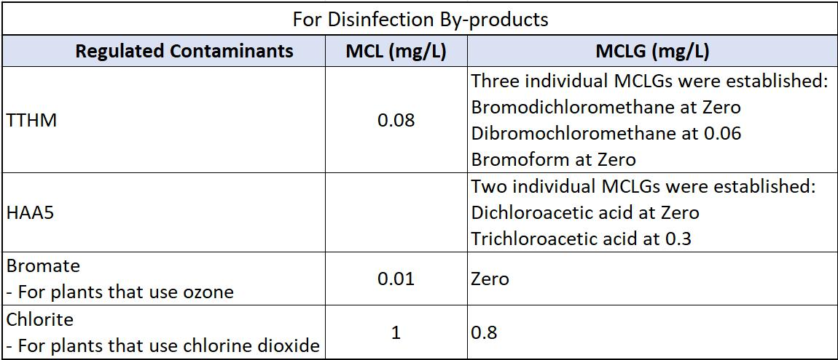

Table 4.4: Disinfectant By-products MCLs

1. Total chlorine residuals are also limited to a maximum of 4.0 mg/l.
2. The D-DBP rule currently only applies to systems serving a population over 10,000.

4.7 Other Drinking Water Rules

4.7.1 Lead and Copper Rule

1. The objective of the 1991 Lead and Copper Rule (LCR) is to control corrosiveness of the finished water in drinking water distribution systems to limit the amount of lead (Pb) and copper (Cu) that may be leached from certain metal pipes and fittings in the distribution system.
2. Applies to all community water systems (CWSs) and non-transient non-community water systems (NTNCWSs)that use ground water as a source of drinking water.
3. Establishes action level (AL) of 0.015 mg/L for Pb and 1.3 mg/L for Cu based on 90th percentile level of tap water samples. The rule also establishes an MCLG of zero for lead.
4. The lead action level is a measure of the effectiveness of the corrosion control treatment in water systems. The action level is not a standard for establishing a safe level of lead in a home.
5. Number of samples is based on system size - population served and Systems must conduct monitoring every 6 months unless they qualify for reduced monitoring.
6. Utilities are required to identify sampling locations and determining initial tap water Pb and Cu levels and also monitor other water quality parameters (WQPs) at these locations to monitor and evaluate the corrosion control characteristics of supplied water.
7. Each utility must complete a survey and evaluate materials that comprise their distribution system, in addition to using other available information, to target homes that are at high risk for Pb/Cu contamination.
8. An AL exceedance is not a violation but can trigger other requirements that include water

112 Chapter 4. Drinking Water Regulations

quality parameter (WQP) monitoring, corrosion control treatment (CCT), source water monitoring/treatment, public education, and lead service line replacement (LSLR).

1. Pb, Cu, and WQPs are initially collected at 6-month intervals. This frequency can be reduced if action levels are not exceeded and optimal water treatment is maintained.
2. Systems that are in noncompliance and are performing additional corrosion-control activ-ities must continue to monitor at six-month intervals, plus they must collect WQPs from distribution system entry points every two weeks.

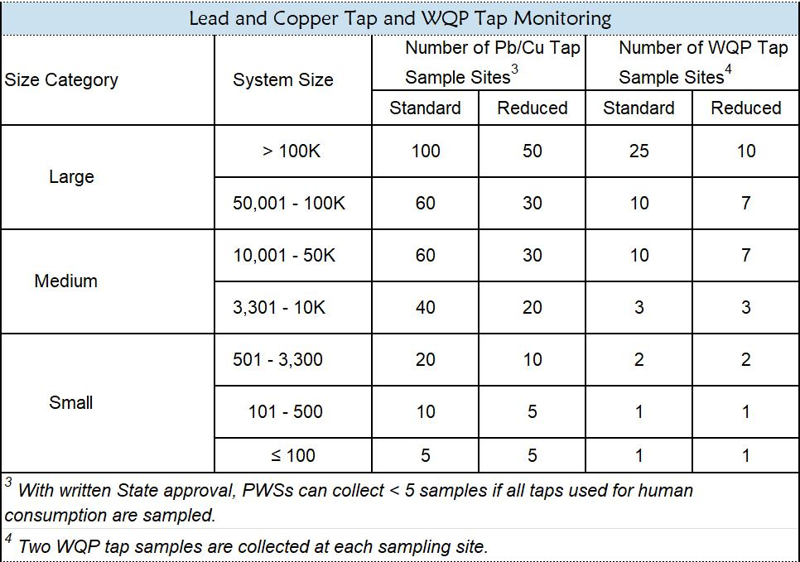

Table 4.5: Lead and Copper Tap and WQP Tap Monitoring

4.7.2 Radionuclides Rule

1. The 2000 Radionuclide Rule regulates radionuclides in drinking water to protect public health.
2. Radionuclides are radioactive elements which mostly enters the drinking water source from natural sources.
3. Radiation from radionuclide is known to cause cancer.
4. Radionuclide Rule applies only to Community Water Systems.
5. The rule extablishes the MCLs for radionuclides.

|  |  |
| --- | --- |
| 4.7 Other Drinking Water Rules | 113 |
|  |  |

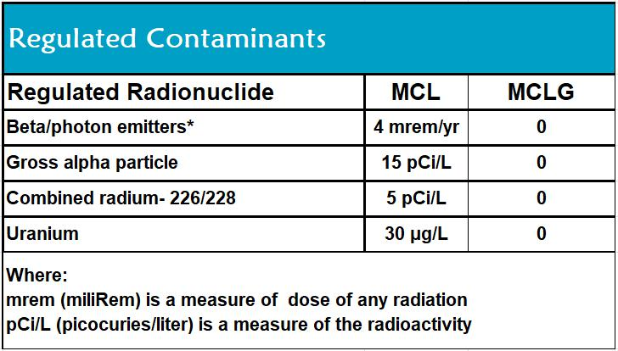

Figure 4.4: Radionuclide MCLs

1. Systems violating the MCL for one of the radionuclide, are required to work with the state to identify and implement options which may include finding a better source of water or blending.

4.7.3 Arsenic Rule

1. Arsenic is released to the environment from a variety of natural and anthropogenic sources.

– In the environment, arsenic occurs in rocks, soil, water, air, and in biota.

– Anthropogenic sources of arsenic relate to its use as wood preservative and in agricul-ture, livestock, and general industries.

1. There is evidence that associates chronic arsenic ingestion at low concentrations with increased risk of skin cancer, and that arsenic may cause cancers of the lung, liver, bladder, kidney, and colon.
2. This rule establishes an Arsenic MCL of 10 ppb.

4.7.4 Vulnerability Assessment

* Under the Public Health Security and Bioterrorism Preparedness and Response Act of 2002, community water systems that serve populations of greater than 3,300 persons are required to conduct vulnerability assessments.
* Vulnerability assessments help water systems evaluate susceptibility to potential threats and identify corrective actions that can reduce or mitigate the risk of serious consequences from malevolent acts and natural hazards. .
* Such an assessment for a water system takes into account the vulnerability of the water supply (both ground and surface water), transmission, treatment, and distribution systems. It also considers risks posed to the surrounding community related to attacks on the water system.
* An effective vulnerability assessment serves as a guide to the water utility by providing a prioritized plan for security upgrades, modifications of operational procedures, and/or policy changes to mitigate the risks and vulnerabilities to the utility’s critical assets.

114 Chapter 4. Drinking Water Regulations

* Water systems should review their vulnerability assessments periodically to account for changing threats or additions to the system to ensure that security objectives are being met.
* Preferably, a vulnerability assessment is "performance-based,” meaning that it evaluates the risk to the water system based on the effectiveness (performance) of existing and planned measures to counteract adversarial actions.

4.7.5 Public Notification Rule

* Public Notification (PN) Rule requires PWS to notify their customers when:

– If they violate EPA or state drinking water regulations (including monitoring require-ments), or

– If they provide drinking water that may pose a risk to consumer’s health. Water sys-tems test regularly for approximately 90 contaminants. The monitoring ensures identification of regulated contaminants at levels which may pose a risk to human health.

* Summary of key public notification requirements: Tier 1: - Immediate Notice, Within 24 Hours

Tier 1 PN is required to be issued as soon as practical but no later than 24 hours after the PWS learns of the violation or situation including:

– Distribution system sample violation when fecal coliform or E. coli are present; failure to test for fecal coliform or E. coli after initial total coliform distribution system sample tests positive.

– Nitrate, nitrite, or total nitrate and nitrite MCL violation; failure to take confirmation sample.

– Exceedance of maximum allowable turbidity level, if elevated to a Tier 1 notice by primacy agency.

– Waterborne disease outbreak or other waterborne emergency.

– Detection of E. coli, enterococci, or coliphage in a ground water source sample.

– All MCL, MRDL, and treatment technique violations, except where Tier 1 notice is required.

– Monitoring violations, if elevated to Tier 2 notice by primacy agency.

– For ground water systems providing 4-log treatment and conducting GWR compli-ance monitoring, failure to maintain required treatment for more than 4 hours.

Tier 3: Annual Notice Tier 3 PN is required to be issued within 12 months and repeated annually for unresolved violations.

– All monitoring or testing procedure violations, unless primacy agency elevates to Tier 2, including failure to conduct benchmarking and profiling (surface water systems) and failure to develop a monitoring plan (disinfecting systems).

– Special public notice for availability of unregulated contaminant monitoring results.

– Special public notice for fluoride secondary maximum contaminant level (SMCL)

|  |  |
| --- | --- |
| 4.7 Other Drinking Water Rules | 115 |
|  |  |

exceedance.

4.7.6 Sanitary Survey

* Under the SDWA, every primacy agency is required to have a sanitary survey program which evaluates the adequacy of the system’s capability for producing and distributing safe drinking water.
* A sanitary survey must include the following eight essential elements :
  1. Water source (protection, physical components, and condition)
  2. Water treatment
  3. Distribution system
  4. Finished water storage
  5. Pumps, pumping facilities, and controls
  6. Monitoring, reporting, and data verification
  7. Water system management and operation
  8. Operator compliance with state requirements
* Sanitary surveys are intended to identify deficiencies before they present a public health risk.
* Significant deficiencies are serious sanitary deficiencies identified in water systems which is determined to be causing, or has potential to cause, the introduction of contamination into the water delivered to consumers.
* PWSs must respond in writing to significant deficiencies identified in sanitary survey re-ports no later than 45 days after receipt of the report, indicating how and on what schedule the PWS will address significant deficiencies noted in the survey.
* Sanitary surveys must be conducted no less than once every three years for community water systems (CWSs) and no less than once every five years for non-community water systems. Primacy agencies may choose to conduct sanitary surveys more frequently than the minimum requirements.

4.7.7 SDWA Monitoring, Reporting and Recordkeeping Requirements

* A PWS is required to monitor and verify that the levels of contaminants present in the water do not exceed the MCL.
* If a PWS fails to have its water tested as required or fails to report test results correctly to the primacy agency, a monitoring violation occurs.
* Significant Monitoring Violations - are defined as any major monitoring violation that occurred during the calendar year of the report. A major monitoring violation, with rare exceptions, occurs when no samples were taken or no results were reported during a com-pliance period.
* The Detection Limit for Reporting (DLR) is the detection level set by federal or state regulation for each reportable analyte for reporting. DLR is the designated minimum level at or above which any analytical finding of a contaminant in drinking water resulting from

116 Chapter 4. Drinking Water Regulations

the mandatory monitoring requirement is to be reported to the State Board.

* Every Community Water System is required to deliver to its customers a brief annual water quality report . This report is to include some educational material, and will provide information on the source water, the level of any detected contaminants, and compliance with drinking water regulations.
* Significant Consumer Notification Violations occurs if a community water system com-pletely failed to provide its customers the required annual water quality report.
* Record-keeping requirements for a water supplier are summarized below:

|  |  |
| --- | --- |
| Record | Minimum Record Retention Period |
| Microbiological analyses | 5 years |
| Turbidity analyses | 5 years |
| Chemical analyses | 10 years |
| Sanitary survey documents | 10 years |
| Variances and exemptions granted | 5 years |
| Tier 1, Tier 2 and Tier 3 Notices | 3 years |
| Level 1 and Level 2 assessments | 5 years |

Table 4.6: Summary of regulatory record-keeping requirements

|  |  |  |  |  |  |  |  |  |  |  |  |  |  |  |  |  |  |  |  |  |  |
| --- | --- | --- | --- | --- | --- | --- | --- | --- | --- | --- | --- | --- | --- | --- | --- | --- | --- | --- | --- | --- | --- |
| 4.7 Other Drinking Water Rules | | | | | | |  |  |  |  |  |  |  |  |  |  | 117 | | | | |
|  |  |  |  | |  |  | |  | |  |  | |  |  | |  |  |  |  |  |  |
| • Key elements of SDWA monitoring framework are summarized below: | | | | | | | | | | | | | | | | |  |  |  |  |  |
|  |  |  |  |  |  |  |  |  | |  |  |  |  |  |  |  |  |  |  |  |  |
|  |  |  |  |  |  |  | Inorganics | | | | |  |  |  |  |  |  |  |  |  |  |
|  |  | With waiver | | | |  | ≤ MCL and | | | |  | Reliably and | | |  |  | >MCL or not | | | |  |
|  |  |  |  |  |  |  | no waiver | | | |  | consistently | | |  |  | Reliably and | | | |  |
|  |  |  |  |  |  |  |  |  |  |  |  | <MCL | | |  |  | consistently | | | |  |
|  |  |  |  |  |  |  |  |  |  |  |  |  |  |  |  |  | <MCL | | | |  |
| Surface water | | Once every 10 | | | |  | Annual | |  |  |  | Annual | | |  |  | Quarterly at | | | |  |
|  |  | years | | |  |  |  |  |  |  |  |  |  |  |  |  | each EPTDS | | | |  |
|  |  |  |  | |  |  |  |  | |  |  |  |  |  |  |  |  |  |  |  |  |
| Ground water | | Once every 10 | | | |  | Triennial | | | |  | Triennial | | |  |  | Quarterly at | | | |  |
|  |  | years | | |  |  |  |  |  |  |  |  |  |  |  |  | each EPTDS | | | |  |
|  |  |  |  |  |  |  | |  | |  |  | |  |  |  |  |  |  |  |  |  |
|  |  |  |  |  |  | | |  | |  | | |  |  |  |  |  |  |  |  |  |
|  |  |  |  | Volatile Organic Compounds (VOCs) | | | | | | | | | | |  |  |  |  |  |  |  |
|  | Waiver with | | | | <Detect and | | |  | <Detect af- | | | | Reliably and | | | |  | ≥Detect not |  |  |  |
|  | vulnerability | | | | no waiver | | |  | ter at least | | | | consistently | | | |  | Reliably and |  |  | |
|  | analysis | | |  |  |  |  |  | three annual | | | | <MCL | |  |  |  | consistently |  |  | |
|  |  |  |  |  |  |  |  |  | samples | | |  |  |  |  |  |  | <MCL |  |  | |
| Surface | Once every | | | | Annual | |  |  | Triennial | | |  | Annual | |  |  |  | Quarterly |  |  |  |
| water | 10 years | | |  |  |  |  |  |  |  |  |  |  |  |  |  |  |  |  |  |  |
|  |  | |  | |  | |  |  |  |  | |  |  |  |  |  |  |  |  |  | |
| Ground | Once every | | | | Annual | |  |  | Annual | | |  | Annual | |  |  |  | Quarterly |  |  |  |
| water | 10 years | | |  |  |  |  |  |  |  |  |  |  |  |  |  |  |  |  |  |  |
|  |  |  |  |  |  | | |  | |  | | |  |  |  |  |  |  |  |  |  |
|  |  |  |  |  | | | | | |  | | | |  |  |  |  |  |  |  |  |
|  |  |  |  | Synthetic Organic Compounds (SOCs) | | | | | | | | | | |  |  |  |  |  |  |  |
| Reliably and con- | | |  | >Detect or not Re- | | | | |  | Waiver with Vul- | | | |  | <Detect and no | | | | |  |  |
| sistently <MCL | |  |  | liably and consis- | | | | |  | nerability Assess- | | | |  | waiver | | | | |  | |
|  |  |  |  | tently <MCL | | |  |  |  | ment every three | | | |  |  |  |  |  |  |  |  |
|  |  |  |  |  |  |  |  |  |  | years | |  |  |  |  |  |  |  |  |  |  |
| Annual |  |  |  | Quaterly | | |  |  |  | Triennial | |  |  |  | Pop. >3,300 Semi- | | | | |  |  |
|  |  |  |  |  |  |  |  |  |  |  |  |  |  |  | annual Pop. <3,300 | | | | |  | |
|  |  |  |  |  |  |  |  |  |  |  |  |  |  |  | Annual | | | | |  | |
|  |  |  |  |  |  |  |  | | |  | |  |  |  |  |  |  |  |  |  |  |
|  |  |  |  |  |  |  |  | | | | |  |  |  |  |  |  |  |  |  |  |
|  |  |  |  |  |  |  | Nitrates | | | | |  |  |  |  |  |  |  |  |  |  |
|  | <1/2 MCL | | |  | Reliably and | | |  | ≥ 1/2 MCL | | | | After four | | | |  | ≥ 1/2 MCL |  |  |  |
|  |  |  |  |  | consistently | | |  | OR not Re- | | | | consecutive | | | |  | with last |  | | |
|  |  |  |  |  | <MCL | |  |  | liably and | | |  | quarters | | | |  | four quar- |  | | |
|  |  |  |  |  |  |  |  |  | consistently | | | | <1/2 MCL | | | |  | ters |  | | |
|  |  |  |  |  |  |  |  | <MCL | | | |  |  |  |  |  |  |  |  |  |  |
| Surface | Annual | | |  | Annual | |  |  | Quarterly | | |  |  |  |  |  |  |  |  |  |  |
| water |  |  |  |  |  |  |  |  |  |  |  |  |  |  |  |  |  |  |  |  |  |
|  |  |  |  |  |  |  |  |  |  |  |  |  |  | |  |  |  |  |  | | |
| Ground |  |  |  |  |  |  |  |  |  |  |  |  | Annual | |  |  |  | Quarterly |  |  |  |
| water |  |  |  |  |  |  |  |  |  |  |  |  |  |  |  |  |  |  |  |  |  |
|  |  |  |  |  |  |  |  |  | | | |  |  |  |  |  |  |  |  |  |  |
|  |  |  |  |  |  |  |  | | | | |  |  |  |  |  |  |  |  |  |  |
|  |  |  |  |  |  |  | Radionuclides | | | | |  |  |  |  |  |  |  |  |  |  |
| <Detect |  |  |  | ≥ Detect and ≤ 1/2 | | | | |  | >1/2 MCL and ≤ | | | |  | >MCL | | | | |  |  |
|  |  |  |  | MCL | | |  |  |  | MCL | |  |  |  |  |  |  |  |  |  |  |
| Every 10 years | |  |  | Every 10 years | | | | |  | Triennial | |  |  |  | Quarterly | | | | |  |  |

Table 4.7: Summary of SDWA Monitoring Requirements

118 Chapter 4. Drinking Water Regulations

4.8 Recycled Water Regulations

* Title 22 of California’s Code of Regulations refers to state guidelines for how treated and recycled water is discharged and used.
* State discharge standards for recycled water and its reuse are regulated by the 1969 Porter-Cologne Water Quality Control Act and the State Water Resources Control Board’s 2019 Water Recycling Policy.
* Title 22 lists 40 specific uses allowed with disinfected tertiary recycled water (such as irrigating parks), 24 specific uses allowed with disinfected secondary recycled water (such as irrigating animal feed and other unprocessed crops), and seven specific uses allowed with undisinfected secondary recycled water (such industrial uses).
* The State Water Board governs the permitting of recycled water projects, develops uniform water recycling criteria and reviews and approves Title 22 engineering reports for recycled water use.

4.9 State and Local Drinking Water Regulations

Individual States are responsible for the oversight and enforcement of the federal standards re-lated to drinking water treatment and distribution. Each State and even local authorities have the option of adopting more stringent standards, or develop standards regulations for contam-inants that the federal government has not acted on (perchlorate is a good example of such a standard). A state cannot set a drinking water standard that is less protective than the US EPA. A comparison of the Federal and California MCL standards is provided in the following table.

In California, the drinking water treatment and distribution systems are required to be designed, constructed, operated and maintained per the regulations codified under Titles 17 and 22 of the California Code of Regulations (CCR). A Table of Contents for the Drinking Water Regulations in the CCR is provided in Appendix E.

For chemical contaminants not on the MCL list, California Law establishes the following concen-tration based standards:

* A Public Health Goal (PHG) : PHG is a non-mandatory goals which reflects the risk from long-term exposure to a contaminant at that level. At the PHG level, the contaminant does not pose a significant health risk. It serves to establish a benchmark concentration level for the state to establish drinking water standard for that chemical. The current list of contaminants with PHG is summarized in Tables 4.8, 4.9, and 4.10.
* Notification Levels : Table 4.11 summarizes the current Notification Levels. Drinking water systems are required to issue timely notification whenever a chemical contamination level exceeds the notification level.
* Response Level : This level reflects the recommendation for the drinking water system take the source out of service, if the listed chemical contaminant exceeds the level. Table 4.12 summarizes the current Response Levels.

|  |  |
| --- | --- |
| 4.9 State and Local Drinking Water Regulations | 119 |
|  |  |

|  |  |
| --- | --- |
| Chemical Name | Public Health Goal (mg/L) |
| Alachlor | 0.004 |
| Aluminum | 0.6 |
| Antimony | 0.001 (1 ppb) |
| Arsenic | 0.000004 |
| Asbestos | 7 million fibers/L |
| Atrazine | 0.00015 |
| Barium | 2 |
| Bentazon | 0.2 |
| Benzene | 0.00015 |
| Benzo(a)pyrene | 0.000007 |
| Beryllium and Beryllium Compounds | 0.001 |
| Bromate | 0.0001 |
| Cadmium | 0.00004 |
| Carbofuran | 0.0007 |
| Carbon Tetrachloride | 0.0001 |
| Chlordane | 0.00003 |
| Chlorite | 0.05 |
| Chlorobenzene | 0.07 |
| Chromium-hexavalent | 0.00002 |
| Copper | 0.3 |
| Cyanide | 0.15 |
| Dalapon | 0.79 |
| Di(2-ethylhexyl)adipate | 0.2 |
| Di(2-ethylhexyl)phthalate | 0.012 |
| 1,2-Dibromo-3-chloropropane | 0.000003 |
| 1,2-Dibromoethane | 0.00001 |
| 1,2-Dichlorobenzene | 0.6 |
| 1,4-Dichlorobenzene | 0.006 |
| 1,1-Dichloroethane | 0.003 |
| 1,2-Dichloroethane | 0.0004 |
| 1,1-Dichloroethylene | 0.01 |
| 1,2-Dichloroethylene, cis | 0.013 |
| 1,2-Dichloroethylene, trans | 0.05 |
| 2,4-Dichlorophenoxyacetic Acid | 0.02 |
| 1,2-Dichloropropane | 0.0005 |
| 1,3-Dichloropropene | 0.0002 |
| Dinoseb | 0.014 |
| Diquat | 0.006 |
| Endothall | 0.094 |
| Endrin | 0.0003 |
| Ethylbenzene | 0.3 |

Table 4.8: Public Health Goals Levels - Table 1 of 2

|  |  |  |  |  |
| --- | --- | --- | --- | --- |
| 120 | Chapter 4. Drinking Water Regulations | | |  |
|  |  |  |  |  |
|  |  |  |  |  |
| Chemical Name (Contd.) |  | Public Health Goal (mg/L) |  |
| Fluoride |  | 1 |  |  |
| Glyphosate |  | 0.9 |  |  |
| Gross Alpha Particle Activity |  | N/A |  |  |
| Gross Beta Particle Activity |  | N/A |  |  |
| Haloacetic Acids: Dibromoacetic Acid |  | 0.00003 |  |  |
| Haloacetic Acids: Dichloroacetic Acid |  | 0.0002 |  |  |
| Haloacetic Acids: Monobromoacetic Acid |  | 0.025 |  |  |
| Haloacetic Acids: Monochloroacetic Acid |  | 0.053 |  |  |
| Haloacetic Acids: Trichloroacetic Acid |  | 0.0001 |  |  |
| Heptachlor |  | 0.000008 |  |  |
| Heptachlor Epoxide |  | 0.000006 |  |  |
| Hexachlorobenzene |  | 0.00003 |  |  |
| Lindane |  | 0.000032 |  |  |
| Hexachlorocyclopentadiene |  | 0.002 |  |  |
| Lead |  | 0.0002 |  |  |
| Mercury (Inorganic) |  | 0.0012 |  |  |
| Methoxychlor |  | 0.00009 |  |  |
| Methyl Tertiary Butyl Ether |  | 0.013 |  |  |
| Methylene Chloride (Dichloromethane) |  | 0.004 |  |  |
| Molinate |  | 0.001 |  |  |
| Nickel and Nickel Compounds |  | 0.012 |  |  |
| Nitrate |  | 45 (10 as nitrogen) |  |  |
| Nitrite |  | 3 (1 as nitrogen) |  |  |
| Nitrite and Nitrate |  | 10 as nitrogen |  |  |
| n-Nitrosodimethylamine |  | 0.000003 |  |  |
| Oxamyl |  | 0.026 |  |  |
| Pentachlorophenol |  | 0.0003 |  |  |
| Perchlorate |  | 0.001 |  |  |
| Picloram |  | 0.166 |  |  |
| Polychlorinated Biphenyls |  | 0.00009 |  |  |
| Radium-226 |  | 0.05 pCi/L |  |  |
| Radium-228 |  | 0.019 pCi/L |  |  |
| Selenium |  | 0.03 |  |  |
| Silvex |  | 0.003 |  |  |
| Simazine |  | 0.004 |  |  |
| Strontium-90 |  | 0.35 pCi/L |  |  |
| Styrene |  | 0.0005 |  |  |
| 2,3,7,8-Tetrachlorodibenzo-p-dioxin and related compds. | | 0.05 picograms/L (pg/L) |  |  |
| 1,1,2,2-Tetrachloroethane |  | 0.0001 |  |  |
| Tetrachloroethylene |  | 0.00006 |  |  |
| Thallium |  | 0.0001 |  |  |
| Thiobencarb |  | 0.042 |  |  |
| Toluene |  | 0.15 |  |  |
| Toxaphene |  | 0.00003 |  |  |
| 1,2,4-Trichlorobenzene |  | 0.005 |  |  |
| 1,1,1-Trichloroethane |  | 1 |  |  |

Table 4.9: Public Health Goals Levels - Table 2 of 2

|  |  |  |  |
| --- | --- | --- | --- |
| 4.9 State and Local Drinking Water Regulations | 121 | |  |
|  |  |  |  |
|  |  |  |  |
| Chemical Name (Contd.) | Public Health Goal (mg/L) |  |
| 1,1,2-Trichloroethane | 0.0003 |  |  |
| Trichloroethylene | 0.0017 |  |  |
| Trichlorofluoromethane (Freon 11) | 1.3 |  |  |
| 1,2,3-Trichloropropane | 7E-07 |  |  |
| Trichlorotrifluoroethane (Freon 113) | 4 |  |  |
| Trihalomethanes: Bromodichloromethane | 0.00006 |  |  |
| Trihalomethanes: Bromoform | 0.0005 |  |  |
| Trihalomethanes: Chloroform | 0.0004 |  |  |
| Trihalomethanes: Dibromochloromethane | 0.0001 |  |  |
| Tritium | 400 pCi/L |  |  |
| Uranium | 0.43 pCi/L |  |  |
| Vinyl chloride | 0.00005 |  |  |
| Xylene | 1.8 |  |  |

Table 4.10: Public Health Goals Levels - Table 3 of 3

122 Chapter 4. Drinking Water Regulations

|  |  |
| --- | --- |
| Chemical | Notification Level (milligrams per liter) |
| Boron | 1 |
| n-Butylbenzene | 0.26 |
| sec-Butylbenzene | 0.26 |
| tert-Butylbenzene | 0.26 |
| Carbon disulfide | 0.16 |
| Chlorate | 0.8 |
| 2-Chlorotoluene | 0.14 |
| 4-Chlorotoluene | 0.14 |
| Diazinon | 0.0012 |
| Dichlorodifluoromethane (Freon 12) | 1 |
| 1,4-Dioxane | 0.001 |
| Ethylene glycol | 14 |
| Formaldehyde | 0.1 |
| HMX | 0.35 |
| Isopropylbenzene | 0.77 |
| Manganese | 0.5 |
| Methyl isobutyl ketone (MIBK) | 0.12 |
| Naphthalene | 0.017 |
| N-Nitrosodiethylamine (NDEA) | 0.00001 |
| N-Nitrosodimethylamine (NDMA) | 0.00001 |
| N-Nitrosodi-n-propylamine (NDPA) | 0.00001 |
| Perfluorobutanesulfonic acid (PFBS) | 0.0005 |
| Perfluorohexanesulfonic acid (PFHxS) | 0.000003 |
| Perfluorooctanoic acid (PFOA) | 0.0000051 |
| Perfluorooctanesulfonic acid (PFOS) | 0.0000065 |
| Propachlor | 0.09 |
| n-Propylbenzene | 0.26 |
| RDX | 0.0003 |
| Tertiary butyl alcohol (TBA) | 0.012 |
| 1,2,4-Trimethylbenzene | 0.33 |
| 1,3,5-Trimethylbenzene | 0.33 |
| 2,4,6-Trinitrotoluene (TNT) | 0.001 |
| Vanadium | 0.05 |

Table 4.11: Notification Levels

|  |  |  |  |
| --- | --- | --- | --- |
| 4.9 State and Local Drinking Water Regulations | | | 123 |
|  |  |  |  |
|  |  |  |  |
|  | Chemical | Response Level (Multiples of Notification Level) |  |
|  | RDX | 100 times the NL |  |
|  | TBA | 100 times the NL |  |
|  | TNT | 100 times the NL |  |
|  | NDPA | 50 times the NL |  |
|  | 1,4-Dioxane | 35 times the NL |  |
|  | NDMA | 30 times the NL |  |
|  | NDEA | 10 times the NL |  |
|  | PFOS and PFOA | 100 times Cancer risk* |  |
|  | PFHxS | 10 times Toxicological endpoint** |  |
|  | All others | 10 times the NL |  |

Table 4.12: Response Levels



Chapter 4 Assessment

Chapter 4 Assessment

* Primary drinking water standards are set to protect the public from illnesses as a direct result in drinking water that exceeds maximum set levels. Secondary standards were set to alert the public to
  + the incidences of local cancer numbers
  + dissolved solids in water
  + immediate health concerns
  + radiological conditions concerning drinking water
  + aesthetic issues with drinking water
* A positive fecal coliform test must be reported to the primacy agency within
  + 8 hours.
  + 12 hours.
  + 24 hours.
  + 48 hours.
* Which agency sets legal limits on the concentration levels of harmful contaminants in potable water distributed to customers?
  + National Primary Drinking Water Regulations
  + United States Environmental Protection Agency
  + United States Public Health Service
  + Occupational Health and Safety Organization
* Which may be substituted for the analysis of residual disinfectant concentration, when total coliforms are also sampled at the same sampling point?

126 Chapter 4. Drinking Water Regulations

a. Heterotrophic plate count (HPC)

b. Fecal coliforms

c. Giardia lamblia

d. Combined chlorine

1. What does the acronym MCL stand for?
   1. Minimum contaminant level
   2. Micron contaminant level
   3. Maximum contaminant level
   4. Milligrams counted last
2. How long do sanitary surveys have to be retained for records?
   1. 3 years
   2. 5 years
   3. 7 years
   4. 10 years
3. The most severe water system violation that requires the fastest public notification
   1. Tier I
   2. Tier II
   3. Tier III
   4. Tier IV
4. The primacy agency may grant a variance or exemption as long as
   1. The agency is using the Best Available Technology
   2. There is no threat to public health
   3. There is never a scenario for a variance or exemption
   4. Both A. and B.
5. A public water system that serves at least 25 people six months out of the year
   1. Nontransient noncommunity
   2. Transient noncommunity
   3. Community public water system
   4. None of the above
6. Regulations based on the aesthetic quality of drinking water
   1. Primary Standards
   2. Secondary Standards
   3. Microbiological Standards
   4. Radiological Standards
7. The lowest reportable limit for a water sample
   1. 0.5mg/1
   2. Zero
   3. Public health goal
   4. Detection Level for reporting
8. Primary Standards are based on

|  |  |
| --- | --- |
| 4.9 State and Local Drinking Water Regulations | 127 |
|  |  |

a. Color and Taste

b. Aesthetic quality

c. Public Health

* 1. Odor
* A disease causing microorganism
  1. Pathogen
  2. Colilert
  3. Pathological
  4. Turbidity
* According to Surface Water Treatment Rule, what is the combined inactivation and re-moval for Giardia?
  1. 1.0 log s
  2. 2.0 log s
  3. 3.0 log s
  4. 4.0 Logs
* What is the equivalency expressed as a percentage for the SWTR inactivation and removal of viruses?
  1. 99.9%
  2. 99.99%
  3. 99.0%
  4. 99.999%
* A water agency that takes more than 40 coliform samples must fall under what percentile?
  1. 10%
  2. 7%
  3. 5%
  4. No positive samples allowable
* The National Primary Drinking Water Regulations apply to drinking water contaminants that may have adverse effects on
  1. Water color
  2. Water taste
  3. Water odor
  4. Human health
* Which of the following is considered an acute risk to health?
  1. Two Tier 2 violations
  2. One Tier 2 violation
  3. Two Tier 1 violations
  4. One Tier 1 violation
* Records on turbidity analyses should be kept for a minimum of
  1. 5 years
  2. 7 years

128 Chapter 4. Drinking Water Regulations

c. 10 years

d. 25 years

* Records on bacteriological analyses should be kept for a minimum of
  1. 5 years
  2. 7 years
  3. 10 years
  4. 25 years

V Chapter 5

* Water Treatment . . . . . . . . . . . . . . . . . . . . 131

5.1 Background

5.2 Categories of Treatment Methods

5.3 Source Management

5.4 Surface Water Treatment Processes

5.5 Other Treatment Processes

5.6 Best Available Technology (BAT)

5.7 Chemical Feed Systems

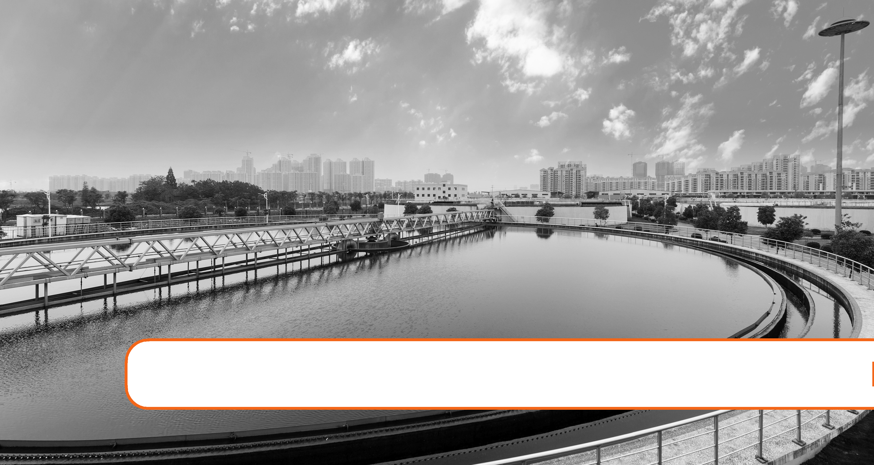

5. Water Treatment

Expected Range of Knowledge for Water Properties and Sources Water Distribution System Operator License Exams

D2 Ability to recognize normal operation of in-line sensors

D2 Ability to troubleshoot a chemical feeder

D2 Knowledge of analysis methods

D2 Knowledge of chemical feeder components

D2 Knowledge of chemical feeder types

D2 Knowledge of required reagents and standards

D3 Knowledge of corrosion control techniques

D3 Knowledge of principles of operation of cathodic protection devices

Water Treatment Operator License Exams

T1 Ability to calculate a dosage for a chemical feeder

T1 Ability to calibrate and adjust a chemical feeder pump

T1 Ability to operate a chemical feeder system

T1 Ability to replace components of a chemical feeder system

T1 Ability to set proper chemical feed rate

T1 Knowledge of chemical feeder calibration and adjustment

T1 Knowledge of the components of chemical feeder systems

T1 Knowledge of the operation of chemical feeder systems

T1 Knowledge of basic unit processes used in treating drinking water

T1 Knowledge of corrective actions to take when regulations are violated

T2 Knowledge of pretreatment procedures

T2 Knowledge of head loss effects on filters

T2 Knowledge of filter surface washing methods

T2 Knowledge of filtration mechanisms (absorption, adsorption)

T2 Ability to choose an appropriate disinfectant for a specific microbial problem

132 Chapter 5. Water Treatment

Expected Range of Knowledge for Water Properties and Sources Water Treatment Operator License Exams (Continued)

|  |  |
| --- | --- |
| T2 | Knowledge of chloramine chemistry |
| T2 | Knowledge of disinfectant byproduct reduction procedures |
| T2 | Knowledge of TOC/Disinfection byproduct correlation |
| T2 | Knowledge of corrosion reduction methods |
| T2 | Knowledge of Best Available Technology (BAT) for common water contaminants |
| T2 | Knowledge of effective removal techniques for common contaminants |
| T2 | Knowledge of hardness removal processes |
| T2 | Knowledge of the components of on-line analyzers |
| T3 | Ability to recognize and correct problems in gravity filters |
| T3 | Ability to recognize and correct problems in multimedia filters |
| T3 | Knowledge of backwash sequencing |
| T3 | Knowledge of filter media types and uses |
| T3 | Knowledge of maximum filtration rates |
| T3 | Knowledge of normal and abnormal filter media conditions |
| T3 | Ability to calculate filter media volume and capacity |
| T3 | Knowledge of iron and manganese removal techniques |
| T3 | Knowledge of the aeration process |
| T3 | Knowledge of the operation of blowers and compressors |
| T3 | Ability to discriminate between normal and abnormal operation of blowers and compressors |
| T3 | Knowledge of the components of pressure gauges |
| T3 | Ability to recognize analytical interferences in on-line analyzers |
| T3 | Ability to repair or replace defective parts of on-line analyzers |
| T3 | Knowledge of the operation of on-line analyzers |
| T3 | Knowledge of the operation of an electrical generator |
| T3 | Knowledge of the components of an electrical generator |
| T4 | Ability to conduct a comprehensive performance evaluation of a filter |
| T4 | Ability to operate an air scour system |
| T4 | Ability to perform a filter assessment surveillance program |
| T4 | Ability to perform a filter profile analysis |
| T4 | Ability to recognize and correct problems in granular activated carbon filters |
| T4 | Knowledge of air scouring systems |
| T4 | Knowledge of filter media replacement requirements and techniques |
| T4 | Knowledge of filter porosity |
| T4 | Ability to choose the proper corrosion control chemical for a specific problem |
| T4 | Knowledge fluoridation chemicals |
| T4 | Knowledge of fluoride chemistry |
| T4 | Knowledge of chemical oxidation techniques and uses |
| T4 | Knowledge of granular activated carbon (GAC) |
| T4 | Knowledge of nitrate removal processes |
| T4 | Ability to replace components of blowers and compressors |
| T4 | Knowledge of the components of blowers and compressors |

|  |  |
| --- | --- |
| 5.1 Background | 133 |
|  |  |

5.1 Background

* Purpose of water treatment is to provide safe drinking water that does not contain ob-jectionable taste, odor or color and provide adequate quantities of water for domestic, commercial, industrial and fire protection needs.
* All water produced by public water systems must be drinking water quality, even though only about 1% of water produced is used for drinking and cooking.
* Water may be treated differently in different communities depending on the quality of the source water that enters the treatment plant. The water that enters the treatment plant is most often either surface water or ground water. Surface water typically requires more treatment and filtration than ground water because lakes, rivers, and streams contain more sediment (sand, clay, silt, and other soil particles), germs, chemicals, and toxins than ground water.
* Even though U.S. tap water supplies are considered to be among the safest in the world, water contamination can still occur. There are many possible sources of contamination, including:

– Sewage releases

– Naturally occurring chemicals and minerals (for example, arsenic, radon, uranium)

– Local land use practices (for example, fertilizers, pesticides, livestock, concentrated feeding operations)

– Manufacturing processes (for example, heavy metals, cyanide)

– Malfunctioning on-site wastewater treatment systems (for example, septic systems)

– In addition, drinking water that is not properly treated or that travels through an improperly maintained distribution system (pipes) may also create conditions that increase risk of contamination.

* The purpose of water treatment is to condition, modify, or remove undesirable impurities and to provide water that is safe, palatable, and acceptable to users. Some regulations state that if the contaminants listed under the various regulations are found in excess of the Maximum Contaminant Levels (MCLs), the water must be treated to reduce the levels.
* Drinking water quality varies from place to place, depending on the condition of the source water from which it is drawn and the treatment it receives, but it must meet U.S. Environmental Protection Agency (EPA) regulations. Community water systems follow the rules set forth by the Safe Drinking Water Act (SDWA).
* Many states enforce their own drinking water standards that are at least as protective as EPA’s national standards. The SDWA rules include guidelines for drinking water quality, water testing schedules, and water testing methods.
* The level of treatment and treatment processes used are primarily dependent on the quality
  1. level of contamination of the source water.
* Generally speaking surface waters contain more contaminants compared to groundwater as surface waters are more exposed to contamination from runoffs etc.

134 Chapter 5. Water Treatment

* Although groundwaters are succeptible to contamination from seepage and soil percola-tion, the sediment layers help filter water naturally.
* The quantity and quality of surface water supplies vary more than groundwater, particu-larly seasonally.
* If we assume that the water source used to feed a typical water supply system is groundwa-ter, which is usually the case in the U.S., a number of common groundwater problems may require water treatment. Among these other problems are: bacteriological contamination, hydrogen sulfide odors, hard water, corrosive water,and iron and manganese.
* Private wells, which are not regulated by the EPA, supply drinking water to over 15 mil-lion homes. Well owners are responsible for keeping their water clean and safe.
* Some water supplies may contain radionuclides (small radioactive particles), specific chemicals (such as nitrates), or toxins (such as those made by cyanobacteria). Specialized methods to control or remove these contaminants can also be part of water treatment.
* There are many treatment approaches when it comes to treating a range of problems that can occur in groundwater. Many of these methods use a combination of technologies. When considering the appropriate approach, it is important to note that each site should be treated case by case. Since every site offers a different history, background, and unique landscape.

5.2 Categories of Treatment Methods

Typical treatment methods used can be categorized as:

* Biological

– Microbes based biological systems are used for nutrient and organic removals from drinking water

– Typically the biological processes utilize the fixed biofilm - support medium on which the biomass is attached.

– Some applications use suspended growth reactors where the biomass is sus-pended in the water being treated.

* Chemical

– Chemical oxidants are injected or mixed into groundwater to destroy contam-inants upon contact. Chemical oxidants include oxygen gas, ozone, and other liquid chemicals.

* Physical

Most common physical techniques are:

– Sedimentation: Involves gravity settling of settleable particles by gravitational force from the water.

– Filtration involves removal of pollutants by physical processes including strain-ing, adsorbtion and absorption.

– Dissolved air flotation or Degasification: Utilizes pressurized air to remove

|  |  |
| --- | --- |
| 5.3 Source Management | 135 |
|  |  |

dissolved gases is the process of removing dissolved gases from the water.

5.3 Source Management

– When options are available, source management implies effectively managing wa-ter sources, to ensure the intake of best possible quality of water from a regulatory compliance and treatment optimization perspective.

– Examples of source management include:

* For systems using lake or reservoir sources, selecting the optimum depth from which to draw water depending on the water quality during that time of year or

for other reasons (e.g. algal bloom, storm upsets, etc).

* Systems that have multiple sources may consider blending or alternating surface and ground water sources to attain the best blended raw water for compliance. If blended prior to treatment, all water must be treated to surface water standards.

5.4 Surface Water Treatment Processes

5.4.1 Typical surface water treatment process

* Water is withdrawn from a lake, reservoir or river at the intake
* It is screened to remove debris
* Water then enters the flash mixing tank where coagulants and other chemicals are added
* Then it is divided into the flocculation basin
* After flocculation, the water enters the settling basins where solids are removed
* Filtration then removes particles that are too small to settle by gravity
* The water is disinfected using some form of chlorine
* Other chemicals such as fluoride, phosphate corrosion inhibitors or pH adjustment chemicals may be added
* After a minimum detention time, the water may be pumped to the distribution sys-tems Other processes may occur, such as pre-oxidation or activated carbon treatment.

5.4.2 Source Water Treatment

– Source water treatment in reservoirs or lakes includes treatment to contain algae growth.

– Algal bloom is a sudden large increase in algae caused by weather or by nutrients.

– Reasons for controlling algae:

* Taste and odor problems
* Shortened filter runs
* Changes in pH - increases during the day, decreases at night

136 Chapter 5. Water Treatment

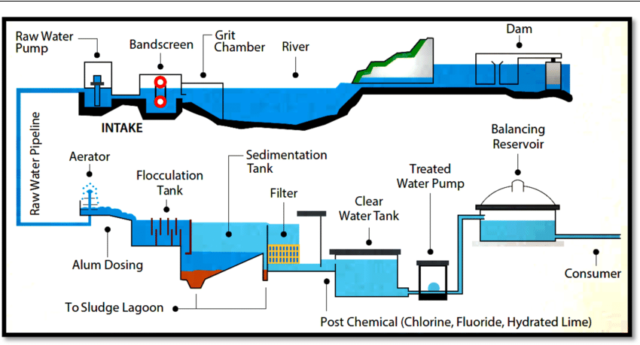

Figure 5.1: Conventional Water Treatment

* 1. When algae dies, causes depletion of dissolved oxygen (DO)
  2. Organic loading which is DBP pre-cursor resulting in TTHMs.

– Algaecide such as blue stone, copper sulfate (CuSO4) is used to control algae.

– Action level for copper is 1.3 mg/L· ·

– Copper sulfate dose is usually specified in terms of pounds/acre.

– 5.4 lbs/acre is common dosage - the rate of application is based on the surface area of the reservoir not the volume

– For water with alkalinify of higher than 150 mg/L, citric acid has to be mixed with CuSO4 for it to be effective

– Applying far more copper sulfate than necessary is uneconomical and ecologically undesirable. Excessive amounts of copper can kill fish and other bottom organisms, and copper tends to accumulate in bottom sediments.

5.4.3 Screening

– River water (the source of water used in our discussion) frequently contains sus-pended and floating debris varying in size from small rags to logs. Screening is usu-ally the first major step where by large and suspended debris in the source water including sticks, leaves etc. is removed from the water before it enters the plant.

– Removing these solids is primarily to prevent damage to downstream equipment including pumps, prevent deposition of this debris in open channels or pipes, or in treatment processes.

– The most important criteria used in the selection of a particular screening system for are the screen opening size and flow rate. Other important criteria include costs related to operation and equipment, plant hydraulics, debris handling requirements,

|  |  |
| --- | --- |
| 5.4 Surface Water Treatment Processes | 137 |
|  |  |

and operator qualifications and availability.

– Depending on the characteristics of the source water, variety of screening devices including trash rakes, bar screens and wire mesh screens may be used. Very small screens can be used to screen out elements including algae in the water.

– Typical screening devices used include:

* Trash Screens (Rakes) - used to remove rough or large debris. The bar spacing in Rakes range from 1.5 to 4 inches.
* Traveling Water Screens (Bandscreens) - these are placed in a channel of flowing water to remove floating or suspended debris.

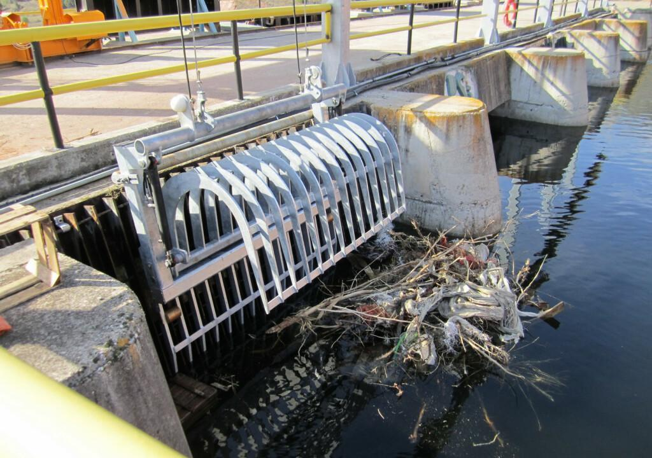

Figure 5.2: Trash Rake

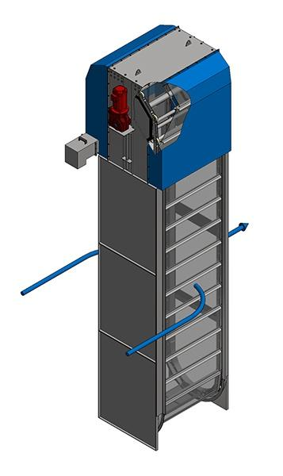

Figure 5.3: Band Screen

5.4.4 Coagulation and Flocculation

– A significant amount of suspended particles in the raw water are too small to be filtered or settled out in the sedimentation basin. These particles, termed as colloids are non-settleable solids and include organic matter, silt, clay.

– These particles impart turbidity and color to the water and may harbor pathogens and typically carry a negative electrostatic charge on its surface - negative zeta potential. The like surface charge on these particles cause electrostatic repulsion (particles keep

138 Chapter 5. Water Treatment

bouncing off one another) which makes these particles difficult to settle.

– Coagulation and flocculation are sequential processes both of which involve chemical addition.

– For coagulation, either metal salt type coagulant - typically an aluminum salt such as alum or aluminum sulfate or an iron salt such as ferric or ferrous chloride or sulfate, polyaluminum chloride or a organic coagulant such as polyDADMAC or polyamine is used. The coagulant helps coalesce the non-settleable solids into larger particles.

– Sodium aluminate is often used as an aide to alum coagulation particularly for cold water and during lime softening.

– Coagulation is affected by changes in the water’s pH, alkalinity, temperature, time, velocity and zeta potential.

– The effectiveness of a coagulant is generally pH dependent. Water with a color will coagulate better at low pH (4.4-6) with alum.

– Alkalinity is needed to provide anions, such as (OH−) for forming insoluble com-pounds to precipitate them out. It could be naturally present in the water or needed to be added as hydroxides, carbonates, or bicarbonates. Generally 1 part alum uses 0.5 parts alkalinity for proper coagulation.

– The higher the temperature, the faster the reaction, and the more effective is the coagulation. Winter temperature will slow down the reaction rate

– The coagulation process requires rapid mixing of the water upon the addition of the coagulant followed by a sufficient contact time prior to the flocculation step.

– The flocculant which is added after the coagulation step is to make even larger, more compact and settleable - floc, from the coagulated solids.

– Flocculants are typically long chain organic compounds - polymers with charged end groups. anionic polymers have a negative end group whereas nonionic polymers have balanced - positive and negative end groups.

– For the floc formed to remain intact, the polymer is gently "folded in" with the coagu-lated solids. The flocculation is done in a flocculator which have a detention time of 5 -30 minutes and the water is mixed with the polymer using slow moving paddles.

– Coagulant aids - chemicals which aid in the coagulation process and strengthening the flow include:

* + Alakalinity enahncers - lime, Soda ash, caustic soda and sodium bicarbonate.
  + Weighting agents - calcimu carbonate and bentonite clay. These are used in waters which are low in tubidity and high in color which under normal condition would have formed weak, slow settlling floc.
  + Activated sililca - sodium silicate activated by hypochlorous acid is often used as a coagulant aid with alum.
* These will usually be used in conjunction with a primary coagulant such as ferric chloride, ferric sulfate, or alum.

|  |  |
| --- | --- |
| 5.4 Surface Water Treatment Processes | 139 |
|  |  |

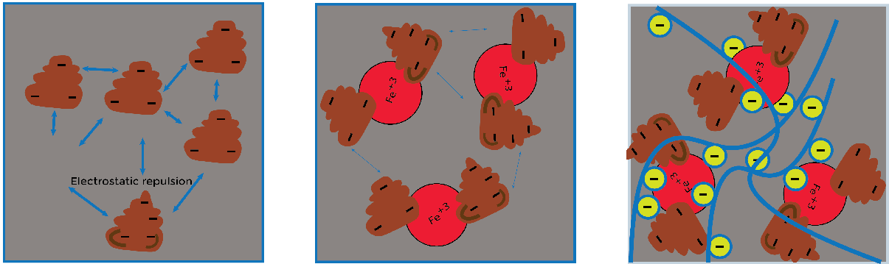

Untreated Water Coagulation Flocculation

Figure 5.4: Coagulation-Flocculation Schematic

* Determining the amount and type of coagulant used changes based on a variety of process conditions and quality of water. For example, a heavy rain will greatly impact the influent, or raw, water in a municipal treatment plant.
* The jar test is a standard method in which various amounts of coagulant and flocculation times are tested on a raw water sample. There are multiple samples to test before imple-mentation into a larger volume of the water treatment process.

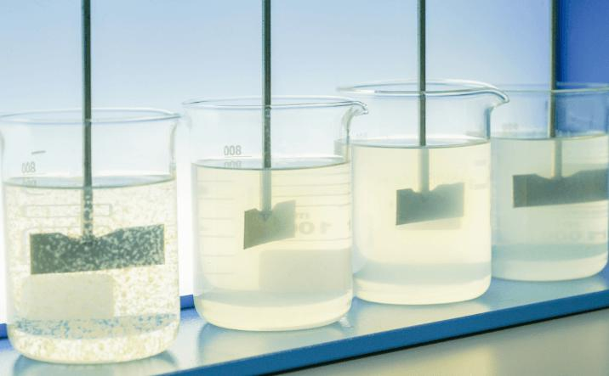

Figure 5.5: Jar Testing

5.4.5 Clarification/Sedimentation

* Clarification, or sedimentation, is the third step in conventional water treatment, after coagulation and flocculation and before filtration.
* In the sedimentation basin the flocculated particles settle out under the influence of gravity.
* In conventional sedimentation basins the solids drop out (settle) as the water slowly flows across the basin from the influent to effluent end.
* Sedimentation basins are designed to create conditions in which the water flows very slowly through the basin, with minimal turbulence.
* Conventional sedimentation basins are typically rectangular or cylindrical concrete or steel vessels which incorporate a horizontal flow of water.

140 Chapter 5. Water Treatment

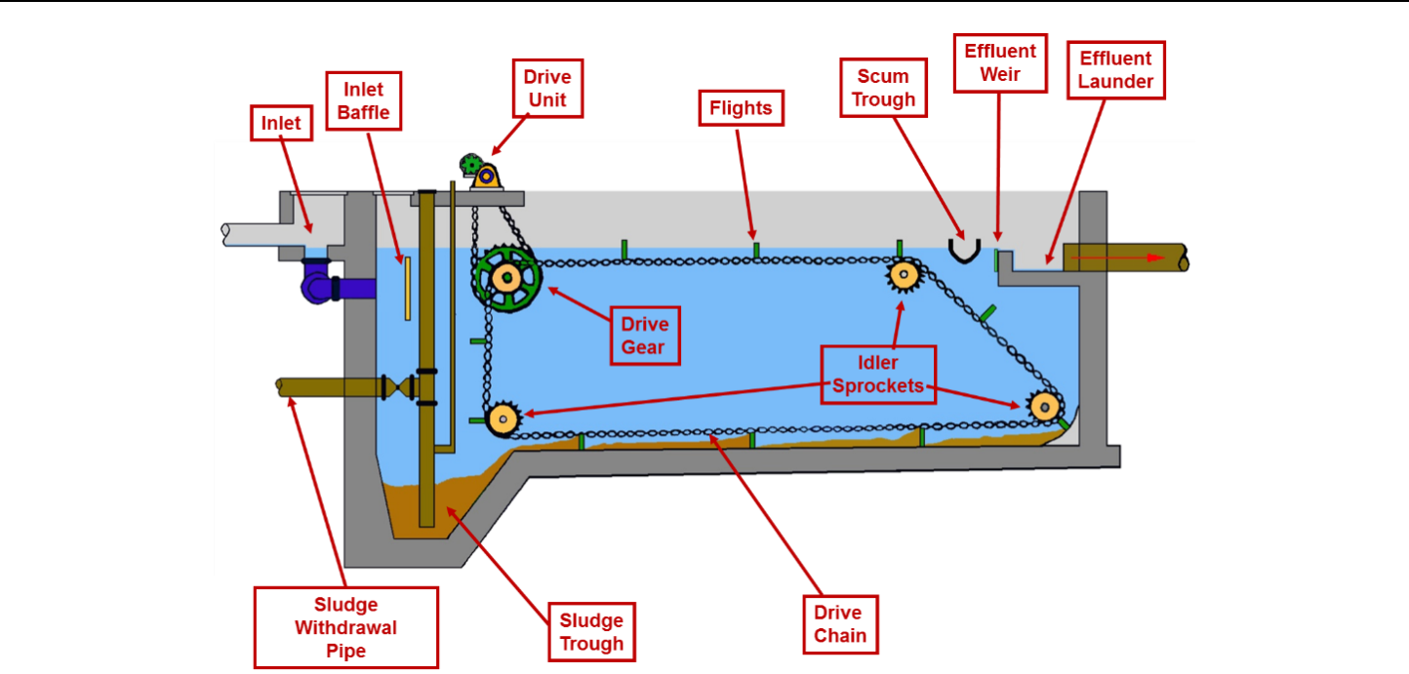

Cross section of a Rectangular Clarifier

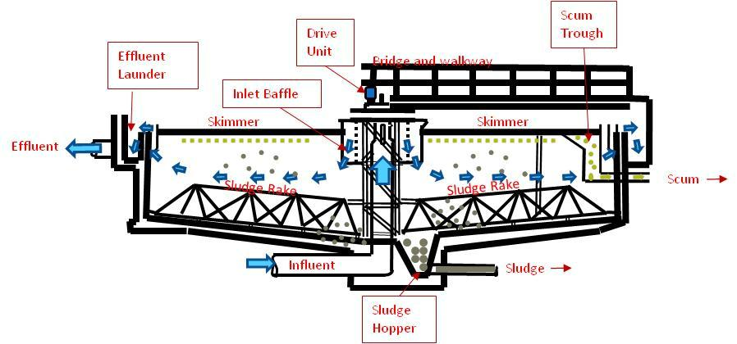

Schematic cross section of a circular clarifier

Clarifier Zones

* Inlet Zone: is where the water enters the end of a rectangular tank, or the center of a circu-lar or square tank. The Inlet Zone is designed to accomplish two objectives:
  1. Reduce the velocity (dissipate energy in the incoming water). This is accomplished by the inlet baffle.
  2. Distribute the flow evenly using baffles in front of the influent baffle.
* Settling Zone: This is the largest portion of the tank where the water is flowing very slowly allowing the solids to settle. The clarifier is said to be short circuiting if the velocity of the water is greater in some sections than in others. The water passing through the higher velocity region will have a reduced detention time and settleable solids will carry through with this water as it exits the clarifier.
* Sludge Zone: Sludge zone is the bottom of the tank where the settled solids collect and compact. Sludge rakes push the sludge to one end or the center of the tank so that it can be pumped out.

|  |  |
| --- | --- |
| 5.4 Surface Water Treatment Processes | 141 |
|  |  |

* Skimming Zone: The skimming zone is at the surface of the tank for removing scum removing lighter solids which float to the surface.
* Outlet Zone: This is the part of the clarifier where the settled water leaves the clarifier. A channel called the effluent launder collects the effluent flow and directs it to the clarifier effluent piping. Weirs are installed along the edge of the effluent launder channel to skim the water evenly off the surface of the tank.

5.4.6 Filtration

Process Basics

* The SWTR requires the filtration of surface water and ground water under the direct influ-ence of surface water.
* Filtration is the mechanical removal of turbidity particles by passing the water through a porous medium, which is either a granular bed or a membrane.
* The process of filtration involves straining, settling, and adsorption.
* Filtration does not remove dissolved solids and by itelf is not effective for the removal of bacteria.
* In filtration, solids are removed physically by:

– Straining – trapping particles, and

– Adsorption.

* The filtration based treatment process can be either:
* Conventional - which is a four step treatment process that consists of the treatment steps of coagualation, flocculation, sedimentation and rapid sand filtration.
* Direct - where the sedimentation step is omitted. It is for areas with high quality of water and allows for cost and space savings by eliminating the need for sedimenta-tion basins.

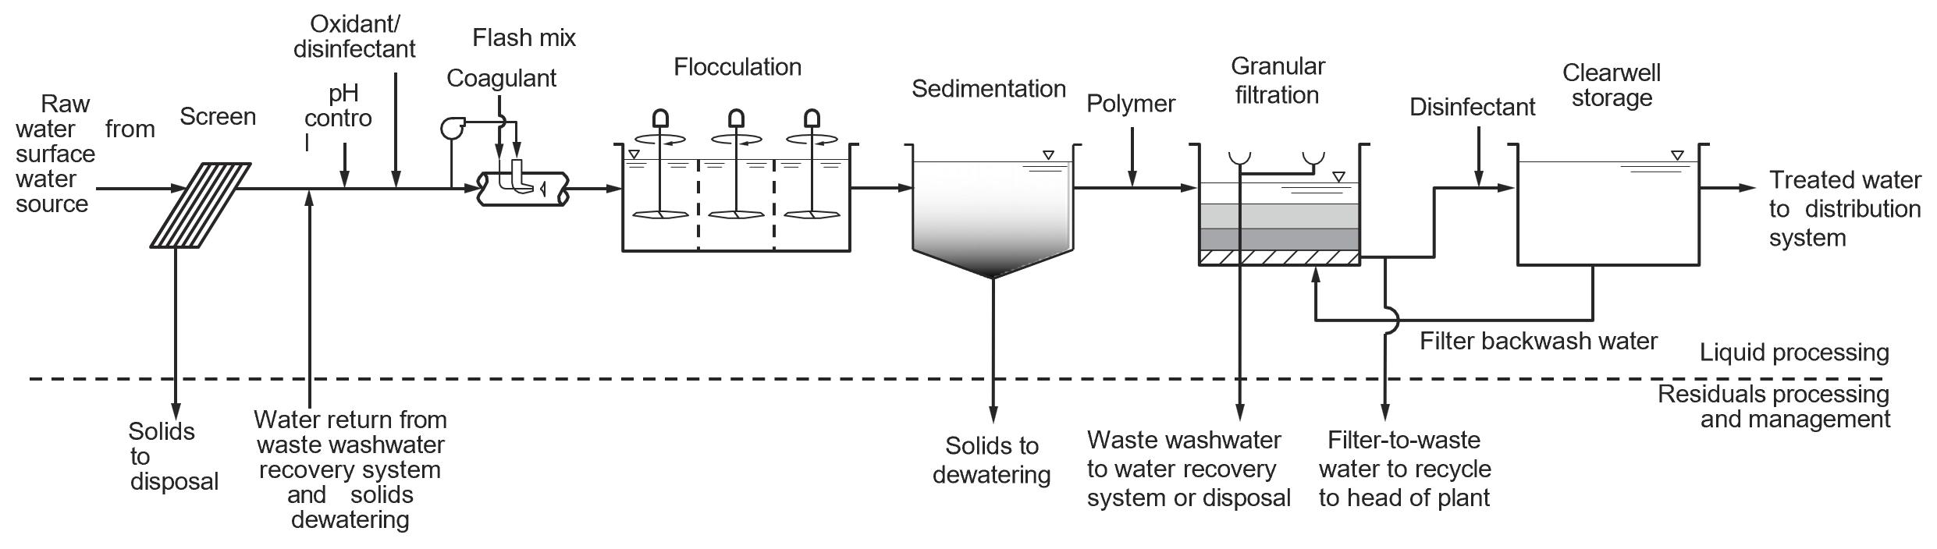

Figure 5.6: Direct Filtration

142 Chapter 5. Water Treatment

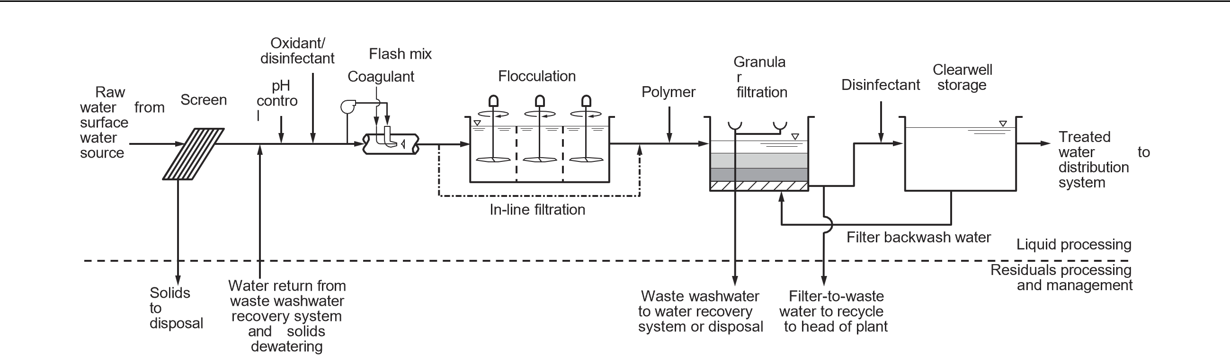

Figure 5.7: Conventional Filtration

* Filters can also be classified as:

– Gravity – open to atmosphere and rely on the depth of water above the filter media to provide the driving force to pass water through the media.

– Pressure – utilize a pressure vessel to contain the media and can operate with a much higher driving force to pass water through the media.

* Rapid gravity filters and slow sand filters are the two major types of filters used for water treatment.
* Rapid filtration has following features that allow it to operate at higher water loading rates:
  1. A filter bed of granular material that has been processed to a more uniform size than typically found in nature.
  2. Use of a coagulant to precondition the water, and
  3. Mechanical and hydraulic systems to efficiently remove collected solids from the bed.
* The rapid filtration cycle consists of two stages:
  1. Filtration stage, when water flows downward through the filter bed and particles collect within the bed, and
  2. Backwash stage, water flows in the direction opposite to remove the particles that have collected in the filter bed. Efficient removal of collected solids is a key compo-nent of rapid filtration systems, so while the backwashing stage is very short com-pared to the filtration stage, it is a very important part of the filtration cycle.
* Rapid filtration is classified by the level of pretreatment, as presented in Figure 5.8. The most important factors that determine the required level of pretreatment are the raw-water quality and the preference and resources of the operating utility.

|  |  |
| --- | --- |
| 5.4 Surface Water Treatment Processes | 143 |
|  |  |

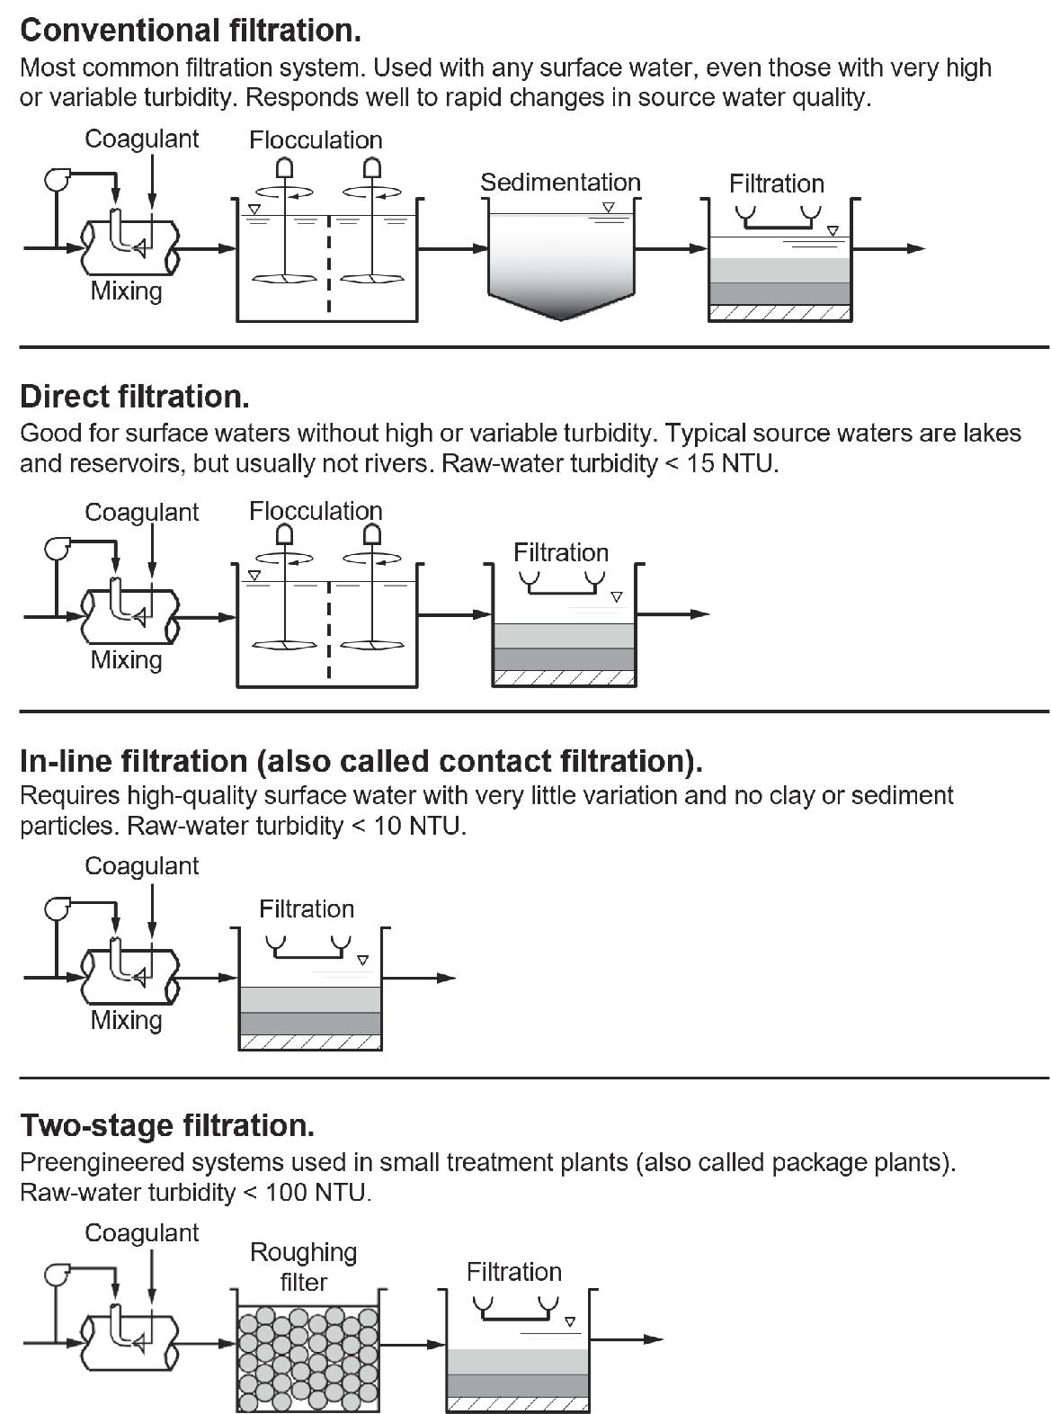

Figure 5.8: Rapid Filtration by Pretreatment Level

* In a slow sand filter there is a layer - Schmutzdecke that develops on the top and is made up of microrganisms that feed on and break down organic material that is trapped on the surface of the filter. If the source water naturally contain low levels of nutrients, initial nutrient addition may be needed to develop this layer.
* The Schmutzdecke enhances the particulate removal. As the Schmutzdecke develops, the filter performance – as measured by the turbidity typically improves as the filter run progresses.
* Filter media can consist of silica sand, greensand, anthracite coal, activated carbon, and many other types of media.
* Filter media maybe a single media or mixed to provide improved filtration characteristics.
* Two most common types of granular media filters include dual-media filters such as an-thracite coal and silica sand and tri-media which have anthracite coal, silica sand and fine garnet.
* Greensand media which incorporates potassium permanganate and manganese green-sand which is the mineral called glauconite coated with manganese oxide. Manganese

144 Chapter 5. Water Treatment

greensand is a popular filtration media choice as it removes dissolved iron and manganese, hydrogen sulfide, radium and arsenic. Regeneration of traditional Greensand every six to twelve months with permanganate is recommended.

* Activated carbon can be used as a topping for silica sand. The activated carbon does not only remove solids but also helps adsorb organic contaminants.
* Pre-coat filters, utilize a slurry of raw water with diatomaceous earth (DE) as a pre-coat on a septum filter media which then captures the turbidity causing particles from raw water. The filtration process is followed by a backwash cycle to remove the filtered cake buildup. Precoat filtration is used to remove very small particulate matter, oil particles, and even bacteria from water. This method is practical only for relatively small quantities of water which contain low concentrations of contaminants.

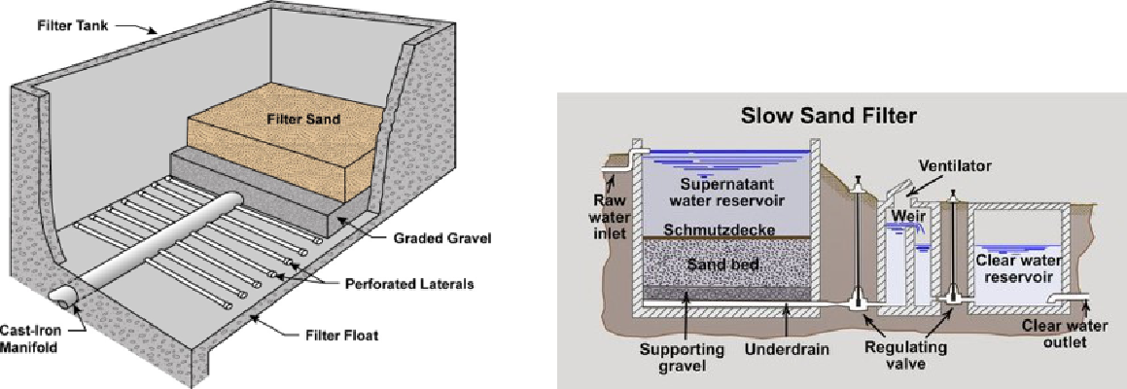

Rapid Sand Slow Sand

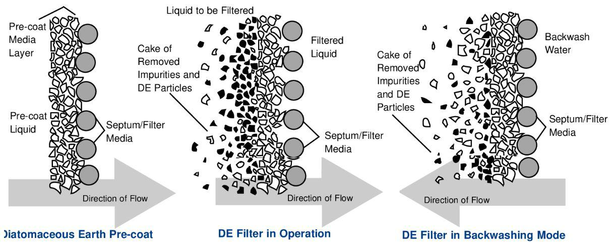

Pre-coat - Diatomaceous Earth

Figure 5.9: Filter Types

* Filters can also be classified as:

– Depth filtration – solids are removed within the granular material. Example: Rapid granular bed filter

– Cake filtration – solids are removed on the entering face of the granular material. Example: Precoat

* The Surface Water Treatment Rule describes five different types of filtration systems:

– Conventional treatment

|  |  |
| --- | --- |
| 5.4 Surface Water Treatment Processes | 145 |
|  |  |

– Direct filtration

– Slow sand filtration

– Diatomaceous earth filtration

– Alternate filtration technologies such as bag filters and cartridge filters.

* Besides using a filter media, process akin to filtration can also be accomplished using membranes.
* A membrane is a thin layer of material that will only allow certain compounds to pass through it.
* During operation, permeable components pass through the membrane and impermeable components are retained on the feed side. As a result, the product stream is relatively free of impermeable constituents and the waste stream is concentrated in impermeable constituents.
* Which material will pass through the membrane is determined by the size and the chemical characteristics of the membrane and the material being filtered.
* Membranes can be classified into two distinct physicochemical processes:
* Membrane filtration which encompasses the use of:
  1. Microfiltration (MF)membrane which function like a sieve. MF membrane pore size ranges from 0.1 to 1 micrometer (µm); therefore, they remove all particles bigger than 1 µm, including Cryptosporidium oocysts, Giardia cysts and all bacteria., and
  2. Ultrafiltration (UF) membranes which are similar to the microfiltration mem-branes except the pore size is smaller - 0.003 to 0.1 µm which removes very small particles including viruses and THM formation precursors.
  3. Nanofiltration (NF) membranes which have nanometer (0.001 µm, or 1 nm) pore size and can remove all the particles above nanometer size - besides remov-ing viruses, cysts, and bacteria they remove some dissolved substances including

divalent ions such as Ca+2 and Mg+2,and are used for softening water and to reduce the concentration of organic matter to control disinfection by-product (DBP) formation.

* Reverse Osmosis (RO) where preferential diffusion of water through a semiperme-able membrane in response to a concentration gradient.

– In RO, the feed stream is a solution, or single-phase system, in which the con-stituents targeted for removal are truly dissolved solutes - ions such as sodium, chloride and dissolved NOM.

– RO membranes are semipermeable - they function as sieves and selective diffu-sion membranes due to osmosis, allowing for specific dissolved substances to pass through.

– Osmosis is the passage of water through a semipermeable membrane from the lower concentration of the dissolved substances to the higher concentration to equalize the concentration on both sides of the membrane. The force with

146 Chapter 5. Water Treatment

which water flows through the membrane is called osmotic pressure. The greater the difference in concentration on two sides of the membrane, the higher the osmotic pressure, and faster is the flow. In reverse osmosis, a pressure higher than the osmotic pressure is applied on the higher concentration side to force the water through the membrane in the reverse order.

– RO membranes are used to treat seawater that has total dissolved solids (TDS) in the range of 3.5% (35,000 mg/L) and other brackish water (TDS up to 3%).

– RO is also capable of removing specific dissolved contaminants - pesticides, arsenic, nitrate, radionuclides.

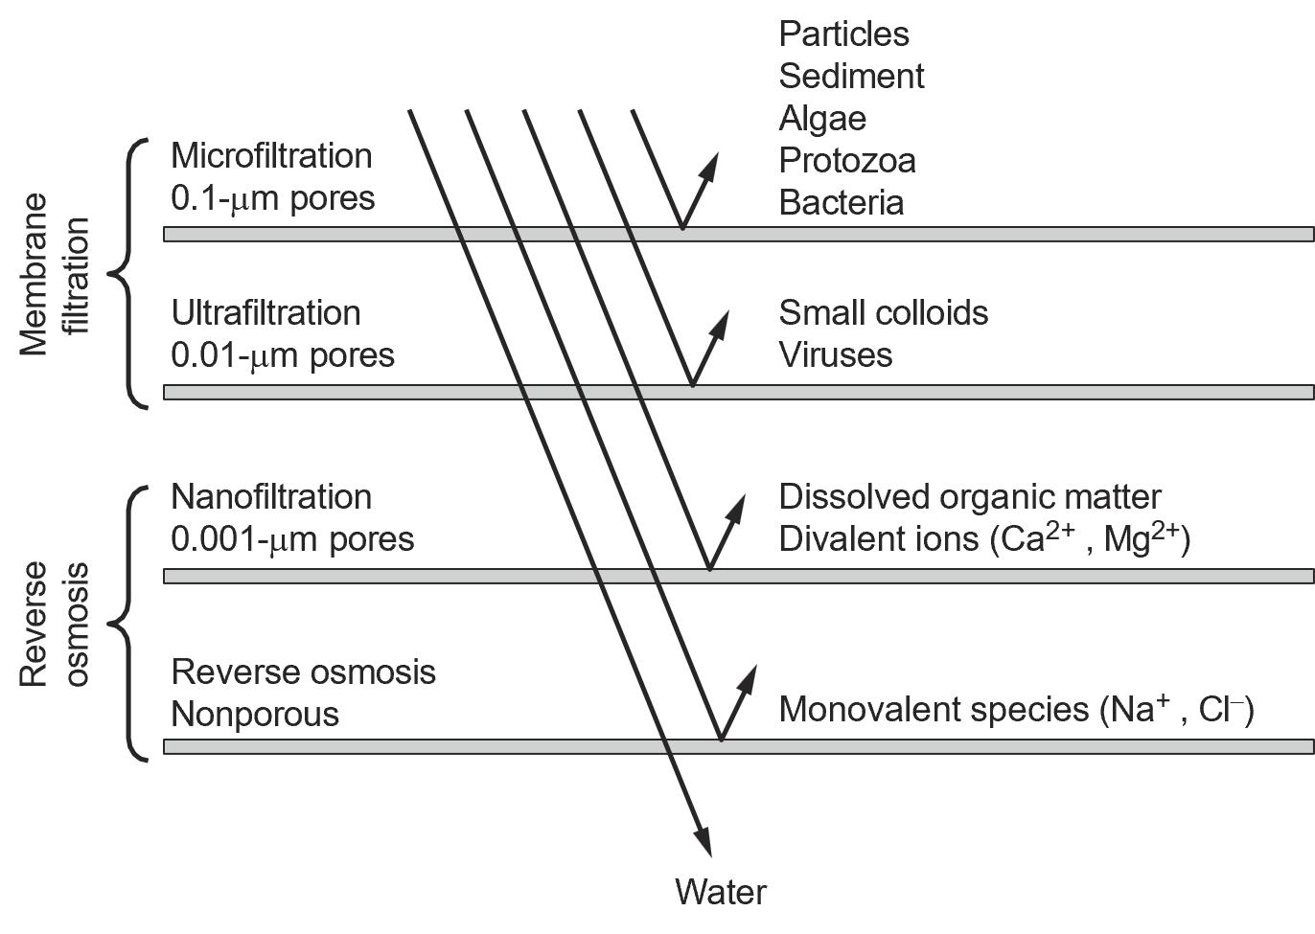

Figure 5.10: Membrane Processes

Operation

* The removal mechanism in filtration involves straining – trapping larger particles and through adsorbtion where particles attach themselves to the filter media
* Typical Filtration Rates:

– Slow Sand: 0.05 gpm/ft2 - 3 feet sand

– Rapid Sand: 2 gpm/ft2 – 3 feet sand

– Pressure filters: 3 gpm/ft2

– High Rate: 2-6 gpm/ft2 – various media configurations

* After a period of operation – filter cycle, the filter headloss increases because of the accu-mulation of the trapped solids.
* Rapid filters are cleaned by backwashing using an upward, high-rate flow of water
* Coagulation-flocculation is not required for cake filtration whereas chemical treatment is required for depth filtration.
* Backwashing involves reversing the flow of water through the filter causing water to travel from the bottom of the filter to the top.
* Backwash is done at specific rates in order to most effectively remove the particulate material. Backwashing process can be augmented by introducing low pressure air into

|  |  |
| --- | --- |
| 5.5 Other Treatment Processes | 147 |
|  |  |

the backwash line.

* Backwash rates of 12-15 gpm/ft2 or higher are common for sand, and rates for anthracite may range from 8 to 12 gpm/ft2.
* Wastewater used for the backwash is collected and removed from the filter.
* Operational Problems Two common issues include:

– Air Binding – vacuum generated due to higher water outflow than inflow causes violent upheaval impacting the media bed, gravel and/or underdrain.

– Mud balls – these are formed as a result of inadequate backwashing and can cause the the filter to completely clog-up.

5.5 Other Treatment Processes

5.5.1 Pre-chlorination

1. Pre-chlorination - chlorine is added to the incoming flow or, instead, added right before filtration. Benefits of prechlorination include:

– Elimination of algae and other forms of aquatic life from the water so they won’t cause problems in the later stages of water treatment.

– Removal of tastes and odors

– Control of biological growth throughout the water treatment system, thus preventing growth in the sedimentation tanks (where solids are removed from the water by grav-ity settling) and the filtration media (the filters through which the water passes after sitting in the sedimentation tanks).

– Oxidation of iron, manganese and/or hydrogen sulfide present in the water into a precipitate which can be removed in the sedimentation and filtration steps.

5.5.2 Packed Tower Air Stripping

1. Water is sprayed on the top of a packed bed while air is blown at the bottom.
2. The packing provide the interface for the transfer of the contaminants from water into the air phase.
3. Air stripping is for removing:

– Volatile solids compounds

– Carbon dioxide

– Hydrogen sulfide

– Ammonia

148 Chapter 5. Water Treatment

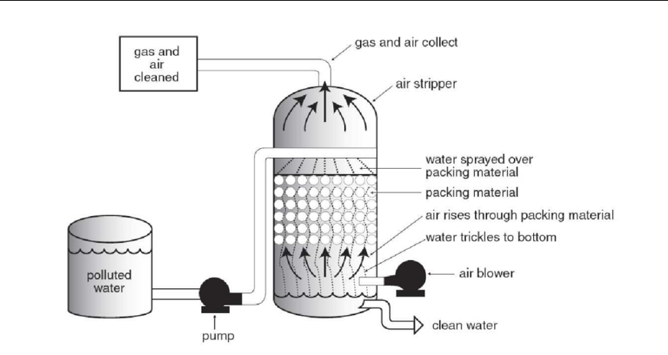

Figure 5.11: Air Stripper

5.5.3 Aeration

1. In the aeration process the water is either pumped up into the air or allowed to fall over an aeration device
2. Aeration as a water treatment practice is used for the following operations:

– carbon dioxide reduction (decarbonation)

– oxidation of iron and manganese found in many well waters (oxidation tower). Dur-ing aeration, iron and manganese get oxidized into an insoluble precipitate which is removed during filtration.

– ammonia and hydrogen sulfide reduction (stripping)

– Aeration is also an effective method of bacteria control.

1. Two general methods may be used for the aeration of water:

– Water-fall aeration Many variations of the water-fall principle are used for this type of aeration. The simplest configuration employs a vertical riser that discharges water by free fall into a basin.

– Air diffusion aeration where air is diffused into a receiving vessel containing counter-current flowing water, creating very small air bubbles. This ensures good air-water contact for "scrubbing" of undesirable gases from the water.

5.5.4 Iron and Manganese Sequestration

1. Polyphosphates are used for sequestering iron and magnesium. Sequestration is the ad-dition of chemicals to groundwater aimed at controlling problems caused by iron and manganese without removing them.
2. These chemicals are added to groundwater at the well head or at the pump intake before the water has a chance to come in contact with air or chlorine. This ensures that the iron

|  |  |
| --- | --- |
| 5.5 Other Treatment Processes | 149 |
|  |  |

and manganese stays in a soluble form.

* If the water contains less than 1.0 mg/L iron and less than 0.3 mg/L manganese, using polyphosphates followed by chlorination can be an effective and inexpensive method for mitigating iron and manganese problems.
* No sludge is generated in this method. Below these concentrations, the polyphosphates combine with the iron and manganese preventing them from being oxidized.
* Any of the three polyphosphates (pyrophosphate, tripolyphosphate, or metaphosphate) can be used.
* Applying sodium silicate and chlorine simultaneously has also been used to sequester iron and manganese. However, while this technique is reliable in the case of iron treatment, it has not been found to be effective in manganese control.

5.5.5 Fluoridation and Defluoridation

Fluoridation is the use of fluoride in the drinking water. Fluoride is an important component of bones and teeth. Fluoride deficiency causes weaker bones and tooth decay. Too much fluoride causes skeletal and dental fluorosis, resulting in brittle bones and mottled teeth, respectively. An effective daily dose of fluoride is 0.9 to 1.7 mg/L. A dose less than 0.7 mg/L does not do the job, and more than 4.0 mg/L can cause fluorosis leading to irreversible demineralization of bone and tooth tissues.

The U.S. Department of Health and Human Services Agency (HHS) is recommending that water systems practicing fluoridation adjust their fluoride content to 0.7 mg/L (parts per million), as opposed to the previous temperature-dependent optimal levels ranging from 0.7 mg/L to 1.2 mg/L.

EPA has set the maximum contaminant level for fluoride in the drinking water at 4mg/L. Addi-tionally, a secondary standard of 2.0 mg/L is intended as a guideline for an upper boundary level in areas which have high levels of naturally occurring fluoride.

Theoretically, any compound that forms fluoride ions in water solution can be used for increasing the fluoride content of a water supply. Most commonly used chemicals for this purpose include:

* Fluorosilicic acid fluorosilicic acid, as hexafluorosilicic acid (H2SiF6) which is a water-based solution used by most water systems in the United States. Fluorosilicic acid is also referred to as hydrofluorosilicate, FSA, or HFS.
* Sodium fluorosilicate as disodium hexafluorosilicate (Na2SiF6) which is a dry salt additive, dissolved into a solution before being added to water, and
* Sodium fluoride, a dry salt additive, typically used in small water systems, dissolved into a solution before being added to water.

In certain areas that have a naturally high level of fluoride in the groundwater defluoridation may have to occur. Defluoridation methods include:

* Precipitation method utilizes chemical such as Aluminum salts (i.e. Alum) and lime.
* Ion-Exchange Methods utilizes different ion-exchange materials studied include bone, bone char and anion and cation exchange resins.

150 Chapter 5. Water Treatment

* Adsorption method uses chemical and physical adosrbents including activated carbon and alumina (Al2O3). Activated alumina is used to treat water with fluoride concentrations from 4-20 mg/L in an adsorption process.

Fluoride Dosing Chemicals Safety

1. Rubber gloves, coveralls, and protective eyewear should be worn when handling fluoride.
2. Solid forms of fluoride are the most problematic to operators, since inhaling fluoride dust is very dangerous. A dust collector should be used and a respirator should be worn when handling fluoride powders.
3. Liquid forms, such as hydrofluosilicic acid, can also be dangerous. Hydrofluosilicic acid produces poisonous fumes which must be vented and which are irritating to the skin. The liquid itself can cause burns when allowed to touch skin.
4. The most extreme safety problem when dealing with fluoride is fluoride poisoning, which can be fatal. However, fluoride poisoning occurs only when a large amount of fluoride - approximately one tablespoon - is ingested. This is an amount much larger than would normally be inhaled while handling dry fluorides.
5. Accidental ingestion of fluoride chemicals can occur through contaminated food and drink. The operator should always wash his hands after handling fluoride chemicals and should not eat, drink, or smoke in areas where fluorides are used or stored.

5.5.6 Hardness Removal

* In almost every raw water supply, hardness is present as calcium and magnesium bicarbon-ate - (Ca/Mg)HCO3, often referred to as carbonate hardness or temporary hardness. These compounds result from the action of acidic, carbon dioxide laden rain water on naturally

occurring minerals in the earth, such as limestone. CO2 + H2O = H2CO3

H2CO3 + CaCO−3 = Ca(HCO3)2

* Hardness may also be present as a sulfate or chloride salt, referred to as noncarbonate or permanent hardness. These salts are caused by mineral acids present in rain water or the solution of naturally occurring acidic minerals.
* Softening removes hardness and alkalinity making the product water more corrosive.
* It may be necessary to add corrosion-inhibiting materials to the finished water to protect the distribution system and prevent possible simultaneous compliance issues with other regulations like the Lead and Copper Rule.
* Another option is to bypass a portion of water around the softening process and blending

the treated and untreated waters are blended to produce an effluent with a total hardness around 50 to 75 mg/L as CaCO3.

* Two common methods used to reduce hardness:
  + Cation exchange:

– In this process the calcium (Ca+2) and magnesium (Mg+2) ions that cause water

|  |  |
| --- | --- |
| 5.5 Other Treatment Processes | 151 |
|  |  |

hardness are replaced or exchanged with with a non-hardness ion like sodium.

– The exchange medium can be natural “zeolites” or synthetic resin beads that resemble wet sand and hold loosley the sodium ions provided by dissolving sodium chloride salt.

– As hard water passes through a softener, the calcium and magnesium trade places with sodium ions.

– Eventually when the exchange medium becomes coated with calcium and mag-nesium ions, it must be recharged or regenerated.

* Precipitation Softening

– Here the water is treated with lime or a combination of lime and soda ash (sodium carbonate, Na2CO3).

– These chemicals react with the hardness and natural alkalinity in the water to form insoluble compounds (precipitate) which are removed from the water by sedimentation and, usually, filtration.

– Waters with moderate to high hardness and alkalinity concentrations (150-500 ppm as CaCO3) are often treated in this fashion.

* 1. Lime removes bicarbonates - which cause carbonate hardness.
  2. Soda ash is used to remove chemicals that cause non-carbonate hardness.

– The addition of lime as either hydrated lime (calcium hydroxide - Ca(OH)2) or as quicklime (CaO) results in:

* 1. Increases the pH of water
  2. Reaction with calcium bicarbonate Ca(HCO3)− typically the major source of hardness converting it to CaCO3. For each molecule of calcium bicarbon-ate hardness removed, one molecule of lime is used.
  3. As the pH increases further, additional Ca(OH)2 will then react with mag-nesium bicarbonate Mg(HCO3) ultimately converting it to magnesium hy-droxide (Mg(OH)2. For each molecule of magnesium bicarbonate hardness removed, two molecules of lime are used.
  4. Calcium is removed in the 9.0-9.5 pH range and the pH needs to be at least 10.6 to remove magnesium.
  5. Both CaCO3 and Mg(OH)2 have limited solubility in water and precipitate out.
  6. Because CaCO3 and Mg(OH)2 precipitates are very slightly soluble, some hardness remains in the water–usually about 50 to 85 mg/l (as CaCO3). This hardness level is desirable to prevent corrosion problems associated with water being too soft and having little or no hardness.

– Use of lime along with soda ash with results in:

* 1. The magnesium non-carbonate hardness such as Mg(SO4) is converted by lime to Mg(OH)2 and Ca(SO4) - a form of calcium non-carbonate hardness
  2. The calcium non-carbonate hardness - CaSO4 is converted by soda ash to

152 Chapter 5. Water Treatment

CaCO3.

* 1. For each molecule of non-carbonate calcium hardness removed, one molecule of soda ash is used.
  2. For each molecule of non-carbonate magnesium hardness removed one molecule of lime plus one molecule of soda ash is used.
  3. When water has minimal magnesium hardness, only calcium needs to be removed. Only enough lime and soda ash are added to water to raise pH to between 10.3 and 10.6, and calcium hardness will be removed from the water (but minimal magnesium hardness will be removed).
  4. Extra lime addition is required to raise the pH above 10.6 to precipitate Mg(OH)2 out of the water.
  5. To improve magnesium reduction, which also improves silica reduction, sodium aluminate is added. The sodium aluminate provides hydroxyl ion

(OH−) needed for improved magnesium reduction, without increasing cal-cium hardness in the treated water. Additonal benefits of adding sodium aluminate comes from its formation of aluminum hydroxide which aids floc formation, conditions sludge blanket and helps reduce silica.

– The portion of raw water may be bypassed

– Precipitation softening is often done in conjunction with coagulation and floccu-lation.

– The precipitate formed is separated in the sedimentation tank as sludge.

– The high pH, softened water produced is corrosive and Recarbonation of the softened water using carbon dioxide (CO2) is conducted to lower the pH and thus its corrosivity.

– Lime softening produces large quantity of sludge.

– The reaction of Quicklime with water leading to the formation of Ca(OH)2 releases large quantity of heat and is dangerous if left uncontrolled. Also, Quicklime should never be stored with alum as the water of hydration in alum will react with quicklime causing an explosion

5.5.7 Corrosion Control

* Corrosion is the gradual deterioration or destruction of metal surfaces by chemical and electrochemical processes.
* As corrosive water stands or seals in pipes or tanks, it leaches metals from the piping, tanks, well casing, or other metal surfaces that water is in contact.
* Corrosion can happen both from the inside of pipes and fittings and from the outside - because of the action of the external environment - including soils.
* Lead and copper in service lines and household plumbing leach into the drinking water because of the corrosivity of water.
* Lead is a toxic metal that can be harmful to human health even at low exposure levels.

|  |  |
| --- | --- |
| 5.5 Other Treatment Processes | 153 |
|  |  |

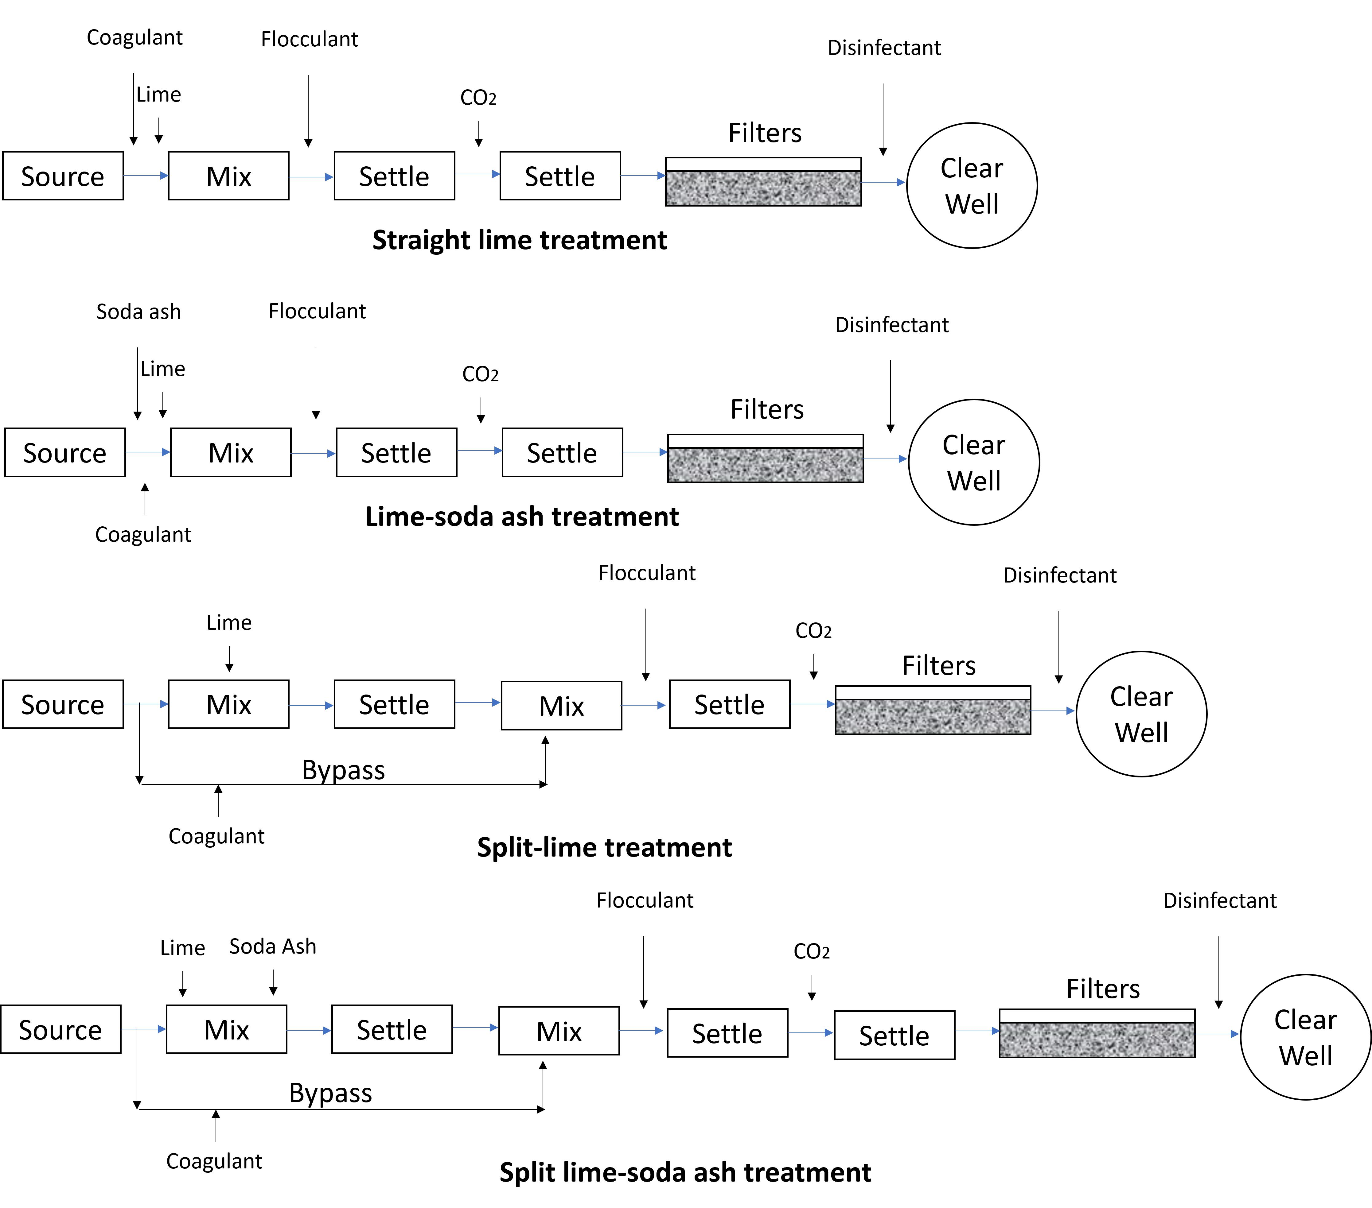

Figure 5.12: Precipitation Softening

154 Chapter 5. Water Treatment

Lead is persistent and can bioaccumulate in the body over time.

* The corrosivity of water will depend on the material of construction of the distribution system components and characteristics of water - water is less corrosive at higher pH and alkalinity.
* Corrosion potential of the water on the distribution system components can be mitigated by chemical treatment:

– Adding alkalinity in the form of lime, soda ash, or caustic soda to make the water stable or slightly scale-forming.

– Orthophosphates are added to chemically react with lead and copper atoms forming lead and copper phosphate. The lead and copper phosphate is then electrochemically drawn back down onto the piping surface, where it forms a tough, water-resistant coating on the piping.

– Silicate compounds added to water also inhibit corrosion by forming a thin protective films on pipe walls.

5.6 Best Available Technology (BAT)

Below is the summary of BATs - the very best (state-of-the-art) control and treatment measures that have been developed, or are capable of being developed, and that are economically achiev-able, identified in the California Code of Regulations.

5.6.1 BATs for Inorganics

|  |  |
| --- | --- |
| Chemical | Best Available Technologies (BATs) |
| Aluminum | 10 |
| Antimony | 2, 7 |
| Arsenic | 1, 2, 5, 6, 7, 9, 13 |
| Asbestos | 2, 3, 8 |
| Barium | 5, 6, 7, 9 |
| Beryllium | 1, 2, 5, 6, 7 |
| Cadmium | 2, 5, 6, 7 |
| Chromium | 2, 5, 6a , 7 |
| Cyanide | 5, 7, 11 |
| Fluoride | 1 |
| Mercury | 2 b , 4, 6 b , 7 b |
| Nickel | 5, 6, 7 |
| Nitrate | 5, 7, 9 |
| Nitrite | 5, 7 |
| Perchlorate | 5, 12 |
| Selenium | 1, 2 c , 6, 7, 9 |
| Thallium | 1, 5 |

* BAT for chromium III (trivalent chromium) only.
* BAT only if influent mercury concentrations <10 µg/L.

|  |  |
| --- | --- |
| 5.6 Best Available Technology (BAT) | 155 |
|  |  |

|  |  |  |
| --- | --- | --- |
| Treatment | How It Works | What It Removes |
| Method |  |  |
| Activated carbon | As water flows through the filter contam- | Pesticides; organic compounds such as benzene and carbon |
| filtration | inants adsorb, or stick to, the surface of | tetrachlo- ride; many odors; bacterial or colloidal iron or |
|  | activated carbon particles. | tannins when combined with continuous chlorination; radon; |
|  |  | lead or copper if equipped with special media; some other |
|  |  | heavy metals in certain cases; chlorine; chloramines; tri- |
|  |  | halomethanes. Filters with molded activated carbon blocks |
|  |  | will treat Cryptosporidium and Giardia. |
| Reverse osmosis | Contaminants are removed by forcing water | Certain tastes; some pesticides; high chloride content; fluo- |
| (RO) | through a membrane which has microscopic | ride; nitrate; lead, copper, and other heavy metals; arsenic; |
|  | holes. Water molecules pass through the | Cryp tosporidium; viruses. |
|  | membrane but larger particles cannot. The |  |
|  | membrane is flushed to remove trapped |  |
|  | contaminants. |  |
|  |  |  |
| Ion exchange | As water passes through a resin bed in | Hard water (calcium and magnesium); dissolved iron; man- |
| water softening | the softener, calcium and magnesium in | ganese; will treat cadmium, copper and zinc if operated |
|  | the water are exchanged for sodium or | properly. |
|  | potassium which do not create the nuisance |  |
|  | problems associated with hard water. |  |
| Sediment filtra- | As water passes through a filter made of | Sediment; acidic water when preceded by soda ash feed; |
| tion | sand, filter paper, compressed glass wool or | dissolved iron or manganese when preceded by continuous |
|  | other straining material suspended particles | chlorination, ozonation or aeration; turbidity. |
|  | such as sand, soil or other particles are |  |
|  | trapped on the filter. |  |
| Distillation | Water is heated to create steam which is | Sediment; high salt content; high total dissolved solids; |
|  | then condensed to be collected as treated | pesticides if properly equipped with gas vent; fluoride; nitrate; |
|  | water. Contaminants removed remain in | lead, copper and other heavy metals; arsenic; bacteria. |
|  | the heating chamber or boil off into the |  |
|  | atmosphere. |  |
| Aeration | Oxygen is introduced into the water by an | Dissolved iron or manganese when followed by sediment |
|  | aerator. This oxidizes contaminants such as | filtration; may help reduce rotten egg odor from dissolved |
|  | iron and manganese, causing them to form | hydrogen sulfide gas; radon. |
|  | solids which can then be filtered out of the |  |
|  | water. |  |
| De-Aeration | Mix air with water to remove dissolved | Dissolved hydrogen sulfide gas; radon. De-aeration equip- |
|  | gases from the water. Aeration and | ment sometimes are very similar, but are designed for differ- |
|  |  | ent treatment goals. |
| Continuous | Chlorine is fed or injected into the water | Dissolved iron or manganese when followed by sediment |
| Chlorination | to kill bacteria and other microbial con- | filtration; rotten egg odor from dissolved hydrogen sulfide gas |
|  | taminants, as well as to oxidize iron and | or sulfate-reducing bacteria (followed by activated carbon fil- |
|  | manganese causing them to form solids | tration); bacterial or colloidal iron or tannins when combined |
|  | which can then be filtered out. | with activated carbon filtration; bacteria; Giardia; viruses. |
| Ultraviolet (UV) | As water passes through the system, a |  |
| radiation | special lamp produces ultraviolet light |  |
|  | that kills bacteria and other microbial |  |
|  | contaminants. |  |
| Ozonation | Water enters a system where ozone is | Bacteria; Giardia; Cryptosporidium; viruses; Ozonation |
|  | produced and mixed with the water, a | destroys bacteria and other microbial pathogens and oxidizes |
|  | chemical form of pure oxygen, | compounds such as iron and manganese causing them to form |
|  |  | solids which can then be filtered out using sediment filtration. |
| Ultra, micro, and | As water passes through a filter, suspended | Cryptosporidium; Giardia; viruses. |
| nano filtration | particles are trapped on the filter. Particles |  |
|  | removed depends upon the size of the pores |  |
|  | in the filter. Pore sizes from smallest to |  |
|  | largest are nanofiltration, ultra filtration and |  |
|  | microfiltration. |  |

Table 5.1: Summary of Water Treatment Methods

156 Chapter 5. Water Treatment

* BAT for selenium IV only. where:

1 = Activated Alumina

2 = Coagulation/Filtration (not BAT for systems <500 service connections) 3 = Direct and Diatomite Filtration

4 = Granular Activated Carbon

5 = Ion Exchange

6 = Lime Softening (not BAT for systems <500 service connections) 7 = Reverse Osmosis

8 = Corrosion Control

9 = Electrodialysis

10 = Optimizing treatment and reducing aluminum added

11 = Chlorine oxidation

12 = Biological fluidized bed reactor

13 = Oxidation/Filtration

5.6.2 BATs for Microbiological Contaminants

Best available technology (BAT) (for a public water system serving more than 10,000 persons), affordable technology (for a public water system serving 10,000 or fewer persons), treatment techniques, or other means available for achieving compliance with the E. coli MCL are as fol-lows:

1. Protection of wells from fecal coliform contamination by appropriate placement and construc-tion;
2. Maintenance of a disinfectant residual throughout the distribution system;
3. Proper maintenance of the distribution system including appropriate pipe replacement and repair procedures, main flushing programs, proper operation and maintenance of storage tanks and reservoirs, cross connection control, and continual maintenance of positive water pressure in all parts of the distribution system;
4. Filtration and/or disinfection of approved surface water, in compliance with Section 64650, or disinfection of groundwater, in compliance with Section 64430, using strong oxidants such as chlorine, chlorine dioxide, or ozone; and
5. For a system using groundwater, compliance with the groundwater portion of a Drinking Water Source Assessment and Protection Program.

|  |  |  |  |  |
| --- | --- | --- | --- | --- |
|  | 5.7 Chemical Feed Systems | 157 | |  |
|  |  |  |  |  |
| 5.6.3 BATs for Radionuclides | |  |  |  |
|  |  |  |  |  |
|  | Radionuclide | Best Available Technology |  |
|  | Combined radium-226 and radium-228 | Ion exchange, reverse osmosis, lime softening |  |  |
|  | Uranium | Ion exchange, reverse osmosis, lime softening, |  |  |
|  |  | coagulation/filtration |  |  |
|  |  |  |  |  |
|  | Gross alpha particle activity | Reverse osmosis |  |  |
|  | Beta particle and photon radioactivity | Ion exchange, reverse osmosis |  |  |

5.7 Chemical Feed Systems

* Chemical feed systems are designed for automated and precise injection (dosing) of chemi-cals into the water to be treated.
* Chemical feed systems are mainly employed for the following types of water treatment:

– Disinfection

– Flocculation and Coagulation

– Nutrient Removal

– Sludge Conditioning

– Alkalinity Supplementation

– Corrosion Inhibition

* The chemical feed systems is comprised of different components and is typically designed to ensure suitability with the chemical dispensed and the environment.
* There are three types of chemicals used by chemical feed systems:

1. Dry Chemicals: These chemicals are in dry, powdered form. Sodium bicarbonate, calcium hypochlorite, calcium chloride, algaecides, and soda ash are a few popular types of dry chemicals. Dry chemicals may or may not be mixed with liquids.
2. Liquid Chemicals: These are most common form of chemicals used due to the ease of use. Aluminum sulfate or liquid alum, 50% sodium hydroxide, and caustic soda are a few liquid chemicals used regularly.
3. Gaseous Chemicals: Chlorine gas is widely used in water treatment for disinfection.

5.7.1 Key Components of a Chemical Feed System

Delivery Systems

* Feed pumps carry chemicals for dosing.
* Metering pumps are the most common types of feed pumps used for liquid chemical feed systems. Types of chemical metering pumps used in the water industry include:

– Diaphragm Pumps:

* A diaphragm pump consists of one or more pumping chambers alternately filled

and discharged by the movement of flexible diaphragms and check valves on the inlet and outlet.

* The diaphragm pump is composed of the following:
  + A chamber used to pump the fluid

158 Chapter 5. Water Treatment

* A diaphragm or diaphragms operated by either electric or mechanical means
* Two valve assemblies: a suction valve assembly and a discharge valve as-sembly

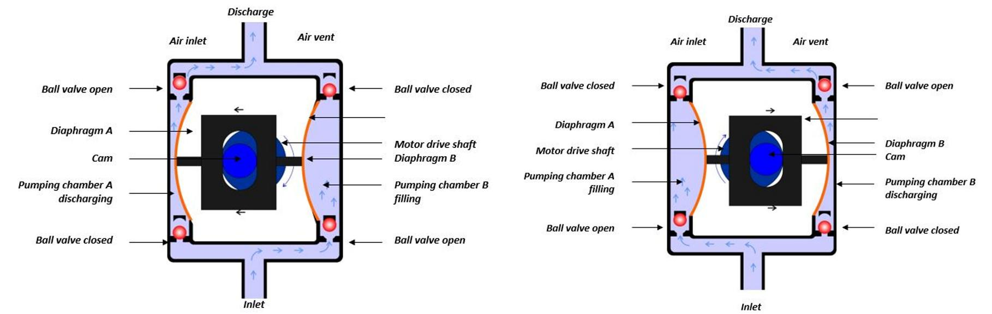

Figure 5.13: Air Operated Double Diaphragm Pump

* + These pumps are widely used to handle mostly all liquid chemicals, as well as sludges and slurries with ease.

– Peristaltic Pumps:

* + These pumps are also known as roller pumps because it uses a set of rollers to pump the fluid.
  + The chemical fluid to be pumped is contained in a flexible tube, which is posi-tioned inside a pump casing.
  + The rotors equipped with rollers compress the tube, thereby forcing the fluid to move towards the pipe. The pump comes to its original position after the fluid moves out. This whole process is known as peristalsis.
  + Peristaltic pumps are suited for applications requiring small feed rates of < 0.1 gallons per hour.

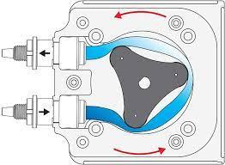

Figure 5.14: Peristaltic Pump

– Other Metering pumps include: Packed Plunger Pumps, Liquid Gravity Feeders and Jet Pumps (Eductors)

* For dry chemicals the following types of feeder systems are used:

– Volumetric Feeders: These feeders dispense an accurate amount of powdered mate-rial. Volumetric feeders are generally used for feeding dry chemicals such as lime slaking, lime feed, clay feed, dry polymer, and so on.

|  |  |
| --- | --- |
| 5.7 Chemical Feed Systems | 159 |
|  |  |

– Gravimetric Feeders: The feeders feed chemicals by weight. Gravimetric feeders assure accuracy within 1-2%.

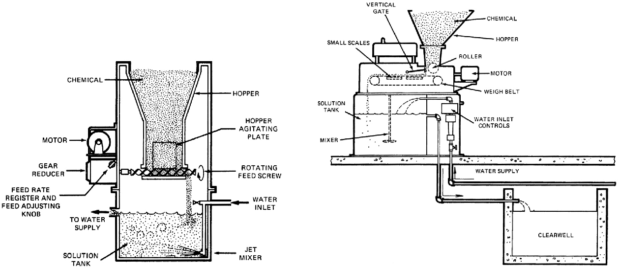

Volumetric Feeder Gravimetric Feeder

Figure 5.15: Dry Chemical Feeders

* Gaseous chemicals are transferred using gas feeders. To ensure safety, particularly when used in an application involving chemical such as chlorine, these gas systems are used under vacuum. To use these systems, special equipment and arrangements need to be done. Self-contained breathing equipment, special containment chorine rooms, chlorine gas detectors, as well as chlorine air room scrubbers are some of the requirements.

Chemical Storage Systems

Solution tanks are the chemical storage systems used for holding chemical solutions to be fed into the water. There are three types of chemical storage systems used:

* Bulk Storage: The storage tank of this type can hold liquid chemicals in bulk. The chem-icals for treatment are delivered by a carrier or a vendor truck. The tank is usually posi-tioned near the feed system.
* Semi Bulk Storage: This type of storage is ideal for applications that do not use chemical feeds regularly. Semi bulk storage tanks are designed in such a way that the tanks can be stored easily by stacking above one another when not in use.
* Drum Storage: This was one of the most popular methods of chemical storage until a few years back. Safe disposal of drums after the end of their lifespan was one of the key challenges faced by users. To avoid this, nowadays, reusable containers - totes are used.

Accessories

* Mixers: The job of the mixer is to rapidly disperse the chemical additives to ensure a uni-form mixture. A rapid (or flash) mixer utilizes specifically designed impeller to uniformly disperse and blend chemicals, such as coagulant aids, chlorine, and sulfur dioxide, into the

160 Chapter 5. Water Treatment

process stream. Flash mixer can be installed in a tank, process chamber or pipe.

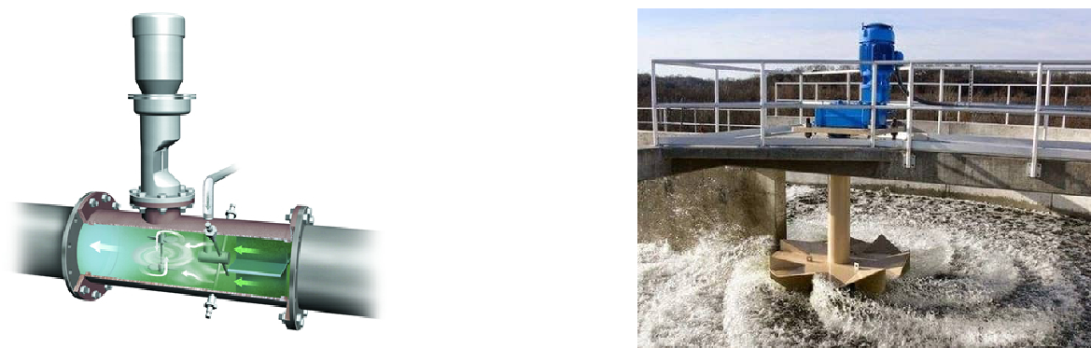

In-line Flash Mixer

Process Flash Mixer

Figure 5.16:

Flash Mixers

* Timers: Timers used to control the function of mixers, as well as the feeding of chemicals.
* Alarms: Alarms are typically used as monitoring systems for different components of the chemical dosing system. They can be set to monitor tank levels, chemical feed rates, pump status, and changed operating conditions. Alarms help to reduce damages caused due to dry running or change in operating variables, or some unspecified conditions.
* Level Gauges: As the name indicates, these devices are used to monitor the level of chemi-cals in tanks.
* Control Panels: The control panel may also contain lights that indicate the status of the pumps, various alarm conditions, and hour meters.

Types of Chemical Feed Systems

* Chemicals are fed into the water stream in different ways based on the required feed rate and feed pump output.
* Typically, solid and liquid chemicals can be fed in any of the following ways:

– Continuous Feed: This system is commonly used for liquid chemicals, which are continuously fed into the water tank. This feed system is commonly employed for deposit control in once-through systems, as well as domestic water chlorination.

The continuous feed may be provided by a gravity drip feed, where the feed rate is regulated by a needle valve.

– Shot/slug Feed: The chemical is shot/slug-fed by an on-off control on a feeder pump. It may also be discharged from a measuring chamber or a calibrated pump. This type of feeding is widely used in bio-oxidation basins or cooling systems with high system volume to blowdown ratio.

* For gaseous chemicals dosing, the following two methods are utilized.

– Solution Feed: This type of feeding is seen in vacuum-type feeders, where gas is drawn to the piping system by vacuum. If there is any leak in piping then it leads to vacuum loss, and as a result, the system is shut down for supply. The vacuum feeders

|  |  |
| --- | --- |
| 5.7 Chemical Feed Systems | 161 |
|  |  |

use ejectors to create a vacuum required for operation.

– Direct Feed: In this feed, gas is fed into the flow stream to be treated. This involves the direct injection of gas under high pressure. This type of feeding is usually re-stricted to small applications, which have no regular water supply for solution feed.

Chemical control systems

Typical types of chemical control systems include:

* Manual Controls: This is one of the simplest, yet popular controls employed in the water industry. The output of the pump is set manually using dials or knobs, and the pump is put on or off using a manual switch. Sometimes, the power supply on the pump is put on or off for operating or closing the pump.
* Automatic chemical dosing control instrumentation is usually set up as either a “feed forward” or a “feedback” loop.

– An example of a feed forward loop would be a venturi flow meter which is located forward of the chlorine feed point sending a signal to change a chlorine dosage based on a change in flow.

– An example of a feedback loop would be a chlorine analyzer located downstream of the chlorine dosage point, changing the chlorine dosage based on a change in residual downstream of the chlorinator.

* On-off Constant Rate Mode: In this type of pump control, the pump on and off is auto-mated. This control is more apt for cooling towers or other similar applications that do not require a continuous or regular feed of chemicals. In short, it is most suitable for control-ling acid feed rates at low or high pH setpoints.



Chapter 5 Assessment

Chapter 5 Assessment

1. What is the purpose of coagulation and flocculation?
   1. control corrosion
   2. to kill disease causing organisms
   3. to remove leaves, sticks, and fish debris
   4. to remove particulate impurities and suspended matter
2. How are filter production (capacity) rates measured?
   1. Mgd/sq.ft.
   2. Gpm/sq.ft.
   3. Gpm
   4. Mgd
3. Why should a filter be drained if it is going to be out-of-service for a prolonged period?
   1. to allow the media to dry out
   2. to save water
   3. to prevent the filter from floating on groundwater levels
   4. to avoid algal growth
4. Which of the following are commonly used coagulation chemicals?
   1. hypochlorites and free chlorine
   2. sodium and potassium chlorides
   3. alum and polymers
   4. bleach and HTH
5. How can an operator tell if a filter is NOT completely cleaned after backwashing?

164 Chapter 5. Water Treatment

a. the initial headloss is on the high side

b. the backwash rate was too slow

c. mudballs are NOT present

d. backwashing pumping rate is too low

1. Flocculation is defined as
   1. the gathering of fine particles after coagulation by gentle mixing
   2. clumps of bacteria
   3. the capacity of water to neutralize acids
   4. a high molecular weight of compounds that have negative charges
2. A multi-barrier water filtration plant that contains a flash mix, a coagulation/flocculation zone, sedimentation, filtration and a clear well is considered to be a
   1. community special treatment plant
   2. direct filtration plant
   3. reverse osmosis plant
   4. conventional filtration plant
   5. traditional plant
3. The filtration unit process usually
   1. is located at the beginning of a filtration plant
   2. follows the coagulation/flocculation/sedimentation processes
   3. is located after the clear well area
   4. is located on the plant effluent line after the clearwell
4. Filters are generally backwashed when the loss-of-head indicator registers a certain set value, such as 6-ft, or upon a certain time, say 48-hours, or upon a rise in
   1. alkalinity
   2. a jar-test result
   3. turbidity
   4. temperature
5. What is a method of reducing hardness?
   1. Softening
   2. Hardening
   3. Lightning
   4. Flashing
6. The solid that adsorbs a contaminant is called the:
   1. Adsorbent
   2. Adsorbate
   3. Sorbet
   4. Rock
7. The adsorption process is used to remove:
   1. Organics or inorganics
   2. Bugs or salts

|  |  |
| --- | --- |
| 5.7 Chemical Feed Systems | 165 |
|  |  |

c. Organisms or dirt

d. Color or particles

1. Describe two primary methods used to control taste and odor?
   1. Oxidation and adsorption
   2. Filtration and sedimentation
   3. Mixing and coagulation
   4. Sedimentation and clarification
2. What is the recommended loading rate for copper sulfate for algae control at an alkalinity greater than 50mg/L ?
   1. 0.9 of copper sulfate per acre of surface area
   2. 1.9 of copper sulfate per acre of surface area
   3. 2-4 lb of copper sulfate per acre of surface area
   4. 5.4 of copper sulfate per acre of surface area
3. The basic goal for water treatment is to
   1. Protect public health
   2. Make it clear
   3. Make it taste good
   4. Get stuff out

|  |  |  |  |  |
| --- | --- | --- | --- | --- |
| 16. Greensand can be operated in either |  | regeneration or |  | regeneration |
| modes. |  |  |  |  |
| a. Continuous or intermittent |  |  |  |  |
| b. Fast or slow |  |  |  |  |
| c. Hot or cold |  |  |  |  |
| d. Constant or unusual |  |  |  |  |

VI Chapter 6

6 Disinfection . . . . . . . . . . . . . . . . . . . . . . . . 169

6.1 Background

6.2 Chlorination

6.3 Chlorine Dioxide

6.4 Ultraviolet (UV) disinfection

6.5 Ozonation

6.6 Summary of Disinfectants’ Attributes

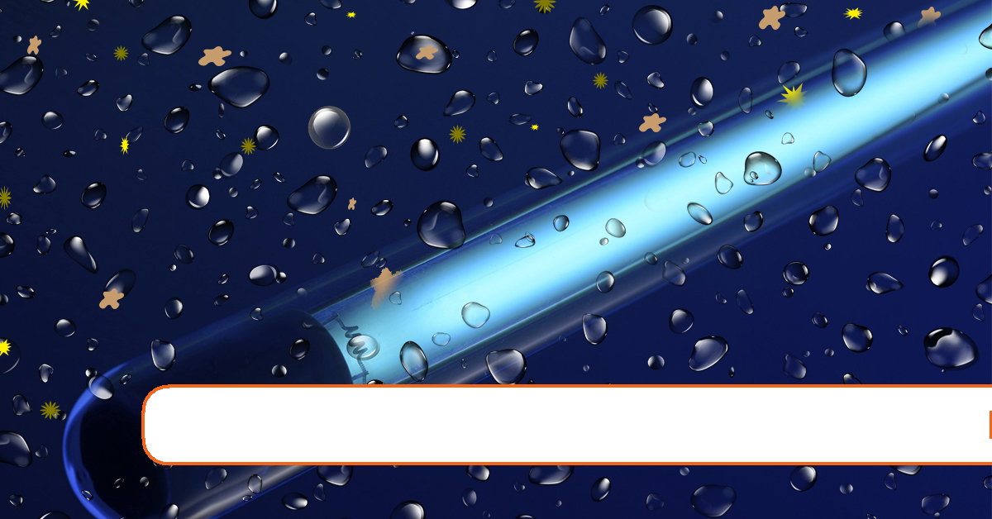170 Chapter 6. Disinfection

6. Disinfection

Expected Range of Knowledge for Water Properties and Sources Water Distribution System Operator License Exams

|  |  |
| --- | --- |
| D1 | Ability to measure total chlorine |
| D1 | Ability to monitor and interpret chlorine residual |
| D1 | Knowledge of causes of chlorine demand |
| D1 | Knowledge of contact time |
| D1 | Knowledge of dechlorination techniques |
| D1 | Knowledge of the purpose of disinfection |
| D1 | Ability to apply disinfectant |
| D1 | Knowledge of water main disinfectant techniques |
| D1 | Knowledge of well disinfection techniques |
| D2 | Ability to choose the proper disinfectant technique |
| D2 | Ability to recognize when breakpoint has been met |
| D2 | Knowledge of advantages/disadvantages of chloramination |
| D2 | Knowledge of chloramine compounds |
| D2 | Knowledge of chlorine analysis techniques |
| D2 | Knowledge of disinfectant types and characteristics |
| D2 | Knowledge of factors affecting chlorine disinfection |
| D2 | Knowledge of the causes of DBPs |
| D2 | Knowledge of the chlorine curve |
| D2 | Knowledge of the definition of breakpoint chlorination |
| D2 | Ability to calculate chlorine/ammonia ratio for chloramination |
| D2 | Ability to calculate the surface area of the interior walls of a storage reservoir |
| D3 | Ability to calculate CT |
| D3 | Ability to recognize abnormal levels of DBPs in the water distribution system |
| D3 | Knowledge of chlorine chemistry |
| D3 | Knowledge of DBP compounds |
| D3 | Knowledge of DBP formation |
| D3 | Knowledge of DBP reduction methods |

171

Expected Range of Knowledge for Water Properties and Sources Water Treatment Operator License Exams

T1 Knowledge of acceptable chlorine residual levels

T1 Knowledge of breakpoint chlorination chemistry

T1 Knowledge of chlorine chemistry

T1 Knowledge of common chlorine compounds used for disinfection

T1 Knowledge of disinfectant byproduct formation

T1 Knowledge of disinfectant properties and uses

172 Chapter 6. Disinfection

6.1 Background

* The primary goal of water treatment is to ensure that the water is safe to drink and does not contain any disease-causing microorganisms.
* Disinfection refers to an operation to inactivate the microorganisms in water that can cause an infection or disease. These organisms are collectively referred to as pathogens and include many species of bacteria, fungus, protozoa, worms, viruses, etc.
* The processes prior to disinfection - sedimentation and filtration, remove a large percent-age of bacteria and other microorganisms from the water by physical means.
* Disinfection is different from sterilization, which is the complete destruction of all organ-isms which is expensive and unnecessary.
* Water disinfection can be sub-divided as:
  1. Primary disinfection :

– Kills or inactivates bacteria, viruses, and other potentially harmful organisms in drinking water.

– Disinfection prevents infectious diseases such as typhoid fever, hepatitis, and cholera

– Some disinfectants are more effective than others at inactivating certain poten-tially harmful organisms.

– Disinfection processes vary from water utility to water utility based on their needs and to meet EPA treatment requirements.

* 1. Secondary disinfection :

– Maintenance of a disinfectant residual that prevents regrowth of microorganisms in the water distribution system between treatment and consumer.

– Secondary disinfection maintains water quality by killing potentially harmful organisms such as those that cause Legionnaire’s disease that may get in water as it moves through pipes.

– Monochloramine is commonly used as a secondary disinfectant.

* Elements of an "ideal" disinfectant

– It must act in a reasonable time.

– It must act as temperature or pH changes.

– It must be nontoxic.

– No harmful byproducts.

– It must not add unpleasant taste or odor.

– It must be readily available.

– It must be safe and easy to handle and apply.

– It must be easy to determine the concentration of.

– It must be able to provide residual protection.

– Pathogenic organisms must be more sensitive to the disinfectant than are non-pathogens.

– It must be capable of being applied continually.

|  |  |
| --- | --- |
| 6.2 Chlorination | 173 |
|  |  |

– Versatile: effective against all types of pathogens.

– Fast-acting: effective within short contact times

– Robust: effective in the presence of interfering materials including particulates, sus-pended solids and other organic and inorganic constituents

– Handy: easy to handle, generate, and apply (nontoxic, soluble, non-flammable, non-explosive)

– Compatible with various materials/surfaces in WTPs (pipes, equipment)

– Economical

* In addition to the desirable characteristics of a disinfectant listed above, the disinfectant chosen must be able to kill off or deactivate pathogenic microorganisms by one of several possible methods, including:

1. Damaging the cell wall

2. Altering the ability to pass food and waste through the cell membrane

3. Altering the cell protoplasm

4. Inhibiting the cells’ conversion of food to energy

5. Inhibiting reproduction

* Most chemical disinfectants being strong oxidizers, aid the water treatment process by providing other benefits which include:

– Taste and odor control

– Oxidize iron and manganese

– Limit nuisance growths - algae

– Reduce mudball formation in filter media

– Limit anaerobic sludge conditions

– Improving coagulation

6.2 Chlorination

* Despite potential drawbacks, chlorine is the disinfectant of choice.
* In general, chlorination is effective, relatively inexpensive, and provides effective levels of disinfectant residual for safe distribution.
* Chlorine can be applied as:

– As a gas - elemental chlorine, Cl2:

– Liquid (sodium hypochlorite)

– Solid (calcium hypochlorite)

each of these forms has advantages and disadvantages.

6.2.1 Chlorine properties

* Chlorine is a yellowish-green gas at room temperature and atmospheric pressure
* Chlorine gas can be pressurized and cooled to its liquid form for making it easy to ship and store.

174 Chapter 6. Disinfection

* When liquid chlorine is released, it quickly turns into a gas that stays close to the ground (being heavier than air) and spreads rapidly.
* While it is not explosive or flammable, as a liquid or gas it can react violently with many substances
* Chlorine is only slightly soluble in water (0.3 to 0.7% by weight.)
* Chlorine gas has a greenish-yellow color
* It has a characteristic disagreeable and pungent odor, similar to chlorine-based laundry bleaches, and is detectable by smell at concentrations as low as 0.2 to 0.4 ppm
* It is about two and a half times as heavy as air
* One volume of liquid chlorine yields about 460 volumes of chlorine gas.
* Liquid chlorine is amber in color and is about one and a half times as heavy as water
* Chlorine is an irritant to the eyes, skin, mucous membranes, and the respiratory system

6.2.2 Chlorine storage and safety

* Chlorine gas is lethal at concentrations as low as 0.1% air by volume. In nonlethal concen-trations, it irritates the eyes, nasal membranes, and respiratory tract.
* Typically for smaller plants chlorine gas is shipped in pressurized steel cylinders - 150 lb or 2000 lb (ton cylinder) size. Larger plants may get their chlorine supply in rail tank cars.
* The daily chlorine usage is typically established based upon the weighing of the chlorine containers.
* The withdrawal rates from a chlorine cylinder is based on the temperature of the liquid in the cylinder, and thus the pressure of the gas.
* As chlorine gas is withdrawn from the cylinder, it absorbs the heat from the surroundings.
* For low withdrawal rates, heat will be able to be transferred from the surrounding air to the container in time so that there is no drop in temperature or pressure,
* If the chlorine withdrawal is larger, the air will not be able to transfer the heat quickly enough and the temperature (and pressure) of the chlorine will drop, thus resulting in a lower feed rate.
* If high enough and prolonged enough, this can even result in ice formation around the outside of the container, further decreasing the withdrawal rate.
* The most effective way to increase withdrawal rate from a single container is to circulate the surrounding air with a fan. Again, never apply heat to the containers.
* The maximum withdrawal rate for 100 or 150-pound cylinders should be limited to 40 pounds per day per cylinder. The maximum withdrawal rate for one-ton containers should be limited to 400 pounds per day per cylinder.
* If chlorine gas escapes from a container or system, being heavier than air, it will seek the lowest level in the building or area
* Only trained staff with access to proper personal protection equipment (PPE) including self-contained breathing apparatus, should handle the chlorine cylinders and address chlo-rine leak issues

|  |  |
| --- | --- |
| 6.2 Chlorination | 175 |
|  |  |

* When a leak is suspected, it is recommended that ammonia vapors be used to find the source. When ammonia vapor using a rag or brush, is directed at a leak, a white cloud will form. To produce ammonia vapor, a plastic squeeze bottle containing about 5 % ammonia, aqua ammonia (ammonium hydroxide solution) should be used. A weaker solution such as household ammonia may not be concentrated enough to detect minor leaks
* All safety equipment should be located outside of the chlorine room and be easily accessed by all personnel
* Small leaks around valve stems can usually be corrected by tightening the packing nut or closing the valve. A leak can also be reduced by removing the chlorine as rapidly as possible
* If it cannot be added to the process there are several chemicals which can be used to ab-sorb the chlorine gas. For example, chlorine can be absorbed by using 1 1 pounds of caus-

4

tic soda or hydrated lime, or 3 pounds of soda ash per pound of chlorine.

* If the leaking container can be moved, it should be transported to an outdoors area where minimal harm will occur. Keep the leaking part the most elevated so that gaseous chlorine will leak rather than liquid chlorine.
* If the leak is large, all persons in the adjacent area must be warned and evacuated. Only authorized persons equipped with the proper breathing apparatus, and protective measures to the eyes and body should investigate.
* As water is not an efficient absorbent for chlorine and the fact that chlorine reacts with water to form very corrosive hydrochloric acid, never apply water to a leak or consider submerging a chlorine cylinder (for example, in a pond or tank), since it will probably float.
* Remember to keep windward of the leak.
* As chlorine cylinders pressure increases with temperature, as a safety measure the chlorine cylinders are fitted with fusible plug which melts between 158o and 165o F.
* Keep chlorine cylinder or container emergency repair kits available. Be familiar with their use and location.
* Leaks at fusible plugs and cylinder valves requires special handling and emergency equip-ment. The chlorine supplier must be notified immediately
* Pin hole leaks in cylinder walls or ton tanks can usually be stopped by mechanical pres-sure applications (clamps, turnbuckles, etc.). This only temporary and may require your ingenuity.
* Leaking containers cannot be shipped.
* In general, daily inspection of all chlorine cylinders will avoid major problems
* In order to respond to leaks in chlorine containers, kits specific to the size of the container have been developed by the Chlorine Institute .

– Emergency Kit "A" is designed for use with the standard 100 and 150 pound capacity cylinders in chlorine service only. It contains devices and tools to contain leaks in

176 Chapter 6. Disinfection

and around the cylinder valve and in the side wall of chlorine cylinders.

– Emergency Kit "B" is designed for use with the standard chlorine ton container. It contains devices and tools to contain leaks in and around the ton container valves and in the side wall of ton containers.

– Emergency Kit "C" is designed for use with the standard chlorine tank car, chlorine cargo tank and portable tank in chlorine service.

6.2.3 Forms of chlorine

* Due to safety issues related to the use of chlorine gas, hypochlorites are often used in lieu of chlorine
* Types of hypochlorites

– Sodium hypochlorite (NaOCl) comes in a liquid form which contains up to 12.5%

chlorine

– Calcium hypochlorite (Ca(OCl)2), also known as High-test Hypochlorite (HTH), is a solid which is mixed with water to form a hypochlorite solution. Calcium hypochlo-rite is 65-70% concentrated.

* Hypochlorites decompose in strength over time while in storage. Temperature, light, and physical energy can all break down hypochlorites before they are able to react with pathogens in water.

6.2.4 Chlorine reactions related to disinfection

Chlorine reacts with water to form hypochlorous and hydrochloric acids

|  |  |  |  |  |  |  |  |
| --- | --- | --- | --- | --- | --- | --- | --- |
| Cl2 | + | H2O |  | HOCl | + | HCl |  |
| chlorine | | water |  | hypochlorous acid | | hydrochloric acid | |
| • | Hypochlorous acid dissociates in water to form the hydrogen and hypochlorite ions | | | | | | |
|  | HOCl |  |  |  | H+ | + | OCl− |
|  | hypochlorous acid | |  | hydrogen ion | |  | hypochlorite ion |

– Hypochlorous acid is the most effective form of chlorine available to kill microorgan-isms

– Hypochlorite ions is much less efficient disinfectant

* The concentration of hypochlorous acid and hypochlorite ions in chlorinated water will depend on the water’s pH

– A higher pH facilitates the formation of more hypochlorite ions and results in less hypochlorous acid in the water

* A significant percentage of the chlorine is still in the form of hypochlorous acid even between pH 8 and pH 9

6.2.5 Factors affecting chlorine disinfection

The disinfection efficiency of chlorine depends on the following factors:

|  |  |
| --- | --- |
| 6.2 Chlorination | 177 |
|  |  |

* pH: Disinfection is more efficient at a low pH when large quantities of hypochlorous acid are present than at a high pH when hypochlorite ions is the dominant species in the water
* Concentration: Contact Time Ratio (CT): For effective chlorine disinfection both sufficient chlorine dosages – concentration (C) as well as contact time (T) are necessary. Generally both of these factors must be worked out experimentally for a given system
* Disinfection activity can be expressed as the product of disinfection concentration (C) and contact time (T) - CT
* The same CT values will achieve the same amount of inactivation
* Temperature: Colder temperatures are less favorable for disinfection. Proper contacting or

mixing or agitation: This is necessary to make sure that the chlorine applied contacts or reaches the microbial cells

* Organic and inorganic material present: The chlorine used by these organic and inorganic reducing substances including metal ions, organic matter and ammonia, is defined as the chlorine demand. So that the amount of chlorine that has to be added to wastewater for different purposes will also vary.

6.2.6 Chlorine Application

* Continuous chlorination of systems less than 75 gpm is by the use of a hypochlorinator where a motor driven pump pulls the hypochlorite solution out of a holding chamber and pumps it into the water to be treated. Where the pipe from the pump joins the pipe carry-ing the raw water, the Venturi effect creates a small vacuum and pulls the chlorine solution into the water.
* For larger system, chlorinators - devices which introduce chlorine gas to water using liquid chlorine supplied in steel cylinders are used.
* In the commonly used Vacuum Chlorinator:

– Chlorine gas is pulled from the cylinder into the source water by a vacuum created by water flowing through the injector and creating a negative head.

– This negative head forces open the pressure regulating valve on the cylinder and allows chlorine gas to flow out of the cylinder and into the chlorinator.

– Once the gas has entered the chlorinator, the chlorine feed rate is measured using an indicator known as a rotameter

– Just beyond the rotameter, the chlorine gas flows past a regulating device (a V-notch

plug or a valve) which is used to adjust the chlorine feed rate.

6.2.7 Chlorination Byproducts

* Main drawback of chlorine disinfection is the adverse health effects of the byproducts
  + Disinfection by-products ( DBPs ) formed from its reaction with certain organic com-pounds present in the water.
* Adverse health effects on humans exposed to DBPs through drinking-water and oral, der-mal, and inhalational contact with chlorinated water, include cancers of vital organs.
* Halogenated trihalomethanes ( THMs ) and haloacetic acids ( HAAs ) are two major

178 Chapter 6. Disinfection

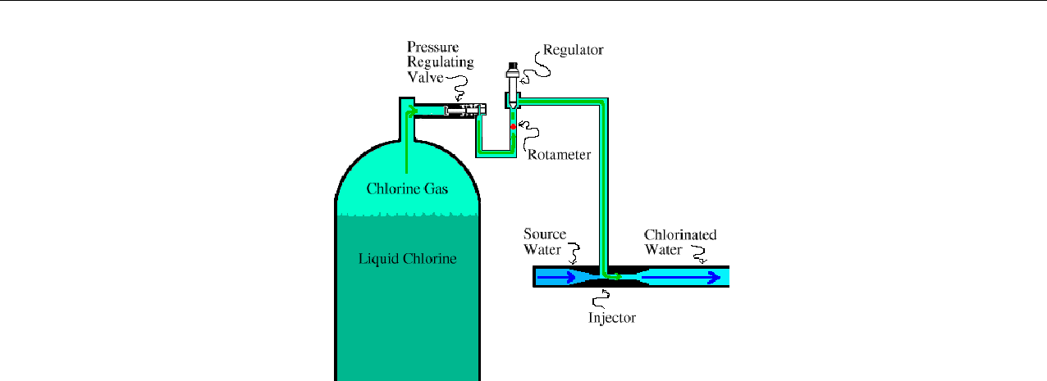

Figure 6.1: Vacuum Chlorinator

classes of disinfection byproducts (DBPs) commonly found in waters disinfected with chlorine.

* At the present time, about 90% of U.S. water utilities use chlorine to disinfect water. Al-though chlorine has virtually eliminated the risks of waterborne disease such as typhoid fever, cholera, and dysentery, recent studies have shown risks associated with byproducts of chlorine—a reason why water utilities already have been looking at alternative methods for disinfecting water.
* Approaches for reducing DBPs includes:

– Avoiding pre-chlorination where chlorine is added to the raw water before coagula-tion and filtration.

– Removal of organics using Aeration or adsorption on activated carbon

– reevaluating the chlorine dosing to a level which will accomplish the same degree of disinfection with a lower chlorine dosage.

– Another current approach is using alternative disinfection methods.

6.2.8 Chloroamination

* When chlorine is added to water containing ammonia, chlorine reacts with ammonia to form chloramines .
* Water utilities practice chloroamination - practice of utilizing the disinfectant properties of chloramines, by feeding chlorine to the water containing ammonia.
* Chloramines are not as reactive as chlorine and are not as effective as chlorine as primary oxidizers. However, chloramines decay rate is much slower than that for chlorine.
* Chloramine is used as a secondary disinfectant to maintain a disinfectant residual through-out the distribution system so that drinking water remains safe as it travels from the treat-ment facility to the customer.
* One-third of all public water systems in the United States use chloramine for residual disinfection.
* Chloramines are formed by the controlled addition of ammonia to chlorinated water form

|  |  |
| --- | --- |
| 6.2 Chlorination | 179 |
|  |  |

monochloramine (NH2Cl), often in the recommended chlorine to ammonia ratio of 4.5:1 to prevent nitrification.

NH3 + HOCl NH2Cl + H2O

* Chlorine reacts with ammonia as follows: When chlorine is added to water containing ammonia:
  1. First the free chlorine in contact with ammonia forms monochloramine and water NH3 + HOCl → NH2Cl(monochloramine) + H2O

– Monochloramine has disinfection properties

– Dominates when Cl:N mass ratio is 0 to 5:1

* 1. Monochloramine reacts further with chlorine to give dichloramine and water HOCl + NH2Cl → NHCl2 + H2O

Also, monochloramine auto decomposes into dichloramine 2NH2Cl → NHCl2 + NH3

– Dichloramine is formed between 5:1 and 7:1 Cl:N mass ratio

– Dichloramine is a more effective disinfectant than monochloramine but their use may cause taste and odor problems. Thus the water industry only uses monochloramine as a disinfectant.

at pH > 7.5, monochloramine is the dominant chloramine species as pH decreases from 7.5, dichloramine becomes the dominant chloramine species increases in the chlorine to nitrogen dose ratio results in corresponding increases of nitrogen trichlo-ride, but only when the pH is < 7.4

1. Formation of nitrogen trichloride from the reaction of chlorine and dichloramine

does not typically occur as it is the favored product at low pH - <4 NHCl2 + HOCl → NCl3(nitrogentrichloride)

4. Additional f ree chlorine + chloramines → H+ + H2O + N2

* Chloramine levels up to 4 milligrams per liter (mg/L) or 4 parts per million (ppm) are considered safe in drinking water. At these levels, harmful health effects are unlikely to occur.
* Chloramines have disinfection properties albeit much lower than free chlorine ( 5% of free available chlorine) but last much longer in the system than free chlorine.
* Monochloramine is about 2,000 and 100,000 times less effective than free chlorine for the inactivation of E. Coli and rotaviruses, respectively.

6.2.9 Advantages of Chloramines

* As chloramines do not tend to react with organic compounds, its use can reduce the forma-tion of cancer-causing disinfection byproducts, such as the trihalomethanes and haloacetic acids and also result in fewer taste and odor complaints.
* Chloramine being more stable, its residual and thus its disinfectant benefit can persist for several days.

180 Chapter 6. Disinfection

* Chloramine dosing systems are relatively easy to install and operate. It also is among the less expensive disinfectant alternatives to chlorine.

6.2.10 Disadvantages of Chloramines

* Poorest Disinfection
* No taste and odor control or other aesthetic quality benefits.
* Chloramine levels are more difficult to regulate than chlorine levels. Too much free ammo-nia remaining in the distribution system can lead to nitrification and increased corrosion of pipes in the distribution system.

6.2.11 Breakpoint Chlorination

Breakpoint chlorination curve provides a graphical representation of the fate of chlorine as it is being added to water containing ammonia and serves as an important tool for systems using chloramination, The breakpoint curve can be explained as follows:

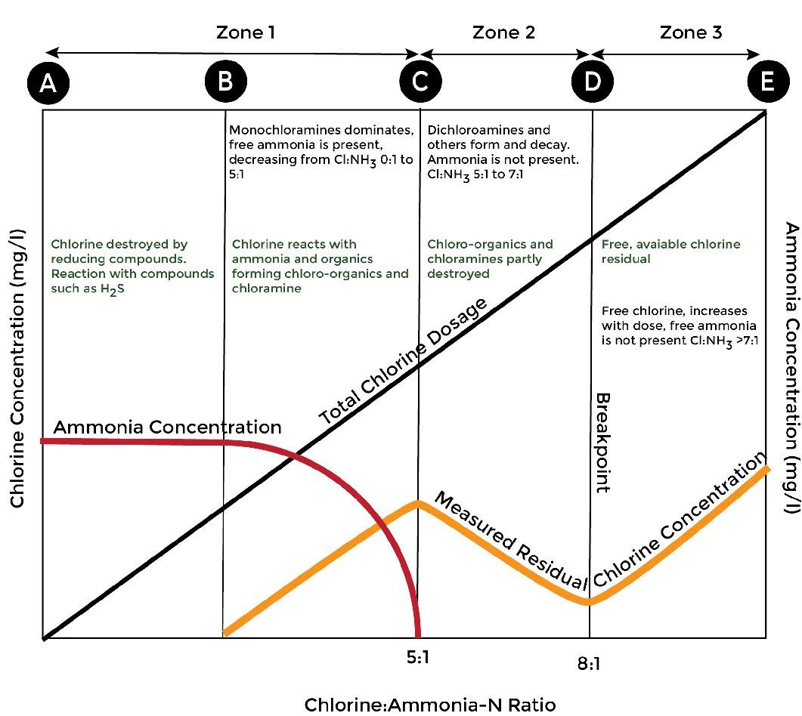

* Point A is at the beginning of chlorine application
* Between Points A and B, the chlorine dosage produces no residual because of an immedi-ate chlorine demand caused by fast-reacting ions from metal salts and H2S.
* Point B is the beginning of the reaction between chlorine and ammonia present
* Mono and dichloramines are formed between points B and C

|  |  |
| --- | --- |
| 6.2 Chlorination | 181 |
|  |  |

* Zone 1 - between points A and C, is the combined zone and has mono and dichloramines and ammonia. Monochloramines is a stable disinfectant while dichloramines is a strong disinfectant but unstable.
* After the maximum combined residual is reached (point C), further chlorine doses de-crease the residual due to chloramine oxidation to dichloramine, occurring between points C and D. This is Zone 2 - Breakpoint Zone
* Point D represents the breakpoint - the point at which chlorine demand has been satisfied and additional chlorine appears as free residuals
* Between points D and E, free available residual chlorine increases in direct proportion to the amount of chlorine applied. This is Zone 3 which is the free chlorine zone and has hypochlorous acid but no ammonia.
* Breakpoint chlorination is the application of sufficient chlorine beyond the chlorine de-

mand to maintain a free available chlorine residual. Theoretically chlorine requirement = Wt. NH3-N x 7.6 In practice (Margin of safety) = Wt. NH3-N x 10

* After the breakpoint, free chlorine residuals develop. Free chlorine residuals usually de-stroy odors, kill microorganisms and oxidize organic matter.
* Factors that affect breakpoint chlorination are initial ammonia nitrogen concentration, pH, temperature, and demand exerted by other inorganic and organic species
* Weight ratio of chlorine applied to initial ammonia nitrogen must be 8:1 or greater for the breakpoint to be reached. If the weight ratio is less than 8:1, there is insufficient chlorine present to oxidize the chlorinated nitrogen compounds initially formed
* When instantaneous chlorine residuals are required, the chlorine needed to provide free available chlorine residuals may be 20 or more times the quantity of ammonia present. Reaction rates are fastest at pH 7-8 and high temperatures

6.2.12 Chlorine dosing terms

* Chlorine dose - the amount of chlorine added to the system. It can be determined by adding the desired residual for the finished water to the chlorine demand of the untreated water. Dosage can be either milligrams per liter (mg/L) or pounds per day (lb/day).
* Chlorine Demand - the amount of chlorine consumed by iron, manganese, turbidity, algae, and microorganisms in the water. Because the reaction between chlorine and mi-croorganisms is not instantaneous, demand is relative to time. For instance, the demand 5 minutes after applying chlorine will be less than the demand after 20 minutes.
* Free chlorine - free chlorine refers to all chlorine present in the water as Cl2(g), HOCl(aq) and OCl−(aq).
* Combined residual - is the result of combining free chlorine with nitrogen compounds. Combined residuals are also referred to as chloramines.
* Total chlorine residual - is the mathematical combination of free chlorine and combined residuals. Total residual can be determined directly with standard chlorine residual test

182 Chapter 6. Disinfection

kits. Residual, like demand, is based on time. The longer the time after dosage, the lower the residual will be, until all of the demand has been satisfied. Residual, like demand,

is expressed in mg/L. The presence of a free residual usually provides a high degree of assurance that the disinfection of the water is complete.

ChlorineDose(mg/L) = ChlorineDemand + ChlorineResidual

* Theoretically, while microorganisms are killed as the chlorine demand is being satisfied, disinfection is generally the result of chlorine residual or the amount of chlorine remaining after the chlorine demand has been satisfied.

6.2.13 Contact Time

* Contact time is the amount of time which the chlorine has to react with the microorgan-isms in the water, which will equal the time between the moment when chlorine is added to the water and the moment when that water is used by the customer.
* The longer the contact time, the more efficient the disinfection process is. When using chlorine for disinfection a minimum contact time of 30 minutes is required for adequate disinfection.
* Contact time is just as important as the chlorine residual in determining the efficiency of chlorination.
* An operator measures the amount of contact time available at the plant before the water goes out to the public to ensure that 99.9% of giardia lamblia is either removed with filtra-tion or inactivated with chlorine before the water gets to the public.
* The operator compares the contact time at the plant to the CT tables provided by the EPA.
* As long as the contact time the operator measures at the plant is greater than that required by the EPA, the water passes the disinfection portion of the treatment process.
* The "baffling efficiency" of a tank is used to determine chlorine contact time in the tank. If the water used to calculate disinfection contact time moves through a storage tank, pres-sure tank, or pipes too quickly, the situation is called "shortcircuiting".
* Some vessels provide better contact time than others do. Water systems can modify reser-voirs to improve the baffling efficiency.
* In some cases little or no baffling efficiency can be awarded. Pipes with a length to width ratio of 150 or more typically have a baffling efficiency of 100 percent.
* Table below provides theoretical baffling factors for various baffling conditions and factors.

In summary, to calculate CT you must know:

1. The contact time (T) for each water system component between the chlorine injection point and where free chlorine is measured before the first customer.
2. The volume and baffling efficiency of each component.
3. The peak flow through each component.

|  |  |
| --- | --- |
| 6.2 Chlorination | 183 |
|  |  |

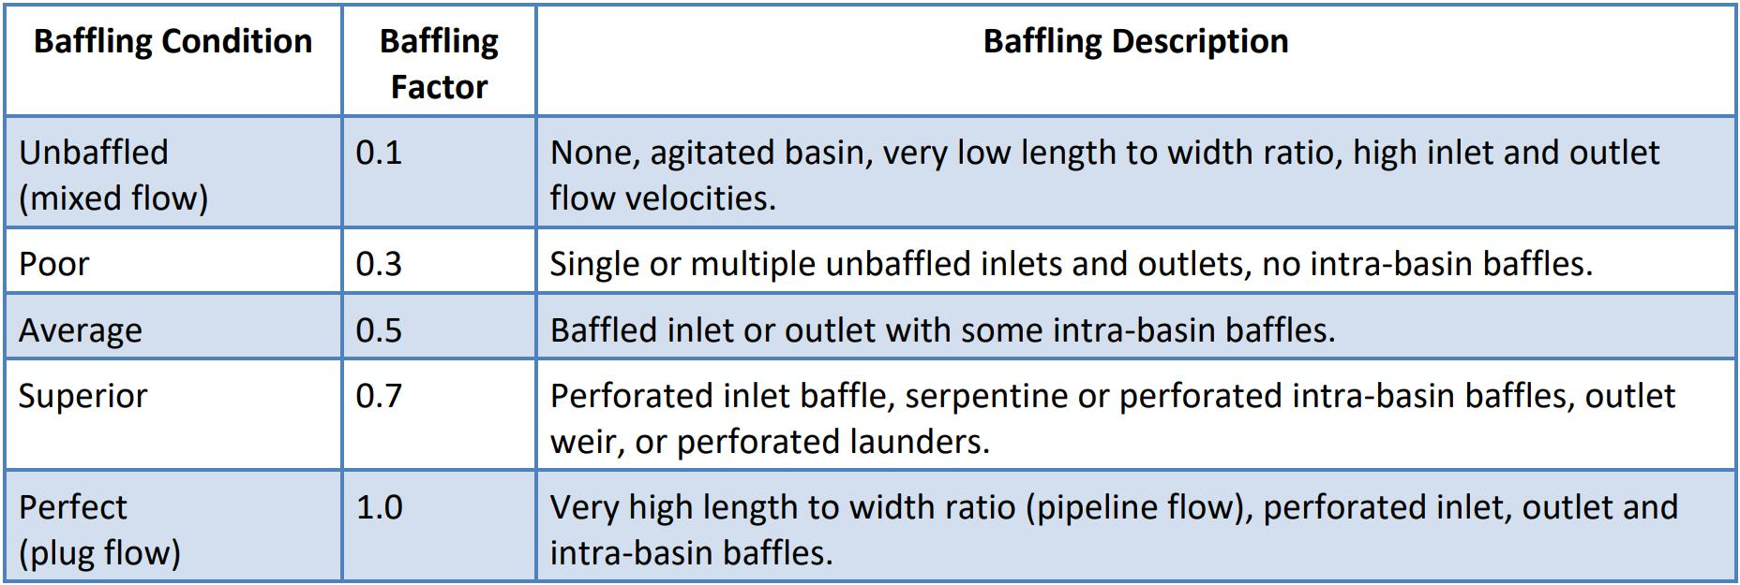

Table 6.1: Theoretical Baffling Factors

1. The free chlorine residual measured downstream of all the components and upstream of the first customer.

When calculating Contact Time, use the lowest volume of water in the tank under non-emergency/normal operating conditions.

The following steps have been set up to help operators determine contact time.

Step 1: Determine the time available in the basin at peak flow. Multiply the basin volume by the baffling factor and divide by the Peak Hourly Flow to determine the Time portion of the contact time equation.

Time (min) = Basin Volume ( gal )x baffling factor

Peak Hourly Flow (gpm)

Step 2: Determine the contact time available at peak flow. Multiply the Time by your chlorine concentration at peak hourly flow. This is the Contact Time you have available.

Available Contact Time (min mg/L) = Time (min)× Chlorine concentration (mg/L)

Step 3: Find the required Contact Time (CT) from the tables at peak flow. Determine the CT required by the EPA. You need to do this by looking up the CT from the CT tables provided using your pH, temperature and chlorine concentration.

Step 4: Does your water system meet CT requirements?

Compute the inactivation ratio by dividing the actual contact time by required contact time. If the rateo is greater than 1 , then your water system met its contact time requirements. If you cannot meet contact time, you can either increase your storage volume or increase your disinfectant residual.

Actual Contact Time

Inactivation Ratio =

Required Contact Time

Example: Your campground has a 5,000 gallon steel tank. An engineer has determined that the baffling factor for the tank is 0.3. The flow of water through the system is determined to be 15 gallons per minute at maximum flow conditions. The pH is 7.0 and the temperature is 10 Celsius. Determine whether or not your campground meets contact time requirements at 1.5mg/L chlorine.

184 Chapter 6. Disinfection

Step 1:

Time (min) = 5, 000gal ×0.3

15gpm

Time (min) = 100

Step 2: Available Contact Time ( min mg/L) = Time (min)× Chlorine concentration (mg/L) Available Contact Time (min mg/L) = 100 min ×1.5mg/L

Available Contact Time (min mg/L) = 150

Step 3: Look up the contact time that you need to achieve from the applicable EPA CT Table - Chlorine disinfectant, pH=7.0, 1.5 mg/l chlorine residual and temperature=10oC

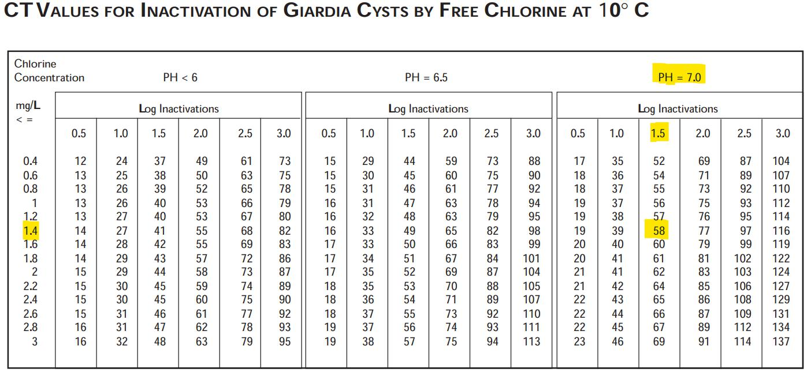

Figure 6.2: EPA - CT Table

You will notice under the Chlorine Concentration (mg/L) column, 1.5mg/L is not listed, so use the next lowest chlorine residual, 1.4mg/L. Look at the table at 1.4mg/L and go across to the pH = 7.0. The CT required for compliance, from the table, is 58 mg/l-min.

Step 4: Is the inactivation ratio greater than 1 ? Divide 150 by 58 to get 2.6. Since 2.6 is greater than 1 your system did meet the contact time requirements.

150

Inactivation Raio =

Inactivation Raio = 2.6

6.3 Chlorine Dioxide

* Chlorine dioxide, a greenish-yellow gas, produced by reacting sodium chlorite with chlo-rine or an acid.
* Because it is explosive under pressure and difficult to transport, it is generated on-site by reacting chlorite with chlorine or hydrochloric acid.
* Chlorine dioxide is a strong disinfectant.

|  |  |
| --- | --- |
| 6.4 Ultraviolet (UV) disinfection | 185 |
|  |  |

• The efficiency is pH dependent; is is optimum at a pH of 3 to 5.

6.3.1 Advantages of Chlorine Dioxide

* Chlorine dioxide has a higher oxidation capacity than most species of chlorine.
* It does not hydrolyze to form an acid, and therefore is less corrosive.
* Unlike chlorine, it acts only by oxidation and does not combine with organic compounds to form environmentally hazardous disinfection by-products.
* Its effectiveness is not affected by ammonia and pH, and does not produce THMs.
* Its effectiveness against Giardia and Cryptosporidium is reported as better than chlorine.

6.3.2 Disdvantages of Chlorine Dioxide

* Chlorine dioxide is unstable and reverts to chlorite and therefore it needs to be generated at the site and applied immediately.
* It is relatively expensive to generate
* It is explosive at a concentration above 10 percent in the air.
* It forms chlorites and chlorates which cause an anemic condition in some individuals.

6.4 Ultraviolet (UV) disinfection

• UV Disinfection of wastewater is conducted in specially designed reactors fitted with ultraviolet lamps producing energy in the UV-C range (200-400 nm)

• The UV lamps produce light photons that attack the microorganisms in wastewater as it flows through the reactor.

• Within only a few seconds of exposure to the UV energy, the DNA of the microorganisms is permanently altered and the bacteria can no longer reproduce or infect those coming in contact with the water.

• UV for wastewater disinfection has been in use for more than 50 years

• Increased interest after the discovery in the late 1990’s of its remarkable effectiveness against Cryptosporidium parvum and Giardia lamblia - pathogens in surface waters which can find its way into the drinking water supplies

• The big advantage of UV disinfection over chlorine and ozone is that UV does not involve chemical use.

• The UV dose expressed as mJ−sec or µW −sec is the product of UV intensity (energy per unit

cm2 cm2

surface area) - mJ/cm2 or µW/cm2 and residence time - sec.

6.4.1 Advantages of UV disinfection

* Very effective against bacteria, fungi, protozoa
* Independent on pH, temperature, and other materials in water
* Smaller reactor size requirement compared to chlorination

186 Chapter 6. Disinfection

6.4.2 Disadvantages of UV disinfection

* Suspended solids, slime growth, turbidity, and color present in wastewater will inhibit the effectiveness of UV
* No lasting residuals
* UV light tends to ionize compounds and break them apart (i.e. nitrate could become nitrite in UV light), causing toxic effects on the effluent.
* Expensive

6.5 Ozonation

* Ozone (O3) is the triatomic form of oxygen - it is composed of three oxygen atoms.
* Under normal conditions ozone is unstable and quickly decomposes to the more stable gaseous oxygen, O2.
* Because of its instability, ozone cannot be stored and thus generated at the point of applica-tion.
* Ozone is generated by passing air or oxygen through an electrical discharge - the notice-able clean smell in the air after a thunder and lightning storm is likely due to the formation of ozone due to the lightning bolts passing through the atmosphere.
* Ozone is thirteen times more soluble in water than oxygen.
* Ozone is even more effective against some viruses and cysts than chlorine.
* It has the added advantage of leaving no taste or odor and is unaffected by pH or the am-monia content of the water.
* When ozone reacts with reduced inorganic compounds and with organic material, an oxy-gen atom instead of a chloride atom is added to the organics, the end result being an envi-ronmentally acceptable compound.
* Ozone disinfects 3,100 times faster than chlorine. It has also been found that disinfection occurs within contact times of 3 to 8 seconds.
* Viricidal properties of ozone is exhibited at longer contact time of about 5 minutes needed.
* Any residual ozone in the effluent of the contactor disappears in a matter of seconds out-side the contactor.

6.5.1 Advantages of ozonation

The advantages of ozonation include :

* Reduces colors, phenolics, cyanides, oxygen demanding matter, turbidity and surfactants
* Increases dissolved oxygen
* Does not produce any significant toxic by-products
* Increases suspended solids reduction

6.5.2 Disadvantages of ozonation

The disadvantages of ozonation include :

|  |  |
| --- | --- |
| 6.6 Summary of Disinfectants’ Attributes | 187 |
|  |  |

* High capital cost
* High electric consumption
* Highly corrosive, especially with steel or iron and even oxidizes Neoprene
* Ozone promotes formation of bromates and brominated DBPs.

6.6 Summary of Disinfectants’ Attributes

Pathogen Destruction: Ozone > ClO2 > Chlorine » Chloramines

Residual Stability: Chloramines > Chlorine > > ClO2 > Ozone

Other Treatment Benefits: Chlorine > Ozone, & ClO2 » Chloramines

Disinfection By-Product Yield: Chloramines » ClO2 Ozone & Chlorine



Chapter 6 Assessment

Chapter 6 Assessment

1. The two most common types of chlorine disinfection by-products include:
   1. TTHM and HAA5
   2. TTHA of HMM5
   3. Turbidity and color
   4. Chloride and fluoride
2. Chlorine gas is times heavier than breathing air
   1. 2.5
   2. 20
   3. 60
   4. 460
3. A commonly used method to test for chlorine residual in water is called the method.
   1. HTH
   2. THM
   3. VOC
   4. DPD
4. When chlorine gas is added to water the pH goes down due to
   1. chlorine gas producing caustic substances
   2. two base materials that form
   3. two acids that form
   4. caustic soda being formed in the water
5. Disinfection by-products are a product of:

190 Chapter 6. Disinfection

* 1. Filtration
  2. Disinfection
  3. Sedimentation
  4. Adsorption

1. Chloramine is most effective as a disinfectant.
   1. Primary
   2. Secondary
   3. Third
   4. First
2. Name two methods commonly used to disinfect drinking water other than chlorination.
   1. Ozone and ultraviolet light
   2. Soap and agitation
   3. Filtration and adsorption
   4. Salt and vinegar
3. In order to determine the effectiveness of disinfection, it is desirable to maintain a disinfec-tant residual of at least mg/L entering the distribution system.
   1. 0.10
   2. 0.5
   3. 0.3
   4. 0.2
4. Secondary disinfectants are used to provide a in the distribution system.
   1. Color
   2. Chemical
   3. Smell
   4. Residual
5. Primary disinfectants are used to microorganisms.
   1. Hurt
   2. Inactivate
   3. Burn up
   4. Evaporate
6. The quantity of chlorine remaining after primary disinfection is called a residual.
   1. Chlorine
   2. Permaganate
   3. Hot
   4. Cold
7. The two most common types of chlorine disinfection by-products include:
   1. TTHM and HAA5
   2. TTHA of HMM5
   3. Turbidity and color
   4. Chloride and fluoride

|  |  |
| --- | --- |
| 6.6 Summary of Disinfectants’ Attributes | 191 |
|  |  |

1. In order to determine the effectiveness of disinfection, it is desirable to maintain a disinfec-tant residual of at least mg/L entering the distribution system.
   1. 0.10
   2. 0.5
   3. 0.3
   4. 0.2

14. A residual of chlorine is required throughout the distribution system.

* 1. Large
  2. High
  3. Trace
  4. Hot

1. The test used to determine the effectiveness of disinfection is called the:
   1. Coliform bacteria test
   2. Color test
   3. Turbidity test
   4. Particle test
2. Name two methods commonly used to disinfect drinking water other than chlorination.
   1. Ozone and ultraviolet light
   2. Soap and agitation
   3. Filtration and adsorption
   4. Salt and vinegar
3. Name the two types of hypochlorites used to disinfect water.
   1. Chloride and monochloride
   2. Sodium and calcium
   3. Ozone and hydroxide
   4. Arsenic and manganese

18. Free chlorine can only be obtained after chlorination has been achieved.

* 1. Breakpoint
  2. Fastpoint
  3. Softpoint
  4. Onpoint

1. The meaning of the " C" and the " T " in the term CT stands for:
   1. Concentration and time
   2. Color and turbidity
   3. Calcium and tortellini
   4. Chlorine and turbidity
2. Chloramine is most affective as a disinfectant.
   1. Primary
   2. Secondary
   3. Third

192 Chapter 6. Disinfection

* 1. First

1. TTHMs and HAA5s can affect:
   1. Health
   2. Aesthetics
   3. Color
   4. Odor

VII Chapter 7

7 Pumping Systems . . . . . . . . . . . . . . . . . . . 195

7.1 Background

7.2 Rotodynamic Pumps

7.3 Positive Displacement Pump

7.4 Pump Calculations

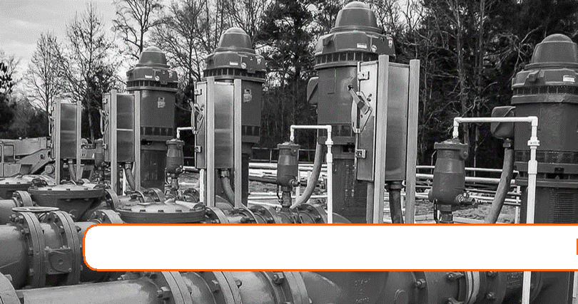

7. Pumping Systems

Expected Range of Knowledge for Water Properties and Sources Water Distribution System Operator License Exams

|  |  |
| --- | --- |
| D1 | Ability to read and interpret a pressure gauge |
| D1 | Ability to recognize abnormal pressure readings (too high or too low) |
| D1 | Ability to recognize abnormal pump operating conditions |
| D1 | Knowledge of pump types |
| D1 | Knowledge of the causes of water hammer |
| D1 | Knowledge of the definition of water hammer |
| D1 | Knowledge of the relationship between water velocity and water pressure |
| D1 | Knowledge of water hammer reduction techniques |
| D2 | Ability to recognize the signs of cavitation |
| D2 | Ability to repair and replace pump and motor system components |
| D2 | Knowledge of operational principles of a water pump |
| D2 | Knowledge of packing gland settings |
| D2 | Knowledge of pump maintenance procedures |
| D2 | Knowledge of the causes of cavitation |
| D2 | Knowledge of the mechanical components of pumps and motors |
| D2 | Knowledge of the relationship between head loss and friction |
| D3 | Ability to interpret a pump curve |
| D3 | Ability to match pump type to application |
| D3 | Knowledge of proper phase balance |

196 Chapter 7. Pumping Systems

Expected Range of Knowledge for Water Properties and Sources Water Distribution System Operator License Exams (Continued)

D3 Knowledge of proper pump alignment

D3 Knowledge of recordkeeping requirements

D3 Knowledge of the effect of corrosion on head loss

D3 Knowledge of when to "MEG" a motor

Water Treatment Operator License Exams (Continued)

T1 Ability to discriminate between normal and abnormal operation of a water pump

T1 Knowledge of pump types and uses

T1 Knowledge of the components of a water pump

T1 Knowledge of the operation of a water pump

T1 Knowledge of valve types and uses

T1 Ability to replace components of a water pump

T2 Knowledge of pump installation procedures

T3 Ability to administer a safety plan

|  |  |
| --- | --- |
| 7.1 Background | 197 |
|  |  |

7.1 Background

* A pump is a device that inputs energy into the water to increase its pressure and/or increase its flow. Pumps typically convert electrical energy into hydraulic energy of the water.
* For water treatment and distribution, pumps are widely used for purposes which include the following:

– Remove water from a source, such as a river, lake, reservoir, well, spring, or muskeg pond.

– Move water from the treatment plant to the distribution system or reservoir.

– Circulate water through a distribution system.

– Maintain pressure in the distribution system.

– Pump chemicals into the system.

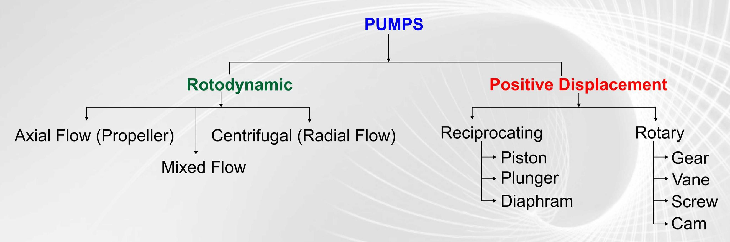

Figure 7.1: Pump Types

* Pumps can be classified as:
  1. Rotodynamic pumps: Here the energy is continuously imparted to the pumped fluid by means of a rotating impeller, propeller or rotor.

These pumps transfer mechanical energy to the fluid primarily by increasing the fluid kinetic energy. Kinetic energy is then converted into potential energy (pressure) in the discharge collector.

The most common types of rotodynamic pumps are:

– Radial (centrifugal)

– Mixed flow, and

– Axial flow (propeller) pumps - vertical turbine pumps.

198 Chapter 7. Pumping Systems

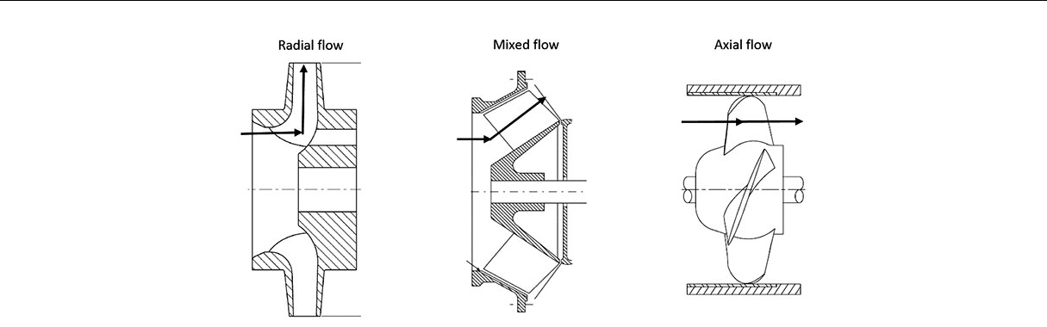

Figure 7.2: Types of Rotodynamic Pumps

1. Positive-displacement pump: These pumps utilize a mechanical device such as a piston or plunger to pump the fluid.

7.2 Rotodynamic Pumps

With this pump, the volume of the liquid delivered for each cycle depends on the resistance offered to flow. A pump produces a force on the liquid that is constant for each particular speed of the pump. Resistance in a discharge line produces a force in the opposite direction. When these forces are equal, a liquid is in a state of equilibrium and does not flow. If the outlet of a non-positive-displacement pump is completely closed, the discharge pressure will rise to the maximum for a pump operating at a maximum speed.

7.2.1 Centrifugal pumps

* Centrifugal pumps are the most common type of pump used in water systems.
* In a centrifugal pump, energy is transferred from the shaft to the impeller and from the impeller to the water.
* Centrifugal force - the force used to throw the water from the spinning impeller in a cen-trifugal pump, is the same force that is experienced by the ball when whirled on a string.
* The centrifugal pump components related to imparting the energy to the water include:

– Volute - Also called casing, it surrounds the impeller. Its spiral-like geometry with an increasing through-flow area, reduces the impeller induced fluid velocity and increases its static pressure. The fluid exiting the casing is then diffused towards the casing discharge.

– Impeller - A rotating set of vanes designed to impart rotation to a mass of fluid. flow enters the impeller which is in line with the pump shaft but the flow exits from the impeller perpendicular to the pump shaft.

– Water being pumped provides cooling to dissipate the heat generated by its moving parts - shaft and impeller. If the pump is run dry for an extended period of time, the heat generated may severely damage to the pump and greatly limiting its service life.

|  |  |
| --- | --- |
| 7.2 Rotodynamic Pumps | 199 |
|  |  |

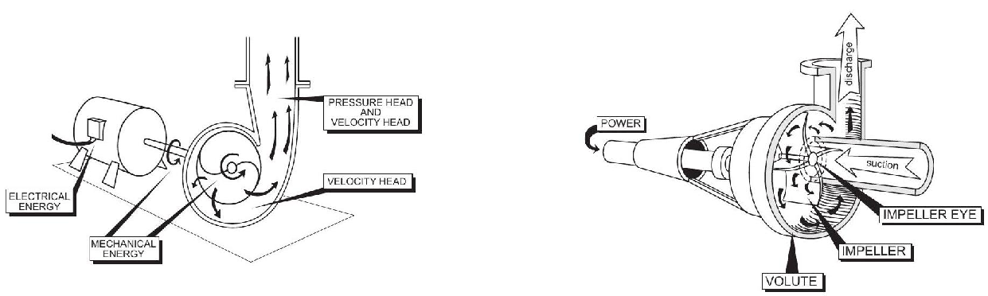

Centrifugal Pump Operating Principle

Centrifugal Pump Types

1. One way to classify impellers is based on the use a or lack of shroud or covering.
   * Closed impeller: This impeller has a top and bottom shroud and is used in large pumps primarily in clean water pumping application as it is prone to clogging when in contact with solids.
   * Open impeller: Here the vanes are open on both sides. Without the shroud support the vanes are weaker and are used in inexpensive pumps for applications without much strain.
   * Semi-open impeller: These impellers have a back wall which adds mechanical strength to the vanes. These impellers are suited for medium sized pumps with a small amounts of soft solids.

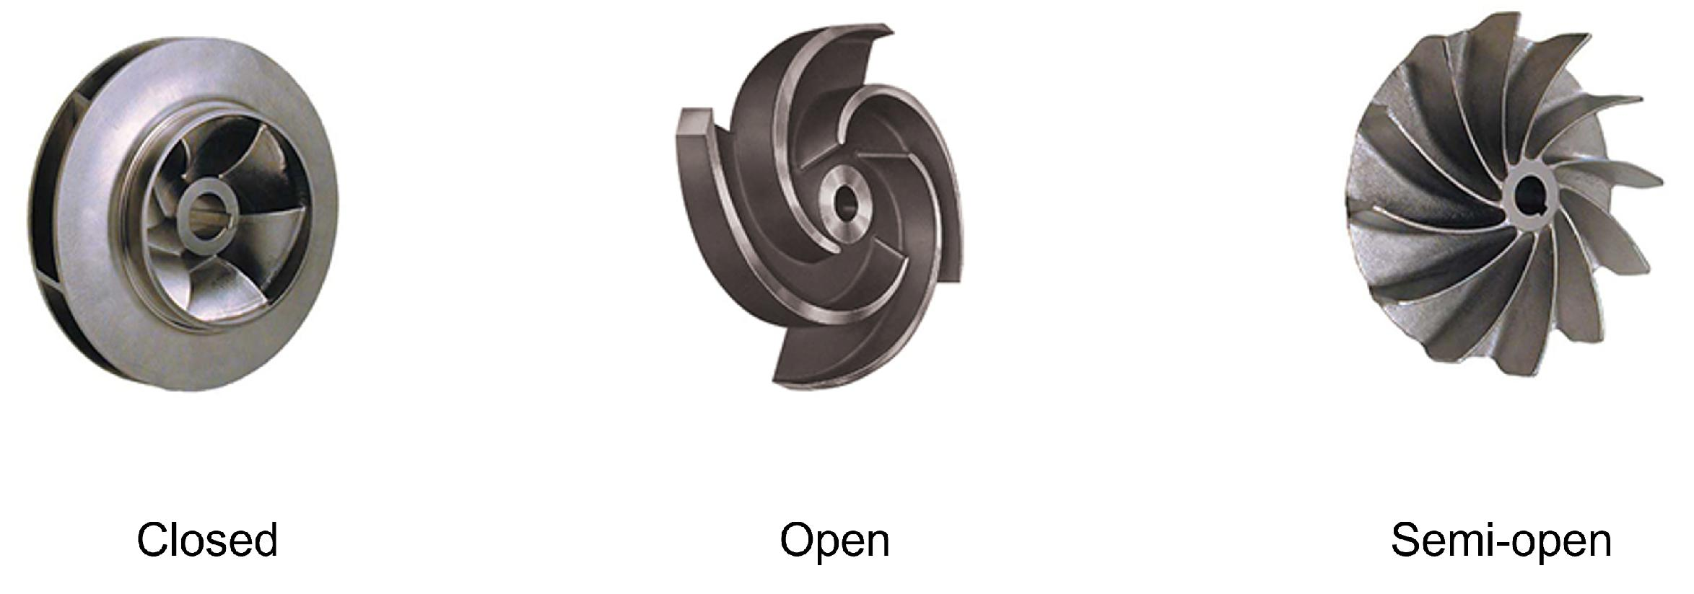

Figure 7.3: Impeller Types

1. Classification of centrifugal pumps based upon the configuration of the suction - point of entry of the into the pump:
   * End-suction centrifugal pumps - The most common style of centrifugal pump. The center of the suction line is centered on the impeller eye. End suction centrifugal pumps are further classified as either frame-mounted or close-coupled.

End-suction centrifugal can be classified

– Frame mounted: These pumps are mounted next to a motor on a common base-

200 Chapter 7. Pumping Systems

plate, with the pump shaft and the motor shaft connected by a flexible coupling. The design includes a bearing housing to prolong the life of the bearings and allows for continuous operation with high radial and thrust loads.

Frame-mounted pumps are commonly used for larger applications, where power ratings are anywhere from 20HP to 200HP plus.

– Close-coupled: A close-coupled pump has only one shaft and one set of bear-ings: the motor shaft and bearings. The pump impeller is placed directly onto the motor shaft. Close-coupled pumps require less space and are less expensive than frame-mounted pumps.

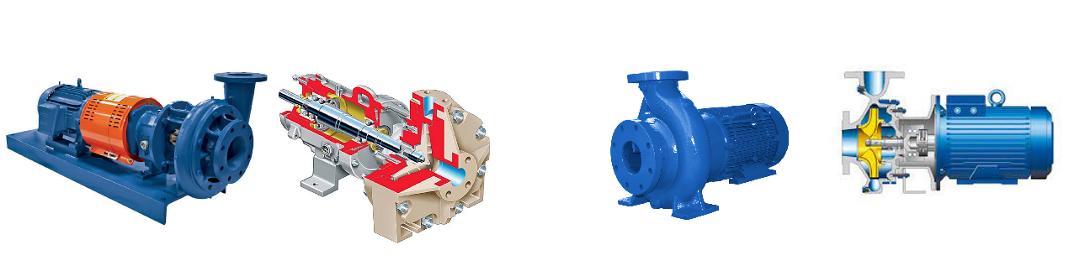

Frame Mounted End-Suction Pump Close-Coupled Pump

* Split-case centrifugal pumps:

– A centrifugal pump designed so that the volute case is split horizontally.

– The case divides on a plane that cuts though the eye of the impeller.

– This design allows easy access to the pump’s internal parts for maintenance.

– Split-case pumps are used in high flow applications including water treatment plants for distributing potable water and for fire protection.

– Split-case pumps are classied based upon their case design:

* Radial Split – Radially split pump casing opens perpendicular to the shaft

axis and parallel to the impeller.

* Axial Split – In this design, the pump casing is spliced into two halves that get separated horizontally, or you can say that parallel to the shaft axis.

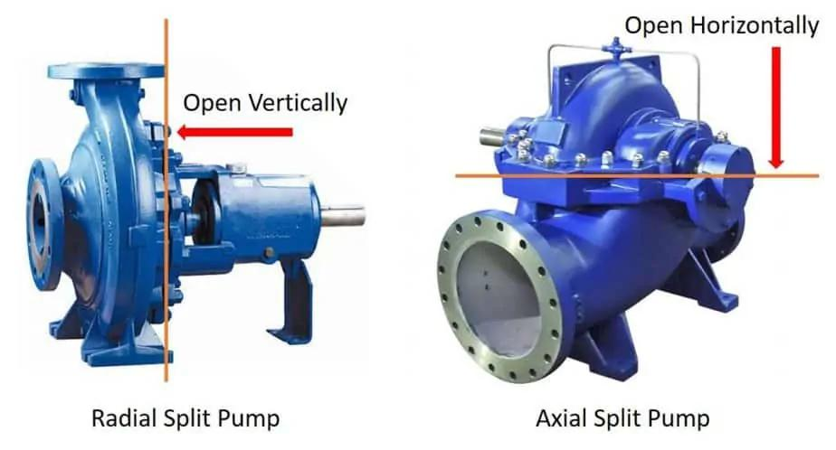

Figure 7.4: Horizontal Split-case pumps Radial and Axial

|  |  |
| --- | --- |
| 7.3 Positive Displacement Pump | 201 |
|  |  |

7.2.2 Axial-flow Pumps

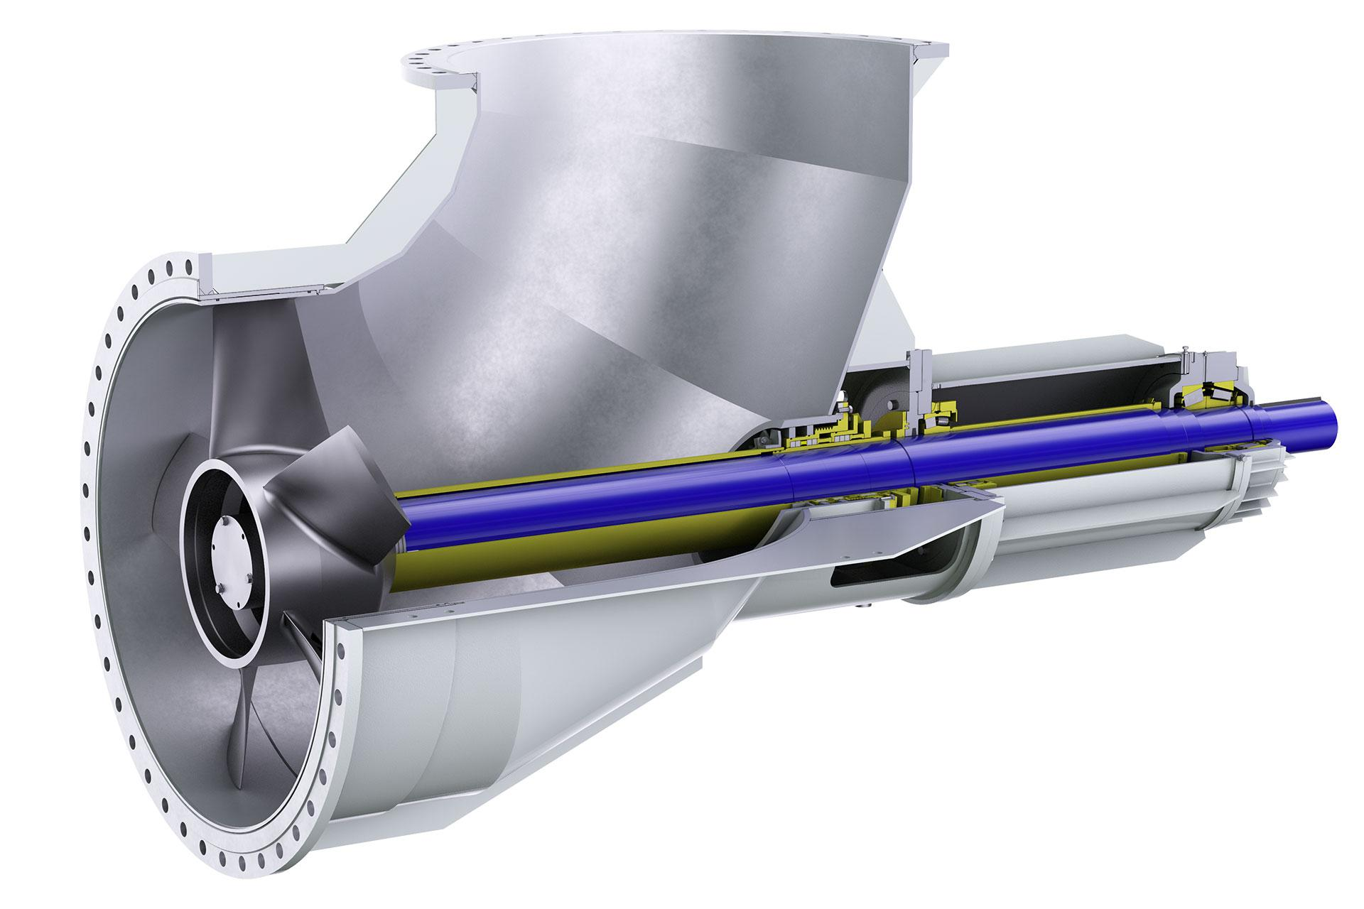

Figure 7.5: Axial flow pump

* Utilizes a propeller driven by a sealed motor in a pipe to impart the hydraulic energy.
* Unlike the centrifugal pumps, the direction of flow is unchanged in axial-flow pumps.
* The axial flow
* Axial flow pumps are characterized by the highest flow rates and lowest discharge pres-sures. Vertical turbine pump - These type of centrifugal pumps are primarily mounted with a vertical shaft; the motor is commonly mounted above the pump. Vertical turbine pumps are either mixed or axial flow devices.

7.2.3 Mixed-flow Pumps

* Mixed flow pumps borrow design characteristics from both axial and radial pumps.
* Their design includes a diagonally operating impeller that uses centrifugal force to direct the water out of the pump and give it an axial pushing action.
* This dual pumping action enables mixed flow pumps to have higher mass flow rate of axial pumps with higher pressure of centrifugal pumps.
* Therefore, mixed flow pumps are ideal for any application that requires the pumps to operate within the gap left between axial and radial pumps.

7.3 Positive Displacement Pump

* A positive displacement pump operate by forcing a fixed volume of fluid from inlet pres-sure section of the pump into the discharge zone of the pump.
* Positive displacement pumps are a category of pumps designed to move fluid at a steady rate through a system.
* These pumps are able to handle viscous fluids, which flow at lower speeds and create more resistance, more efficiently than kinetic (dynamic) pumps.
* These pumps cannot achieve high flow rates and are typically used not for pumping water.
* They are used typically for chemical dosing applications including dosing coagulants and flocculants as they are more efficient in applications involving low flows of higher viscosity fluid.
* Displacement pumps will not change their volume with a change in discharge pressure.

202 Chapter 7. Pumping Systems

* It can be classified into two types:
  1. Rotary-type positive displacement pump:

– This pump can move the fluid by using a rotating mechanism that creates a vacuum that captures and draws in the liquid.

– Rotary positive displacement pump can be classified into two main types: * Gear Pump:

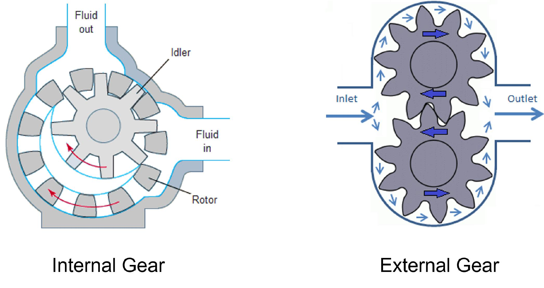

Figure 7.6: Gear Pumps

* 1. This pump provides a constant volume of fluid that passes between the teeth of two meshing gears and the casing.
  2. The rotating gears and separation of teeth create a suction that pulls fluid in through the inlet.
  3. The gears then trap the liquid and move it around the casing to the dis-charge or outlet.
  4. Each revolution creates consistency in the flow of fluid.
  5. There are two main types of rotary gear pumps - internal and external

which are differentiated by the way the gear teeth lock together. * Lobe pump:

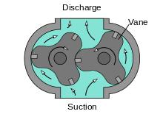

Figure 7.7: Lobe Pump

* Lobe pumps are like gear pumps in that fluid flows around the interior of the casing, but they use lobes instead of the gears with teeth.
* The lobes do not touch each other, thus reducing wear, and they are driven by external timing gear which can allow the lobe pump to operate in either direction.
* Rotary lobe pumps are capable of handling thick fluids that are laden with solids. Their gentle handling of solids works well mixed with low

|  |  |
| --- | --- |
| 7.3 Positive Displacement Pump | 203 |
|  |  |

viscosity substances.

* Screw pump:

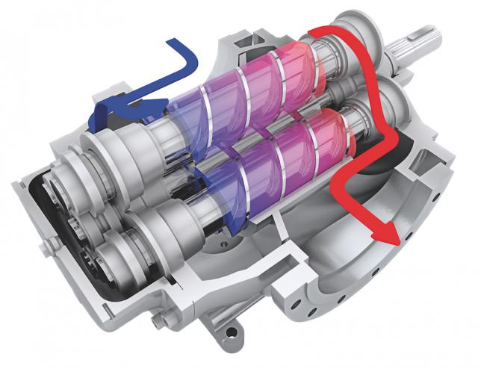

Figure 7.8: Screw pump - Twin-screw type

* + - 1. Screw pumps and twin-screw pumps use rotating screws to move liquids and solids from one end of the pump to the other.
      2. The turning action creates a spinning motion that pumps material.
      3. The twin-screw pumps are identical to the screw pump, but with a dual screw for more power.
      4. Screw pumps are capable of high flow rates with very little to no vibra-tion.
* Reciprocating-type positive displacement pump:

– This pump works by the repeated back-and-forth movement (strokes) of either a piston, plunger or diaphragm.

– Types of this pump are:

* Piston pump: In a piston pump, the first stroke of the piston creates a vac-uum, opens an inlet valve, closes the outlet valve and draws fluid into the piston chamber (the suction phase). As the motion of the piston reverses, the inlet valve, now under pressure, is closed and the outlet valve opens allowing the fluid contained in the piston chamber to be discharged (the compression phase).

* 1. Plunger pump: The plunger pump works similar to the piston pump. The volume of fluid moved by a piston pump depends on the cylinder volume; in a plunger pump it depends on the plunger size.
  2. Diaphragm Pump: A diaphragm pump uses a flexible membrane instead of a piston or plunger to move fluid. By expanding the diaphragm, the vol-ume of the pumping chamber is increased and fluid is drawn into the pump. Compressing the diaphragm decreases the volume and expels some fluid. Diaphragm pumps have the advantage of being hermetically sealed systems making them ideal for pumping hazardous fluids.

– The cyclic action of reciprocating pumps creates pulses in the discharge with the fluid accelerating during compression and slowing down during the suction

204 Chapter 7. Pumping Systems

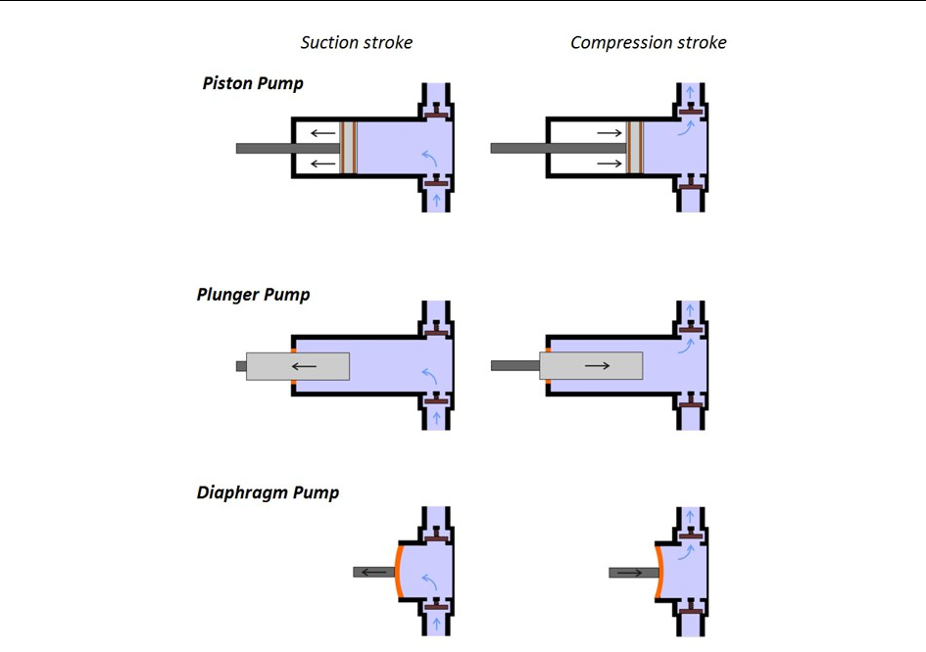

Figure 7.9: Reciprocating Pumps Design

phase.

– Pulsing can be minimized by using two or more pistons, plungers or diaphragms with on in its compression phase whilst the other is in suction.

– The repeatable and predictable action of reciprocating pumps make them ideal for applications where accurate metering or dosing is required.

7.3.1 Turbine Pumps

* Turbine pumps are centrifugal in nature but have some characteristics of positive displace-ment.
* First, the way they impart energy to the liquid is kinetic (and hence centrifugal) in nature. However, they typically have multiple “stages,” with each stage generating a little incre-mental pressure. Since each stage is incremental, the risk of cavitation is lower.
* Clearances are said to be very tight, and hence, the reference to them having some charac-teristics of positive displacement pumps.
* They are often used in high head but relatively low-volume applications, such as pumping water a significant height. Typical applications include wells that are bored to provide agricultural or turf irrigation, or to provide water supply for municipalities that rely on ground water rather than surface water. They are also used to provide plant make-up water and fire water for industrial plants.
* Mostly due to their compact size and multiple stage capability, their typical application

|  |  |
| --- | --- |
| 7.3 Positive Displacement Pump | 205 |
|  |  |

is with clean water (fresh or waste) with minimal solids content. (Their relatively close tolerances cannot long survive abrasive slurries such as drilling muds.)

* The term “turbine” in the pump name is somewhat of a misnomer, as this pump type has nothing to do with a turbine.
* The pump end consists of at least one rotating impeller that is attached to a shaft and di-rects the well water into a diffuser casing called a bowl.
* This pump is often staged – that is, designed with more than one impeller. Each additional impeller increases the amount of head the pump can produce while the flow remains un-changed.
* In a staged turbine pump, water enters the pump at the bottom through a bell-shaped part called the suction bell. From there it moves into the first stage impeller, which raises the water’s velocity. The water then enters the diffuser bowl immediately above the impeller, where this high velocity energy is converted into high pressure. The bowl also directs the fluid into the next impeller located immediately above the bowl, and this process continues through all of the stages of the pump.
* The two main types of turbine pumps are vertical turbine pumps and submersible turbine pumps.
* While submersible pumps have the electric motor located underwater at the bottom of the pump, vertical turbine pumps have the motor located above ground, connected via a long vertical shaft to impellers at the bottom of the pump.

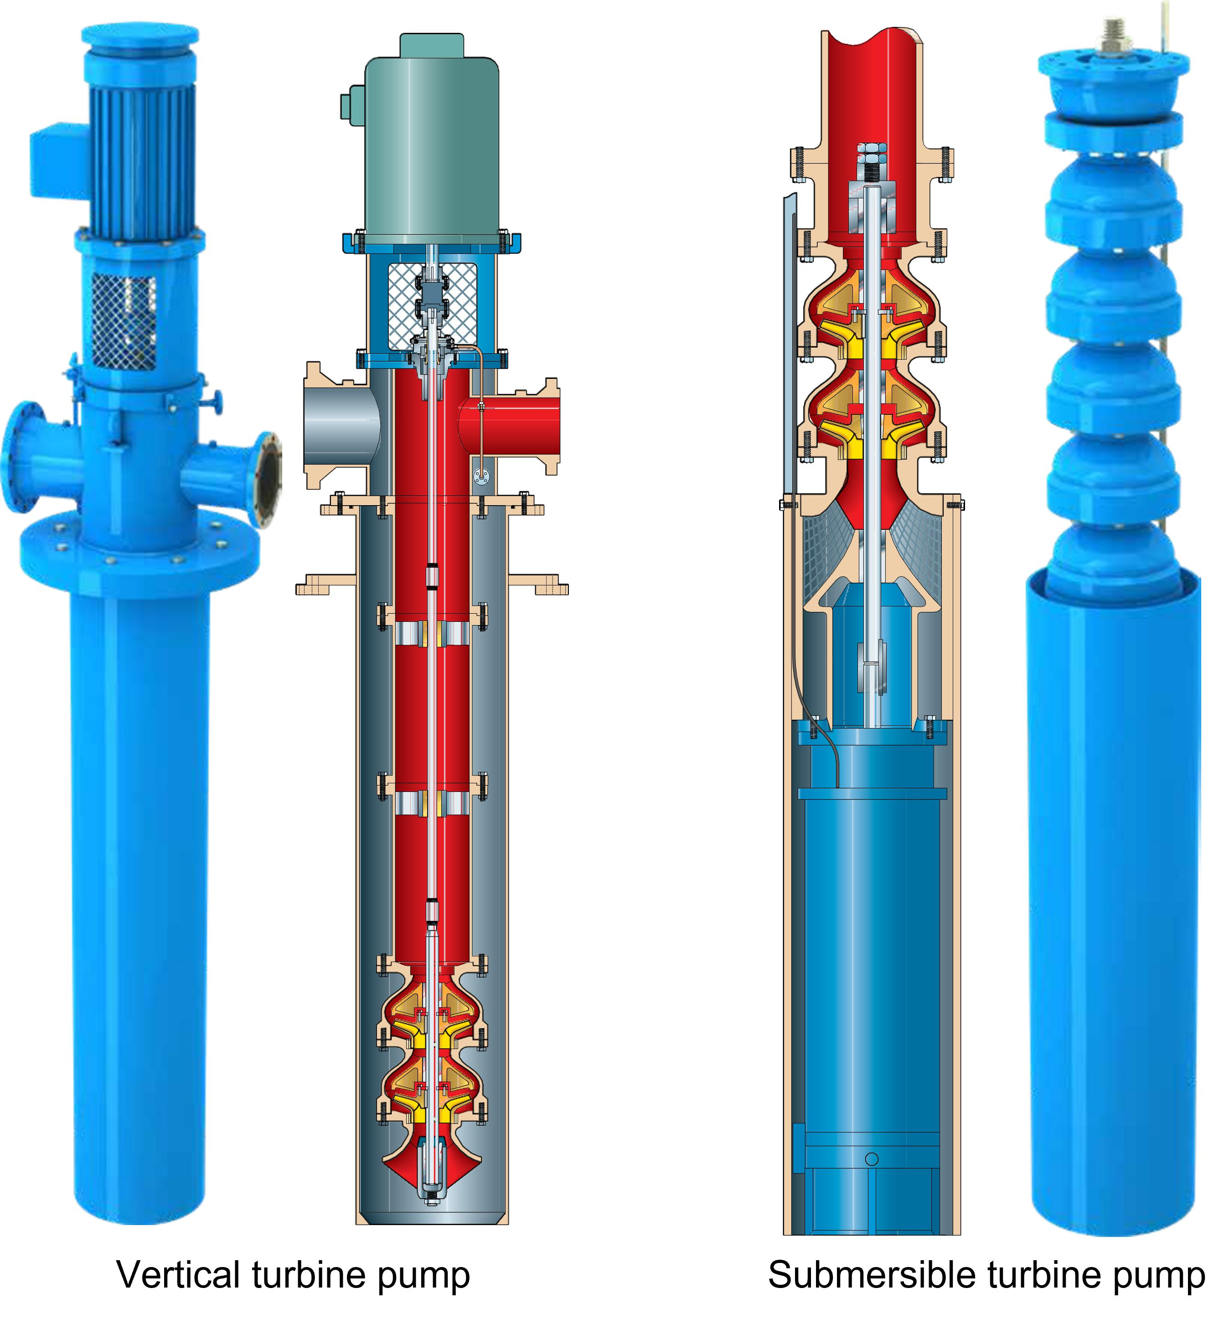

Figure 7.10: Turbine Pumps

7.3.2 Choosing Between Positive Displacement and Centrifugal Pumps

* Common Positive Displacement Pump Applications and Handled Fluids:

– High-viscosity fluids (e.g., chemicals including polymers)

– High-pressure requirements

206 Chapter 7. Pumping Systems

– Low flow rate requirements

* Common Centrifugal Pump Applications and Handled Fluids:

– Most water pumping applications

– High-flow applications

7.3.3 Mechanical Parts of Rotodynamic Pumps

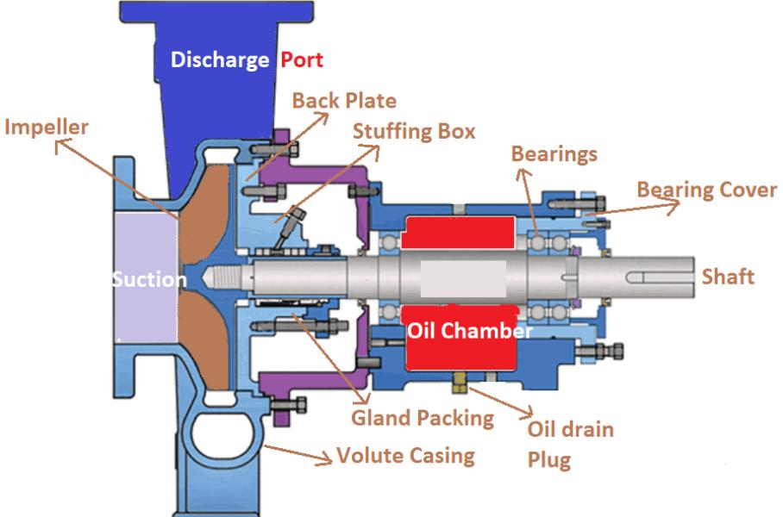

Figure 7.11: Centrifugal Pump Components

The mechanical parts of a typical rotodynamic pump include:

* Wear Rings:

With closed impellers, the impeller fits very close to the case. As a result, the case is worn by material passing from the high-pressure side to the low-pressure side of the impeller. To protect the case, brass or stainless steel wear rings are inserted into the case which creates the contact area between rotating and stationary parts inside the pump.

* Volute Case:

Around the impeller is the volute case. The volute case gathers the water thrown from the impeller and directs it in a single direction.

* Backing Plate:

Behind the volute case is the backing plate. The backing plate seals the back of the volute case area.

* Stuffing Box:

Attached to, and sometimes part of, the backing plate is the stuffing box. Stuffing Box - That portion of the pump that houses the packing or mechanical seal. Usually referred to as the dry portion of the pump. The stuffing box is located in back of the impeller and around the shaft.

* Shaft:

The impeller is attached to a shaft. The shaft is often made of steel or stainless steel to support the impeller. The sizes of the shafts must be measured accurately. An undersized shaft may increase pump vibration, reduce bearing life, cause shaft breakage, and shorten

|  |  |
| --- | --- |
| 7.3 Positive Displacement Pump | 207 |
|  |  |

the overall pump life. On the other hand, an oversized shaft can unnecessarily increase the pump costs.

* Shaft Sleeve:

Usually, a portion of the shaft located below the seals is covered with a shaft sleeve. The shaft sleeve is made of a metal, generally bronze or stainless steel. It is designed to oper-ate with the ability to slide or thread on the shaft. The shaft sleeve is applied to properly position the impeller on the shaft as well as to protect the shaft.

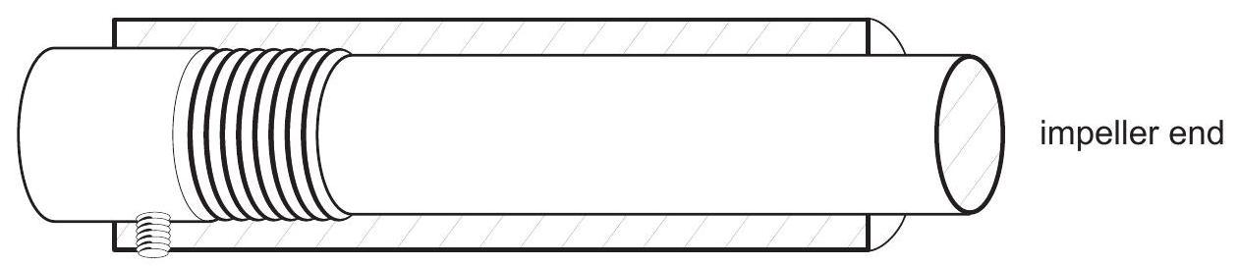

Figure 7.12: Shaft sleeve threaded to shaft

* Seals:

– The place where the shaft passes through the casing is the stuffing box must be sealed to prevent the pressurized water from the "wet" end of the pump to escape the rotat-ing shaft in the stuffing box.

– Typically either a mechanical seal or a packing seal (traditional method) are used for stopping this leakage.

– Packing/Mechanical Seals:

Packing and mechanical seals serve the same purpose: they control leakage through

the stuffing box.

* Packing: A packing is composed of some type of fiber, like cotton, and some type of lubricant, like graphite or Teflon. Packing seals are rings of braided, fibrous material. are housed in a are “stuffed” into a pump stuffing box (or seal

chamber), located around the outside diameter of the pump shaft, to reduce the amount of pumped medium that is forced out of the pump along the drive shaft.

* Mechanical seal: A mechanical seal is composed of two finely machined sur-faces, one hard and one soft, that prevent water from passing. When installing packing, joints should be staggered.

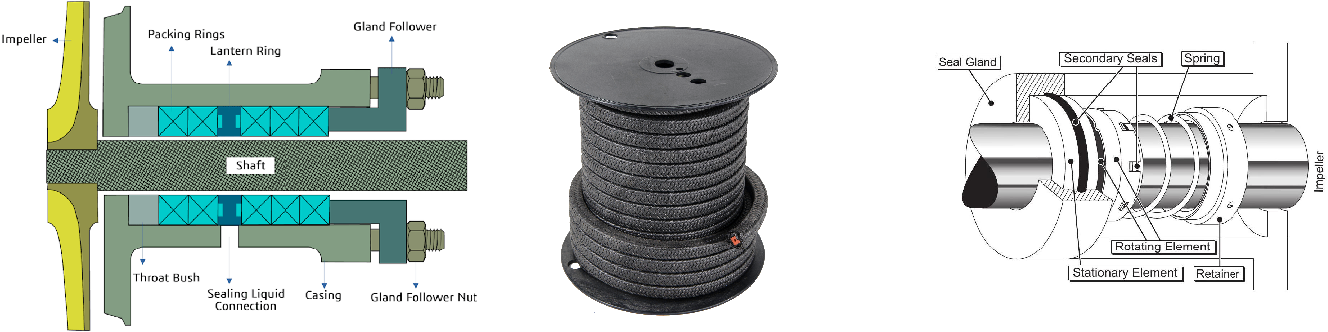

Stuffing Box Braided Packing Mechanical Seal

208 Chapter 7. Pumping Systems

* Packing Gland:

In order to control leakage with packing, pressure must be placed on the packing. This pressure is applied by the packing gland, two pieces of metal at the back of the stuffing box. There should be a slow drip from the stuffing box to show lubrication between the shaft and the packing.

* Lantern Ring:

It is often desirable to lubricate and cool the packing with external water or oil. When water is used, it is called seal water or flush water. The seal water is distributed into the stuffing box through the lantern ring, which is commonly a brass ring with holes that allow the water to easily pass.

* Gland: The gland is located around the shaft of the pump and bolts to the face of the stuff-ing box directly on the pump casing. The gland nut allows the packing material to be compressed to form a watertight seal and prevent leakage of the pumped water.
* Both, packing seals and mechanical seals, rely on seal water for effective operation. Seal water serves three main purposes: to cool the seal and the shaft, to lubricate the seal and to flush away impurities in the system.

7.4 Pump Calculations

* Pump is a machine used for moving water (and other fluids) through a piping system and raise the pressure of the water.
* Pumping is accomplished by transforming the input energy - typically from an electric motor or from other sources such as high-pressure air.
* The pump calculations in this section are for electrically driven rotodynamic pumps.
* To move water, a pump will need to overcome resistance due its density, gravitational force and friction.
* This resistance is dependent on:

– Height the water needs to be raised. This height of the fluid in a container is referred to as head.

– Quantity of water involved

7.4.1 Glossary of Pump Calculations Terms

Force: In the English system force and weight are often used in the same way. The weight of the cubic foot of water is 62.4 pounds. The force exerted on the bottom of the one foot cube is 62.4 pounds. If we have two cubes stacked on top of one another, the force on the bottom will be 124.8 pounds.

Pressure: Pressure is a force per unit of area, pounds per square inch or pounds per square foot are common expressions of pressure. The pressure on the bottom of our cube is 62.4 pounds per square foot. It is normal to express pressure in pounds per square inch (psi). This can be accomplished by determining the weight of one square inch of our cube one foot high. Since the

|  |  |
| --- | --- |
| 7.4 Pump Calculations | 209 |
|  |  |

cube is 12 inches on each side, the number of square inches on the bottom surface of the cube is 12 ×12 = 144in2. Now by dividing the weight by the number of square inches we can determine the weight on each square inch.

Head: Pressure is directly related to the height of a column of fluid. This height is called head or feet of head. Pressure and feet of head head are directly related - for every one foot of head there is a pressure of 0.433 psi.

|  |  |  |  |  |  |  |  |  |
| --- | --- | --- | --- | --- | --- | --- | --- | --- |
| Thus, |  | 0.433 | psi |  | or conversely | 1 f t (water | column) |  |
| f t | (water | column) | |  | psi |  |
|  | 2.31 | |  |

Note: This pressure/head will include the height the water pumped and also the head asso-ciated with friction losses - energy loss because of the water moving through the pipe and fittings.

Pressure = Force



Area

|  |  |  |  |  |  |  |  |  |
| --- | --- | --- | --- | --- | --- | --- | --- | --- |
| Pressure exerted by |  |  | 62.4 lb | |  |  | 12" |  |
| = |  | = 0.43 psi |  |  |  |
| a 1ft column of water |  |  |  |  |  |  |
| 12in x 12in | | |  |  |  |
|  |  | 12" |  |  |  |
|  |  |  |  |  |  |  |  |
| As 1 f t3 of water weighs 62.4 lbs | | | | |  |  |  |  |
|  |  |  |  |  | 12" | |  |  |

The pressure at the bottom of a container is affected only by the height of water in the container and not by the shape or the volume of the container. In the drawing below there are four contain-ers all of different shapes and sizes. The pressure at the bottom of each is the same.

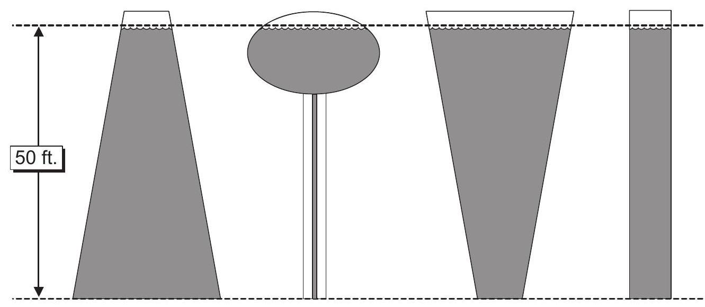

The pressure exerted at the bottom of a tank is relative only to the head on the tank and not the volume of water in the tank. For example, below are two tanks each containing 5000 gallons. The pressure at the bottom of each is 22 psi. If half of the water were drained from the tanks the pressure at the bottom of the elevated tank would be 17.3 psi while the pressure at the bottom of the standpipe would be 11 psi.

210 Chapter 7. Pumping Systems

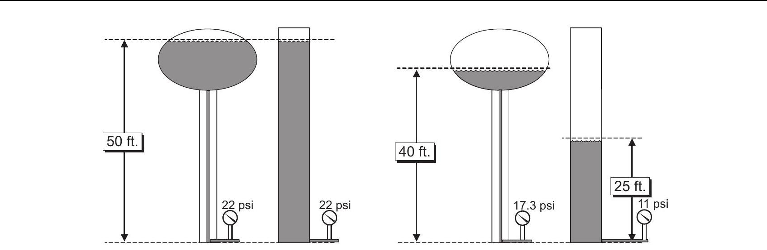

Velocity: Velocity is the speed that the water is moving along a pipe or through a basin. Velocity is usually expressed in feet per second, ft/sec.

Flow: Flow is commonly expressed in gallons per minute (gpm) and/or cubic feet per second (cfs). There is a relationship between gallons per minute and cubic feet per second. One cubic foot per second is equal to 448.8 gallons per minute. 1cfs = 448.8gpm

Flow Equation; The basic equation for determining flow is as follows:

Q = V ×A

Where:

Q = cfs ft3/sec

V = ft/sec

A = ft2

Static Pressure: Static implies a non-moving condition. The pressure measured when there is no water moving in a line or the pump is not running is called static 32 pressure. This is the pressure represented by the gauges on the tanks in the discussion above.

Dynamic Pressure/Velocity Head: When water is allowed to run through a pipe and the pres-sure (called pressure head) measured at various points along the way we find that the pressure decreases the further we are from the sources. The amount of energy required to bring a fluid from standstill to its velocity. For a given quantity of flow, the velocity head will vary indirectly with the pipe diameter.

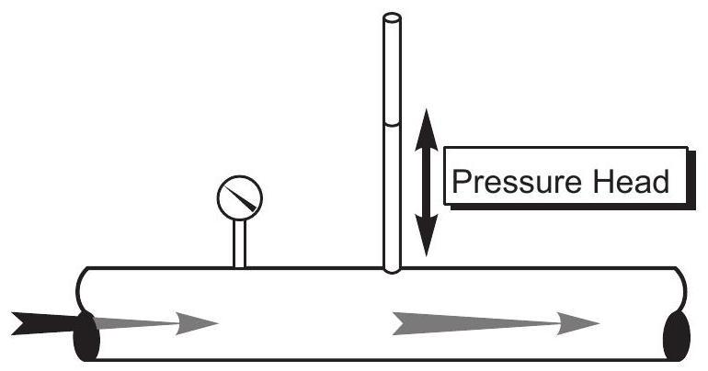

Headloss: The reason for this reduction in pressure is a phenomenon called headloss. Headloss is the loss of energy (pressure) due to friction. The energy is lost as heat.

If the headloss in a certain pipe is 25 feet, it means the amount of energy required to overcome the friction in the pipe is equivalent to the amount of energy that would be required to lift this amount of water straight in the air 25 feet.

In a pipe, the factors that contribute to headloss include the following:

|  |  |
| --- | --- |
| 7.4 Pump Calculations | 211 |
|  |  |

* Roughness of pipe - If the roughness of a pipe were doubled the headloss would double.
* Length of pipe - If the length of the pipe were doubled the headloss would double.
* Diameter of pipe - If the diameter of a pipe were doubled the headloss would be cut in half
* Velocity of water - If the velocity of the water in a pipe were doubled the headloss would be increased by about four times. It should be apparent that velocity, more than any other single factor, affects headloss. To double the velocity we would have to double the flow in the line.
* Pumping System Components and Fittings - Each type of fitting has a specific headloss depending upon the velocity of water through the fitting. For instance the headloss though a check valve is two and one quarter times greater than through a ninety degree elbow and ten times greater than the headloss through an open gate valve.

Static Head: Static head is the distance between the suction and discharge water levels when the pump is shut off.

* A pump is said to be in a suction lift condition any time the eye (center) of the impeller is above the water being pumped. Suction lift is the distance between the suction water level and the center of the pump impeller.
* A suction lift simply means the maximum level of the liquid to be pumped is physically below the centerline of the pump impeller. Most centrifugal pumps can operate with a suction lift if they are primed first.
* Primed means the suction line, pump casing and impeller are full of liquid and all of the air or non-condensable gases are removed.
* A centrifugal pump cannot “suck” or ‘lift” the liquid into itself. Atmospheric pressure is the force pushing the liquid into the pump for open systems. From this information we can conclude; the maximum suction lift - theoretical lift at sea level with a perfect pump, a perfect liquid and a frictionless leak free system can approach 34 feet (Atmospheric pressure at sea level is 14.7 psia X 2.31 = 34).
* Because a perfect vacuum is never achieved and because some lift is lost to friction in the suction line, the maximum actual suction lift for a positive-displacement pump is approximately 22 ft.
* The maximum actual suction lift for a centrifugal pump is approximately 15 ft when pump-ing water from an open air tank.
* Positive-displacement pumps can operate with lower suction pressures or high suction lifts because they can create stronger vacuums.
* Suction lift will be greater if the pressure in a closed tank is greater than atmospheric pressure.

Total Dynamic Head (TDH): The total energy needed to move water from the center line of a pump (eye of the first impeller of a lineshaft turbine) to some given elevation or to develop some given pressure. This includes the static head, velocity head and the headloss due to friction. Horsepower: Horsepower is a measurement of the amount of energy required to do work. Mo-

212 Chapter 7. Pumping Systems

tors are rated in horsepower. The horsepower of an electric motor is called brake horsepower. The horsepower requirements of a pump are dependent on the flow and the total dynamic head. 33,000 foot pounds per minute of work is 1 horsepower. The horsepower output of an electric motor is directly reflected to the amperage that the motor draws. Any increase in horsepower requirements will give a corresponding increase in amperage.

Suction Head: Suction head is the distance between the suction water level and the center of the pump impeller when the pump is in a suction head condition. A pump is said to be in a suction head condition any time the eye (center) of the impeller is below the water level being pumped.

Velocity Head: Velocity head is the amount of energy required by the pump and motor to over-come inertia and bring the water up to speed. Velocity head is often shown mathematically as V2/2 g. ( g is the acceleration due to gravity −32.2ft/sec2 ).

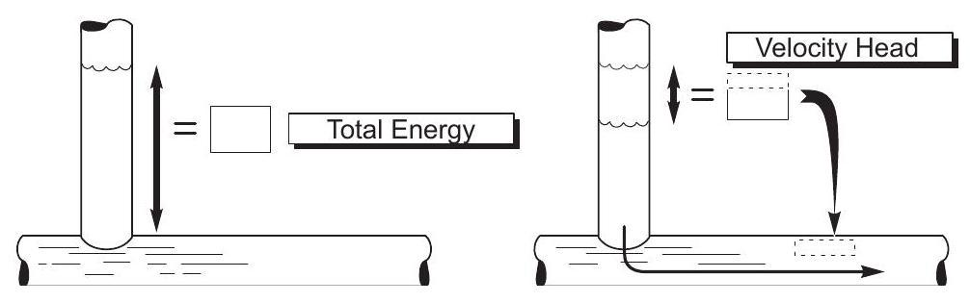

Cavitation: Cavitation in pumps is the rapid creation and subsequent collapse of air bubbles occuring as a result of the inlet pressure falling below the design inlet pressure or when the pump is operating at a flow rate higher than the design flow rate. This collapse of the air bubbles typically manifests as a pinging or crackling noise. Cavitation is undesirable because it can damage the impeller, cause noise and vibration, and decrease pump efficiency.

|  |  |
| --- | --- |
| 7.4 Pump Calculations | 213 |
|  |  |

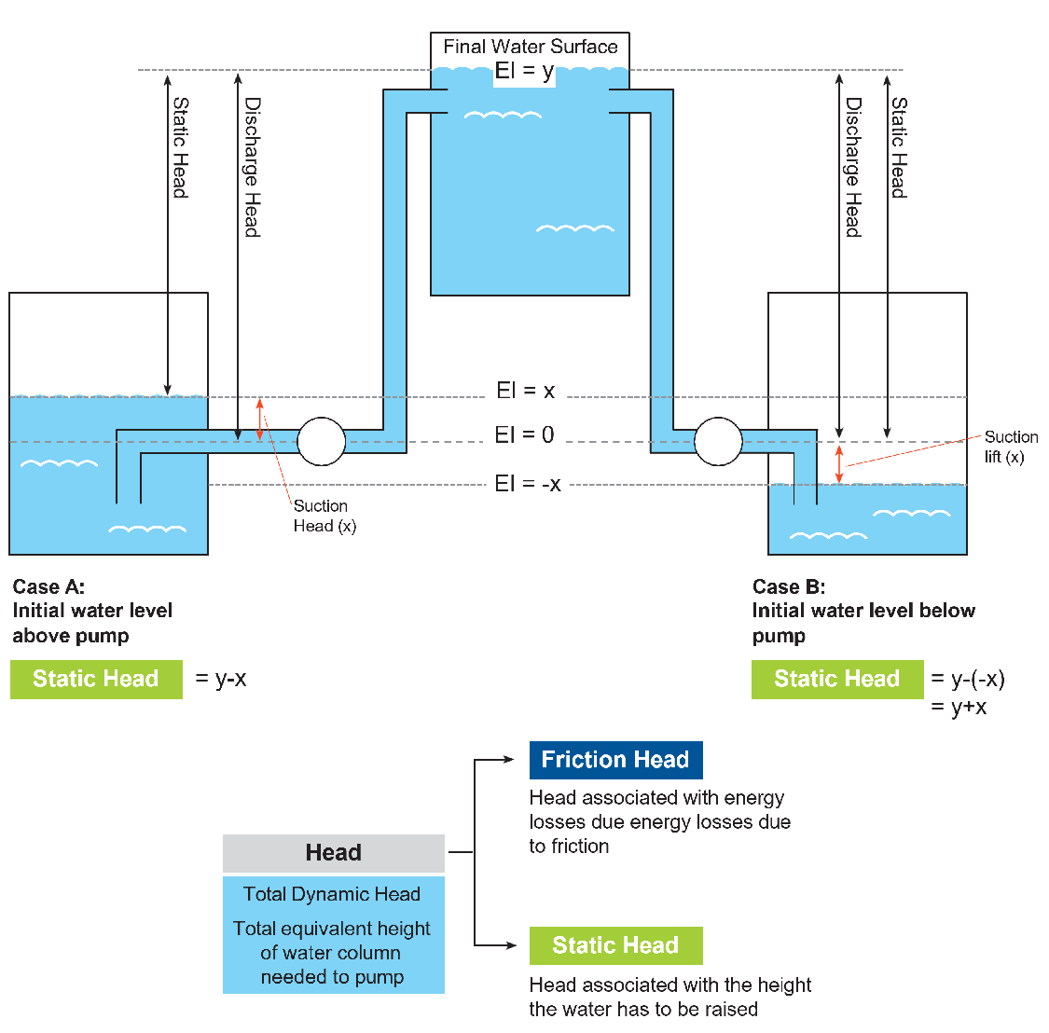

Figure 7.13: Pumping heads illustration



Chapter 7 Assessment

Chapter 7 Assessment

* Name the type of valve that is sometimes found on the suction side of a centrifugal pump and is located where the water enters the casing.
  1. Check valve
  2. Gate valve
  3. Altitude valve
  4. Pressure relief valve
  5. Foot valve
* After a pump is shut off but continues to run backwards indicates:
  1. The bearings are failing
  2. The packing needs tightening
  3. The main lock nut needs to be tightened
  4. The check valve is leaking
  5. A valve on the discharge side of the pump is shut
* Wear rings are installed in a pump to:
  1. hold the shaft in position
  2. keep the impeller in place
  3. keep wear concentrated on economically replaceable part
  4. wear out the sleeve
* Pump motors draw more power starting than during normal operating conditions because:
  1. check valves have to be pushed open
  2. energy is required to get the water moving

216 Chapter 7. Pumping Systems

c. the motor and pump have to start turning

d. all of the above

* Head is measured in
  1. absolute pressure.
  2. gauge pressure.
  3. feet.
  4. foot-pounds.
* To ease installation of impeller wear rings, they can be
  1. lubricated with a light oil.
  2. greased with lithium.
  3. heated.
  4. cooled.
* Packing is designed to
  1. add lubricant to the shaft.
  2. expand and deteriorate with normal use.
  3. protect the shaft.
  4. wear and deteriorate with normal use.
* Bearings on a line shaft turbine can be lubricated with
  1. oil or water.
  2. grease or oil.
  3. lithium or grease.
  4. graphite or grease.
* Packing replacement is usually performed when
  1. water leakage sprays out of the pump housing.
  2. no further tightening can be done on the packing gland.
  3. the packing gland bolts are exposed by more than 21/2 inches above the nut.
  4. the packing has completely disintegrated.
* Which is at the top of a stuffing box?
  1. Packing gland
  2. Lantern ring
  3. Mechanical seal
  4. Seal cage
* Which assembly holds the lantern ring and packing?
  1. Shaft assembly
  2. Casing ring assembly
  3. Packing gland casing
  4. Stuffing box
* Which of the following prevents the impeller of a pump from turning on the shaft?
  1. Lock nut on threaded shaft
  2. Key

|  |  |
| --- | --- |
| 7.4 Pump Calculations | 217 |
|  |  |

c. Steel pin

d. Caliper pin

* Which device serves the same function as the packing?
  1. Inline suction gland
  2. Packing gland
  3. Mechanical seal
  4. Lantern seal
* Vertical turbine pumps that are used in wells may be oil-lubricated or water-lubricated. Operators should use extreme care not to start any water-lubricated pump before making sure that the:
  1. Valve on discharge side is open.
  2. Bearings are dry.
  3. Valve on suction side is closed.
  4. Bearings are wet.
* The head against which a pump must operate:
  1. Is the sum of the static head and the head due to friction loss.
  2. Must always be above the shut-off head.
  3. Is the static head.
  4. Is the friction head.
* What term describes the condition that exists when the source of the water supply is below the centerline of the pump?
  1. Pressure head
  2. Velocity head
  3. Suction lift
  4. Total discharge head
* What is the most common use today for a positive-displacement pump?
  1. Raw water intake pump
  2. System booster pump
  3. Chemical feed pump
  4. Filter feed pump
* A pumping condition where the eye of the impeller is above the water is called?
  1. Dry Well
  2. Suction Head
  3. Wet Well
  4. Suction Lift
* The force used in an End-suction pump is called
  1. Pressure
  2. Centrifugal
  3. Velocity
  4. Kinetic

218 Chapter 7. Pumping Systems

* __ is the loss of energy as a result of friction.
  1. Velocity loss
  2. Headloss
  3. Elevation Loss
  4. Pump Loss
* As the water travels around the volute towards the discharge line the total energy shifts from
  1. High Velocity Head to low PSI b. Low Velocity Head to high PSI c. Low Velocity Head to low PSI d. High Velocity Head to high PSI
* The part that in an End Suction pump that is used to collect the liquid discharged from the impeller is called?
  1. Shaft
  2. Packing
  3. Suction Head
  4. Volute
* Head is the energy that a body has by virtue of its position or state.
  1. Velocity
  2. Potential
  3. Kinetic
  4. Pressure
* An impeller that has no shrouds and used to pump fluid with large objects is called?
  1. Semi-open
  2. Open
  3. Closed
  4. Very-closed
* A pump station design where the eye of the impeller is submerged in water is called?
  1. Dry Well
  2. Suction Head
  3. Wet Well
  4. Suction Lift

VIII Chapter 8

8 Water Distribution . . . . . . . . . . . . . . . . . . . 221

8.1 Introduction

8.2 Pipelines

8.3 Water storage

8.4 Valves Used in Water Distribution

8.5 Fire Hydrants

8.6 Water Meters

8.7 Distribution System Operation and Maintenance

Elements

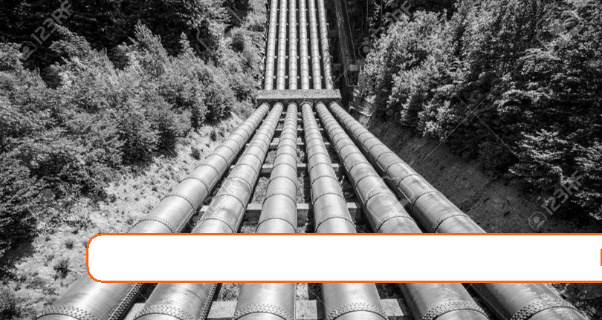

8. Water Distribution

Expected Range of Knowledge for Water Distribution Water Distribution System Operator License Exams

|  |  |
| --- | --- |
| D1 | Knowledge of basic operation |
| D1 | Knowledge of start-up procedures |
| D1 | Ability to flush a service line |
| D1 | Ability to recognize a cross-connection |
| D1 | Ability to recognize a potential backflow hazard |
| D1 | Ability to tap a water main |
| D1 | Knowledge of "back-pressure" and "back-siphonage" conditions |
| D1 | Knowledge of "grid," "tree„" "arterial," and "dead end" water systems |
| D1 | Knowledge of available backflow prevention methods |
| D1 | Knowledge of conditions that cause backflow |
| D1 | Knowledge of equipment used for flushing |
| D1 | Knowledge of pressure/elevation relationships |
| D1 | Knowledge of proper flushing velocities |
| D1 | Knowledge of service connection materials and fittings |
| D1 | Knowledge of the impacts of flushing on a distribution system |
| D1 | Ability to connect water pipe |
| D1 | Ability to operate a dewatering pump |
| D1 | Ability to set up a temporary service line |
| D1 | Knowledge of bedding techniques |
| D1 | Knowledge of compaction tools and methods |
| D1 | Knowledge of excavating techniques |
| D1 | Knowledge of notification requirements |
| D1 | Knowledge of proper backfill techniques |
| D1 | Knowledge of proper flushing procedures |

222 Chapter 8. Water Distribution

Expected Range of Knowledge for Water Distribution

Water Distribution System Operator License Exams (Continued)

|  |  |
| --- | --- |
| D1 | Ability to flush using a hydrant |
| D1 | Knowledge of hydrant types |
| D1 | Knowledge of hydrant valve operation/testing |
| D1 | Knowledge of mechanical parts of hydrants |
| D1 | Knowledge of pressure requirements |
| D1 | Knowledge of proper hydrant installation |
| D1 | Knowledge of thrust blocks |
| D1 | Knowledge of maintenance recordkeeping |
| D1 | Knowledge of predictive, preventative, and corrective maintenance |
| D1 | Ability to differentiate pipe tap size |
| D1 | Ability to recognize abnormal operating conditions |
| D1 | Ability to recognize faulty or damaged pipe |
| D1 | Knowledge of compatible materials |
| D1 | Knowledge of material compatibility |
| D1 | Knowledge of pipe connectors and applications |
| D1 | Knowledge of pipe fitting and joining methods |
| D1 | Knowledge of pipe locating methods |
| D1 | Knowledge of pipe material and applications |
| D1 | Knowledge of pipe material compatibility |
| D1 | Knowledge of proper backfill procedures and compaction |
| D1 | Knowledge of proper bedding techniques |
| D1 | Knowledge of proper joints and fitting applications |
| D1 | Knowledge of system pressure zones |
| D1 | Knowledge of AC pipe handling procedures |
| D1 | Ability to recognize a malfunctioning valve |
| D1 | Knowledge of pressure regulating valve maintenance |
| D1 | Knowledge of proper valve installation |
| D1 | Knowledge of the principles of operation of valves |
| D1 | Knowledge of valve types and applications |
| D1 | Ability to choose the correct meter size |
| D1 | Ability to differentiate meter size |
| D1 | Knowledge of water meter types and purposes |
| D1 | Knowledge of AWWA disinfection standards for storage facilities |
| D1 | Knowledge of AWWA disinfection standards for water mains |
| D1 | Knowledge of AWWA disinfection standards for wells |
| D1 | Knowledge of storage reservoir disinfection techniques |
| D2 | Ability to recognize corrosive conditions in distribution systems |
| D2 | Knowledge of the causes of corrosion in a distribution system |
| D2 | Knowledge of the effect of corrosion in a distribution system |
| D2 | Knowledge of type and applications of cathodic protection devices |
| D2 | Ability to differentiate between a "trunk" line and a "transmission" line |
| D2 | Ability to drain, clean, and disinfect a storage facility |
| D2 | Ability to interpret map symbols |
| D2 | Ability to recognize when flushing is required |

223

Expected Range of Knowledge for Water Properties and Sources Water Distribution System Operator License Exams (Continued)

|  |  |  |
| --- | --- | --- |
| D2 | Knowledge of flushing techniques |  |
| D2 | Knowledge of map types |  |
| D2 | Knowledge of storage facility components |  |
| D2 | Knowledge of storage facility corrosion control methods |  |
| D2 | Knowledge of the terms, "peak demand," "peak hour demand," "maximum daily demand," and |  |
| "per-capita demand" |  |
|  |  |
|  |  |  |
| D2 | Knowledge of the types of storage facilities and their applications |  |
| D2 | Ability to identify different soil types |  |
| D2 | Knowledge of dewatering techniques |  |
| D2 | Knowledge of pipe cleaning procedures |  |
| D2 | Knowledge of the causes and effects of tuberculation |  |
| D2 | Knowledge of the fire hydrant testing program |  |
| D2 | Ability to choose the correct type of joint |  |
| D2 | Knowledge of advantages/disadvantages of pipe materials |  |
| D2 | Knowledge of allowable leak loss |  |
| D2 | Knowledge of C-Factor |  |
| D2 | Knowledge of factors affecting leak detection |  |
| D2 | Knowledge of leak detection methods |  |
| D2 | Knowledge of proper disinfection techniques |  |
| D2 | Knowledge of proper thrust block uses |  |
| D2 | Knowledge of proper thrust restraint |  |
| D2 | Knowledge of tapping methods |  |
| D2 | Knowledge of tapping tools/equipment |  |
| D2 | Knowledge of thrust restraint requirements |  |
| D2 | Ability to interpret SCADA information |  |
| D2 | Knowledge of communication techniques |  |
| D2 | Knowledge of the components of a SCADA system |  |
| D2 | Knowledge of pressure ratings |  |
| D2 | Knowledge of valve exercise program |  |
| D2 | Knowledge of mechanical parts of water meters |  |
| D2 | Ability to calculate a water velocity |  |
| D3 | Knowledge of flow demand requirements |  |
| D3 | Knowledge of permit requirements for flushing |  |
| D3 | Ability to choose the proper cleaning technique |  |
| D3 | Ability to recognize tuberculation |  |
| D3 | Knowledge of storage tank corrosion control measures |  |
| D4 | Ability to calculate a hydraulic gradient |  |
| D4 | Knowledge of power requirements (e.g. efficiency) |  |
| D5 | Ability to calculate annual expenditures |  |
| D5 | Knowledge of local water usage patterns |  |
| D5 | Knowledge of water rate structures, water rate setting methods |  |

224 Chapter 8. Water Distribution

Expected Range of Knowledge for Water Properties and Sources Water Treatment Operator License Exams

|  |  |
| --- | --- |
| T1 | Knowledge of storage tank disinfection procedures |
| T1 | Ability to read and interpret water meter readings |
| T1 | Knowledge of the components of water meters |
| T1 | Knowledge of the operation of water meters |
| T1 | Knowledge of water meter types and uses |
| T1 | Knowledge of head pressure |
| T1 | Knowledge of the operation of pressure gauges |
| T1 | Knowledge of basic SCADA system components |
| T2 | Ability to calibrate a water meter |
| T2 | Ability to replace pressure gauges |
| T2 | Ability to calibrate a pH meter |
| T2 | Ability to determine normal operation of a SCADA system |
| T2 | Ability to administer a maintenance program |
| T3 | Knowledge of C-factor |
| T3 | Knowledge of the cathodic protection process |
| T3 | Knowledge of corrosion control inhibitors |
| T3 | Ability to develop an operational site sampling plan |
| T3 | Ability to develop an operations plan |
| T3 | Ability to evaluate treatment facility performance |
| T3 | Knowledge of facility operation and maintenance |
| T3 | Knowledge of management principles |
| T3 | Knowledge of principles of supervision |
| T3 | Knowledge of public relations principles |

|  |  |
| --- | --- |
| 8.1 Introduction | 225 |
|  |  |

8.1 Introduction

* The basic function of a water distribution system is to transport the water from the treat-ment facility to the customer.
* In addition, distribution systems may also provide:
  1. Storage
  2. Provide flow and pressure adequate for fire protection
  3. Provide a point to sample water to ensure the end user is being provided with water that is safe and meets the regulatory requirements.
* As the volume of water necessary to fight fires is much greater than domestic and commer-cial water demand in most communities, the size of water mains, pump station capacity, and storage reservoir volume is determined by fire suppression needs.
* Distribution systems should provide adequate and reliable water to the customer.
* Adequate means:

– Providing all the water the customer needs at a pressure not less than 20 psi.

– Water provided meets the customer’s needs for quality.

* Reliable means:

– Reliable means that customers can expect to obtain all the water they need, anytime they need it. In other words, they can expect that there will be water at the tap.

* As part of being adequate and reliable, the system must be operated in a way so that the quality of the water does not deteriorate between the treatment facility and the customer.
* In most communities it is expected that adequate flow, pressure, and storage volume is available for fire prevention
* The scope of this text is to describe the details of the piped distribution system.
* Basic components of the piped distribution system includes: pipes, valves, fire hydrants, service connections, and reservoirs. Piped systems may also have pumping stations which are discussed in another Module.
* Per Title 22 Regulations, the minimum operating pressure in the water main at the user service line conectionshould be 20 psi at all times.
* Characteristics of and ideal distribution system:

– Sized appropriately to accommodate system flows including fire flows.

– Minimally impact water quality

– Provide water at appropriate line pressures.

– Built with components that are durable and corrosion resistant.

* Primary components of the distribution system include:
* Pipelines. which include:

– Transmission Mains

– Distribution Mains

– Service Laterals

* Facilities

226 Chapter 8. Water Distribution

– Storage Structures

– Pump Stations

– Pressure Reducing Stations

* 1. Appurtenances

– Valves

– Angle Joints

– Fire Hydrants

– Meters

* The friction between the inside surface of the pipe and the water flowing through it, pro-vides a resistance to the flow. This resistance depletes the energy of the flowing water, and is therefore important to ensure the pipe inside surface is smooth.
* Besides the pipe, other components of the water distribution system including fittings, bends, valves, expansion joints and any change in direction can also create friction that causes energy/pressure loss.
* "C" factor is a measured value which quantifies the smoothness of the interior of a pipe. For most pipe materials C ranges from 60 - 150. A high C value implies less friction or a smoother pipe, greater water carrying capacity, and the smaller the friction or energy losses from water flowing in the pipe. A CPVC pipe has a C factor value of 150 whereas the C factor of a worn/pitted cast iron pipe would be about 60-80.

8.2 Pipelines

Pipelines are arteries and veins of a water distribution system. They are in a variety of lengths and sizes and deliver water throughout a wide range of areas. They are typically categorized as: transmission mains, distribution mains, and service laterals.

8.2.1 Transmission Mains

* Transmission mains are large diameter pipes, carrying large volumes of water to the distri-bution system.
* Not all water suppliers have transmission mains of this size and some may not travel long distances.
* Typically there are no service connections to customers off transmission mains unless they are smaller in size and are located within a distribution system.
* Transmission mains are commonly welded steel and ductile iron pipe.
* All newly installed water mains shall comply with the materials and installation standards of the American Water Works Association (AWWA).

8.2.2 Distribution Mains

* California Code of Regulations require water mains to have a nominal diameter of at least four-inches. Typical Distribution mains range in size from 6 inches up to 24 inches in

|  |  |
| --- | --- |
| 8.2 Pipelines | 227 |
|  |  |

diameter.

* Unlike transmission mains, distribution mains have customer services connected to them.
* Distribution mains are most commonly ductile iron pipe. However, polyvinyl chloride is also extensively used. Asbestos cement pipe is found only in older water systems.
* Table 8.1 summarizes the advantages and disadvantages of the distribution mains:

|  |  |  |  |  |  |  |
| --- | --- | --- | --- | --- | --- | --- |
|  | SYSTEM | ADVANTAGES | | DISADVANTAGES | |  |
|  |  |  |  |  |  |  |
|  |  |  |  | • | Does not maintain |  |
|  |  |  |  |  | satisfactory pressure in |  |
|  |  |  |  |  | high-rise buildings. |  |
| Dead-end or Tree Distribution Sys- | | • Pipe laying is simple | | • As one pipe provides | |  |
| tem | In this type of water distribution |  | the water to the entire |  |
|  | and easy. |  |  |
|  | system, one main pipeline runs | • | Fewer cut-off valves are |  | building - quite risky. |  |
|  | • High head loss, req. | |  |
|  | through the center of the building, |  | required - lower O&M |  |
|  |  |  | larger dia. piping |  |
|  | and the sub-mains branch lines |  | costs. |  |  |
|  |  | • | System discharge |  |
|  | off from both sides. The sub-main | • | Maintenance done |  |
|  |  | capacity is limited. |  |
|  | lines are divided into several |  | without disrupting flow |  |  |
|  |  | • Dead-ends can cuase | |  |
|  | branch lines for service connection |  |  |  |
|  |  |  |  | water quality problems |  |
|  | to a particular house. |  |  |  |  |
|  |  |  |  | and require frequent |  |
|  |  |  |  |  |  |
|  |  |  |  |  | flushing. |  |
|  |  |  |  |  | |  |
| Ring Distribution System |  |  |  | • The length of pipe | |  |
|  | • | Discharge rate is high, |  | laying is more which |  |
|  |  |  |  |
|  | Here, the main pipeline encloses |  | low head losses |  | ultimately leads to |  |
|  | • | Maintenance can be |  | higher cost. |  |
|  | the system. The branch pipes are |  | done without disrupting | • | Several valves are |  |
|  | connected cross-wise to the mains |  | flow |  | required to control the |  |
|  | and also to each other. | • | No endpoints, minimal |  | flow and discharge of |  |
|  |  |  | stagnation |  | water. |  |
|  |  |  | |  |  |  |
|  |  | • Typically used in high- | |  |  |  |
| Radial Distribution System | In this types of water distribution |  | rise buildings. | • | The design of the pipe |  |
| system, the whole buildings are | • | Discharge rate is high, |  |
|  | divided into several distribution |  | low head losses. |  | laying system is compli- |  |
|  |  |  | cated. |  |
|  | areas. Each building has a centrally | • | Maintenance can be |  |  |
|  | • More length of pipe is | |  |
|  | located elevated reservoir from |  | done with minimal flow |  |
|  |  |  | required. |  |
|  | where distribution pipes run radi- |  | disruption. |  |  |
|  |  |  |  |  |
|  | ally towards the periphery of the | • | No endpoints, minimal |  |  |  |
|  | distribution areas. |  | stagnation |  |  |  |
|  |  |  |  |  |  |  |
| Grid Iron Distribution System | Main supply lines run through | • | Minimal stagnation or | • | In this system, more cut- |  |
|  |  | sediment deposit. |  | off valves are required. |  |
|  | the center, and sub mains branch |  | • | This system requires |  |
|  | • | Water is available |  |
|  | off in perpendicular directions. |  | longer pipe lengths with |  |
|  |  | at every point with |  |  |
|  | The branch interconnects the |  |  | larger diameters. |  |
|  |  | minimum loss of head. |  |  |
|  | sub-mains. All types of pipes are |  | • The analysis of dis- | |  |
|  | • Water is delivered with | |  |
|  | interconnected - no dead ends. |  | charge, pressure, and |  |
|  |  | adequate pressure for |  |  |
|  | Water can reach any given point |  |  | velocity in the pipes is |  |
|  |  | firefighting. |  |  |
|  | from many directions, which |  |  | difficult and cumber- |  |
|  | • | During repair, few |  |  |
|  | allows more flexible operation, |  | some. |  |
|  |  | houses are affected. |  |  |
|  | particularly for repairs. |  |  |  |  |
|  |  |  |  |  |  |
|  |  |  |  |  |  |  |

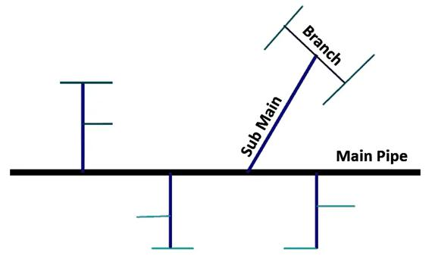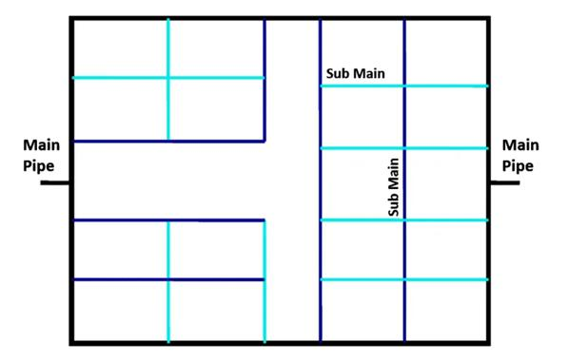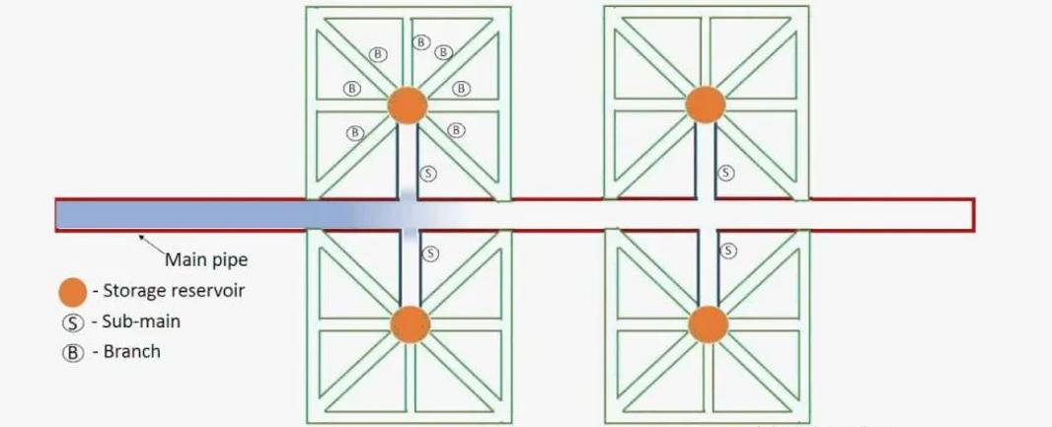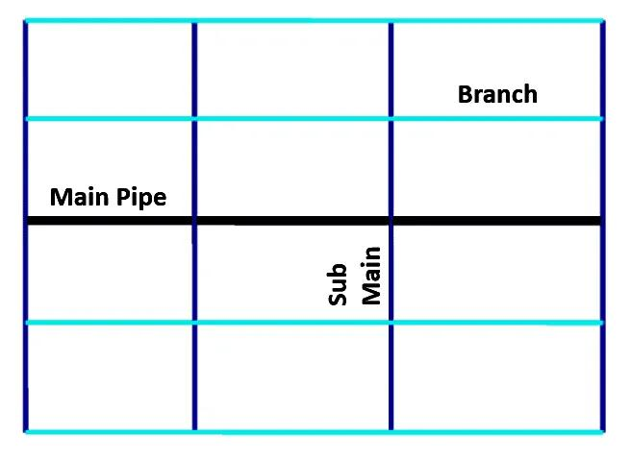

Table 8.1: Types of Distribution Systems

8.2.3 Service Laterals

* A service lateral is the pipe that provides water from the water main in the street to a home or business.
* For residences this pipe is usually 1 inch in size and runs from the water main into the home where the water meter is installed.
* Service lateral is typically connected to the main line through a brass plug valve called a corporation stop .
* A curb stop is a brass plug valve installed at the water meter inside the valve box. The curb stop is used to shut off the water flow to the user.

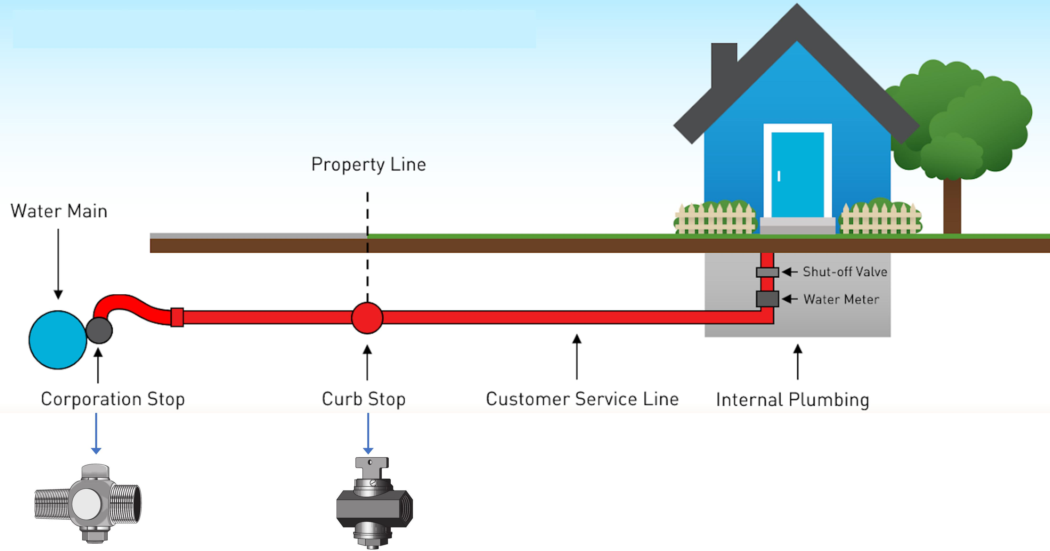

Figure 8.1: Typical Service Lateral Installation

8.2.4 Piping Material

The attributes for good pipe materials include:

* It should have adequate structural strength.
* Impervious, corrosion-resistant, durable and long, lasting.
* Cost-effective.
* Resistance to abrasion.
* Light weight so that easy to transport and handle.
* Easy to join, flexible in design, easy to repair and maintain.
* Environmentally friendly.
* Ease of locating piping without excavation - pipes with electrical conductive material

may be detected using electromagnetic metal detectors whereas pipes made from non-conductive material maybe detected by inducing a signal into the pipe from a valve or hydrant that may be picked up by an above-ground sensor.

Tables 8.2 and 8.3 summarize the properties, advantages, disadvantages and joints related to the common distribution system pipeline materials.

|  |  |  |  |  |  |  |  |
| --- | --- | --- | --- | --- | --- | --- | --- |
| Pipe Material | Advantages | Disadvantages | | Joints |  | .8 |  |
|  | 2 |  |
|  | • Numbers of joints are less because these |  |  |  |  | Pipelines |  |
| Steel: These are fabricated by rolling the | are available in long lengths. | • | Maintenance cost is high. |  |  |  |
|  |  |  |  |
| • The pipes are cheap at the first cost. |  |  |  |  |
| mild steel plates to proper diameter and can | • | The pipes are likely to be rusted by acidic | Steel pipe is coupled by a variety of |  |  |  |
| • The pipes are durable and strong enough |  |  |  |
| be joined by riveting or welding. Steel pipe |  | or alkaline water. | methods; threaded couplings, welded |  |  |  |
| to resist high. |  |  |  |  |
| is coupled by a variety of methods; threaded | • | The pipes require more time for repairs | couplings, Dresser™type couplings, Vic- |  |  |  |
| • The pipes are flexible to some extent |  |  |  |
| couplings, welded couplings, Dresser™type |  | during breakdown and hence are not | taulic™couplings, flanges and rubber ring |  |  |  |
| laid on curves. and they can therefore |  |  |  |  |
| couplings, Victaulic™couplings, flanges |  | suitable for distribution pipes. | push-on joints. |  |  |  |
| 5. Transportation is easy because of |  |  |  |  |
| and rubber ring push-on joints. |  |  |  |  |  |  |
| lightweight. |  |  |  |  |  |  |
|  |  |  |  |  |  |  |
|  |  |  | |  |  |  |  |
|  | • Cost of these pipes is moderate. | • The co-efficient of expansion for plastic | |  |  |  |  |
|  |  | is high. | PVC Class and Pressure pipe can be con- |  |  |  |
|  | • Pipes are cheap and durable. |  |  |  |  |
|  | • | It is difficult to obtain plastic pipes of | nected using either an integral bell and |  |  |  |
| • Polyvinyl chloride (PVC) | • The pipes are flexible, light in weight and |  |  |  |
|  | uniform composition. | spigot process or a double ended bell. In |  |  |  |
| • Cross linked PVC (CPVC) | they can easy to mold any shape. |  |  |  |  |
| • | The pipes are less resistant to heat. | either case the gasket is a rubber material |  |  |  |
|  | • Does not corrode, tuberculate or support |  |  |  |
|  | • | Some pipes of plastic impart taste to the | and the joints are made by lubricating the |  |  |  |
|  | bacteria growth like metal pipe. |  |  |  |
|  |  | water. | pipe and pushing it into the coupling or bell. |  |  |  |
|  |  |  |  |  |  |
|  |  |  |  |  |  |  |  |
|  | • Comparatively DI pipes possess greater |  |  |  |  |  |  |
|  | ductility and impact resistance than CI |  |  | Ductile cast iron pipe is commonly con- |  |  |  |
|  | pipes. | • | The pipes require internal and external |  |  |  |
| Ductile iron (DI): Typically, the pipe is | nected using mechanical joints (M.J.), |  |  |  |
| • Lighter than CI pipes so that easy to |  | lining or protection. |  |  |  |
| manufactured using centrifugal casting |  | flanges or the various common rubber ring |  |  |  |
| handle and transport. | • | Corrosion may take place as equal in CI |  |  |  |
| in metal or resin-lined molds. Protective | push-on joints. Fittings used are commonly |  |  |  |
| • The pipes are easy to join and simple |  | pipes. |  |  |  |
| internal linings and external coatings are |  | made of gray or ductile cast iron and use |  |  |  |
| also can accommodate some angular | • | The polyethylene wrappings may cause |  |  |  |
| done to ductile iron pipes to overcome | M.J. or hub joints. Service taps are made |  |  |  |
| deflection. |  | damage. |  |  |  |
| corrosion problems. |  | by directly tapping the line or using service |  |  |  |
| • These pipes are of more strength than CI |  |  |  |  |  |
|  |  |  | saddles. |  |  |  |
|  | pipes. |  |  |  |  |  |
|  |  |  |  |  |  |  |
|  |  |  |  |  |  |  |  |
|  | • There are pipes that are most durable |  |  |  |  |  |  |
|  | with usual life of about 75 years. |  |  |  |  |  |  |
| Concrete Pipe: Cement concrete pipe pipes | • The pipes can be cast at site work and | • | Transportation is difficult. | This pipe is connected by bell and spigot |  |  |  |
| may be either plain cement or reinforced | thus there is the reduction in transport | • | Repair work is difficult. |  |  |  |
| rubber ring pushon joints. Once the joint |  |  |  |
| cement concrete. PCC pipes can be used | charges. | • | Initial cost is high. |  |  |  |
| has been connected the exposed steel must |  |  |  |
| up to 15 m head whereas RCC pipes can be | • Maintenance cost is less. | • | These pipes are affected by acids, alka- |  |  |  |
| be coated with concrete to protect the steel |  |  |  |
| used up to the head of 60 in and for higher | • Inside surface of the pipe can be made |  | lies, and salty waters. |  |  |  |
|  | cylinder from corrosion. |  |  |  |
| head pre-stressed concrete can be used. | smooth. |  |  |  |  |  |
|  |  |  |  |  |  |
|  | • No danger of rusting. |  |  |  |  |  |  |
|  |  |  |  |  |  | 229 |  |
|  |  |  |  |  |  |  |

Table 8.2: Pipe Material of Construction - 1 of 2

|  |  |  |  |  |
| --- | --- | --- | --- | --- |
| Pipe Material | Advantages | Disadvantages | Joints |  |
|  | • PEX has a perfect blend of rigidity and |  | The most common connection for HDPE |  |
|  | flexibility. | • Due to their relatively young age, long | pipe is a heat fused weld. The pipe is com- |  |
|  | • These pipes are able to withstand high | term capabilities still remain untested and | monly connected using a butt welding |  |
| Polyethylene: | water pressure. | they are yet to be approved for building | process. There are special stainless steel |  |
| • Their structural integrity is not compro- | codes in several jurisdictions. | adapters that allow the pipe to be con- |  |
|  |  |
| • Crosslinked polyethylene (PEX) | mised if they are bent and woven through | • They also are not compatible with all, | nected using the Victaulic type of coupling. |  |
| • High density polyethylene (HDPE) | walls, ceilings, and basements. | or even most, fittings and leaks are a | Flanged connections can be made by weld- |  |
|  | • These pipes are easy to cut and mold and | common occurrence. | ing a butt or socket weld flange to the pipe. |  |
|  | do not require any complex tools to do | • It is environmentally unfriendly as it is | Repairs can be made to the pipe using typi- |  |
|  | so. | non-recyclable. | cal cast iron couplings, providing a special |  |
|  | • They are relatively inexpensive. |  | stainless steel insert is placed in the pipe to |  |
|  |  |  | prevent collapsing of the pipe. |  |
|  |  |  |  |  |
|  |  | AC pipe undergoes gradual degradation in | The material is connected together using |  |
| Asbestos Cement (Transite or AC)): Was |  | the form of corrosion (i.e., internal calcium |  |
|  | a double bell coupling with a rubber ring |  |
| used extensively in the mid-1900s in |  | leaching due to conveyed water and/or ex- |  |
|  | in each end. Fittings and valves used on |  |
| potable water distribution systems, par- | The pipes were cheap to produce, and at the | ternal leaching due to groundwater). Such |  |
| AC pipe are commonly made of cast iron |  |
| ticularly in the western United States. The | time, thought to be resistant to internal and | leaching leads to reduction in effective |  |
| using a rubber push-on ring for connection. |  |
| AC lifespan estimates were at 70 years, but | external corrosion. | cross-section, which results in pipe soften- |  |
| Service line connections may be made |  |
| actual service life depends largely on pipe |  | ing and loss of mechanical strength. These |  |
|  | by direct tapping of the line or by using a |  |
| condition and working environment. |  | pipes can contain up to 20 per cent asbestos |  |
|  | service saddle. |  |
|  |  | which poses health risks. |  |
|  |  |  |  |
|  |  |  |  |  |

Table 8.3: Pipe Material of Construction - 2 of 2

|  |  |
| --- | --- |
| 8.2 Pipelines | 231 |
|  |  |

8.2.5 Basic Water Main Installation

1. California Code of Regulations, Title 22, Division 4, Chapter 16, Section 64572 estab-lishes criteria for the separation of new water mains from non-potable pipelines. These standards include:

– New water mains and new supply lines shall not be installed in the same trench as and shall be at least 10 feet horizontally from and one foot vertically above, any parallel pipeline conveying untreated/treated sewage, disinfected secondary recycled water or hazardous fluids such as fuels, industrial wastes, and wastewater sludge.

– New water mains and new supply lines shall be installed at least 4 feet horizontally from, and one foot vertically above, any parallel pipeline conveying tertiary recycled water, and storm drainage.

– New water mains shall not be installed within 100 horizontal feet of the nearest edge of any sanitary landfill, wastewater disposal pond, or hazardous waste disposal site, or within 25 horizontal feet of the nearest edge of any cesspool, septic tank, sewage leach field, seepage pit, underground hazardous material storage tank, or groundwater recharge project site.

1. Water main installation begins with excavation which is expensive and dangerous. Before excavation can begin, the project must be well planned and all safety elements must be considered.
2. To protect the trench and workers from traffic, the excavated material should be piled on the pavement side of the trench.
3. Place all excavated or fill materials a minimum of two feet away from the top edge of the trench. If materials need to be closer than two feet from the edge of the trench, install an effective barrier to prevent them from falling into the excavation.

4. Before entering the trench, determine if shoring is necessary.

1. OSHA requires a protective system for trenches 5 feet or greater.

5. Determine if a hazardous atmosphere exist in the trench.

1. Normal oxygen levels range from 19.5 to 21.5%.

6. Determine if access to and exit from the trench is required.

1. Trenches 4 feet or more in depth must have a safe means of egress.
2. Spacing between ladders or other means of egress must be such that a worker will not have to travel more than 25 feet laterally to the nearest means of egress.
3. Ladders must be secured and extend a minimum of 36 inches above the landing.
4. Inspect the pipe for defects, damage, oil, dirt, grease, and/or foreign matter.
5. Any unsound material should be replaced and all foreign matter or dirt should be removed from the interior of the pipe before lowering into the trench.

Before lowering the pipe into the trench the trench bottom should be smooth and free of material like large stones or large dirt clods.

232 Chapter 8. Water Distribution

Lower the pipes, and other necessary equipment carefully into the trench.

Before connecting the pipe:

* Inspect the bell to be sure that no dirt or foreign material is on the ring.
* Clean the pipe end around the entire circumference from the end spigot to 1 inch above the reference line (note: this line is used for proper insertion depth of bell and spigot).
* Once the pipe is cleaned, be careful during installation to ensure gravel does not enter into the line.

Be sure to use blocks or restraints to avoid leaks and pipe movement from the thrust against tees, valves, bends, reducers and fire hydrants.

* Size and type of the thrust block depends on maximum pressure, pipe size, kinds of soil and types of fittings. After the water main pipe and fittings have been installed in the trench, the excavation must be backfilled with suitable material.
* Only clean sand or selected soil should be used for the first layer. The bedding around the pipe should be of uniform size and material. Allowing materials of various sizes such as large rocks could cause the pipe to fracture during settlement.
* The first layer of backfill should be placed equally on both sides of the pipe, up to about the center of the pipe. This material should then be compacted, a process often called haunching.
* Depending on the area and conditions, generally another layer of backfill is placed over the pipe and again compacted to protect and secure the pipe.
* The trench needs refilled appropriately. The backfill material should be compacted at 12 inch intervals to minimize settlement.
* Backfill practices vary depending on type of pipe, local soil conditions and regulatory requirements. Proper backfilling is very important:
* Improper compaction = broken lines
* Large backfill = increase probability of main break
* To properly disinfect water mains, different methods can be applied. Due to the dangers of chlorine it is advised that the operator choose the best method that suits the facility’s needs.
* Calcium hypochlorite tables can be placed in each section of pipe and fire hydrant as work progresses.
* A concentrated chlorine solution can be injected through a corporation stop.
* The chlorination rate should be such that it will produce a concentration of about 50mg/L when mixed with incoming water.
* Mathematical calculations are necessary to determine how much chlorine will be needed.
* This will be addressed in the chlorination section.
* The chlorine solution should remain in the pipe for at least 24 hours.

After the trench has been backfilled, the new main must be pressure tested to determine whether there are any leaks.

|  |  |
| --- | --- |
| 8.3 Water storage | 233 |
|  |  |

* The test may be performed one section at a time between valves or the installer may wait and test the entire job at one time.

At the end of the contact period, the chlorinated water should be flushed from the pipeline.

1. One or more fire hydrants should be used for flushing so that a velocity of around 5ft/s is obtained in the pipe.
2. This velocity should be maintained long enough to allow two or three complete changes of water and for the water to run visibly clean. - Gravel in the line is an indication of im-proper installation.
3. The highly chlorinated water will probably kill grass, so the flow should be carried to a disposal site through hoses.
4. In some cases, the water may need dechlorinated before it is released to a waterway.

After a new pipeline has been disinfected and flushed, it should be refilled with water from the distribution system and tested for bacteriological quality.

* This test takes at least 24 hours to complete from the time of sampling.
* The test must meet requirements of the Department of Environmental Protection.

8.3 Water storage

* Water storage reservoir in a water distribution system allows for:
  1. Maintaining water supply pressure - typically maintained by the water level in the storage reservoir.
  2. As water demand changes during the day, the water reservoir provides the buffer ca-pacity to meet the demand during peak period. Allows for leveling out the pumping demands by allowing the pumping system to fill the reservoir to a specific level after which the pumps are shut off, and water is drawn from the reservoir until the level drops to a predetermined point at which time the pumps restart.
  3. Providing fire fighting demand which may account for as much as fifty percent of total storage. In addition, fire-fighting demands must be met during main line breaks, power outages, and maximum customer demands.
  4. Providing a point to blend different water supplies.
  5. Providing ability to supply water during power outages and during maintenance of transmission mains.
  6. Providing the detention time for chlorine disinfection to meet the water quality re-quirements.
* There are four basic type of storage reservoirs:
  1. Underground reservoir
  2. Ground level reservoir
  3. Elevated reservoirs which include elevated tanks and standpipes
  4. Hydropneumatic tanks which are tanks which contain 1/3 air and 2/3 water. The air in the tank is compressed as the tank fills with water and the pressurized air pushes

234 Chapter 8. Water Distribution

water out of the tank.

* Typical material of construction include welded and bolted steel and cast-in-place and pre-stressed concrete. Some smaller tanks such as the hydropneumatic tank is made from fiberglass.
* Newly-installed distribution reservoir or distribution reservoir that has been taken out of service for repair or inspection is required to be disinfected and sampled for bacteriologi-cal quality in accordance with the American Water Works Association Standard C652-02. If the results of the bacteriological sampling are positive for coliform bacteria, the reser-voir shall be re-sampled for bacteriological quality and the test results shall be submitted to the State Board for review and approval before the reservoir is placed into service.

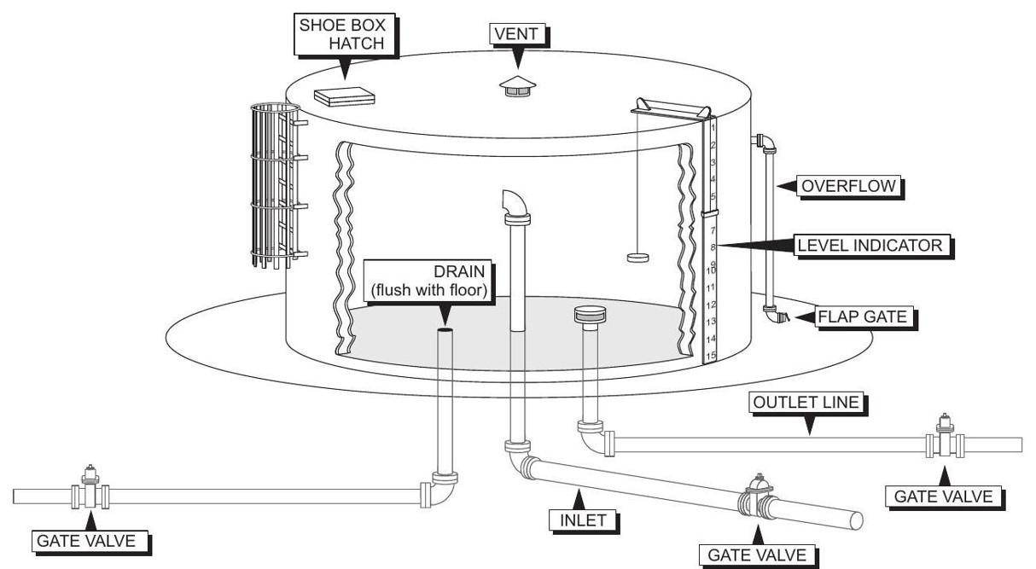

Figure 8.2: Typical reservoir piping

8.4 Valves Used in Water Distribution

* Valves are a critical component of every water systems.
* Main type of valves used in the water distribution system include:
  1. Flow control and isolation valves
  2. Air valves
  3. Backflow prevention valves
* Valves can be classified based upon the movement of the closure element as:
  1. Rotary valve:

– The stem modes from fully open to fully closed position by rotating 90 degrees.

– Rotary valves include: plug, ball and butterfly valves.

* 1. Linear valves:

– Also known as multi-turn valves, these have a sliding-stem design that pushes a closure element into an open or closed position.

– Linear valves include: globe, gate and check valves.

– They offer flow control capabilities.

* Valves are used for the following applications:

– Flow and pressure regulation

|  |  |
| --- | --- |
| 8.4 Valves Used in Water Distribution | 235 |
|  |  |

– System isolation

– Air relief

– Backflow or cross-connection prevention

– Pressure reducing and pressure sustaining

– Controlling levels and preventing overflow in elevated tanks and standpipes - Alti-tude valves

– Blowoff and drain valves for removing accumulated sediments from low spots and for dewatering lines and reservoirs.

– Controlling level of water in tanks and activating controls - Float valves

8.4.1 Flow Control and Isolation Valves

* These valves are used for controlling flows or for isolation of pipelines.
* Valve selection is based upon the application elements including size of pipe and water pressure.
* Tables 8.4 and 8.5 summarize the properties and use of the commonly used distribution system valves.

|  |  |
| --- | --- |
| Globe Valve | Use |
|  |  |
| • Linear stroke type valve | • Globe valves have higher pressure drops in comparison to |
| • Has a spherical shape of valve body. | other valves. |
| • Globe valves have a movable closure that moves up and down inside of the | • Used for flow and pressure control in large size applica- |
| valve body. | tions and for isolation in small sizes. |
| • Valve body is divided into two halves by a partition or baffle. | • The torturous path of the flow through a globe valve causes |
| • A small horizontal disc or plug is the closure member which can move up and | a larger pressure drop compared to other valves. |
| down attached to the stem, thus opening or closing the valve. | • An altitude valve is a type of a globe valve, is used for |
| • The discs in contact with the seat closes the valve. The seat can be damaged | controlling the level of water in a reservoir. It opens and |
| by formation of solid deposits. Hence globe valves are suitable only for clean | closes to fill a high-level tower or tank hydraulically and it |
| service. | functions by sensing the static level of water in the tower. |
|  |  |

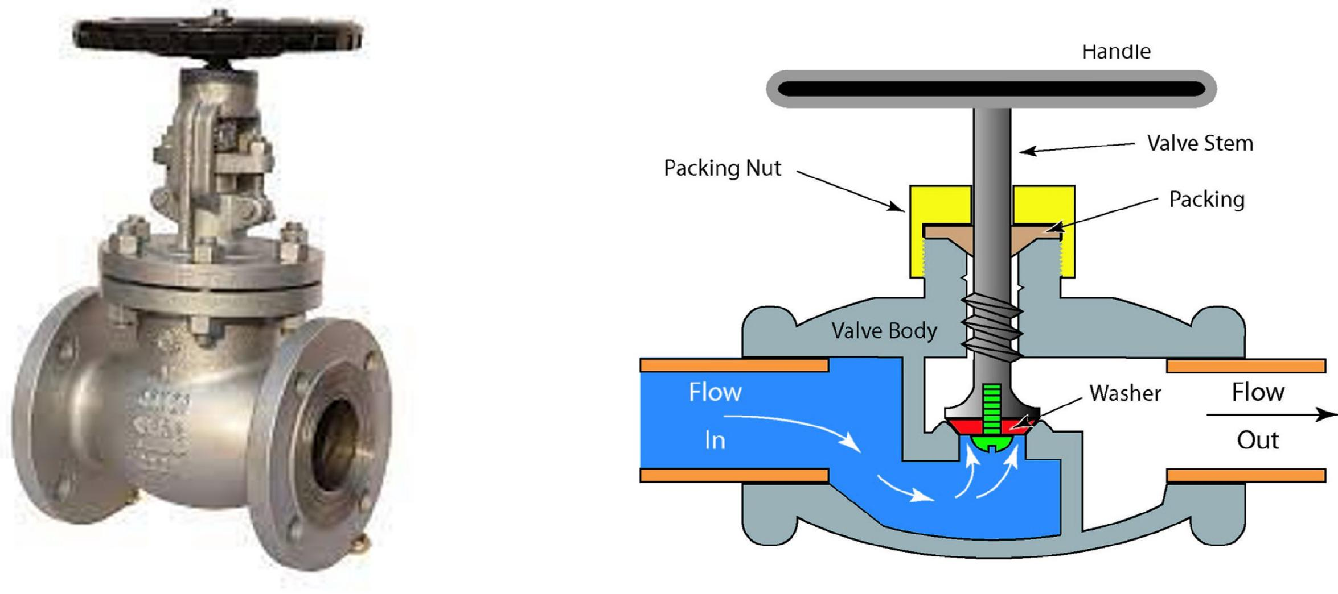

|  |  |
| --- | --- |
| Plug Valve | Use |
| • Rotary stroke type valve | • The plug valve is the simplest of all valves. |
| • Valves have a cylindrical or conically tapered "plugs" which can be rotated | • The movable closure has a hole through which water is |
| inside the valve body to control flow through the valve. | permitted to pass. |
| • The plugs in plug valves have one or more hollow passageways going sideways | • A1/4 turn turns the valve from open to closed. |
| through the plug, so that fluid can flow through the plug when the valve is open. | • Commonly used as the isolation valves on the customer |
|  | service lines Corporation Stops. |
|  |  |

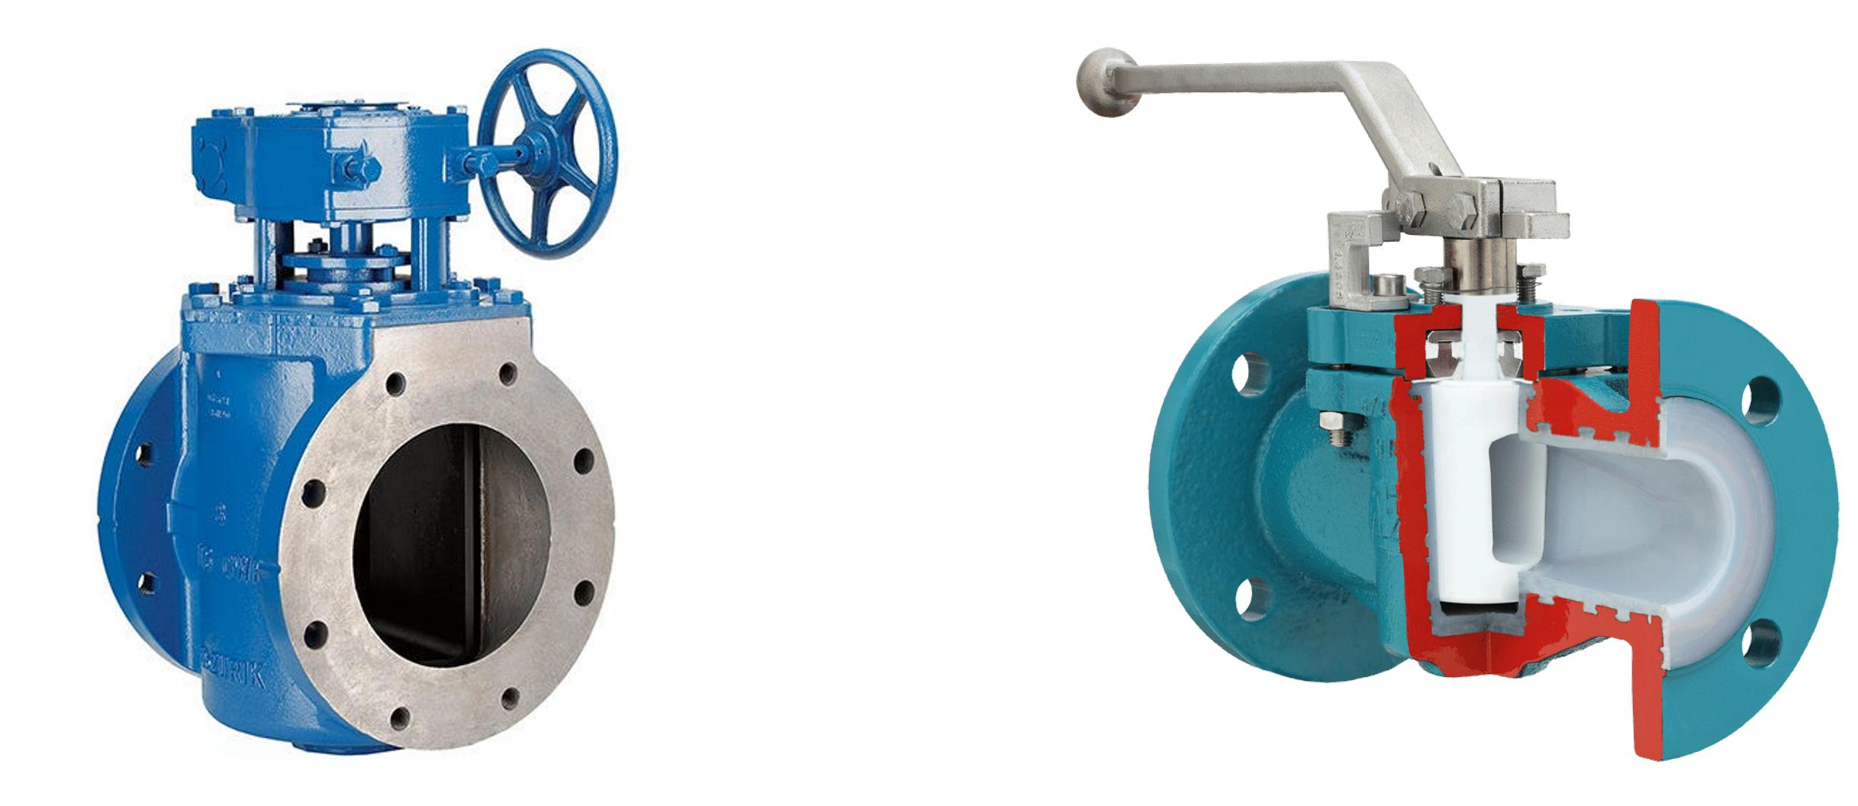

|  |  |  |
| --- | --- | --- |
| Gate Valve | Use |  |
| • Linear stroke type valve | • Main application in to isolate sections of mains |  |
| • Gate valves are mostly used with larger pipe diameters |  |
| • A gate valve, also known as a sluice valve, is a valve that opens by lifting a | (from 2" to the largest pipelines) since they are less com- |  |
| barrier (gate) out of the path of the fluid. | plex to construct than other types of valves in large sizes. |  |
| • Gate valves require very little space along the pipe axis and hardly restrict the | • Gate valves should not be used to throttle flow as the high |  |
| flow of fluid when the gate is fully opened. | velocity of water through a small valve opening can cause |  |
| • The gate faces can be parallel but are most commonly wedge-shaped (in order | cavitation and scour damage to the valve. |  |
| to be able to apply pressure on the sealing surface). |  |  |
|  |  |  |

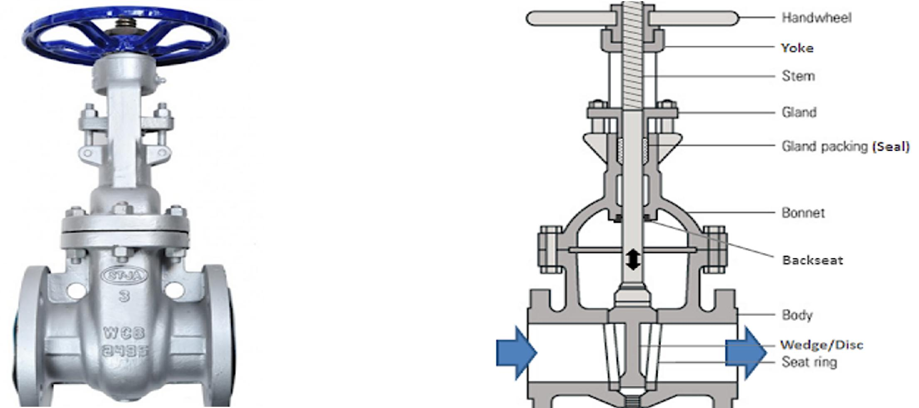

Table 8.4: Flow control and isolation valves - Table 1 of 2

|  |  |  |
| --- | --- | --- |
| Butterfly Valve | Use |  |
|  |  |  |
| • Rotary stroke type valve | • Butterfly valves offer some restriction to flow, which |  |
| increases headloss. |  |
| • Butterfly valves are a family of quarter-turn rotational motion valves that are |  |
| • However, they are much easier to open and close in large |  |
| used in pipelines to shut-off flow. |  |
| lines than gate valves. |  |
| • The butterfly valve has a disc gate to stop or throttle fluid flow. |  |
| • The butterfly valve is not 100 % watertight when closed. |  |
| • When closed, the disc seats against a rubber-like seal set into the valve body. |  |
| • Typically used as a shut-off valve and not for regulating |  |
| • In the closed position, the disc blocks the valve bore while in the open position, |  |
| flow. |  |
| the disc is oriented perpendicular to the flow direction to allow flow. |  |
|  |  |
|  |  |  |

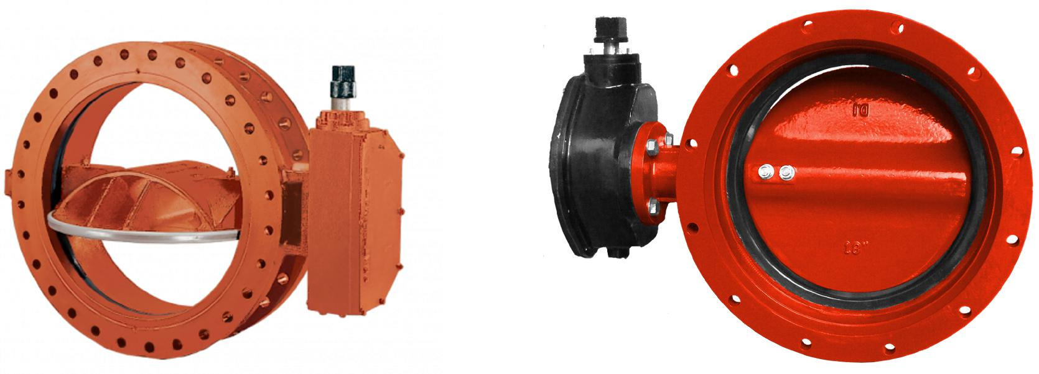

|  |  |  |
| --- | --- | --- |
| Ball Valve | Use |  |
| • Rotary stroke type valve |  |  |
| • Typically used as a shut-off valve. |  |  |
| • Water flow is controlled through a rotational ball containing a hole through its | • Ball valves are durable, performing well after many cycles, |  |
| centre placed in the middle of the valve. |  |
| and reliable, closing securely even after long periods of |  |
| • When the ball’s hole is parallel to the water inlet, water can flow through. When |  |
| disuse. |  |
| the hole is rotated a quarter turn - 90◦ to the pipe the passage is blocked, and |  |
|  |  |
| water cannot flow through. |  |  |
|  |  |  |

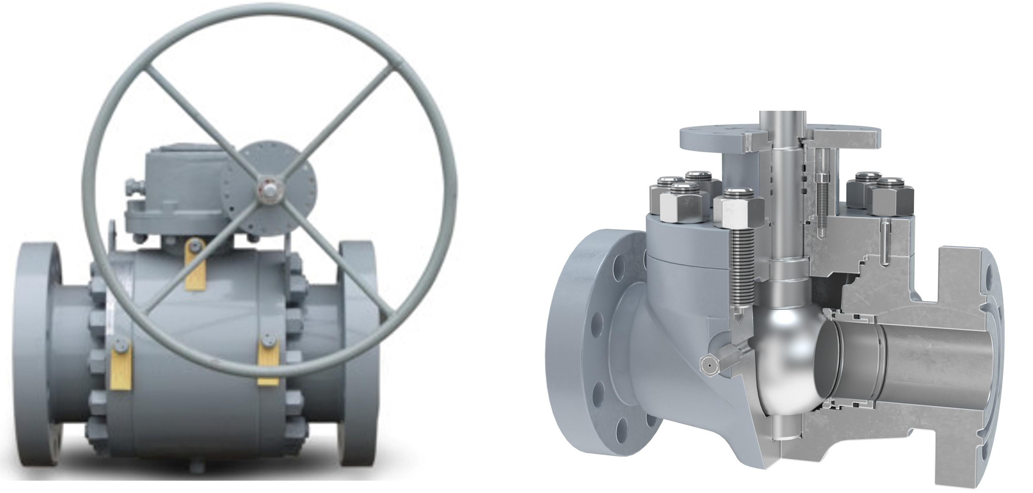

|  |  |  |
| --- | --- | --- |
| Foot Valve | Use |  |
| • Linear stroke type valve |  |  |
| • While the pump is running, there’s a constant column of water in the pipe as a |  |  |
| result of the suction that’s created. But when the pump is shut off, the suction |  |  |
| disappears, the water will flow downward through the pipe because of gravity, |  |  |
| back to its original source. The pipe would be left empty of water, instead filled | • Foot valves are used for suction lift applications, like a |  |
| with air. |  |
| well pump. help keep a pump primed therefor stopping |  |
| • Foot valve is a check valve which helps prevent draining of the pump suction |  |
| your pump from burning out. |  |
| pipe after the pump is turned off keeping the pump primed. |  |
|  |  |
| • Foot valves open in one direction and close off when the direction of flow is |  |  |
| reversed. That means that in an application such as pumping from a well, the |  |  |
| water can only be extracted out of the well. |  |  |
|  |  |  |

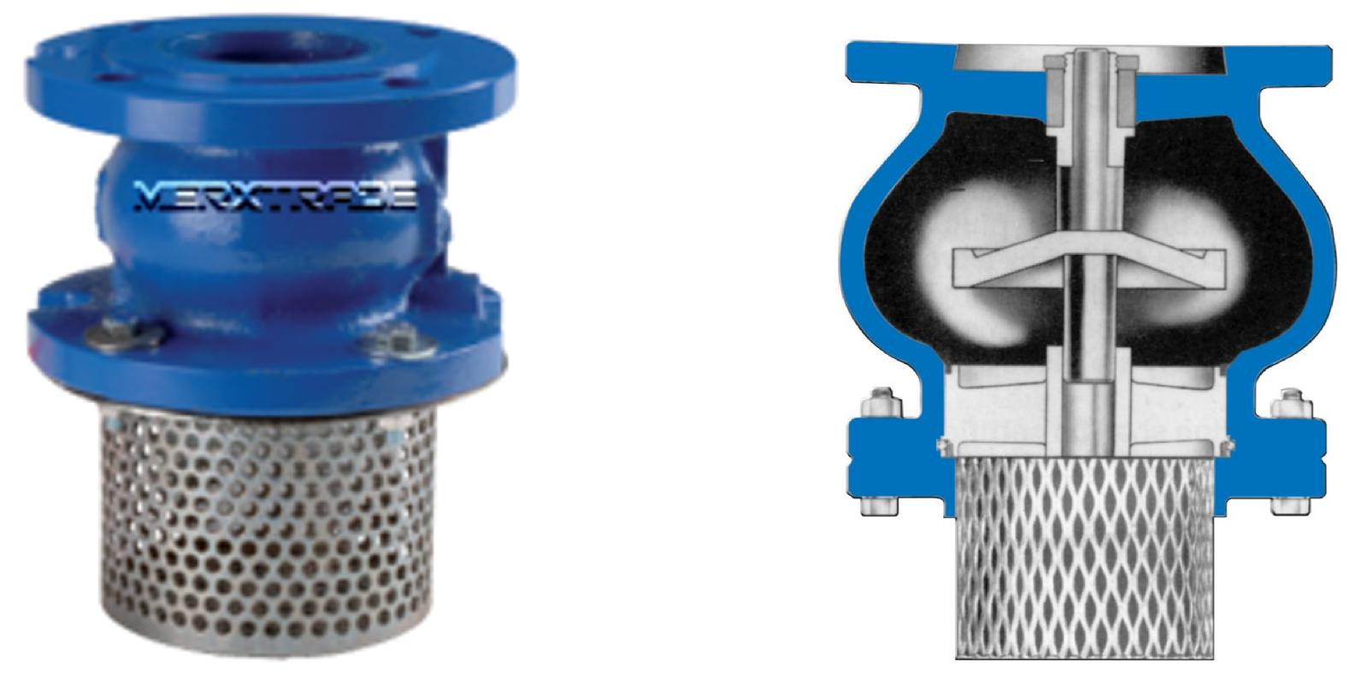

Table 8.5: Flow control and isolation valves - Table 2 of 2

238 Chapter 8. Water Distribution

8.4.2 Air Valves

* Air valves are an essential component of the water supply system
* Air and vacuum formed in water mains may lead to serious operating problems and even some dramatic consequences. Air can enter piping systems in several ways:

– Empty Pipelines: Pipelines not in operations are occupied with air. Most of it is evacuated during startup, but some air pockets can remain in the system.

– Dissolved air in water: Depending on the temperature and pressure, water can con-tain trapped or dissolved air. During fluid flow, it separates from the liquid and can become trapped at the system’s high points. Also, in pipelines conveying sewage, the liquid waste can undergo chemical reactions and evolve into gases that can get trapped in the wastewater system.

– Mechanical equipment: Air can also get into the pipeline through mechanical sys-tems like pumps, pipe joints, valves, etc. Leaks or faulty seals in these components.

* Consequences of air and vacuum in pipelines include:

– Reduced pumping efficiency: Air in pipelines can reduce the efficiency of the pump-ing system. The air trapped at the high points of the system blocks flow, increasing the pressure head and thus the energy required for flow to occur.

– Pipeline corrosion: Depending on the pipeline’s temperature, oxygen in the trapped air can be a powerful corrosive agent. The oxygen oxidizes the metal gradually, which leads to rusting, blockage, and structural failure of the pipe.

– Faulty metering and instrumentation devices: Air pockets and vacuums can cause problems for flow measuring and control devices. They affect the ability of the de-vices to accurately measure and control the flow.

– Air hammer: When a trapped air pocket is present in a pipe, pressure builds up around the blockage. The pressure of the water swirling around this blockage sends vibrations throughout the pipe. This vibration, known as an air hammer, can poten-tially damage the distribution system components.

– Pipe failure: Vacuums can cause catastrophic failures in pipelines. If there is a sub-stantial vacuum, the pipe can collapse inwards due to the pressure difference on both sides of the pipe’s walls.

* Table 8.6 summarizes the properties and use of the commonly used distribution system air valves and Figure 8.3 provides a schematic of the air valve applications.

|  |  |  |
| --- | --- | --- |
| Air and vacuum valves | Use |  |
|  |  |  |
| • These float operated valves allow the escape of air while the line is being filled. |  |  |
| • Once the line is filled, the pressure in the valve keeps the valve from opening | • Exhausts large quantities of air at system start-up. |  |
| even if air accumulates in the valve. | • Provides pipeline vacuum protection. |  |
| • When the line is drained and the internal pressure drops below atmospheric, the | • Admits large quantities of air to prevent loss of pressure |  |
| valve opens, allowing air in preventing a vacuum and possible pipeline collapse. | during power failures, line breaks and drainage |  |
| • These valves are also referred to as air relief valves. |  |  |
|  |  |  |
| Air Release Valve | Use |  |
|  |  |  |
| Automatic air release valves are installed at the highest points in a pipeline where air | • Air is from: the pipeline itself, air dissolved in the water |  |
| pumped and drawn in from equipment like pumps, joints |  |
| naturally collects. Air bubbles enter the valve and displace the liquid inside, lowering |  |
| etc. |  |
| the liquid level. When the level drops to where it no longer buoys the float, the float |  |
| • Prevents pressure surges, water hammer and prevent flow |  |
| drops. This motion pulls the seat away from the orifice, triggering the valve to open and |  |
| stoppage due to air binding. |  |
| vent the accumulated air into the atmosphere. |  |
|  |  |
|  |  |  |
| Combination Valves | Use |  |
|  |  |  |
| • There are two types of combination valves. |  |  |
| 1. The most common is the combination of air release and vacuum relief |  |  |
| often referred to simply as an air vac valve. |  |  |
| 2. The second combination valve is one designed with two orifices, one for | • Gate valves are used to shut off the flow of liquids rather |  |
| high airflow and one for low airflow. | than for flow regulation. |  |
| • Combination air vac valves are installed at high points in the line to allow air in | • Gate valves are mostly used with larger pipe diameters |  |
| (from 2" to the largest pipelines) since they are less com- |  |
| and out of the line to reduce problems due to a blockage by air. | plex to construct than other types of valves in large sizes. |  |
| • Allowing air when the line may be being emptied prevents the low internal |  |  |
| pressure from drawing a joint gasket into the pipe and thus causing a leak.. |  |  |
|  |  |  |

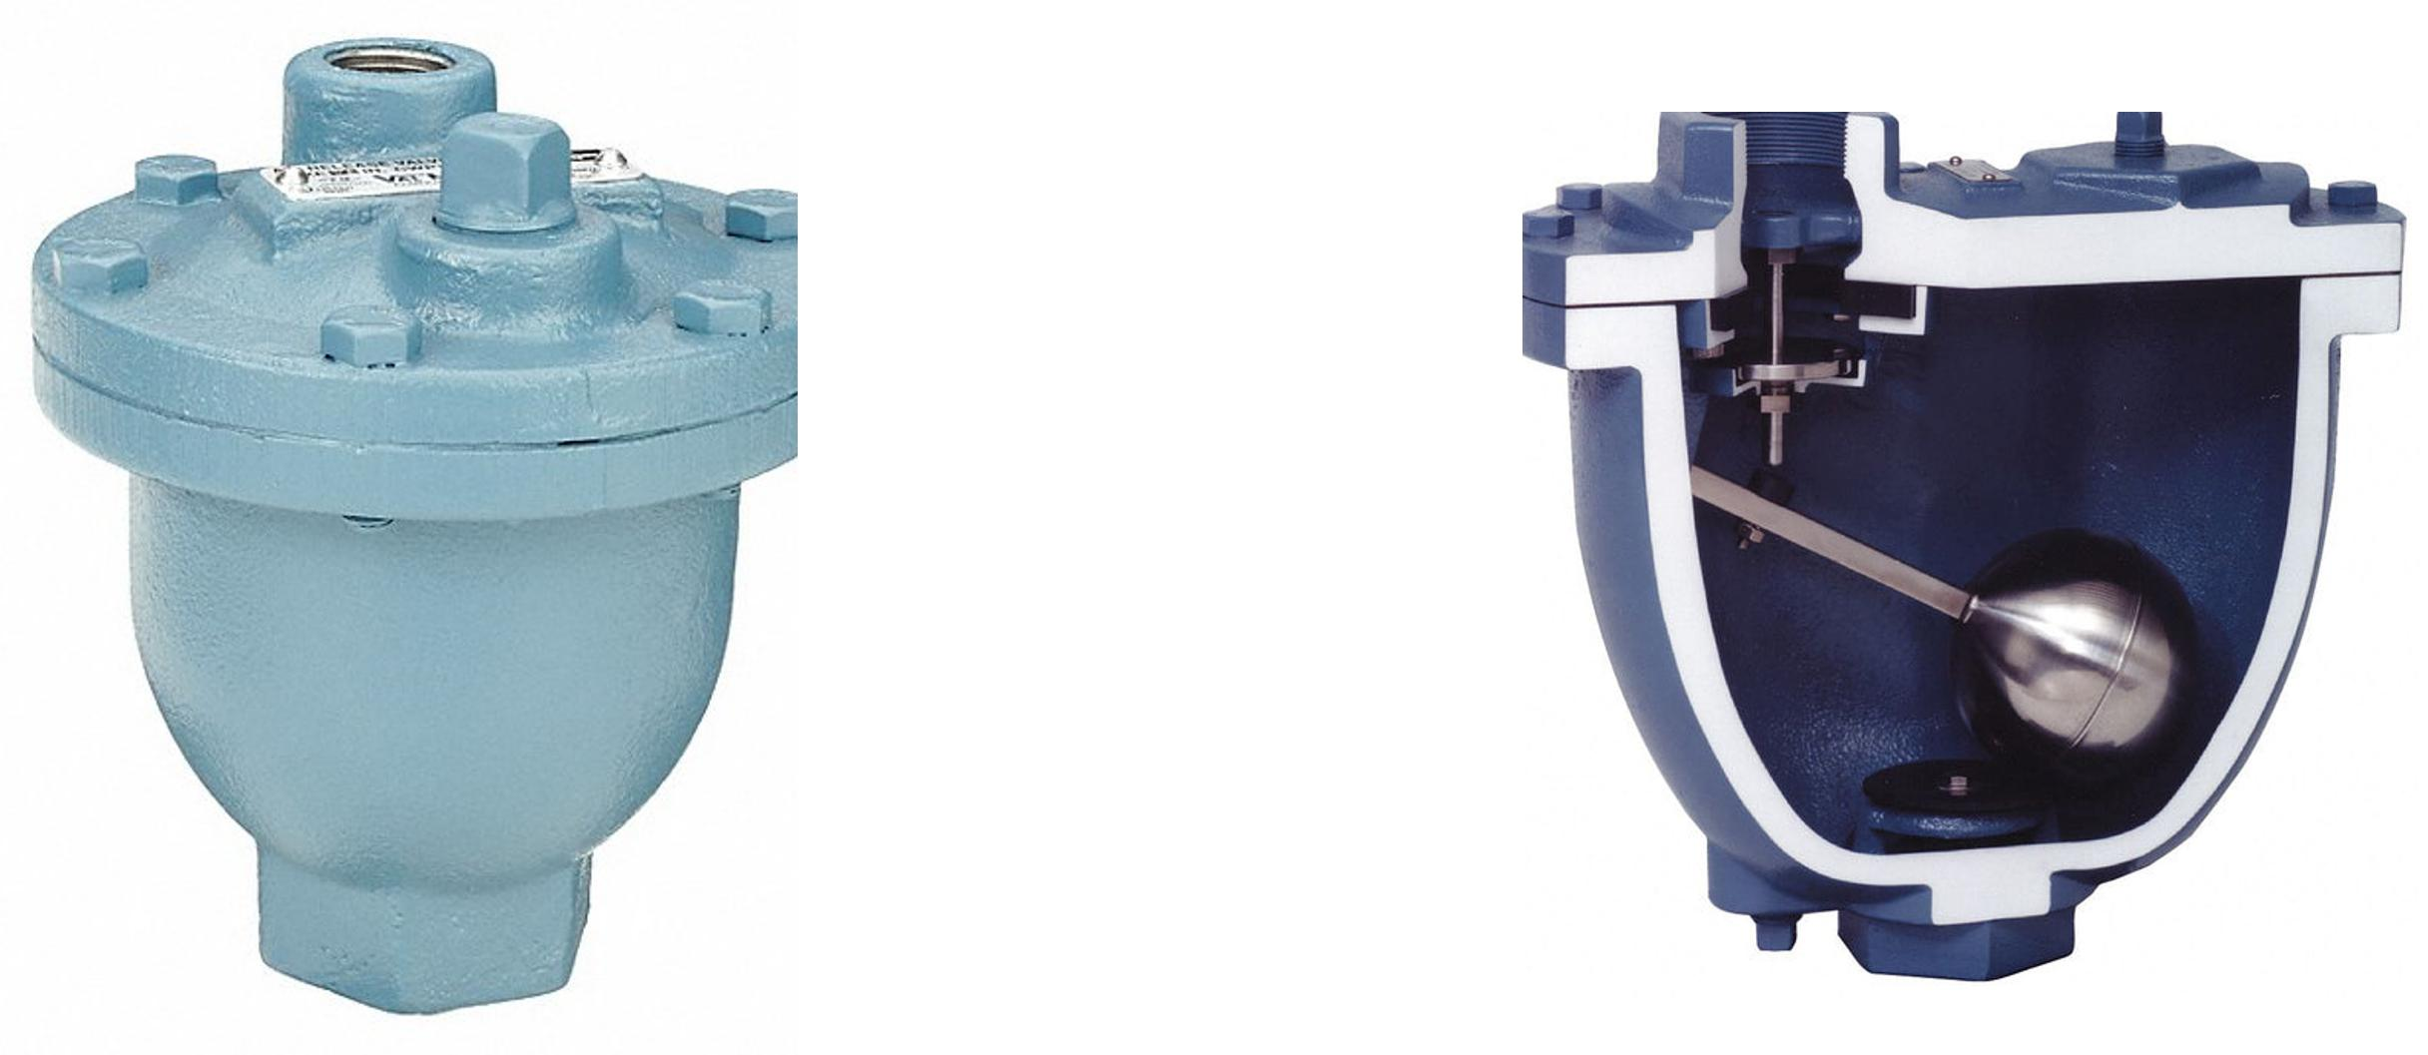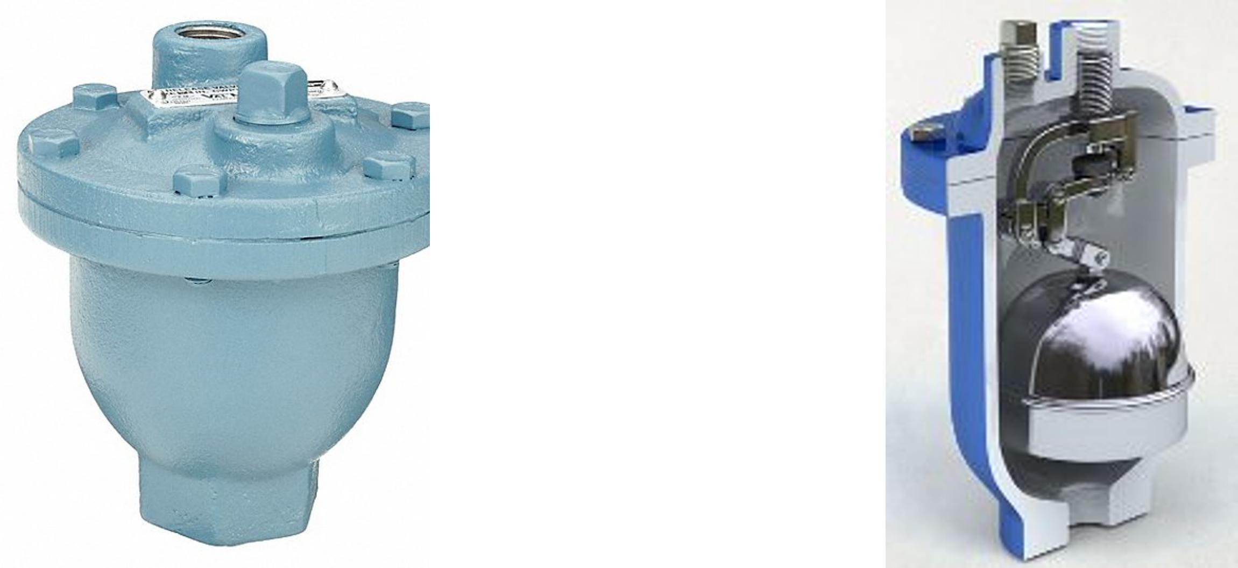

Table 8.6: Air valves in water system

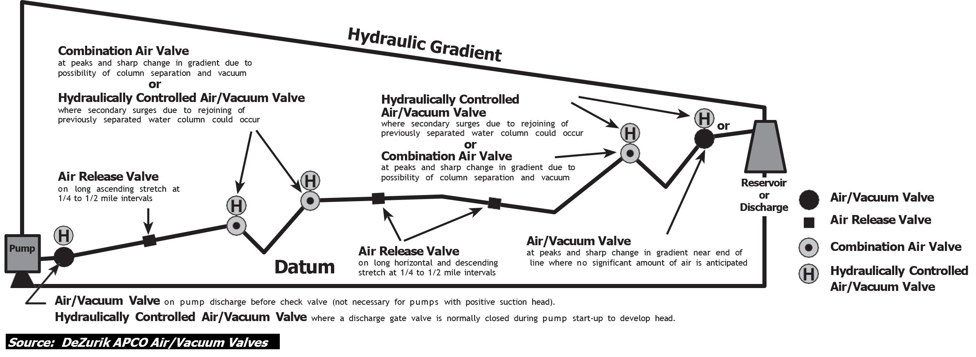

Figure 8.3: Summary of air valve applications

|  |  |
| --- | --- |
| 8.4 Valves Used in Water Distribution | 241 |
|  |  |

8.4.3 Backflow Prevention

* Backflow means the undesirable reversal of flow of a liquid, gas, or suspended solid into the potable water supply.
* A backflow preventer is designed to keep this from happening.
* Points at which a potable water system connects with a non-potable water system are called cross connections. Such connections occur naturally in appliances such as clothes washers and dishwashers, but they must be carefully designed and installed to prevent backflow.
* Back-siphonage:

– This is when higher pressure fluids, gases, or suspended solids move to an area of lower pressure fluids. A significant drop of pressure in a water delivery system cre-ates a similar suction, pulling possibly undesirable material into the system. The effect is similar to drinking water through a straw.

– This is an example of an indirect cross-connection.

* Back-pressure:

– Occurs when a fluid under a higher pressure from systems like boilers, heat exchang-ing equipment, power washing equipment, fire sprinklers, or pumps enter potable water piping. This is an example of a direct cross-connection , with undesirable material being pushed into the system.

* To reduce the risk of contamination, a backflow preventer can be fitted. A backflow pre-venter is also important when potentially toxic chemicals are used, for instance for com-mercial/industrial descaling of boilers, or when chemical bleaches are used for residential power washing.
* Another common location for a backflow preventer is the connection of a fire sprinkler sys-tem to a water main, to prevent pressurized water from flowing from the fire suppression system into the public water supply.
* Backflow preventers are categorized into three groupings: Assembly, Device or Method.
* Tables 8.7 and 8.8 summarize the properties and use of the commonly used backflow devices.

Air Gap

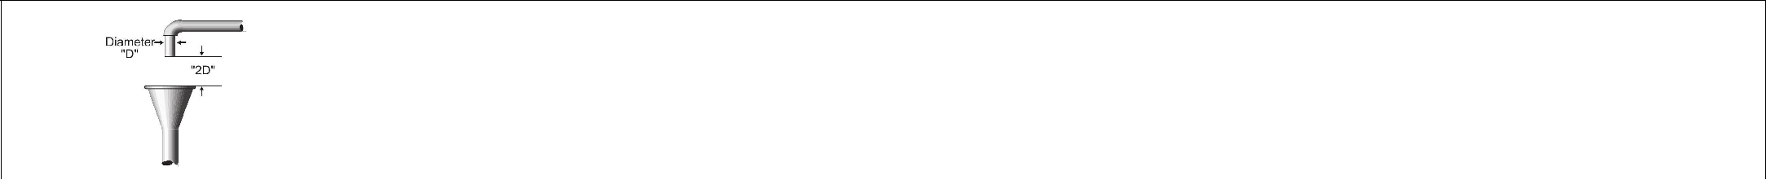

1. A physical separation between the free-flowing discharge end of a potable water supply pipeline and an open or non-pressure receiving vessel.
2. Should not be used in an area with dangerous atmosphere.
3. An "approved air gap" shall be at least twice the diameter of the supply pipe measured vertically above the overflow rim of the receiving vessel; in no case less than 1 inch (2.54 cm).

Common Applications - Lethal hazards (raw sewage, recycled water, auxiliary water supply

Atmospheric Vacuum Breaker Assembly (AVB)

* Also known as the non-pressure type vacuum breaker, it consists of an air inlet valve, a check seat and an air inlet port(s). (.) The flow of water into the body causes the air inlet valve to close the air inlet port(s).
* When the flow of water stops the air inlet valve falls and forms a check valve against backsiphonage. At the same time it opens the air inlet port(s) allowing air to enter and satisfy the vacuum.
* A shutoff valve immediately upstream may be an integral part of the assembly, but there shall be no shutoff valves or obstructions downstream.
* An atmospheric vacuum breaker is designed to protect against a non-health hazard (i.e., pollutant) or a health hazard (i.e., contaminant) under a back-siphonage condition only.

Common Applications - Irrigation systems

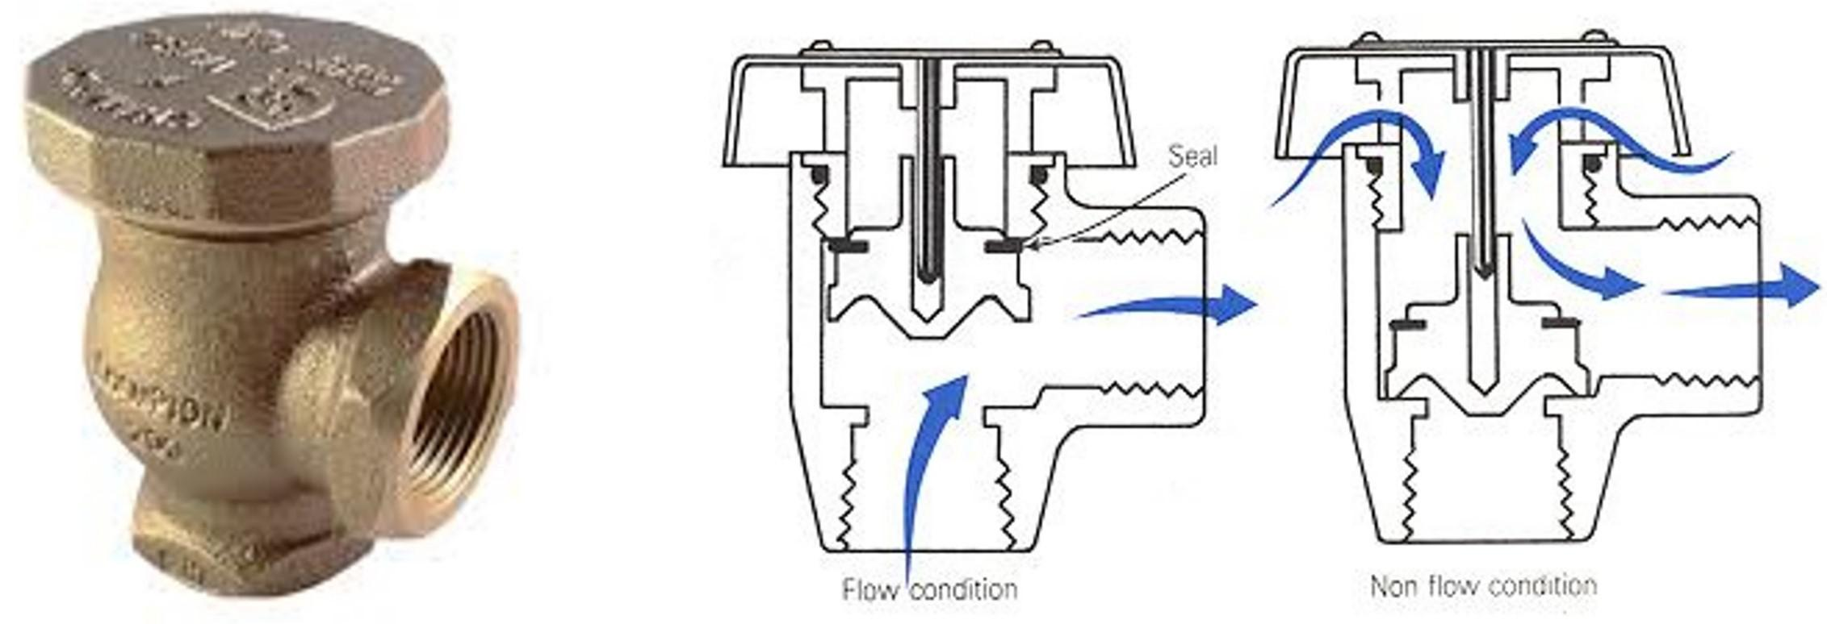

Spill Resistant Vacuum Breaker

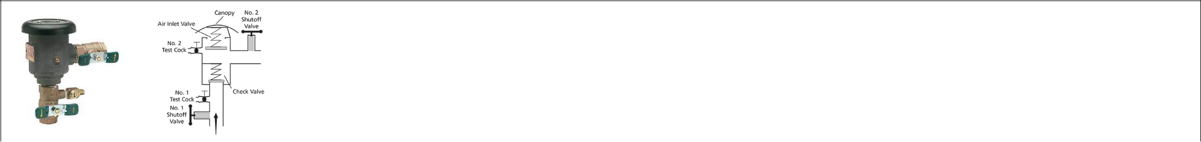

1. Its assembly consists of an independently operating internally loaded check valve and independently operating loaded air inlet valve located on the discharge side of the check valve.
2. The assembly is to be equipped with a properly located resilient seated test cock, a properly located bleed/vent port, and tightly closing resilient seated shutoff valves attached at each end of the assembly.
3. This assembly is designed to protect against a non-health hazard(i.e., pollutant) or a health hazard (i.e., contaminant) under a backsiphonage condition only. Common Applications - Irrigation systems

Swing Check Valve

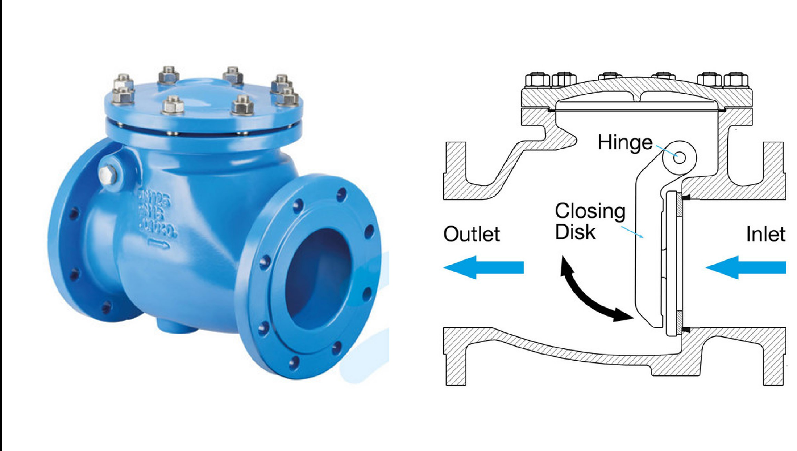

* Its assembly consists of an independently operating internally loaded check valve and independently operating loaded air inlet valve located on the discharge side of the check valve.
* The assembly is to be equipped with a properly located resilient seated test cock, a properly located bleed/vent port, and tightly closing resilient seated shutoff valves attached at each end of the assembly.
* This assembly is designed to protect against a non-health hazard(i.e., pollutant) or a health hazard (i.e., contaminant) under a backsiphonage condition only. Common Applications - Irrigation systems

Table 8.7: Backflow prevention devices - Table 1 of 2

Double Check Valve Assembly

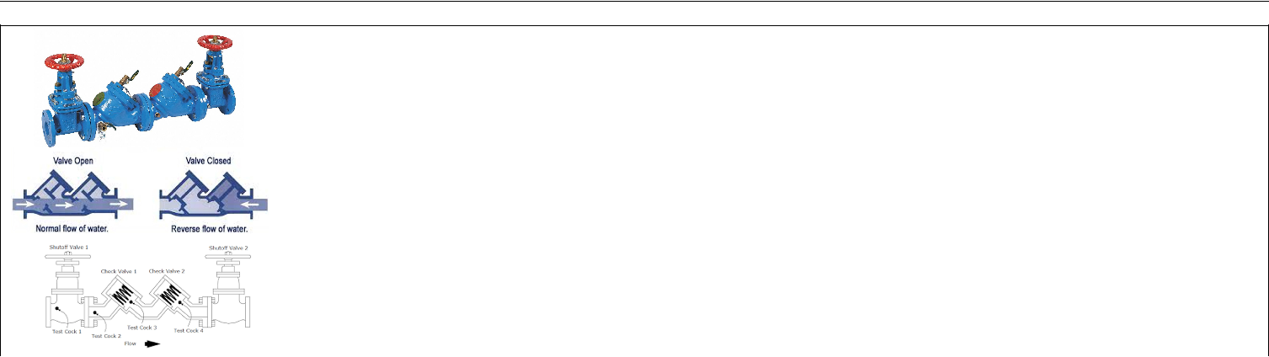

* Its assembly is composed of two independently acting, approved check valves, including tightly closing resilient seated shutoff valves attached at each end of the assembly and fitted with properly located resilient seated test cocks.
* This assembly is used to protect against a non-health hazard (i.e., pollutant)

Common Applications - Fire sprinkler systems, non-hazardous irrigation, combi-boilers, non-health hazards

Reduced Pressure Zone Assembly

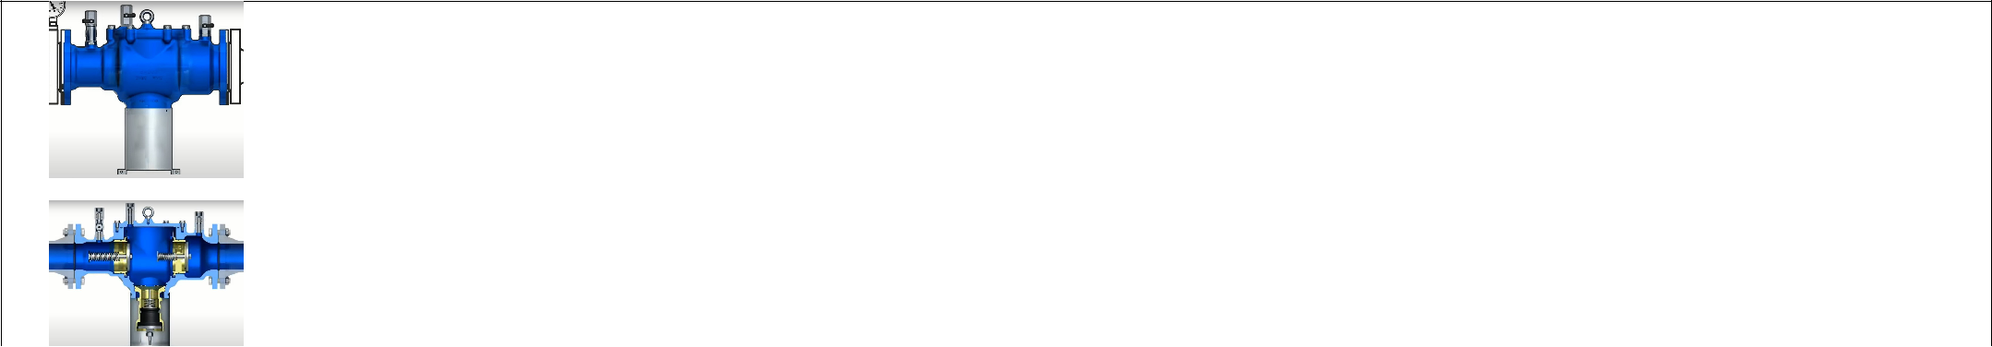

* This assembly includes two independently acting check valves and an intermediate relief valve that opens to the atmosphere if both check valves should fail.
* Also includes properly located resilient seated test cocks and tightly closing resilient seated shutoff valves at each end of the assembly.
* This is considered suitable for significant hazard applications that is, where the consequence of backflow into the water supply would cause significant harm.
* They are considered suitable because they prevent both back pressure and back-siphonage,
* Its redundant design allows it to provide protection even with two check valves broken
* This assembly is not for backflow protection of sewage or reclaimed water.

Common Applications – Domestic water and irrigation service protection, health hazards

Table 8.8: Backflow prevention devices - Table 2 of 2

244 Chapter 8. Water Distribution

8.5 Fire Hydrants

* Fire hydrants is a visible connection pint in the water distribution system to provide water at a high flow rates primarily for:

– Fire fighting

– Flushing distribution systems

– For other utilities, such as street cleaning and sewer cleaning

* Hydrants can be categorized as:

– Wet barrel

* + Have the operating valve in the nozzle section of the hydrant and are operated by rotating the operating stem on each of the outlets.
  + These hydrants are used in warm climates where it rarely freezes.
  + Their main advantage is the ease of connecting a second fire truck.
  + Each discharge port is independently valved.

– Dry barrel

* + These have the operating valve installed below ground.
  + The hydrant is equipped with a special drain valve that allows the above ground portion to automatically drain when not in use.
  + The dry barrel hydrant is widely used in colder climates.
  + Its main advantage is that it is less likely to freeze and normally not loose water when hit by a vehicle.
  + The dry-barrel hydrant must always be opened completely and never partially as the partially opened hydrant will allow pressurized flow through the drain valve, which may wash away the soil from the area surrounding the base, or the partially open main valve may trap small stones or other debris between the valve seal and seat.

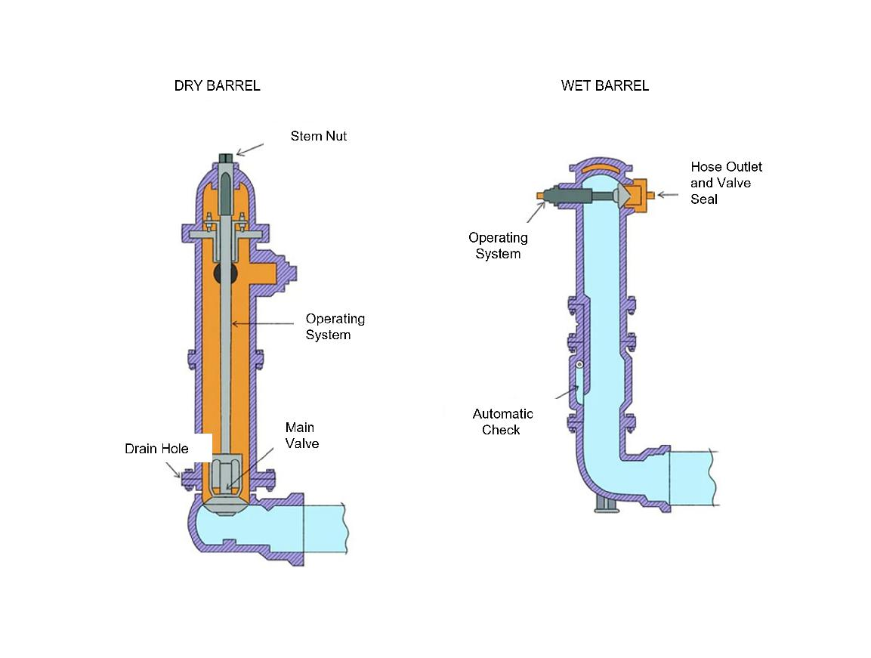

Figure 8.4: Types of fire hydrants

|  |  |
| --- | --- |
| 8.6 Water Meters | 245 |
|  |  |

* A flush hydrant sits flush with the surface of the ground and is used in airports, on bridges, and other places where the exposure of the hydrants is more of a hazard than the difficulty of connecting to a ground-level hydrant.

8.6 Water Meters

* Meters measure, display, and record the amount of water that passes through a distribution system component.
* Typical applications of meters in a distribution network include:

– Measuring the amount of water supplied to the system.

– Measuring the amount of water supplied to a particular area of the system, including through a pump station or control valve.

– Measuring the amount of water used by a customer, for billing purposes.

– Monitoring unaccounted-for water in a distribution network.

* Table 8.9 summarizes the properties and use of the commonly used distribution system water meters.

246 Chapter 8. Water Distribution

Positive Displacement (PD) Meter

* Nutating disc flow meter is the most common types of PD flow me-ter. A disc mounted to a central ball wobbles (nutates) when fluid enters the chamber, transferring the displaced volume to the register.
* Commonly used as customer service meters.
* Typically has a diameter of 2-inches or less.
* Generally used to measure low flow rates.
* Have limitations at very high flows.

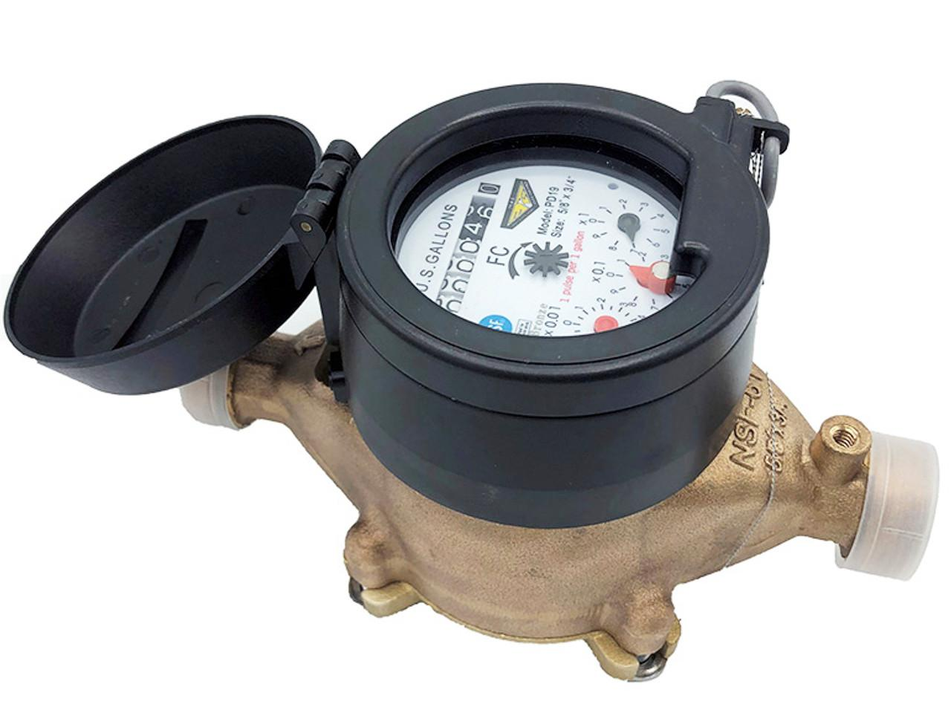

Velocity Meter

* Commonly used in pump stations, industrial facilities, and large diameter mains to measure high rates of flow.
* Does not accurately measure low flow rates.
* Includes the Venturi, Turbine, and Propeller type meters.

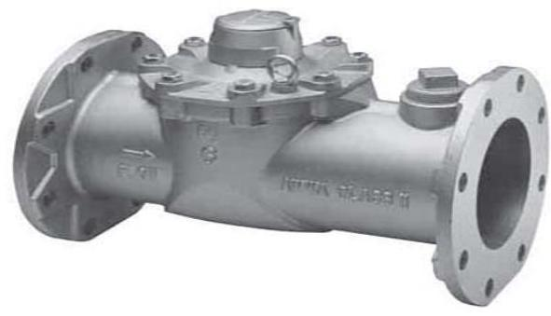

Compound Meter

* Commonly used to measure flow at apartment complexes, schools, and industries that can typically have high peaks in water use com-pared with daily averages.
* Composite of the displacement and velocity meters.
* Used to measure flowrates that vary widely.

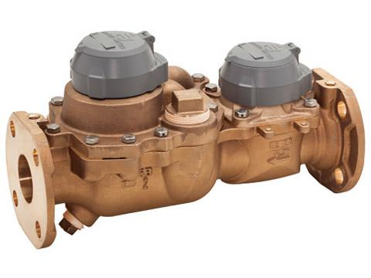

Electronic Meter

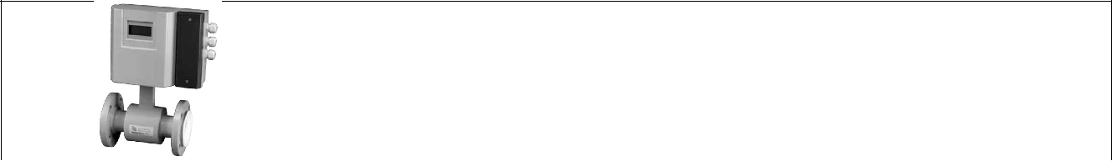

* Measures flow magnetically (mag meter) or sonically.
* Highly accurate if properly located.

Proportional Meter

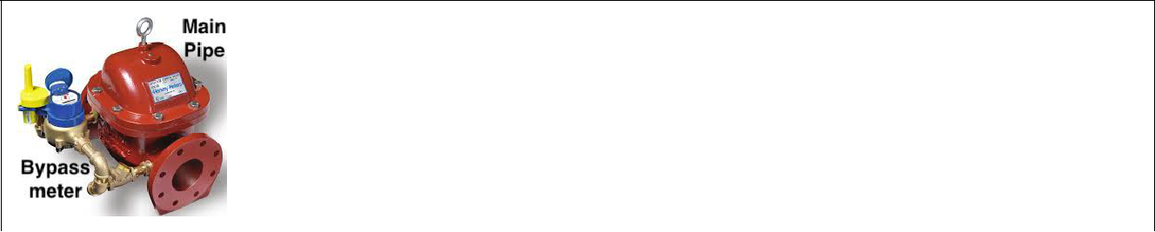

* Measures high flowrates at larger pipes such as fire service lines.
* It has a small bypass meter, located parallel to the main pipe which is calibrated to measure the flow through the main pipe.
* Does not measure low flows accurately.

Table 8.9: Types of water meters

|  |  |
| --- | --- |
| 8.7 Distribution System Operation and Maintenance Elements | 247 |
|  |  |

8.7 Distribution System Operation and Maintenance Elements

8.7.1 Maintaining distribution system pressure

* Distribution systems must be maintained under pressure at all times to help ensure that contamination does not enter the system.
* In the event that the distribution system is de-pressurized, the water system operator must promptly restore pressure and take corrective action to monitor and restore water quality. The corrective action should include flushing and disinfection.

8.7.2 System Disinfection Program

Disinfecting new and existing wells

Well disinfection under the following circumstances should be performed in accordance with the American Water Works Association C654-03, and re-sampled for bacteriological quality and the test results shall be submitted to the State Board for review and approval before the well is placed into service:

1. A new or repaired well, or a well that has not been in operation for more than three months
2. When coliform bacteria are present in the water
3. After flooding of the well
4. After plumbing installation, e.g. softeners, sinks, filters
5. After casing or pump repairs - submersible types or other
6. When water taste or odor changes, e.g. from iron or sulfur reducing bacteria
7. As part of annual maintenance
8. During startup of seasonal wells
9. Elements of well disinfection include:

– Disinfection is accomplished using sodium hypochlorite

– A 50 mg/l chlorine concentration is recommended with a 24-hour contact time

– Application of bleach through the pump column pipe is preferred over the application using the vent pipe as the chlorine injection point.

– At the end of the disinfection period, the well is pumped until all evidence of residual is gone.

Disinfecting Water Mains

1. Disinfection of repaired mains is not required, if the repairs are done with the line full of water and under pressure.
2. Utmost care should be taken to prevent contamination during installation or repairs
3. Valves and fittings must be cleaned during installation.
4. Sections of pipes, fittings and valves and other items that will not be disinfected by the filled line must be precleaned and disinfected.
5. Prior to use, newly installed water mains, or water mains that have been taken out of ser-vice for maintenance or repair, shall be disinfected and sampled for bacteriological quality in accordance with American Water Works Association Standard C651-05.

248 Chapter 8. Water Distribution

1. Crushed HTH tablets be placed in joints and hydrant branches to improve disinfection of spaces that are difficult to chlorinate once filled with water.
2. Flushing the mains for atleast 30 minutes at a minimum velocity of 2.5 ft/sec is recom-mended prior to disinfection
3. Common methods for disinfecting water mains are:

|  |  |  |  |
| --- | --- | --- | --- |
| CHLORINATION | MAXIMUM | MINIMUM CON- | MINIMUM |
| METHOD | CHLORINE | TACT TIME, HR | CHLORINE |
|  | DOSAGE, mg/l |  | RESIDUAL, mg/l |
|  |  |  |  |
| Continuous | 50 | 24 | 25 |
|  |  |  |  |
| Slug | 500 | 3 | 300 |
|  |  |  |  |
| Tablet | 50 | 24 | 25 |
|  |  |  |  |

* Post-disinfection, lines must be flushed until chlorine residual is less than 1 mg/l
* Bacteriological test - 24-hour membrane filter test is required to be conducted after disin-fection and prior to placing the line in service.

8.7.3 Disinfecting Water Storage Tanks

* After the repair/rehabilitation of the water tank is conducted or after the construction of the new tank, prior ot putting the tank in-service, the surfaces of the walls, floor, and operating facilities of the storage facility shall be cleaned thoroughly by use of a high pressure water jet, sweeping, scrubbing, or equally effective means.
* After the cleaning, the tank is required to be disinfected and is deemed adequately dis-infected and ready for service only if the bacteriological testing results show negative coliform results.
* AWWA C652-19 Disinfection of Water Storage Facility is the standard for disinfection of water-storage facilities describes materials, facility preparation, application of disinfectant to interior surfaces of facilities, and sampling and testing for the presence of coliform bacteria, chlorine residual, and acceptable aesthetic water quality.
* Acceptable water storage disinfection procedures include:
  1. A new tank can be disinfected by filling the tank to the overflow level with potable water with an initial chlorine concentration of 50 mg/L in the full tank and holding that water for 24 hours.
  2. Application of a chlorine solution containing at least 200 mg/L of free available chlorine using either spray equipment or brushes followed by keeping the chlorine solution in contact with the tank surfaces for at least 30 minutes. The tank is then filled with the distribution system water that is treated with chlorine to provide a residual of atleast 3 mg/l and held for 3-6 hours.
* After the disinfection step is completed, the tank is filled with potable water to the over-flow level and tested for satisfactory bacteriological quality before placing the tank in service.
* For the bacteriological testing, two water samples from the tank are to be collected at least

|  |  |
| --- | --- |
| 8.7 Distribution System Operation and Maintenance Elements | 249 |
|  |  |

24 hours apart and analyzed by a certified laboratory. The results of these samples must indicate no coliform contamination before the pipe, tanks, or equipment can be utilized as part of the water distribution system.

8.7.4 System Flushing Program

* Each public water system should flush the water distribution system as necessary to reduce stagnant water and sediment build-up.
* Flushing is normally practiced after receiving water quality complaints.
* Advance planning elements include: minimizing inconvenience to customers and traffic impacts, public notifications, identifying sections of mains to be flushed and required valving and resource allocations.
* Unidirectional flushing - where the flushing start point is at or near the source of supply and working outward into the distribution system is usually practiced.
* A minimum flushing velocity of 2.5 ft/sec is recommended.
* Hydrants are opened for atleast 5 to 10 minutes to stir up deposits.
* Usually lines are flushed for atleast 30 minutes while ensuring the system pressure of the affected area does not drop below 20 psi.
* Water samples may be taken at the beginning ad after flushing to determine its effective-ness and to identify need for additional flushing.

8.7.5 Valves Operation and Maintenance

* Hydraulic problems associated with improper operation of valves include:

– Cavitation

* Cavitation is a common occurrence in valves used in throttling or modulating service during the last few degrees of closure when the supply pressure is greater

than about 100 psig.

* Cavitation is the sudden vaporization and violent condensation of a liquid down-stream of the valve due to localized low pressure zones.
* When flow passes through a throttled valve, a localized low pressure zone forms immediately downstream of the valve. If the localized pressure falls below the vapor pressure of the fluid, the liquid vaporizes (boils) and forms a vapor pocket. As the vapor bubbles flow downstream, the pressure recovers, and the bubbles violently implode causing a popping or rumbling sound similar to tumbling rocks in a pipe.
* The sound of cavitation in a pipeline is unmistakable.
* Cavitation can quickly destroy valve internals and even erode through pipe walls.
* The condensation of the bubbles not only produces a ringing sound, but also creates localized stresses in the pipe walls and valve body that can cause severe pitting.

250 Chapter 8. Water Distribution

*

* Cavitation may be prevented by ensuring selection of right size, type and loca-tion of the valve.

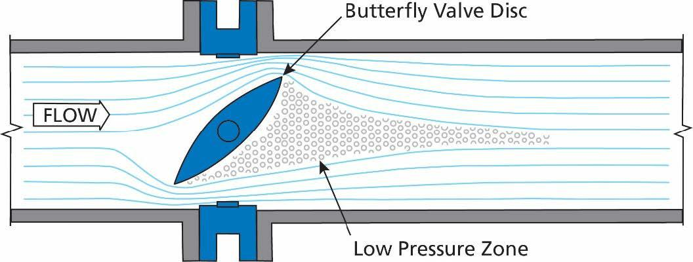

Figure 8.5: Valve Cavitation

– Water Hammer

* Water hammer is the result of a pressure surge, or high-pressure shockwave that propagates through a piping system when a fluid in motion is forced to change

direction or stop abruptly.

* + 1. This shockwave is typically characterized by a marked banging or knocking sound on the pipes immediately after a shutoff.
    2. Water hammer can occur when an open valve suddenly closes, causing the wa-ter to slam into it, or when a pump suddenly shuts down and the flow reverses direction back to the pump.
    3. Since water is incompressible, the impact of the water results in a shock wave that propagates at the speed of sound between the valve and the next elbow in the piping system or within the column of water after the valve.
    4. Water hammer, like cavitation, has the potential to cause catastrophic destruction to the distribution system piping.
    5. Selecting the correct valve and lengthening the valve closure duration help miti-gate water hammer occurrence.
* Valves must be maintained in working order. This necessitates that valves be “exercised” on a routine basis and visually inspected for leaks on a regular basis.
* Valve information including the following should be readily available:

– System map showing valve locations and system isolation points

– Information on valve sizing, direction to open the valve, number of turns, model type and installation date

* Adequate inventory of valves and its replaceable parts need to be maintained to ensure availability .
* Detailed records of valve inspections and maintenance activities including inspection logs and service requests must be maintained.

|  |  |
| --- | --- |
| 8.7 Distribution System Operation and Maintenance Elements | 251 |
|  |  |

8.7.6 Distribution System Map

* Each water system should maintain an accurate map of the distribution system piping and valves.
* The map should be sufficiently detailed to enable maintenance personnel to promptly locate facilities for repair or operational purposes.
* All valves and pipes are shown on the system’s "as built" plans. They are updated as re-pairs are made. In addition, the fixed facilities and structures are shown on the map.
* Comprehensive and plat maps are typically used.
* A comprehensive map provides an overall view of the entire distribution system.
* A plat map shows property boundaries and includes roads and location of utilities such as gas lines, access by water and sewer lines, as well as the location of buildings and other infrastructure on the property.
* A map scale which is distance on the map and distance on the ground (actual), allows for showing locations and distances accurately on a sheet of paper of convenient size.
* A map scale is provided on the map as a fraction or a ratio-1/10,000 or 1:10,000. These "representative fraction" scales mean that one unit of measurement on the map 1 inch or 1 centimeter represents 10,000 of the same units on the ground.
* The scale used will be dependent on the size of system and the size of the map. A com-monly used scale for maps used for utilities is 1:600 - 1-inch on the map represents 600 inches or 50 feet (600 feet * 12inches/1 feet) on the ground.

8.7.7 Distribution System Record keeping

The minimum record keeping requirements include:

* Date, time and cause of any system pressure loss.
* Corrective action taken in response to system pressure loss.
* Distribution system repairs and maintenance: date, location and reason for repairs.

8.7.8 Water Usage Records

* Each public water system should have production meters and should maintain records on water usage throughout the year. These records are kept for future information.

8.7.9 Storage Tank Maintenance

* Water storage tanks should be inspected on a regular basis to ensure that the structure is in satisfactory condition and properly secured.
* Records should be maintained of these inspections.
* Access hatches should be locked and all openings to the tank should be properly screened.
* Roofs should not allow entry of contaminants.
* The storage tank is visually inspected weekly. A detailed inspection is done on the tank every four (4) months.

252 Chapter 8. Water Distribution

* Applying protective coating - painting/coating, the internal and external walls of the tank needs to be conducted periodically.
* Several tank coating related considerations and precautions include:

– Selecting the right paint - paints containing lead, PCBs, trichloroethylene etc. should be avoided.

– Ensuring appropriate surface preparation and adequate coatings drying times are provided.

* Periodic, visual inspections and detailed cleaning and internal inspections are required.
* Records of the inspections are kept and any problems noted.

8.7.10 Lead and Copper Sampling

* Samples are collected at customer’s tap usually by the customer.
* Sample needs to be a first draw sample - not allowing the water to run and NOT flushing out the service line.
* Sample is collected early in the morning - no water to be used for a minimum of six hours before a sample is collected, no flushing and no opening a faucet.
* Samples are not be be collected from unoccupied home where water has not been used for over 24 hours.
* Action level for lead is 0.015 mg/L and copper is 1.30 mg/L
* Action level means entailing either service line replacement program or changing water quality parameters, or adding chemicals such as polyphosphate to the water to reduce its corrosion potential.

8.7.11 Computer Based Controls and Monitoring

* SCADA
  + SCADA - Supervisory Control and Data Acquisition is a useful and now widely used computer based control system
  + Distribution system components and operational parameters including - pressures, flows, meters, pump speed, wetwell levels, valve positions etc. can be monitored and controlled onsite or from a central location using SCADA.
  + SCADA allows for monitoring system operations to identify excursions of operat-ing equipment from normal operating conditions/ranges and help predict/identify maintenance, repair and replacement requirements.
* Automated Meter Reading
  + Automated Meter Reading (AMR) is the communication technology water utilities use to automatically collect water consumption and status data from water meters.
  + After collection, the meter data is transferred to a database where utilities can mon-itor and analyze usage, troubleshoot issues and bill customers based on actual con-sumption, rather than predictions that were often required with bi-monthly or quar-terly manual reads.

|  |  |
| --- | --- |
| 8.7 Distribution System Operation and Maintenance Elements | 253 |
|  |  |

* Advanced Metering Infrastructure
  + Advanced metering infrastructure (AMI) is an integrated system of water meters, communication networks and data management systems that enables two-way com-munication between meter endpoints and utilities.
  + The utility can use the data to improve operational efficiencies and sustainability by effectively monitoring water usage and system efficiency, detecting malfunctions and recognizing irregularities.

8.7.12 Corrosion Control

* Metallic elements of the water distribution system, including pipes and fittings, is subject to corrosion where the metal is converted to its salt or oxide.
* Corrosion in the water distribution system leads to:

– Reduced mechanical strength leading to a loss in service life and piping failures - leaks and ruptures.

– Leaching of toxic metals such as lead and copper into the drinking water

– Formation and deposition of corrosion by-products in pipes made from material

which include iron, leading to:

* Desposition of corrosion products on the inside surface of the pipe - Tuber-culation increase the roughness of the pipe, increasing the resistance to water thereby decreasing the water carrying capacity of the pipe and increasing the pumping cost.

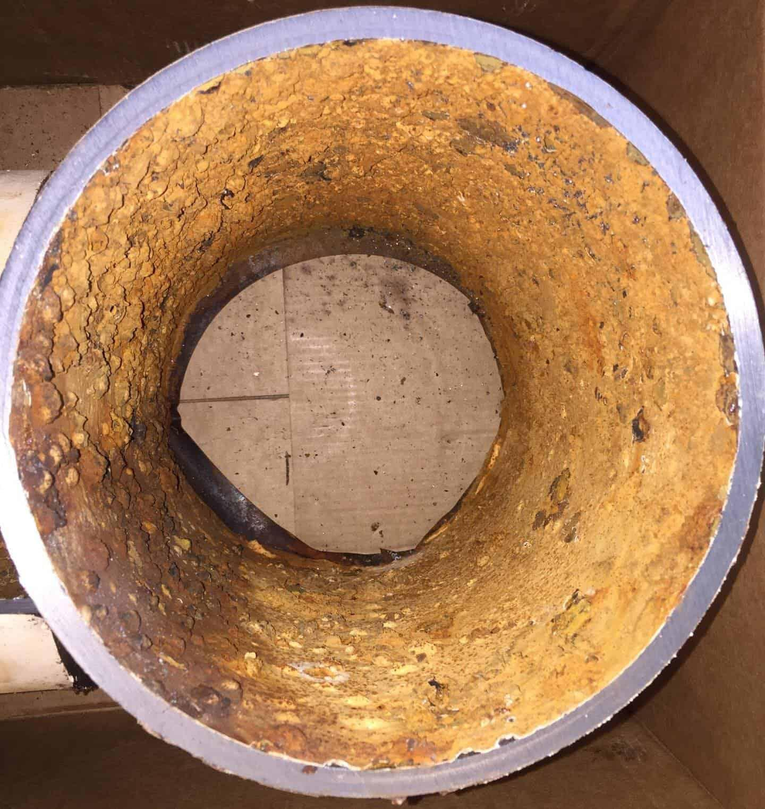

Figure 8.6: Tuberculation

* 1. Consumer complaints of reddish or reddish-brown water and staining of plumb-ing fixtures due to the presence of iron oxides.
* Corrosion can happen from the outside of the pipe and also from the inside.
* Corrosion from the outside occurs because of either Galvanic Corrosion resulting from and electric current flowing between two dissimilar metals which are in direct contact or indirect contact through a conductive environment such as moist soil or due to Chemical Corrosion due to corrosive soil.

254 Chapter 8. Water Distribution



Figure 8.7: External Corrosion

1. Corrosion from the inside occurs because of:

– Water quality parameters which promote corrosion - low pH (acidic water, less than 7.0, but typically in the range of 4.0 to 6.5), low carbonate alkalinity, high oxygen content, high total dissolved solids, and/or high chloride or sulfides

– Biofilm/slime formed on the inside surface of the pipe by bacteria creates an oxygen depleted environment under the biofilm next to the pipe surface, which in turn leads to the growth of specific types of bacteria that produce by-products corrosive to metals.

1. Corrosion control is critical to ensure integrity of the distribution system.
2. Corrosion rates are affected by the quality of water and system components design.
3. Regular inspections and observations provide indications of corrosion activity.
4. Corrosion coupons placed in the system provide quantitative measurement of corrosion. Coupons are small pieces of the same type of metal as the piping which are inserted into pipes at various locations in the distribution system and are left in place for a period of time after which the amount of metal lost from the coupon due to corrosion can be deter-mined.

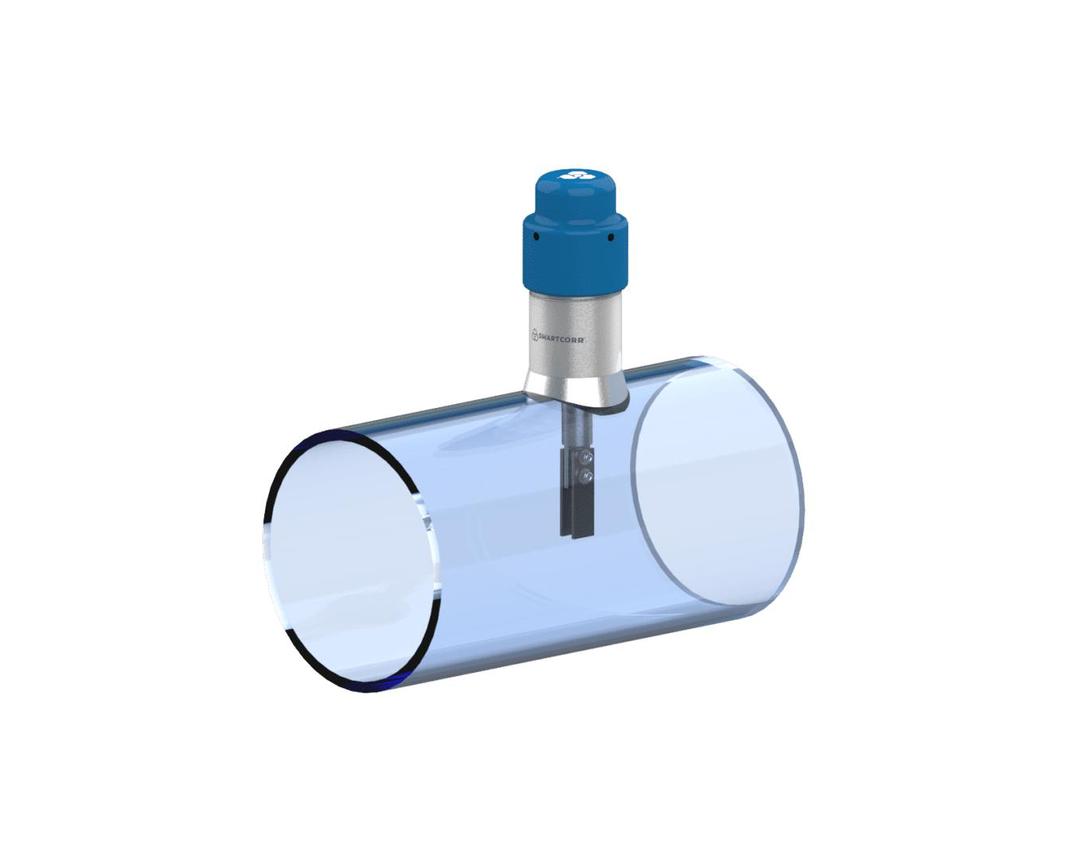

Figure 8.8: Corrosion Coupon

Figure shows how a corrosion coupon is inserted using a transparent pipe

* Other maintenance and operation elements to control corrosion include:

– Ensuring integrity of internal and external coatings of pipes and storage tanks

– Dosing adequate quantities of corrosion inhibitors

|  |  |
| --- | --- |
| 8.7 Distribution System Operation and Maintenance Elements | 255 |
|  |  |

– Protecting the piping from external galvanic corrosion by the installation and proper operation of cathodic protection systems. A cathodic protection system protects a steel pipe from galvanic corrosion by electrically connecting the pipe to a replace-able, highly active metal - anode, which looses its ions and keeps the less active steel pipe from corroding.

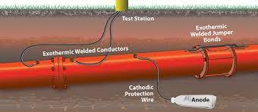

Figure 8.9: Cathodic Protection

– Ensuring adequate secondary disinfection and periodic flushing of lines to minimize and remove biofilm/slime growth.



Chapter 8 Assessment

Chapter 8 Assessment

* What is the reason for keeping adequate, reliable records in a treatment plant?

*a. *to record the plant’s effectiveness and because of requirements by regulatory agencies

* 1. to maintain records for cold cases
  2. in case the IRS wishes to check files for due diligence
  3. because of homeland security issues and files being available to the public
* Which statement about displacement meters is not correct:
  1. The most common type of water service meter is the displacement type
  2. Displacement meters are accurate at low flows
  3. Excess sediment can cause the meter to stop registering
  4. Displacement meters have little head loss due to friction
  5. Displacement meters operated at a rate in excess of its stated capacity can result in excessive wear
* A fire hydrant should be closed slowly to avoid:
  1. Excessive wear
  2. Water hammer
  3. Excessive head loss
  4. Injury to operator
* The minimum separation between municipal water mains and sanitary sewers for installa-tion in a common trench shall be:
  1. 5 feet horizontal separation
  2. 10 feet horizontal separation

258 Chapter 8. Water Distribution

c. 15 feet horizontal separation

d. 25 feet horizontal separation

* To properly disinfect a water main after new construction, you should:
  1. apply 50mg/l chlorine for 24 hours.
  2. clean the pipe out’ with a pig and then disinfect at 10mg/1 for 24 hours
  3. use a 10% solution of calcium chloride

d don’t use them main for one week

* When using a dry-barrel fire hydrant, the valve:
  1. should never be opened completely
  2. be opened only during the hours of 8AM to 5PM
  3. be opened to the desired amount of flow
  4. be opened all the way
* The primary reason for dry barrel-fire hydrants is to:
  1. allow easy maintenance
  2. prevent water hammer
  3. keep the hydrant from freezing
  4. keep the barrel from rusting
* A centrifugal pump should not be run empty except momentarily because:
  1. a serious counter pressure could develop and damage the pump casing. b. it is a waste of energy to run a pump without water.
  2. the excessive end thrust of the shaft would damage the thrust bearing.
  3. the parts lubricated by water could be damaged.

1. Pipes of dissimilar metal should not be connected together because of problems due:
   1. to scale formation
   2. corrosion
   3. water hammer
   4. the venturi effect
2. Which type of valve will prevent the collapse of a pipe?
   1. Pressure-relief valve
   2. Needle valve
   3. Pinch valve
   4. Air-and-vacuum relief valve
3. The correct protective methods for backflow-prevention devices in order of decreasing effectiveness are
   1. air gap, VB, RPZ, and DCVA.
   2. air gap, VB, DCVA, and RPZ.
   3. air gap, RPZ, VB, and DCVA.
   4. air gap, RPZ, DCVA, and VB.
4. The C-value is a measure of a pipe’s wall
   1. smoothness.

|  |  |
| --- | --- |
| 8.7 Distribution System Operation and Maintenance Elements | 259 |
|  |  |

b. smoothness giving even flow.

c. smoothness that retards turbulent flow.

d. roughness that retards flow due to friction.

1. Which one of the following is a type of joint for ductile iron piping?
   1. Expansion joint
   2. Push-on joint
   3. Bell and spigot with rubber o-ring
   4. Rubber gasket joint
2. Water hammer can be described as
   1. particle waves.
   2. acoustic waves.
   3. rogue waves.
   4. longitudinal waves.
3. Which thrust control is easy to use, especially in locations where existing utilities or struc-tures are numerous?
   1. Restraining fittings
   2. Tie rods
   3. Thrust anchors
   4. Thrust blocks
4. The backfill material for a pipe installation should contain enough to allow for thorough compaction.
   1. moisture
   2. sand
   3. gravel
   4. mixed sizes
5. Thrust from a water surge almost always acts pushes against. to the inside surface that it
   1. vertically
   2. horizontally
   3. perpendicular
   4. vertically and horizontally
6. The breaking of a buried pipe when it is unevenly supported is called
   1. stress breakage.
   2. shear breakage.
   3. beam breakage.
   4. flexural breakage.
7. Compression fittings used with copper or plastic tubing seal by means of a
   1. beveled sleeve.
   2. compression ring.
   3. compressed beveled gasket.
   4. compressed o-rings located at either end of the fitting’s beveled neck.

260 Chapter 8. Water Distribution

* Which should be installed at a dead-end water main?
  1. Vacuum valve
  2. Air valve
  3. Blowoff valve
  4. Water quality sampling station
* First draw samples for the analysis of lead and copper water must be collected from taps where the water has stood motionless in the plumbing for at least
  1. 4 hours.
  2. 6 hours.
  3. 8 hours.
  4. 24 hours.
* According to AWWA Standard C651, disinfection of water mains requires 24-hour expo-sure to which minimum free chlorine residual?
  1. 10mg/L
  2. 25mg/L
  3. 50mg/L
  4. 100mg/L
* The tensile strength of a pipe is its ability to
  1. Stretch or pull without breakage
  2. Resist internal pressure without breakage
  3. Resist external pressure without breakage
  4. Twist or bend without breakage
  5. Resist heating without breakage
* The lowest point of the inside of a pipe is known as the a Pervert
  1. Soffit
  2. Invert
  3. Curb stop
  4. None of the above
* A lightweight type of pipe that has a very smooth interior, is essentially corrosion-free, and which is difficult to locate when buried is
  1. Polyvinyl chloride
  2. Cast iron
  3. Ductile iron
  4. Concrete cylinder
  5. Steel

IX Chapter 9

9 Safety . . . . . . . . . . . . . . . . . . . . . . . . . . . . . . 263

9.1 Hazard Control Approaches

9.2 Water Treatment Hazards

9.3 Safety Practices

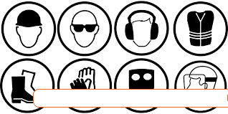

9. Safety

Expected Range of Knowledge for Safety

Water Distribution System Operator License Exams

|  |  |  |
| --- | --- | --- |
| D1 | Knowledge of OSHA/Cal-OSHA safety regulations |  |
| D1 | Knowledge of the components of the Emergency Response Plan |  |
| D1 | Knowledge of Cal-OSHA trenching and shoring requirements |  |
| D1 | Ability to recognize a confined space |  |
| D1 | Knowledge of chemical handling safety equipment and procedures |  |
| D1 | Knowledge of confined space safety equipment and procedures |  |
| D1 | Knowledge of electrical safety equipment and procedures |  |
| D1 | Knowledge of fire safety equipment and procedures |  |
| D1 | Knowledge of hazardous material safety equipment and handling |  |
| D1 | Knowledge of personal safety equipment and procedures |  |
| D1 | Knowledge of safety regulation requirements (e.g. IIPP) |  |
| D1 | Knowledge of the elements of a safety program (e.g. policy statement, training, promotion, |  |
| accident investigation, reporting) |  |
|  |  |
|  |  |  |
| D1 | Knowledge of traffic control procedures |  |
| D1 | Knowledge of trenching safety equipment and procedures |  |
| D1 | Knowledge of safety equipment requirements |  |
| D3 | Knowledge of recordkeeping/reporting requirements to OSHA |  |
| D4 | Ability to develop and implement a safety plan |  |

264 Chapter 9. Safety

Expected Range of Knowledge for Safety

Water Treatment Operator License Exams

T1 Ability to demonstrate safe work habits

T1 Ability to identify potential safety hazards

T1 Ability to recognize unsafe working conditions

T1 Ability to select and utilize safety equipment

T1 Knowledge of compressed gas safety procedures

T1 Knowledge of confined space safety procedures

T1 Knowledge of electrical safety

T1 Knowledge of hazardous chemical handling

T1 Knowledge of incompatible chemicals

T1 Knowledge of lock-out/tag-out procedures

T1 Knowledge of Material Safety Data (MSD) sheets

T1 Knowledge of personal protective equipment (PPE)

T1 Knowledge of proper chemical handling techniques

T1 Knowledge of safe working practices

T1 Knowledge of the use of safety equipment

T2 Knowledge of HAZWOPER guidelines

T3 Ability to generate a written safety plan

|  |  |
| --- | --- |
| 9.1 Hazard Control Approaches | 265 |
|  |  |

9.1 Hazard Control Approaches

* Treatment plant operators face a variety of workplace safety hazards ranging from physical injuries to hazardous material exposure.
* The three principal approaches for hazard control are:
  1. Engineering Controls: Engineering controls include incorporating safety elements during engineering design and include considerations related to selecting a less haz-ardous alternatives, establishing physical barriers and elements related to ventilation.
  2. Administrative Controls: Administrative controls are used to improve safety within the workplace by putting in place policies and rules that reduce the occupational risk faced by workers via altering the way their work is performed. These include: house-keeping, materials handling and transfer procedures, training, providing facilities to support personal hygiene practices and medical surveillance.
  3. Personal Protective Equipment: Personal protective equipment (PPE) is equipment worn to minimize exposure to hazards that cause serious workplace injuries and illnesses. PPE includes respiratory protection and protective clothing - hard hats, safety glasses/goggles, work gloves, chemical resistant gloves and safety shoes.
* The Occupational Safety and Health Administration - OSHA , a. Federal Government agency is responsible for establishing and enforcing workplace safety and health regula-tions.

9.2 Water Treatment Hazards

9.2.1 Hazardous Chemicals

* Hazardous chemicals are used throughout water treatment plants and in distribution sys-tems.
* To understand the dangers of these chemicals and to take adequate steps OSHA requires that the chemical manufacturer, distributor, or importer provide Safety Data Sheets (SDSs) (formerly MSDSs or Material Safety Data Sheets) for each hazardous chemical to down-stream users to communicate information on hazards related to that particular chemical or product.
* Employers must ensure that the SDSs are available and readily accessible to employees for all hazardous chemicals in their workplace.
* The SDS includes information such as the properties of each chemical; the physical, health, and environmental health hazards; protective measures; and safety precautions for han-dling, storing, and transporting the chemical.
* OSHA’s Hazardous Waste Operations and Emergency Response (HAZWOPER) standards aims to prevent and minimize the possibility of worker injury and illness resulting from potential exposures to hazardous substances. It requires that employers follow specific work policies, practices, and procedures to protect their workers potentially exposed to hazardous substances.

266 Chapter 9. Safety

Effects of Chemical Hazards

Hazardous chemicals can cause:

* Headaches, rashes and burns
* Respiratory problems
* Lung and liver damage
* Reproductive damage
* Cancer
* Death

Protection from chemicals

Chemical manufacturers, distributors, or importers are required to provide Safety Data Sheets (SDS) (formerly MSDSs or Material Safety Data Sheets) for each hazardous chemical to down-stream users to communicate information on these hazards.

* Reading and understanding the associated Safety Data Sheets
* Wearing appropriate Personal Protective Equipment
* Implementing safe work practices by:

– NEVER: Eating, drinking or smoking when working with hazardous chemicals, and washing or storing PPE with personal clothing.

– ALWAYS:Washing hands, arms and face with soap and water after use, ensuring

integrity of PPE before and after use and also very importantly ensuring readiness to deal with chemical exposure or spill.

OSHAs SDS Guidance Document provides detailed information on the structure and contents.

This document is provided in Appendix H.

A sample SDS is provided in Appendix I.

|  |  |
| --- | --- |
| 9.2 Water Treatment Hazards | 267 |
|  |  |

Ensuring chemicals storage compatibility

Storing incompatible chemicals together could create a hazardous reaction such as the produc-tion of toxic gas, accelerated corrosion, or an exothermic reaction - reaction that releases heat, potentially resulting in an explosion and/or fire.

9.2.2 Falls

* Falls are one of the leading causes of injuries and deaths on the job. Fall protection is a combination of methods and devices used to protect workers from falling off, onto, or through working levels.
* Working on top of tanks, walkways roofs, and other elevated surfaces more than 4 feet or when working above open tanks or hazardous machinery requires the provision of fall protection.
* Fall protection methods and devices are typically divided into two categories: those that prevent falls and those that arrest falls.
* Examples of fall protection methods and devices include rails, guards, guardrails, barriers, fall-arrest systems, safety nets, hole covers, and various work practices and procedures.

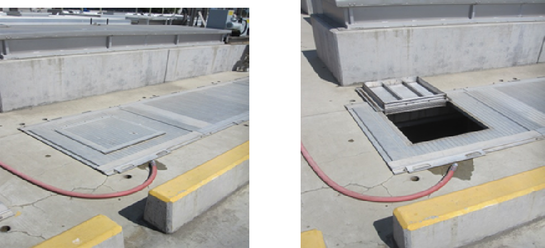

9.2.3 Noise

* Noise as a hazard is sound that is especially loud or impacting.
* A wastewater treatment plant has equipment that produces high noise levels both continu-ously and intermittently.
* As such, it is important to be aware of this hazard and to take preventive steps to reduce exposure to damaging noise levels by wearing effective hearing protection and to minimize the duration of the exposure to the noise.

9.2.4 Electrical Hazards

1. Ordinary 120-V electricity can be fatal; most wastewater facility electrical systems operate at 120 to 4000 V or more.
2. All voltages should be considered dangerous and potentially life threatening.

268 Chapter 9. Safety

1. Safe working rules and practices that should be followed when working on electrical sys-tems
2. Before working on an electrical system, perform a job hazard analysis to determine any potential hazards and methods of abating those hazards

9.2.5 Trenching & Excavation Hazards

1. Trench collapses, or cave-ins, pose the greatest risk to workers’ lives.
2. Potential hazards related to trenching include: falls, falling loads, hazardous atmospheres, and incidents involving mobile equipment including vehicular traffic.
3. A good rule of thumb is to slope the sidewalls at least one and one half foot back for every one foot in depth on both sides of the trench unless the soils have been classified as to the type and the options provided in the OSHA Standard have been selected by a competent person.
4. For excavations greater than 4 feet, potential for hazardous atmospheres must be consid-ered. If the environment has the potential for a hardous atmosphere, adequate precautions need to be taken to prevent worker exposure to those conditions.
5. Provision for access and egress for personnel as well as equipment is required. Ramps for access/egress must be designed by a competent person and be capable of handling the intended loads.
6. A stairway, ladder or ramp must be provided within 25 lateral feet of employees in trench excavations greater than 4 feet. Ladders should extend a minimum distance of 3 feet past the edge they rest against but not more than 4 feet.
7. Trenches 5 feet deep or greater require a protective system unless the excavation is made entirely in stable rock.
8. Trenches 20 feet deep or greater require that the protective system be designed by a regis-tered professional engineer.
9. Types of protective systems :

– Benching - excavating the sides of an excavation to form one or a series of horizontal

levels or steps.

– Sloping - involves cutting back the trench wall at an angle inclined away from the excavation. A good rule of thumb is to slope the sides of the excavation to an angle not steeper than 1½:1 (for every foot of depth, the trench must be excavated back 11/2 feet) excavated back 1½ feet). A slope of this gradation is safe for any type of soil.

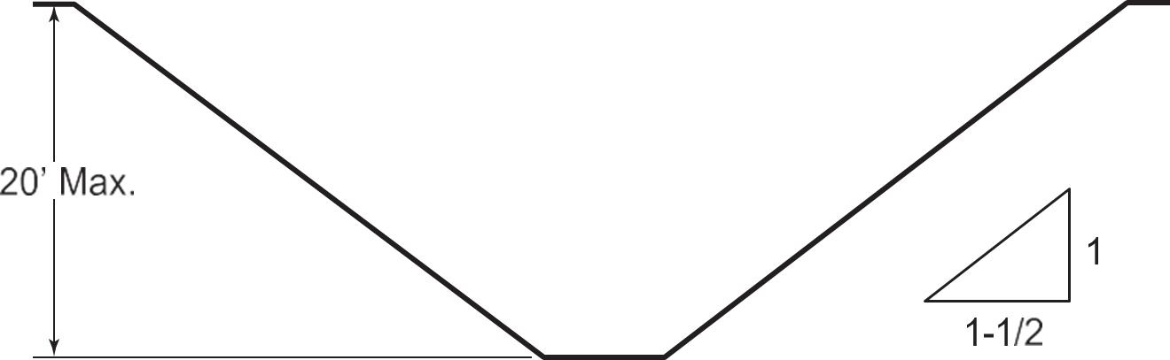

Figure 9.1: Trench Slope

– Sloping and benching consists of the removal of the trench wall at a specific slope based on

|  |  |
| --- | --- |
| 9.2 Water Treatment Hazards | 269 |
|  |  |

the type of soil being excavated.

– Sheeting - wooden sheets or metal plates are placed against the side of the trench to hold back the walls. Uprights placed vertically along the face of the trench wall are used to sup-port the sheeting. Stringers or wales are placed horizontally along the uprights in which trench braces are attached to prevent cave-in.

– Shoring - requires installing aluminum hydraulic or other types of supports designed to support the walls of a trench.

– Shielding - uses a two-sided, braced box sometimes referred to as a drag shield or trench box, which is open at the top, bottom and ends.

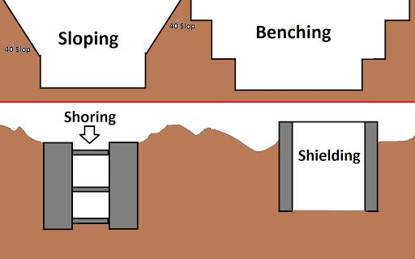

Figure 9.2: Trench Protection Systems

1. OSHA standards require, before any worker entry, that employers have a competent per-son inspect trenches daily and as conditions change to ensure elimination of excavation hazards.
2. Key elements related to ensuring trench safety :

– Ensure that there’s a safe way to enter and exit

– Ensure trenches have cave-in protection

– Test for atmospheric hazards such as low oxygen, hazardous fumes and toxic gases when > 4 feet deep.

– Inspect trenches at the start of each shift and following a rainstorm or other water intrusion.

– Keep excavated soil (spoils) and other materials at least 2 feet from trench edges.

– Never enter a trench unless it has been properly inspected by a competent person

9.2.6 Rotating and Moving Equipment

1. All rotating and moving equipment should be guarded.
2. The best method for preventing machinery-related injuries is through use of equipment guards enforced through engineering and administrative controls.

270 Chapter 9. Safety

1. The best way to prevent this type of injury is to install point-of-operation guards that pre-vent contact with nip points, pinch points, rotating parts, flying chips, and sparks.

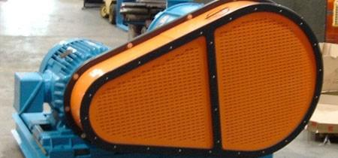

9.2.7 Heat Stress

1. Heat stress falls into two categories: heat illness and heat stroke.
2. Both are serious conditions and should not be taken lightly.
3. Heat stress can result from:

– High temperature and humidity, dehydration from low fluid consumption

– Direct sun exposure (with no shade) or extreme heat,

– Limited air movement (no breeze or wind),

– Physical exertion, Use of bulky protective clothing and equipment,

– Poor physical condition or ongoing health problems,

– Some medications

– Pregnancy

9.2.8 Fire Safety

Fires are classified based upon the material involved in the fire. It is very important to note that the fire fighting measures are specific to the material involved and if these measures are not followed, it may aggravate the situation or pose additional safety hazards.

9.3 Safety Practices

9.3.1 Lockout - Tagout (LOTO)

When conducting routine inspections, repairs and maintenance activities, requires meeting the mandates of Occupational Safety Hazard Administration(OSHAs) Lock-Out/Tag-Out (LOTO) program

which is designed to prevent injury or fatalities. It involves preventing an equipment from acci-dentally starting up and release of all stored energy. Hazardous energy sources include:

1. Electrical
2. Mechanical
3. Hydraulic
4. Pneumatic
5. Chemical
6. Thermal

|  |  |  |  |  |
| --- | --- | --- | --- | --- |
| 9.3 Safety Practices | | 271 | |  |
|  |  |  |  |  |
|  |  |  |  |  |
| CLASS | MATERIAL INVOLVED | MEASURES TO FIGHT SMALL |  |
|  |  | FIRES |  |  |
|  |  |  |  |  |
| CLASS A | This class of fire involves ordinary | Extinguish with pressurized wa- |  |  |
|  | combustibles or fibrous material, | ter, foam, or multipurpose dry |  |  |
|  | such as wood, paper, cloth, paper, | chemical extinguishers. Do not |  |  |
|  | and some plastics. | use carbon dioxide or ordinary dry |  |  |
|  |  | chemical extinguishers on Class A |  |  |
|  |  | fires. |  |  |
|  |  |  |  |  |
| CLASS B | Class B fire is flammable or com- | Extinguish Class B fires by remov- |  |  |
|  | bustible liquids such as gasoline, | ing oxygen, by preventing vapors |  |  |
|  | diesel, kerosene, paint, paint thin- | from reaching ignition sources, or |  |  |
|  | ners, and propane. | by inhibiting the chemical chain |  |  |
|  |  | reaction. Use foam, carbon diox- |  |  |
|  |  | ide, ordinary dry chemical, multi- |  |  |
|  |  | purpose dry chemical, and halon |  |  |
|  |  | extinguishers. |  |  |
|  |  |  |  |  |
| CLASS C | A Class C fire is energized elec- | Extinguish Class C fires by using |  |  |
|  | trical equipment, such as motors, | carbon dioxide, ordinary dry chem- |  |  |
|  | motor controls, switches panel | ical, multipurpose dry chemical, |  |  |
|  | boxes, and power tools. | and halon-free extinguishers. |  |  |
|  |  |  |  |  |
| CLASS D | A Class D fire is certain com- | Extinguish Class D fires by using |  |  |
|  | bustible metals, such as magne- | dry powder extinguishers made |  |  |
|  | sium, titanium, potassium, and | especially for this type of fire |  |  |
|  | sodium. These metals bum at high |  |  |  |
|  | temperatures and give off sufficient |  |  |  |
|  | oxygen to support combustion. |  |  |  |
|  | They may react violently with wa- |  |  |  |
|  | ter or other chemicals and must be |  |  |  |
|  | handled with care. |  |  |  |
|  |  |  |  |  |

Table 9.1: Fires Classifications

• Other energy

The LOTO involves established and documented procedures specific to an equipment or machin-ery. It typically comprises of:

* Notifying affected employees
* Stopping and isolating the equipment
* Releasing stored energy
* Verification of the isolation and de-energization
* Placing lock-out devices which use a positive means such as a lock, either key or combina-tion type, to hold an energy isolating device in the safe position and prevent the energizing of a machine or equipment
* Appropriately tagging the devices to indicate its non-operation and that it may not be operated until the tagout device is removed

272 Chapter 9. Safety

9.3.2 Personal Protective Equipment (PPE)

Employees depend on personal protective equipment to protect themselves from hazards and perform daily duties. PPE includes but is not limited to safety glasses, face shields, hard hats, gloves, foot protection, and durable and disposable chemical-protective clothing. Respirators and fall protection might also be required. However, respirators and fall protection fall under separate OSHA standards. The National Institute for Occupational Safety and Health (NIOSH) is the federal agency responsible for testing and approving respirators used in workplace settings.

9.3.3 Confined Space Entry

OSHA defines a confined space as an area that:

* is large enough and so configured that an employee’s body can enter and perform assigned work
* has limited or restricted means for entry or exit; and
* is not designed for continuous employee occupancy.

Potentially dangerous conditions which can exist in confined spaces include:

1. Oxygen level: Some gasses are heavier than air and so will fill up a confined space, which forces oxygen out. The oxygen concentration must not fall below 19.5% at any time. In plants where pure oxygen is used there is a potential hazard due to high the oxygen con-centration. Oxygen concentration greater than 23% increases the risk of ignition and fire
2. Explosive conditions: Many gasses are explosive when present in certain ratios with oxy-gen. These ratios are defined by the upper explosive limit(UEL) and the lower explosive limit (LEL). The minimum concentration of a particular combustible gas or vapor neces-sary to support its combustion in air is defined as the Lower Explosive Limit (LEL) for that gas. Below this level, the mixture is too “lean” to burn. The maximum concentration of a gas or vapor that will burn in air is defined as the Upper Explosive Limit (UEL) . Above this level, the mixture is too “rich” to burn. The range between the LEL and UEL is known as the flammable range for that gas or vapor.
3. Toxic conditions: This condition could potentially exist due to the presence of gasses such as carbon dioxide, chlorine and hydrogen sulfide.
4. Engulfment by liquids
5. Electrical hazards
6. Mechanical Hazards associated with equipment including mixers

A permit-required confined space is defined as a confined space that:

* contains or has a potential to contain a hazardous atmosphere
* contains a material that potentially could engulf an entrant
* has an internal configuration that could trap or asphyxiate an entrant through inwardly converging walls or a floor that slopes downward and tapers to a smaller cross-section
* contains any serious safety or health hazard

|  |  |
| --- | --- |
| 9.3 Safety Practices | 273 |
|  |  |

9.3.4 Material Handling Ergonomics

1. Wastewater operators are potentially subject to risk of musculoskeletal injuries associated with handling heavy or unwieldy objects including tools and supplies as part of their daily work routine.
2. The risk and severity of these injuries can be mitigated through utilizing proper ergonomic techniques which include:

– Use mechanical means (e.g. hand trucks, pushcarts, etc.) when possible for heavier or awkward loads.

– It is easier and safer to push than to pull.

– Keep loads as close to the body as possible and do not twist while lifting, carrying, or setting down a load. Nose, shoulders, hips, and toes should all be facing the same direction.

– Minimize reaching.

– As a general rule, bend at the knees, not the hips.

– Get help when needed. Do not lift or carry things you don’t feel comfortable with, no matter how light the load.

– Plan ahead for all parts of the lift: lifting, carrying, and setting down.

– Use personal protective equipment where needed, such as gloves with good grip and steel-toed boots where appropriate.

– Implement rest breaks and job rotation for frequent and/or heavy lifting.



Chapter 9 Assessment

Chapter 9 Assessment

1. What federal law is designed to protect the safety and health of operators?
   * OSHA
   * FMLA
   * FLSA
   * ADEA
2. What are the two most important safety concerns when entering a confined space?
   * Corrosive chemicals and falls
   * Bad odors and claustrophobia
   * Extreme air temperatures and slippery surfaces
   * Oxygen deficiency and hazardous gases
3. Which document provides a profile of hazardous substances?
   * CERCLA
   * SARA
   * CFR
   * SDS
4. What is the purpose of a pump guard?
   * Allows operators to turn off pump in emergency situations
   * Notifies operators of excessive temperatures
   * Allows operators to pump against a closed discharge valve
   * Protects operators from rotating parts
5. Atmosphere is considered oxygen deficient when the oxygen level is below

276 Chapter 9. Safety

* 1. 21.5%
  2. 20%
  3. 19.5%
  4. 17%
* Employee hazards include
  + Noxious or toxic gases or vapors
  + Oxygen deficiency
  + Physical injuries
  + All of the above
* Before entering a permit-required confined space, you must:
  + Check the atmosphere with a calibrated gas detector.
  + Make notification that personnel are entering the space.
  + Lock out and tag out all equipment.
  + All of the above.
* When making a sulfuric acid dilution, the appropriate method is:
  + Add the water to the acid.
  + Add the acid to the water.
  + Add both at the same time.
  + None of the above.
* When manually lifting any object, be sure to
  + Hold it at arm’s length.
  + Keep your back bent and hold it low.
  + Keep it close to your body and use leg strength.
  + Keep your knees locked and bend at the waist.
* What is the proper slope of a ladder?
  + Every 4 feet up the ladder is 1 foot out from the wall.
  + Every 5 feet up the ladder is 1 foot out from the wall.
  + Every 6 feet up the ladder is 1 foot out from the wall.
  + Every 7 feet up the ladder is 1 foot out from the wall.
* When working on a chemical feed pump, what of the following is not required?
  + Nitrile gloves.
  + Safety glasses.
  + Leather work gloves.
  + Full face shield.
* When must the atmosphere of a confined space be tested?
  + Only before a worker enters
  + Never, if adequate ventilation exists
  + Continuously
  + Only if welding or painting is being performed
* Some gases in a confined space can be:

|  |  |
| --- | --- |
| 9.3 Safety Practices | 277 |
|  |  |

* 1. Colorless
  2. Odorless
  3. Deadly
  4. All of the above

1. Why should you contact other area companies with underground utilities before starting an underground repair job?
   1. To determine if there have been recent excavations in that location
   2. To ask these companies to mark the location of their utilities in the area of the repair job
   3. To see if they also have excavating to do in the area
   4. To see if they will help route traffic while you are doing the repair job
2. The only acceptable breathing device to wear while handling chlorine leaks is the
   1. Activated carbon canister type
   2. Potassium tetroxide canister type
   3. Self-contained breathing apparatus
   4. Oxygen supply apparatus

X Chapter 10

1. Water Math . . . . . . . . . . . . . . . . . . . . . . . . 281

|  |  |
| --- | --- |
| 10.1 | Fractions |
| 10.2 | Decimals and Powers of Ten |
| 10.3 | Rounding and Significant Digits |
| 10.4 | Working with Percent |
| 10.5 | Averages |
| 10.6 | Ratio and Proportion |
| 10.7 | Area and Volume |
| 10.8 | Flow and Velocity |
| 10.9 | Unit Conversions |
| 10.10 | Concentration |
| 10.11 | Density and Specific Gravity |
| 10.12 | Contaminant Removal Efficiency |
| 10.13 | Pounds Formula |
| 10.14 | Blending and Dilution Calculations |
| 10.15 | Force, Pressure and Head |
| 10.16 | Pumping Calculations |
| 10.17 | Well Hydraulics Calculations |
| 10.18 | Sedimentation |
| 10.19 | Filtration |



10. Water Math

Expected Range of Knowledge for Water Math

Water Distribution System Operator License Exams

|  |  |
| --- | --- |
| D1 | Ability to calculate flow rates for a storage facility |
| D1 | Ability to calculate the volume of a storage facility |
| D1 | Knowledge of unit conversions |
| D1 | Ability to calculate flow rates |
| D1 | Ability to calculate pipe volumes |
| D1 | Ability to calculate the area of a pipe cross-section |
| D1 | Ability to calculate the surface area of a valve face |
| D1 | Ability to calculate the volume of a cylinder, rectangle, and square |
| D1 | Ability to calculate the volume of a pipe |
| D1 | Ability to calculate the volume of a well, storage reservoir, pipe, trench |
| D1 | Ability to calculate the well draw down |
| D1 | Ability to calculate total force on a valve |
| D1 | Ability to convert pressure to feet of head |
| D1 | Ability to convert units of volume, area, and time |
| D1 | Ability to convert units of volume, area, pressure, and time |
| D1 | Ability to convert units of volume, pressure and area |
| D1 | Ability to convert water units |
| D1 | Ability to calculate a disinfectant dosage |
| D1 | Ability to calculate a dosage |
| D1 | Ability to calculate the volume of a storage reservoir |
| D1 | Ability to calculate the volume of a well |
| D1 | Ability to calculate the volume of a trench |

282 Chapter 10. Water Math

Expected Range of Knowledge for Water Math

Water Distribution System Operator License Exams (Continued)

D2 Ability to calculate pipe capacity

D2 Ability to calculate the velocity of water

D2 Ability to calculate thrust block size

D2 Ability to calculate water velocity

D2 Ability to convert a pressure reading to depth of water

D2 Ability to convert a scale to actual distance

D3 Ability to calculate brake-horsepower

D3 Ability to calculate pump efficiency

D3 Ability to calculate specific yield of a well

D3 Ability to calculate the cost of water production

D4 Ability to calculate a water loss rate

D4 Ability to calculate the cost of pumping water

D4 Ability to calculate the hydraulic gradient

D4 Ability to calculate water production costs

Water Treatment Operator License Exams

T1 Ability to calculate flow rates and water velocity

T1 Ability to calculate the volume of water in a storage facility

T1 Ability to calculate well head pressure

T1 Ability to convert common water units (e.g. gallons per minute to MGD)

T1 Ability to convert head pressure to water elevation

T1 Ability to convert units of length, volume, flow and pressure

T1 Ability to determine water level in a storage tank, reservoir, or well

T1 Ability to calculate a chemical dosage

T1 Ability to calculate a chemical solution concentration

T1 Ability to calculate chlorine demand and chlorine residual

T1 Ability to convert common water units, (gallons per minute to MGD, etc...)

T1 Ability to determine water level in a storage tank, reservoir or well

T1 Ability to calculate well drawdown

T1 Ability to calculate detention time

T1 Ability to calculate well specific capacity

T2 Ability to calculate daily filter production

T2 Ability to calculate filter backwash rate

T2 Ability to calculate a CT value

T3 Ability to perform blending calculations

T3 Ability to calculate a dilution factor

T3 Ability to mix chemicals and prepare reagents

T3 Ability to perform dilutions

T3 Ability to calculate a coagulant dose from a jar test

T3 Ability to calculate a filter-aid dosage

T3 Ability to calculate a filtration rate

T3 Ability to calculate filter loading rate

T3 Ability to calculate percent or log removal of contaminants from water

T3 Ability to calculate the cost of water treatment operations

|  |  |
| --- | --- |
| 10.1 Fractions | 283 |
|  |  |

10.1 Fractions

• A fraction is defined as part of whole. If in a class there are 20 male students and 30 male

20 2

students, the fraction of male students is or .

* It is composed of three items: two numbers and a line.
* The number on the top is called the numerator, the number on the bottom is called the denominator, and the line in between them means to divide.

|  |  |  |  |
| --- | --- | --- | --- |
| Divide −→ | 3 | Numerator |  |
|  |  |  |
| 4 | Denominator |  |

* A proper fraction is a fraction that has no whole number part and its numerator is smaller than its denominator. An improper fraction is a fraction that has a larger numerator than denominator and it represents a number greater than one.
* Any whole number can be expressed as a fraction by placing a "1" in the denominator. For example:

2 is the same as 2 and 45 is the same as 45

1 1

* Only fractions with the same denominator can be added/subtracted, and only the numera-tors are added/subtracted. For example:

|  |  |  |  |  |  |  |  |  |  |  |  |
| --- | --- | --- | --- | --- | --- | --- | --- | --- | --- | --- | --- |
| 1 | + | 3 | = | 4 | and, | 7 | − | 3 | = | 4 |  |
|  |  |  |  |  |  |  |
| 8 | 8 | 8 | 8 | 8 | 8 |  |

• A fraction combined with a whole number is called a mixed number. For example:

|  |  |  |  |  |  |  |  |  |  |  |  |  |  |  |
| --- | --- | --- | --- | --- | --- | --- | --- | --- | --- | --- | --- | --- | --- | --- |
| 4 | 1 | , | 16 | 2 | , | 8 | 3 | , | 45 | 1 | and, 12 | 17 |  |  |
|  |  |  |  |  |  |
| 8 | |  | 3 | |  | 4 | |  | 2 | | 32 | | |  |

These numbers are read, four and one eighth, sixteen and two thirds, eight and three fourths, forty-five and one half, and twelve and seventeen thirty seconds. Mized numbers

* A fraction can be changed by multiplying the numerator and denominator by the same number. This does not change the value of the fraction, only how it looks. For instance:

|  |  |  |  |  |  |  |  |  |  |
| --- | --- | --- | --- | --- | --- | --- | --- | --- | --- |
| 1 | is the same as | 1 |  | 2 | which is | 2 | | |  |
|  |  |  |  |  |  |  |
| 2 | 2 | 2 |  | 4 |  |  |

* Steps to convert 17 to a mixed number: 4

Step 1. How many times can 4 fit into 17? 4 because 4×4=16. Thus, 4 becomes the whole number part

Step 2. How much is left over in the numerator? 1 because 17 −16 = 1. Thus, 1 becomes the

284 Chapter 10. Water Math

numerator of the fractional part

Step 3. 17 = 4 1

4 4

* To turn a mixed number into an improper fraction, multiply the whole number part by the denominator and add the numerator. This becomes the new numerator over the original denominator.

Example: Converting 1.5 feet to fraction 1.5 f t = 1 1

2

1 1 = 1 2 + 1 = 2 + 1 = 3

2 2 2 2

* A mixed value - say a circumference is given in feet and fraction of feet (say 7 3/4), needs to be converted to a fraction for calculation purposes.

10.2 Decimals and Powers of Ten

* A decimal is composed of two sets of numbers: the numbers to the left of the decimal are whole numbers, and numbers to the right of the decimal are parts of whole numbers, a fraction of a number.
* The term used to express the fraction component is dependent on the number of characters to the right of the decimal.

– The first character after the decimal point is tenths: 0.1 - tenths

– The second character is hundredths: 0.01 - hundredths

– The third character is thousandths: 0.001 - thousandths

* Powers of 10 notation enables us to work with these very large and small quantities effi-ciently.
* In water math, the most common application of this concept is related to parts per million (ppm) or parts per billion (ppb).
* 1 million - 1,000,000 can be represented as 106. Likewise, 1 billion - 1,000, 000,000 can be represented as 109
* The sequence of powers of ten can also be extended to negative powers.
* 1 part per million (1/1,000,000) can be written as 10−6

10.3 Rounding and Significant Digits

* Significant digits (also called Significant Figures) are digits which give us useful informa-tion about the accuracy of a measurement and are related to rounding.
* This concept is used to determine the direction to round a number (answer). The basic idea is that no answer can be more accurate than the least accurate piece of data used to calculate the answer.
* Significant digits is the count of the numerals in a measured quantity (counting from the left) whose values are considered as known exactly, plus one more whose value could be

|  |  |  |  |  |  |  |
| --- | --- | --- | --- | --- | --- | --- |
| 10.3 Rounding and Significant Digits | | | | 285 | |  |
|  |  |  |  |  |  |  |
|  |  |  |  |  |  |  |
| Name | Power | Number | SI symbol | SI prefix |  |
| one | 100 | 1 |  |  |  |  |
| ten | 101 | 10 | da (D) | deca |  |  |
| hundred | 102 | 100 | h (H) | hecto |  |  |
| thousand | 103 | 1,000 | k (K) | kilo |  |  |
| million | 106 | 1,000,000 | M | mega |  |  |
| billion | 109 | 1,000,000,000 | G | giga |  |  |
| tenth | 10−1 | 0.1 | d | deci |  |  |
| hundredth | 10−2 | 0.01 | c | centi |  |  |
| thousandth | 10−3 | 0.001 | m | milli |  |  |
| millionth | 10−6 | 0.000 001 | µ | micro |  |  |
| billionth | 10−9 | 0.000 000 001 | n | nano |  |  |

one more or one less.

* Rules for determining the number of significant digits:
  1. All nonzero digits are significant:

1.234 g has 4 significant figures, and 1.2 g has 2 significant figures.

* 1. Zeroes between nonzero digits are significant: 1002 kg has 4 significant figures, 3.07 mL has 3 significant figures.
  2. Zeroes to the left of the first nonzero digits are not significant; such zeroes merely

indicate the position of the decimal point: 0.001 ◦C has only 1 significant figure, 0.012 g has 2 significant figures.

* 1. Zeroes to the right of a decimal point in a number are significant: 0.023 mL has 2 significant figures, 0.200 g has 3 significant figures.
  2. When a number ends in zeroes that are not to the right of a decimal point, the zeroes are not necessarily significant: 190 miles may be 2 or 3 significant figures, 50,600 calories may be 3, 4, or 5 significant figures. The potential ambiguity in the last rule can be avoided by the use of standard exponential, or ”scientific,” notation. For example, depending on whether 3, 4, or 5 significant figures is correct, we could

write 50,600 calories as: 5.06 104 calories (3 significant figures) 5.060 104 calories (4 significant figures), or 5.0600 104) calories (5 significant figures).

* Examples of significant figures:
* Addition and Subtraction

– When you are adding or subtracting a bunch of numbers and need to be concerned with significant figures, first add (or subtract) the numbers given in their entire for-mat, and then round the final answer. When rounding the final answer after adding or subtracting, the answer must be written with the same significant figures as the least accurate decimal place given.

Example: 13.214 + 234.6 + 7.0350 + 6.38

* 13.214 + 234.6 + 7.0350 + 6.38 = 261.2290
* 234.6 is only accurate to the tenths place making it the least accurate number.

286 Chapter 10. Water Math

1000 has one significant digit: only the 1 is interesting (only it tells us anything specific); we don’t know anything for sure about the hundreds, tens, or units places; the zeroes may just be placeholders; they may have rounded something off to get this value.

1000.0 has five significant digits: the ".0" tells us something interesting about the presumed accuracy of the measurement being made; namely, that the measurement is accurate to the tenths place, but that there happen to be zero tenths.

0.00035 has two significant digits: only the 3 and 5 tell us something; the other zeroes are placeholders, only providing information about relative size.

0.000350 has three significant digits: the last zero tells us that the measurement was made accurate to that last digit, which just happened to have a value of zero.

1006 has four significant digits: the 1 and 6 are interesting, and we have to count the zeroes, because they’re between the two interesting numbers.

560 has two significant digits: the last zero is just a placeholder.

1. : notice that "point" after the zero! This has three significant digits, because the decimal point tells us that the measurement was made to the nearest unit, so the zero is not just a placeholder.

560.0 has four significant digits: the zero in the tenths place means that the measurement was made accurate to the tenths place, and that there just happen to be zero tenths; the 5 and 6 give useful information, and the other zero is between significant digits, and must therefore also be counted.

My answer must be rounded to the same place as the least accurate number:

* + - 261.2290 rounds to 261.2 (one decimal place)
* Multiplication and Division

– When multiplying or dividing multiple numbers you would do these calculations as normal. When the answer must be written in the appropriate significant figure your answer must round to the same number of significant figures as the least number of significant figures.

Example 1: Simplify, and round, to the appropriate number of significant digits

16.235 x 0.217 x 5

Step 1. First off, 5 has only one significant figure, thus the final answer needs to be rounded to one significant digit

Step 2. 16.235 x 0.217 x 5 = 17.614975

Step 3. To round 17.614975 to one digit. I’ll start with the 1 in the tens place. Immedi-ately to its right is a 7, which is greater than 5, so 1 is rounded up to 2, and then replacing the 7 with a zero, and dropping the decimal point and everything after it.

Step 4. 17.614975 rounds to 20

Example 2: Simplify, and round, to the appropriate number of significant figures

0.00435 x 4.6

Step 1. 4.6 has only 2 significant figures, so the final answer should be rounded to two significant figures.

Step 2. 0.00435 x 4.6 = 0.02001

Step 3. 0.02001 would round to 0.020, which has 2 significant figures (0.020). The an-swer cannot be 0.02, because that value would have only one significant figure.

* A number is rounded off by dropping one or more numbers from the right and adding zeroes, if necessary, to maintain the decimal point.

|  |  |
| --- | --- |
| 10.4 Working with Percent | 287 |
|  |  |

* If the last figure dropped is 5 or more, increase the last retained figure by 1. If the last digit dropped is less than 5, do not increase the last retained figure.

10.4 Working with Percent

* Percent expresses portions of the whole.
* The whole is considered as 1 or 100% and a part of the whole can be expressed as a per-cent. Example: If a tank is 1/2 full, we say that it contains 50% of the original solution.
* Percentage is written as a whole number with a % sign after it.
* In a calculation, percent is expressed as a decimal.
* The decimal form of a percent value is obtained by dividing the percent by 100.

Example: 11% is expressed as the decimal 0.11, since 11% is equal to 11/100. This deci-mal is obtained by dividing 11 by 100.

* To determine what percentage a part is of the whole, divide the part by the whole. Example: There are 80 water meters to read, Jim has finished 24 of them. What percent-age of the meters have been read?

24 ÷80 = 0.30

The 0.30 is converted to percent by multiplying the answer by 100.

0.30 100 = 30%

Thus 30% of the 80 meters have been read.

* To find the percentage of a number, multiply the number by the decimal equivalent of the percentage given in the problem.

Example:

What is 28% of 286?

Step 1. Change the 28% to a decimal equivalent:

28% ÷100 = 0.28

Step 2. Multiply 286 0.28 = 80

Thus 28% of 286 is 80.

* To increase a value by a percent, add the decimal equivalent of the percent to " 1 " and multiply it times the number.

Example: A filter bed will expand 25% during backwash. If the filter bed is 36 inches deep, how deep will it be during backwash?

Step 1. Change the percent to a decimal.

25% ÷100 = 0.25

288 Chapter 10. Water Math

Step 2. Add the whole number 1 to this value.

1 + 0.25 = 1.25

Step 3. Multiply times the value.

36 in 1.25 = 45 inches

10.5 Averages

* Also known as arithmetic mean, this value is arrived at by adding the quantities in a series and dividing the total by the number in the series.

1. Find the average of the following series of numbers: 12,8,6,21,4,5 , 9 , and 12. Adding the numbers together we get 77.

There are 8 numbers in this set. Divide 77 by 8.

* 1. = 9.6 is the average of the set

8

1. Find the average of the set of daily turbidity data - 0.3,0.4,0.3,0.1,and 0.8 The total is 1.9.

There are 5 numbers in the set. Therefore:

1.9

= 0.38, rounding off = 0.4

10.6 Ratio and Proportion

Ratio:

* Ratio is used for comparing the size of two or more quantities.
* Say if there are 10 red cubes and 5 pink marbles in a bag, the ratio 5 is the ratio of pink 10

marbles and red cubes. It can also be represented by 5:10.

* 5 lbs of chemical in 10 gallons solution is a ratio. So is 30 miles per gallon.
* Unlike fractions, ratio does not compare things that have the same units.
* Two quantities are said to be in proportion if one changes, the other changes in a specific way.
* Two quantities are said to be directly proportional, if the increase in one will increase the

other value proportionally.

– Thus, if two quantities x and y are directly proportional, its ratio x will be a fixed

y

value. Thus for x1 and y1 different values of x and y respectively will be related by the equation x = x1 .

* + y1

– This relationship is useful for calculating unknown values in water treatment calcula-tions as in the following example:

|  |  |
| --- | --- |
| 10.6 Ratio and Proportion | 289 |
|  |  |

Knowing 200 lbs of bleach is needed to disinfect 5 MG of water at a treatment plant, calculate the lbs of bleach required to disinfect 3.2 MGD flow.

The ratio 200 pounds bleach or 40 lbs bleach per MG is a constant. Using this 5MG

known proportion the lbs of bleach is needed to disinfect 3.2 MG at this plant can be calculated as follows by setting up the equation as:

|  |  |  |  |  |
| --- | --- | --- | --- | --- |
| 40 pounds bleach | = | X | where X is the unknown lbs of bleach that is required |  |
|  | 3.2 MG |  |
| MG | |  |  |

to disinfect the 3.2 MG flow.

X can be calculated by cross multiplying the above equation: X = 3.2 40 = 128 lbs bleach 1

* Two quantities are said to be inversely proportional if the increase in one will decrease the other value proportionally.

– Thus, if two quantities x and y are inversely proportional, its product x y will be a fixed value and different values of x and y respectively will be related by the equation x y = x1 y1.

– Examples of inversely proportional relationship include:

* Labor hours required to perform a certain task or time required to pump down a

wetwell depending on the size of the pump. An increase in assignment of labor hours will reduce the time required to perform the task

* Using a larger pump will reduce the time to pump down the wetwell.
* In the Pounds formula:

|  |  |  |  |  |  |  |
| --- | --- | --- | --- | --- | --- | --- |
| lbs or |  | lbs | = Concentration | mg | 8.34 volume(MG) or Flow(MGD) |  |
|  |  |  |  |
| day | | l |  |

for the same lbs or lbs/day, concentration varies inversely with volume or flow. Thus, for a certain pounds added, the concentration will go down if the flow increases and vice versa.

* + In the flow equation, Q=V*A, for the same flow (Q), velocity (V) and surface area (A) are inversely related. If Q is remaining the same, an increase in surface area will reduce the velocity and vice versa.

Additionally, for a flow through a pipe as the surface area of the pipe is propor-tional to the square of the diameter, the velocity in the pipe is inversely propor-tional to the square of the diameter.

For a constant Q: V A = V1 A1 or V D2 = V1 D21

– Application of inversely proportional relationship in water related calculation can be demonstration with the following example:

If it takes 20 minutes to pump a wet well down with one pump pumping at 125 gpm, then how long will it take if a 200 gpm pump is used?

As this is an inversely proportional relationship ( a larger pump will reduce the time required):

= 12.5 minutes

290 Chapter 10. Water Math

(20minutes 125gpm) = (Xminutes 200gpm)

where X is the unknown time to pump down the wetwell with the 200 gpm pump.

Solving for X: X = 20 125 200

10.7 Area and Volume

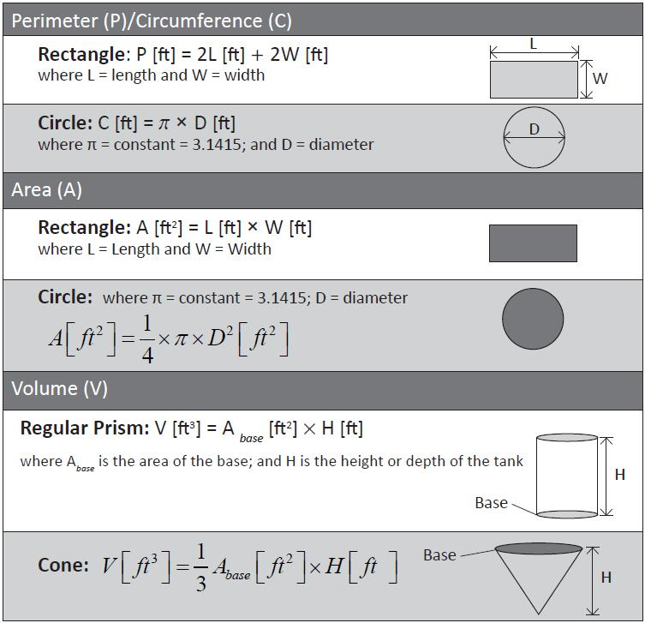

Example Problems:

1. The floor of a rectangular building is 20 feet long by 12 feet wide and the inside walls are 10 feet high. Find the total surface area of the inside walls of this building

Solution:

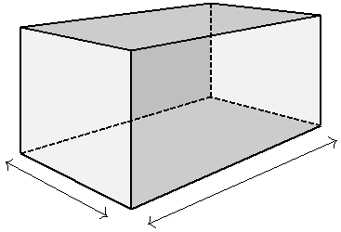

Ceiling=W*L



W*H

Wall - L*H

Height=10’

Wall - L*H

Wall - W*H

Floor=W*L

Length=20’

Width=12’

2 Walls W*H + 2 Walls L*H= 2 12 10 f t2 + 2 20 10 f t2

* 240 + 400 = 640 f t2

2 Walls W*H + 2 Walls L*H + Floor + Ceiling= 2 12 10 f t2 + 2 20 10 f t2 + 2 12 20 f t2

= 240 + 400 + 480 = 1, 120 f t2

1. How many gallons of paint will be required to paint the inside walls of a 40 ft long x 65 ft wide x 20 ft high tank if the paint coverage is 150 sq. ft per gallon. Note: We are painting walls only. Disregard the floor and roof areas.

|  |  |
| --- | --- |
| 10.8 Flow and Velocity | 291 |
|  |  |

Solution:

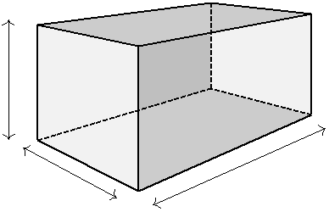

W*H

Height=20’

Wall - L*H

|  |  |  |
| --- | --- | --- |
| Wall - L*H | Wall - W*H |  |
|  |  |
| Length=40’ | Width=65’ |  |
|  |  |
| 2 Walls W*H + 2 Walls L*H = 2 65 20 f t2 + 2 40 20 f t2 = 2, 600 + 1, 600 = 4, 200 f t2 | |  |

|  |  |  |  |  |  |  |  |  |
| --- | --- | --- | --- | --- | --- | --- | --- | --- |
|  | f t2 |  | 4, 200 f t2 | | | |  |  |
| = @150 |  | paint coverage → |  |  |  | = | 28 gallons |  |
| gal | 150 | f t2 | |  |
|  |  |  |
|  |  |  |  |  |  |  |  |

gal

1. What is the circumference of a 100 ft diameter circular sedimentation tank? Solution:

Circum f erence = π D = 3.14 100 f t = 314 f t

4. If the surface area of a clarifier is 5,025 f t2, what is its diameter?

Solution:

|  |  |  |  |  |  |  |  |  |  |  |  |  |
| --- | --- | --- | --- | --- | --- | --- | --- | --- | --- | --- | --- | --- |
| Sur f ace area = | | | | | π | D2 = 5025( f t2) = 0.785 | | | | | D2( f t2) |  |
|  |  |
| 4 |  |
|  | 2 |  | 5025 | |  | √ |  |  |  |  |  |  |
|  |  |  |  |  |  |  |  |  |
|  |  |  |  |  |  |
| = D |  | = |  | | = D = 6401.3 = | | | | 80 f t |  |  |  |
|  |  | 0.785 |  |  |
|  |  |  |  |  |  |  |

5. How many gallons of water would 600 feet of 6-inch diameter pipe hold, approximately?

Solution:



|  |  |  |  |  |  |  |  |  |  |  |  |  |  |  |  |
| --- | --- | --- | --- | --- | --- | --- | --- | --- | --- | --- | --- | --- | --- | --- | --- |
|  |  |  |  |  |  |  |  |  |  |  |  |  |  | Diameter=6" |  |
|  |  |  |  |  |  |  |  |  | |  |  |  |  |  |  |
|  |  |  |  |  |  |  |  |  | |  |  |  |  |  |  |
|  |  |  |  |  |  |  |  | Length=600’ | | |  |  |  | Volume = |  |
|  |  |  |  |  |  |  |  |  |  |  |  |  |  |  |
| π | | | D2 | L = 0.785 | 6 |  | 2 | 600 f t3 7.48 | gallons | |  |  |  |  |  |
| = | 881 gallons | |  |  |
|  | | |  |  |  |  |  |  |
| 4 | | | 12 |  | f t3 | |  |
|  |  |  |  |  |  |  |



10.8 Flow and Velocity

* Flow Rate - Q (volume/time) = velocity (distance or length traveled /time) * surface area
* Velocity is the speed at which the water is flowing. It is measured in units of length/time – ft./sec.
* Velocity of water flowing through can be calculated by dividing the flow rate by area of the flow stream.

|  |  |  |  |  |  |  |  |
| --- | --- | --- | --- | --- | --- | --- | --- |
| length | |  | f low rate( | volume or | cubic length | ) |  |
|  |  |  |  |
|  |  | time | | |  |
| Velocity |  | = |  |  |  |  |  |
| time | sur f ace area in the direction | | o f f low −square length | |  |
|  |  |  |

292 Chapter 10. Water Math

For a flow in a channel:

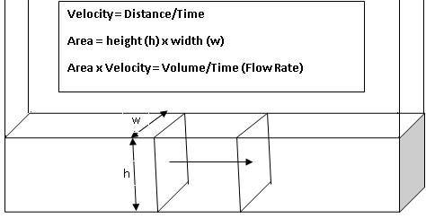

For a flow in a pipe:

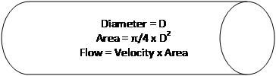

Example Problems:

1. If a chemical is added in a pipe where water is flowing at a velocity of 3.1 feet per second, how many minutes would it take for the chemical to reach a point 7 miles away?

|  |  |  |  |  |  |  |  |  |  |  |  |  |  |  |  |  |  |  |  |  |  |  |  |  |  |  |  |  |  |  |  |  |
| --- | --- | --- | --- | --- | --- | --- | --- | --- | --- | --- | --- | --- | --- | --- | --- | --- | --- | --- | --- | --- | --- | --- | --- | --- | --- | --- | --- | --- | --- | --- | --- | --- |
| Note - we want the answer in minutes | | | | | | | | | | | | | | |  |  |  |  |  |  |  |  |  |  |  |  |  |  |  |  |  |  |
|  |  |  |  |  | 1 |  | sec | | |  | 5280 f t | | | |  |  |  |  | min | |  |  |  |  |  |  |  |  |  |  |  |  |
|  |  |  |  | Min = |  |  |  |  |  | |  |  |  |  | 7miles | | | |  | | | = | 199min | | |  |  |  |  |  |  |  |
|  |  |  | 3.1 | f t | |  | mile | | | 60sec | | |  |  |  |  |  |  |  |
|  |  |  |  |  |  |  |  |  |  |  |  |  |  |  |  |  |  |
| 2. Find the flow in cfs in a 6-inch line, if the velocity is 2 feet per second. | | | | | | | | | | | | | | | | | | | | | | | | | |  |  |  |  |  |  |  |
| Q=Velocity * Area= = | | | | | Q |  | f t3 |  | | = 2 | | | f t |  |  | π |  | (6 in)2 | |  |  | f t2 | | = | 2 |  | 0.785 |  | 36 | | = |  |
|  |  |  |  |  |  |  |  |  |  |  |  |  |  |  |  |  |  |  |
|  | sec | | |  |  |  |  |  |  |  |  |  |  |  |  |  |  |  |
|  |  |  |  |  |  |  |  |  |  | sec | | 4 | | |  |  |  | 144 in2 | | |  |  | 144 |  |  |  |  |
|  | 0.4 | f t3 |  |  |  |  |  |  |  |  |  |  |  |  |  |  |  |  |
| sec |  |  |  |  |  |  |  |  |  |  |  |  |  |  |  |  |  |  |  |  |  |  |  |  |  |  |  |  |  |  |
|  |  |  |  |  |  |  |  |  |  |  |  |  |  |  |  |  |  |  |  |  |  |  |  |  |  |  |  |  |  |  |  |

1. A rectangular channel 3 ft. wide contains water 2 ft. deep flowing at a velocity of 1.5 fps. What is the flow rate in cfs?

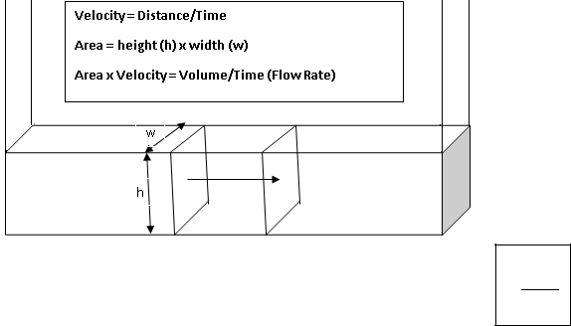

Q = V A = Q = 1.5 f t (3 2) f t2 = 9 f t3

sec sec

10.9 Unit Conversions

* A conversion is a number that is used to multiply or divide into a measure in order to change the units of the original measure.
* In most instances, the conversion factor cannot be derived. It must be known. Therefore, tables such as the one below are used to find the common conversions.

|  |  |  |  |  |  |  |  |  |
| --- | --- | --- | --- | --- | --- | --- | --- | --- |
| 10.9 Unit Conversions | | | | 293 | | | |  |
|  |  |  |  |  |  |  |  |  |
|  |  |  |  |  |  |  |  |  |
|  |  | Measure |  | Units | | |  |
|  |  | Length |  | inches, ft, miles | | |  |  |
|  |  | Area |  | ft2, acres | | |  |  |
|  |  | Volume |  | ft3, gallons, acres-ft. | | |  |  |
|  |  | Density |  | weight per volume, lbs/ft3, lbs/gallon | | |  |  |
|  |  | Flow |  | ft3/min, MGD, acres-ft/day | | |  |  |
|  |  | Table 10.1: Common units in water calculations | | | | | |  |
|  |  |  | |  |  |  | |  |
|  |  | Some Common Conversions | |  | Weight |  | |  |
|  |  |  | |  |  |  | |  |
|  |  | Linear Measurements | |  | 1ft3 of water = 62.4lbs |  |  |  |
|  |  | 1 inch = 2.54 cm | |  | 1gal = 8.34lbs |  |  |  |
|  |  | 1foot = 30.5 cm | |  | 1lb = 453.6grams |  | |  |
|  |  | 1 meter = 100 cm = 3.281feet = 39.4 inches 1 | | | 1 kg = 1000 g = 2.2lbs |  | |  |
|  |  | acre = 43, 560ft2 | |  | 1% = 10, 000mg/l |  | |  |
|  |  | 1yard = 3feet | |  | 1pound = 16ozdrywt |  | |  |
|  |  |  |  |  | 1ft3 = 62.4lbs |  | |  |
|  |  | Volume | |  | Pressure |  |  |  |
|  |  |  | |  |  |  | |  |
|  |  | 1gal = 3.78 liters | |  | 1ft of head = 0.433psi |  |  |  |
|  |  | 1ft = 7.48 gal | |  | 1psi = 2.31ft of head |  | |  |
|  |  | 1 L = 1000 mL | |  |  |  |  |  |
|  |  | 1gal = 16cups | |  |  |  |  |  |
|  |  |  | |  |  |  |  |  |
|  |  | Flow | |  |  |  |  |  |
|  |  |  | |  |  |  |  |  |
|  |  | 1cfs = 448gpm | |  |  |  |  |  |
|  |  | 1gpm = 1440gpd | |  |  |  |  |  |
|  |  |  |  |  |  |  |  |  |

* Common conversions in water related calculations include the following:

– gpm to cfs

– Million gallons to acre feet

– Cubic feet to acre feet

– Cubic feet of water to gallons

– gpm to MGD

– psi to feet of head

* Steps for unit conversion:

|  |  |  |  |  |  |
| --- | --- | --- | --- | --- | --- |
| Step 1: Make sure the original unit is for the same measurement as the converted (desired) | | | |  |  |
| unit. So if the original unit is for area, say in ft2 the converted unit should be another | | | |  |  |
| area unit such as in2 or acre but it cannot be gallons as gallon is a unit of volume. | | | |  |  |
| Note: Calculating the weight of a certain volume of water involves the use of density | | | |  |  |
| which is the mass per volume - value in units including lbs/gallon or lbs/ f t3 | | |  |  |  |
| Step 2: Write down the conversion formula as: | ((( |  | Conversion unit | |  |
|  |  |  |
| Quantity in converted unit = Quantity (Original((( U nit) Conversion Factor | | | ( | (( |  |
| ( |  |  |  |  |
|  |  | Original((( unit | |  |
|  |  |  | ( |  |  |

294 Chapter 10. Water Math

* Note: If you wish to convert cubic feet of water to pounds, you have to use its density which is the known mass per unit volume.

|  |  |  |  |  |  |  |  |
| --- | --- | --- | --- | --- | --- | --- | --- |
|  | 8.34 lbs | or | 62.4 lbs | |  |  |  |
|  | gallon |  | |  |  |
|  |  | f t3 |  | |  |  |
| mass o f | | water = | |  | | Density( |  |
| Volume | |  |

Example Problems:

1. Convert 1000 f t3 to cu. yards 1000 f t3 cu.yards = 37cu.yards

27 f t3

mass

)

1. Convert 10 gallons/min to f t3/hr

Note: This involves use of two conversion factors - one for converting gallons to cubic feet

and another for converting minute to gallons.

|  |  |  |  |  |  |  |  |  |  |  |  |  |  |  |  |  |  |  |  |  |  |
| --- | --- | --- | --- | --- | --- | --- | --- | --- | --- | --- | --- | --- | --- | --- | --- | --- | --- | --- | --- | --- | --- |
|  | | |  |  |  |  |  | 3 |  |  |  |  | | | |  |  |  |  | 3 |  |
|  | |  |  |  |  |  | f t |  |  |  |  | 80.2 f t | | |  |
|  | 10gallons |  |  | |  |  |  |  |  |  |  | 60min | | = |  |  |
|  | min | |  |  |  |  |  |  | |  |  | hr |  | hr | |  |  |  |
|  | 7.48gallons | | | | | | |  |  |  |  |  |  |  |
| 3. Convert 100,000 f t3 | | | | | | | | |  | to acre-ft. | | | | |  |  |  |  |  |  |  |
| 100, 000 f t | | | 3 |  | | | acre − f t | | | | |  |  | = 2.3acre | | | | − | f t | |  |
|  |  |  |  | , |  | f t2 f t | | | | | |  |  |  |  |  |  |
|  |  |  |  |  | 43 | | 560 | | | − | |  |  |  |  |  |  |  |  |  |  |

1. Convert 8 f t3 of water to pounds.

Here the conversion is from a volume ( f t3) to a weight (lbs). It involves use of a standard correlation of the volume of water to its weight - its density.

|  |  |  |  |
| --- | --- | --- | --- |
| Weight o f water in lbs = 8 f t3 62.4( | lbs | ) = 499.2 lbs |  |
| f t3 |  |

10.9.1 Temperature Conversion

* Two scales are commonly used to measure temperature: degrees Fahrenheit (◦F) and de-grees Centigrade or Celsius(◦C).
* Fahrenheit is the standard scale used in the U.S. and Celsius is the metric scale.
* In the Celsius scale, water freezes at 0◦C and boils at 100◦C. In the Fahrenheit scale, water freezes at32◦F and boils at 212◦F.
* The following factors can be used when converting from one temperature scale to another:

◦C = ◦F −32

1.8

◦F = (◦C 1.8) + 32

10.10 Concentration

* Concentration is typically expressed as mg/l which is the weight of the constituent (mg) in 1 liter of water.
* As 1 liter of water weighs 1 million mg, a concentration of 1 mg/l implies 1 mg of con-stituent per 1 million mg of water or one part per million (ppm). Thus, mg/l and ppm are synonymous.
* Sometimes the constituent concentration is expressed in terms of percentage.

|  |  |
| --- | --- |
| 10.10 Concentration | 295 |
|  |  |

Example: 12.5% chlorine concentration solution.

100% would mean 1,000,000 mg/l or 1,000,000 ppm

= 1% would be 1, 000, 000 mg/l = 10,000 mg/l or 10,000 ppm 100

= 12.5% chlorine concentration is 125,000 mg/l or 125,000 ppm.

mg

1% concentration = 10, 000 ppm or

0.1% concentration = 1, 000 ppm or

l

mg

l

mg

0.01% concentration = 100 ppm or

* mg

10% concentration = 100, 000 ppm or

|  |  |  |  |  |  |  |
| --- | --- | --- | --- | --- | --- | --- |
| 5% concentration = 50, 000 |  | mg l | | |  |  |
| ppm or | |  |  |  |  |
| l | | mg |  |
|  |  |  |  |
| 12.5% concentration = 125, 000 | | ppm or | | |  |
|  |  |
|  |  |

l

Above concepts are used for chemicals such as fluoride and hypochlorites - the strength of the product as used is commonly expressed as a percentage.

Example Problem:

1. A chlorine solution was made to have a 4% concentration. It is often desirable to deter-mine this concentration in mg/l. This is relatively simple: the 4% is four percent of a million.

To find the concentration in mg/l when it is expressed in percent, do the following:

* 1. Change the percent to a decimal.

4% ÷100 = 0.04

2. Multiply times a million.

0.04 1, 000, 000 = 40, 000mg/l

We get the million because a liter of water weighs 1, 000, 000mg.1mg in 1 liter is 1 part in a million parts ( ppm).1% = 10, 000mg/l.

1. How much 65% calcium hypochlorite is required to obtain 7 pounds of pure chlorine? 65% implies that in every lb of calcium hypochlorite has 65% lbs of available chlorine.

|  |  |  |  |  |  |  |  |  |  |  |  |  |  |
| --- | --- | --- | --- | --- | --- | --- | --- | --- | --- | --- | --- | --- | --- |
| Therefore, | 0.65 lbs available chlorine | or conversely | | lb of calcium hypochlorite | | | | |  |  |  |  |  |
|  | 0.65 lbs available chlorine | | | | | |  |  |  |  |
|  | lb of calcium hypochlorite | |  | (((((( | | |  |
|  |  |  |  |  |  |  |  |  |  |  |
|  |  |  | lb of calcium hypochlorite 7 lb of(available( | | | | | | | | chlorine | |  |
|  |  |  |  |  |  |  |  | ( | |  |  |  |  |
| = lbs calcium hypchlorite required = | | |  |  |  |  |  | (( |  |  |  |  |  |
|  |  | (((((( | | |  |  |  |  |  |  |
|  |  |  | 0.65(lbs(available( | | | chlorine | |  |  |  |  |  |  |
|  |  |  | ( | |  |  |  |  |  |  |  |  |  |

* 10.8 lbs of calcium hypochlorite with 65%available chlorine is required

296 Chapter 10. Water Math

10.11 Density and Specific Gravity

10.11.1 Density

* Density is defined as the weight of a substance per a unit of its volume. For example, pounds per cubic foot or pounds per gallon.
* Here are a few key facts about density:

– Density is measured in units of lb/ft3, lb/gal, or mg/L. Density of water = 62.4 lb/ft3 = 8.34 lb/gal.

10.11.2 Specific Gravity

* Specific gravity is the ratio of the density of a substance (liquid or solid) to the density water.
* It is the ratio of the weight of the substance of a certain volume to the weight of water of the same volume.
* Any substance with a density greater than that of water will have a specific gravity greater than 1.0. Any substance with a density less than that of water will have a specific gravity less than 1.0.
* Specific gravity examples:

– Specific gravity of water = 1.0

– Specific gravity of concrete = 2.5 (depending on ingredients)

– Specific gravity of alum (liquid @ 60°F) = 1.33

– Specific gravity of hydrogen peroxide (35%) = 1.132

* Specific gravity is used in two ways:

1. To calculate the total weight of a % solution (either as a single gallon or a drum volume).

Total Weight = Drum Vol X SG X 8.34

1. To calculate the “active ingredient” weight of a single gallon or a drum.

Active Ingredient Weight within Drum = Drum Volume X SG X 8.34 X % solution as a decimal. (i.e., Total Weight X % solution as a decimal)

NOTE: Both ways start with solving for the total weight (Drum Vol X SG X 8.34). When solving for “active ingredient” weight, you have to then multiply by % solution as a decimal.

Example Problem:

1. What is the weight of 5 gallons of a 40% ferric chloride solution given its specific gravity of 1.43?

(8.34 1.43) lbs/gal 5 gallons = 59.6 lbs

The weight of active ferric chloride in the drum will be 59.6*0.4=23.84 lbs (as ferric chlo-ride is 40% strength)

|  |  |
| --- | --- |
| 10.12 Contaminant Removal Efficiency | 297 |
|  |  |

10.12 Contaminant Removal Efficiency

* The removal efficiency of a certain constituent in a treatment process is frequently reported as the percent (%) removal efficiency If CIn is the concentration of the constituent entering the process and COut is the concentration of that constituent leaving the process

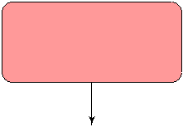

CIn  Process  COut

Removal E f f iciency = RE%

* Removal E f f iciency (%) = CIn −COut 100

CIn

* If 10 units of a contaminant are entering a process and 8 units of pollutant are leaving (pro-cess removes 2 units), then the process removal rate for that pollutant is (10-8)/10*100=20%. In this example the process is 20% efficient in removing that particular contaminant.
* For water pathogens including coliforms, viruses and parasites (Giardia and Crypto), their removal is expressed in terms of log reduction. This is because the pathogens entering and

exiting the process are quantified as numbers and as these numbers can be very large, their concentrations are expressed in terms of their order of magnitude using their log10 value instead of their absolute values.



log10CIn  Process  log10COut

Removal E f f iciency = log Reduction

Log Reduction = log10CIn - log10COut . Thus:

1 log removal =90% removal efficiency

2 log removal =99% removal efficiency

3 log removal =99.9% removal efficiency

4 log removal =99.99% removal efficnecy

298 Chapter 10. Water Math

Example Problems:

1. Calculate the removal efficiency if the CIn value of E. Coli is 1.00*108MPN/100ml and COut is 1.00*105MPN/100ml.



|  |  |  |  |  |  |  |  |  |  |  |  |  |
| --- | --- | --- | --- | --- | --- | --- | --- | --- | --- | --- | --- | --- |
| 1.00*108MPN/100ml |  |  |  | Process | | | |  | 1.00*105MPN/100ml | | |  |
|  |  |  |  |  |
|  | |  |  | | | |  | | |  |  |  |
|  | |  |  | | |  |  | | |  |  |  |
| Removal | | E f f iciency(RE%)orlog Reduction | | | | | | | |  |  |  |
| Using the Removal Efficiency % Method: | | | | | |  |  |  |  |  |  |  |
| Removal E f f iciency (%) = | | | CIn −COut | |  | 100 = | 1.00 108 −1.00 105 | | |  | 100 = 99.9% |  |
|  |  |  |  | CIn |  |  | 1.00 108 | |  |  |
| Using the log Reduction Method: | | | | |  |  |  |  |  |  |  |  |
| Log Reduction = log10CIn | | - log10COut = log101.00*108-log101.00*108=8-5=3 | | | | | | | | | |  |



1. What is the % removal efficiency if the influent concentration is 10 mg/L and the effluent concentration is 2.5 mg/L?

Removal Rate(%) = In −Out 100 = 10 −2.5 100 = 75%

In 10

10.13 Pounds Formula

• Pounds formula:

|  |  |  |  |  |  |  |
| --- | --- | --- | --- | --- | --- | --- |
| lbs or |  | lbs | = Concentration | mg | 8.34 volume(MG) or Flow(MGD) |  |
|  |  |  |  |
| day | | l |  |

* So if the concentration of a particular constituent (in mg/liter) and the volume or flow of water is given, one can calculate the amount of that constituent or using this formula. Important notes:
  1. The unit of the constituent loading rate will be in lbs per the unit of time the flow is expressed in. So if the flow is in MG per day the calculated loading rate will be in lbs/day. Likewise if the flow value used is in MG per minute, the calculated loading rate will be in lbs/min.
  2. If volume is used, the calculated value will be the mass of the constituent in that volume. If flow is used, the calculated value will be the mass of the constituent in that flow.
  3. For the Pound Formula to work, the volume or flow needs to be expressed in MG.
* The formula assumes that all of the material found in water (TSS, BOD, MLSS, Chlorine, etc.) weighs the same as water, that is, 8.34 pounds per gallon.

|  |  |
| --- | --- |
| 10.13 Pounds Formula | 299 |
|  |  |

* In the Pounds Formula, there are three variables – lbs, concentration and volume, and one constant - 8.34. Knowing any of the two variables in the formula, one can calculate the third (unknown) variable by rearranging the equation.

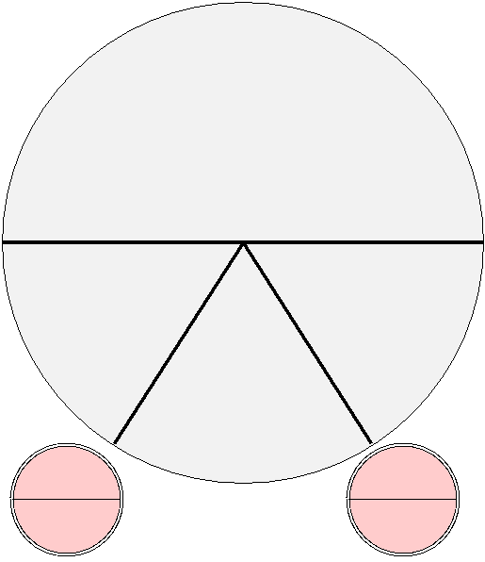

lbs or lbs/day



÷

=

Concentration Volume(MG)

mg/l Flow(MGD)

8.34

X

X

Multiply

Multiply

Figure 10.1: Davidson Pie

* Davidson Pie provides a pictorial reference for calculating any unknown variable. If for example, if Concentration is unknown, it can be calculated as follows:

|  |  |  |  |  |  |  |  |
| --- | --- | --- | --- | --- | --- | --- | --- |
| Concentration |  | = | lbs or |  | lbs |  |  |
| mg | day | |  |  |
|  |  |  |
|  |  |  |  |  |  |

* + 8.34 Volume(MG) or Flow(MGD)
* Likewise, if Volume (or Flow) is the unknown variable. it can be calculated as:

|  |  |  |  |  |  |  |
| --- | --- | --- | --- | --- | --- | --- |
|  | lbs or |  | lbs | |  |  |
| Volume(MG) or Flow(MGD) = | day | | | |  |
|  |  |
|  | mg | | | |  |
|  |  |  |
| Concentration | |  |  | 8.34 | |  |
|  | l |  |

* Pounds formula is used for:

– Calculating the quantity in pounds of a particular water constituent entering or leav-ing a treatment process

– Calculating the pounds of chemicals to be added

10.13.1 Chemical Dosing

* Use lbs formula to calculate the lbs of chemicals required
* Using the calculated lbs chemical required value, calculate the amount of that chemical at the concentration available

1. If a 5 MGD flow is to be dosed with 25 mg/l of a certain chemical, calculate the lbs/day that chemical required.

|  |  |  |  |  |  |  |  |  |  |
| --- | --- | --- | --- | --- | --- | --- | --- | --- | --- |
| 300 |  |  |  |  |  |  |  | Chapter 10. Water Math |  |
|  |  |  |  |  |  |  |  |  |  |
| Solution | | |  |  |  |  |  |  |  |
| Applying lbs formula: | | | |  |  |  |  |  |  |
|  | lbs | | mg |  |  | lbs | |  |  |
|  |  | = 5MGD 250 |  | 8.34 = | 1, 042 |  |  |  |  |
|  | day | l | day | |  |  |
|  |  |  |  |  |  |  |  |  |  |

1. Calculate the lbs of chemical in 7,500 gallons of 4.5% active solution of that chemical. Solution

7500

lbs chemical = 1, 000, 000 MG 4.5 10, 000 8.34 = 2, 815 lbs

1. Determine the chlorinator setting (lb/day) required to treat a flow of 4MGD with a chlorine dose of 5mg/l.

Chlorine feed rate (lb/ day ) = Chlorine (mg/l) Flow (MGD) 8.34lb/gal Chlorine feed rate lb/day =5mg/l 4MGD 8.34lb/gal = 167lb/day

1. A pipeline that is 12 inches in diameter and 1400ft long is to be treated with a chlorine dose of 48mg/l. How many lb of chlorine will this require?

Solution:

First determine the volume of the pipeline in MG:

|  |  |  |  |  |  |  |  |  |  |  |  |  |  |  |  |
| --- | --- | --- | --- | --- | --- | --- | --- | --- | --- | --- | --- | --- | --- | --- | --- |
| Pipe Volume (MG) = 0.785 D2(ft2) length(ft) | | | | | | | | 7.48gal | | |  |  | MG | |  |
|  |  |  |  |  |  |  |
|  | f t3 |  | 1, 000, 000gal |  |  |
| = 0.785 (1ft)2 1400ft | 7.48gal | | |  |  | MG | | = 0.008221MG | | | | | | |  |
|  |  |  |  |  |  |  |
|  | f t3 |  | 1, 000, 000gal |  |  |

Next calculate the amount of chlorine required using pounds formula: Chlorine required (lbs)=Chlorine mg/l * Pipe Volume (MG) * 8.34 = 48mg/l 0.008221MGD 8.34lb/gal = 3.3lbschlorine

1. A water sample is tested and found to have a chlorine demand of 1.7mg/l. If the desired chlorine residual is 0.9 mg/l, what is the desired chlorine dose (in mg/l)?

Chlorine Dose (mg/l) = Chlorine Demand + Chlorine Residual= 1.7mg/l + 0.9mg/l = 2.6mg/l

1. The chlorine dosage for water is 2.7mg/l. If the chlorine residual after a 30-minute contact time is found to be 0.7mg/l, what is the chlorine demand (in mg/l )?

Chlorine Demand = Chlorine Dose − Chlorine Residual Chlorine Demand = 2.7mg/l −0.7mg/l = 2.0mg/l

1. How many gallons per day of bleach solution (SG 1.2)containing 12.5% available chlorine is required to disinfect a 10 MGD flow of water given the required chlorine dosage of 7 mg/l.
   1. Calculate the lbs of chlorine required using the lbs formula:

=10MGD 7 mg 8.34 = 583.8 lbs chlorine per day l

|  |  |
| --- | --- |
| 10.14 Blending and Dilution Calculations | 301 |
|  |  |

* Calculate the gallons of bleach which will provide the 583.8 lbs chlorine

Applying the lbs formula - note that 8.34 * SG will give the actual lbs/gal of bleach. If SG is not provided, use only 8.34 lbs per gallon:

|  |  |  |  |  |  |  |  |  |  |  |  |  |  |  |  |  |  |  |  |  |  |
| --- | --- | --- | --- | --- | --- | --- | --- | --- | --- | --- | --- | --- | --- | --- | --- | --- | --- | --- | --- | --- | --- |
|  | lbs | | bleach | | | |  | gal | |  |  |  | lbs bleach | | | | | |  | lbs chlorine |  |
| 583.8 |  |  |  | |  | = | x |  |  |  | 8.34 1.2 | | |  |  |  |  |  | 0.0125 |  |  |
|  |  | day | |  | day |  | gal | | | | lb bleach |  |
|  |  |  | |  |  |  | 583.8 | | |  |  |  |  |  |  | |  | |  |  |  |
| = x | | gal | | = |  |  |  |  | = | 467 | | gal | |  | |  |  |  |
|  | |  | |  | |  |  |  |  |  |  | |  |  |  |
| day | | . | | . | |  | . |  | day | |  | |  |  |  |
|  |  |  |  |  | 8 34 | | 1 2 | | | 0 125 | |  |  |  |  |  |  |  |  |  |  |

The above problem can be solved directly using the formula below given in the SWRCB Water Treatment Exam Formula Sheet.

|  |  |  |  |  |  |  |  |  |
| --- | --- | --- | --- | --- | --- | --- | --- | --- |
| GPD = | (MGD) (ppm or mg/l) 8.34 lbs/gal | GPD = | 10 7 8.34 | = | 467 | gal |  |  |
|  | 0.125 (1.2 8.34) |  |  |
|  | % purity Chemical Wt. (lbs/gal) | |  | day | | |  |

10.14 Blending and Dilution Calculations

1. Blending and dilution calculations apply to the following scenarios:

– Blending involves mixing two streams - each with a different concentration of con-taminant/chemical, to obtain a certain volume or flow containing the target concentra-tion of contaminant/chemical. For example: Finding the correct blend of two source water streams - one with 15 mg/L of iron and other containing 4 mg/L of iron to get a 100 gpm product water containing 8 mg/l of iron. OR

Calculating the actual combined TDS concentration obtained by mixing two known flows with known TDS concentrations.

– Dilution involves makedown of a higher concentration of a chemical to a lower con-centration using water as a dilutant. For example: How much initial volume of a 4% polymer solution is needed to make 3500 gallons of polymer at 0.25% concentra-tion?

1. These type of problems are solved using C*V relationship where:

– C is the concentration expressed in ppm or mg/l or as % purity.

– V is either the volume or flow.

mass

– The product - C*V - volume/flow = mass

volume/flow

* For blended streams, the sum of the mass from each of the two source streams will equal to the mass in the target stream:
* Thus, for blending calculations, if:

C1 and V1 is the concentration and volume respectively of the one of the sources streams and

C2 and V2 is the concentration and volume respectively of the second source stream, and C3 and and V3 is the concentration and volume respectively of the target stream

302 Chapter 10. Water Math

The sum of the mass from each of the two source streams will equal to the mass in the target stream:

C1 * V1 + C2 * V2 = C3 * V3.

This equation can be manipulated algebraically to calculate anyone of the unknown values in the equation.

Also, any of the three volume variables can be expressed as the sum or difference of the other two - , or V1 + V2 = V3 or V1 = V3 - V2 or V2 = VT - V1

1. For dilution, the mass of the target chemical will remain the same, as only water is added to the source (concentrated chemical).
2. Thus, for dilution calculations, if:

C1 and V1 is the concentration and volume respectively of the concentrated product used for the dilution, and

C2 and V2 is the concentration and volume of the resultant product after dilution with water

The mass of the target chemical in the volume of the concentrated product used for dilu-tion will remain the same in the final diluted product:

C1 * V1 = C2 * V2.

Example Problems:

1. Two wells are used to satisfy demand during the summer months. One well produces water that contains 22 mg/L of Arsenic. The other well produces water that contains 3 mg/L of Arsenic. If the total demand for water is 400 gpm and the target Arsenic concentration in the finished water is 8 mg/L, what is the highest pumping rate possible for the first well?

Solution:

C1 * V1 + C2 * V2 = C3 * V3 Thus 22 * V22 + 3 * V3 = 8 * V8 V22 + V3 = V8 = 400 gpm

As we want to solve for V22, we can express V3 as: V3 = 400-V22 Thus, 22 * V22 + 3 * (400-V22) = 8 * 400=3,200

22V22 + 1200-3V22 = 3,200

V22(22-3) = 2,000

V22 = 2, 000 = 105.3 gpm 19

Also, V3=400-105.3=294.7

|  |  |
| --- | --- |
| 10.15 Force, Pressure and Head | 303 |
|  |  |

NOTE: If one does not want to utilize algebraic manipulation, one may memorize the following formula:

|  |  |  |  |
| --- | --- | --- | --- |
| V1/2 | = | |C3 −C2/1| V3 |  |
| C1 −C2 |  |
|  |  |  |

|8 −3| 400

V22 = = 105.3 gpm

|8 −22| 400

V3 = = 294.7 gpm

1. How many gallons of a 4% polymer solution is required to make a 3,500 gallon batch of 0.25% polymer solution.

Here, we are adding water - which has zero percent of polymer concentration to the 4% polymer to make a 0.25% polymer solution.

C1 * V1 = C2 * V2

C4% * V4% = C0.25% * V0.25%

4 * V4% = 0.25 * 3,500

= V4% = 0.25 3500 = 219 gal

4

Take 219 gallons of the 4% polymer and dilute to 3,500 gallons to give a 0.25% polymer solution.

10.15 Force, Pressure and Head

Force: In the English system force and weight are often used in the same way. The weight of the cubic foot of water is 62.4 pounds. The force exerted on the bottom of the one foot cube is 62.4 pounds. If we have two cubes stacked on top of one another, the force on the bottom will be 124.8 pounds.

Pressure: Pressure is a force per unit of area, pounds per square inch or pounds per square foot are common expressions of pressure.

Head: Pressure is directly related to the height of a column of fluid. This height is called head or feet of head. Pressure and feet of head head are directly related - for every one foot of head there is a pressure of 0.433 psi.

|  |  |  |  |  |  |  |  |  |
| --- | --- | --- | --- | --- | --- | --- | --- | --- |
| Thus, |  | 0.433 | psi |  | or conversely | 1 f t (water | column) |  |
| f t | (water | column) | |  | psi |  |
|  | 2.31 | |  |

Note: This pressure/head will include the height the water pumped and also the head associated with friction losses - energy loss because of the water moving through the pipe and fittings.

The pressure at the bottom of a container is affected only by the height of water in the container and not by the shape or the volume of the container. In the drawing below there are four contain-

|  |  |  |  |  |  |  |  |  |  |  |
| --- | --- | --- | --- | --- | --- | --- | --- | --- | --- | --- |
| 304 |  |  |  |  |  |  |  | Chapter 10. Water Math | |  |
|  |  |  |  |  |  |  |  |  |  |  |
| Pressure = | Force |  |  |  |  |  |  |  |  |  |
| Area | |  |  |  |  |  |  |  |  |
|  |  |  |  |  |  |  |  |  |
|  |  |  |  |  |  |  |  |  |  |  |
| Pressure exerted by | | |  |  | 62.4 lb | | 12" | | |  |
| = |  | = 0.43 psi | | |  |
| a 1ft column of water | | |  |  |  |  |
| 12in x 12in | | |  |
|  |  |  |  | 12" |  |  |  |
|  |  |  |  |  |  |  |  |  |  |



As 1 f t3 of water weighs 62.4 lbs

12"

ers all of different shapes and sizes. The pressure at the bottom of each is the same.



The pressure exerted at the bottom of a tank is relative only to the head on the tank and not the volume of water in the tank. For example, below are two tanks each containing 5000 gallons. The pressure at the bottom of each is 22 psi. If half of the water were drained from the tanks the pressure at the bottom of the elevated tank would be 17.3 psi while the pressure at the bottom of the standpipe would be 11 psi.

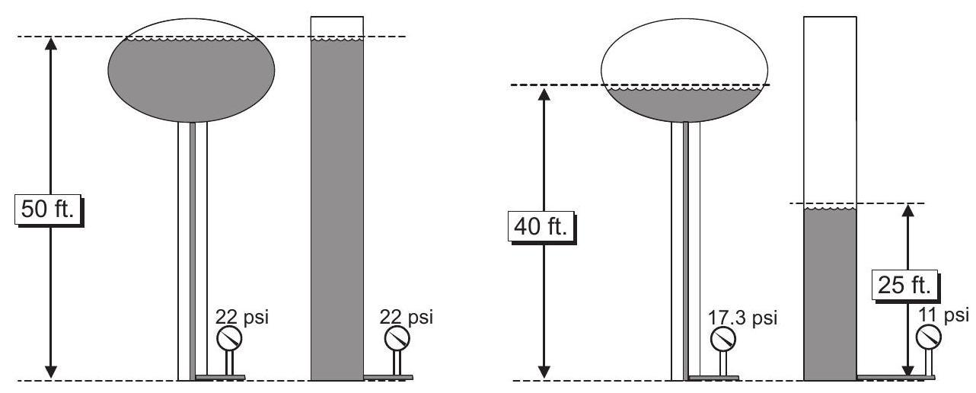

Example Problems:

* A reservoir is 40 feet tall. Find the pressure at the bottom of the reservoir. 40ft 0.433psi/ft = 17.3psi

|  |  |
| --- | --- |
| 10.16 Pumping Calculations | 305 |
|  |  |

* Find the height of water in a tank if the pressure at the bottom of the tank is 12 psi. 12psi ÷0.433psi/ft = 27.7ft
* If a pump discharge pressure gauge read 10 psi, the height of the water corresponding to this pressure would be:

|  |  |  |  |  |
| --- | --- | --- | --- | --- |
|  | 2.31 | f t | |  |
| 10 psi |  |  | = 23.1 f t |  |
| psi |  |  |

1. Find the force on a 12-inch valve if the water pressure within the line is 60 psi. Express your answer in tons. Solution:

|  |  |  |  |  |  |  |  |  |
| --- | --- | --- | --- | --- | --- | --- | --- | --- |
| Force = Pressure ×Area | | | |  |  |  |  |  |
|  |  | lbs | 0.785 (12in)2 |  | 1ton |  |  |  |
| = 60 |  |  | = | 3.39 tons |  |
|  |  |  |  |  |
| in2 |  | 2000lbs |  |
|  |  |  |  |  |

10.16 Pumping Calculations

1. Pump is a machine used for moving water (and other fluids) through a piping system and raise the pressure of the water.
2. Pumping is accomplished by transforming the input energy - typically from an electric motor or from other sources such as high-pressure air.
3. The pump calculations in this section are for electrically driven rotodynamic pumps.
4. To move water, a pump will need to overcome resistance due its density, gravitational force and friction.
5. This resistance is dependent on:

– Height the water needs to be raised. This height of the fluid in a container is referred to as head.

– Quantity of water involved

10.16.1 Glossary of Pump Calculations Terms

Static Pressure: Static implies a non-moving condition. The pressure measured when there is no water moving in a line or the pump is not running is called static 32 pressure. This is the pressure represented by the gauges on the tanks in the discussion above.

Dynamic Pressure: When water is allowed to run through a pipe and the pressure (called pres-sure head) measured at various points along the way we find that the pressure decreases the further we are from the sources.



306 Chapter 10. Water Math

Headloss: The reason for this reduction in pressure is a phenomenon called headloss. Headloss is the loss of energy (pressure) due to friction. The energy is lost as heat.

If the headloss in a certain pipe is 25 feet, it means the amount of energy required to overcome the friction in the pipe is equivalent to the amount of energy that would be required to lift this amount of water straight in the air 25 feet.

In a pipe, the factors that contribute to headloss include the following:

* Roughness of pipe - If the roughness of a pipe were doubled the headloss would double.
* Length of pipe - If the length of the pipe were doubled the headloss would double.
* Diameter of pipe - If the diameter of a pipe were doubled the headloss would be cut in half
* Velocity of water - If the velocity of the water in a pipe were doubled the headloss would be increased by about four times. It should be apparent that velocity, more than any other single factor, affects headloss. To double the velocity we would have to double the flow in the line.
* Pumping System Components and Fittings - Each type of fitting has a specific headloss depending upon the velocity of water through the fitting. For instance the headloss though a check valve is two and one quarter times greater than through a ninety degree elbow and ten times greater than the headloss through an open gate valve.

Static Head: Static head is the distance between the suction and discharge water levels when the pump is shut off.

Suction Lift: Suction lift is the distance between the suction water level and the center of the pump impeller. This term is only used when the pump is in a suction lift condition. A pump is said to be in a suction lift condition any time the eye (center) of the impeller is above the water being pumped.

Velocity Head: The amount of energy required to bring a fluid from standstill to its velocity.

For a given quantity of flow, the velocity head will vary indirectly with the pipe diameter.

Total Dynamic Head (TDH): The total energy needed to move water from the center line of a pump (eye of the first impeller of a lineshaft turbine) to some given elevation or to develop some given pressure. This includes the static head, velocity head and the headloss due to friction.

Horsepower: Horsepower is a measurement of the amount of energy required to do work. Mo-tors are rated in horsepower. The horsepower of an electric motor is called brake horsepower. The horsepower requirements of a pump are dependent on the flow and the total dynamic head. 33,000 foot pounds per minute of work is 1 horsepower.

Suction Head: Suction head is the distance between the suction water level and the center of the pump impeller when the pump is in a suction head condition. A pump is said to be in a suction head condition any time the eye (center) of the impeller is below the water level being pumped.

Velocity Head: Velocity head is the amount of energy required by the pump and motor to over-come inertia and bring the water up to speed. Velocity head is often shown mathematically as V2/2 g. ( g is the acceleration due to gravity −32.2ft/sec2 ).

|  |  |
| --- | --- |
| 10.16 Pumping Calculations | 307 |
|  |  |



Total Dynamic Head: Total dynamic head (TDH) is a theoretical distance. It is the static head, velocity head and headloss required to get the water from one point to another.

The horsepower output of an electric motor is directly reflected to the amperage that the motor draws. Any increase in horsepower requirements will give a corresponding increase in amperage. Cavitation: Cavitation in pumps is the rapid creation and subsequent collapse of air bubbles occuring as a result of the inlet pressure falling below the design inlet pressure or when the pump is operating at a flow rate higher than the design flow rate. This collapse of the air bubbles typically manifests as a pinging or crackling noise. Cavitation is undesirable because it can damage the impeller, cause noise and vibration, and decrease pump efficiency.



308 Chapter 10. Water Math

10.16.2 Pumping Rate Calculations

* For calculating volume pumped given the pump flow rate: Multiply the pump flow rate by the time interval

Make sure:

– The time units - in the given time interval and in the pump flow rate match

* For calculating time to pump a certain volume:

Step 1. Calculate the total volume pumped

Step 2. Divide the total volume by the pump flow rate

Make sure:

– The volume units - in the volume that needs to be pumped and in the pump flow rate match

– The time unit in the pump flow rate needs to be converted to the time unit that you need the answer in

Example Problems:

* A pump is set to pump 5 minutes each hour. It pumps at the rate of 35 gpm. How many gallons of water are pumped each day?

Solution:

|  |  |  |  |  |  |  |  |  |  |  |
| --- | --- | --- | --- | --- | --- | --- | --- | --- | --- | --- |
| 35 gal sludge |  | 5 |  | |  | 24 |  | |  |  |
|  | min | |  | hr | | = |  |
| min |  | hr |  | day | |  |  |

4, 200 gallons

day

2. A pump operates 5 minutes each 15 minute interval. If the pump capacity is 60 gpm, how many gallons are pumped daily?

|  |  |  |  |  |  |  |  |  |  |  |  |  |  |  |
| --- | --- | --- | --- | --- | --- | --- | --- | --- | --- | --- | --- | --- | --- | --- |
| 60 gal sludge |  | 5 | H | |  |  |  | | |  | 28, 800 gal sludge | | |  |
|  | Hmin |  |  | 1440 | min | | | = |  |
| H | 15 |  |  |  | day |  |  | day |  |  |
| Hmin | min | |  |  |  |  |  |

* Given the tank is 10ft wide, 12 ft long and 18 ft deep tank including 2 ft of freeboard when filled to capacity. How much time (minutes) will be required to pump down this tank to a depth of 2 ft when the tank is at maximum capacity using a 600 GPM pump

Solution:

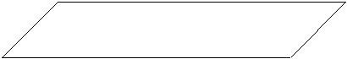 2’ Freeboard

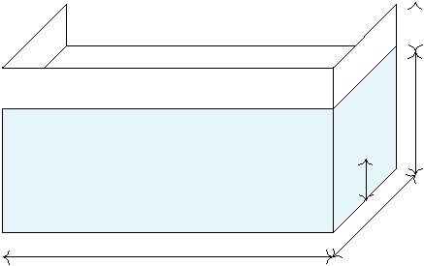

16’ Water Depth (Initial)

2’ Water Depth (Final)

10’ Wide

12’ Long

Volume to be pumped=12 f t 10 f t (16 −2) f t = 1, 680 f t3

|  |  |  |  |  |  |  |  |  |  |  |
| --- | --- | --- | --- | --- | --- | --- | --- | --- | --- | --- |
| 3 | |  |  |  | gal | | | | |  |
|  |  |  |  | |  |  |  |  |
|  | 1, 680 f t | 7.48 | | |  | f t3 |  | |  |  |
| = |  |  | 21min |  |
|  |  |  |  |  |  |  | = |  |
|  |  | gal | |  |  |  |  |
|  |  |  |  |  |  |  |  |
| 600 | | |  |  |  |  |  |  |  |  |
|  |  |  |  |  |  |  |  |

min

|  |  |
| --- | --- |
| 10.16 Pumping Calculations | 309 |
|  |  |

10.16.3 Power Requirements for Pumping

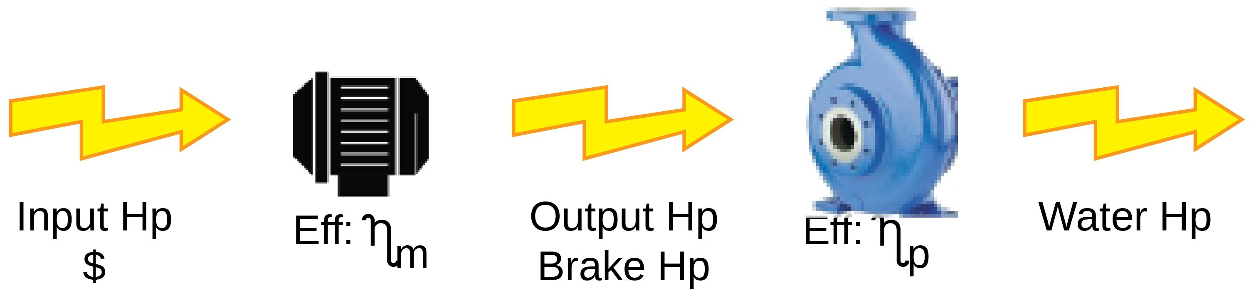

Where:

* Input Hp is the input power to the motor which produces the Output Hp or Brake Hp - the mechanical power which runs the pump.
* The ratio of Output Hp and Input Hp is the motor efficiency - ηm.
* The Output Hp is the input power (Brake Hp) to the pump to pump the water.
* Water Hp is the rate of energy transferred to the water being pumped and can be calculated

by the formula:

H − Head of water (ft) Q − Flow (GPM)

3, 960 (Conversion factor for converting GPM −ft to Hp)

• The ratio of Output Hp and Water Hp is the pump efficiency - ηp.

Example Problems:

* 1 MGD is pumped against a 14’ head. What is the water Hp? The pump mechanical effi-ciency is 85%. What is the brake horsepower?

water Hp = flow * head

|  |  |  |  |  |  |  |  |  |  |  |  |  |  |
| --- | --- | --- | --- | --- | --- | --- | --- | --- | --- | --- | --- | --- | --- |
|  | 1, 000, 000 gal | |  |  | day | | |  |  | H p |  |  |  |
|  |  |  |  |  | |  | 14 | f t |  |  | = | Water H p = 2.46 H p |  |
|  | day |  | 1440 min | | | 3, 960 GPM − f t | |  |
|  |  |  |  |  |
| pump Hp = brake Hp * pump efficiency | | | | | | | | | | |  |  |  |
|  | | 2.46 | | |  |  | | | |  |  |  |  |
| Brake H p = | | = | Brake H p = 2.89H p | | | |  |  |  |  |
| 0.85 | | |  |  |  |
|  |  |  |  |  |  |  |  |  |  |  |
|  |  |  |  |  |  |  |  |  |  |  |

* A flow of 200 gpm is pumped against a total head of 4.0 feet. The pump is 78% efficient and the motor’ is 90% efficient. Calculate the input Hp.

water Hp = flow * head

H p

200GPM 4 f t 3, 960GPM − f t = 0.2H p



water Hp=brake Hp*pump efficiency, and

brake Hp=input Hp*motor efficiency

Therefore, water Hp=input Hp*motor efficiency*pump efficiency

|  |  |  |  |  |  |  |  |  |
| --- | --- | --- | --- | --- | --- | --- | --- | --- |
| 310 |  |  |  |  | Chapter 10. Water Math | | |  |
|  |  |  |  |  |  |  |  |  |
|  | water H p |  |  | 0.2 |  |  |  |  |
| input Hp= |  | = | = | 0.28H p |  |  |
|  |  |  |  |  |
| motor e f f iciency pump | e f f iciency | 0.9 0.78 |  |
|  |  |  |  |  |  |

10.17 Well Hydraulics Calculations

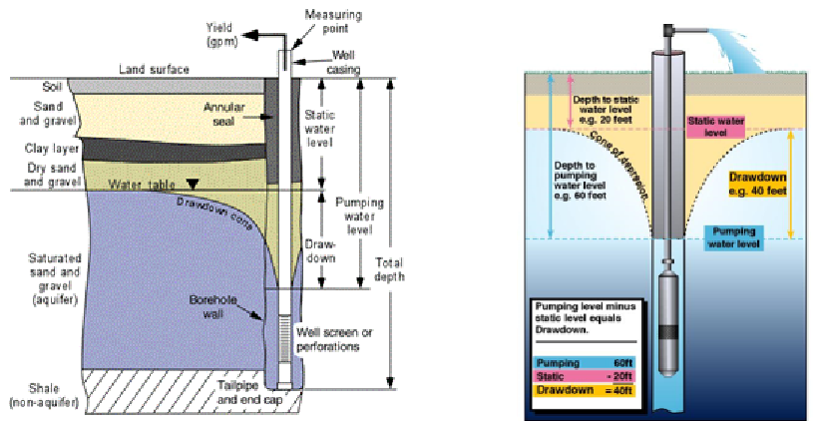

The amount of water a well will produce depends mainly on the type of aquifer, well construc-tion, and the depth of the zone of saturation. The annual recharge rate from percolation, along with the ability of the water bearing formation to transmit water to any given point, will also influence well production. The performance of a well can be determined by taking readings of the hydraulic conditions. An operator must be familiar with these terms and definitions*, in order to accurately troubleshoot problems that may be discovered.

Static level is the water level in a well when the pump is not operating.

Pumping level is the water level in the well when it is producing.

Drawdown is the difference in elevations between the static level and the pumping level. The amount of water produced is approximately proportional to the draw-down. For example, increas-ing the yield by 10% will increase the drawdown by 10%. The draw-down that occurs when a well is running is roughly equal to the head loss encountered in moving the water into the well. Water bearing formations of gravel, limestone and course sand will usually provide more water with less draw-down than formations containing fine sand or clay.

Specific capacity is the relationship between the yield of a well and the amount of drawdown in the well. It can be expressed as a ratio of the yield, in terms of gallons per minute, to the draw-down in feet. A well producing 100 gpm with a drawdown of 20 feet would have a specific capacity of 5 gpm per foot of draw-down. In this particular case every time the yield is increased by 5 gpm the drawdown will increase by one foot. This relationship will exist until the yield exceeds the aquifer’s ability to deliver water to any single point, When this limit is reached, the draw-down increases dramatically with little or no increase in the yield.

Cone of depression is directly related to the drawdown in the well. As the pump draws down the water level, a portion of the aquifer surrounding the well is drained of water. A cone shaped de-pression is formed in the water table around the well. The shape of the cone will vary depending

|  |  |
| --- | --- |
| 10.18 Sedimentation | 311 |
|  |  |

on the type of formation in which the well is located. A fine sand formation will usually cre-ate a steep cone of depression, while a shallow cone is usually found in coarse sand and gravel formations.

Radius of influence is the farthest distance from the well that the cone of depression affects the water table. This distance can be determined by sinking test holes around the well and monitor-ing the water levels in them while the well is pumping.

Recovery time is the amount of time required for the aquifer to stabilize at its static water level once pumping has stopped. This can also be determined by monitoring the water levels in the test holes used to determine the radius of influence.

* A well is drilled through an unconfined aquifer. The top of the aquifer is 80 feet below grade. After the well was in service for a year, the water level in the well stabilized at 110 feet below grade. What is the drawdown?

Drawdown = Static Level − Pumping Level = 80ft −110ft = 30feet

* A well produces 300 gpm. If the drawdown is 30 feet, find the specific yield.

|  |  |  |  |  |  |
| --- | --- | --- | --- | --- | --- |
| Specific Yield = | Yield | = | 300gpm | = 10gpm/ft |  |
| Drawdown |  |  |
|  |  | 30ft | |  |

* The specific yield for a well is 10gpm/ft. If the well produces 550gpm, what is the draw-down?

|  |  |  |  |  |  |  |  |  |
| --- | --- | --- | --- | --- | --- | --- | --- | --- |
| Specific Yield = | | Yield | = 10gpm/ft = | 550gpm | = Drawdown = | 550 | = |  |
|  |  |  |  |
| Drawdown | Drawdown | 10 |  |
| 55ft |  |  |  |  |  |  |  |  |

* The pumped water level of a well is 400 feet below the surface. The well produces 350 gpm. If the aquifer level is 250 feet below the surface, what is the specific yield for the well?

Drawdown = Static Level − Pumping Level = 400ft −350ft = 50feet

|  |  |  |  |  |  |
| --- | --- | --- | --- | --- | --- |
| Specific Yield = | Yield | = | 350gpm | = 7gpm/ft |  |
| Drawdown |  |  |
|  | 50 | |  |  |

10.18 Sedimentation

Sedimentation calculations include the following:

1. Tank Volume

For rectangular sedimentation basins use the following equation:

Volume, gal = Length, ft Width, ft Depth, ft 7.48gal/ft3 Example Problem:

* 1. A sedimentation basin is 25ft wide by 80ft long and contains water to a depth of 14ft. What is the volume of water in the basin, in gallons?

Volume, gal = Length, ft Width, ft Depth, ft 7.48gal/ft3 Volume, gal = 80ft 25ft 14ft 7.48gal/ft3

= Length, ft Width, ft Depth, ft 7.48gal/ft3 f low gal/hr

312 Chapter 10. Water Math

Volume, gal = 209, 440gal

For circular clarifiers, use the following equation:

Volume, gal = 0.785 ( Diameter )2 Depth, ft 7.48gal/ft3

Example Problem:

* 1. A clarifier has a diameter of 25ft and contains water to a depth of 18ft. What is the volume of water in the basin, in gallons?

Volume, gal = 0.785 ( Diameter )2 Depth, ft 7.48gal/ft3 Volume, gal = 0.785 (25ft)2 18ft 7.48gal/ft3 Volume, gal = 66, 058gal

1. Detention Time

Detention time is the length of time that water stays in the sedimentation tank is called the detention time. It is also the time it takes for a unit volume of water to pass entirely through the clarifier. Additionally, detention time is also the time it would take to fill an empty clarifier at a given flow rate.

|  |  |  |  |
| --- | --- | --- | --- |
| Clari f ier detention time (hr) = | Clari f ier volume(cu. f t | or gal) |  |
| In f luent f low (cu. f t or | gal)/hr) |  |
|  |  |

Rectangular clarifier volume = width * length * depth of water Circular clarifier volume = 0.785 * Diameter2 * depth of water

Typically volume is calculated in cu. ft and influent flow is given in gallons. Use 7.48 gal/ft3 conversion factor to convert volume in cu. ft to gallons.

* A sedimentation tank has a volume of 137,000 gal. if the flow to the tank is 121, 000gph, what is the detention time in the tank, in hours?

|  |  |  |  |  |  |  |
| --- | --- | --- | --- | --- | --- | --- |
|  | Volume of tank, gal |  | 137, 000gal |  |  |  |
| Detention time (hrs= | = | = | 1.1hr |  |
|  |  |  |
|  | Flow rate, gph |  | 121, 000gph | |  |  |
|  |  |  |  |

* A sedimentation basin is 60 ft long by 22 ft wide and has water to a depth of 10 ft. If the flow to the basin is 1, 500, 000gpd, what is the sedimentation basin detention time?

Detention time, hr = Volume of tank, gal

Flow rate, gph

7.48gal

60 f t 22 f t 10 f t

Detention Time = = 1.6 hrs 1, 500, 000gal day

day 24hours

* Surface Overflow Rate

The hydraulic or surface loading rate measures how rapidly water moves through the clari-fier. It is measured in terms of the number of gallons flowing each day through one square

|  |  |  |  |  |  |  |  |  |  |
| --- | --- | --- | --- | --- | --- | --- | --- | --- | --- |
| 10.19 Filtration |  |  |  |  |  |  | 313 | |  |
|  |  |  |  |  |  |  |  |  |  |
| foot surface area of the clarifier. |  |  |  |  |  |  |  |  |  |
| Clari f ier hydraulic loading |  | gpd | = | Clari f ier | | in f luent | f low(gpd) | |  |
|  |  |  |  |  |  |  |
| f t2 |  | Clari f ier | sur f ace | area( f t2) |  |

Rectangular clarifier surface area = width * length

Circular clarifier surface area = 0.785 * Diameter2

Example Problems:

* A circular clarifier has a diameter of 80ft. If the flow to the clarifier is 1800 gpm, what is the surface overflow rate in gpm/sq.ft ?

*Remember that the area of a circular clarifier can be determined by 0.785 (Diame-ter) 2

|  |  |  |  |  |  |  |  |
| --- | --- | --- | --- | --- | --- | --- | --- |
|  | Flow, gpm |  | 1800gpm |  |  |  |  |
| Surface overflow rate = | = |  | = | 0.36gpm/ft2 |  |
| 2 | 0.785 (80ft) | 2 |  |
|  | Area, ft | |  |  |  |  |
|  |  |  |  |  |

* A sedimentation basin 70ft by 25ft receives a flow of 1000gpm. What is the surface overflow rate in gpm/sq. ft ?

*Remember that the area of a rectangle can be found by length,ft x width, ft

|  |  |  |  |  |  |  |  |
| --- | --- | --- | --- | --- | --- | --- | --- |
|  | Flow, gpm |  |  | 1000gpm |  |  |  |
| Surface overflow rate = |  | = | = | 0.6gpm/ft2 |  |
| Area, ft2 | |  |  |
|  | 70ft 25ft | | |  |  |
|  |  |  |

* Weir Loading Rate (Overflow Rate) The weirs at the end of the clarifier allow for the even distribution of the the outlet flow across the entire length of the weir. An adequate length of weir is needed to ensure smooth and even flow of water over the weirs. Weir overflow rate measures the number of gallons of water per day (or per minute) flowing over one foot of weir.

gpd or gpm

Weir over f low rate

f t

clarifier weir length = 3.14 * Diameter Example Problem:

|  |  |  |  |  |
| --- | --- | --- | --- | --- |
| = | Clari f ier in f luent | f low(gpd) | Circular |  |
| Total e f f luent weir | length ( f t) |  |

1. A circular clarifier receives a flow of 3.55 MGD. If the diameter of the weir is 90ft, what is the weir loading rate in gpm/sq. ft ?

|  |  |  |  |  |  |  |  |  |  |  |  |  |  |  |  |  |  |  |  |
| --- | --- | --- | --- | --- | --- | --- | --- | --- | --- | --- | --- | --- | --- | --- | --- | --- | --- | --- | --- |
| Weir over | | | | |  | f low rate | gpd or gpm | | | |  | = | Clari f ier in f luent | | | f low(gpd) | |  |  |
|  |  |  |  |  |  |  |  |  |  |  |
|  |  |  | f t | Total e f f luent weir | | | length ( f t) | |  |
|  | 3.55MG | | |  | 1, 000, 000gal | | | |  | day | = 2, 465gpm | | | |  |  |  |  |  |
|  |  |  |  |  |  |  |  |  |  |  |  |  |  |
|  |  | day | |  | MG |  |  | 1440min |  |  |  |  |
|  |  |  |  |  | 8.7gpm/ f t |  |  |  |  |
|  |  |  |  |  |  |  |  |  |  |  |  |  |  | = |  |  |  |  |
|  |  |  |  |  |  | 3.14 90 f t | | | | |  |  |  |  |  |  |  |
|  |  |  |  |  |  |  |  |  |  |  |  |  |  |  |
|  |  |  |  |  |  |  |  |  |  |  |  |  |  |  |

10.19 Filtration

* Filter Flow Rates – the flow rate expressed in gpm can be calculated from the total flow over certain time or vice-versa can be used for determining either the time it would take to process a certain flow or calculate the total flow.

Example Problems:

* 1. A filter box is 20 ft by 30 ft (including the sand area). If the influent valve is shut, the

|  |  |  |  |  |  |  |  |  |  |  |  |  |  |  |  |  |  |  |  |  |  |
| --- | --- | --- | --- | --- | --- | --- | --- | --- | --- | --- | --- | --- | --- | --- | --- | --- | --- | --- | --- | --- | --- |
| 314 |  |  |  |  |  |  |  |  |  |  |  |  | Chapter 10. Water Math | | | | | | | |  |
|  |  |  |  |  | |  | |  | | |  | | |  |  |  |  |  |  |  |  |
| water drops 3 inches per minute. What is the rate of filtration in MGD? | | | | | | | | | | | | | | |  |  |  |  |  |  |  |
| Solution: | | | | |  |  |  |  |  |  |  |  |  |  |  |  |  |  |  |  |  |
| Water passing through the filter - Rate of Filtration (ft3/min) = 600 f t2 | | | | | | | | | | | | | | | 3in | |  | f t | |  |  |
|  |  |  | |  | = |  |
| min | 12in | | |  |
|  |  | 150 f t3 |  | |  |  |  |  |  |  |  |  |  |  |  |  |  |  |  |  |  |
|  |  | min | | |  |  |  |  |  |  |  |  |  |  |  |  |  |  |  |  |  |
|  |  |  |  |  | 150 f t | | 3 |  | 7.48gal | | |  | MG | |  |  |  |  | |  |  |
|  |  |  |  |  |  |  |  | 1440min | | | | |  |  |
|  |  | = Rate o f Filtration(MGD) = | | |  |  |  |  |  | |  |  |  |  |  |  |  |  | = | |  |
|  |  |  | min |  | f t | 3 |  | 1, 000, 000gal | day | | |  |  |
|  |  |  |  |  |  |  |  |  |  |  |  |  |  |  |  |  |  |  |  |  |
|  |  | 1.62MGD | |  |  |  |  |  |  |  |  |  |  |  |  |  |  |  |  |  |  |

2. The flow rate through a filter is 4.25 MGD. What is this flow rate expressed as gpm?

Flow rate, gpd

Flowrate, gpm =

Note: We are assuming that the filter operated uniformly over that 24 hour period.

|  |  |  |  |  |  |  |  |  |  |  |  |  |  |  |
| --- | --- | --- | --- | --- | --- | --- | --- | --- | --- | --- | --- | --- | --- | --- |
|  |  |  | | |  |  |  |  |  | gal | |  |  |  |
| 4.25 | | MG | | | 1, 000, 000 | | | |  |  |  |  |
|  |  |  |  |  |  | |  |  |
| day | | |  |
| Flowrate, gpm = |  |  |  |  |  | MG | | | = | 2, 951 gpm |  |
|  | 1440 | | | |  | min | |  |  |  |  |
|  |  |  |  |  |  |  |  |  |
|  |  |  |  |  |  |  |  |  |
|  |  |  |  |  |  |  |  |  |  |  |
|  |  |  |  |  |  | day | | |  |  |  |  |  |  |

1. At an average flow rate of 4000 gpm, how long of a filter run, in hours, would be required to produce 25 MG of filtered water?

|  |  |  |  |  |  |  |  |  |  |  |  |  |
| --- | --- | --- | --- | --- | --- | --- | --- | --- | --- | --- | --- | --- |
| Flow rate (gpm) = | | Total f low (gal) | | | | | |  |  |  |  |  |
|  |  |  |  |  |  |  |  |  |  |  |
|  |  | (min) | | | |  |  |  |  |  |
|  | Filter run time | | |  |  |  |  |  |
| = Filter run time (min) = | | | Total | f low | | | | (gal) | |  |  |  |
|  | | |  | | |  |  |  |  |
| Flow rate (gpm) | | | | | |  |  |  |
|  |  |  |  |  | 1, 000, 000 gal | | | | | | |  |
| = Filter run time (hr) = 25 MG | | | | |  |  |  |  | |  |  |  |
|  |  |  | MG | |  |  |
| 104 hrs |  | | |  |  |  |  |  |  |  |  |  |

|  |  |  |  |  |  |  |  |  |
| --- | --- | --- | --- | --- | --- | --- | --- | --- |
|  | |  |  |  | hr | |  |  |
|  | min | | 60 |  | = |  |
|  | 4, 000 gal |  |  | min |  |  |
|  | |  |  |  |  |  |  |  |

1. Filtration Rates – It is the gallons of water filtered per minute through each square foot of

filter area. It generally ranging from 2 to 10gpm/ft2. Filtration rate is determined by the following equation:

|  |  |  |  |
| --- | --- | --- | --- |
| Filtration rate, gpm/ft2 | = | Flow rate, gpm |  |
| Filter surface area, ft2 |  |
|  |  |  |
| Example Problems: |  |  |  |

1. A filter 28ft long by 18ft wide treats a flow of 3.5MGD. What is the filtration rate in gpm/ft 2 ?

Approach: The flow will need to be converted to gpm and the surface area calculated

in feet.

|  |  |  |  |  |  |  |  |  |  |  |  |  |  |
| --- | --- | --- | --- | --- | --- | --- | --- | --- | --- | --- | --- | --- | --- |
|  |  | | | | 1, 000, 000 | | gal |  | |  |  |  |  |
|  |  |  | 3.5 MG |  |  | day |  |  |  |  |
|  |  |  | day | |  |  |  | 1440min | | |  |  |  |
|  |  |  |  | MG |  |  |  |  |
| Filtration rate, gpm/ft2 | = |  | |  |  |  |  |  |  |  | = | 4.8 gpm/ f t2 |  |
|  | |  | 28 f t 18 | | f eet |  |  |  |  |
|  |  |  |  |  |  |  |  |  |  |  |

* A filter is 40ft long by 20ft wide. During a test of flow rate, the influent valve to the filter is closed for 6 minutes. The water level drop during this period is 16 inches.

!

gpm/ft2 12in/ft

Backwash rate, gpm/ft2 12in/ft 7.48gal/ft3

|  |  |
| --- | --- |
| 10.19 Filtration | 315 |
|  |  |

What is the filtration rate for the filter in gpm/ft2 ?

Note: The volume of the water dropped after the inlet valve was closed would be the filter flow rate. Since the dimensions to calculate are in feet and inches, the volume needs to be converted from ft3 to gallons

|  |  |  |  |  |  |  |  |  |  |
| --- | --- | --- | --- | --- | --- | --- | --- | --- | --- |
| (40ft 20ft 16in | | f t | | ) f t3 7.48 | gal | | | |  |
|  |  |  |  |  |  |  |
| 12 | in | f t3 | | |  |  |
| Filtration rate, gpm/ft2 = |  |  |  |  |  |  | = | 1.7 gpm/ f t2 |  |
| 40 f t 20 | | f eet | |  |  |  |
|  |  |  |  |  |  |

* Backwashing Rates - is the amount of water, in gallons, required for each backwash. This is analogous to the Filter Flow Rate.

Example Problem:

* 1. A filter has the following dimensions: 30ft long by 20ft wide with a depth of 24

inches of filter media. Assuming that a backwash rate of 15gal/ft2/min is recom-mended and 10 minutes of backwash is required, calculate the amount of water, in gallons, required for each backwash.

The backwashing rate given in gal/ f t2/min will need to be converted into gallons by multiplying it with the area (to eliminate f t2 and by the backwash time in minutes

|  |  |  |  |  |  |  |  |  |  |  |  |
| --- | --- | --- | --- | --- | --- | --- | --- | --- | --- | --- | --- |
|  |  |  | gal | |  | 2 |  |  |  |  |  |
| Backwashing rate (gal) = 15 |  |  | (30ft 20ft) f t | 10 |  | 90, 000 gal |  |
|  | 2 |  |  |  | min | = |  |
|  | f t |  | −min | |  |  |  |  |  |  |  |
|  |  |  |  |  |  |  |  |  |

* Backwash Rinse Rates - it is the upward velocity of the water during backwashing, ex-

pressed as in/min rise. To convert from gpm/ft2 backwash rate to an in/min rise rate, use either of the following equations:

Backwash rinse rate, in/min =

Example Problems:

* A filter 22ft long by 12ft wide has a backwash rate of 3260gpm. What is this back-wash rate expressed as a in/min rise?

Backwash rate, gpm/ft2 12in/ft

Backwash rinse rate, in/min =

7.48gal/ft3

Based upon the above formula, the Backwash tate in gpm/ f t2 needs to be calculated by dividing the gpm flow by the surface area

3260gpm 22ft 12ft

|  |  |  |  |  |
| --- | --- | --- | --- | --- |
| Backwash Rinse Rate, in/min = |  | = 19.7in/min | |  |
| 7.48gal/ft3 |  |
|  |  |  |  |

* Percent Product Water Used for Backwashing - the equation for percent of product water used for backwashing calculations used is:
* A total of 11, 400, 000 gal of water was filtered during a filter run. If backwashing used 48,500 gal of this product water, what percent of the product water is used for

|  |  |  |  |  |  |  |
| --- | --- | --- | --- | --- | --- | --- |
| 316 |  |  |  |  | Chapter 10. Water Math |  |
|  |  |  |  |  |  |  |
| backwashing? |  |  |  |  |  |  |
|  |  | 48, 500 gal |  |  |  |  |
| Backwash water, % = |  | 100 = | 0.43% |  |  |
|  | |  |  |
|  | 11, 400, 000 gal |  |
|  |  |  |  |  |



Chapter Assessment

Practice Problems - Fractions

* Convert 22 1 into a fraction 4
* Express 10ft, 6in into fraction
* Express 10ft, 6in into decimal

Practice Problems - Decimals and Powers of Ten

1. Write the equivalent of 10,000,000 as a power of ten

2. Find the product of 3.4564 102

3. Find the product of 534.567 10−2

4. Find the value of 165.93

10−2

5. Find the value of 0.023 104

Practice Problems - Rounding and Significant Digits

Round the following to the nearest hundredths (the second place after the decimal).

1. 2.4568
2. 27.2534
3. 128.2111

318 Chapter 10. Water Math

* 364.8762
* 354.777777
* 34.666666
* 67.33333

Round the following to the nearest tenths (the first place after the decimal).

1. 2.4568
2. 27.2534
3. 128.2111
4. 364.8762
5. 354.777777
6. 34.666666
7. 67.33333

Round the following answers off to the most significant digit.

|  |  |  |  |  |  |  |
| --- | --- | --- | --- | --- | --- | --- |
|  | Problem | |  | Accurate Answer | |  |
|  |  | |  |  |  |  |
| A. | 25.1 + 26.43 | |  |  |  |  |
|  |  | |  |  |  |  |
| B. | 128.456 −121.4 | |  |  |  |  |
| C. | 85 −7.924328 | |  |  |  |  |
| D. | 8.564 | + 5 |  |  |  |  |
|  |  | |  |  |  |  |
|  |  | | |  |  | |
|  | Problem | | |  | Accurate Answer | |
|  |  |  | |  |  |  |
| A. | 26.34 | ×124.34567 | |  |  |  |
| B. | 23.58 | ×34.251 |  |  |  |  |
| C. | 12, 453/13.9 | |  |  |  |  |
|  |  | |  |  |  |  |
| D. | 12, 457.92 ×3 | |  |  |  |  |

Practice Problems - Totalizing and Averages

1. Find the average of the following set of numbers: 0.2

0.2

0.1

0.3

0.2

0.4

0.6

0.1

0.3

|  |  |
| --- | --- |
| 10.19 Filtration | 319 |
|  |  |

* The chemical used for each day during a week is given below. Based on these data, what was the average lb/day chemical used during the week?

|  |  |
| --- | --- |
| Monday | 92 lb/day |
|  |  |
| Tuesday | 93 lb/day |
|  |  |
| Wednesday | 98 lb/day |
|  |  |
| Thursday | 93 lb/day |
|  |  |
| Friday | 89 lb/day |
|  |  |
| Saturday | 93 lb/day |
|  |  |
| Sunday | 97 lb/day |
|  |  |

1. The average chemical use at a plant is 77 lb/day. If the chemical inventory is 2800 lbs, how many days supply is this?
2. A well pumped for 45 days. The beginning gallon meter reading was 7,456,400 and 45 days later the same meter was 15,154,400. What was the average flow in gallons per day?

Practice Problems - Percentage

1. 25% of the chlorine in a 30-gallon vat has been used. How many gallons are remaining in the vat?
2. The annual public works budget is $147, 450. If 75% of the budget should be spent by the end of September, how many dollars are to be spent? How many dollars will be remain-ing?
3. A 75 pound container of calcium hypochlorite has a purity of 67%. What is the actual weight of the calcium hypochlorite in the container?
4. 3/4 is the same as what percentage?
5. A 2% chlorine solution is what concentration in mg/L ?
6. A water plant produces 84,000 gallons per day. 7,560 gallons are used to backwash the filter. What percentage of water is used to backwash?
7. The average day winter demand of a community is 14,500 gallons. If the summer demand is estimated to be 72% greater than the winter, what is the estimated summer demand? Demand - When related to use, the amount of water used in a period of time. The term is in reference to the "demand" put onto the system to meet the need of customers.
8. The master meter for a system shows a monthly total of 700,000 gallons. Of the total wa-ter, 600,000 gallons were used for billing. Another 30,000 gallons were used for flushing. On top of that, 15,000 gallons were used in a fire episode and an estimated 20,000 gallons were lost to a main break that was repaired that same day. What is the total unaccounted for water loss percentage for the month?
9. Your water system takes 75 coliform tests per month. This month there were 6 positive samples. What is the percentage of samples which tested positive?

320 Chapter 10. Water Math

Practice Problems - Ratio and Proportion

* It takes 6 gallons of chlorine solution to obtain a proper residual when the flow is 45,000 gpd. How many gallons will it take when the flow is 62,000 gpd?
* A motor is rated at 41 amps average draw per leg at 30Hp. What is the actual Hp when the draw is 36 amps? C.
* If it takes 2 operators 4.5 days to clean an aeration basin, how long will it take three opera-tors to do the same job?
* It takes 3 hours to clean 400 feet of collection system using a sewer ball. How long will it take to clean 250 feet?
* It takes 14 cups of HTH to make a 12% solution, and each cup holds 300 grams. How many cups will it take to make a 5% solution?
* A bike travelling at 5 miles/hr completes a journey in 40 minutes. How long would the same journey take if the speed was increased to 8 miles/hr?
* Water is flowing at a velocity of 1.3ft/sec in a 4.0 -in. diameter pipe. If the pipe changes from the 4.0-inch to a 3.0-in. pipe, what will the velocity be in the 3.0-in. pipe?

Practice Problems - Area and Volume

* A 60-foot diameter tank contains 422,000 gallons of water. Calculate the height of water in the storage tank.
* What is the volume of water in ft3, of a sedimentation basin that is 22 feet long, and 15 feet wide, and filled to 10 feet?
* What is the volume in ft3 of an elevated clear well that is 17.5 feet in diameter, and filled to 14 feet?
* What is the area of the top of a storage tank that is 75 feet in diameter?
* What is the area of a wall 175ft. in length and 20ft. wide?
* You are tasked with filling an area with rock near some of your equipment. 1 Bag of rock covers 250 square feet. The area that needs rock cover is 400 feet in length and 30 feet wide. How many bags do you need to purchase?
* How many gallons of paint will be required to paint the walls of a 40 ft long x 65 ft wide x 20 ft high tank if the paint coverage is 150 sq. ft per gallon. Note: We are painting walls only. Disregard the floor and roof areas.
* A new 24" diameter pipe is to be installed with a pipe depth, to top of pipe, of 48" and a length of 12,000 feet The trench will be backfilled with sand. The trench walls will be excavated one foot wider than the pipe on each side and six inches below the pipe. How much excavated material must be hauled away?
* A chemical feed pump with a 6-inch bore and a 6-inch stroke pumps 60 cycles per minute. Find the pumping rate in gpm.

|  |  |
| --- | --- |
| 10.19 Filtration | 321 |
|  |  |

Practice Problems - Flow and Velocity

* Flow in an 8-inch pipe is 500 gpm. What is the average velocity in ft/sec? (Assume pipe is flowing full)
* A pipeline is 18” in diameter and flowing at a velocity of 125 ft. per minute. What is the flow in gallons per minute?
* The velocity in a pipeline is 2 ft./sec. and the flow is 3,000 gpm. What is the diameter of the pipe in inches?
* Find the flow in a 4-inch pipe when the velocity is 1.5 feet per second.
* A 42-inch diameter pipe transfers 35 cubic feet of water per second. Find the velocity in ft/sec.
* A plastic float is dropped into a channel and is found to travel 10 feet in 4.2 seconds. The channel is 2.4 feet wide and 1.8 feet deep. Calculate the flow rate of water in cfs.
* A channel is 3.25 feet wide and is conveying a a flow of 3.5 MGD. The depth of the water is 8 inches. Calculate the velocity of this flow.

Practice Problems - Unit Conversions

Convert the following:

1. Convert 1000 f t3 to cu. yards
2. Convert 10 gallons/min to f t3/hr
3. Convert 100,000 f t3 to acre-ft.
4. Find the flow in gpm when the total flow for the day is 65,000 gpd.
5. Find the flow in gpm when the flow is 1.3cfs.
6. Find the flow in gpm when the flow is 0.25cfs.
7. The flow rate through a filter is 4.25 MGD. What is this flow rate expressed as gpm?
8. After calibrating a chemical feed pump, you’ve determined that the maximum feed rate is 178 mL/ minute. If this pump ran continuously, how many gallons will it pump in a full day?
9. A plant produces 2,000 cubic foot of water per hour. How many gallons of water is pro-duced in an 8-hour shift?
10. Change 70 °F to °C
11. Change 4 °C to °F

Practice Problems - Concentration

1. How many lbs of salt needs to be dissolved in water to make 1 liter of 5% salt solution?
2. What is the concentration in mg/l of 4.5% solution of that substance.
3. An operator mixes 40 lb of lime in a 100-gal tank containing 80 gal of water. What is the percent of lime in the slurry?

322 Chapter 10. Water Math

1. An operator mixes 40 lb of lime in a 100-gal tank containing 80 gal of water. What is the percent of lime in the slurry? Solution:

|  |  |  |  |  |  |  |  |  |  |  |  |  |  |
| --- | --- | --- | --- | --- | --- | --- | --- | --- | --- | --- | --- | --- | --- |
| 40 | lbs | lime |  |  |  | 1 | , 000, 000 lbs | ! | % | |  | = |  |
|  |  |  |  |  |  |  |  |  |
| 80 gal water 8.34 |  | lbs | + 40 lbs |  |  | million lbs |  | 10, 000 ppm |  |  |
|  |  | lime | | |  |  |  |  |  |  |  |
| gal | water |  |  |  |  |  |  |  |

5.7%

Practice Problems - Density and Specific Gravity

* What is the specific gravity of a 1 ft3 concrete block which weighs 145 lbs?
* What is the specific gravity of a chlorine solution if 1 (one) gallon weighs 10.2lbs?
* How much does each gallon of zinc orthophosphate weigh (pounds) if it has a specific gravity of 1.46?
* How much does a 55 gallon drum of 25% caustic soda weigh (pounds) if the specific gravity is 1.28?

Practice Problems - Pounds Formula

* A water treatment plant operates at the rate of 75 gallons per minute. They dose soda ash at 14 mg/L. How many pounds of soda ash will they use in a day?

Practice Problems - Chemical Dosing

* In order to disinfect a sedimentation basin measuring 20ft in width, 60 feet in length, and is 10 feet deep to obtain 50ppm would require how many lbs. of 65% available HTH ?
* Determine the chlorinator setting (lb/day) required to treat a flow of 4MGD with a chlorine dose of 5mg/L.
* A pipeline that is 12 inches in diameter and 1400ft long is to be treated with a chlorine dose of 48mg/L. How many lb of chlorine will this require?
* What should the chlorinator seting be (lb/day) to treat a flow of 2.35MGD if the chlorine demand is 3.2mg/L and a chlorine residual of 0.9mg/L is desired?
* A water treatment plant operates at the rate of 75 gallons per minute. They dose soda ash at 14 mg/L. How many pounds of soda ash will they use in a day?
* A water treatment plant is producing 1.5 million gallons per day of potable water, and uses 38 pounds of soda ash for pH adjustment. What is the dose of soda ash at that plant?
* A water treatment plant produces 150,000 gallons of water every day. It uses an average of 2 pounds of permanganate for iron and manganese removal. What is the dose of the permanganate?
* A water treatment plant uses 8 pounds of chlorine daily and the dose is 17 mg/l. How many gallons are they producing?

|  |  |
| --- | --- |
| 10.19 Filtration | 323 |
|  |  |

Practice Problems - Blending and Dilution

1. Ferric chloride is being added as a coagulant to the raw water entering a plant. Sampling shows that the concentration of ferric in the raw water is 25 ppm. A quick check of the chemical metering pump shows that it is operating at a flow rate of 4.3 gpm. If the flow through the water plant is 800 gpm, what is the concentration of raw chemical in the dos-ing tank?
2. A water plant is fed by two different wells. The first well produces water at a rate of 600 gpm and contains arsenic at 0.5 mg/L. The second well produces water at a rate of 350 gpm and contains arsenic at 12.5 mg/L. What is the arsenic concentration of the blended water?

Practice Problems - Pumping Rates

1. How long will it take (hrs) to fill a 2 ac-ft pond if the pumping rate is 400 GPM?
2. A pump is set to pump 5 minutes each hour. It pumps at the rate of 35 gpm. How many gallons of water are pumped each day?
3. A pump operates 5 minutes each 15 minute interval. If the pump capacity is 60 gpm, how many gallons are pumped daily?
4. Given the tank is 10ft wide, 12 ft long and 18 ft deep tank including 2 ft of freeboard when filled to capacity. How much time (minutes) will be required to pump down this tank to a depth of 2 ft when the tank is at maximum capacity using a 600 GPM pump

Practice Problems - Pressure, Force and Head Relationship

* A 42-inch main line has a shut off valve. The same line has a 10-inch bypass line with another shut-off valve. Find the amount of force on each valve if the water pressure in the line is 80 psi. Express your answer in tons.
* A water tank is 15 feet deep and 30 feet in diameter. What is the force exerted on a 6-inch valve at the bottom of the tank?
* A water tank is filled to depth of 22 feet. What is the psi at the bottom of the tank?
* The static pressure in a water main is 85 psi. What elevation of water is needed to provide that kind of pressure?
* The pressure at the top of the hill is 62 psi. The pressure at the bottom of the hill, 60 feet below, is 100 psi. The water is flowing uphill at 120 gpm. What is the friction loss, in feet, in the pipe?

324 Chapter 10. Water Math

Practice Problems - Pumping Power Requirements

* If a pump is operating at 2,200 gpm and 60 feet of head, what is the water horsepower? If the pump efficiency is 71%, what is the brake horsepower?
* The water horsepower of a pump is 10Hp and the brake horsepower output of the motor is 15.4Hp. What is the efficiency of the pump?
* The water horsepower of a pump is 25Hp and the brake horsepower output of the motor is 48Hp. What is the efficiency of the pump?
* The efficiency of a well pump is determined to be 75%. The efficiency of the motor is estimated at 94%. What is the efficiency of the well?
* If a motor is 85% efficient and the output of the motor is determined to be 10 BHp, what is the electrical horsepower requirement of the motor?
* The water horsepower of a well with a submersible pump has been calculated at 8.2 WHp. The Output of the electric motor is measured as 10.3BHp. What is the efficiency of the pump?
* Water is being pumped from a reservoir to a storage tank on a hill. The elevation difference between water levels is 1200 feet. Find the pump size required to fill the tank at a rate of 120 gpm. Express your answer in horsepower.
* A 25hp pump is used to dewater a lake. If the pump runs for 8 hours a day for 7 days a week, how much will it cost to run the pump for one week? Assume energy costs $0.07 per kilowatt hour.
* A pump station is used to lift water 50 feet above the pump station to a storage tank. The pump rate is 500gpm. If the pump has an efficiency of 85% and the motor has an effi-ciency of 90%, find each of the following: Water Horsepower, Brake Horsepower, Motor Horsepower, and Wire-to-Water Efficiency.
* Find the brake horsepower for a pump given the following information: Total Dynamic Head = 75 feet, Pump Rate = 150 gpm, Pump Efficiency = 90%, Motor Efficiency = 85%
* Water is being pumped from a reservoir to a storage tank on a hill. The elevation difference between water levels is 1200 feet. Find the pump size required to fill the tank at a rate of 120 gpm. Express your answer in horsepower.

Practice Problems - Well Hydraulics

* A well yields 2,840 gallons in exactly 20 minutes. What is the well yield in gpm?
* Before pumping, the water level in a well is 15 ft. down. During pumping, the water level is 45 ft. down. The drawdown is:
* A well produces 365 gpm with a drawdown of 22.5 ft. What is the specific yield in gallons per minute per foot?
* A well is located in an aquifer with a water table elevation 20 feet below the ground sur-face. After operating for three hours, the water level in the well stabilizes at 50 feet below the ground surface. The pumping water level is:

|  |  |
| --- | --- |
| 10.19 Filtration | 325 |
|  |  |

1. Calculate drawdown, in feet, using the following data:

The water level in a well is 20 feet below the ground surface when the pump is not in operation, and the water level is 35 feet below the ground surface when the pump is in operation.

1. Calculate the well yield in gpm, given a drawdown of 14.1 ft and a specific yield of 31 gpm/ft.

Practice Problems - Sedimentation

* Calculate the detention time for a sedimentation tank that is 48 feet wide, 210 feet long and 9 feet deep with a flow of 5 MGD.
* At a 2.5 MGD wastewater treatment plant the primary clarifier has a detention time of 2 hours. How many gallons does this clarifier hold?
* A circular clarifier has a diameter of 80 ft. If the flow to the clarifier is 1800 gpm, what is the surface overflow rate in gpm/ft
* A sedimentation basin 70 ft by 25 ft receives a flow of 1000 gpm. What is the surface overflow rate in gpm/ft2?
* A circular clarifier receives a flow of 3.55 MGD. If the diameter of the weir is 90 ft, what is the weir loading rate in gpm/ft?

Practice Problems - Filtration

* At an average flow of 4,000 gpm, how long of a filter run in hours would be required to produce 25 MG of filtered water?
* A filter is 40ft long by 20ft wide. During a test of flow rate, the influent valve to the filter

is closed for 6 minutes. The water level drop during this period is 16 inches. What is the filtration rate for the filter in gpm/ft2 ?

* A water treatment plant treats 6.0 MGD with four filters. Each filter use 60,000 gallons per wash. What is the percent backwash at the plant?
* A treatment plant filter washes at a rate of 10,000 GPM. The filter measures 18ft. wide by 24ft. long. What is the rate of rise expressed in inches per minute?
* If a filter measures 20 feet by 30 feet by 7 foot deep and the backwash flow is 3.5cuft/sec, what is the backwash rate?

XI Chapter Assessment Solutions

11 Assessments Solutions . . . . . . . . . . . . . . 329

11.1 Chapter 2 - Properties and Sources

11.2 Chapter 3 - Water Quality and Laboratory Proce-

dures

11.3 Chapter 4 - Regulations

11.4 Chapter 5 - Treatment

11.5 Chapter 6 - Disinfection

11.6 Chapter 7 - Pumping

11.7 Chapter 8 - Distribution

11.8 Chapter 9 - Safety

11.9 Chapter 10 - Math



11. Assessments Solutions

11.1 Chapter 2 - Properties and Sources

1. Groundwaters generally have consistent water quality that include *a. having a higher total dissolved solids content than surface water
   1. having a lower mineral content than surface waters
   2. having lower pH values than surface waters
   3. having a higher amount of bacteria than surface waters
2. When underground water is under pressure greater than atmospheric pressure and could rise above the its confining space and above the ground level is referred to as a(n)
   1. aquifer
   2. anaerobic condition

*c. artesian effect

* 1. drawdown
  2. pressure gradient
* The gradual flow or movement of water into and through the pores of the soil is called *a. percolation
  1. run-off
  2. precipitation
  3. impermeable flow
  4. evapotranspiration
* Water that has been used to carry solids away from a home or office into a treatment facil-ity is referred to as

*a. wastewater or sewage

330 Chapter 11. Assessments Solutions

* 1. potable
  2. seawater intrusion injection water
  3. riparian water
* The water right to put it to beneficial use of the surface water adjacent to your land is called water.
  1. wastewater

*b. riparian

c. filter ripening

* + infiltration
  + run-off
* The difference between static level and pumping level in a well is called: *a. drawdown.
  + cone of depression
  + zone of saturation
  + radius of influence
* Which one of the following best defines the term aquifer?
  1. A low lying area where water pools

*b. Water-bearing stratum of rock, sand, or gravel

c. Impervious stratum near the ground surface

d. Treated water leaving the water system

1. The height to which water will rise in wells located in an artesian aquifer is called the
   1. Pumping water level
   2. Water table

*c. Piezometric surface

* 1. Drawdown
  2. Radius of influence

1. What percentage of all the earth’s water is readily available as a potential drinking water supply in the form of lakes, rivers, and near-surface groundwater?
   1. 97
   2. 50
   3. 2
   4. 1

*e. 0.34

1. To prevent the entry of surface contamination into a well is the purpose of
   1. The well casing
   2. The water table
   3. The louvers or slots
   4. Well development

*e. The annular grout seal

11. An aquifer that is located underneath an aquiclude is called

|  |  |
| --- | --- |
| 11.1 Chapter 2 - Properties and Sources | 331 |
|  |  |

a. An unconfined aquifer

*b. A confined aquifer

c. A water table

d. Unreachable groundwater

e. An Artesian spring

1. The process by which water changes from the gas to the liquid phase is termed *a. Condensation ·
   1. Evaporation
   2. Percolation
   3. Precipitation
   4. Runoff
2. The free surface of the water in an unconfined aquifer is known as the
   1. Pumping water level
   2. Artesian spring

*c. Water table

* + 1. Drawdown
    2. Percolation

1. The transfer of liquid water from plants and animals on the surface of the earth into water vapor in the atmosphere is called

* a. Transpiration

* + 1. Evaporation
    2. Condensation
    3. Runoff
    4. Percolation

1. The elevation of water in the casing of an operating well is called the
   * 1. Piezometric surface
     2. Water table

*c. Pumping water level

* 1. Drawdown
  2. Radius of influence

1. An aquifer under pressure is often termed
   1. Unconfined
   2. Pacific

*c. Artesian

* 1. Alluvial
  2. Elevated

1. An aquifer is usually composed of *a. Sand and gravel
   1. Clays and silts
   2. Bedrock

332 Chapter 11. Assessments Solutions

d. Large voids in the soil, resembling underground lakes e. None of the above

1. Which of the following best defines the term specific capacity?
   1. Amount of water a given volume of saturated rock or sediment will yield to gravity
   2. Amount of water a given volume of saturated rock or sediment will yield to pumping
   3. Rate at which water would flow in an aquifer if the aquifer were an open conduit

*d. Amount of water a well will produce for each foot of drawdown

1. The most common type of well used for public water supply systems is a a. Jetted well

*b. Driven well

c. Drilled well

d. Bored well

1. An aquifer that is underneath a layer of low permeability is known as *a. Confined aquifer
   1. Water Table aquifer
   2. Unconfined aquifer
   3. Unreachable groundwater
2. What is the middle layer of a stratified lake known as?
   1. Hypolimnion
   2. Benthic Zone

*c. Thermocline

* 1. Epilimnion

1. The amount of water that can be pulled from a aquifer without depleting
   1. Drawdown

*b. Safe yield

1. Overdraft
2. Subsidence

|  |  |
| --- | --- |
| 11.2 Chapter 3 - Water Quality and Laboratory Procedures | 333 |
|  |  |

11.2 Chapter 3 - Water Quality and Laboratory Procedures

1. Hard water contains an abundance of
   1. sodium
   2. iron
   3. lead

*d. calcium carbonate

1. A specific class of bacteria that only inhibit the intestines of warm-blooded animals is referred to as?
   1. Eutrophic
   2. Grazing
   3. Salmonella

*d. Fecal coliform

* 1. pathogenic

1. Water with a pH of 8.0 is considered to be
   1. acidic

*b. basic or alkaline

* 1. neutral
  2. undrinkable

1. Over which water quality indicator do operators have the greatest control?
   1. alkalinity
   2. pH
   3. temperature

*d. turbidity

1. Which piece of laboratory equipment is used to titrate a chemical reagent? a. graduated cylinder

*b. burette

* 1. pipet
  2. Buchner funnel

1. Which pH range is generally accepted as most palatable (drinkable)? *a. 6.5 to 8.5
   1. 4.5 to 6.5
   2. 8.5 to 9.5
   3. 9.5 and above
   4. all of the above
2. Which of the following conditions is favorable for the rapid growth of algae? *a. plant nutrients
   1. high pH and water hardness
   2. low temperatures and low dissolved oxygen
   3. high alkalinity and water hardness

334 Chapter 11. Assessments Solutions

1. Which of the following is the name given for a turbidity meter that has reflected or scat-tered light off suspended particles as a measurement?
   1. Hach colorimeter
   2. spectrophotometer
   3. Wheaton bridge

*d. Nephelometer

1. Water hardness is the measure of the concentrations of and dissolved in the water sample.
   1. iron, manganese
   2. nitrates, nitrites
   3. sulfates, bicarbonates

*d. calcium & magnesium carbonates

e. ferric chlorides and polymers

1. The electrical potential required to transfer electrons from one compound or element to another is commonly referred to as

*a. oxidation-reduction potential (ORP)

* 1. voltage potential (OHM/P)
  2. resistance-impedance potential
  3. microMho differential

1. Water has physical, chemical, and biological characteristics. Which of the following is a physical characteristic?
   1. Coliform

*b. Turbidity

* 1. Hardness
  2. All the above

1. Tastes and odors in surface water are most often caused by:
   1. clays
   2. hardness

*c. algae

d. coliform bacteria

1. Which of the following elements cause hardness in water? a. sodium and potassium

*b. calcium and magnesium

c. iron and manganese

d. turbidity and suspended solids

1. When measuring for free chlorine residual, which method is the quickest and simplest? *a. DPD color comparator
   1. Orthotolidine method
   2. Amperometric titration
   3. 1, 2 nitrotoluene di-amine method

|  |  |
| --- | --- |
| 11.3 Chapter 4 - Regulations | 335 |
|  |  |

11.3 Chapter 4 - Regulations

1. Primary drinking water standards are set to protect the public from illnesses as a direct result in drinking water that exceeds maximum set levels. Secondary standards were set to alert the public to
   1. the incidences of local cancer numbers
   2. dissolved solids in water
   3. immediate health concerns
   4. radiological conditions concerning drinking water

*e. aesthetic issues with drinking water

1. A positive fecal coliform test must be reported to the primacy agency within
   1. 8 hours.
   2. 12 hours.

*c. 24 hours.

d. 48 hours.

1. Which agency sets legal limits on the concentration levels of harmful contaminants in potable water distributed to customers?

a. National Primary Drinking Water Regulations

*b. United States Environmental Protection Agency

c. United States Public Health Service

d. Occupational Health and Safety Organization

1. Which may be substituted for the analysis of residual disinfectant concentration, when total coliforms are also sampled at the same sampling point?

*a. Heterotrophic plate count (HPC)

* 1. Fecal coliforms
  2. Giardia lamblia
  3. Combined chlorine

1. What does the acronym MCL stand for?
   1. Minimum contaminant level
   2. Micron contaminant level

*c. Maximum contaminant level

d. Milligrams counted last

1. How long do sanitary surveys have to be retained for records?
   1. 3 years
   2. 5 years
   3. 7 years

*d. 10 years

1. The most severe water system violation that requires the fastest public notification *a. Tier I

b. Tier II

336 Chapter 11. Assessments Solutions

c. Tier III

d. Tier IV

1. The primacy agency may grant a variance or exemption as long as
   1. The agency is using the Best Available Technology
   2. There is no threat to public health
   3. There is never a scenario for a variance or exemption

*d. Both A. and B.

1. A public water system that serves at least 25 people six months out of the year *a. Nontransient noncommunity
   1. Transient noncommunity
   2. Community public water system
   3. None of the above
2. Regulations based on the aesthetic quality of drinking water
   1. Primary Standards

*b. Secondary Standards

c. Microbiological Standards

d. Radiological Standards

1. The lowest reportable limit for a water sample
   1. 0.5mg/1
   2. Zero
   3. Public health goal

*d. Reporting Detection Level

1. Primary Standards are based on
   1. Color and Taste
   2. Aesthetic quality

*c. Public Health

* 1. Odor

1. A disease causing microorganism *a. Pathogen
   1. Colilert
   2. Pathological
   3. Turbidity
2. According to Surface Water Treatment Rule, what is the combined inactivation and re-moval for Giardia?
   1. 1.0 log
   2. 2.0 log

*c. 3.0 log

d. 4.0 Logs

1. What is the equivalency expressed as a percentage for the SWTR inactivation and removal of viruses?

|  |  |
| --- | --- |
| 11.3 Chapter 4 - Regulations | 337 |
|  |  |

* 1. 99.9% *b. 99.99% c. 99.0% d. 99.999%

1. A water agency that takes 40 or more of total coliform samples will trigger a monthly

|  |  |  |
| --- | --- | --- |
| MCL violation if more than |  | of the samples are determined to be total coliform |
| positive. |  |  |

* 1. 10%
  2. 7% *c. 5%
  3. No positive samples allowable

1. The National Primary Drinking Water Regulations apply to drinking water contaminants that may have adverse effects on
   1. Water color
   2. Water taste
   3. Water odor

*d. Human health

1. Which of the following is considered an acute risk to health?
   1. Two Tier 2 violations
   2. One Tier 2 violation
   3. Two Tier 1 violations

*d. One Tier 1 violation

1. Records on turbidity analyses should be kept for a minimum of *a. 5 years
   1. 7 years
   2. 10 years
   3. 25 years
2. Records on bacteriological analyses should be kept for a minimum of *a. 5 years
   1. 7 years
   2. 10 years
   3. 25 years

338 Chapter 11. Assessments Solutions

11.4 Chapter 5 - Treatment

1. What is the purpose of coagulation and flocculation?
   1. control corrosion
   2. to kill disease causing organisms
   3. to remove leaves, sticks, and fish debris

*d. to remove particulate impurities and suspended matter 2. How are filter production (capacity) rates measured?

* 1. Mgd/sq.ft. *b. Gpm/sq.ft.
  2. Gpm
  3. Mgd

1. Why should a filter be drained if it is going to be out-of-service for a prolonged period?
   1. to allow the media to dry out
   2. to save water
   3. to prevent the filter from floating on groundwater levels

*d. to avoid algal growth

1. Which of the following are commonly used coagulation chemicals?
   1. hypochlorites and free chlorine
   2. sodium and potassium chlorides

*c. alum and polymers

d. bleach and HTH

5. How can an operator tell if a filter is NOT completely cleaned after backwashing?

a. the initial headloss is on the high side

*b. the backwash rate was too slow

c. mudballs are NOT present

d. backwashing pumping rate is too low

6. Flocculation is defined as

*a. the gathering of fine particles after coagulation by gentle mixing b. clumps of bacteria

c. the capacity of water to neutralize acids

d. a high molecular weight of compounds that have negative charges

1. A multi-barrier water filtration plant that contains a flash mix, a coagulation/flocculation zone, sedimentation, filtration and a clear well is considered to be a
   1. community special treatment plant
   2. direct filtration plant
   3. reverse osmosis plant

*d. conventional filtration plant

e. traditional plant

8. The filtration unit process usually

|  |  |
| --- | --- |
| 11.4 Chapter 5 - Treatment | 339 |
|  |  |

a. is located at the beginning of a filtration plant

*b. follows the coagulation/flocculation/sedimentation processes c. is located after the clear well area

d. is located on the plant effluent line after the clearwell

1. Filters are generally backwashed when the loss-of-head indicator registers a certain set value, such as 6-ft, or upon a certain time, say 48-hours, or upon a rise in
   1. alkalinity
   2. a jar-test result

*c. turbidity

* 1. temperature

1. What is a method of reducing hardness? *a. Softening
   1. Hardening
   2. Lightning
   3. Flashing
2. The solid that adsorbs a contaminant is called the: *a. Adsorbent
   1. Adsorbate
   2. Sorbet
   3. Rock
3. The adsorption process is used to remove: *a. Organics or inorganics
   1. Bugs or salts
   2. Organisms or dirt
   3. Color or particles
4. Describe two primary methods used to control taste and odor? *a. Oxidation and adsorption
   1. Filtration and sedimentation
   2. Mixing and coagulation
   3. Sedimentation and clarification
5. What is the recommended loading rate for copper sulfate for algae control at an alkalinity greater than 50mg/L ?
   1. 0.9 of copper sulfate per acre of surface area
   2. 1.9 of copper sulfate per acre of surface area
   3. 2-4 lb of copper sulfate per acre of surface area

*d. 5.4 of copper sulfate per acre of surface area

1. The basic goal for water treatment is to *a. Protect public health
   1. Make it clear
   2. Make it taste good

|  |  |  |  |  |
| --- | --- | --- | --- | --- |
| 340 |  | Chapter 11. Assessments Solutions | | |
|  |  |  |  |  |
| d. Get stuff out |  |  |  |  |
| 16. Greensand can be operated in either |  | regeneration or |  | regeneration |

modes.

*a. Continuous or intermittent

b. Fast or slow

c. Hot or cold

d. Constant or unusual

|  |  |
| --- | --- |
| 11.5 Chapter 6 - Disinfection | 341 |
|  |  |

11.5 Chapter 6 - Disinfection

1. The two most common types of chlorine disinfection by-products include: *a. TTHM and HAA5
   1. TTHA of HMM5
   2. Turbidity and color
   3. Chloride and fluoride
2. Chlorine gas is times heavier than breathing air

*a. 2.5

* 1. 20
  2. 60
  3. 460

1. A commonly used method to test for chlorine residual in water is called the method.
   1. HTH
   2. THM
   3. VOC

*d. DPD

1. When chlorine gas is added to water the pH goes down due to
   1. chlorine gas producing caustic substances
   2. two base materials that form

*c. two acids that form

d. caustic soda being formed in the water

5. Disinfection by-products are a product of:

a. Filtration

*b. Disinfection

* 1. Sedimentation
  2. Adsorption

1. Chloramine is most effective as a disinfectant.
   1. Primary
   2. Secondary
   3. Third
   4. First
2. Name two methods commonly used to disinfect drinking water other than chlorination. *a. Ozone and ultraviolet light
   1. Soap and agitation
   2. Filtration and adsorption
   3. Salt and vinegar
3. In order to determine the effectiveness of disinfection, it is desirable to maintain a disinfec-tant residual of at least mg/L entering the distribution system.
   1. 0.10

342 Chapter 11. Assessments Solutions

* 1. 0.5
  2. 0.3 *d. 0.2

1. Secondary disinfectants are used to provide a in the distribution system.
   1. Color
   2. Chemical
   3. Smell

*d. Residual

10. Primary disinfectants are used to microorganisms.

a. Hurt

*b. Inactivate

c. Burn up

* 1. Evaporate

1. The quantity of chlorine remaining after primary disinfection is called a residual. *a. Chlorine
   1. Permaganate
   2. Hot
   3. Cold
2. The two most common types of chlorine disinfection by-products include: *a. TTHM and HAA5
   1. TTHA of HMM5
   2. Turbidity and color
   3. Chloride and fluoride
3. In order to determine the effectiveness of disinfection, it is desirable to maintain a disinfec-tant residual of at least mg/L entering the distribution system.
   1. 0.10
   2. 0.5
   3. 0.3

|  |  |
| --- | --- |
| *d. 0.2 |  |
| 14. A | residual of chlorine is required throughout the distribution system. |

* 1. Large
  2. High *c. Trace
  3. Hot

1. The test used to determine the effectiveness of disinfection is called the: *a. Coliform bacteria test
   1. Color test
   2. Turbidity test
   3. Particle test
2. Name two methods commonly used to disinfect drinking water other than chlorination.

|  |  |
| --- | --- |
| 11.5 Chapter 6 - Disinfection | 343 |
|  |  |

a. Ozone and ultraviolet light

b. Soap and agitation

c. Filtration and adsorption

d. Salt and vinegar

17. Name the two types of hypochlorites used to disinfect water.

a. Chloride and monochloride

*b. Sodium and calcium

c. Ozone and hydroxide

d. Arsenic and manganese

18. Free chlorine can only be obtained after chlorination has been achieved. *a. Breakpoint

* 1. Fastpoint
  2. Softpoint
  3. Onpoint

1. The meaning of the " C" and the " T " in the term CT stands for: *a. Concentration and time
   1. Color and turbidity
   2. Calcium and tortellini
   3. Chlorine and turbidity
2. Chloramine is most affective as a disinfectant.
   1. Primary

*b. Secondary

* 1. Third
  2. First

1. TTHMs and HAA5s can affect: *a. Health
   1. Aesthetics
   2. Color
   3. Odor

344 Chapter 11. Assessments Solutions

11.6 Chapter 7 - Pumping

1. Name the type of valve that is sometimes found on the suction side of a centrifugal pump and is located where the water enters the casing.
   1. Check valve
   2. Gate valve
   3. Altitude valve
   4. Pressure relief valve

*e. Foot valve

1. After a pump is shut off but continues to run backwards indicates:
   1. The bearings are failing
   2. The packing needs tightening
   3. The main lock nut needs to be tightened

*d. The check valve is leaking

e. A valve on the discharge side of the pump is shut

1. Wear rings are installed in a pump to:
   1. hold the shaft in position
   2. keep the impeller in place

*c. keep wear concentrated on economically replaceable part d. wear out the sleeve

1. Pump motors draw more power starting than during normal operating conditions because:
   1. check valves have to be pushed open
   2. energy is required to get the water moving
   3. the motor and pump have to start turning

*d. all of the above

1. Head is measured in
   1. absolute pressure.
   2. gauge pressure. *c. feet.
   3. foot-pounds.
2. To ease installation of impeller wear rings, they can be
   1. lubricated with a light oil.
   2. greased with lithium.

*c. heated.

* 1. cooled.

1. Packing is designed to
   1. add lubricant to the shaft.
   2. expand and deteriorate with normal use.
   3. protect the shaft.

*d. wear and deteriorate with normal use.

|  |  |
| --- | --- |
| 11.6 Chapter 7 - Pumping | 345 |
|  |  |

1. Bearings on a line shaft turbine can be lubricated with *a. oil or water.
   1. grease or oil.
   2. lithium or grease.
   3. graphite or grease.
2. Packing replacement is usually performed when

*a. water leakage sprays out of the pump housing.

b. no further tightening can be done on the packing gland.

c. the packing gland bolts are exposed by more than 21/2 inches above the nut.

d. the packing has completely disintegrated.

1. Which is at the top of a stuffing box? *a. Packing gland
   1. Lantern ring
   2. Mechanical seal
   3. Seal cage
2. Which assembly holds the lantern ring and packing?
   1. Shaft assembly
   2. Casing ring assembly

*c. Packing gland casing

d. Stuffing box

12. Which of the following prevents the impeller of a pump from turning on the shaft? a. Lock nut on threaded shaft

*b. Key

c. Steel pin

d. Caliper pin

1. Which device serves the same function as the packing?
   1. Inline suction gland
   2. Packing gland

*c. *Mechanical seal

d. Lantern seal

1. Vertical turbine pumps that are used in wells may be oil-lubricated or water-lubricated. Operators should use extreme care not to start any water-lubricated pump before making sure that the:
   1. Valve on discharge side is open.
   2. Bearings are dry.
   3. Valve on suction side is closed.

*d. Bearings are wet.

1. The head against which a pump must operate:

*a. Is the sum of the static head and the head due to friction loss. b. Must always be above the shut-off head.

346 Chapter 11. Assessments Solutions

c. Is the static head.

d. Is the friction head.

1. What term describes the condition that exists when the source of the water supply is below the centerline of the pump?
   1. Pressure head
   2. Velocity head

*c. Suction lift

d. Total discharge head

1. What is the most common use today for a positive-displacement pump? *a. Raw water intake pump
   1. System booster pump
   2. Chemical feed pump
   3. Filter feed pump
2. A pumping condition where the eye of the impeller is above the water is called?
   1. Dry Well
   2. Suction Head
   3. Wet Well

*d. Suction Lift

19. The force used in an End-suction pump is called

* 1. Pressure *b. Centrifugal
  2. Velocity
  3. Kinetic

1. is the loss of energy as a result of friction.
   1. Velocity loss

*b. Headloss

c. Elevation Loss

d. Pump Loss

1. As the water travels around the volute towards the discharge line the total energy shifts from
   1. High Velocity Head to low psi
   2. Low Velocity Head to high psi
   3. Low Velocity Head to low psi

*d. High Velocity Head to high psi

1. The part that in an End Suction pump that is used to collect the liquid discharged from the impeller is called?
   1. Shaft
   2. Packing
   3. Suction Head

*d. Volute

|  |  |
| --- | --- |
| 11.6 Chapter 7 - Pumping | 347 |
|  |  |

1. Head is the energy that a body has by virtue of its position or state. a. Velocity

*b. Potential

* 1. Kinetic
  2. Pressure

1. An impeller that has no shrouds and used to pump fluid with large objects is called?
   1. Semi-open

*b. Open

* 1. Closed
  2. Very-closed

1. A pump station design where the eye of the impeller is submerged in water is called?
   1. Dry Well
   2. Suction Head

*c. Wet Well

d. Suction Lift

348 Chapter 11. Assessments Solutions

11.7 Chapter 8 - Distribution

1. What is the reason for keeping adequate, reliable records in a treatment plant?

*a. to record the plant’s effectiveness and because of requirements by regulatory agencies

* 1. to maintain records for cold cases
  2. in case the IRS wishes to check files for due diligence
  3. because of homeland security issues and files being available to the public

1. Which statement about displacement meters is not correct:
   1. The most common type of water service meter is the displacement type
   2. Displacement meters are accurate at low flows
   3. Excess sediment can cause the meter to stop registering

*d. Displacement meters have little head loss due to friction

e. Displacement meters operated at a rate in excess of its stated capacity can result in excessive wear

1. A fire hydrant should be closed slowly to avoid: a. Excessive wear

*b. Water hammer

c. Excessive head loss

d. Injury to operator

1. The minimum separation between municipal water mains and sanitary sewers for installa-tion in a common trench shall be:
   1. 5 feet horizontal separation
   2. 10 feet horizontal separation
   3. 15 feet horizontal separation
   4. 25 feet horizontal separation
2. To properly disinfect a water main after new construction, you should: *a. apply 50mg/l chlorine for 24 hours.
   1. clean the pipe out with a pig and then disinfect at 10mg/1 for 24 hours
   2. use a 10% solution of calcium chloride
   3. don’t use them main for one week
3. When using a dry-barrel fire hydrant, the valve:
   1. should never be opened completely
   2. be opened only during the hours of 8AM to 5PM
   3. be opened to the desired amount of flow

*d. be opened all the way

1. The primary reason for dry barrel-fire hydrants is to:
   1. allow easy maintenance
   2. prevent water hammer

*c. keep the hydrant from freezing

d. keep the barrel from rusting

|  |  |
| --- | --- |
| 11.7 Chapter 8 - Distribution | 349 |
|  |  |

1. A centrifugal pump should not be run empty except momentarily because:
   1. a serious counter pressure could develop and damage the pump casing. b. it is a waste of energy to run a pump without water.
   2. the excessive end thrust of the shaft would damage the thrust bearing. *d. the parts lubricated by water could be damaged.
2. Pipes of dissimilar metal should not be connected together because of problems due:
   1. to scale formation

*b. corrosion

c. water hammer

d. the venturi effect

1. Which type of valve will prevent the collapse of a pipe?
   1. Pressure-relief valve
   2. Needle valve
   3. Pinch valve

*d. Air-and-vacuum relief valve

1. The correct protective methods for backflow-prevention devices in order of decreasing effectiveness are
   1. air gap, VB, RPZ, and DCVA.
   2. air gap, VB, DCVA, and RPZ.
   3. air gap, RPZ, VB, and DCVA.

*d. air gap, RPZ, DCVA, and VB.

1. The C-value is a measure of a pipe’s wall
   1. smoothness.
   2. smoothness giving even flow.
   3. smoothness that retards turbulent flow.

*d. roughness that retards flow due to friction.

13. Which one of the following is a type of joint for ductile iron piping?

a. Expansion joint

*b. Push-on joint

c. Bell and spigot with rubber o-ring

d. Rubber gasket joint

1. Water hammer can be described as
   1. particle waves.
   2. acoustic waves.
   3. rogue waves.
   4. longitudinal waves.
2. Which thrust control is easy to use, especially in locations where existing utilities or struc-tures are numerous?
   1. Restraining fittings
   2. Tie rods

350 Chapter 11. Assessments Solutions

c. Thrust anchors

d. Thrust blocks

16. The backfill material for a pipe installation should contain enough to allow for thorough compaction.

* 1. moisture *b. sand
  2. gravel
  3. mixed sizes

1. Thrust from a water surge almost always acts pushes against. to the inside surface that it *a. vertically
   1. horizontally
   2. perpendicular
   3. vertically and horizontally
2. The breaking of a buried pipe when it is unevenly supported is called
   1. stress breakage.
   2. shear breakage.

*c. beam breakage.

d. flexural breakage.

1. Compression fittings used with copper or plastic tubing seal by means of a *a. beveled sleeve.
   1. compression ring.
   2. compressed beveled gasket.
   3. compressed o-rings located at either end of the fitting’s beveled neck.
2. Which should be installed at a dead-end water main?
   1. Vacuum valve
   2. Air valve

*c. Blowoff valve

d. Water quality sampling station

1. First draw samples for the analysis of lead and copper water must be collected from taps where the water has stood motionless in the plumbing for at least
   1. 4 hours.
   2. 6 hours.
   3. 8 hours.

*d. 24 hours.

22. According to AWWA Standard C651, disinfection of water mains requires 24-hour expo-sure to which minimum free chlorine residual?

1. 10mg/L *b. 25mg/L c. 50mg/L d. 100mg/L

|  |  |
| --- | --- |
| 11.7 Chapter 8 - Distribution | 351 |
|  |  |

1. The tensile strength of a pipe is its ability to *a.Stretch or pull without breakage
   1. Resist internal pressure without breakage
   2. Resist external pressure without breakage
   3. Twist or bend without breakage
   4. Resist heating without breakage
2. The lowest point of the inside of a pipe is known as the a Pervert
   1. Soffit

*c.Invert

d. Curb stop

e. None of the above

1. A lightweight type of pipe that has a very smooth interior, is essentially corrosion-free, and which is difficult to locate when buried is

*a. Polyvinyl chloride

* 1. Cast iron
  2. Ductile iron
  3. Concrete cylinder
  4. Steel

352 Chapter 11. Assessments Solutions

11.8 Chapter 9 - Safety

1. What federal law is designed to protect the safety and health of operators? *a. OSHA
   1. FMLA
   2. FLSA
   3. ADEA
2. What are the two most important safety concerns when entering a confined space?
   1. Corrosive chemicals and falls
   2. Bad odors and claustrophobia
   3. Extreme air temperatures and slippery surfaces

*d. Oxygen deficiency and hazardous gases

1. Which document provides a profile of hazardous substances?
   1. CERCLA
   2. SARA
   3. CFR

*d. SDS

1. What is the purpose of a pump guard?
   1. Allows operators to turn off pump in emergency situations
   2. Notifies operators of excessive temperatures
   3. Allows operators to pump against a closed discharge valve *d. Protects operators from rotating parts
2. Atmosphere is considered oxygen deficient when the oxygen level is below
   1. 21.5%
   2. 20%

*c. 19.5%

* 1. 17%

1. Employee hazards include
   1. Noxious or toxic gases or vapors
   2. Oxygen deficiency
   3. Physical injuries

*d. All of the above

1. Before entering a permit-required confined space, you must:
   1. Check the atmosphere with a calibrated gas detector.
   2. Make notification that personnel are entering the space.
   3. Lock out and tag out all equipment.

*d. All of the above.

1. When making a sulfuric acid dilution, the appropriate method is: a. Add the water to the acid.

*b. Add the acid to the water.

|  |  |
| --- | --- |
| 11.8 Chapter 9 - Safety | 353 |
|  |  |

c. Add both at the same time.

d. None of the above.

1. When manually lifting any object, be sure to
   1. Hold it at arm’s length.
   2. Keep your back bent and hold it low.

*c. Keep it close to your body and use leg strength.

d. Keep your knees locked and bend at the waist.

1. What is the proper slope of a ladder?

*a. Every 4 feet up the ladder is 1 foot out from the wall.

* 1. Every 5 feet up the ladder is 1 foot out from the wall.
  2. Every 6 feet up the ladder is 1 foot out from the wall.
  3. Every 7 feet up the ladder is 1 foot out from the wall.

1. When working on a chemical feed pump, what of the following is not required?
   1. Nitrile gloves.
   2. Safety glasses.

*c. Leather work gloves.

d. Full face shield.

1. When must the atmosphere of a confined space be tested?
   1. Only before a worker enters
   2. Never, if adequate ventilation exists

*c. Continuously

d. Only if welding or painting is being performed

1. Some gases in a confined space can be:
   1. Colorless
   2. Odorless
   3. Deadly

*d. All of the above

1. Why should you contact other area companies with underground utilities before starting an underground repair job?

a. To determine if there have been recent excavations in that location

*b. To ask these companies to mark the location of their utilities in the area of the repair job

c. To see if they also have excavating to do in the area

d. To see if they will help route traffic while you are doing the repair job

1. The only acceptable breathing device to wear while handling chlorine leaks is the
   1. Activated carbon canister type
   2. Potassium tetroxide canister type

*c. Self-contained breathing apparatus

d. Oxygen supply apparatus

354 Chapter 11. Assessments Solutions

11.9 Chapter 10 - Math

Practice Problems - Fractions

1. Convert 22 1 into a fraction 4

* 22 4 + 1 = 89

4 4

1. Express 10ft 6in as a fraction Solution:

|  |  |  |  |  |  |  |  |  |  |  |  |  |  |  |  |  |  |  |  |  |  |  |  |  |  |  |  |  |  |  |
| --- | --- | --- | --- | --- | --- | --- | --- | --- | --- | --- | --- | --- | --- | --- | --- | --- | --- | --- | --- | --- | --- | --- | --- | --- | --- | --- | --- | --- | --- | --- |
| 6” = 6in | | | |  | f t |  | = | 6 | = | 1 | f t | = 10 f t6in = 10 | | | | 1 | f t = | 10 2 + 1 | | = |  | 21 | |  |  |  |  |  |  |  |
| 12 in | |  |  |  |  | | 2 | | |  |  |  |
|  |  |  |  | 12 2 | | | |  |  | 2 | | | | | 2 |  | |  |  |  |  |  |  |  |
| Alternatively : 10 f t 6” is 10 f t + | | | | | | | | | | | | |  | 6 | = 0.5 f t = 10.5 f t = | | | | 10.5 | | = | | 105 | | | = | 5 21 | | = |  |
|  |  |  | | |  | |  |
|  |  |  |  |  |  |  |  |  |  |  |  |  | 12 | |  |  |  |  |  | | | | | | | | | 2 | |  |
|  |  |  |  |  |  |  |  |  |  |  |  |  |  |  |  |  | 105 | | | | | | | | |  |
| 21 | |  |  |  |  |  |  |  |  |  |  |  |  |  |  |  |  |  |  |  |  |  |  |  |  |  |  |  |  |  |
|  | |  |  |  |  |  |  |  |  |  |  |  |  |  |  |  |  |  |  |  |  |  |  |  |  |  |  |  |  |  |
|  | 2 |  |  |  |  |  |  |  |  |  |  |  |  |  |  |  |  |  |  |  |  |  |  |  |  |  |  |  |  |  |

3. Express 10ft, 6in as decimal

Solution:

6

10 f t 6” is 10 + = 10 f t + 0.5 f t = 10.5 f t

1. Add 3 + 1 4 7

For the two fraction 3 1 Lowest common denominator would be 4*7=28 4 7

Write each of the fractions as a fraction with a denominator of 28 by multiplying with a fraction which equals to 1

3 7 + 1 4 = 21 + 4

4 7 7 4 28 28

As both fractions have a common denominator, the numerators can now be added

21 + 4 = 21 + 4 = 25

28 28 28 28

1. Multiply 4 3 9 16

|  |  |  |  |  |  |  |  |  |  |  |  |  |  |  |
| --- | --- | --- | --- | --- | --- | --- | --- | --- | --- | --- | --- | --- | --- | --- |
|  |  |  |  | 1 | | | 1 | | |  |  |  |  |  |
| 4 3 | | |  | 4 | |  | 3 | |  | = | 1 | |  |  |
|  |  |  |  |  | | |  | |  |  |  |  |  |  |
|  |  |  |  | = |  | 3 |  |  |  | |  |  |  |  |
| 9 | 16 |  | >4 | | |  | 12 |  |  |
|  |  |  |  | 9 | | | 16 | |  |  |  |  |  |  |

Practice Problems - Decimals and Powers of Ten

1. Write the equivalent of 10,000,000 as a power of ten

Solution: 107

1. Find the product of 3.4564 102 Solution:

345.64

1. Find the product of 534.567 10−2

|  |  |
| --- | --- |
| 11.9 Chapter 10 - Math | 355 |
|  |  |

Solution:

5.34567

1. Find the value of 165.93 10−2

Solution:

1.6593

1. Find the value of 0.023 104 Solution:

230

Practice Problems - Rounding and Significant Digits

Round the following to the nearest hundredths (the second place after the decimal).

1. 2.4568
2. 27.2534
3. 128.2111
4. 364.8762
5. 354.777777
6. 34.666666
7. 67.33333

Solution:

1. 2.46
2. 27.25
3. 128.21
4. 364.88
5. 354.78
6. 34.67
7. 67.33

Round the following to the nearest tenths (the first place after the decimal).

1. 2.4568
2. 27.2534
3. 128.2111
4. 364.8762
5. 354.777777
6. 34.666666
7. 67.33333

Solution:

A. 2.5

356 Chapter 11. Assessments Solutions

1. 27.3
2. 128.2
3. 364.9
4. 354.8
5. 34.7
6. 67.3

Round the following answers off to the most significant digit.

|  |  |  |  |  |  |  |
| --- | --- | --- | --- | --- | --- | --- |
|  | Problem | |  | Accurate Answer | |  |
|  |  | |  |  |  |  |
| A. | 25.1 + 26.43 | |  | 51.5 | |  |
|  |  | |  |  |  |  |
| B. | 128.456 −121.4 | |  | 7.1 | |  |
| C. | 85 −7.92432 | |  | 77 | |  |
| D. | 8.564 | + 5 |  | 14 | |  |
|  |  | |  |  |  |  |
|  |  | | |  |  | |
|  | Problem | | |  | Accurate Answer | |
|  |  |  | |  |  |  |
| A. | 26.34 | ×124.34567 | |  | 3,275 |  |
| B. | 23.58 | ×34.251 |  |  | 807.6 |  |
| C. | 12, 453/13.9 | |  |  | 896 |  |
|  |  | |  |  |  |  |
| D. | 12, 457.92 ×3 | |  |  | 40,0000 |  |

Practice Problems - Totalizing and Averages

1. Find the average of the following set of numbers: 0.2

0.2

0.1

0.3

0.2

0.4

0.6

0.1

0.3 Solution:

0.2 + 0.2 + 0.1 + 0.3. + 0.2 + 0.4 + 0.6 + 0.1 + 0.3 = 2.67

9

1. The chemical used for each day during a week is given below. Based on these data, what was the average lb/day chemical used during the week?

|  |  |  |  |
| --- | --- | --- | --- |
| 11.9 Chapter 10 - Math | | | 357 |
|  |  |  |  |
|  |  |  |  |
|  | Monday | 92 lb/day |  |
|  |  |  |  |
|  | Tuesday | 93 lb/day |  |
|  |  |  |  |
|  | Wednesday | 98 lb/day |  |
|  |  |  |  |
|  | Thursday | 93 lb/day |  |
|  |  |  |  |
|  | Friday | 89 lb/day |  |
|  |  |  |  |
|  | Saturday | 93 lb/day |  |
|  |  |  |  |
|  | Sunday | 97 lb/day |  |
|  |  |  |  |
| Solution: | |  |  |

92 + 93 + 98 + 93 + 89 + 93 + 97 = 93.6

7

1. The average chemical use at a plant is 77 lb/day. If the chemical inventory is 2800 lbs, how many days supply is this?

Solution:

2800 lbs day = 36 days

77 lb

1. A well pumped for 45 days. The beginning gallon meter reading was 7,456,400 and 45

days later the same meter was 15,154,400. What was the average flow in gallons per day?

Solution:

|  |  |  |  |  |  |  |  |
| --- | --- | --- | --- | --- | --- | --- | --- |
|  | Total Flow | |  | 15, 154, 400 −7, 456, 400 |  |  |  |
| Average flow = | = | = | 171, 067 gallons |  |
|  |  |  |  |
|  | Number of days | | 45 | |  |  |  |
|  |  |  |  |

Practice Problems - Percentage

1. 25% of the chlorine in a 30-gallon vat has been used. How many gallons are remaining in the vat?

Solution:

Amount of chlorine remaining in the vat is 100%-25%=75% Gallons of chlorine remaining in the vat: 30 0.75 = 22.5 gallons

1. The annual public works budget is $147, 450. If 75% of the budget should be spent by the end of September, how many dollars are to be spent? How many dollars will be remain-ing?

Solution:

Amount to be spent = $147,450*0.75 = $110, 812.50 Amount remaining = $ 147,450 - 110,812.50 = $36, 367.50

1. A 75 pound container of calcium hypochlorite has a purity of 67%. What is the actual weight of the calcium hypochlorite in the container?

|  |  |  |  |  |  |  |  |  |  |  |  |  |  |
| --- | --- | --- | --- | --- | --- | --- | --- | --- | --- | --- | --- | --- | --- |
| Solution: | |  |  |  |  |  |  |  |  |  |  |  |  |
| Note: Calcium Hypochlorite can be written as Ca(OCl)2 | | | | | | | | |  |  |  |  |  |
| 75 lbs |  |  | (((( | ((((**(** |  |  |  | 0.67 lbs Ca(OCl)2 | | | | **(** = |  |
|  | − |  |  |  |  |  |
| ((((2 |  |  |  |  |  |  |  | ((((( |  |
| Ca(OCl) | | (((product in container | | |  |  |  |  |  |  |  |  |
| ((( |  |  |  |  |  |  | Ca(OCl) | |  | ((( |  |  |  |
|  |  |  |  |  | lb | | ((product in container | | | |  |
|  |  |  |  |  |  | ((((2 | (− |  |  |  |  |
|  |  |  |  |  | (( | | |  |  |  |  |  |  |

358 Chapter 11. Assessments Solutions

50.25 lbs Ca(OCl)2

4. 3/4 is the same as what percentage?

Solution:

* + 100 = 75%

4

1. A water plant produces 84,000 gallons per day. 7,560 gallons are used to backwash the filter. What percentage of water is used to backwash?

Solution:

7560 100 = 9%

84000

1. The average day winter demand of a community is 14,500 gallons. If the summer demand is estimated to be 72% greater than the winter, what is the estimated summer demand? Demand - When related to use, the amount of water used in a period of time. The term is in reference to the "demand" put onto the system to meet the need of customers.

Solution:

(1 + 0.72) 14, 500 = 24, 940gallons

1. The master meter for a system shows a monthly total of 700,000 gallons. Of the total wa-ter, 600,000 gallons were used for billing. Another 30,000 gallons were used for flushing. On top of that, 15,000 gallons were used in a fire episode and an estimated 20,000 gallons were lost to a main break that was repaired that same day. What is the total unaccounted for water loss percentage for the month?

Solution:

!

1 − 600000 + 30000 + 150000 + 20000 100 = 5%

700000

1. Your water system takes 75 coliform tests per month. This month there were 6 positive samples. What is the percentage of samples which tested positive? Solution:

* 100 = 8%

75

Practice Problems - Ratio and Proportion

1. It takes 6 gallons of chlorine solution to obtain a proper residual when the flow is 45,000 gpd. How many gallons will it take when the flow is 62,000 gpd?

Solution:

Required gallons of chlorine is directly proportional to the flow being treated.

|  |  |  |  |  |  |
| --- | --- | --- | --- | --- | --- |
| Thus, | 6 gallons | = | X gallons | Solving for X: |  |
|  |  |  |
| 45, 000 gpd | |  | 62, 000 gpd | |  |

6 62, 000

= X = = 8.3 lbs bleach

|  |  |
| --- | --- |
| 11.9 Chapter 10 - Math | 359 |
|  |  |

1. A motor is rated at 41 amps average draw per leg at 30Hp. What is the actual Hp when the draw is 36 amps? C. Solution:

Ampere draw and horsepower (Hp) are directly proportional - when Hp goes up, the am-

|  |  |  |  |  |  |
| --- | --- | --- | --- | --- | --- |
| pere draw goes up | |  |  |  |  |
|  | 30 H p |  | X H p | |  |
| Thus, |  | = |  | Solving for X: |  |
|  |  |  |
| 41 Amperes | |  | 36 amperes | |  |

6 62, 000

= X = = 8.3 lbs bleach

1. If it takes 2 operators 4.5 days to clean an aeration basin, how long will it take three opera-tors to do the same job? Solution:

Number of operators and the time required to accomplish a certain task are inversely pro-portional - when more operators are involved, the task will take less time.

(2 Operators 4.5 days) = (3 Operators X days) Solving for X:

= X = 2 4.5 = 3 days

3

1. It takes 3 hours to clean 400 feet of collection system using a sewer ball. How long will it take to clean 250 feet? Solution:

The hours to clean and length of system are directly proportional - when length goes up, the hours go up and vice versa

|  |  |  |  |  |  |  |
| --- | --- | --- | --- | --- | --- | --- |
| Thus, | 3 hours | = | X | hrs | Solving for X: |  |
|  | 250 |  |  |
| 400 f eet | | | f eet | |  |

3 250

= X = = 1.9 lbs hours

1. It takes 14 cups of HTH to make a 12% solution, and each cup holds 300 grams. How many cups will it take to make a 5% solution?

Solution:

The number of HTH cups/grams and percent solution are directly proportional - more cups/grams are required for a higher percent solution.

|  |  |  |  |  |  |  |  |
| --- | --- | --- | --- | --- | --- | --- | --- |
| Thus, |  | 14 cups |  | = | X hrs | Solving for X: |  |
| 12% solution | | |  |  |
|  | 5% f eet | | |  |

14 5

= X = = 5.83 cups

1. A bike travelling at 5 miles/hr completes a journey in 40 minutes. How long would the same journey take if the speed was increased to 8 miles/hr?

Solution:

The bike speed and the time to complete a journey are inversely proportional - more speed then less time to complete a journey.

|  |  |  |  |  |  |  |
| --- | --- | --- | --- | --- | --- | --- |
| 360 |  |  |  |  | Chapter 11. Assessments Solutions |  |
|  | |  |  |  |  |  |
| (5 mph 40 minutes) = (8 mph X min) Solving for X: | | | | | |  |
|  |  | 5 40 |  |  |  |  |
| = | X = | = | 25 min |  |  |
|  | 8 | |  |  |  |  |
|  |  |  |  |

1. Water is flowing at a velocity of 1.3ft/sec in a 4.0-in. diameter pipe. If the pipe changes from the 4.0-inch to a 3.0-in. pipe, what will the velocity be in the 3.0-in. pipe? Solution:

This problem is solved here using proportional relationship. Note: This is a simpler way of solving compared to the method used to solve the same problem in the Flow - Velocity section.

* + Q (Flow) = V (Velocity) * A (Area) = V = Q
* As the flow is the same in both - 4 in and 3 in pipes - Q is a constant, V and A are inversely proportional.
* Therefore, V1*A1=V2*A2
* As A= π D2

4

• As π is a constant, V1*D1 2=V2*D2 2 or V4in*D4in 2=V3in*D3in 2.

4

(1.3 42) = (X 32)

Solving for X:

1.3 42

= X = = 2.3 f t/s

Practice Problems - Area and Volume

1. A 60-foot diameter tank contains 422,000 gallons of water. Calculate the height of water in the storage tank.

|  |  |  |  |  |  |  |  |  |
| --- | --- | --- | --- | --- | --- | --- | --- | --- |
|  |  |  |  | 3 | | f t | |  |
|  |  |  |  |  |  |  |
| Volume = Area * Height = | | | | Height( f t) = | Volume − f t |  |  |  |
|  |  |  |  |  | Area f t2 | | |  |
|  | π | |  |  |  |  |  |  |
| Volume ( f t3) = | D2 f illheight = 0.785 17.52 f t2 14 f t = | | | | 240 f t3 |  |
|  | |  |
|  | 4 |  |
|  |  |  |  |

2. What is the volume of water in ft3, of a sedimentation basin that is 22 feet long, and 15 feet wide, and filled to 10 feet?

Volume = Length * Width * Height = 22 ft * 15 ft * 10 ft = 3300 f t3

Volume ( f t3) = π D2 f ill height = 0.785 17.52 f t2 14 f t = 240 f t3 4

1. What is the volume in ft3 of an elevated clear well that is 17.5 feet in diameter, and filled to 14 feet?

Volume = Area * Height

|  |  |  |  |  |  |  |  |  |  |
| --- | --- | --- | --- | --- | --- | --- | --- | --- | --- |
|  |  |  | π | | | | |  |  |
|  |  |  | 240 f t3 |  |
| Volume ( f t3) = | | |  |  | D2 f illheight = 0.785 17.52 f t2 14 f t = | | |  |
|  | 4 |  |
|  |  |  |  |  |  |
| 4. What is the area of the top of a storage tank that is 75 feet in diameter? | | | | | | | | |  |
| π | | |  |  |  |  |  |  |  |
|  |  |  | 4416 f t2 |  |  |  |
| Area ( f t2) = |  |  | D2 = 0.785 752 f t2 = 0.785 = | | |  | |  |
| 4 |  |
|  |  |  |  | |  |

|  |  |
| --- | --- |
| 11.9 Chapter 10 - Math | 361 |
|  |  |

1. What is the area of a wall 175ft. in length and 20ft. wide? Solution:

Area = 175 20 = 3, 500 f t2

1. You are tasked with filling an area with rock near some of your equipment. 1 Bag of rock covers 250 square feet. The area that needs rock cover is 400 feet in length and 30 feet wide. How many bags do you need to purchase?

Solution:

|  |  |  |  |  |  |
| --- | --- | --- | --- | --- | --- |
| Area to be covered = 400’ * 30’ = 12,000 f t2 = 12, 000 f t2 |  | Bag |  |  |  |
|  | = | 48 bags |  |
|  |  |
| 250 f t2 |  |
|  |  |  |

1. How many gallons of paint will be required to paint the walls of a 40 ft long x 65 ft wide x 20 ft high tank if the paint coverage is 150 sq. ft per gallon. Note: We are painting walls only. Disregard the floor and roof areas.

Solution:



|  |  |  |  |
| --- | --- | --- | --- |
|  | Ceiling |  |  |
|  | W*H | Wall - L*H |  |
| Height=20’ |  |  |
| Wall - W*H | |  |
| Wall - L*H |  |
|  |  |  |
|  | Floor |  |  |
| Length=45’ |  | Width=65’ |  |
|  |  |  |



2 Walls W*H + 2 Walls L*H = 2 65 20 f t2 + 2 45 20 f t2 = 2, 600 + 1, 800 = 4, 400 f t2

|  |  |  |  |  |  |  |  |  |
| --- | --- | --- | --- | --- | --- | --- | --- | --- |
|  | f t2 |  | 4, 400 f t2 | | | |  |  |
| = @150 |  | paint coverage → |  |  |  | = | 30 gallons |  |
| gal | 150 | f t2 | |  |
|  |  |  |
|  |  |  |  |  |  |  |  |

gal

1. A new 24" diameter pipe is to be installed with a pipe depth, to top of pipe, of 48" and a length of 12,000 feet The trench will be backfilled with sand. The trench walls will be excavated one foot wider than the pipe on each side and six inches below the pipe. How much excavated material must be hauled away?

Solution:

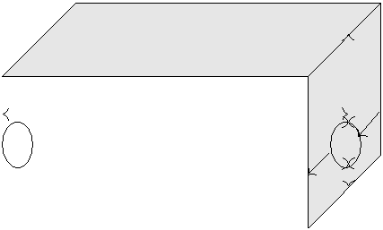

|  |  |  |  |  |  |  |  |  |  |  |  |  |  |  |  |  |  |  |  |  |
| --- | --- | --- | --- | --- | --- | --- | --- | --- | --- | --- | --- | --- | --- | --- | --- | --- | --- | --- | --- | --- |
|  |  |  |  |  |  |  |  |  |  |  | 48" cover | | |  |  |  |  |  |  |  |
|  | 1200 ft length | | | | |  |  |  |  |  |  |  |  |  |  |  |  |
|  |  |  |  |  |  | 1’ |  |  |  |  |  |  |  |  |  |
|  |  |  |  |  |  |  | 1’ | | |  | 24" pipe diameter | | | | |  |  |  |  |  |
|  |  |  |  |  |  |  |  |  |  |  | 6" from bottom | | | |  |  |  |  |  |  |
|  |  |  |  |  |  |  |  |  |  |  |  |  |  |  |  |  |  |  |  |  |
| Total volume to be excavated = Trench Length*Depth*Width | | | | | | | | | | | | | | | | | |  |  |  |
| = 1200 f t | | 12 | + | 12 | | + | | 12 | |  | ! f t 1 + | 12 | | + 1 | ! | f t! | 27 f t3 | = 1156cu.yds | |  |
|  |  | 48 |  | 24 | |  |  | 6 | |  |  | 24 | |  |  |  | cu.yds | |  |  |
|  |  |  |  |  |  |  |  |  |  |  |  |
|  |  |  |  |  |  |  |  |  |  |  |  |  |  |  |  |  |  |  |  |  |

1. A chemical feed pump with a 6-inch bore and a 6-inch stroke pumps 60 cycles per minute. Find the pumping rate in gpm.

3.2 f t/sec

362 Chapter 11. Assessments Solutions

Solution:

Total volume pumped = Volume per stroke * cycles per minute

|  |  |  |  |  |  |  |  |  |  |  |  |  |  |  |  |  |  |  |  |  |
| --- | --- | --- | --- | --- | --- | --- | --- | --- | --- | --- | --- | --- | --- | --- | --- | --- | --- | --- | --- | --- |
|  |  |  |  | 2 |  |  |  |  | 3 |  |  |  |  |  | |  |  |  |  |  |
|  |  |  | 12 | ! |  | 12 | ! |  |  |  | 60 | |  | f t3 | |  |  |
|  | cycle | | | min | |  |  |
| = | 0.785 |  | 6 |  |  | 6 |  | f t |  |  | | cycles | |  | 7.48 gal | = | 44 gpm |  |
|  |  |  |  |  |  |  |  |  |  |  |  |  |  |

Practice Problems - Flow and Velocity

1. Flow in an 8-inch pipe is 500 gpm. What is the average velocity in ft/sec? (Assume pipe is flowing full)

Solution:

Flow (Q) = Velocity (V) ×Area (A) = Q = V A = V = Q

A

We need to convert Q which is given in gpm to ft3/sec and calculate the area of the pipe in ft2 so velocity can be valculated in ft/sec.

|  |  |  |  |  |  |  |  |  |  |  |  |  |  |  |  |  |  |  |  |  |  |  |  |  |  |  |  |  |  |
| --- | --- | --- | --- | --- | --- | --- | --- | --- | --- | --- | --- | --- | --- | --- | --- | --- | --- | --- | --- | --- | --- | --- | --- | --- | --- | --- | --- | --- | --- |
|  |  |  | 3 | | | | | | |  | f t |  |  |  |  |  |  |  |  |  |  |  |  |  |  |  |  |  |  |
|  |  |  |  |  |  |  |  |  |  |  |  |  |  |  |  |  |  |  |  |  |  |  |
|  |  | f t |  | Q | f t | | | |  |  |  |  |  |  |  |  |  |  |  |  |  |  |  |  |  |  |  |  |  |
| V | | = | sec | | | | | | |  |  |  |  |  |  |  |  |  |  |  |  |  |  |  |  |  |  |
|  |  |  |  |  |  |  |  |  |  |  |  |  |  |  |  |  |  |  |
|  | A |  | f t | | |  |  |  |  |  |  |  |  |  |  |  |  |  |  |  |  |  |  |  |  |  |
|  | sec | |  |  |  |  |  |  |  |  |  |  |  |  |  |  |  |  |  |  |  |  |  |  |  |
| Step 1 - Converting Q - 500 gpm to ft3/min: | | | | | | | | | | | | | | | | | | | | | | |  |  |  |  |  |  |  |
|  |  |  |  | | | |  |  |  |  |  | 3 |  |  |  | H | |  |  |  |  |  | 3 |  |  |  |  |  |  |
|  |  |  |  | |  |  |  |  |  |  | f t |  |  |  |  |  |  |  |  |  |  |  |  |  |  |
|  | 500 gallons | | | | |  |  | |  |  |  | |  |  |  | minH = 1.1 f t | | | | | |  |  |  |  |  |  |  |
|  |  |  | | |  |  |  |  | | |  |  | |  |  | |  |  |  | |  |  |  |  |  |  |
|  |  | HminH | | |  |  |  | 7.48 gallon | | | 60 sec | | | | |  | sec | | |  |  |  |  |  |
| Step 2 - Calculating area in ft2: | | | | | | | | | | | | | | | |  |  |  |  |  |  |  |  |  |  |  |  |  |  |
| Area | | | f t2 = | |  | π | | | D2 = 0.785 | | | | |  | | 8 | |  | 2 |  | f t2 = 0.785 | | | | 64 | |  | = 0.349 f t2 |  |
|  | | |  |  |  |  |  |  |  |  |  |
|  | 4 | |  |  | 12 |  |  |  | 144 |  |  |

f t 1.1 f t3/sec = V sec = 0.349 f t2 =

1. A pipeline is 18” in diameter and flowing at a velocity of 125 ft. per minute. What is the flow in gallons per minute?

Solution:

Flow (Q) = Velocity (V) ×Area (A)

As the velocity is given in ft/min, and the area can be calculated in ft2, flow can be calu-lated in ft3/min and then converted to gal/min.

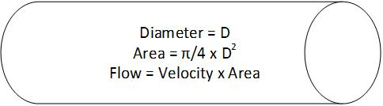

|  |  |  |  |  |  |  |  |  |  |  |  |  |  |  |  |  |
| --- | --- | --- | --- | --- | --- | --- | --- | --- | --- | --- | --- | --- | --- | --- | --- | --- |
| Step 1: Calculating area in ft2: | | | | | | | |  |  |  |  |  |  |  |  |  |
| π | | |  |  | 0 | 3 |  | 18 |  | 2 |  |  |  | 324 |  |  |
| Area ( f t2) = | 4 | | D2 = | | 12 | f t2 |  |  | 144 | = 0.349 f t2 |  |
|  |  |  | .785 |  |  |  | = 0.785 | |  |  |  |
| Step 2: Calculate flow in ft /min: | | | | | | | |  |  |  | f t3 | |  |  |  |  |
| Q f t3/min = 125 | | | f t | |  |  | f t2 |  |  |  |  |  |  |  |
|  | 1.77 | | | = 221.25 | | |  |  |  |  |  |  |
| min | min | |  |  |  |  |

|  |  |  |  |  |  |  |  |  |  |
| --- | --- | --- | --- | --- | --- | --- | --- | --- | --- |
| 11.9 Chapter 10 - Math | | |  |  |  | 363 | | |  |
|  |  |  | | |  | |  |  |  |
| Step 3: Convert Q to gallons per minute | | | | | | | | |  |
|  | f t3 | |  |  |  |  | |  |  |
|  | gal |  |  | gal | |  |  |
| Q = 221.25 |  | 7.48 |  | = | 1655 |  |  |  |  |
| min | f t3 | min | |  |  |

1. The velocity in a pipeline is 2 ft./sec. and the flow is 3,000 gpm. What is the diameter of the pipe in inches?

Solution:

Flow (Q) = Velocity (V) ×Area (A) = Q = V A = A = Q



V

We need to convert Q which is given in gpm to ft3/sec and calculate the area of the pipe in ft2 given the velocity.

From the calculated area of the pipe, the pipe diameter can be calculated.

|  |  |  |  |  |  |  |  |  |  |  |  |  |  |  |  |  |  |  |  |  |  |  |  |  |  |  |  |  |  |  |  |  |  |  |  |  |  |  |  |  |  |  |  |  |  |  |  |  |  |
| --- | --- | --- | --- | --- | --- | --- | --- | --- | --- | --- | --- | --- | --- | --- | --- | --- | --- | --- | --- | --- | --- | --- | --- | --- | --- | --- | --- | --- | --- | --- | --- | --- | --- | --- | --- | --- | --- | --- | --- | --- | --- | --- | --- | --- | --- | --- | --- | --- | --- |
|  |  |  |  |  | 3 | | | | | | | | | |  |  |  | f t2 | | |  |  |  |  |  |  |  |  |  |  |  |  |  |  |  |  |  |  |  |  |  |  |  |  |  |  |  |  |  |
|  |  |  |  |  |  |  |  |  |  |  |  |  |  |  |  |  |  |  |  |  |  |  |  |  |  |  |  |  |  |  |  |  |  |  |  |  |  |  |  |
|  |  | f t | |  |  | Q | | f t | | | | |  |  |  |  |  |  |  |  |  |  |  |  |  |  |  |  |  |  |  |  |  |  |  |  |  |  |  |  |  |  |  |  |  |  |  |  |  |
|  |  |  |  |  | | | | | | | |  |  |  |  |  |  |  |  |  |  |  |  |  |  |  |  |  |  |  |  |  |  |  |  |  |  |  |  |  |  |  |  |  |  |
| A | |  |  | = |  | sec | | | | | | | | | | |  |  |  |  |  |  |  |  |  |  |  |  |  |  |  |  |  |  |  |  |  |  |  |  |  |  |  |  |  |  |  |  |  |
|  |  |  | | | | | |  |  |  |  |  |  |  |  |  |  |  |  |  |  |  |  |  |  |  |  |  |  |  |  |  |  |  |  |  |  |  |  |  |  |  |  |  |  |  |
|  | sec | | |  |  |  |  |  |  |  |  |  |  |  |  |  |  |  |  |  |  |  |  |  |  |  |  |  |  |  |  |  |  |  |  |  |  |  |  |  |  |  |  |
|  |  |  |  |  | V | |  |  | f t | | | |  |  |  |  |  |  |  |  |  |  |  |  |  |  |  |  |  |  |  |  |  |  |  |  |  |  |  |  |  |  |  |  |  |  |  |  |  |
|  |  |  |  |  |  |  | | | | | | |  | |  |  |  |  |  |  |  |  |  |  |  |  |  |  |  |  |  |  |  |  |  |  |  |  |  |  |  |  |  |  |  |  |  |
|  |  |  |  |  |  | sec | | | | | | | | | | | |  |  |  |  |  |  |  |  |  |  |  |  |  |  |  |  |  |  |  |  |  |  |  |  |  |  |  |  |  |  |  |  |
| Step 1 - Converting Q - 3000 gpm to ft3/sec: | | | | | | | | | | | | | | | | | | | | | | | | | | | | | | | | | | | | | |  |  |  |  |  |  |  |  |  |  |  |  |
|  |  |  |  |  |  |  |  |  | | | |  |  |  |  |  |  |  |  |  |  |  |  |  |  | 3 |  |  |  |  |  |  | H | | |  |  |  |  | 3 |  |  |  |  |  |  |  |  |  |
| 3000 | | | |  |  | | | | | |  |  |  |  |  |  |  |  |  |  |  |  |  |  | f t |  | | |  |  |  |  |  |  |  |  |  |  |  |  |  |  |  |  |
| gallons | | | | | | | | |  | | | | |  |  |  |  |  |  |  |  |  | |  |  | minH = 6.68 f t | | | | | |  |  |  |  |  |  |  |  |  |  |
|  |  |  |  | | | | |  |  |  |  |  |  |  |  | | | |  |  | |  |  |  |  | | |  |  |  |  |  | |  |  |  |  |  |  |  |  |  |
|  |  |  | HminH | | | | |  |  |  |  |  | 7.48 gallon | | | | | | | | | | 60 sec | | |  |  |  | sec | | | |  |  |  |  |  |  |  |
| Step 2 - Calculating area in ft2: | | | | | | | | | | | | | | | | | | | | | | | | | | | | | | | |  |  |  |  |  |  |  |  |  |  |  |  |  |  |  |  |  |  |
|  |  |  |  |  |  |  |  |  |  |  |  |  |  | 6.68 f t3/sec | | | | | | | | | | | | | | | |  |  |  |  |  |  |  |  |  |  |  |  |  |  |  |  |  |  |  |  |
|  | = A f t2 | | | | | | | = | | | |  |  |  |  |  |  |  |  |  |  |  |  |  |  |  |  | = 3.34 f t2 | | | | | | | |  |  |  |  |  |  |  |  |  |  |  |  |  |  |
|  |  |  |  |  |  |  |  |  |  | 2 | | f t | |  |  |  |  |  |  |  |  |  |  |  |  |  |  |  |  |
|  |  |  |  |  |  |  |  |  |  |  |  |  |  |  |  |  |  |  |  |  |  | sec | |  |  |  |  |  |  |  |  |  |  |  |  |  |  |  |  |  |  |  |  |  |  |  |  |
|  |  |  |  |  |  |  |  |  |  |  |  |  |  |  |  |  |  |  |  |  |  |  |  |  |  |  |  |  |  |  |  |  |  |  |  |  |  |  |  |  |  |  |  |  |  |  |  |
|  |  |  |  |  |  |  |  |  |  |  |  |  |  |  |  |  |  |  |  |  |  |  |  |  |  |  |  |  |  |  |  |  |  |  |  |  |  |  |  |  |  |  |  |  |  |  | 1 | |  |
| Area (A) = | | | | | | | |  | π | | | |  | D | | | | | | | | 2 | 1 0 785 D | | | | | | | | | | 2 | D | | 2 |  |  | A | | | | D |  |  | A |  |  |  |
|  |  |  |  |  |  |
| 4 | | | |  |  |  | 0.785 | | | | | 0.785 | |  |  |
|  |  |  |  |  |  |  |  |  |  |  |  |  |  |  |  |  |  |  |  |  |  | = . | | | |  |  |  |  |  |  | = |  | = |  |  |  |  |  | = | = |  |  | 2 | |  |
|  | = D = | | | | | | | .34 | | | | | | | | | | | |  |  | |  |  |  |  |  |  |  |  |  |  |  |  |  |  |  |  |  |  |  |
|  |  |  |  |  |  |  |  |  |  |  |  |  |  |  |  |  |  |  |  |  |  |  |  |  |  |  |  |  |
|  |  |  |  |  |  |  |  |  |  |  |  |  |  |  |  |  |  |  |  |  |  |  |  |  |  |  |  |  |
|  |  | 3 | | | | | | | | | | |  | 2 = | | | | 2 f t | | | |  |  |  |  |  |  |  |  |  |  |  |  |  |  |  |  |  |  |  |
|  | 0.785 | | | | | | | | | | |  |  |  |  |  |  |  |  |  |  |  |  |  |  |  |  |  |  |  |
|  |  |  |  |  |  |  |  |  |  |  |  |  |  |  |  |  |  |  |  |  |  |  |  |  |  |  |  |  |  |

1. Find the flow in a 4-inch pipe when the velocity is 1.5 feet per second. Solution:

Flow (Q) = Velocity (V) ×Area (A)

The velocity is given in ft/sec and after calculating the area in ft2, flow can be calculated in ft3/min.

|  |  |  |  |  |  |  |  |  |  |  |  |  |  |  |  |  |  |  |
| --- | --- | --- | --- | --- | --- | --- | --- | --- | --- | --- | --- | --- | --- | --- | --- | --- | --- | --- |
| Step 1: Calculating area in ft2: | | | | | | | | | |  |  |  |  |  |  |  |  |  |
| π | |  | |  |  |  | 0 | 3 |  | 4 |  | 2 |  |  |  | 324 |  |  |
| 4 | |  |  |  | 12 |  |  |  | 144 |  |  |
| Area ( f t2) = |  |  |  | D2 | | = |  | .785 |  |  |  | f t2 = 0.785 | | |  |  | = 0.087 f t2 |  |
| Step 2: Calculate flow in ft /min: | | | | | | | | | |  |  |  | f t3 |  |  |  |  |  |
| Q f t3/min = 1.5 | | |  | f t |  | 0.087 | | | f t2 | = | 0.13 | |  |  |  |  |
| sec | |  | sec | |  |  |  |  |

|  |  |
| --- | --- |
| 364 | Chapter 11. Assessments Solutions |
|  |  |
|  | Q can be converted to a more commonly used gallons per minute unit |

Q = 0.13 f t3 7.48 gal 60 sec = 59 gal

sec f t3 min min

1. A 42-inch diameter pipe transfers 35 cubic feet of water per second. Find the velocity in ft/sec.

Solution:

Flow (Q) = Velocity (V) ×Area (A) = Q = V A = V = Q



A

Q is already given in ft3/sec. We need to first calculate the area of the pipe in ft2 so veloc-ity can be valculated in ft/sec.

|  |  |  |  |  |  |  |  |  |  |  |  |  |  |  |  |  |  |  |  |  |  |
| --- | --- | --- | --- | --- | --- | --- | --- | --- | --- | --- | --- | --- | --- | --- | --- | --- | --- | --- | --- | --- | --- |
|  |  |  |  |  |  | | |  |  |  | f t |  |  |  |  |  |  |  |  |  |  |
|  |  |  |  |  | 3 | |  |  |  |  |  |  |  |  |  |  |  |  |
|  | f t |  |  | Q |  | f t | | | |  | |  |  |  |  |  |  |  |  |  |  |
| V | = | |  | sec | | | | |  |  |  |  |  |  |  |  |  |  |  |
|  |  |  |  |  |  |  |  |  |  |  |  |
|  |  |  | f t2 | | | | | |  |  |  |  |  |  |  |  |  |  |
| sec | |  |  | A |  |  |  |  |  |  |  |  |  |  |  |
| Step 1 - Calculating area in ft2: | | | | | | | | | | | | | |  |  |  |  |  |  |  |  |
|  |  |  |  |  |  |  | π |  | D2 = 0.785 | | | | | 42 |  | 2 |  | 1764 | |  |  |
| Area | | f t2 = | | | | |  |  |  | f t2 = 0.785 | |  |  | = 9.616 f t2 |  |
| 4 | 12 |  | 144 |  |
|  |  |  | f t | |  |  |  |  | 35 f t3/sec | | |  |  |  |  |  |  |  |  |  |  |
| = V | | | = | | |  | = | 3.6 f t/sec | | | |  |  |  |  |  |
| sec | |  | 9.616 f t2 | | |  |  |  |  |  |
|  |  |  |  |  |  |  |  |  |  |  |  |  |  |

1. A plastic float is dropped into a channel and is found to travel 10 feet in 4.2 seconds. The channel is 2.4 feet wide and the water is flowing 1.8 feet deep. Calculate the flow rate of water in cfs.

Solution:



|  |  |  |  |  |  |  |  |  |  |  |  |  |  |
| --- | --- | --- | --- | --- | --- | --- | --- | --- | --- | --- | --- | --- | --- |
| Q = V A = V = | | |  | Q | |  |  |  |  |  |  |  |  |
|  |  |  |  |  |  |  |  |  |  |  |
|  | A | |  |  |  |  |  |  |  |  |
| Flow (Q) = Velocity (V) ×Area (A) | | | | | |  |  |  |  | 10 | | f t |  |
| The speed of the float travelling is the velocity of the water = Velocity = | | | | | | | | | |  |
|  | |  |  |
|  | 4.2 | sec |  |
| Thus flow = | 10 f t |  | (2.4 1.8) f t2 = | | | 4.32 | f t3 |  |  |  |  |  |  |
| 4.2 sec |  | sec | |  |  |  |  |  |

1. A channel is 3.25 feet wide and is conveying a a flow of 3.5 MGD. The depth of the water is 8 inches. Calculate the velocity of this flow.

Solution:

|  |  |
| --- | --- |
| 11.9 Chapter 10 - Math | 365 |
|  |  |



|  |  |  |  |  |  |  |  |  |  |  |  |  |  |  |  |  |  |  |  |  |  |  |  |
| --- | --- | --- | --- | --- | --- | --- | --- | --- | --- | --- | --- | --- | --- | --- | --- | --- | --- | --- | --- | --- | --- | --- | --- |
| Q = V A = V = | | | | | | | | Q |  |  |  |  |  |  |  |  |  |  |  |  |  |  |  |
|  |  |  |  |  |  |  |  |  |  |  |  |  |  |  |  |
| A |  |  |  |  |  |  |  |  |  |  |  |  |  |  |  |
|  |  |  |  |  |  | | |  | 1000000gal |  |  | f t | 3 |  |  | day |  |  |  |  |  |  |  |
|  |  |  |  |  | MG | | |  |  |  |  |  |  |  |  |  |  |  |  |  |
|  |  |  |  |  |  |  |  |  |  |  |  |  |  |  |  |  |  |  |  |  |  |  |
|  |  |  | 3.5 | |  |  |  |  |  |  |  |  |  |  |  |  |  |  |  |  |  |  |  |
|  | f t | |  | day | |  |  |  | . |  |  | | ( | 1440 60 | )s | |  |  | f t |  |  |
| = V |  |  |  | MG |  | = | 2.2 |  |  |
| = | |  |  |  | |  |  |  |  | 7 48gal | | | |  |  |  |  |  |  |
|  |  |  |  |  |  |  |  |  |  |  | | | |  |  |  |  |  |  |  |  |  |  |
| s | |  |  |  |  |  |  | (3.25 0.75) f t2 | | | | | |  |  |  |  |  |  | s |  |  |

Practice Problems - Unit Conversions

1. Convert 1000 f t3 to cu. yards Solution:

|  |  |  |  |  |  |  |  |  |  |  |  |  |  |  |  |  |  |  |  |  |  |  |
| --- | --- | --- | --- | --- | --- | --- | --- | --- | --- | --- | --- | --- | --- | --- | --- | --- | --- | --- | --- | --- | --- | --- |
|  |  |  |  |  |  |  |  |  | yd3 | | | |  |  |  |  |  |  |  |  |  |  |
| yds3 = 1000 f t3 | | | | | | |  |  |  | 37 yds3 | | | |  |  |  |  |  |
|  |  | |  | = | |  |  |  |  |  |
| 27 f t3 | | |  |  |  |  |
|  |  |  |  |  |  |  |  |  |  |  |  |  |  |  |  |  |  |  |
| 2. Convert 10 gallons/min to f t3/hr | | | | | | | | | | | | | | | |  |  |  |  |  |  |  |
| Solution: | | | |  |  |  |  |  |  |  |  |  |  |  |  |  |  |  |  |  |  |  |
|  |  |  |  |  | gal | |  |  |  |  |  |  |  | | |  |  |  |  |  |  |  |
|  | f t | 3 |  |  |  |  | f t | 3 |  |  |  |  |  | f t | 3 |  |  |
|  |  |  |  |  |  |  |  |  | 60min | | |  |  |  |  |  |  |
|  |  |  | = 10 |  |  |  |  |  |  |  |  | |  |  |  | = | 80.2 | |  |  |  |  |
|  | hr | |  | min | 7.48gal | | | | hr | | | hr | |  |  |
|  |  |  |  |  |  |  |  |  | | |  |  |  |  |  |  |  |  |  |  |  |  |
|  |  |  |  |  |  |  |  |  |  |  |  |  |  |  |  |  |  |  |  |

1. Find the flow in gpm when the flow is 0.25cfs. Solution:

|  |  |  |  |  |  |  |  |  |  |  |  |  |  |  |  |  |
| --- | --- | --- | --- | --- | --- | --- | --- | --- | --- | --- | --- | --- | --- | --- | --- | --- |
| gal | |  | f t | 3 |  |  |  |  |  |  | |  | gal | |  |  |
|  |  |  |  | 7.48gal 60sec | | | | |  |  |  |
|  | = 0.25 |  |  | |  |  |  |  |  |  | = | 112.2 |  |  | vspace0.2cm |  |
|  |  | |  |  | f t3 | |  |  |  |
| min | | sec | | | |  | min | |  | min | |  |  |

1. The flow rate through a filter is 4.25 MGD. What is this flow rate expressed as gpm? Solution:

|  |  |  |  |  |  |  |  |  |  |  |  |  |  |  |
| --- | --- | --- | --- | --- | --- | --- | --- | --- | --- | --- | --- | --- | --- | --- |
| gal | |  | | | 1, 000, 000gal |  |  | |  |  |  | gal |  |  |
| MG | | |  |  | day | |  |  |  |  |
|  | = 4.25 |  |  |  |  |  |  |  |  | = | 2, 951 |  |  |  |
|  | day | | |  | 1, 440min | | |  |  |  |
| min | | MG |  | min | |  |  |

1. After calibrating a chemical feed pump, you’ve determined that the maximum feed rate is 178 mL/ minute. If this pump ran continuously, how many gallons will it pump in a full day?

Solution:

|  |  |  |  |  |  |  |  |  |  |  |  |  |  |  |  |  |
| --- | --- | --- | --- | --- | --- | --- | --- | --- | --- | --- | --- | --- | --- | --- | --- | --- |
| gal |  |  | |  |  | L |  |  |  | | | |  | gal |  |  |
| = 178 | mL |  |  |  |  | 1, 440min | | | = | 119, 680 |  |  |
| day |  |  |  |  | day |  |  |  |  |
| min | | | 1000mL | |  |  | day | |  |  |

1. A plant produces 2,000 cubic foot of water per hour. How many gallons of water is pro-duced in an 8-hour shift?

Solution:

|  |  |  |  |  |  |  |  |  |  |  |  |  |
| --- | --- | --- | --- | --- | --- | --- | --- | --- | --- | --- | --- | --- |
| gal |  | f t | 3 |  | 7.48gal |  |  |  |  | gal |  |  |
| = 2, 000 |  |  |  | 8hr | = | 253.6 |  |
| 8 −hr shi f t | hr | | f t3 | 8 −hr shi f t | day | |  |

7. Change 70 °F to °C

366 Chapter 11. Assessments Solutions

Solution:

◦C = ◦F −32 = 70 −32 = 21.1◦C

1.8 1.8

1. Change 4 °C to °F Solution:

◦F = (◦C ×1.8) + 32 = (4 1.8) + 32 = 39.2◦F

Practice Problems - Concentration

1. How many lbs of salt needs to be dissolved in water to make 1 liter of 5% salt solution? Solution:

5% salt solution = 50, 000 mg/l salt

|  |  |  |  |  |  |  |  |  |  |  |
| --- | --- | --- | --- | --- | --- | --- | --- | --- | --- | --- |
|  |  | lb | |  | gm | |  |  |  |  |
| 50, 000 | mg |  | = | 0.11 lb salt | in enough water to make 1 liter of |  |
|  | |  |  |  |
| 453.6 gms |  | 1, 000 mg |  |  |
|  |  |  |  |  |  |  |

solution.

1. What is the concentration in mg/l of 4.5% solution of that substance. 450, 000mg/l
2. An operator mixes 40 lb of lime in a 100-gal tank containing 80 gal of water. What is the percent of lime in the slurry? Solution:

|  |  |  |  |  |  |  |  |  |  |  |
| --- | --- | --- | --- | --- | --- | --- | --- | --- | --- | --- |
| 40 | lbs | lime |  |  |  | 1, 000, 000 lbs | !ppm | % | = |  |
|  |  |  |  |  |  |  |
| 80 gal water 8.34 |  | lbs | + 40 lbs |  | million lbs | 10, 000 ppm |  |
|  |  | lime | |  |  |  |  |  |
| gal | water |  |  |  |  |  |

5.7%

Practice Problems - Density and Specific Gravity

1. What is the specific gravity of a 1 ft3 concrete block which weighs 145 lbs? Solution: Specific gravity is the ratio of the weight of the substance to that of an equal volume of water.

As one cu. ft of water weighs 62.43 lbs/cu. ft (8.34 lbs/gal*7.48 gal/cu. ft):

Specific gracvity of this concrete block= 145 = 2.3 62.43

2. What is the specific gravity of a chlorine solution if 1 (one) gallon weighs 10.2lbs? Solu-tion:

Specific gravity is the ratio of the weight of the substance to that of an equal volume of water.

As one gallon of water weighs 8.34 lbs: Specific gracvity of this chlorine solution= 10.2 = 8.34

1.2

|  |  |
| --- | --- |
| 11.9 Chapter 10 - Math | 367 |
|  |  |

1. How much does each gallon of zinc orthophosphate weigh (pounds) if it has a specific gravity of 1.46?

Solution:

8.34 lb 1.46 = 12.18 lb

gal gal

1. How much does a 55 gallon drum of 25% caustic soda weigh (pounds) if the specific gravity is 1.28?

Solution:

8.34 lb 1.28 55gal = 12.18 lb

gal gal

Practice Problems - Pounds Formula

1. A water treatment plant operates at the rate of 75 gallons per minute. They dose soda ash at 14 mg/L. How many pounds of soda ash will they use in a day?



lbs/day

14 mg/l 75 GPM

8.34

|  |  |  |  |  |  |  |  |  |  |  |  |  |  |  |  |  |  |  |  |  |  |  |  |  |
| --- | --- | --- | --- | --- | --- | --- | --- | --- | --- | --- | --- | --- | --- | --- | --- | --- | --- | --- | --- | --- | --- | --- | --- | --- |
| lbs | = Flow | | MG | | Concentration | | | | | | mg | 8.34 | | |  |  |  |  |  |  |  |  |  |  |
|  |  |  |  |  |  |  |  |  |  |  |  |  |  |
| day | day |  | l |  |  |  |  |  |  |  |  |  |  |
| lbs |  |  | | | |  |  | | |  |  | MG |  |  |  |  | mg | |  |  |  |  |  |  |
|  |  |  |  |  |  |  |  |  |  |  | lbs |  |  |
| = 75 | gallons | | |  | 1440 | min | | |  |  |  |  |  | 250 |  | 8.34 = | 225 |  |  |
|  |  |  |  |  |  |  |  |  |  |  |  |  |  |  |  |  |  |  |
| day |  |  |  |  | day | | 1, 000, 000 | | |  | l | |  |  |  |  |
|  | min | | |  |  | gallons | |  |  | day | |  |  |

1. What is the influent plant loading of phosphorus in lbs/day if the plant flow is 4.5 MGD and the influent phosphorous concentration is 1.5 mg/l?

Solution:



? lbs/day

1.5 mg/l 4.5 MGD

8.34

|  |  |  |  |  |  |  |
| --- | --- | --- | --- | --- | --- | --- |
| 368 |  |  |  |  | Chapter 11. Assessments Solutions |  |
|  |  |  |  |  |  |  |
|  | mg | |  |  |  |  |
| 1.5 | 4.5MGD 8.34 = | 56 lbs/day |  |  |
|  |  |  |  |
| l | |  |
|  |  |  |  |

1. A water treatment plant uses 8 pounds of chlorine daily and the dose is 17 mg/l. How many gallons are they producing? Solution:



8 lbs/day

17 mg/l ? MGD

8.34

|  |  |  |  |  |  |  |  |  |  |  |  |  |  |  |  |  |  |  |  |  |  |  |  |  |  |  |  |  |  |  |  |  |  |  |
| --- | --- | --- | --- | --- | --- | --- | --- | --- | --- | --- | --- | --- | --- | --- | --- | --- | --- | --- | --- | --- | --- | --- | --- | --- | --- | --- | --- | --- | --- | --- | --- | --- | --- | --- |
|  | lbs |  |  |  | MG | | | | | | |  |  |  |  |  | mg | | | |  |  |  |  |  |  |  |  |  |  |  |  |  |  |
|  |  | = Flow | | | |  |  |  | |  |  | Concentration | | | | |  |  |  |  | 8.34 | | |  |  |  |  |  |  |  |  |  |  |  |
|  | day | day | | | | |  | l | | |  |  |  |  |  |  |  |  |  |  |  |
|  |  |  |  |  |  |  |  |  |  |  |  |  |  |  | lbs |  |  |  |  |  |  |  |  |  |  | 8 | lbs | |  |  |  |  |  |  |
|  |  |  |  | MG | | | | |  |  |  |  |  | day | | |  |  |  |  |  |  |  |  |  | day | | | |  | MG | |  |
|  |  |  |  |  |  |  |  |  |  |  |  |  |  |  |  |  |  |  |  |  |
|  | = Flow | | | |  | |  |  | = | | | |  |  |  |  |  | |  |  |  |  | = |  |  |  | |  | |  | = 0.056425 |  |  |  |
|  | day | | |  |  |  |  | mg | | | |  |  |  |  | mg | | | | |  | day |  |
|  |  |  |  |  |  |  |  |  |  |  |  |  | Concentration | | | |  | l | |  | 8.34 | | | 17 | | l | | 8.34 | | |  |  |  |  |
|  |  |  | MG | | | | | | 1, 000, 000 Gallons | | | | | | | | | | | |  |  |  |  |  |  |  |  |  |  |  |  |  |  |
| 0.056425 | | |  |  | | |  | |  |  |  |  |  |  | | |  |  |  |  | = | 56, 425 Gallons | | | | | | | |  |  |  |  |  |
|  | day | | |  |  |  |  |  | MG | | |  |  |  |  |  |  |  |  |
|  |  |  |  |  |  |  |  |  |  |  |  |  |  |  |  |  |  |  |  |  |  |  |  |  |  |  |

Practice Problems - Chemical Dosing

1. In order to disinfect a sedimentation basin measuring 20ft in width, 60 feet in length, and is 10 feet deep to obtain 50ppm would require how many lbs. of 65% available HTH ?
   1. 5.0lbs
   2. 41.3lbs
   3. 37.4lbs

*d) 57.6lbs

1. Determine the chlorinator setting (lb/day) required to treat a flow of 4MGD with a chlorine dose of 5mg/L.

Chlorine feed rate (lb/ day ) = Chlorine (mg/L)× Flow (MGD) ×8.34lb/gal Chlorine feed rate (lb/ day ) = 5mg/L ×4MGD ×8.34lb/gal

Chlorine feed rate (lb/ day ) = 167lb/ day

1. A pipeline that is 12 inches in diameter and 1400ft long is to be treated with a chlorine dose of 48mg/L. How many lb of chlorine will this require?

First determine the gallon volume of the pipeline:

Volume (gal) = 0.785 ×D2× length (ft) ×7.48gal/cuft

Volume (gal) = 0.785 ×(1ft)2 ×1400ft ×7.48gal/cuft Volume (gal) = 8221gal Next calculate the amount of chlorine required:

Chlorine feed rate (lb/ day ) = Chlorine (mg/L) x Flow ( MGD) ×8.34lb/gal

|  |  |
| --- | --- |
| 11.9 Chapter 10 - Math | 369 |
|  |  |

Chlorine feed rate (lb/ day ) = 48mg/L ×0.008221MGD ×8.34lb/gal Chlorine feed rate (lb/ day ) = 3.3lb

1. What should the chlorinator seting be (lb/day) to treat a flow of 2.35MGD if the chlorine demand is 3.2mg/L and a chlorine residual of 0.9mg/L is desired?

First, determine the chlorine dosage (in mg/L ):

Chlorine Dose (mg/L) = Chlorine Demand + Chlorine Residual Chlorine Dose (mg/L) = 3.2mg/L + 0.9mg/L

Chlorine Dose (mg/L) = 4.1mg/L

Next calculate the chlorine dosage (feed rate) in lb/ day:

Chlorine feed rate (lb/ day ) = Chlorine (mg/L)× Flow (MGD) ×8.34lb/gal Chlorine feed rate (lb/ day ) = 4.1mg/L ×2.35MGD ×8.34lb/gal Chlorine feed rate (lb/ day ) = 80.4lb/ day

1. A water treatment plant operates at the rate of 75 gallons per minute. They dose soda ash at 14 mg/L. How many pounds of soda ash will they use in a day? Solution:



lbs/day

14 mg/l 75 GPM

8.34

|  |  |  |  |  |  |  |  |  |  |  |  |  |  |  |  |  |  |  |  |  |  |  |
| --- | --- | --- | --- | --- | --- | --- | --- | --- | --- | --- | --- | --- | --- | --- | --- | --- | --- | --- | --- | --- | --- | --- |
| lbs | = Flow | | MG | | Concentration | | | | | | mg | 8.34 | |  |  |  |  |  |  |  |  |  |
|  |  |  |  |  |  |  |  |  |  |  |  |  |
| day | day |  | l |  |  |  |  |  |  |  |  |  |
| lbs |  |  | | | |  |  | | |  |  | MG |  |  | mg | |  |  |  |  |  |  |
|  |  |  |  |  |  |  |  |  | lbs |  |  |
|  | gallons | | |  | 1440 | min | | |  |  |  |  |  |  |  |  |  |
|  | = 75 |  |  |  |  |  |  |  |  |  |  |  |  | 14 |  |  | 8.34 = | 12.6 |  |  |  |
| day |  |  |  | day | | 1, 000, 000 | | |  | l |  |  |  |  |
|  | min | | |  |  | gallons |  |  | day | |  |  |

1. A water treatment plant is producing 1.5 million gallons per day of potable water, and uses 38 pounds of soda ash for pH adjustment. What is the dose of soda ash at that plant? Solution:



38 lbs/day

? mg/l 1.5 MGD

8.34

|  |  |  |  |  |  |  |  |  |  |  |  |  |  |  |  |  |  |  |  |  |  |  |  |  |  |  |  |  |  |  |  |
| --- | --- | --- | --- | --- | --- | --- | --- | --- | --- | --- | --- | --- | --- | --- | --- | --- | --- | --- | --- | --- | --- | --- | --- | --- | --- | --- | --- | --- | --- | --- | --- |
| 370 |  |  |  |  |  |  |  |  |  |  |  |  |  |  |  |  |  |  |  |  | Chapter 11. Assessments Solutions | | | | | | | | | |  |
|  |  |  |  |  |  |  |  |  |  |  |  |  |  |  |  |  |  |  |  |  |  |  |  |  |  |  |  |  |  |  |  |
|  |  |  |  |  |  |  |  |  |  |  |  |  |  |  |  |  |  |  |  |  |  |  |  |  |  |  | lbs | |  |  |  |
|  | lbs |  | MG | | | |  |  |  |  |  |  |  | mg | | |  |  |  |  |  | mg | |  |  |  | |  |  |  |  |
|  | = Flow | Concentration | | | | | | | 8.34 | | |  | = Concentration | = |  |  | day | |  |  |  |
|  | day |  | day | |  | l | |  |  |  | l |  | MG | | |  |  |  |
|  |  |  |  |  |  |  |  |  |  |  |  |  |  |  |  |  |  |  |  |  |  |  |  | Flow | |  | | | 8.34 | |  |
|  |  |  |  |  |  |  |  |  |  |  | lbs | |  |  |  |  |  |  |  |  |  |  |  | day | |  |  |
|  |  |  |  |  |  |  |  |  |  | 38 |  |  |  |  |  |  |  |  |  |  |  |  |  |  |  |  |  |  |  |
|  |  |  |  |  |  |  |  |  |  |  |  |  |  |  |  |  |  |  |  |  |  |  |  |  |  |  |  |  |  |
| Concentration | | | | | mg | | | = |  |  | day | | |  |  | = | | 3 | mg |  |  |  |  |  |  |  |  |  |  |  |  |
|  | | |  | MG | | | |  |  | l |  |  |  |  |  |  |  |  |  |  |  |  |
|  |  |  |  |  | l | |  |  |  |  |  |  |  |  |  |  |  |  |  |  |  |  |  |  |  |  |
|  |  |  |  |  |  |  | 1.5 | | |  | | 8.34 | | | |  |  |  |  |  |  |  |  |  |  |  |  |  |  |  |  |
|  |  |  |  |  |  |  | day | |  |  |  |  |  |  |  |  |  |  |  |  |  |  |  |  |

1. A water treatment plant produces 150,000 gallons of water every day. It uses an average of 2 pounds of permanganate for iron and manganese removal. What is the dose of the permanganate?

Solution:



38 lbs/day

? mg/l 1.5 MGD

8.34

|  |  |  |  |  |  |  |  |  |  |  |  |  |  |  |  |  |  |  |  |  |  |  |  |  |  |  |  |  |  |  |  |  |  |  |  |  |
| --- | --- | --- | --- | --- | --- | --- | --- | --- | --- | --- | --- | --- | --- | --- | --- | --- | --- | --- | --- | --- | --- | --- | --- | --- | --- | --- | --- | --- | --- | --- | --- | --- | --- | --- | --- | --- |
|  |  |  |  |  |  |  |  |  |  |  |  |  |  |  |  |  |  |  |  |  |  |  |  |  |  |  |  |  |  |  | lbs | | | |  |  |
|  | lbs |  | MG | | | |  |  |  |  | mg | | |  |  |  |  |  |  |  |  | mg | |  |  |  |  |  |  |  | |  |  |  |  |  |
|  |  |  |  |  |  |  |  |  |  |  |  |  |  |  |  |  |  |  |  |  | day | | | |  |  |
|  |  | = Flow |  |  |  |  | Concentration | | | |  | 8.34 | | | |  | = Concentration | | | | |  |  | = | | |  |  |  |  | |  |  |  |  |  |
|  | day |  | day | |  | l |  | l |  |  |  | MG | | | | |  |  |
|  |  |  |  |  |  |  |  |  |  |  |  |  |  |  |  |  |  |  |  |  |  |  |  |  |  | Flow | | | |  | |  |  | | 8.34 |  |
|  |  |  |  |  |  |  |  |  |  |  |  |  |  |  |  |  | lbs |  |  |  |  |  |  |  |  | day | | | |  |  |
|  |  |  |  |  |  |  |  |  |  |  |  |  |  |  | 2 | |  |  |  |  |  |  |  |  |  |  |  |  |  |  |  |  |  |  |  |
|  |  |  |  |  |  |  |  |  |  |  |  |  |  |  |  |  |  |  |  |  |  |  |  |  |  |  |  |  |  |  |  |  |  |
| Concentration | | | | | mg | | | = |  |  |  | |  |  |  | day | | |  |  |  |  |  |  |  | = | | 3 | mg | | |  |  | |  |  |
|  | | |  |  |  | | |  |  |  |  |  |  |  |  |  |  |  |  |  | | |  |  |
|  |  |  |  |  | l | |  |  |  |  |  | |  |  |  |  |  |  |  |  |  |  |  |  |  |  |  |  | l |  |  |  |  |  |  |  |
|  |  |  |  |  |  |  |  |  | 150, 000 | Gallons | | |  |  |  |  |  | MG | **(** | 8.34 | | | |  |  |  |  |  |  |  |  |  |  |  |  |  |
|  |  |  |  |  |  |  |  |  |  |  |  |  |  |  |  |  |  |  |  |  |  |  |  |  |  |  |
|  |  |  |  |  |  |  |  |  |  | | |  |  |  |  |  |  |  |  |  |  |  |  |  |  |  |  |  |  |
|  |  |  |  |  |  |  |  |  |  |  | day | | |  | 1, |  |  |  | ( |  |  | ! | | | |  |  |  |  |  |  |  |  |  |  |  |
|  |  |  |  |  |  |  |  |  |  |  | 000, 000(Gallons( | | | | |  |  |  |  |  |  |  |  |  |  |  |

1. A water treatment plant uses 8 pounds of chlorine daily and the dose is 17 mg/l. How many gallons are they producing?

Solution:



8 lbs/day

17 mg/l ? MGD

8.34

|  |  |  |  |  |  |  |  |
| --- | --- | --- | --- | --- | --- | --- | --- |
| lbs | = Flow | MG | | Concentration | mg | 8.34 |  |
|  |  |  |  |  |
| day | day |  | l |  |

|  |  |  |  |  |  |  |  |  |  |  |  |  |  |  |  |  |  |  |  |  |  |  |  |  |  |  |  |
| --- | --- | --- | --- | --- | --- | --- | --- | --- | --- | --- | --- | --- | --- | --- | --- | --- | --- | --- | --- | --- | --- | --- | --- | --- | --- | --- | --- |
| 11.9 Chapter 10 - Math | | | | | | | | | | |  |  |  |  |  |  |  |  |  |  |  |  |  | 371 | | |  |
|  |  |  |  |  |  |  |  |  |  |  |  |  |  |  |  |  |  |  |  |  |  |  |  |  |  |  |  |
|  |  |  |  |  |  |  |  |  | lbs |  |  |  |  |  |  |  |  | 8 | lbs | |  |  |  |  |  |  |  |
|  | MG | | | |  |  |  | day | | |  |  |  |  |  |  |  | day | | | |  | MG | | |  |
|  |  |  |  |  |  |  |  |  |  |  |  |  |  |
| = Flow | |  |  |  | = | |  |  |  |  |  |  |  |  | = |  |  |  | |  | |  | = 0.056425 |  |  |  |  |
| day | |  |  |  |  | mg | |  |  |  |  | mg | | | | |  | day | |  |
|  |  |  |  |  |  |  | Concentration | | | | l | | 8.34 | | | 17 | | l | | 8.34 | | |  |  |  |  |  |
| MG | | | | | 1, 000, 000 Gallons | | | | | | | |  |  |  |  |  |  |  |  |  |  |  |  |  |  |  |
| 0.056425 |  | |  | |  |  |  |  | | |  |  | = | 56, 425 Gallons | | | | | | | |  |  |  |  |  |  |
| day | |  |  |  | MG | | |  |  |  |  |  |  |  |
|  |  |  |  |  |  |  |  |  |  |  |  |  |  |  |  |  |  |  |  |  |

Practice Problems - Blending and Dilution

1. Ferric chloride is being added as a coagulant to the raw water entering a plant. Sampling shows that the concentration of ferric in the raw water is 25 ppm. A quick check of the chemical metering pump shows that it is operating at a flow rate of 4.3 gpm. If the flow through the water plant is 800 gpm, what is the concentration of raw chemical in the dos-ing tank?

Solution:

FeCl3



VFeCl3 =4.3gpm

CFeCl3 = ?

Water

|  |  |
| --- | --- |
| 800gpm | C2=25ppm FeCl3 |
|  | V2=4.3+800=804.3 gpm |

C1 * V1 = C2 * V2

CFeCl3 * VFeCl3 = C2 * (VFeCl3 +VWater)

CFeCl3 * 4.3 = 25 * (804.3)

25 (804.3)

CFeCl = = 4, 676 ppm or 0.47%

1. A water plant is fed by two different wells. The first well produces water at a rate of 600 gpm and contains arsenic at 0.5 mg/L. The second well produces water at a rate of 350 gpm and contains arsenic at 12.5 mg/L. What is the arsenic concentration of the blended water?

Solution:

C1 * V1 + C2 * V2 + = C3 * V3=C3*(V1 + V2)

CWell 1 * VWell 1 + CWell 2 * VWell 2 = CBlend * VBlend =CBlend *(VWell 1 + VWell 2)

|  |  |  |  |  |  |  |  |  |  |  |
| --- | --- | --- | --- | --- | --- | --- | --- | --- | --- | --- |
|  |  |  | CWell 1 VWell 1 | +CWell 2 VWell 2 |  | 0.5 600 + 12.5 | 350 |  |  |  |
| = | C | = | = | = | 4.9 mg/l |  |
|  | Blend |  | VWell 1 | +VWell 2 | 600 + 350 | |  |  |  |  |
|  |  |  |  |  |  |

Practice Problems - Pumping Rates

1. How long will it take (hrs) to fill a 2 ac-ft pond if the pumping rate is 400 GPM?

372 Chapter 11. Assessments Solutions

Time to f ill (hours) = Volume = Flow

|  |  |  |  |  |  |  |  |  |  |  |  |  |  |
| --- | --- | --- | --- | --- | --- | --- | --- | --- | --- | --- | --- | --- | --- |
|  |  |  |  |  |  |  |  |  | | |  |  |  |
|  |  | 325, 851 | | | | | |  | |  |  |  |  |
|  |  | gallons | | |  |  |  |
| 2 |  | | |  |  |  |  |  |  |  |  |  |  |
|  |  |  |  |  |  |  |  |  |  |
| Ac − f t | | |  |  | Ac f t | | | | |  |  |  |
|  |  |  |  |  |  |
|  |  |  |  |  | | − | | | | | = | 27 hours |  |
|  |  |  | | |  |  | 60 |  | |  |  |  |  |
|  |  |  |  |  |  |  |  |
|  | 400 | gallons | | | |  | min | | |  |  |  |
|  |  | min | |  |  | hr |  | |  |  |  |

1. A pump is set to pump 5 minutes each hour. It pumps at the rate of 35 gpm. How many gallons of water are pumped each day?

Solution:

|  |  |  |  |  |  |  |  |  |  |  |
| --- | --- | --- | --- | --- | --- | --- | --- | --- | --- | --- |
| 35 gal sludge |  | 5 |  | |  | 24 |  | |  |  |
|  | min | |  | hr | | = |  |
| min |  | hr |  | day | |  |  |

4, 200 gallons

day

3. A pump operates 5 minutes each 15 minute interval. If the pump capacity is 60 gpm, how many gallons are pumped daily?

|  |  |  |  |  |  |  |  |  |  |  |  |  |  |  |
| --- | --- | --- | --- | --- | --- | --- | --- | --- | --- | --- | --- | --- | --- | --- |
| 60 gal sludge |  | 5 | H | |  |  |  | | |  | 28, 800 gal sludge | | |  |
|  | Hmin |  |  | 1440 | min | | | = |  |
| H | 15 |  |  |  | day |  |  | day |  |  |
| Hmin | min | |  |  |  |  |  |

1. Given the tank is 10ft wide, 12 ft long and 18 ft deep tank including 2 ft of freeboard when filled to capacity. How much time (minutes) will be required to pump down this tank to a depth of 2 ft when the tank is at maximum capacity using a 600 GPM pump

Solution:

 2’ Freeboard



16’ Water Depth (Initial)

2’ Water Depth (Final)

10’ Wide

12’ Long

Volume to be pumped=12 f t 10 f t (16 −2) f t = 1, 680 f t3

|  |  |  |  |  |  |  |  |  |  |  |
| --- | --- | --- | --- | --- | --- | --- | --- | --- | --- | --- |
| 3 | |  |  |  | gal | | | | |  |
|  |  |  |  | |  |  |  |  |
|  | 1, 680 f t | 7.48 | | |  | f t3 |  | |  |  |
| = |  |  | 21min |  |
|  |  |  |  |  |  |  | = |  |
|  |  | gal | |  |  |  |  |
|  |  |  |  |  |  |  |  |
| 600 | | |  |  |  |  |  |  |  |  |
|  |  |  |  |  |  |  |  |

min

Practice Problems - Pressure, Force and Head Relationship

1. A 42-inch main line has a shut off valve. The same line has a 10-inch bypass line with another shut-off valve. Find the amount of force on each valve if the water pressure in the line is 80 psi. Express your answer in tons.

Solution:

Force = Pressure ×Area

|  |  |  |  |  |  |  |  |
| --- | --- | --- | --- | --- | --- | --- | --- |
|  |  | lbs | 0.785 (42in)2 | 1ton |  |  |  |
| Force on the 42-in valve: = 80 |  | = | 3.39 tons |  |
|  | in2 | 2000lbs |  |
|  |  |  |  |

|  |  |  |  |  |  |  |  |  |
| --- | --- | --- | --- | --- | --- | --- | --- | --- |
| 11.9 Chapter 10 - Math |  |  |  |  | 373 | | |  |
|  |  |  |  |  |  |  |  |  |
|  |  | lbs | 0.785 (10in)2 | 1ton |  |  |  |  |
| Force on the 10-in valve: = 80 |  | = | 3.39 tons |  |  |
|  |  |  |  |  |
| in2 | 2000lbs |  |
|  |  |  |  |  |

1. A water tank is 15 feet deep and 30 feet in diameter. What is the force exerted on a 6-inch valve at the bottom of the tank?

|  |  |  |  |  |  |  |  |  |
| --- | --- | --- | --- | --- | --- | --- | --- | --- |
| Force = Pressure ×Area | | | | | |  |  |  |
|  | 0.433 | | psi | |  | (6in)2 = |  |  |
| = 15 ft | 0.785 | 183 lbs |  |
|  |  |  |  |  |
|  | ft |  |  |  |
|  |  |  |  |  |

3. A water tank is filled to depth of 22 feet. What is the psi at the bottom of the tank?

Solution:

0.433psi

22 f t = 9.5 psi

f t head

4. The static pressure in a water main is 85 psi. What elevation of water is needed to provide that kind of pressure?

Solution:

f t head

85 psi = 196.3 feet

1. The pressure at the top of the hill is 62 psi. The pressure at the bottom of the hill, 60 feet below, is 100 psi. The water is flowing uphill at 120 gpm. What is the friction loss, in feet, in the pipe?

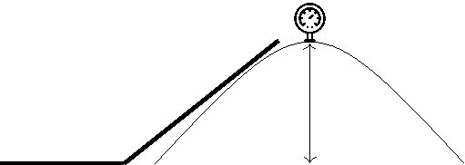

|  |  |  |
| --- | --- | --- |
|  |  | Pressure = 62psi |
| Flow = 120gpm |  | 60’ |

Pressure = 100psi 

Total headloss = Headloss due to elevation gain + Headloss due to friction

= Headloss due to friction = Total headloss - Headloss due to elevation gain

|  |  |  |  |  |  |  |  |  |
| --- | --- | --- | --- | --- | --- | --- | --- | --- |
| Total headloss = (100 −62) |  |  |  | f t | head |  | = 87.8 f t |  |
| 0.433psi | | | |  |
| psi |  |
| Headloss due to elevation gain = 60 | | | | | f t | |  |  |

= Headloss due to friction = 87.8 −60 = 27.8 f t

Practice Problems - Pumping Power Requirements

1. If a pump is operating at 2,200 gpm and 60 feet of head, what is the water horsepower? If the pump efficiency is 71%, what is the brake horsepower?

Solution:

water Hp = flow * head

H p

2, 200GPM 60 f t 3, 960GPM − f t = Water H p = 33.3H p

374 Chapter 11. Assessments Solutions

pump Hp = brake Hp * pump efficiency

33.3

brake H p = = Brake H p = 47H p

1. The water horsepower of a pump is 10Hp and the brake horsepower output of the motor is 15.4Hp. What is the efficiency of the pump?

Solution:



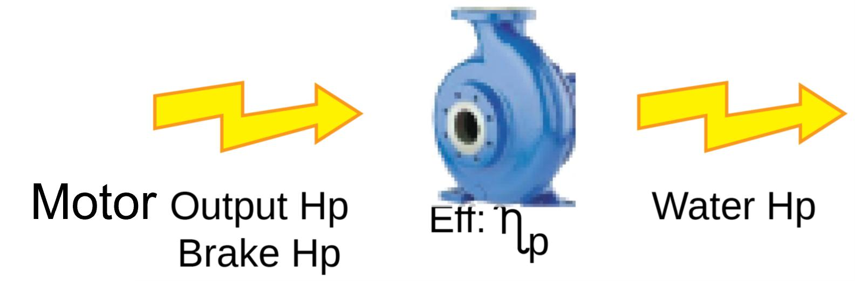 ηp = 10BHp ×100 = 65% 15.4EHp

1. The water horsepower of a pump is 25Hp and the brake horsepower output of the motor is 48Hp. What is the efficiency of the pump?

Solution:



 ηp = 25 Water Hp ×100 = 52% 48 brake Hp

1. The efficiency of a well pump is determined to be 75%. The efficiency of the motor is estimated at 94%. What is the efficiency of the well?

Solution:

Well e f f iciency = ηm ηp = 0.94 ×0.75 = 0.705 ×100 = 71%

1. If a motor is 85% efficient and the output of the motor is determined to be 10 BHp, what is the electrical horsepower requirement of the motor? Solution:

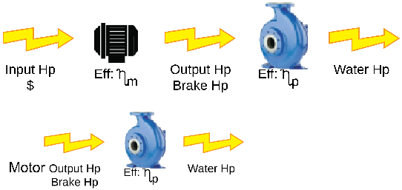

10BHp

= 11.8EHp or Input Hp

1. The water horsepower of a well with a submersible pump has been calculated at 8.2 WHp. The Output of the electric motor is measured as 10.3BHp. What is the efficiency of the

|  |  |
| --- | --- |
| 11.9 Chapter 10 - Math | 375 |
|  |  |

pump?

Solution:



ηp = 82 W Hp ×100 = 79.6% 10.3 BHp

1. Water is being pumped from a reservoir to a storage tank on a hill. The elevation difference between water levels is 1200 feet. Find the pump size (in Hp) required to fill the tank at a rate of 120 gpm.

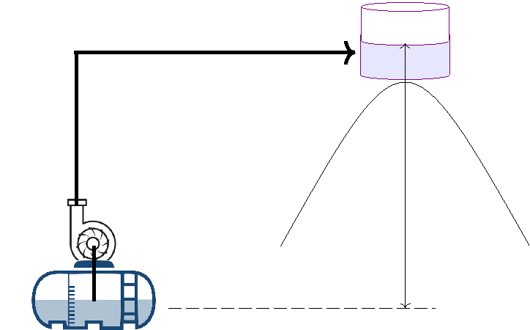

|  |  |
| --- | --- |
| Flow = 120gpm | Water |
|  | Storage |

Elevation difference = 1200 ft

Solution:

water Hp = flow * head

H p

120GPM 1, 200 f t 3, 960GPM − f t = Water H p = 36.4H p

Practice Problems - Well Hydraulics

1. A well yields 2,840 gallons in exactly 20 minutes. What is the well yield in gpm? Solution:

2, 840gal = 142 gal

20min min

1. Before pumping, the water level in a well is 15 ft. down. During pumping, the water level is 45 ft. down. The drawdown is:

Solution:

45 −15 = 30 f t

1. A well is located in an aquifer with a water table elevation 20 feet below the ground sur-face. After operating for three hours, the water level in the well stabilizes at 50 feet below

376 Chapter 11. Assessments Solutions

the ground surface. Calculate the pumping water level.

Solution:

50 f t

1. Calculate drawdown, in feet, using the following data:

The water level in a well is 20 feet below the ground surface when the pump is not in operation, and the water level is 35 feet below the ground surface when the pump is in operation.

Solution:

Drawdown = 35ft −20ft = 15 f t

1. Calculate the well yield in gpm, given a drawdown of 14.1 ft and a specific yield of 31 gpm/ft.

Solution:

Yield (gpm)

Speci f ic Yield (gpm/ f t) =

Drawdown ( f t)

= Yield (gpm) = Speci f ic Yield (gpm/ f t) Drawdown ( f t) = 31 14.1 = 437.1 gpm

Practice Problems - Sedimentation

1. Calculate the detention time for a sedimentation tank that is 48 feet wide, 210 feet long and 9 feet deep with a flow of 5 MGD.

|  |  |  |  |  |  |  |  |  |  |  |  |  |  |  |  |  |  |  |  |  |  |  |  |  |  |  |  |  |  |  |
| --- | --- | --- | --- | --- | --- | --- | --- | --- | --- | --- | --- | --- | --- | --- | --- | --- | --- | --- | --- | --- | --- | --- | --- | --- | --- | --- | --- | --- | --- | --- |
| Solution: |  |  |  |  | Clari f ier volume(cu. f t | | | | | | | | | | | | | | |  | or gal) | | | |  | | | | |  |
| Clari f ier | detention time (hr) = | | |  |  |  |
| In f luent | | | | |  | f low | (cu. f t | | | | | | or | | | | gal)/hr) | | | | | | | | |  |
|  |  |  |  |  |  |
|  |  | | |  |  |  |  | (48 210 9) f t3 | | | | | | | | | | | |  |  |  |  |  | |  |  |  |  |  |
| Clari f ier | detention time (hr) = | | |  | | |  |  |  | |  | = | |  | 3.25hrs |  |  |  |
|  |  |  |  | 10 | | | 6 |  |  |  | f t | 3 |  |  |  |  |  |  |  |  |  |  |  |  |  |
|  |  |  |  |  |  |  |  |  |  |  |  |  |  |  |  |  |  |
|  |  |  |  | 5MG | | | gal |  |  |  |  |  |  |  |  |  |  | day | | | | | | | |  |
|  |  |  |  |  |  |  |  |  |  |  |  |  |  |  |  |  |  |  |  |  |  |  |  |  |  |  |  |  |  |  |
|  |  |  |  |  | day | |  |  |  |  |  | 7.48gal | | | | | | | | |  | 24hrs | | | | | | | |  |
|  |  |  |  |  |  | MG | | |  |  |
|  |  |  |  |  |  |  |  |  |  |  |  |  |  | | | |  |  |  |  |  |  |  |  |  |  |  |  |  |  |
| 2. At a 2.5 MGD wastewater treatment plant the primary clarifier has a detention time of 2 | | | | | | | | | | | | | | | | | | | | | | | | | | | | | |  |
| hours. How many gallons does this clarifier hold? | | | | | | | | | | |  |  |  |  |  |  |  |  |  |  |  |  |  |  |  |  |  |  |  |  |
| Solution: |  |  |  |  |  |  |  |  |  |  |  |  |  |  |  |  |  |  |  |  |  |  |  |  |  |  |  |  |  |  |
| Clari f ier | detention time (hr) = | | |  | Clari f ier | | | | | volume(gal) | | | | | | | | |  |  |  |  |  |  |  |  |  |  |  |  |
| In f luent | | | | |  | f low | (gal/hr) | | | | | | | | |  |  |  |  |  |  |  |  |  |  |  |
|  |  |  |  |  |  |  |  |  |  |  |  |  |  |  |  |
| = Clari f ier | | volume(gal) = Clari f ier | | | | |  | detention | | | | | time | | | | (hr) In f luent f low (gal/hr) | | | | | | | | | | | | |  |
|  |  |  |  |  |  |  |  |  |  |  |  |  |  | gal | | |  |  |  |  | day | | | | | |  | |  |  |
| = Clari f ier | | volume(gal) = | 2 hrs | | | | | | 2.5 106 | | | |  |  | |  |  | | |  | | | = | | | | 208, 333 gals | |  |  |
| day | | | | 24 hrs | | |  |
|  | |  |  |

1. A circular clarifier has a diameter of 80 ft. If the flow to the clarifier is 1800 gpm, what is the surface overflow rate in gpm/ft?

Solution:

|  |  |  |  |  |  |  |  |
| --- | --- | --- | --- | --- | --- | --- | --- |
| 11.9 Chapter 10 - Math | |  |  |  | 377 | |  |
|  |  |  |  |  |  |  |  |
|  | Flow, gpm |  |  | 1, 800 gpm |  |  |  |
| Surface overflow rate = | = |  | = | 0.36 gpm/ft2 |  |
|  |  |  |  |
|  |  |  |  |
| Clarifier surface area, ft2 | |  | (0.785 802)ft2 | |  |  |  |
|  |  |  |  |

1. A sedimentation basin 70 ft by 25 ft receives a flow of 1000 gpm. What is the surface overflow rate in gpm/ft2?

|  |  |  |  |  |  |  |  |
| --- | --- | --- | --- | --- | --- | --- | --- |
| Solution: | |  |  |  |  |  |  |
|  | Flow, gpm |  | 1, 000 gpm | |  |  |  |
| Surface overflow rate = | = | = | 0.6 gpm/ft2 |  |
|  |  |  |  |
| Clarifier surface area, ft2 | | (70ft | | 25ft)ft2 |  |  |  |
|  |  |  |

1. A circular clarifier receives a flow of 3.55 MGD. If the diameter of the weir is 90 ft, what is the weir loading rate in gpm/ft?

|  |  |  |  |  |  |  |  |  |  |  |  |  |  |  |  |  |  |
| --- | --- | --- | --- | --- | --- | --- | --- | --- | --- | --- | --- | --- | --- | --- | --- | --- | --- |
| Solution | | | | |  |  |  | Flow, | | gpm | | | | | | |  |
| Weir | overflow rate = | | | | | | |  |
|  |  |  |  |  |  |  |  |  |  |
| Weir length | | | | f t | | | | |  |
|  |  |  |  |  |  |  |  |  |
|  |  | 3.55 MG | | |  | 1, 000, 000 | | | gal | |  |  | day | | | |  |
|  |  |  |  |  |  |  |  |  |  |  | |  |  |  |  |
|  |  |  | day |  |  | | MG |  |  | 1440 min | |  |  |  |  |
| = |  |  |  |  |  |  |  |  | = | 2, 465 gpm/ft |  |
|  |  |  |  |  | ( . | |  | ) |  |  |  |  |  |  |
|  |  |  |  |  |  |  | 3 14 90 | |  | ft |  |  |  |  |  |  |  |
|  |  |  |  |  |  |  |  |  |  |  |  |  |  |  |

Note: The concentration and volume (or flow) units need to be the same. Thus, the gpm flow rate of Line 1 was converted to math the MGD flow rate unit of Line 2.

Practice Problems - Filtration

1. At an average flow of 4,000 gpm, how long of a filter run in hours would be required to produce 25 MG of filtered water?

|  |  |  |  |  |  |  |  |  |  |
| --- | --- | --- | --- | --- | --- | --- | --- | --- | --- |
| Solution | | |  |  |  |  |  |  |  |
| Flow rate (gpm) = | Total f low (gal) | | | | | |  |  |  |
|  |  |  |  |  |  |  |  |  |
|  |  | (min) | | | |  |  |  |
| Filter run time | | |  |  |  |
| = Filter run time (min) = | | Total | f low (gal) | | | |  |  |  |
|  | |  | |  |  |  |  |
| Flow rate (gpm) | | | |  |  |  |
|  |  |  |  | 1, 000, 000 gal | | | | |  |
| = Filter run time (hr) = 25 MG | | |  |  |  | |  |  |  |
|  |  | MG | |  |  |

|  |  |  |  |  |  |  |  |  |
| --- | --- | --- | --- | --- | --- | --- | --- | --- |
|  |  |  |  | hr | |  |  |  |
| min | | 60 |  | = | 104 hrs |  |
| 4, 000 gal |  |  | min |  |  |
|  |  |  |  |  |  |
|  |  |  |  |  |  |  |  |  |

1. A filter is 40ft long by 20ft wide. During a test of flow rate, the influent valve to the filter

is closed for 6 minutes. The water level drop during this period is 16 inches. What is the filtration rate for the filter in gpm/ft2 ?

|  |  |  |  |  |  |  |  |  |  |  |  |
| --- | --- | --- | --- | --- | --- | --- | --- | --- | --- | --- | --- |
| Solution | | f t | | |  | gal | | | | |  |
|  | (40ft 20ft 16in | ) f t3 7.48 |  |
|  |  |  |  |  |  |  |  |  |  |
| 12 | in | |  | f t3 | | |  |  |
| Filtration rate, gpm/ft2 = |  | 1.7 gpm/ f t2 |  |
|  |  |  |  |  |  |  |  | = |  |
| 40 f t 20 | | f eet | | |  |  |  |  |
|  |  |  |  |  |  |  |

1. A water treatment plant treats 6.0 MGD with four filters. Each filter use 60,000 gallons per wash. What is the percent backwash at the plant?

Solution:

|  |  |  |  |  |  |  |
| --- | --- | --- | --- | --- | --- | --- |
| 378 |  |  |  | Chapter 11. Assessments Solutions | |  |
|  |  |  |  |  |  |  |
|  | 60, 000 4 gal |  |  |  |  |  |
| Backwash water, % = | × | 100 = | 4% |  |  |
| 6, 000, 000 gal | |  |  |  |  |
|  |  |  |  |

1. A treatment plant filter washes at a rate of 10,000 GPM. The filter measures 18ft. wide by 24ft. long. What is the rate of rise expressed in inches per minute?

Solution:

Backwash rate, gpm/ft2 ×12in/ft

Backwash rinse rate, in/min =

7.48gal/ft3

Based upon the above formula, the Backwash tate in gpm/ f t2 needs to be calculated by dividing the gpm flow by the surface area

|  |  |  |  |  |  |  |  |  |  |  |  |
| --- | --- | --- | --- | --- | --- | --- | --- | --- | --- | --- | --- |
|  | 10, 000gpm | | | | ! × | 12in | | | | |  |
|  |  |  |  |  |  |  |  |  |  |  |
|  |  | 18ft | × | 24ft |  | ft |  |  |  |  |
| Backwash Rinse Rate, in/min = |  |  |  | = | 37in/min |  |
|  | |  |  |  |  |  |  |  |
|  |  | 7.48gal/ft3 | | | |  |  |  |  |  |  |
|  |  |  |  |  |  |  |  |

1. If a filter measures 20 feet by 30 feet by 7 foot deep and the backwash flow is 3.5cuft/sec, what is the backwash rate?

|  |  |  |  |  |  |  |  |  |  |  |  |  |  |
| --- | --- | --- | --- | --- | --- | --- | --- | --- | --- | --- | --- | --- | --- |
| Solution: | | |  |  |  |  |  |  |  |  |  |  |  |
|  |  | 3.5 f t3 |  | 7.48 gal | |  | 60 sec |  | |  | |  |  |
| Backwash Rate (gpm/sq.ft)= | sec | | f t3 |  | min |  | = |  | 2.6 gpm |  |  |
|  | | (20 30) | | f t2 | |  |  | f t |  |  |
|  |  |  |  |  |  |  |  |  |

XII Appendix

|  |  |  |
| --- | --- | --- |
| A | Treatment Exam - ROK . . . . . . . . . . . . . . | 381 |
| B | Distribution Exam - ROK . . . . . . . . . . . . . | 393 |
| C | Wastewater Exams . . . . . . . . . . . . . . . . . . | 409 |
| D | Water Treatment Facilities Classification | |
|  | 415 |  |
| E | California Code of Regulations Drinking | |
|  | Water Regulations TOC . . . . . . . . . . . . . . | 419 |
| F | Primary and Secondary Contaminant |  |
|  | Levels . . . . . . . . . . . . . . . . . . . . . . . . . . . . . . | 433 |
| G | CCR Drinking Water Regs - TOC . . . . . | 441 |
| H | SDS Content - OSHA Guidance . . . . . . | 455 |
| I | Sample SDS . . . . . . . . . . . . . . . . . . . . . . . . | 463 |

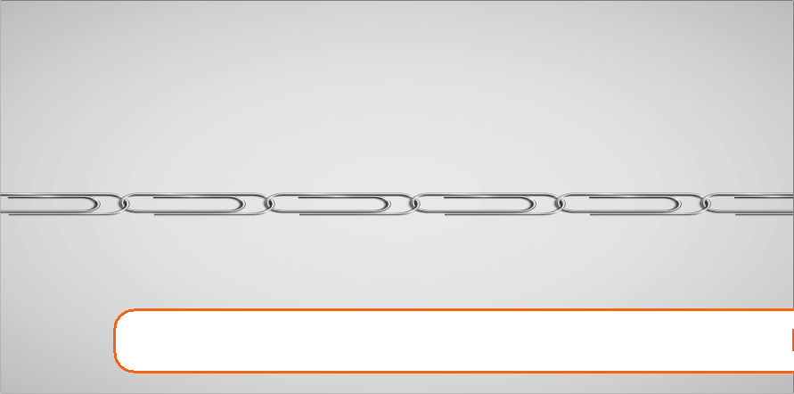

A. Treatment Exam - ROK



**Expected Range of Knowledge for Drinking Water Treatment Exam**

|  |  |  |  |  |
| --- | --- | --- | --- | --- |
|  | **Number of questions by Exam Grade** | | | |
| **Content Category** | **T1** | **T2** | **T3** | **T4** |
| Source Water | 25 | 25 | 20 | 15 |
| Water Treatment Processes | 25 | 25 | 35 | 20 |
| Operation / Maintenance | 20 | 20 | 15 | 15 |
| Laboratory Procedures | 15 | 15 | 15 | 15 |
| Regulations / Administrative Duties | 15 | 15 | 15 | 35 |
|  |  |  |  |  |

Source Water

Clear Well Storage

Raw Water Storage

Surface Water/Reservoirs

Watershed Protection

Wells/Groundwater

Water Treatment Processes

|  |  |  |
| --- | --- | --- |
| Coagulation | Corrosion Control | Flocculation |
| Sedimentation | Taste and Odor | Best Available Technology |
| Filtration | Iron and Manganese Removal |  |
| Disinfection | Fluoridation |  |

Operation / Maintenance

Chemical Feeders

Pumps, Motors, and Gearboxes

Blowers and Compressors

Water Meters

Pressure Gauges

Instrumentation

Electrical Generators

Laboratory Procedures

|  |  |  |
| --- | --- | --- |
| Sampling | pH Analysis | Fluoride Analysis |
| General Lab Practices | Turbidity Analysis | Color Analysis |
| Disinfectant Analysis | Specific Conductance | Taste and Odor Analysis |
| Alkalinity Analysis | Hardness | Microbiological Analysis |

Safety / Regulations / Administrative Duties

|  |  |  |
| --- | --- | --- |
| Controlling | Organizing | Safety |
| Directing | Planning | Secondary Contaminants |
| Implementing Regulations | Primary Contaminants | Total Coliform Rule |
| Lead and Copper Rule | Recordkeeping |  |
| California Waterworks Standards |  |  |
| Operator Certification Regulations |  |  |
| Safe Drinking Water Act & Amendments |  |  |

Surface Water Treatment Rule and Amendments

**Expected Range of Knowledge for Drinking Water Treatment Exam**

The tables below list specific objectives in each content category. The specific exam grades where these objectives are included are also provided below.

**Source Water**

T1 - T4 Ability to calculate flow rates and water velocity

T1 - T4 Ability to calculate the volume of water in a storage facility

T1 - T4 Ability to calculate well drawdown

T1 - T4 Ability to calculate detention time

T1 - T4 Ability to calculate well specific capacity

T1 - T4 Ability to calculate well head pressure

T1 - T4 Ability to convert common water units (e.g. gallons per minute to MGD)

T1 - T4 Ability to convert head pressure to water elevation

T1 - T4 Ability to convert units of length, volume, flow and pressure

T1 - T4 Ability to determine water level in a storage tank, reservoir, or well

T1 - T4 Ability to recognize abnormal chemical characteristics of water

T1 - T4 Ability to recognize abnormal odors or colors

T1 - T4 Ability to recognize abnormal well operations

T1 - T4 Ability to recognize potential security risks

T1 - T4 Ability to recognize potential sources of contamination in surface water

T1 - T4 Ability to recognize the influence of surface water on a groundwater source

T1 - T4 Knowledge of chemicals that contribute alkalinity and hardness to water

T1 - T4 Knowledge of common chemical and microbial contaminants in raw water

T1 - T4 Knowledge of flow measurement devices

T1 - T4 Knowledge of potential microbial and chemical contamination sources in groundwater and surface water

T1 - T4 Knowledge of problems caused by hard water

T1 - T4 Knowledge of storage tank disinfection procedures

T1 - T4 Knowledge of the characteristics of aquifers

T1 - T4 Knowledge of the chemical components of groundwater and surface water

T1 - T4 Knowledge of the hydrologic cycle

T1 - T4 Knowledge of visual signs of contamination in a surface water reservoir

T1 - T4 Knowledge of well components

T1 - T4 Knowledge of well depth measurement procedures

T1 - T4 Knowledge of well disinfection procedures

T1 - T4 Knowledge of well drawdown measurement techniques

T2 - T4 Ability to discriminate between normal and abnormal conditions of a surface water reservoir

T2 - T4 Ability to recognize hydrological changes

T2 - T4 Knowledge of how reservoir intake level effects water quality

T2 - T4 Knowledge of the effects of seasonal changes on water reservoirs

2

Rev. 4/2020

**Expected Range of Knowledge for Drinking Water Treatment Exam**

T2 - T4 Knowledge of pretreatment procedures

T3 - T4 Knowledge of surface water reservoir stratification

T3 - T4 Ability to recognize head loss across an intake screen

T3 - T4 Knowledge of groundwater treatment procedures

**Water Treatment Processes**

Coagulation/Flocculation/Sedimentation

T3 - T4 Ability to calculate a coagulant dose from a jar test

T3 - T4 Ability to perform a jar test

T3 - T4 Ability to recognize and correct abnormal conditions in a sedimentation basin

T3 - T4 Ability to recognize normal and abnormal floc formation

T3 - T4 Knowledge of flocculation tanks

T3 - T4 Knowledge of chemical coagulants and coagulant aids

T3 - T4 Knowledge of coagulation/flocculation start-up/shutdown and adjustment procedures

T3 - T4 Knowledge of enhanced coagulation

T3 - T4 Knowledge of sedimentation basins

T3 - T4 Knowledge of the coagulation/flocculation process

T3 - T4 Knowledge of the effects of temperature, alkalinity, and pH on flocculation

T3 - T4 Knowledge of the flash mixing process

T3 - T4 Knowledge of the jar testing procedure

T3 - T4 Knowledge of the sedimentation process

T3 - T4 Knowledge of tube settlers

T4 Knowledge of water gradient velocities

T4 Knowledge of the zeta potential

T4 Knowledge of Van Der Waals forces

T4 Knowledge of ballasted flocculation procedures

Filtration

T1 - T4 Ability to interpret turbidity information

T1 - T4 Knowledge of turbidity causing matter

T2 - T4 Ability to calculate daily filter production

T2 - T4 Ability to calculate filter backwash rate

T2 - T4 Knowledge of head loss effects on filters

T2 - T4 Knowledge of filter surface washing methods

T2 - T4 Knowledge of filtration mechanisms (absorption, adsorption)

T3 - T4 Ability to calculate a filter-aid dosage

T3 - T4 Ability to calculate a filtration rate

T3 - T4 Ability to calculate filter loading rate

T3 - T4 Ability to recognize and correct problems in gravity filters

3

Rev. 4/2020

**Expected Range of Knowledge for Drinking Water Treatment Exam**

T3 - T4 Ability to recognize and correct problems in multimedia filters

T3 - T4 Knowledge of backwash sequencing

T3 - T4 Knowledge of filter media types and uses

T3 - T4 Knowledge of maximum filtration rates

T3 - T4 Knowledge of normal and abnormal filter media conditions

T3 - T4 Ability to calculate filter media volume and capacity

T4 Ability to conduct a comprehensive performance evaluation of a filter

T4 Ability to operate an air scour system

T4 Ability to perform a filter assessment surveillance program

T4 Ability to perform a filter profile analysis

T4 Ability to recognize and correct problems in granular activated carbon filters

T4 Knowledge of air scouring systems

T4 Knowledge of filter media replacement requirements and techniques

T4 Knowledge of filter porosity

Disinfection

T1 - T4 Ability to calculate a chemical dosage

T1 - T4 Ability to calculate a chemical solution concentration

T1 - T4 Ability to calculate chlorine demand and chlorine residual

T1 - T4 Knowledge of acceptable chlorine residual levels

T1 - T4 Knowledge of breakpoint chlorination chemistry

T1 - T4 Knowledge of chlorine chemistry

T1 - T4 Knowledge of common chlorine compounds used for disinfection

T1 - T4 Knowledge of disinfectant byproduct formation

T1 - T4 Knowledge of disinfectant properties and uses

T1 - T4 Knowledge of disinfection residual requirements

T1 - T4 Knowledge of MCLs and MRDLs of disinfectants

T2 - T4 Ability to calculate a CT value

T2 - T4 Ability to choose an appropriate disinfectant for a specific microbial problem

T2 - T4 Knowledge of chloramine chemistry

T2 - T4 Knowledge of disinfectant byproduct reduction procedures

T2 - T4 Knowledge of TOC/Disinfection byproduct correlation

Corrosion Control

T1 - T4 Ability to recognize corrosion problems

T1 - T4 Knowledge of pH adjustment procedures

T1 - T4 Knowledge of corrosion causes

T2 - T4 Knowledge of corrosion reduction methods

T3 - T4 Knowledge of C-factor

T3 - T4 Knowledge of the cathodic protection process

4

Rev. 4/2020

**Expected Range of Knowledge for Drinking Water Treatment Exam**

T3 - T4 Knowledge of corrosion control inhibitors

T3 - T4 Knowledge of the Langelier Index

T3 - T4 Knowledge of corrosion control chemical reactions

T4 Ability to choose the proper corrosion control chemical for a specific problem

Taste and Odor

T1 - T4 Knowledge of abnormal taste and odors

T1 - T4 Knowledge of chemicals that contribute taste and odor

T1 - T4 Knowledge of taste and odor treatment processes

Iron and Manganese

T1 - T4 Ability to recognize an iron and manganese problem

T3 - T4 Knowledge of iron and manganese oxidation chemistry

T3 - T4 Knowledge of iron and manganese removal techniques

Fluoridation

T4 Knowledge fluoridation chemicals

T4 Knowledge of fluoride chemistry

T4 Knowledge of optimal fluoride level range

T4 Knowledge of the health effects of fluoride

Best Available Technology (BAT)

T1 - T4 Knowledge of health effects of lead and copper

T1 - T4 Knowledge of adverse health effects caused by common contaminants

T2 - T4 Knowledge of Best Available Technology (BAT) for common water contaminants

T2 - T4 Knowledge of effective removal techniques for common contaminants

T3 - T4 Ability to perform blending calculations

T3 - T4 Knowledge of the aeration process

T4 Knowledge of chemical oxidation techniques and uses

T4 Knowledge of granular activated carbon (GAC)

T4 Knowledge of nitrate removal processes

**Operation / Maintenance**

Chemical Feeders

T1 - T4 Ability to calculate a dosage for a chemical feeder

T1 - T4 Ability to calibrate and adjust a chemical feeder pump

T1 - T4 Ability to operate a chemical feeder system

T1 - T4 Ability to replace components of a chemical feeder system

T1 - T4 Ability to set proper chemical feed rate

T1 - T4 Knowledge of chemical feeder calibration and adjustment

5

Rev. 4/2020

**Expected Range of Knowledge for Drinking Water Treatment Exam**

T1 - T4 Knowledge of the components of chemical feeder systems

T1 - T4 Knowledge of the operation of chemical feeder systems

Pumps, Motors, and Gearboxes

T1 - T4 Ability to discriminate between normal and abnormal operation of a water pump

T1 - T4 Knowledge of pump types and uses

T1 - T4 Knowledge of the components of a water pump

T1 - T4 Knowledge of the operation of a water pump

T1 - T4 Knowledge of valve types and uses

T1 - T4 Ability to replace components of a water pump

T2 - T4 Knowledge of pump installation procedures

Blowers and Compressors

T3 - T4 Knowledge of the operation of blowers and compressors

T3 - T4 Ability to discriminate between normal and abnormal operation of blowers and compressors

T4 Ability to replace components of blowers and compressors

T4 Knowledge of the components of blowers and compressors

Water Meters

T1 - T4 Ability to read and interpret water meter readings

T1 - T4 Knowledge of the components of water meters

T1 - T4 Knowledge of the operation of water meters

T1 - T4 Knowledge of water meter types and uses

T2 - T4 Ability to calibrate a water meter

Pressure Gauges

T1 - T4 Knowledge of head pressure

T1 - T4 Knowledge of the operation of pressure gauges

T2 - T4 Ability to replace pressure gauges

T3 - T4 Knowledge of the components of pressure gauges

Instrumentation

T1 - T4 Knowledge of basic SCADA system components

T2 - T4 Ability to determine normal operation of a SCADA system

T2 - T4 Knowledge of the components of on-line analyzers

T3 - T4 Ability to recognize analytical interferences in on-line analyzers

T3 - T4 Ability to repair or replace defective parts of on-line analyzers

T3 - T4 Knowledge of the operation of on-line analyzers

6

Rev. 4/2020

**Expected Range of Knowledge for Drinking Water Treatment Exam**

Electrical Generators

T3 - T4 Knowledge of the operation of an electrical generator

T3 - T4 Knowledge of the components of an electrical generator

**Laboratory Procedures**

Sampling

T1 - T4 Ability to collect a water sample

T1 - T4 Ability to determine a proper sampling site

T1 - T4 Ability to follow chain of custody

T1 - T4 Knowledge of appropriate sample containers and sample sizes

T1 - T4 Knowledge of maximum holding times

T1 - T4 Knowledge of proper sampling and preservation techniques

T1 - T4 Knowledge of well sampling techniques

General Laboratory Practices

T1 - T4 Ability to calculate a chemical solution concentration

T1 - T4 Knowledge of chemical hazards

T2 - T4 Ability to calculate a dilution factor

T2 - T4 Ability to mix chemicals and prepare reagents

T2 - T4 Ability to perform dilutions

Disinfectant Analysis

T1 - T4 Ability to analyze a water sample for free and total chlorine

T1 - T4 Ability to read and interpret a colorimeter

T1 - T4 Knowledge of approved analytical procedures for chlorine analysis

T1 - T4 Knowledge of chlorine chemistry

Alkalinity Analysis

T2 - T4 Knowledge of chemicals that contribute alkalinity to water

T3 - T4 Ability to use a titrator

T3 - T4 Ability to recognize a titration endpoint

T3 - T4 Knowledge of abnormal alkalinity levels

pH Analysis

T1 - T4 Ability to read and interpret a pH meter

T1 - T4 Knowledge of acids and bases

T1 - T4 Knowledge of acceptable water pH range

T1 - T4 Knowledge of chemicals that affect the pH of water

T1 - T4 Knowledge of the effects of pH on water quality

T1 - T4 Knowledge of the pH scale

7

Rev. 4/2020

**Expected Range of Knowledge for Drinking Water Treatment Exam**

T1 - T4 Ability to analyze a water sample for pH

T2 - T4 Ability to calibrate a pH meter

Turbidity Analysis

T1 - T4 Ability to analyze a water sample for turbidity

T1 - T4 Ability to read and interpret a turbidimeter

T1 - T4 Knowledge of the Nephelometric Turbidity Unit (NTU) scale

T1 - T4 Knowledge of turbidimeter instrumentation

T1 - T4 Knowledge of turbidity causing matter

T1 T4 Knowledge of turbidity level requirements



T2 - T4 Ability to prepare and calibrate turbidimeter with Primary Standard (Formazin)

Specific Conductance

T3 - T4 Ability to analyze a water sample for specific conductance

T3 - T4 Ability to read and interpret a specific conductance meter

T4 Ability to calculate a TDS value from a specific conductance reading

T4 Knowledge of EC/TDS ratio

T4 Ability to calibrate a specific conductance meter

Hardness

T1 - T4 Knowledge of chemicals that contribute hardness to water

T2 - T4 Ability to analyze a water sample for water hardness

T2 - T4 Knowledge of hardness removal processes

Fluoride Analysis

T4 Ability to operate an Ion Specific Electrode (ISE)

T4 Knowledge of optimal fluoride level range

Color Analysis

T2 - T4 Ability to recognize abnormal colors in water

T3 - T4 Knowledge of abnormal color levels

T4 Knowledge of color analysis scale

T4 Knowledge of true and apparent color

Taste and Odor Analysis

T1 - T4 Ability to identify an objectionable taste or odor in water

T1 - T4 Knowledge of chemicals that contribute taste and odor to water

T4 Knowledge of odor analysis protocol

8

Rev. 4/2020

**Expected Range of Knowledge for Drinking Water Treatment Exam**

Microbiological Analysis

T1 - T4 Knowledge of the presence/absence test method

T1 - T4 Knowledge of approved analytical procedures for coliform analysis

T1 - T4 Knowledge of common microbial contaminants in raw water

T2 - T4 Knowledge of Heterotrophic Plate Count (HPC)

T3 - T4 Ability to distinguish between presumptive and confirmed coliform results

T3 - T4 Knowledge of the multiple tube fermentation method

T3 - T4 Knowledge of the membrane filtration method

**Safety / Regulations / Administrative Duties**

Safety

T1 - T4 Ability to demonstrate safe work habits

T1 - T4 Ability to identify potential safety hazards

T1 - T4 Ability to recognize unsafe working conditions

T1 - T4 Ability to select and utilize safety equipment

T1 - T4 Knowledge of chemical hazards

T1 - T4 Knowledge of compressed gas safety procedures

T1 - T4 Knowledge of confined space safety procedures

T1 - T4 Knowledge of electrical safety

T1 - T4 Knowledge of hazardous chemical handling

T1 - T4 Knowledge of incompatible chemicals

T1 - T4 Knowledge of lock-out/tag-out procedures

T1 - T4 Knowledge of Material Safety Data (MSD) sheets

T1 - T4 Knowledge of personal protective equipment (PPE)

T1 - T4 Knowledge of proper chemical handling techniques

T1 - T4 Knowledge of safe working practices

T1 - T4 Knowledge of the use of safety equipment

T2 - T4 Knowledge of HAZWOPER guidelines

T3 - T4 Ability to administer a safety plan

T3 - T4 Ability to generate a written safety plan

Regulations / Administrative Duties

T1 - T4 Ability to interpret water quality characteristics (hardness, turbidity, pH)

T1 - T4 Knowledge of basic unit processes used in treating drinking water

T1 - T4 Knowledge of corrective actions to take when regulations are violated

T1 - T4 Knowledge of drinking water monitoring and reporting requirements

T1 - T4 Knowledge of drinking water regulations

T1 - T4 Knowledge of notification protocol and procedures

T1 - T4 Knowledge of NSF Standards

9

Rev. 4/2020

**Expected Range of Knowledge for Drinking Water Treatment Exam**

T1 - T4 Knowledge of operator certification requirements

T1 - T4 Knowledge of Primary and Secondary Drinking Water Standards

T1 - T4 Knowledge of public notification procedures

T1 - T4 Knowledge of record keeping requirements

T1 - T4 Knowledge of California Waterworks Standards

T1 - T4 Knowledge of the Consumer Confidence Report (CCR)

T1 - T4 Knowledge of the Disinfectants and Disinfection Byproduct Rule and amendments

T1 - T4 Knowledge of the Groundwater Rule

T1 - T4 Knowledge of the Lead and Copper Rule

T1 - T4 Knowledge of the Surface Water Treatment Rule and amendments

T1 - T4 Knowledge of the Total Coliform Rule and amendments

T1 - T4 Knowledge of waterborne pathogens

T1 - T4 Ability to interpret water quality reports

T1 - T4 Ability to research and interpret Maximum Contaminant Levels (MCLs)

T2 - T4 Ability to administer a maintenance program

T2 - T4 Knowledge of cryptosporidium action plan

T2 - T4 Knowledge of pending regulations

T2 - T4 Knowledge of performance standards and removal requirements for surface water treatment

T2 - T4 Knowledge of the Filter Backwash Rule

T2 - T4 Knowledge of routine sampling requirements

T3 - T4 Ability to administer a regulatory compliance program

T3 - T4 Ability to calculate percent or log removal of contaminants from water

T3 - T4 Ability to calculate the cost of water treatment operations

T3 - T4 Ability to develop an operational site sampling plan

T3 - T4 Ability to develop an operations plan

T3 - T4 Ability to evaluate treatment facility performance

T3 - T4 Knowledge of facility operation and maintenance

T3 - T4 Knowledge of management principles

T3 - T4 Knowledge of permit requirements for water operations

T3 - T4 Knowledge of principles of supervision

T3 - T4 Knowledge of public relations principles

T3 - T4 Knowledge of pump to waste discharge environmental regulations

T3 - T4 Knowledge of regulatory primacy issues

T3 - T4 Knowledge of source water replenishment processes

T3 - T4 Knowledge of the Sanitary Survey process

T4 Ability to interpret historical water use data

T4 Knowledge of the role of Regional Boards in managing contamination sources

T4 Knowledge of the Source Water Assessment Program

T4 Knowledge of the Watershed Survey process

10

Rev. 4/2020

**Expected Range of Knowledge for Drinking Water Treatment Exam**

T4 Knowledge of the vulnerability assessment process

**Water Treatment Exam Math**

T1 - T4 Ability to calculate flow rates and water velocity

T1 - T4 Ability to calculate the volume of water in a storage facility

T1 - T4 Ability to calculate well drawdown

T1 - T4 Ability to calculate detention time

T1 - T4 Ability to calculate well specific capacity

T1 - T4 Ability to calculate well head pressure

T1 - T4 Ability to convert common water units, (gallons per minute to MGD, etc…)

T1 - T4 Ability to convert head pressure to water elevation

T1 - T4 Ability to convert units of length, volume, flow and pressure

T1 - T4 Ability to determine water level in a storage tank, reservoir or well

T1 - T4 Ability to calculate a chemical dosage

T1 - T4 Ability to calculate a chemical solution concentration

T1 - T4 Ability to calculate chlorine demand and chlorine residual

T1 - T4 Ability to calculate a dosage for a chemical feeder

T1 - T4 Ability to calculate a chemical solution concentration

T2 - T4 Ability to calculate daily filter production

T2 - T4 Ability to calculate filter backwash rate

T2 - T4 Ability to calculate a CT value

T2 - T4 Ability to calculate a dilution factor

T2 - T4 Ability to perform dilutions

T3 - T4 Ability to calculate a coagulant dose from a jar test

T3 - T4 Ability to calculate a filter-aid dosage

T3 - T4 Ability to calculate a filtration rate

T3 - T4 Ability to calculate filter loading rate

T3 - T4 Ability to calculate percent or log removal of contaminants from water

T3 - T4 Ability to calculate the cost of water treatment operations

11

Rev. 4/2020



B. Distribution Exam - ROK



**Expected Range of Knowledge for Drinking Water Distribution Exam**

|  |  |  |  |  |  |  |
| --- | --- | --- | --- | --- | --- | --- |
|  | **Number of questions by Exam Grade** | | | | |  |
| **Content Category** | **D1** | **D2** | **D3** | **D4** | **D5** |  |
| Disinfection | 15 | 20 | 20 | 15 | 10 |  |
| Distribution System Design / Hydraulics | 20 | 20 | 15 | 10 | 10 |  |
| Equipment Operation / Maintenance / | 20 | 20 | 25 | 20 | 15 |  |
| Inspections |  |
|  |  |  |  |  |  |
| Drinking Water Regulations / Management / | 15 | 10 | 15 | 35 | 45 |  |
| Safety |  |
|  |  |  |  |  |  |
| Water Mains and Piping | 20 | 20 | 15 | 5 | 5 |  |
|  |  |  |  |  |  |  |
| Water Quality / Water Source | 10 | 10 | 10 | 15 | 15 |  |
|  |  |  |  |  |  |  |

Disinfection

Water Main Disinfection Well Disinfection Disinfectant By-Products

Chloramination

Chlorine Curve Chemistry

Storage Reservoir Disinfection

Types of Disinfectants

Distribution System Design / Hydraulics

|  |  |  |
| --- | --- | --- |
| System Layout | Assess System Demand | Water Hammer |
| Storage Facilities | Flow Rates and Velocity | Water Pressure and Volume |
| Service Connections | Head Loss | Static and Dynamic Pressure |
| Systems Map | Cavitation |  |

Cross-Connection and Backflow Devices

Equipment Operation / Maintenance / Inspections

|  |  |  |
| --- | --- | --- |
| Valves | Corrosion | Pump Types, Uses, and Sizes |
| Water Meters | In-Line Sensors | Water Horsepower |
| Hydrants | Power Generators | Wells (New and Abandoned) |
| Chemical Feeders | SCADA |  |
| Equipment Installation and Repair |  |  |

Troubleshoot and Repair Pumps and Motors

Inspection of Water Mains, Piping, Storage Tanks

Drinking Water Regulations / Management / Safety

|  |  |  |
| --- | --- | --- |
| Disinfection-By-Product Rule | Safe Drinking Water Act | Maintenance Plan |
| Lead and Copper Rule | Total Coliform Rule | Safety Plan |
| MCLs | Emergency Response Planning | Water Conservation Planning |
| Public Notification | Future Planning | Water Rates |
| Administer Compliance, Budgets |  |  |
| Monitoring and Sampling Requirements |  |  |
| Operator Certification Regulations |  |  |

**Expected Range of Knowledge for Drinking Water Distribution Exam**

Water Mains and Pumping

Cleaning and Maintenance

Excavation

Installation and Repair

Joints and Fittings

Leak Detection and Repair

Pipe Selection

Service Line Installation

Water Quality / Water Sources

Coliform Group

Corrosivity

Heterotrophic Bacteria

Unidirectional Flushing

Waterborne Diseases

Groundwater and Wells

Sanitary Survey

Organic and Inorganic Compounds

pH, Conductivity, Hardness, and Turbidity

The tables below list specific objectives in each content category. The specific exam grades where these objectives are included are also provided below.

**Disinfection**

Water Main Disinfection

D1 - D5 Knowledge of water main disinfectant techniques

D1 - D5 Knowledge of dechlorination techniques

D1 - D5 Ability to apply disinfectant

D1 - D5 Knowledge of AWWA disinfection standards for water mains

Well Disinfection

D1 - D5 Knowledge of contamination sources in a well

D1 - D5 Ability to calculate a disinfectant dosage

D1 - D5 Knowledge of well disinfection techniques

D1 - D5 Knowledge of water depth measurement techniques

D1 - D5 Knowledge of AWWA disinfection standards for wells

D1 - D5 Ability to measure the water depth in a well

D1 - D5 Ability to calculate the volume of a well

Storage Reservoir Disinfection

D1 - D5 Knowledge of water storage contamination sources

D1 - D5 Ability to calculate the volume of a storage reservoir

D1 - D5 Knowledge of storage reservoir disinfection techniques

D1 - D5 Knowledge of AWWA disinfection standards for storage facilities

D1 - D5 Ability to calculate a disinfectant dosage

D2 - D5 Ability to choose the proper disinfectant technique

D2 - D5 Ability to calculate the surface area of the interior walls of a storage reservoir

D3 - D5 Ability to calculate CT

2

Rev. 4/2020

**Expected Range of Knowledge for Drinking Water Distribution Exam**

Disinfectant By-Products

D2 - D5 Knowledge of the causes of DBPs

D3 - D5 Knowledge of DBP reduction methods

D3 - D5 Knowledge of DBP formation

D3 - D5 Knowledge of DBP compounds

D3 - D5 Ability to recognize abnormal levels of DBPs in the water distribution system

Chloramination

D1 - D5 Ability to measure total chlorine

D2 - D5 Knowledge of the chlorine curve

D2 - D5 Knowledge of advantages/disadvantages of chloramination

D2 - D5 Knowledge of chloramine compounds

D2 - D5 Ability to calculate chlorine/ammonia ratio for chloramination

Chlorine Curve Chemistry

D2 - D5 Knowledge of the definition of breakpoint chlorination

D2 - D5 Knowledge of the chlorine curve

D2 - D5 Ability to recognize when breakpoint has been met

Types of Disinfectants

D1 - D5 Knowledge of the purpose of disinfection

D1 - D5 Knowledge of contact time

D1 - D5 Knowledge of causes of chlorine demand

D1 - D5 Ability to monitor and interpret chlorine residual

D1 - D5 Ability to calculate a dosage

D2 - D5 Knowledge of disinfectant types and characteristics

D2 - D5 Knowledge of factors affecting chlorine disinfection

D2 - D5 Knowledge of chlorine analysis techniques

D3 - D5 Knowledge of chlorine chemistry

**Distribution System Design / Hydraulics**

Assess System Demand

D1 - D5 Knowledge of unit conversions

D2 - D5 Knowledge of the terms, “peak demand,” “peak hour demand,” “maximum daily demand,” and “per-capita demand”

Cross-Connection and Backflow Devices

D1 - D5 Knowledge of conditions that cause backflow

D1 - D5 Knowledge of available backflow prevention methods

D1 - D5 Knowledge of “back-pressure” and “back-siphonage” conditions

3

Rev. 4/2020

**Expected Range of Knowledge for Drinking Water Distribution Exam**

D1 - D5 Ability to recognize a potential backflow hazard

D1 - D5 Ability to recognize a cross-connection

Service Connections

D1 - D5 Knowledge of service connection materials and fittings

D1 - D5 Ability to tap a water main

D2 - D5 Knowledge of recordkeeping requirements

Storage Facilities

D1 - D5 Ability to calculate the volume of a storage facility

D1 - D5 Ability to calculate flow rates for a storage facility

D2 - D5 Knowledge of the types of storage facilities and their applications

D2 - D5 Knowledge of storage facility corrosion control methods

D2 - D5 Knowledge of storage facility components

D2 - D5 Ability to drain, clean, and disinfect a storage facility

System Layout

D1 - D5 Knowledge of “grid,” “tree,” “arterial,” and “dead end” water systems

D2 - D5 Ability to differentiate between a “trunk” line and a “transmission” line

D4 - D5 Ability to calculate a hydraulic gradient

System Maps

D1 - D5 Knowledge of pressure/elevation relationships

D2 - D5 Knowledge of map types

D2 - D5 Ability to interpret map symbols

D2 - D5 Ability to convert a scale to actual distance

Flow Rates and Velocity

D1 - D5 Ability to convert units of volume, area, and time

D1 - D5 Ability to calculate the volume of a pipe

D1 - D5 Ability to calculate the area of a pipe cross-section

D1 - D5 Ability to calculate a flow rate

D2 - D5 Ability to calculate water velocity

Head Loss

D2 - D5 Knowledge of the relationship between head loss and friction

D3 - D5 Knowledge of the effect of corrosion on head loss

Cavitation

D2 - D5 Knowledge of the causes of cavitation

4

Rev. 4/2020

**Expected Range of Knowledge for Drinking Water Distribution Exam**

D2 - D5 Ability to recognize the signs of cavitation

Water Hammer

D1 - D5 Knowledge of water hammer reduction techniques

D1 - D5 Knowledge of the definition of water hammer

D1 - D5 Knowledge of the causes of water hammer

D1 - D5 Ability to calculate the surface area of a valve face

D2 - D5 Ability to calculate total force on a valve

Water Pressure and Volume

D1 - D5 Ability to convert units of volume, pressure and area

D1 - D5 Ability to calculate the volume of a cylinder, rectangle, and square

Static and Dynamic Pressure

D1 - D5 Knowledge of the relationship between water velocity and water pressure

D1 - D5 Ability to recognize abnormal pressure readings (too high or too low)

D1 - D5 Ability to read and interpret a pressure gauge

D1 - D5 Ability to convert pressure to feet of head

**Equipment Operation / Maintenance / Inspections**

Valves

D1 - D5 Knowledge of proper valve installation

D1 - D5 Knowledge of valve types and applications

D1 - D5 Knowledge of the principles of operation of valves

D1 - D5 Knowledge of pressure regulating valve maintenance

D1 - D5 Ability to recognize a malfunctioning valve

D2 - D5 Knowledge of pressure ratings

Water Meters

D1 - D5 Knowledge of water meter types and purposes

D1 - D5 Ability to convert water units

D1 - D5 Ability to choose the correct meter size

D2 - D5 Knowledge of mechanical parts of water meters

Hydrants

D1 - D5 Knowledge of thrust blocks

D1 - D5 Knowledge of pressure requirements

D1 - D5 Knowledge of mechanical parts of hydrants

D1 - D5 Knowledge of hydrant types

D1 - D5 Ability to flush using a hydrant

5

Rev. 4/2020

**Expected Range of Knowledge for Drinking Water Distribution Exam**

Chemical Feeders

D1 - D5 Ability to read a graduated cylinder

D1 - D5 Ability to calculate a dosage

D2 - D5 Knowledge of chemical feeder types

D2 - D5 Knowledge of chemical feeder components

D2 - D5 Ability to troubleshoot a chemical feeder

Corrosion

D2 - D5 Knowledge of type and applications of cathodic protection devices

D3 - D5 Knowledge of the galvanic series

D3 - D5 Knowledge of principles of operation of cathodic protection devices

In-Line Sensors

D2 - D5 Knowledge of required reagents and standards

D2 - D5 Knowledge of analysis methods

D2 - D5 Ability to recognize normal operation of in-line sensors

Power Generators

D1 - D5 Knowledge of start-up procedures

D1 - D5 Knowledge of basic operation

D4 - D5 Knowledge of power requirements (e.g. efficiency)

SCADA

D2 - D5 Knowledge of the components of a SCADA system

D2 - D5 Knowledge of communication techniques

D2 - D5 Ability to interpret SCADA information

Pump Types, Uses, and Sizes

D1 - D5 Knowledge of pump types

D2 - D5 Knowledge of operational principles of a water pump

D3 - D5 Ability to match pump type to application

D3 - D5 Ability to interpret a pump curve

Troubleshoot and Repair Pumps and Motors

D1 - D5 Ability to recognize abnormal pump operating conditions

D2 - D5 Knowledge of the mechanical components of pumps and motors

D2 - D5 Knowledge of pump maintenance procedures

D2 - D5 Ability to repair and replace pump and motor system components

D3 - D5 Knowledge of recordkeeping requirements

6

Rev. 4/2020

**Expected Range of Knowledge for Drinking Water Distribution Exam**

D3 - D5 Knowledge of when to “MEG” a motor

Water Horsepower

D3 - D5 Ability to calculate pump efficiency

D3 - D5 Ability to calculate brake-horsepower

D4 - D5 Ability to calculate the cost of pumping water

Inspection of Water Mains and Piping

D1 - D5 Knowledge of proper backfill procedures and compaction

D1 - D5 Knowledge of proper bedding techniques

D1 - D5 Knowledge of pipe connectors and applications

D1 - D5 Knowledge of compatible materials

D1 - D5 Ability to recognize faulty or damaged pipe

D1 - D5 Ability to recognize abnormal operating conditions

D2 - D5 Knowledge of proper thrust restraint

D2 - D5 Knowledge of proper disinfection techniques

D2 - D5 Knowledge of allowable leak loss

Inspection of Storage Tanks

D1 - D5 Knowledge of security procedures/measures

D1 - D5 Knowledge of safety equipment requirements

D3 - D5 Knowledge of storage tank corrosion control measures

Inspection of Equipment Installation and Repair

D1 - D5 Knowledge of proper valve installation

D1 - D5 Knowledge of proper hydrant installation

D1 - D5 Knowledge of hydrant valve operation/testing

D2 - D5 Knowledge of thrust restraint requirements

D2 - D5 Knowledge of packing gland settings

D3 - D5 Knowledge of proper pump alignment

D3 - D5 Knowledge of proper phase balance

Inspection of Wells (New and Abandoned)

D1 - D5 Ability to calculate draw down

D2 - D5 Knowledge of proper installation of a sanitary seal on a well

D3 - D5 Ability to calculate specific yield

D4 - D5 Knowledge of well abandonment procedures and permit requirements

D4 - D5 Knowledge of proper gravel packing and screen depth

D5 Knowledge of permit requirements

7

Rev. 4/2020

**Expected Range of Knowledge for Drinking Water Distribution Exam**

**Drinking Water Regulations / Management / Safety**

Disinfection By-Product Rule

D2 - D5 Knowledge of Disinfection By-Product Rule sampling requirements

D3 - D5 Knowledge of Disinfection By-Product Rule reporting requirements

D3 - D5 Knowledge of Disinfection By-Product Rule MCL requirements

Lead and Copper Rule

D1 - D5 Ability to take a lead and copper sample

D3 - D5 Knowledge of lead and copper sampling requirements

D3 - D5 Knowledge of lead and copper rule reporting requirements

D4 - D5 Ability to recognize a lead and copper rule violation

Maximum Contaminant Levels (MCL)

D1 - D5 Knowledge of the definition of MCL

D2 - D5 Knowledge of maximum disinfectant residual level for chlorine

D2 - D5 Ability to differentiate between a primary and secondary MCL

D2 - D5 Ability to recognize MCL violations

Monitoring and Sampling Requirements

D1 - D5 Ability to read a sample siting plan

D1 - D5 Knowledge of water sampling techniques for bacteriological, organic, and inorganic constituents

D1 - D5 Knowledge of holding times (e.g. preservatives)

Operator Certification Regulations

D1 - D5 Knowledge of certification requirements

Public Notification

D1 - D5 Knowledge of acute violations

D1 - D5 Knowledge of when public notification is required

D4 - D5 Knowledge of required language to use

D4 - D5 Knowledge of notification paths (e.g. newspaper, electronic)

Safe Drinking Water Act (SDWA)

D1 - D5 Knowledge of the purpose of the SDWA

D1 - D5 Knowledge of the major components of the SDWA

D2 - D5 Knowledge of reporting and recordkeeping requirements

D3 - D5 Knowledge of non-compliance penalties

Total Coliform Rule

D1 - D5 Knowledge of Total Coliform Rule sampling requirements

8

Rev. 4/2020

**Expected Range of Knowledge for Drinking Water Distribution Exam**

D1 - D5 Knowledge of Total Coliform Rule reporting requirements

Administer Compliance, Budgets

D1 - D5 Knowledge of OSHA/Cal-OSHA safety regulations

D1 - D5 Knowledge of CDPH Water Quality regulations

D3 - D5 Ability to calculate the cost of water production

D5 Knowledge of RWQCB discharge requirements

D5 Knowledge of Air Quality Management regulations

D5 Knowledge of the components of a budget (e.g. revenues, expenditures, risk management, insurance costs, depreciation)

D5 Knowledge of O&M budget components (e.g. labor, professional services, supplies, energy, water, capital improvement)

Emergency Response Planning

D1 - D5 Knowledge of the components of the Emergency Response Plan

D1 - D5 Knowledge of system pressure zones

D2 - D5 Knowledge of AWWA disinfection standards

D3 - D5 Knowledge of the vulnerability assessment

D3 - D5 Knowledge of public notification requirements

D3 - D5 Ability to train personnel on emergency response procedures

D3 - D5 Ability to perform damage assessment and recovery planning

Future Planning

D4 - D5 Knowledge of long-term water availability

D4 - D5 Knowledge of capital improvement/capital replacement requirements

D4 - D5 Ability to estimate future water needs

Maintenance Plan

D1 - D5 Knowledge of predictive, preventative, and corrective maintenance

D1 - D5 Knowledge of maintenance recordkeeping

D2 - D5 Knowledge of the fire hydrant testing program

D2 - D5 Knowledge of valve exercise program

Safety Plan

D1 - D5 Knowledge of the elements of a safety program (e.g. policy statement, training, promotion, accident investigation, reporting)

D1 - D5 Knowledge of safety regulation requirements (e.g. IIPP)

D3 - D5 Knowledge of recordkeeping/reporting requirements to OSHA

D4 - D5 Ability to develop and implement a safety plan

9

Rev. 4/2020

**Expected Range of Knowledge for Drinking Water Distribution Exam**

Water Conservation Planning

D3 - D5 Knowledge of energy conservation methods

D4 - D5 Ability to conduct a water audit

D4 - D5 Ability to calculate water production costs

D4 - D5 Ability to calculate a water loss rate

Water Rates

D5 Knowledge of water use projection methods

D5 Knowledge of water rate structures, water rate setting methods

D5 Knowledge of local water usage patterns

D5 Ability to calculate annual expenditures

Safety

D1 - D5 Knowledge of trenching safety equipment and procedures

D1 - D5 Knowledge of traffic control procedures

D1 - D5 Knowledge of personal safety equipment and procedures

D1 - D5 Knowledge of hazardous material safety equipment and handling

D1 - D5 Knowledge of fire safety equipment and procedures

D1 - D5 Knowledge of electrical safety equipment and procedures

D1 - D5 Knowledge of confined space safety equipment and procedures

D1 - D5 Knowledge of chemical handling safety equipment and procedures

D1 - D5 Knowledge of AC pipe handling procedures

D1 - D5 Knowledge of the relapse cycle

D1 - D5 Ability to recognize a confined space

**Water Mains and Piping**

Cleaning and Maintenance

D1 - D5 Knowledge of proper flushing procedures

D1 - D5 Knowledge of notification requirements

D1 - D5 Ability to set up a temporary service line

D2 - D5 Knowledge of the causes and effects of tuberculation

D2 - D5 Knowledge of pipe cleaning procedures

D3 - D5 Ability to recognize tuberculation

D3 - D5 Ability to choose the proper cleaning technique

Excavation, Installation, and Repair

D1 - D5 Knowledge of bedding techniques

D1 - D5 Knowledge of proper backfill techniques

10

Rev. 4/2020

**Expected Range of Knowledge for Drinking Water Distribution Exam**

D1 - D5 Knowledge of notification requirements

D1 - D5 Knowledge of excavating techniques

D1 - D5 Knowledge of compaction tools and methods

D1 - D5 Knowledge of Cal-OSHA trenching and shoring requirements

D1 - D5 Ability to operate a dewatering pump

D1 - D5 Ability to connect water pipe

D1 - D5 Ability to calculate the volume of a trench

D2 - D5 Knowledge of dewatering techniques

D2 - D5 Ability to identify different soil types

Joints and Fittings

D1 - D5 Knowledge of proper joints and fitting applications

D1 - D5 Knowledge of pipe fitting and joining methods

D2 - D5 Knowledge of proper thrust block uses

D2 - D5 Ability to choose the correct type of joint

D2 - D5 Ability to calculate thrust block size

Leak Detection and Repair

D1 - D5 Knowledge of pipe locating methods

D2 - D5 Knowledge of leak detection methods

D2 - D5 Knowledge of factors affecting leak detection

Pipe Selection

D1 - D5 Knowledge of pipe material and applications

D1 - D5 Knowledge of pipe material compatibility

D2 - D5 Knowledge of advantages/disadvantages of pipe materials

D2 - D5 Knowledge of C-Factor

D2 - D5 Ability to calculate the velocity of water

D2 - D5 Ability to calculate pipe capacity

D3 - D5 Knowledge of flow demand requirements

Service Line Installation

D1 - D5 Knowledge of material compatibility

D1 - D5 Ability to flush a service line

D1 - D5 Ability to differentiate pipe tap size

D1 - D5 Ability to differentiate meter size

D1 - D5 Ability to calculate pipe volumes

D2 - D5 Knowledge of tapping tools/equipment

D2 - D5 Knowledge of tapping methods

11

Rev. 4/2020

**Expected Range of Knowledge for Drinking Water Distribution Exam**

**Water Quality / Water Sources**

Coliform Group

D1 - D5 Knowledge of the definition of pathogenic organisms

D1 - D5 Knowledge of coliform bacteria types

D1 - D5 Knowledge of coliform analysis methods

D1 - D5 Ability to interpret coliform test results

D2 - D5 Knowledge of the use of coliform as a surrogate

Determination of Corrosivity

D2 - D5 Ability to recognize corrosive conditions in distribution systems

D2 - D5 Knowledge of the effect of corrosion in a distribution system

D2 - D5 Knowledge of the causes of corrosion in a distribution system

D3 - D5 Knowledge of the relationship between corrosion and lead/copper concentrations

D3 - D5 Knowledge of the Langelier Index

D3 - D5 Knowledge of corrosion control techniques

D4 - D5 Ability to interpret a Langelier Index

Heterotrophic Bacteria

D2 - D5 Knowledge of the effects of heterotrophic bacteria in a distribution system

D2 - D5 Knowledge of heterotrophic bacteria

Organic and Inorganic Contaminants

D1 - D5 Knowledge of the impacts of high nitrate concentrations in a distribution system

D2 - D5 Knowledge of nitrate formation in a distribution system

D3 - D5 Knowledge of sources of organic contaminants in a distribution system

D3 - D5 Knowledge of sources of inorganic contaminants in a distribution system

D3 - D5 Knowledge of common organic contaminant compounds

D3 - D5 Knowledge of common inorganic contaminant compounds

pH, Conductivity, Hardness, and Turbidity

D1 - D5 Knowledge of the meaning of high levels of turbidity in a distribution system

D1 - D5 Knowledge of normal pH range in drinking water

D1 - D5 Ability to recognize abnormal turbidity levels in a distribution system

D1 - D5 Ability to recognize abnormal pH levels of water in a distribution system

D2 - D5 Knowledge of the effects of hardness in a distribution system

D2 - D5 Knowledge of the effects of abnormal pH levels in a distribution system

Unidirectional Flushing

D1 - D5 Knowledge of the impacts of flushing on a distribution system

D1 - D5 Knowledge of proper flushing velocities

12

Rev. 4/2020

**Expected Range of Knowledge for Drinking Water Distribution Exam**

D1 - D5 Knowledge of equipment used for flushing

D2 - D5 Knowledge of flushing techniques

D2 - D5 Ability to recognize when flushing is required

D2 - D5 Ability to calculate a water velocity

D3 - D5 Knowledge of permit requirements for flushing

Waterborne Diseases

D2 - D5 Knowledge of potential waterborne diseases

D2 - D5 Ability to distinguish between presumptive and confirmed results

Groundwater and Wells

D1 - D5 Knowledge of the hydrologic cycle

D1 - D5 Ability to measure well depth

D2 - D5 Knowledge of zone of influence

D2 - D5 Knowledge of well protection

D2 - D5 Knowledge of well components and terms

D2 - D5 Knowledge of water table fluctuations

D2 - D5 Knowledge of static and pumping water level

D2 - D5 Knowledge of recovery time

D2 - D5 Knowledge of cone of depression

D2 - D5 Ability to recognize potential sources of contamination

D2 - D5 Ability to convert a pressure reading to depth of water

D3 - D5 Knowledge of well location requirements

D3 - D5 Knowledge of the chemical components of groundwater

D4 - D5 Knowledge of the characteristics of aquifers

Sanitary Survey

D1 - D5 Ability to recognize potential sources of contamination

D4 - D5 Knowledge of sanitary survey requirements

**Water Distribution Exam Math**

D1 - D5 Ability to convert water units

D1 - D5 Ability to convert units of volume, area, pressure, and time

D1 - D5 Ability to convert pressure to feet of head

D1 - D5 Ability to calculate a disinfectant dosage

D1 - D5 Ability to measure the water depth in a well

D1 - D5 Ability to calculate the well draw down

D1 - D5 Ability to calculate the volume of a cylinder, rectangle, and square

D1 - D5 Ability to calculate the volume of a well, storage reservoir, pipe, trench

D1 - D5 Ability to calculate flow rates

13

Rev. 4/2020

**Expected Range of Knowledge for Drinking Water Distribution Exam**

D1 - D5 Ability to calculate the area of a pipe cross-section

D1 - D5 Ability to calculate the surface area of a valve face

D2 - D5 Ability to calculate total force on a valve

D2 - D5 Ability to calculate water velocity

D2 - D5 Ability to calculate pipe capacity

D2 - D5 Ability to calculate the surface area of the interior walls of a storage reservoir

D2 - D5 Ability to convert a scale to actual distance

D2 - D5 Ability to convert a pressure reading to depth of water

D2 - D5 Ability to calculate chlorine/ammonia ratio for chloramination

D2 - D5 Ability to calculate thrust block size

D3 - D5 Ability to calculate specific yield of a well

D3 - D5 Ability to calculate CT

D3 - D5 Ability to calculate pump efficiency

D3 - D5 Ability to calculate brake-horsepower

D3 - D5 Ability to calculate the cost of water production

D4 – D5 Ability to calculate the cost of pumping water

D4 – D5 Ability to estimate future water needs

D4 – D5 Ability to calculate the hydraulic gradient

D4 – D5 Ability to calculate water production costs

D4 – D5 Ability to calculate a water loss rate

D5 Ability to calculate annual expenditures

14

Rev. 4/2020



C. Wastewater Exams

**GRADE I**

**WWTP OPERATOR**

**EXAMINATION INFORMATION**

The Grade I examination contains questions regarding the following subjects: basic safety practices, hazards encountered during wastewater treatment plant operations, sampling and simple analysis of wastewater constituents, operation and maintenance procedures in preliminary and primary treatment unit processes, anaerobic sludge digestion and disinfection.

It also includes specific questions on the operation and maintenance of wastewater stabilization ponds and state regulations regarding the classification of wastewater treatment plants and operator certification.

The Grade I examination also contains mathematical questions. Examinees may be asked to calculate a variety of problems including chlorine demand/residual, overflow rates, removal efficiency (% removal), pumping rate, solids concentration, detention time, hydraulic or organic loading rates and volume or surface area. The examinee should be familiar with typical calculations related to the subject matter listed in paragraph 1.

Examinees are given 2 ½ hours to complete the examination. The question format is as follows:

|  |  |  |  |
| --- | --- | --- | --- |
| 45 True/False Questions | | @ | 1 point each |
| 25 | Multiple Choice Questions | @ | 2 points each |
| 10 | Math Problems | @ | 4 points each |

TOTAL POINTS 135

Passing Score: To pass, you must achieve:

1. a minimum total score of 94.5 points (70 percent), AND
2. a score of at least 20 points (50 percent) on the ten Math Questions.

**GRADE II**

**WWTP OPERATOR**

**EXAMINATION INFORMATION**

The Grade II examination contains questions regarding the following subjects: basic safety practices, hazards encountered during wastewater treatment plant operations, sampling and simple analysis of wastewater constituents, and operation and maintenance procedures in preliminary and primary treatment unit processes, anaerobic sludge digestion and disinfection.

It also includes specific questions on the operation and maintenance of wastewater stabilization ponds and state regulations regarding the classification of wastewater treatment plants and operator certification.

In addition, the Grade II examination includes questions on secondary unit processes (e.g. trickling filters, activated sludge), sludge handling, evaluation of wastewater unit processes as well as overall plant performance and basic supervision responsibilities.

The Grade II examination also contains mathematical questions. Examinees may be asked to calculate a variety of problems including hydraulic or organic loading rate, SVI index, removal efficiency (% removal), activated sludge F/M ratio, activated sludge MCRT, pumping rate, sludge pumping rate, detention time, chlorine residual/demand, flow velocity, volume or surface area, overflow rate and nitrification. The examinee should be familiar with typical calculations related to the subject matter listed in paragraph 1.

Examinees are given 2 ½ hours to complete the examination. The question format is as follows:

|  |  |  |  |
| --- | --- | --- | --- |
| 50 True/False Questions | | @ | 1 point each |
| 30 | Multiple Choice Questions | @ | 2 points each |
| 10 | Math Problems | @ | 4 points each |

TOTAL POINTS 150

Passing Score: To pass, you must achieve:

(a) a minimum total score of 105 points (70 percent), AND

a score of at least 20 points (50 percent) on the ten Math Questions.

**GRADE III**

**WWTP OPERATOR**

**EXAMINATION INFORMATION**

The Grade III examination contains questions regarding the following subjects: basic safety practices, hazards encountered during wastewater treatment plant operations, sampling and simple analysis of wastewater constituents, and operation and maintenance procedures in preliminary and primary treatment unit processes, anaerobic sludge digestion and disinfection.

It also includes specific questions on the operation and maintenance of wastewater stabilization ponds and state regulations regarding the classification of wastewater treatment plants and operator certification.

Other questions may deal with secondary unit processes (e.g. trickling filters, activated sludge), sludge handling, evaluation of wastewater unit processes as well as overall plant performance and basic supervision.

In addition, the Grade III examination includes questions on process control, activated sludge process modifications and tertiary treatment.

The Grade III examination also contains mathematical questions. Examinees may be asked to calculate a variety of problems including efficiency and loading of solid thickening processes, disinfectant usage, digester loading, pumping efficiency, standard BOD test, hydraulic or organic loading rate, activated sludge wasting rate, MLVSS and MLSS, sludge pumping rate, nitrogenous BOD calculation, F/M ratio and polymer usage. The examinee should be familiar with typical calculations related to the subject matter listed in paragraph 1.

Examinees are given 3 ½ hours to complete the examination. The question format is as follows:

|  |  |  |  |
| --- | --- | --- | --- |
| 25 | True/False Questions | @ 1 point each | |
| 20 | Multiple Choice Questions | @ 2 points each | |
| 6 | Multiple Choice Essay Questions | @ | 2 points each |
| 10 | Multiple Choice Math Problems | @ | 2 points each |
|  |  |  | 97 TOTAL POINTS |

Passing Score: To pass, you must achieve:

1. a minimum total score of 68 points (70 percent) AND
2. a score of at least 10 points (50 percent) on the Math Questions.

Rev. 2/2021

**GRADE IV**

**WWTP OPERATOR**

**EXAMINATION INFORMATION**

The Grade IV examination contains questions regarding the following subjects: safety practices, hazards encountered during operations, sampling and analysis of wastewater constituents, operation and maintenance procedures in preliminary, primary and secondary treatment unit processes, anaerobic sludge digestion and disinfection.

It also includes operation and maintenance of wastewater stabilization ponds and state regulations regarding the classification of wastewater treatment plants and operator certification. Questions may deal with sludge handling and evaluation of wastewater unit processes as well as overall plant performance.

In addition, the Grade IV examination includes questions on process control, activated sludge process modifications and tertiary treatment, requirements and practices for water reclamation and reuse, supervision/management responsibilities such as energy management, safety program development, operator training and budget development and control.

The Grade IV examination also contains mathematical questions. Examinees may be asked to calculate problems including heat value/gas generation from an anaerobic digester, BOD/nitrogenous BOD calculations, effects of process adjustments/changes, polymer usage/dose, efficiency and loading of solids thickening processes, disinfection options/dose/residual/cost, use/calculation of process control variables, hydraulic or organic loading rates, pumping efficiency/cost, nitrification and effects of plant operations and infiltration and inflow. The examinee should be familiar with typical calculations related to the subject matter listed in paragraph 1.

Examinees are given 4 hours to complete the examination. The question format is as follows:

|  |  |  |  |
| --- | --- | --- | --- |
| 25 | Multiple Choice Questions | @ | 2 points each |
| 24 | Multiple Choice Essay Questions | @ | 2 points each |
| 15 | Multiple Choice Math Problems | @ | 2 points each |
|  |  |  | 128 TOTAL POINTS |

Passing Score: To pass, you must achieve:

1. a minimum total score of 90 points (70 percent) AND
2. a score of at least 15 points (50 percent) on the Math Questions.

Rev. 2/2021

**GRADE V**

**WWTP OPERATOR**

**EXAMINATION INFORMATION**

The Grade V examination contains questions regarding the following subjects: safety practices, hazards encountered during operations, sampling and analysis of wastewater constituents, operation and maintenance procedures in preliminary, primary and secondary treatment unit processes, anaerobic sludge digestion and disinfection.

It also includes operation and maintenance of wastewater stabilization ponds and state regulations regarding the classification of wastewater treatment plants and operator certification. Questions may deal with sludge handling and evaluation of wastewater unit processes as well as overall plant performance.

In addition, the Grade V examination includes questions on process control, activated sludge process modifications and tertiary treatment, requirements and practices for water reclamation and reuse, supervision/management responsibilities such as energy management, safety program development, operator training and budget development and control.

The Grade V examination contains some of the most complex mathematical questions asked at Grades I-IV. Examinees may be asked to calculate problems including heat value/gas generation from an anaerobic digester, BOD/nitrogenous BOD calculations, effects of process adjustments/changes, polymer usage/dose, efficiency and loading of solids thickening processes, disinfection options/dose/residual/cost, use/calculation of process control variables, hydraulic or organic loading rates, pumping efficiency/cost, nitrification and effects of plant operations and infiltration and inflow. The examinee should be familiar with typical calculations related to the subject matter listed in paragraph 1.

Examinees are given 4 hours to complete the examination. The question format is as follows:

|  |  |  |  |
| --- | --- | --- | --- |
| 25 | Multiple Choice Questions | @ | 2 points each |
| 29 | Multiple Choice Essay Problems | @ | 2 points each |
| 16 | Multiple Choice Math Problems | @ | 2 points each |
|  |  |  | 140 TOTAL POINTS |

Passing Score: To pass, you must achieve:

1. a minimum total score of 98 points (70 percent) AND
2. a score of at least 16 points (50 percent) on the Math Questions.

Rev. 2/2021



D. Water Treatment Facilities Classification

7/30/23, 11:13 AM View Document - California Code of Regulations



**California Code of Regulations**



Home Table of Contents

1. **64413.1. Classification of Water Treatment Facilities.** 22 CA ADC § 64413.1

Barclays Official California Code of Regulations



Barclays California Code of Regulations

Title 22. Social Security

Division 4. Environmental Health

Chapter 15. Domestic Water Quality and Monitoring Regulations

Article 2. General Requirements

22 CCR § 64413.1

§ 64413.1. Classification of Water Treatment Facilities.

Currentness

1. Each water treatment facility shall be classified pursuant to Table 64413.1-A based on the calculation of total points for the facility using the factors specified in subsection (b).

Table 64413.1-A. Water Treatment Facility Class Designations

|  |  |
| --- | --- |
| ***Total Points*** | ***Class*** |
| Less than 20 | T1 |
| 20 through 39 | T2 |
| 40 through 59 | T3 |
| 60 through 79 | T4 |
| 80 or more | T5 |

1. The calculation of total points for each water treatment facility shall be the sum of the points derived in each of paragraphs (1) through (13). If a treatment facility treats more than one source, the source with the highest average concentration of each contaminant shall be used to determine the point value in paragraphs (2) through (5).
   1. For water source, the points are determined pursuant to Table 64413.1-B.

Table 64413.1-B. Points for Source Water Used by the Facility

|  |  |
| --- | --- |
| ***Type of source water used by the facility*** | ***Points*** |
| Groundwater and/or purchased treated water meeting primary and secondary drinking water standards, as | 2 |
| defined in section 116275 of the Health and Safety Code |  |
| Water that includes any surface water or groundwater under the direct influence of surface water | 5 |

1. For influent microbiological water quality, points shall be determined by using the median of all total coliform analyses completed in the previous 24 months pursuant to Table 64413.1-C:

Table 64413.1-C. Influent Water Microbiological Quality Points

|  |  |
| --- | --- |
| ***Median Coliform Density Most Probable Number Index (MPN)*** | ***Points*** |
| less than 1 per 100 mL | 0 |
| 1 through 100 per 100 mL | 2 |
| greater than 100 through 1,000 per 100 mL | 4 |
| greater than 1,000 through 10,000 per 100 mL | 6 |
| greater than 10,000 per 100 mL | 8 |

1. For facilities treating surface water or groundwater under the direct influence of surface water, points for influent water turbidity shall be determined pursuant to Table 64413.1-D on the basis of the previous 24 months of data, except that if turbidity data is missing for one or more of the months, the points given for turbidity shall be 5. The maximum influent turbidity sustained for at least one hour according to an on-line turbidimeter shall be used unless such data is not available, in which case, the maximum influent turbidity identified by grab sample shall be used. For facilities that have not been in operation for 24 months, the available data shall be used. For facilities whose permit specifies measures to ensure that influent turbidity will not exceed a specified level, the points corresponding to that level shall be assigned.

https://govt.westlaw.com/calregs/Document/I779854F85B6111EC9451000D3A7C4BC3?viewType=FullText&originationContext=documenttoc&transitio… 1/3

|  |  |  |  |
| --- | --- | --- | --- |
| 7/30/23, 11:13 AM | | View Document - California Code of Regulations |  |
|  | Table 64413.1-D. Influent Water Turbidity Points |  |  |
|  |  | |  |
|  | *Maximum Influent Turbidity Level Nephelometric Turbidity Units (NTU)* | | *Points* |
|  | Less than 15 |  | 0 |
|  | 15 through 100 |  | 2 |
|  | Greater than 100 |  | 5 |

1. The points for influent water perchlorate, nitrate, or nitrite levels shall be determined by an average of the three most recent sample results, pursuant to Table 64413.1-E.

Table 64413.1-E. Influent Water Perchlorate, Nitrate, and Nitrite Points

|  |  |
| --- | --- |
| ***Perchlorate, Nitrate, and Nitrite Data Average*** | ***Points*** |
| Less than or equal to the maximum contaminant level (MCL), as specified in Table 64431-A | 0 |
| For each contaminant greater than its MCL | 5 |

1. The points for other influent water contaminants with primary MCLs shall be a sum of the points for each of the inorganic contaminants (Table 64431-A), organic contaminants (Table 64444-A) and radionuclides (Tables 64442 and 64443). The points for each contaminant shall be based on an average of the three most recent sample results, pursuant to Table 64413.1-F. If monitoring for a contaminant has been waived pursuant to sections 64432(m) or (n), 64432.2(c), or 64445(d), the points shall be zero for that contaminant.

Table 64413.1-F. Influent Water Chemical and Radiological Contaminant Points

|  |  |  |
| --- | --- | --- |
| ***Contaminant Data Average*** |  | ***Points*** |
| Less than or equal to the MCL |  | 0 |
| Greater than the MCL |  | 2 |
| 5 Times the MCL or greater |  | 5 |

1. The total points for surface water filtration treatment shall be the sum of the points of those treatment processes utilized by the facility for compliance with section 64652, pursuant to Table 64413.1-G.

Table 64413.1-G. Points for Surface Water Filtration Treatment

|  |  |  |
| --- | --- | --- |
| ***Treatment*** |  | ***Points*** |
| Conventional, direct, or inline |  | 15 |
| Diatomaceous earth |  | 12 |
| Slow sand, membrane, cartridge, or bag filter |  | 8 |
| Backwash recycled as part of process |  | 5 |

1. The points for each treatment process utilized by the facility and not included in paragraph (6) that is used to reduce the concentration of one or more contaminants for which a primary MCL exists, pursuant to Table 64431-A, Table 64444-A, and Tables 64442 and 64443, shall be 10. Blending shall only be counted as a treatment process if one of the blended sources exceeds a primary MCL.
2. The points for each treatment process not included in paragraphs (6), or (7) that is used to reduce the concentration of one or more contaminants for which a secondary MCL exists, pursuant to Tables 64449-A and 64449-B, shall be 3. Blending shall only be counted as a treatment process if one of the blended sources exceeds a secondary MCL.
3. The points for each treatment process not included in paragraphs (6), (7), or (8) that is used for corrosion control or fluoridation shall be 3.
4. The total points for disinfection treatment shall be the sum of the points for those treatment processes utilized by the facility for compliance with section 64654(a), pursuant to Table 64413.1-H.

Table 64413.1-H. Points for Disinfection Treatment

|  |  |  |
| --- | --- | --- |
| ***Treatment Process*** |  | ***Points*** |
| Ozone |  | 10 |
| Chlorine and/or chloramine |  | 10 |
| Chlorine dioxide |  | 10 |
| Ultra violet (UV) |  | 7 |

1. The points for disinfection/oxidation treatment not included in paragraphs (6), (7), (8), or (10) shall be a sum of the points for all the treatment processes used at the facility pursuant to Table 64413.1-I.

Table 64413.1-I. Points for Disinfection/Oxidation Treatment without Inactivation Credit

|  |  |  |
| --- | --- | --- |
| ***Treatment Process*** |  | ***Points*** |
| Ozone |  | 5 |

https://govt.westlaw.com/calregs/Document/I779854F85B6111EC9451000D3A7C4BC3?viewType=FullText&originationContext=documenttoc&transitio… 2/3



E. California Code of Regulations Drinking Water R

**California Regulations Related to Drinking Water**

**April 10, 2017**

*Sections amended, adopted, repealed, or not included in the previous version are highlighted in yellow. If the text in a section, subsection, or paragraph is highlighted, it is new. If only the section/paragraph number is highlighted, it was amended or repealed. Nonsubstantive revisions may not be shown. Please note that the water recycling criteria have been removed from this document, but may still be viewed in the “Recycled Water-Related Regulations” document here: http://www.waterboards.ca.gov/drinking_water/certlic/drinkingwater/Lawbook.shtml*

**TITLE 17 CODE OF REGULATIONS**

**DIVISION 1. STATE DEPARTMENT OF HEALTH SERVICES AND STATE WATER RESOURCES CONTROL BOARD**

**CHAPTER 5. SANITATION (ENVIRONMENTAL)**

**SUBCHAPTER 1. ENGINEERING (SANITARY)**

**GROUP 4. DRINKING WATER SUPPLIES**

**Article 1. General**

§7583. Definitions

§7584. Responsibility and scope of program

§7585. Evaluation of hazard.

§7586. User supervisor

**Article 2. Protection of Water System**

§7601. Approval of backflow preventers

§7602. Construction of backflow preventers

§7603. Location of backflow preventers

§7604. Type of protection required.

§7605. Testing and maintenance of backflow preventers

**Article 5. Domestic Water Supply Reservoirs**

§7625. Definitions

§7626. Application for Permit

§7627. Data to Accompany Application

§7629. Reservoirs for Which Permits May be Granted

**TITLE 22 CODE OF REGULATIONS DIVISION 4. ENVIRONMENTAL HEALTH CHAPTER 1. INTRODUCTION**

**Article 1. Definitions**

§60001. Department

§60002. State Board.

§60003. Director

**Article 2. Monitoring and Reporting Requirements - Scope**

§60098. Monitoring and Reporting Requirements

**CHAPTER 2. REGULATIONS FOR THE IMPLEMENTATION OF THE CALIFORNIA ENVIRONMENTAL QUALITY ACT**

**Article 1. General Requirements and Categorical Exemptions**

§60100. General requirements

§60101. Specific Activities Within Categorical Exempt Classes.

**CHAPTER 12. SAFE DRINKING WATER PROJECT FUNDING (Repealed)**

**CHAPTER 13. OPERATOR CERTIFICATION**

**Article 1. Definitions**

§63750.10. Accredited Academic Institution

§63750.15. Certificate

§63750.20. Certified Distribution Operator

§63750.25. Chief Operator

§63750.30. Comprehensive Operator Training Program §63750.35. Contact Hour

§63750.40. Continuing Education Course.

§63750.45. Distribution Operator

§63750.50. Distribution System

§63750.55. GED

§63750.60. Interim Distribution Operator Certificate §63750.65. Operator Experience §63750.70. Shift Operator

§63750.75. Specialized Training.

§63750.85. Water treatment facility

**Article 2. Operator Certification Grades**

§63765. Water Treatment Facility Staff Certification Requirements §63770. Distribution System Staff Certification Requirements

**Article 3. Operator Examination Criteria and Applications**

§63775. Eligibility Criteria for Taking a Water Treatment Operator Examination. §63780. Eligibility Criteria for Taking a Distribution Operator Examination §63785. Examination Application Content and Submittal

§63790. Filing Deadline and Requirement for Identification at Examination.

§63795. Examination Application Resubmittals and Reexaminations

**Article 4. Operator Certification Criteria and Applications**

§63800. Eligibility Criteria for Water Treatment Operator Certification

§63805. Eligibility Criteria for Distribution Operator Certification

§63810. Interim Certification of Distribution Operators

§63815. CNAWWA Distribution Operator Certification

§63820. Temporary Distribution Operator Certification.

§63825. Restricted Operator Certification.

§63830. Certification Application Content and Submittal §63835. Certification Application Resubmittal.

**Article 5. Certification Renewals, Delinquent Renewals and Fees** §63840. Certification Renewals.

§63845. Reinstatement

§63850. Fees

**CHAPTER 14. WATER PERMITS**

**Article 1. Applications**

§64001. Water Permit Application.

**Article 3. State Small Water Systems**

§64211. Permit Requirement

§64212. Bacteriological Quality Monitoring.

§64213. Chemical Quality Monitoring.

§64214. Service Connection Limitation.

§64215. Water Supply Requirements

§64216. Mutual Associations Prohibited.

§64217. Surface Water Treatment Requirement

**Article 4. Local Primacy Delegation**

§64251. Definitions

§64252. Primacy Delegation Application.

§64253. Local Primacy Agency Minimum Program Requirements

§64254. Permits

§64255. Surveillance

§64256. Sampling and Monitoring.

§64257. Reporting.

§64258. Enforcement

§64259. Program Management

§64260. Workplans

**CHAPTER 14.5 FEES**

**Article 1. Public Water System Annual Fees**

§64300. Definitions

§64305. Fee Schedule for Annual Fees

§64310. Reduction of Fees for Public Water Systems Serving Disadvantaged Community.

§64315. Payment of Fees

**CHAPTER 15. DOMESTIC WATER QUALITY AND MONITORING REGULATIONS**

**Article 1. Definitions**

§64400. Acute Risk.

§64400.05. Combined Distribution System

§64400.10. Community Water System

§64400.20. Compliance Cycle.

§64400.25. Compliance Period.

§64400.28. Confluent Growth.

§64400.29. Consecutive System

§64400.30. Customer

§64400.32. Detected.

§64400.34. Detection Limit for Purposes of Reporting (DLR)

§64400.36. Dual Sample Set

§64400.38. Enhanced Coagulation.

§64400.40. Enhanced Softening.

§64400.41. Finished Water

§64400.42. Fluoridation

§64400.45. GAC10.

§64400.46. GAC20.

§64400.47. Haloacetic Acids (Five) or HAA5.

§64400.50. Initial Compliance Period

§64400.60. Initial Finding.

§64400.65. IOC

§64400.66. Locational Running Annual Average or LRAA §64400.67. Maximum Residual Disinfectant Level or MRDL §64400.70. MCL

§64400.80. Nontransient-noncommunity Water System §64400.90. Operational Evaluation Levels or OEL §64401. Repeat Compliance Period §64401.10. Repeat Sample

§64401.20. Replacement Sample

§64401.30. Routine Sample

§64401.40. Sanitary Survey.

§64401.50. Significant Rise in Bacterial Count

§64401.55. SOC

§64401.60. Standby Source

§64401.65. SUVA

§64401.70. System with a Single Service Connection.

§64401.71. Tier 1 Public Notice §64401.75. Too Numerous to Count §64401.80. Total Coliform-positive §64401.82. Total Organic Carbon or TOC §64401.85. Transient-noncommunity Water System §64401.90. Treatment

§64401.92. Total Trihalomethanes or TTHM

§64401.95. VOC

§64402. Vulnerable System

§64402.10. Water Source

§64402.20. Water Supplier

§64402.30. Wholesale System

**Article 2. General Requirements**

§64412. Determination of Persons Served.

§64413.1. Classification of Water Treatment Facilities

§64413.3. Classification of Distribution Systems

§64413.5. Treatment Facility Staff Certification Requirements

§64413.7. Distribution System Staff Certification Requirements §64414. Standby Sources

§64415. Laboratory and Personnel

§64416. Sampling Plan for all Monitoring Except Bacteriological.

**ARTICLE 2.5. Point-of-Use Treatment**

§64417. Definitions

§64418. General Provisions

§64418.1. Economic Feasibility of Centralized Treatment

§64418.2. POU Requirements

§64418.3. POU Treatment Strategy.

§64418.4. POU Operations and Maintenance (O&M) Program

§64418.5. POU Monitoring Program

§64418.6. Public Hearing and Acceptance

§64418.7. Recordkeeping, Reporting, and Compliance

**ARTICLE 2.7. Point-of-Entry Treatment**

§64419. Definitions

§64420.1. Economic Feasibility of Centralized Treatment

§64420.2. POE Requirements

§64420.3. POE Treatment Strategy.

§64420.4. POE Operations and Maintenance (O&M) Program

§64420.5. POE Monitoring Program

§64420.6. Public Hearing and Acceptance

§64420.7. Recordkeeping, Reporting, and Compliance

**Article 3. Primary Standards--Bacteriological Quality**

§64421. General Requirements

§64422. Routine Sample Siting Plan

§64423. Routine Sampling.

§64423.1. Sample Analysis and Reporting of Results

§64424. Repeat Sampling.

§64425. Sample Invalidation.

§64426. Significant Rise in Bacterial Count

§64426.1. Total Coliform Maximum Contaminant Level (MCL) §64426.5. Variance from Total Coliform Maximum Contaminant Level §64427. Sanitary Survey

**Article 3.5. Ground Water Rule**

§64430. Requirements

**Article 4. Primary Standards--Inorganic Chemicals**

§64431. Maximum Contaminant Levels--Inorganic Chemicals.

§64432. Monitoring and Compliance--Inorganic Chemicals.

§64432.1. Monitoring and Compliance--Nitrate and Nitrite

§64432.2. Monitoring and Compliance - Asbestos.

§64432.3. Monitoring and Compliance - Perchlorate

**Article 4.1. Fluoridation**

§64433. System Requirements and Exemptions

§64433.2. Optimal Fluoride Levels

§64433.3. Monitoring and Compliance--Fluoride Levels §64433.5. Fluoridation System

§64433.7. Recordkeeping, Reporting, and Notification for Water Systems Fluoridating

§64433.8. Fluoridation System Operations Contingency Plan.

§64434. Water System Priority Funding Schedule

**Article 5. Radioactivity**

§64442. MCLs and Monitoring - Gross Alpha Particle Activity, Radium-226,Radium-228, and Uranium

§64443. MCLs and Monitoring - Beta Particle and Photon Radioactivity

**Article 5.5. Primary Standards -- Organic Chemicals** §64444. Maximum Contaminant Levels – Organic Chemicals. §64445. Initial sampling - organic chemicals.

§64445.1. Monitoring and Compliance – Organic Chemicals.

§64445.2. Sampling of Treated Water Sources.

**Article 12. Best available technologies (BAT)**

§64447. Best available technologies (BAT) – Microbiological Contaminants §64447.2. Best available technologies (BAT) - inorganic chemicals. §64447.3. Best Available Technologies (BAT) - Radionuclides §64447.4. Best Available Technologies (BATs) - Organic Chemicals.

**Article 14. Treatment Techniques**

§64448. Treatment Technique Requirements

**Article 16. Secondary Drinking Water Standards**

§64449. Secondary Maximum Contaminant Levels and Compliance §64449.2. Waivers for Secondary MCL Compliance

§64449.4. Use of Sources that Exceed a Secondary MCL and Do Not Have Waiver §64449.5. Distribution System Physical Water Quality.

**Article 18. Notification of Water Consumers and the State Board** §64463. General Public Notification Requirements

§64463.1. Tier 1 Public Notice

§64463.4. Tier 2 Public Notice

§64463.7. Tier 3 Public Notice

§64465. Public Notice Content and Format

§64466. Special Notice for Unregulated Contaminant Monitoring Results.

**Article 19. Records, Reporting and Recordkeeping**

§64469. Reporting Requirements

§64470. Recordkeeping.

**Article 20. Consumer Confidence Report**

§64481. Content of the Consumer Confidence Report §64482. Required Additional Health Information.

§64483. Consumer Confidence Report Delivery and Recordkeeping.

**CHAPTER 15.5 DISINFECTANT RESIDUALS, DISINFECTION BYPRODUCTS, AND DISINFECTION BYPRODUCT PRECURSORS**

**Article 1. General Requirements and Definitions** §64530. Applicability of this Chapter

§64531. Definitions Governing Terms Used in this Chapter

**Article 2. Maximum Contaminant Levels for Disinfection Byproducts and Maximum Residual Disinfectant Levels**

§64533. Maximum Contaminant Levels for Disinfection Byproducts *Best Available Technology*

§64533.5. Maximum Residual Disinfectant Levels

**Article 3. Monitoring requirements** §64534. General Monitoring Requirements §64534.2. Disinfection Byproducts Monitoring. §64534.4. Disinfectant Residuals Monitoring.

§64534.6. Disinfection Byproduct Precursors Monitoring.

§64534.8. Monitoring Plans

**Article 4. Compliance requirements**

§64535. General Requirements for Determining Compliance. §64535.2. Determining Disinfection Byproducts Compliance §64535.4. Determining Disinfectant Residuals Compliance

**Article 5. Treatment technique for control of disinfection byproduct precursor(DBPP)**

§64536. Alternative Compliance Criteria to the Enhanced Coagulation and Enhanced Softening Performance Requirements

§64536.2. Enhanced Coagulation and Enhanced Softening Performance Requirements.

§64536.4. Disinfection Byproduct Precursor Compliance Calculations §64536.6. Disinfection Byproduct Precursors Public Notification Requirements.

**Article 6. Reporting and recordkeeping requirements** §64537. General Reporting and Recordkeeping Requirements §64537.2. Disinfection Byproducts Reporting.

§64537.4. Disinfectants Reporting.

§64537.6. Disinfection Byproduct Precursors and Enhanced Coagulation or Enhanced Softening Reporting.

**CHAPTER 16. CALIFORNIA WATERWORKS STANDARDS196**

**Article 1. Definitions**

§64551.10. Distribution Reservoir

§64551.20. Distribution System

§64551.35. Peak Hour Demand (PHD)

§64551.40. Source Capacity.

§64551.60. User Service Line

§64551.70. Water Main.

**Article 1.5. Waivers and Alternatives**

§64551.100. Waivers and Alternatives

**Article 2. Permit Requirements**

§64552. Initial Permit for Public Water System

§64554. New and Existing Source Capacity.

§64556. Permit Amendments

§64558. Source Capacity Planning Study.

**Article3. Water Sources**

§64560. New Well Siting, Construction, and Permit Application.

§64560.5. Well Destruction.

§64561. Source Flow Meters

**Article 4. Materials and Installation of Water Mains and Appurtenances** §64570. Materials and Installation.

§64572. Water Main Separation.

§64573. Minimum Water Main Size for Community Water Systems §64575. Flushing.

§64576. Air-Release, Air Vacuum, and Combination Valves §64577. Isolation Valves

§64578. Water Main Valve Construction.

**Article 5. Disinfection Requirements**

§64580. Disinfection of New or Repaired Mains

§64582. Disinfection of Reservoirs

§64583. Disinfection of Wells

**Article 6. Distribution Reservoirs**

§64585. Design and Construction.

**Article 7. Additives**

§64590. Direct Additives

§64591. Indirect Additives

§64593. Use of Uncertified Chemicals, Materials or Products **Article 8. Distribution System Operation**

§64600. Water System Operations and Maintenance Plan.

§64602. Minimum Pressure

§64604. Preparation and Maintenance of Records

**CHAPTER 17. SURFACE WATER TREATMENT**

**Article 1. General Requirements and Definitions**

§64650. General Requirements

§64651.10. Approved Surface Water

§64651.12. Bag Filters

§64651.13. Bank Filtration.

§64651.15. Cartridge Filters

§64651.16. Coagulant Chemical

§64651.20. Coagulation

§64651.21. Comprehensive Performance Evaluation (CPE)

§64651.23. Conventional Filtration Treatment

§64651.26. Diatomaceous Earth Filtration.

§64651.30. Direct Filtration Treatment

§64651.32. Disinfectant Contact Time

§64651.33. Disinfection

§64651.34. Disinfection Profile

§64651.36. Engineering Report

§64651.38. Filter Profile

§64651.40. Filter-To-Waste.

§64651.43. Filtration.

§64651.46. Flocculation

§64651.48. Flowing Stream

§64651.50. Groundwater Under the Direct Influence of Surface Water

§64651.52. Lake/Reservoir

§64651.53. Legionella

§64651.54. Membrane Filtration

§64651.56. Multibarrier Treatment

§64651.60. NTU (Nephelometric Turbidity Unit)

§64651.61. Plant Intake

§64651.62. Presedimentation.

§64651.63. Pressure Filter.

§64651.66. Qualified Engineer

§64651.70. Residual Disinfectant Concentration

§64651.73. Sedimentation.

§64651.76. Slow Sand Filtration.

§64651.80. Supplier

§64651.83. Surface Water

§64651.86. Turbidity Level

§64651.88. Uncovered Finished Water Storage Facility.

§64651.90. Virus

§64651.91. Waterborne Microbial Disease Outbreak.

§64651.93. Watershed.

**Article 2. Treatment Technique Requirements, Watershed Protection Requirements, and Performance Standards**

§64652. Treatment Technique Requirements and Compliance Options §64652.5. Criteria for Avoiding Filtration.

§64653. Filtration.

§64653.5. Recycle Provisions

**Article 3. Monitoring Requirements**

§64654.8. Source, Raw, Settled, and Recycled Filter Backwash Monitoring.

§64655. Filtration Monitoring.

§64656. Disinfection Monitoring.

§64656.5. Disinfection Profiling and Benchmarking.

**Article 4. Design Standards**

§64658. New Treatment Plants

§64659. Reliability.

**Article 5. Operation**

§64660. Operating Criteria

§64661. Operations Plan.

§64662. Records

**Article 6. Reporting**

§64663. State Board Notification.

§64664. Monthly Report

§64664.2. Supplemental Reports

**Article 7. Sanitary Surveys**

§64665. Watershed Requirements.

§64665.5. Additional Requirements

**Article 8. Public Notification**

§64666. Consumer Notification.

**CHAPTER 17.5. LEAD AND COPPER**

**Article 1. General Requirements and Definitions**

§64670. General Requirements

§64671.05. Action Level

§64671.08. Action Level Exceedance §64671.09. Corrosion Control Treatment or CCT §64671.10. Corrosion Inhibitor.

§64671.15. Detection Limit for Purposes of Reporting or DLR §64671.30. Large Water System §64671.35. Lead Service Line

§64671.40. Medium-size Water System

§64671.55. Period.

§64671.65. Single-family Structure

§64671.70. Small Water System

§64671.75. Tap Sampling.

§64671.80. Water Quality Parameter or WQP

§64671.85. WQP Monitoring.

**Article 2. Requirements According to System Size**

§64673. Small and Medium-size Water System Requirements

§64674. Large Water System Requirements

**Article 3. Monitoring for Lead and Copper**

§64675. General Requirements for Tap Sampling for Lead and Copper

§64675.5. Tap Sampling Frequency.

§64676. Sample Site Selection.

§64677. Sample Collection Methods for Taps

§64677.5. Sample Invalidation.

§64678. Determination of Exceedances of Lead and Copper Action Levels §64678.5. Monitoring Waivers for Small Systems §64679. Supplemental Monitoring.

**Article 4. Water Quality Parameter (WQP) Monitoring** §64680. General WQP Monitoring Requirements §64681. Initial WQP Monitoring.

§64682. WQP Monitoring After CCT Installation **Article 5. Corrosion Control**

§64683. Corrosion Control Study Procedure

§64684. CCT Installation and Operation.

**Article 6. Source Water Requirements for Action Level Exceedances** 64685. Source Water Monitoring and Treatment Designation. §64686. Requirements Subsequent to the Department’s Designation

**Article 7. Public Education Program for Lead Action Level Exceedances**

§64687. Lead Public Education Program Content and Delivery.

**Article 8. Lead Service Line Requirements for Action Level Exceedances**

§64688. Lead Service Line Replacement

§64689. Lead Service Line Sampling.

**Article 9. Reporting and Recordkeeping**

§64690.10. Data Reporting.

§64690.80. Recordkeeping.

**Addendum A: CA Ground Water Rule – A reference to text adopted pursuant to Section 64430.**

§141.21. Coliform sampling.

§141.28. Certified laboratories

§141.153. Content of the reports

Appendix A to Subpart O of Part 141 – Regulated Contaminants §141.202. Tier 1 Public Notice – Form, manner, and frequency of notice §141.202. Tier 2 Public Notice – Form, manner, and frequency of notice Appendix A to Subpart Q of Part 141 – NPDWR Violations and Other Situations Requiring Public Notice.

Appendix B to Subpart Q of Part 141 – Standard Health Effects Language for Public Notification.

§141.400. General requirements and applicability §141.401. Sanitary surveys for ground water systems.

§141.402. Ground water source microbial monitoring and analytical methods

§141.403. Treatment technique requirements for ground water systems §141.404. Treatment technique violations for ground water systems

**Addendum B: CA Long Term 2 Enhanced Surface Water Treatment Rule – A reference to text adopted pursuant to Section 64650(f). [CFR § 141.74 not shown.]**

* 141.211. Special notice for repeated failure to conduct monitoring of the source water for *Cryptosporidium* and for failure to determine bin classification or mean *Cryptosporidium* level

Appendix A to Subpart Q of Part 141—NPDWR Violations and Other Situations Requiring Public Notice 1

* 141.700. General requirements
* 141.701. Source water monitoring.
* 141.702. Sampling schedules
* 141.703. Sampling locations
* 141.704. Analytical methods
* 141.705. Approved laboratories
* 141.706. Reporting source water monitoring results
* 141.707. Grandfathering previously collected data.
* 141.708. Requirements when making a significant change in disinfection practice.

.

* 141.709. Developing the disinfection profile and benchmark.
* 141.710. Bin classification for filtered systems
* 141.711. Filtered system additional *Cryptosporidium* treatment requirements
* 141.712. Unfiltered system *Cryptosporidium* treatment requirements.3
* 141.713. Schedule for compliance with *Cryptosporidium* treatment requirements
* 141.714. Requirements for uncovered finished water storage facilities
* 141.715. Microbial toolbox options for meeting *Cryptosporidium* treatment requirements.
* 141.716. Source toolbox components
* 141.717. Pre-filtration treatment toolbox components
* 141.718. Treatment performance toolbox components
* 141.719. Additional filtration toolbox components
* 141.720. Inactivation toolbox components
* 141.721. Reporting requirements
* 141.722. Recordkeeping requirements
* 141.723. Requirements to respond to significant deficiencies identified in sanitary surveys performed by EPA



F. Primary and Secondary Contaminant Levels

National Primary



Drinking Water Regulations



|  |  |  |  |  |  |  |  |  |  |  |  |  |  |
| --- | --- | --- | --- | --- | --- | --- | --- | --- | --- | --- | --- | --- | --- |
|  |  | **MCL or TT** | **1** | **Potential health effects** | | | |  | **Common sources of contaminant in** | | | **Public Health** |  |
| **Contaminant** |  |  | **from long-term** | | **3** | **exposure** |  |  |
|  | **(mg/L)2** |  |  |  | **drinking water** | |  | **Goal (mg/L)2** |  |
|  |  |  |  |  | **above the MCL** | | |  |  |  |  |  |  |
| Acrylamide |  | TT4 |  | Nervous system or blood | | | |  | Added to water during sewage/ | |  | **zero** |  |
|  |  |  |  | problems; increased risk of cancer | | | | | wastewater treatment | |  |  |  |
|  |  |  |  | Eye, liver, kidney, or spleen | | | |  | Runoff from herbicide used on row | |  | **zero** |  |
| Alachlor |  | 0.002 |  | problems; anemia; increased risk | | | | |  |  |
|  |  | crops |  |  |  |
|  |  |  |  | of cancer |  |  |  |  |  |  |  |  |
|  |  |  |  |  |  |  |  |  |  |  |  |  |
|  | 15 picocuries | | |  |  |  |  |  | Erosion of natural deposits of certain | | |  |  |
| Alpha/photon |  |  |  |  |  | minerals that are radioactive and | |  | **zero** |  |
|  | per Liter |  | Increased risk of cancer | | | |  |  |  |
| emitters |  |  |  | may emit a form of radiation known | | |  |
|  | (pCi/L) |  |  |  |  |  |  |  |  |
|  |  |  |  |  |  |  |  | as alpha radiation |  |  |  |  |
|  |  |  |  |  |  |  |  |  |  |  |  |  |
|  |  |  |  | Increase in blood cholesterol; | | | |  | Discharge from petroleum refineries; | | | **0.006** |  |
| Antimony |  | 0.006 |  |  | fire retardants; ceramics; electronics; | | |  |
|  |  | decrease in blood sugar | | | |  |  |
|  |  |  |  |  | solder |  |  |  |  |
|  |  |  |  |  |  |  |  |  |  |  |  |  |
|  |  |  |  | Skin damage or problems with | | | |  | Erosion of natural deposits; runoff | |  | **0** |  |
| Arsenic |  | 0.010 |  | circulatory systems, and may have | | | | | from orchards; runoff from glass & | |  |  |
|  |  |  |  | increased risk of getting cancer | | | |  | electronics production wastes | |  |  |  |
| Asbestos |  | 7 million |  | Increased risk of developing | | | |  | Decay of asbestos cement in water | |  | **7 MFL** |  |
| (fibers >10 | fibers per Liter | | |  |  |  |
| micrometers) |  | (MFL) |  | benign intestinal polyps | | | |  | mains; erosion of natural deposits | |  |  |  |
|  |  |  |  |  |  |  |  |  |  |  |  |
| Atrazine |  | 0.003 |  | Cardiovascular system or | | | |  | Runoff from herbicide used on row | |  | **0.003** |  |
|  |  | reproductive problems | | | |  | crops |  |  |  |
|  |  |  |  |  |  |  |  |  |
|  |  |  |  |  |  |  |  |  | Discharge of drilling wastes; discharge | | | **2** |  |
| Barium |  | 2 |  | Increase in blood pressure | | | |  | from metal refineries; erosion | |  |  |
|  |  |  |  |  |  |  |  |  | of natural deposits |  |  |  |  |
| Benzene |  | 0.005 |  | Anemia; decrease in blood | | | |  | Discharge from factories; leaching | |  | **zero** |  |
|  |  | platelets; increased risk of cancer | | | | | from gas storage tanks and landfills | |  |  |
|  |  |  |  |  |  |  |
| Benzo(a)pyrene |  | 0.0002 |  | Reproductive difficulties; | | | |  | Leaching from linings of water storage | | | **zero** |  |
| (PAHs) |  |  | increased risk of cancer | | | |  | tanks and distribution lines | |  |  |
|  |  |  |  |  |  |  |
|  |  |  |  |  |  |  |  |  | Discharge from metal refineries and | | |  |  |
| Beryllium |  | 0.004 |  | Intestinal lesions | |  |  |  | coal-burning factories; discharge | |  | **0.004** |  |
|  |  |  |  |  | from electrical, aerospace, and | |  |  |
|  |  |  |  |  |  |  |  |  | defense industries |  |  |  |  |
|  |  |  |  |  |  |  |  |  | Decay of natural and man-made | |  |  |  |
| Beta photon | 4 millirems | | |  |  |  |  |  | deposits of certain minerals that are | | | **zero** |  |
| Increased risk of cancer | | | |  | radioactive and may emit forms of | |  |  |
| emitters |  | per year |  |  |  |  |
|  |  |  |  |  |  |  | radiation known as photons and beta | | |  |  |
|  |  |  |  |  |  |  |  |  |  |  |
|  |  |  |  |  |  |  |  |  | radiation |  |  |  |  |
| Bromate |  | 0.010 |  | Increased risk of cancer | | | |  | Byproduct of drinking water | |  | **zero** |  |
|  |  |  | disinfection |  |  |  |
|  |  |  |  |  |  |  |  |  |  |  |  |  |
|  |  |  |  |  |  |  |  |  | Corrosion of galvanized pipes; erosion | | |  |  |
| Cadmium |  | 0.005 |  | Kidney damage | |  |  |  | of natural deposits; discharge | |  | **0.005** |  |
|  |  |  |  |  | from metal refineries; runoff from | |  |  |
|  |  |  |  |  |  |  |  |  | waste batteries and paints | |  |  |  |
| Carbofuran |  | 0.04 |  | Problems with blood, nervous | | | |  | Leaching of soil fumigant used on rice | | | **0.04** |  |
|  |  | system, or reproductive system | | | |  | and alfalfa |  |  |  |
|  |  |  |  |  |  |  |  |  |
| **LEGEND** |  |  |  |  |  |  |  |  |  |  |  |  |  |
| DISINFECTANT | | DISINFECTION | | | INORGANIC | | | MICROORGANISM | | ORGANIC | RADIONUCLIDES | |  |
|  |  | BYPRODUCT | | | CHEMICAL | | |  | CHEMICAL | |  |  |  |

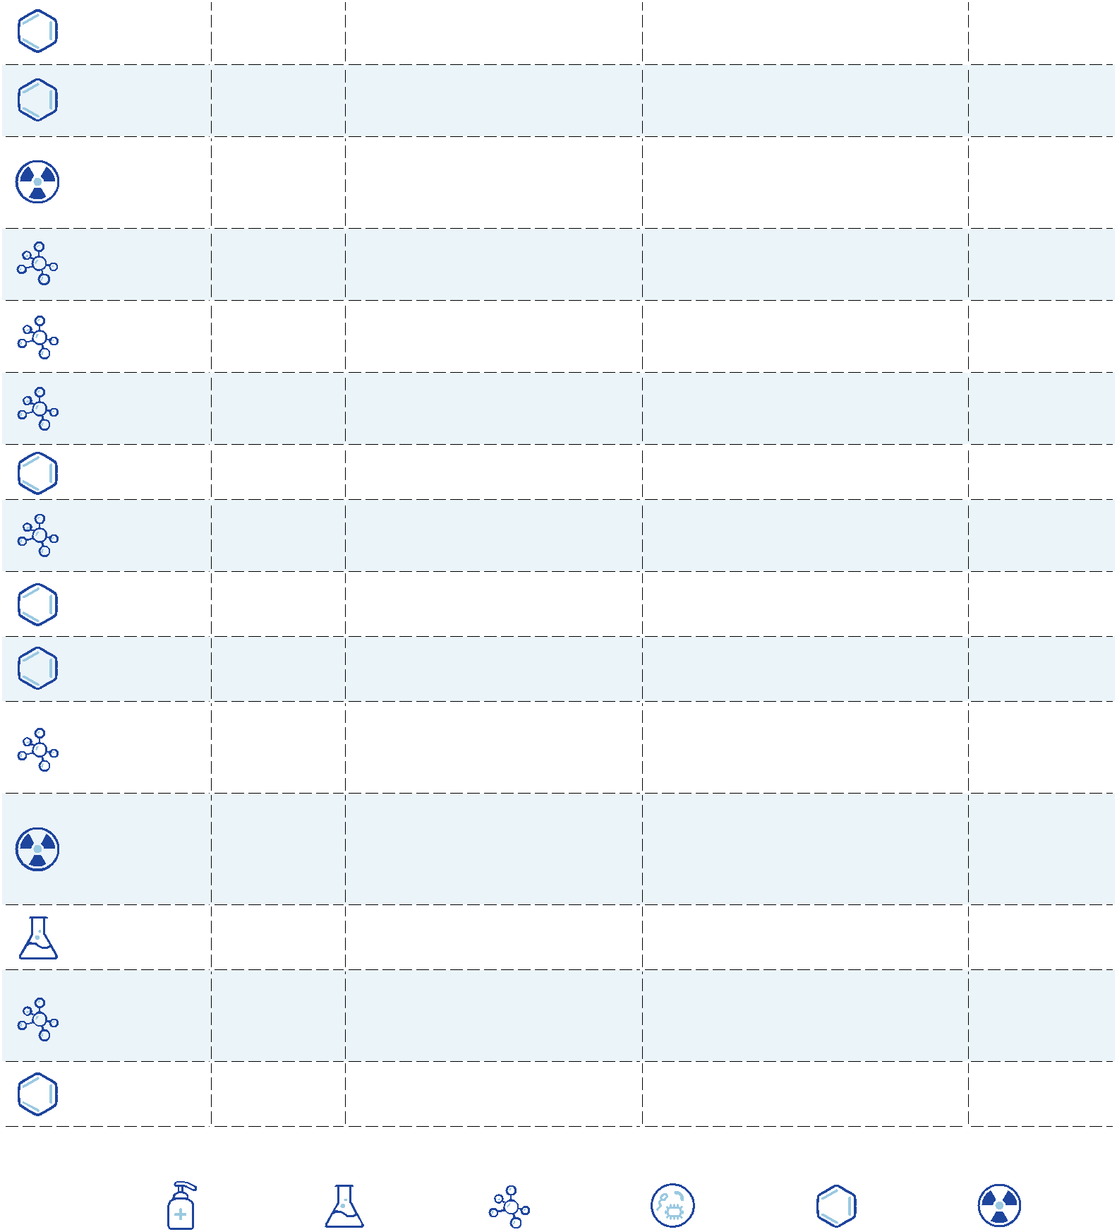

|  |  |  |  |  |  |  |  |  |  |  |  |
| --- | --- | --- | --- | --- | --- | --- | --- | --- | --- | --- | --- |
| National Primary Drinking Water Regulations | |  |  |  |  |  |  | EPA 816-F-09-004 | MAY 2009 | | |  |
|  |  |  |  | | | |  |  |  |  |  |
|  | **MCL or TT** | **1** | **Potential health effects** | | | | **Common sources of contaminant** | | | **Public Health** |  |
| **Contaminant** |  | **from long-term** | | **3** | **exposure** |  |
| **(mg/L)2** |  |  | **in drinking water** | |  | **Goal (mg/L)2** |  |
|  |  |  |  | **above the MCL** | | |  |  |  |  |  |
| Carbon | 0.005 |  | Liver problems; increased risk of | | | | Discharge from chemical plants and | | | **zero** |  |
| tetrachloride |  | cancer |  |  |  | other industrial activities | |  |  |
|  |  |  |  |  |  |  |  |
| Chloramines | MRDL=4.01 | | Eye/nose irritation; stomach | | | | Water additive used to control | |  | **MRDLG=41** |  |
| (as Cl2) | discomfort; anemia | |  |  | microbes |  |  |  |
|  |  |  |  |  |  |  |  |
| Chlordane | 0.002 |  | Liver or nervous system problems; | | | | Residue of banned termiticide | |  | **zero** |  |
|  | increased risk of cancer | | | |  |  |
|  |  |  |  |  |  |  |  |
| Chlorine | MRDL=4.01 | | Eye/nose irritation; stomach | | | | Water additive used to control | |  | **MRDLG=41** |  |
| (as Cl2) | discomfort | |  |  | microbes |  |  |  |
|  |  |  |  |  |  |  |  |
| Chlorine dioxide |  |  | Anemia; infants, young children, | | | | Water additive used to control | |  | **MRDLG=0.81** |  |
| MRDL=0.81 | | and fetuses of pregnant women: | | | |  |  |
| (as ClO2) | microbes |  |  |  |
|  |  | nervous system effects | | | |  |  |  |  |
|  |  |  | Anemia; infants, young children, | | | | Byproduct of drinking water | |  | **0.8** |  |
| Chlorite | 1.0 |  | and fetuses of pregnant women: | | | |  |  |
|  | disinfection |  |  |  |
|  |  |  | nervous system effects | | | |  |  |  |  |
|  |  |  |  |  |  |  |  |
| Chlorobenzene | 0.1 |  | Liver or kidney problems | | | | Discharge from chemical and | |  | **0.1** |  |
|  | agricultural chemical factories | |  |  |
|  |  |  |  |  |  |  |  |  |  |
|  |  |  |  |  |  |  |  | | |  |  |
| Chromium (total) | 0.1 |  | Allergic dermatitis | |  |  | Discharge from steel and pulp mills; | | | **0.1** |  |
|  |  |  | erosion of natural deposits | |  |  |
|  |  |  |  |  |  |  |  |  |  |
|  |  |  | Short-term exposure: | | | |  |  |  |  |  |
|  |  |  | Gastrointestinal distress. Long- | | | |  |  |  |  |  |
|  | TT5; Action | | term exposure: Liver or kidney | | | | Corrosion of household plumbing | | |  |  |
| Copper | damage. People with Wilson’s | | | | **1.3** |  |
| Level=1.3 |  | Disease should consult their | | | | systems; erosion of natural deposits | | |  |
|  |  |  | personal doctor if the amount of | | | |  |  |  |  |  |
|  |  |  | copper in their water exceeds the | | | |  |  |  |  |  |
|  |  |  | action level | |  |  |  |  |  |  |  |
|  |  |  | Short-term exposure: | | | |  |  |  | **zero** |  |
| *Cryptosporidium* | TT7 |  | Gastrointestinal illness (e.g., | | | | Human and animal fecal waste | |  |  |
|  |  |  | diarrhea, vomiting, cramps) | | | |  |  |  |  |  |
| Cyanide |  |  | Nerve damage or thyroid | | | | Discharge from steel/metal | |  | **0.2** |  |
| 0.2 |  | factories; discharge from plastic and | | |  |
| (as free cyanide) |  | problems |  |  |  |  |
|  |  |  |  |  | fertilizer factories | |  |  |  |
|  |  |  |  |  |  |  |  |  |  |
| 2,4-D | 0.07 |  | Kidney, liver, or adrenal gland | | | | Runoff from herbicide used on row | | | **0.07** |  |
|  | problems |  |  |  | crops |  |  |  |
|  |  |  |  |  |  |  |  |  |  |
| Dalapon | 0.2 |  | Minor kidney changes | | | | Runoff from herbicide used on | |  | **0.2** |  |
|  | rights of way |  |  |  |
|  |  |  |  |  |  |  |  |  |  |  |
| 1,2-Dibromo-3- |  |  | Reproductive difficulties; | | | | Runoff/leaching from soil fumigant | | | **zero** |  |
| chloropropane | 0.0002 |  | used on soybeans, cotton, | |  |  |
|  | increased risk of cancer | | | |  |  |
| (DBCP) |  |  | pineapples, and orchards | |  |  |  |
|  |  |  |  |  |  |  |  |  |
| o-Dichlorobenzene | 0.6 |  | Liver, kidney, or circulatory system | | | | Discharge from industrial chemical | | | **0.6** |  |
|  | problems |  |  |  | factories |  |  |  |
|  |  |  |  |  |  |  |  |  |  |
| p-Dichlorobenzene | 0.075 |  | Anemia; liver, kidney, or spleen | | | | Discharge from industrial chemical | | | **0.075** |  |
|  | damage; changes in blood | | | | factories |  |  |  |
|  |  |  |  |  |  |  |
| 1,2-Dichloroethane | 0.005 |  | Increased risk of cancer | | | | Discharge from industrial chemical | | | **zero** |  |
|  | factories |  |  |  |
|  |  |  |  |  |  |  |  |  |  |  |
| **LEGEND** |  |  |  |  |  |  |  |  |  |  |  |
| DISINFECTANT | DISINFECTION | | | INORGANIC | | MICROORGANISM | | ORGANIC | RADIONUCLIDES | |  |
|  | BYPRODUCT | | | CHEMICAL | |  |  | CHEMICAL |  |  |  |

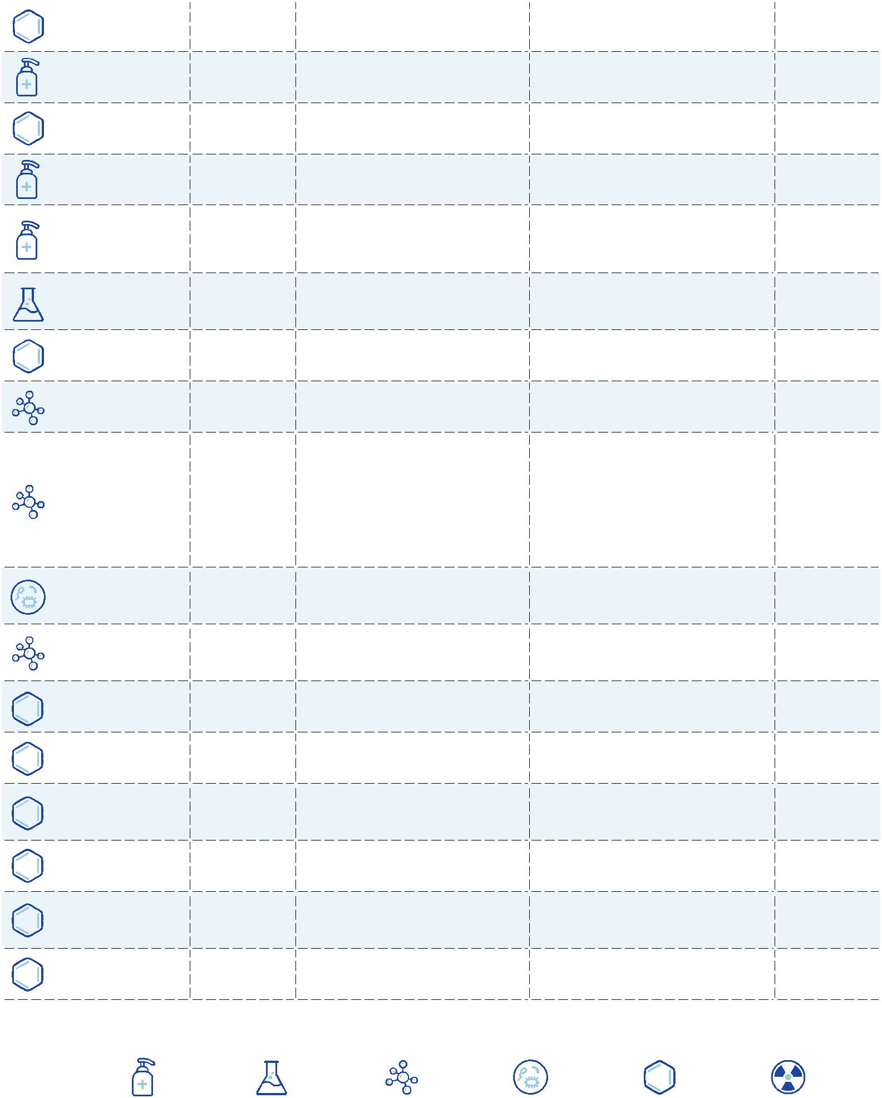

|  |  |  |  |  |  |  |  |  |  |
| --- | --- | --- | --- | --- | --- | --- | --- | --- | --- |
| National Primary Drinking Water Regulations | |  |  |  |  |  | EPA 816-F-09-004 | MAY 2009 | |  |
|  |  |  |  |  | | |  |  |  |
|  | **MCL or TT** | | **1** | **Potential health effects** | | | **Common sources of** | **Public Health** |  |
| **Contaminant** |  | **from long-term** | **3** | **exposure** |  |
| **(mg/L)2** | |  |  | **contaminant in drinking water** | **Goal (mg/L)2** |  |
|  |  |  |  | **above the MCL** | | |  |  |  |
| 1,1-Dichloroethylene | 0.007 | |  | Liver problems |  |  | Discharge from industrial | **0.007** |  |
|  |  |  | chemical factories |  |
|  |  |  |  |  |  |  |  |  |
| cis-1,2- | 0.07 | |  | Liver problems |  |  | Discharge from industrial | **0.07** |  |
| Dichloroethylene |  |  |  | chemical factories |  |
|  |  |  |  |  |  |  |  |
| trans-1,2, | 0.1 | |  | Liver problems |  |  | Discharge from industrial | **0.1** |  |
| Dichloroethylene |  |  |  | chemical factories |  |
|  |  |  |  |  |  |  |  |
| Dichloromethane | 0.005 | |  | Liver problems; increased risk of | | | Discharge from industrial | **zero** |  |
|  | cancer |  |  | chemical factories |  |
|  |  |  |  |  |  |  |  |
| 1,2-Dichloropropane | 0.005 | |  | Increased risk of cancer | | | Discharge from industrial | **zero** |  |
|  | chemical factories |  |
|  |  |  |  |  |  |  |  |  |
| Di(2-ethylhexyl) | 0.4 | |  | Weight loss, liver problems, or | | | Discharge from chemical | **0.4** |  |
| adipate |  | possible reproductive difficulties | | | factories |  |
|  |  |  |  |  |
| Di(2-ethylhexyl) | 0.006 | |  | Reproductive difficulties; liver | | | Discharge from rubber and | **zero** |  |
| phthalate |  | problems; increased risk of cancer | | | chemical factories |  |
|  |  |  |  |  |
| Dinoseb | 0.007 | |  | Reproductive difficulties | | | Runoff from herbicide used on | **0.007** |  |
|  | soybeans and vegetables |  |
|  |  |  |  |  |  |  |  |  |
|  |  |  |  | Reproductive difficulties; increased | | | Emissions from waste |  |  |
| Dioxin (2,3,7,8-TCDD) | 0.00000003 | | | incineration and other | **zero** |  |
| risk of cancer |  |  | combustion; discharge from |  |
|  |  |  |  |  |  |  | chemical factories |  |  |
| Diquat | 0.02 | |  | Cataracts |  |  | Runoff from herbicide use | **0.02** |  |
| Endothall | 0.1 | |  | Stomach and intestinal problems | | | Runoff from herbicide use | **0.1** |  |
| Endrin | 0.002 | |  | Liver problems |  |  | Residue of banned insecticide | **0.002** |  |
|  |  |  |  | Increased cancer risk; stomach | | | Discharge from industrial |  |  |
| Epichlorohydrin | TT | 4 |  | chemical factories; an impurity | **zero** |  |
|  |  | problems |  |  | of some water treatment |  |
|  |  |  |  |  |  |  | chemicals |  |  |
| Ethylbenzene | 0.7 | |  | Liver or kidney problems | | | Discharge from petroleum | **0.7** |  |
|  | refineries |  |
|  |  |  |  |  |  |  |  |  |
|  |  |  |  | Problems with liver, stomach, | | | Discharge from petroleum | **zero** |  |
| Ethylene dibromide | 0.00005 | |  | reproductive system, or kidneys; | | |  |
|  | refineries |  |
|  |  |  |  | increased risk of cancer | | |  |  |
|  |  |  |  |  |  |  |
|  |  |  |  | Fecal coliforms and *E. coli* are | | |  |  |  |
|  |  |  |  | bacteria whose presence indicates | | |  |  |  |
|  |  |  |  | that the water may be contaminated | | |  |  |  |
|  |  |  |  | with human or animal wastes. | | |  |  |  |
| Fecal coliform and |  |  |  | Microbes in these wastes may cause | | |  | **zero6** |  |
| MCL6 | |  | short term effects, such as diarrhea, | | | Human and animal fecal waste |  |
| *E. coli* |  |  |
|  |  |  | cramps, nausea, headaches, or | | |  |  |  |
|  |  |  |  |  |  |  |
|  |  |  |  | other symptoms. They may pose a | | |  |  |  |
|  |  |  |  | special health risk for infants, young | | |  |  |  |
|  |  |  |  | children, and people with severely | | |  |  |  |
|  |  |  |  | compromised immune systems. | | |  |  |  |

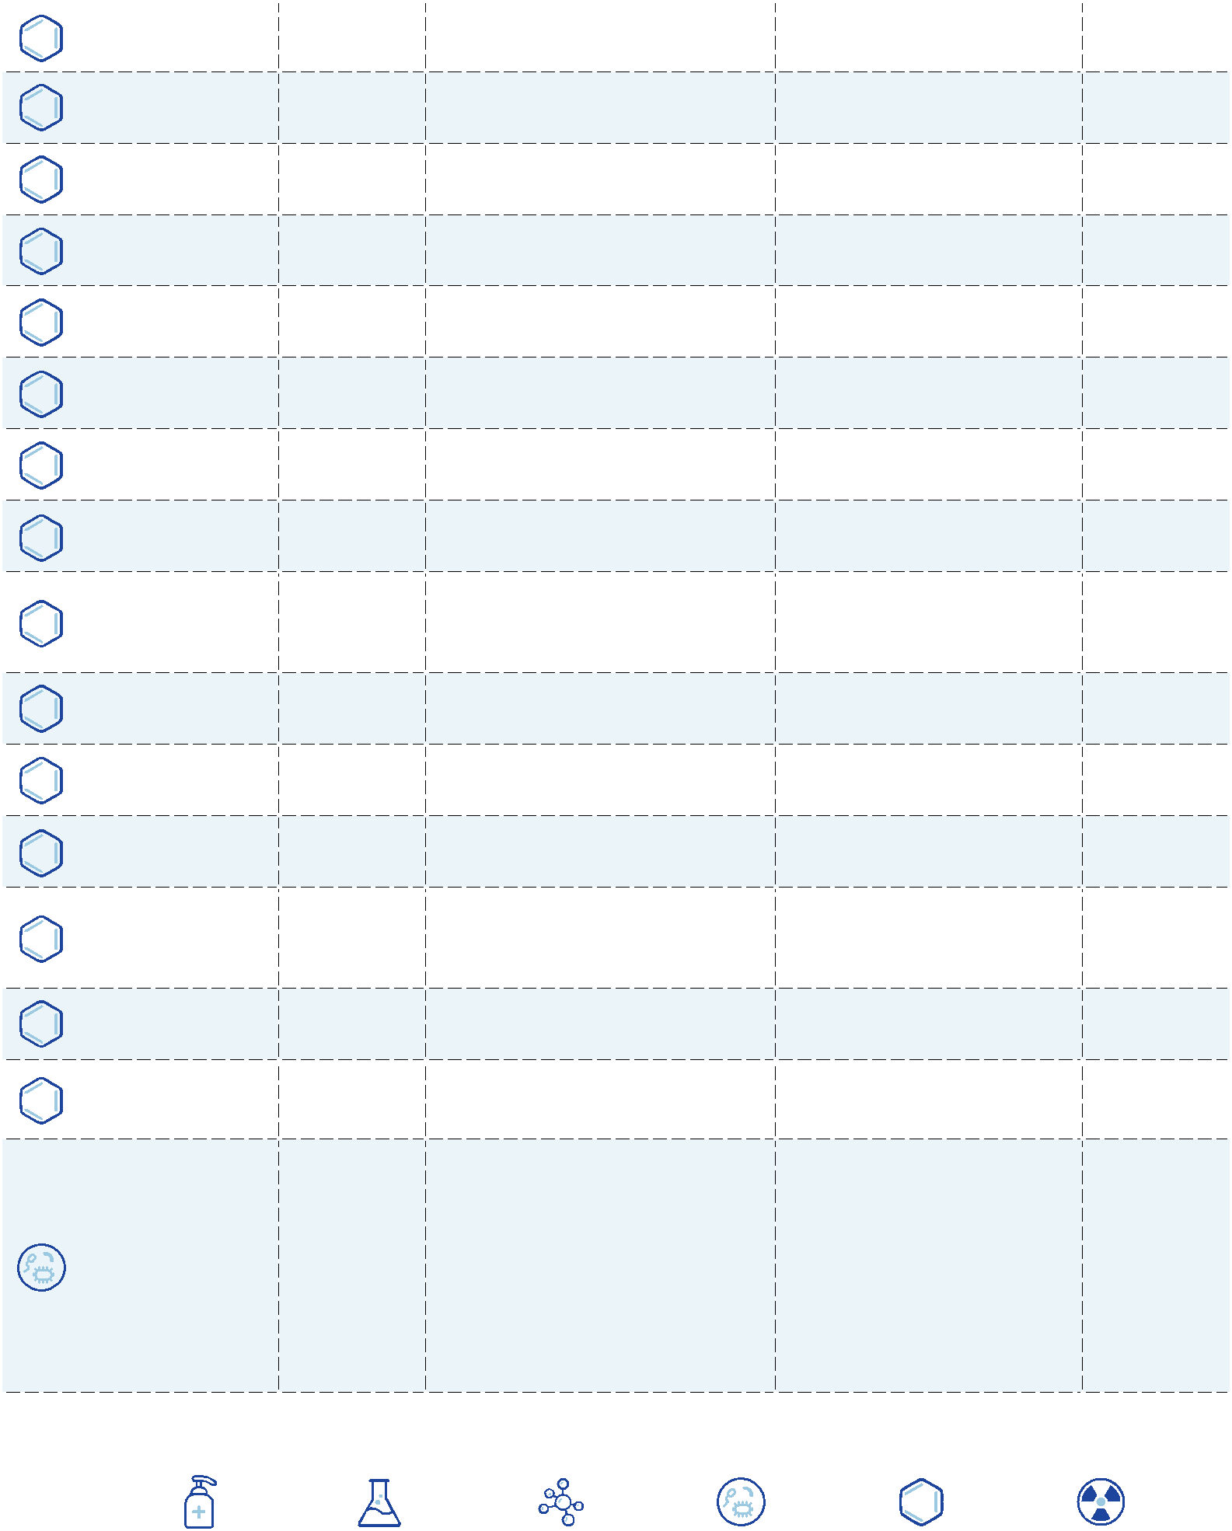

**LEGEND**

|  |  |  |  |  |  |
| --- | --- | --- | --- | --- | --- |
| DISINFECTANT | DISINFECTION | INORGANIC | MICROORGANISM | ORGANIC | RADIONUCLIDES |
|  | BYPRODUCT | CHEMICAL |  | CHEMICAL |  |

|  |  |  |  |  |  |  |  |  |  |  |  |
| --- | --- | --- | --- | --- | --- | --- | --- | --- | --- | --- | --- |
| National Primary Drinking Water Regulations | |  |  |  |  |  |  | EPA 816-F-09-004 | MAY 2009 | | |  |
|  |  |  |  |  | | |  |  |  |  |  |
|  | **MCL or TT** | **1** |  | **Potential health effects** | | | **Common sources of contaminant** | | | **Public Health** |  |
| **Contaminant** |  |  | **from long-term** | **3** | **exposure** |  |
| **(mg/L)2** |  |  |  | **in drinking water** | |  | **Goal (mg/L)2** |  |
|  |  |  |  | **above the MCL** | | |  |  |  |  |  |
|  |  |  | Bone disease (pain and | | | | Water additive which promotes | | |  |  |
|  |  |  | strong teeth; erosion of natural | |  | **4.0** |  |
| Fluoride | 4.0 |  | tenderness of the bones); children | | | |  |  |
|  | deposits; discharge from fertilizer | | |  |
|  |  |  | may get mottled teeth | | | |  |  |
|  |  |  | and aluminum factories | |  |  |  |
|  |  |  |  |  |  |  |  |  |  |
|  |  |  | Short-term exposure: | | | |  |  |  | **zero** |  |
| *Giardia lamblia* | TT7 |  | Gastrointestinal illness (e.g., | | | | Human and animal fecal waste | |  |  |
|  |  |  | diarrhea, vomiting, cramps) | | | |  |  |  |  |  |
| Glyphosate | 0.7 |  | Kidney problems; reproductive | | | | Runoff from herbicide use | |  | **0.7** |  |
|  | difficulties | |  |  |  |  |
|  |  |  |  |  |  |  |  |  |  |
| Haloacetic acids | 0.060 |  | Increased risk of cancer | | | | Byproduct of drinking water | |  | **n/a9** |  |
| (HAA5) |  | disinfection |  |  |  |
|  |  |  |  |  |  |  |  |  |  |
| Heptachlor | 0.0004 |  | Liver damage; increased risk of | | | | Residue of banned termiticide | |  | **zero** |  |
|  | cancer | |  |  |  |  |
|  |  |  |  |  |  |  |  |  |  |
| Heptachlor epoxide | 0.0002 |  | Liver damage; increased risk of | | | | Breakdown of heptachlor | |  | **zero** |  |
|  | cancer | |  |  |  |  |
|  |  |  |  |  |  |  |  |  |  |
|  |  |  | HPC has no health effects; it is an | | | |  |  |  |  |  |
|  |  |  | analytic method used to measure | | | | HPC measures a range of bacteria | | |  |  |
| Heterotrophic plate | TT7 |  | the variety of bacteria that are | | | | **n/a** |  |
|  | common in water. The lower | | | | that are naturally present in the | | |  |
| count (HPC) |  |  | the concentration of bacteria | | | | environment |  |  |  |  |
|  |  |  | in drinking water, the better | | | |  |  |  |  |  |
|  |  |  | maintained the water system is. | | | |  |  |  |  |  |
| Hexachlorobenzene | 0.001 |  | Liver or kidney problems; | | | | Discharge from metal refineries | | | **zero** |  |
|  | reproductive difficulties; increased | | | |  |
|  |  |  | risk of cancer | |  |  | and agricultural chemical factories | | |  |  |
|  |  |  |  |  |  |  |  |  |  |
| Hexachloro- | 0.05 |  | Kidney or stomach problems | | | | Discharge from chemical factories | | | **0.05** |  |
| cyclopentadiene |  |  |
|  |  |  |  |  |  |  |  |  |  |  |
|  |  |  | Infants and children: Delays in | | | |  |  |  |  |  |
|  | TT5; Action | | physical or mental development; | | | | Corrosion of household plumbing | | |  |  |
| Lead | children could show slight deficits | | | | **zero** |  |
| Level=0.015 | | in attention span and learning | | | | systems; erosion of natural deposits | | |  |
|  |  |  | abilities; Adults: Kidney problems; | | | |  |  |  |  |  |
|  |  |  | high blood pressure | | |  |  |  |  |  |  |
| *Legionella* | TT7 |  | Legionnaire’s Disease, a type of | | | | Found naturally in water; multiplies | | | **zero** |  |
|  |  |  | pneumonia | |  |  | in heating systems | |  |  |  |
| Lindane | 0.0002 |  | Liver or kidney problems | | | | Runoff/leaching from insecticide | | | **0.0002** |  |
|  | used on cattle, lumber, and gardens | | |  |
|  |  |  |  |  |  |  |  |  |
|  |  |  |  |  |  |  | Erosion of natural deposits; | |  |  |  |
| Mercury (inorganic) | 0.002 |  | Kidney damage | |  |  | discharge from refineries and | |  | **0.002** |  |
|  |  |  | factories; runoff from landfills and | | |  |
|  |  |  |  |  |  |  | croplands |  |  |  |  |
|  |  |  |  |  |  |  | Runoff/leaching from insecticide | | | **0.04** |  |
| Methoxychlor | 0.04 |  | Reproductive difficulties | | | | used on fruits, vegetables, alfalfa, | | |  |
|  |  |  |  |  |  |  | and livestock |  |  |  |  |
|  |  |  | Infants below the age of six | | | |  |  |  |  |  |
|  |  |  | months who drink water | | | | Runoff from fertilizer use; leaching | | |  |  |
| Nitrate (measured |  |  | containing nitrate in excess of | | | | **10** |  |
| 10 |  | the MCL could become seriously | | | | from septic tanks, sewage; erosion | | |  |
| as Nitrogen) |  |  |
|  |  | ill and, if untreated, may die. | | | | of natural deposits | |  |  |  |
|  |  |  |  |  |  |
|  |  |  | Symptoms include shortness of | | | |  |  |  |  |  |
|  |  |  | breath and blue-baby syndrome. | | | |  |  |  |  |  |
| **LEGEND** |  |  |  |  |  |  |  |  |  |  |  |
| DISINFECTANT | DISINFECTION | | | INORGANIC | | MICROORGANISM | | ORGANIC | RADIONUCLIDES | |  |
|  | BYPRODUCT | | | CHEMICAL |  |  |  | CHEMICAL |  |  |  |

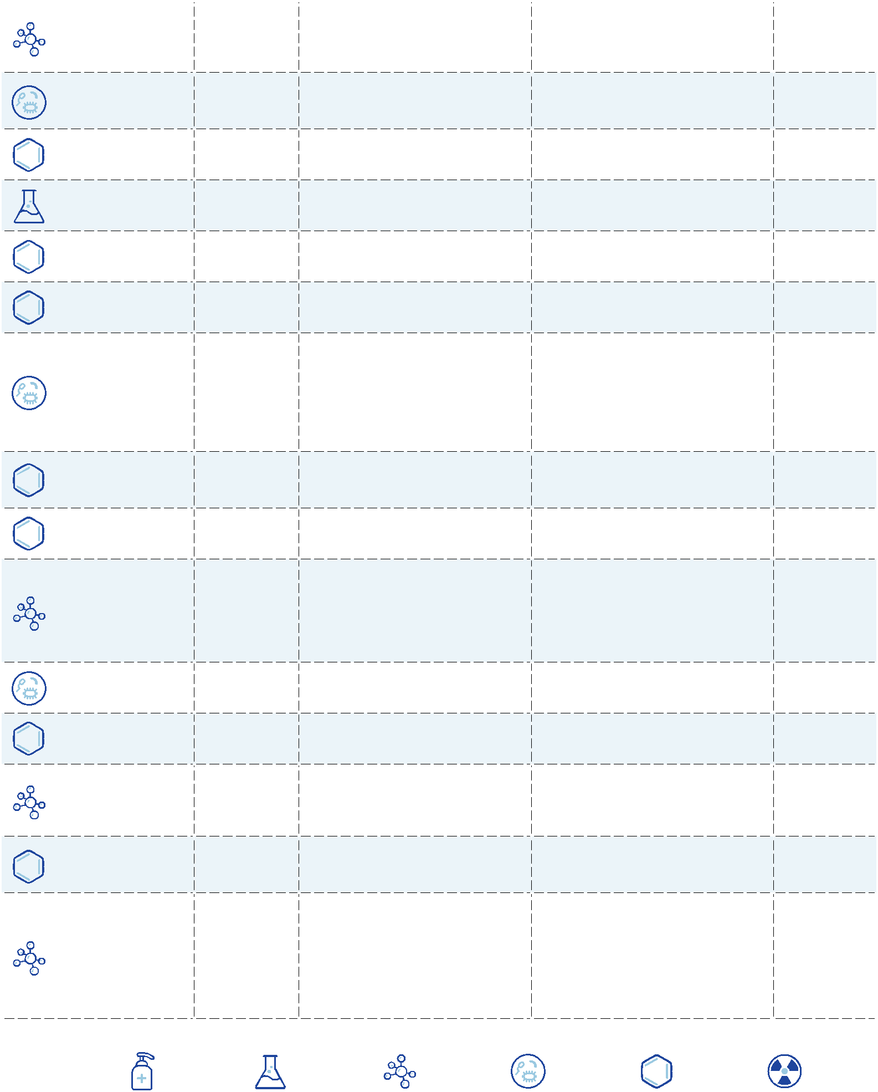

|  |  |  |  |  |  |  |  |  |  |  |  |  |
| --- | --- | --- | --- | --- | --- | --- | --- | --- | --- | --- | --- | --- |
| National Primary Drinking Water Regulations | |  |  |  |  |  |  |  | EPA 816-F-09-004 | MAY 2009 | | |  |
|  |  |  | |  | | | |  |  |  |  |  |
|  | **MCL or TT** | **1** | | **Potential health effects** | | | | **Common sources of contaminant** | | | **Public Health** |  |
| **Contaminant** |  |  | **from long-term** | | **3** | **exposure** |  |
| **(mg/L)2** |  |  |  | **in drinking water** | |  | **Goal (mg/L)2** |  |
|  |  |  |  |  | **above the MCL** | | |  |  |  |  |  |
|  |  |  |  | Infants below the age of six | | | |  |  |  |  |  |
|  |  |  |  | months who drink water | | | | Runoff from fertilizer use; leaching | | |  |  |
| Nitrite (measured |  |  |  | containing nitrite in excess of | | | | **1** |  |
| 1 |  |  | the MCL could become seriously | | | | from septic tanks, sewage; erosion | | |  |
| as Nitrogen) |  |  |  |
|  |  |  | ill and, if untreated, may die. | | | | of natural deposits | |  |  |  |
|  |  |  |  |  |  |  |
|  |  |  |  | Symptoms include shortness of | | | |  |  |  |  |  |
|  |  |  |  | breath and blue-baby syndrome. | | | |  |  |  |  |  |
|  |  |  |  |  |  |  |  | Runoff/leaching from insecticide | | | **0.2** |  |
| Oxamyl (Vydate) | 0.2 |  |  | Slight nervous system effects | | | | used on apples, potatoes, and | |  |  |
|  |  |  |  |  |  |  |  | tomatoes |  |  |  |  |
| Pentachlorophenol | 0.001 |  |  | Liver or kidney problems; | | | | Discharge from wood-preserving | | | **zero** |  |
|  |  | increased cancer risk | | |  | factories |  |  |  |
|  |  |  |  |  |  |  |  |  |
| Picloram | 0.5 |  |  | Liver problems | |  |  | Herbicide runoff | |  | **0.5** |  |
|  |  |  |  | Skin changes; thymus gland | | | |  |  |  |  |  |
| Polychlorinated |  |  |  | problems; immune deficiencies; | | | | Runoff from landfills; discharge of | | | **zero** |  |
| 0.0005 |  |  | reproductive or nervous system | | | |  |
| biphenyls (PCBs) |  |  | waste chemicals | |  |  |
|  |  |  | difficulties; increased risk of | | | |  |  |  |
|  |  |  |  |  |  |  |  |  |
|  |  |  |  | cancer |  |  |  |  |  |  |  |  |
| Radium 226 |  |  |  |  |  |  |  |  |  |  | **zero** |  |
| and Radium 228 | 5 pCi/L |  |  | Increased risk of cancer | | | | Erosion of natural deposits | |  |  |
| (combined) |  |  |  |  |  |  |  |  |  |  |  |  |
|  |  |  |  | Hair or fingernail loss; numbness | | | | Discharge from petroleum and | |  | **0.05** |  |
| Selenium | 0.05 |  |  | in fingers or toes; circulatory | | | | metal refineries; erosion of natural | | |  |
|  |  |  |  | problems | |  |  | deposits; discharge from mines | | |  |  |
| Simazine | 0.004 |  |  | Problems with blood | | |  | Herbicide runoff | |  | **0.004** |  |
| Styrene | 0.1 |  |  | Liver, kidney, or circulatory system | | | | Discharge from rubber and plastic | | | **0.1** |  |
|  |  | problems | |  |  | factories; leaching from landfills | | |  |
|  |  |  |  |  |  |  |  |
| Tetrachloroethylene | 0.005 |  |  | Liver problems; increased risk of | | | | Discharge from factories and dry | | | **zero** |  |
|  |  | cancer |  |  |  | cleaners |  |  |  |
|  |  |  |  |  |  |  |  |  |  |  |
| Thallium | 0.002 |  |  | Hair loss; changes in blood; kidney, | | | | Leaching from ore-processing sites; | | | **0.0005** |  |
|  |  | discharge from electronics, glass, | | |  |
|  |  |  |  | intestine, or liver problems | | | | and drug factories | |  |  |  |
|  |  |  |  |  |  |  |  |  |  |  |
| Toluene | 1 |  |  | Nervous system, kidney, or liver | | | | Discharge from petroleum | |  | **1** |  |
|  |  | problems | |  |  | factories |  |  |  |
|  |  |  |  |  |  |  |  |  |  |
|  |  |  |  | Coliforms are bacteria that | | | | Naturally present in the | |  |  |  |
| Total Coliforms | 5.0 percent | | 8 | indicate that other, potentially | | | |  | **zero** |  |
|  | harmful bacteria may be present. | | | | environment |  |  |  |
|  |  |  |  | See fecal coliforms and *E. coli* | | | |  |  |  |  |  |
| Total |  |  |  | Liver, kidney, or central nervous | | | | Byproduct of drinking water | |  | **n/a9** |  |
| Trihalomethanes | 0.080 |  |  | system problems; increased risk | | | |  |  |
|  |  | disinfection |  |  |  |
| (TTHMs) |  |  |  | of cancer |  |  |  |  |  |  |  |
|  |  |  |  |  |  |  |  |  |  |  |
| Toxaphene | 0.003 |  |  | Kidney, liver, or thyroid problems; | | | | Runoff/leaching from insecticide | | | **zero** |  |
|  |  | increased risk of cancer | | | | used on cotton and cattle | |  |  |
|  |  |  |  |  |  |  |
| 2,4,5-TP (Silvex) | 0.05 |  |  | Liver problems | |  |  | Residue of banned herbicide | |  | **0.05** |  |
|  |  |  |  |  |  |  |  |  | | |  |  |
| 1,2,4- | 0.07 |  |  | Changes in adrenal glands | | | | Discharge from textile finishing | | | **0.07** |  |
| Trichlorobenzene |  |  | factories |  |  |  |
|  |  |  |  |  |  |  |  |  |  |  |
|  |  |  |  |  |  |  |  |  |  |  |  |  |
| **LEGEND** |  |  |  |  |  |  |  |  |  |  |  |  |
| DISINFECTANT | DISINFECTION | | | | INORGANIC | | MICROORGANISM | | ORGANIC | RADIONUCLIDES | |  |
|  | BYPRODUCT | | | | CHEMICAL |  |  |  | CHEMICAL |  |  |  |

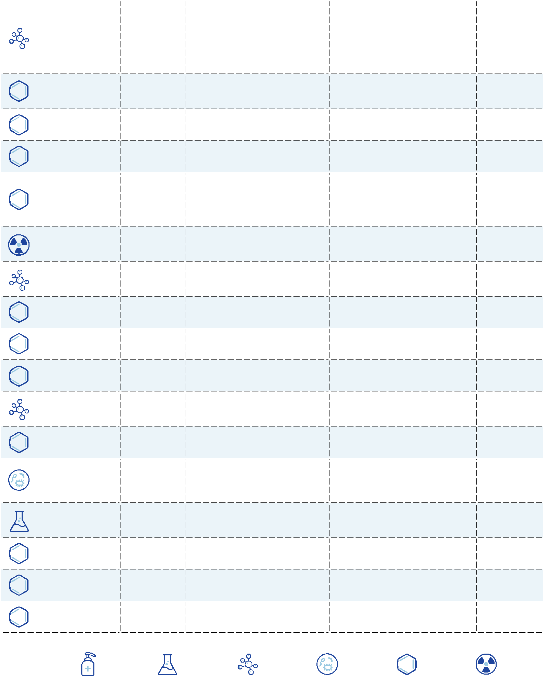

|  |  |  |  |  |  |  |  |  |  |
| --- | --- | --- | --- | --- | --- | --- | --- | --- | --- |
| National Primary Drinking Water Regulations | | |  |  |  | EPA 816-F-09-004 | MAY 2009 | | |  |
|  | **MCL or** | | **Potential health effects** | | | **Common sources of** | **Public Health** | |  |
| **Contaminant** | **TT** | **1** | **from long-term** | **3** | **exposure** | **contaminant in drinking** |  |
|  |  | **Goal (mg/L)** | **2** |  |
|  | **(mg/L)2** | | **above the MCL** | | | **water** |  |  |
| 1,1,1- |  |  |  |  |  | Discharge from metal | **0.2** |  |  |
| 0.2 | | Liver, nervous system, or circulatory problems | | | degreasing sites and other |  |  |
| Trichloroethane |  |  |
|  |  |  |  |  | factories |  |  |  |
|  |  |  |  |  |  |  |  |  |
| 1,1,2- | 0.005 | | Liver, kidney, or immune system problems | | | Discharge from industrial | **0.003** |  |  |
| Trichloroethane | chemical factories |  |  |
|  |  |  |  |  |  |  |  |
|  |  |  |  |  |  | Discharge from metal | **zero** |  |  |
| Trichloroethylene | 0.005 | | Liver problems; increased risk of cancer | | | degreasing sites and other |  |  |
|  |  |  |  |  |  | factories |  |  |  |
|  |  |  | Turbidity is a measure of the cloudiness of | | |  |  |  |  |
|  |  |  | water. It is used to indicate water quality and | | |  |  |  |  |
|  |  |  | filtration effectiveness (e.g., whether disease- | | |  |  |  |  |
|  |  |  | causing organisms are present). Higher turbidity | | |  | **n/a** |  |  |
| Turbidity | TT7 | | levels are often associated with higher levels of | | | Soil runoff |  |  |
|  |  |  | disease-causing microorganisms such as viruses, | | |  |  |  |  |
|  |  |  | parasites, and some bacteria. These organisms | | |  |  |  |  |
|  |  |  | can cause short term symptoms such as nausea, | | |  |  |  |  |
|  |  |  | cramps, diarrhea, and associated headaches. | | |  |  |  |  |
| Uranium | 30μg/L | | Increased risk of cancer, kidney toxicity | | | Erosion of natural deposits | **zero** |  |  |
| Vinyl chloride | 0.002 | | Increased risk of cancer |  |  | Leaching from PVC pipes; | **zero** |  |  |
|  |  | discharge from plastic factories |  |  |
|  |  |  |  |  |  |  |  |  |
| Viruses (enteric) | TT7 | | Short-term exposure: Gastrointestinal illness | | | Human and animal fecal | **zero** |  |  |
|  |  |  | (e.g., diarrhea, vomiting, cramps) | | | waste |  |  |  |
|  |  |  |  |  |  | Discharge from petroleum | **10** |  |  |
| Xylenes (total) | 10 | | Nervous system damage |  |  | factories; discharge from |  |  |
|  |  |  |  |  |  | chemical factories |  |  |  |

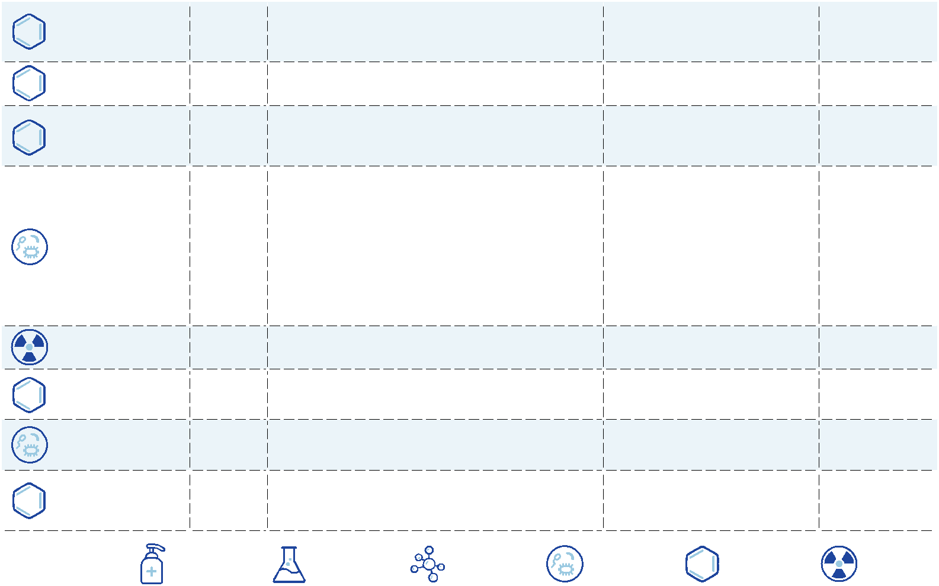

|  |  |  |  |  |  |
| --- | --- | --- | --- | --- | --- |
| **LEGEND** |  |  |  |  |  |
| DISINFECTANT | DISINFECTION | INORGANIC | MICROORGANISM | ORGANIC | RADIONUCLIDES |
|  | BYPRODUCT | CHEMICAL |  | CHEMICAL |  |

NOTES

1. Definitions
   * **Maximum Contaminant Level Goal (MCLG):** The level of a contaminant in drinkingwater below which there is no known or expected risk to health. MCLGs allow for a margin of safety and are non-enforceable public health goals.
   * **Maximum Contaminant Level (MCL):** The highest level of a contaminant that isallowed in drinking water. MCLs are set as close to MCLGs as feasible using the best available treatment technology and taking cost into consideration. MCLs are enforceable standards.
   * **Maximum Residual Disinfectant Level Goal (MRDLG):** The level of a drinking waterdisinfectant below which there is no known or expected risk to health. MRDLGs do not reflect the benefits of the use of disinfectants to control microbial contaminants.
   * **Maximum Residual Disinfectant Level (MRDL):** The highest level of a disinfectantallowed in drinking water. There is convincing evidence that addition of a disinfectant is necessary for control of microbial contaminants.
   * **Treatment Technique (TT):** A required process intended to reduce the level of acontaminant in drinking water.
2. Units are in milligrams per liter (mg/L) unless otherwise noted. Milligrams per liter are equivalent to parts per million (ppm).
3. Health effects are from long-term exposure unless specified as short-term exposure.
4. Each water system must certify annually, in writing, to the state (using third-party or manufacturers certification) that when it uses acrylamide and/or epichlorohydrin to treat water, the combination (or product) of dose and monomer level does not exceed the levels specified, as follows: Acrylamide = 0.05 percent dosed at 1 mg/L (or equivalent);

Epichlorohydrin = 0.01 percent dosed at 20 mg/L (or equivalent).

1. Lead and copper are regulated by a Treatment Technique that requires systems to control the corrosiveness of their water. If more than 10 percent of tap water samples exceed the action level, water systems must take additional steps. For copper, the action level is 1.3 mg/L, and for lead is 0.015 mg/L.
2. A routine sample that is fecal coliform-positive or E. coli-positive triggers repeat samples--if any repeat sample is total coliform-positive, the system has an acute MCL violation. A routine sample that is total coliform-positive and fecal coliform-negative or E. coli-negative triggers repeat samples--if any repeat sample is fecal coliform-positive or E. coli-positive, the system has an acute MCL violation. See also Total Coliforms.
3. EPA’s surface water treatment rules require systems using surface water or ground water under the direct influence of surface water to (1) disinfect their water, and (2) filter their water or meet criteria for avoiding filtration so that the following contaminants are controlled at the following levels:
   * ***Cryptosporidium*:**99 percent removal for systems that filter. Unfiltered systems arerequired to include Cryptosporidium in their existing watershed control provisions.

* **Giardia lamblia:** 99.9 percent removal/inactivation
* **Viruses:** 99.9 percent removal/inactivation
* ***Legionella*:**No limit, but EPA believes that if*Giardia*and viruses are removed/inactivated, according to the treatment techniques in the surface water treatment rule, *Legionella* will also be controlled.
* **Turbidity:** For systems that use conventional or direct filtration, at no time can turbidity

(cloudiness of water) go higher than 1 nephelometric turbidity unit (NTU), and samples for turbidity must be less than or equal to 0.3 NTU in at least 95 percent of the samples in any month. Systems that use filtration other than the conventional or direct filtration must follow state limits, which must include turbidity at no time exceeding 5 NTU.

* **HPC:** No more than 500 bacterial colonies per milliliter
* **Long Term 1 Enhanced Surface Water Treatment:** Surface water systems or groundwater systems under the direct influence of surface water serving fewer than 10,000 people must comply with the applicable Long Term 1 Enhanced Surface Water

Treatment Rule provisions (e.g. turbidity standards, individual filter monitoring,

*Cryptosporidium* removal requirements, updated watershed control requirements forunfiltered systems).

* **Long Term 2 Enhanced Surface Water Treatment:** This rule applies to all surface watersystems or ground water systems under the direct influence of surface water. The rule targets additional *Cryptosporidium* treatment requirements for higher risk systems and includes provisions to reduce risks from uncovered finished water storages facilities and to ensure that the systems maintain microbial protection as they take steps to reduce the formation of disinfection byproducts. (Monitoring start dates are staggered by system size. The largest systems (serving at least 100,000 people) will begin monitoring in October 2006 and the smallest systems (serving fewer than 10,000 people) will not begin monitoring until October 2008. After completing monitoring and determining their treatment bin, systems generally have three years to comply with any additional treatment requirements.)
* **Filter Backwash Recycling:** The Filter Backwash Recycling Rule requires systems thatrecycle to return specific recycle flows through all processes of the system’s existing conventional or direct filtration system or at an alternate location approved by the state.

**8** No more than 5.0 percent samples total coliform-positive in a month. (For water systemsthat collect fewer than 40 routine samples per month, no more than one sample can be total coliform-positive per month.) Every sample that has total coliform must be analyzed for either fecal coliforms or E. coli. If two consecutive TC-positive samples, and one is also positive for E. coli or fecal coliforms, system has an acute MCL violation.

**9** Although there is no collective MCLG for this contaminant group, there are individual

MCLGs for some of the individual contaminants:

* **Haloacetic acids:** dichloroacetic acid (zero); trichloroacetic acid (0.3 mg/L)
* **Trihalomethanes:** bromodichloromethane (zero); bromoform (zero);dibromochloromethane (0.06 mg/L)

National Primary Drinking Water Regulations EPA 816-F-09-004 | MAY 2009

NATIONAL SECONDARY DRINKING WATER REGULATION

National Secondary Drinking Water Regulations are non-enforceable guidelines regarding contaminants that may cause cosmetic effects (such as skin or tooth discoloration) or aesthetic effects (such as taste, odor, or color) in drinking water. EPA recommends secondary standards to water systems but does not require systems to comply. However, some states may choose to adopt them as enforceable standards.

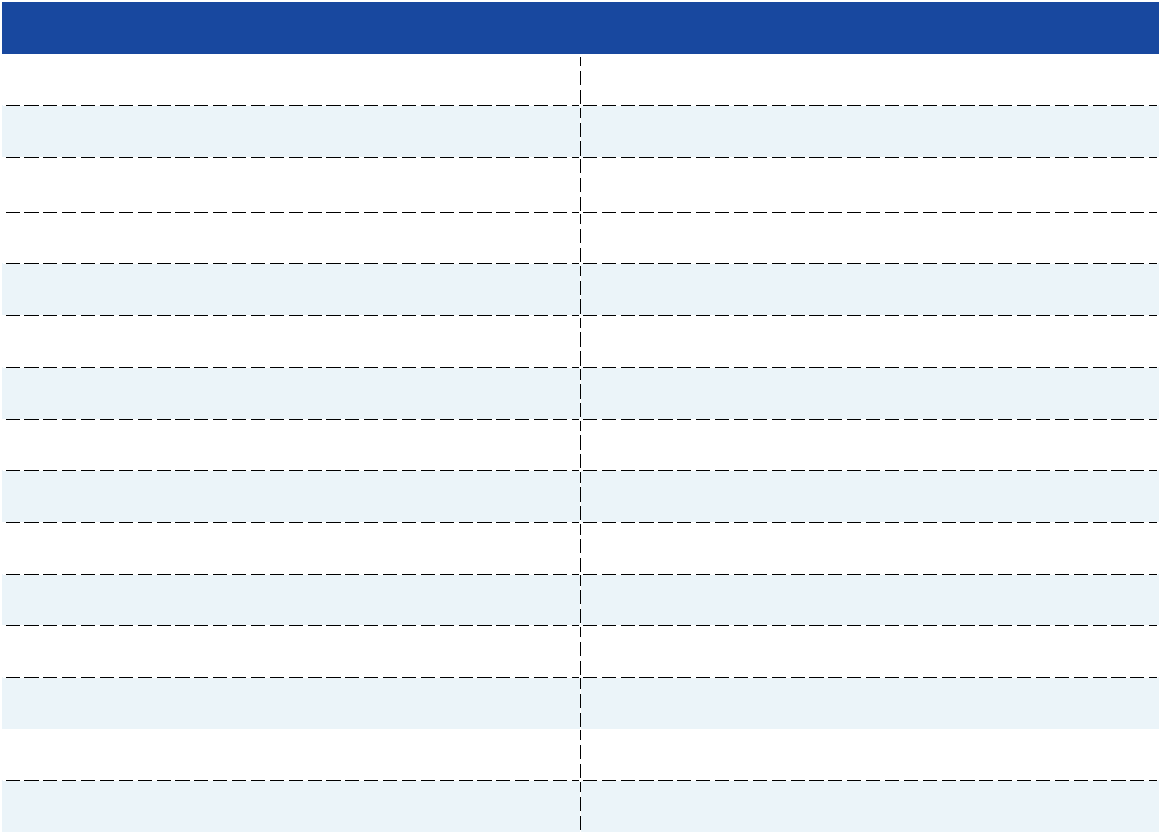

|  |  |
| --- | --- |
| **Contaminant** | **Secondary Maximum Contaminant Level** |
| Aluminum | 0.05 to 0.2 mg/L |
| Chloride | 250 mg/L |
| Color | 15 (color units) |
| Copper | 1.0 mg/L |
| Corrosivity | Noncorrosive |
| Fluoride | 2.0 mg/L |
| Foaming Agents | 0.5 mg/L |
| Iron | 0.3 mg/L |
| Manganese | 0.05 mg/L |
| Odor | 3 threshold odor number |
| pH | 6.5-8.5 |
| Silver | 0.10 mg/L |
| Sulfate | 250 mg/L |
| Total Dissolved Solids | 500 mg/L |
| Zinc | 5 mg/L |
|  |  |

FOR MORE INFORMATION ON EPA’S SAFE DRINKING WATER:

 visit: **epa.gov/safewater**



call: **(800) 426-4791**



ADDITIONAL INFORMATION:

To order additional posters or other ground water and drinking water publications, please contact the National Service Center for Environmental Publications at: **(800) 490-9198**, or email: **nscep@bps-lmit.com**.





G. CCR Drinking Water Regs - TOC

**California Regulations Related to Drinking Water**

**April 10, 2017**

*Sections amended, adopted, repealed, or not included in the previous version are highlighted in yellow. If the text in a section, subsection, or paragraph is highlighted, it is new. If only the section/paragraph number is highlighted, it was amended or repealed. Nonsubstantive revisions may not be shown. Please note that the water recycling criteria have been removed from this document, but may still be viewed in the “Recycled Water-Related Regulations” document here: http://www.waterboards.ca.gov/drinking_water/certlic/drinkingwater/Lawbook.shtml*

**TITLE 17 CODE OF REGULATIONS**

**DIVISION 1. STATE DEPARTMENT OF HEALTH SERVICES AND STATE WATER RESOURCES CONTROL BOARD**

**CHAPTER 5. SANITATION (ENVIRONMENTAL)**

**SUBCHAPTER 1. ENGINEERING (SANITARY)**

**GROUP 4. DRINKING WATER SUPPLIES**

**Article 1. General**

§7583. Definitions

§7584. Responsibility and scope of program

§7585. Evaluation of hazard.

§7586. User supervisor

**Article 2. Protection of Water System**

§7601. Approval of backflow preventers

§7602. Construction of backflow preventers

§7603. Location of backflow preventers

§7604. Type of protection required.

§7605. Testing and maintenance of backflow preventers

**Article 5. Domestic Water Supply Reservoirs**

§7625. Definitions

§7626. Application for Permit

§7627. Data to Accompany Application

§7629. Reservoirs for Which Permits May be Granted

**TITLE 22 CODE OF REGULATIONS DIVISION 4. ENVIRONMENTAL HEALTH CHAPTER 1. INTRODUCTION**

**Article 1. Definitions**

§60001. Department

§60002. State Board.

§60003. Director

**Article 2. Monitoring and Reporting Requirements - Scope**

§60098. Monitoring and Reporting Requirements

**CHAPTER 2. REGULATIONS FOR THE IMPLEMENTATION OF THE CALIFORNIA ENVIRONMENTAL QUALITY ACT**

**Article 1. General Requirements and Categorical Exemptions**

§60100. General requirements

§60101. Specific Activities Within Categorical Exempt Classes.

**CHAPTER 12. SAFE DRINKING WATER PROJECT FUNDING (Repealed)**

**CHAPTER 13. OPERATOR CERTIFICATION**

**Article 1. Definitions**

§63750.10. Accredited Academic Institution

§63750.15. Certificate

§63750.20. Certified Distribution Operator

§63750.25. Chief Operator

§63750.30. Comprehensive Operator Training Program §63750.35. Contact Hour

§63750.40. Continuing Education Course.

§63750.45. Distribution Operator

§63750.50. Distribution System

§63750.55. GED

§63750.60. Interim Distribution Operator Certificate §63750.65. Operator Experience §63750.70. Shift Operator

§63750.75. Specialized Training.

§63750.85. Water treatment facility

**Article 2. Operator Certification Grades**

§63765. Water Treatment Facility Staff Certification Requirements §63770. Distribution System Staff Certification Requirements

**Article 3. Operator Examination Criteria and Applications**

§63775. Eligibility Criteria for Taking a Water Treatment Operator Examination. §63780. Eligibility Criteria for Taking a Distribution Operator Examination §63785. Examination Application Content and Submittal

§63790. Filing Deadline and Requirement for Identification at Examination.

§63795. Examination Application Resubmittals and Reexaminations

**Article 4. Operator Certification Criteria and Applications**

§63800. Eligibility Criteria for Water Treatment Operator Certification

§63805. Eligibility Criteria for Distribution Operator Certification

§63810. Interim Certification of Distribution Operators

§63815. CNAWWA Distribution Operator Certification

§63820. Temporary Distribution Operator Certification.

§63825. Restricted Operator Certification.

§63830. Certification Application Content and Submittal §63835. Certification Application Resubmittal.

**Article 5. Certification Renewals, Delinquent Renewals and Fees** §63840. Certification Renewals.

§63845. Reinstatement

§63850. Fees

**CHAPTER 14. WATER PERMITS**

**Article 1. Applications**

§64001. Water Permit Application.

**Article 3. State Small Water Systems**

§64211. Permit Requirement

§64212. Bacteriological Quality Monitoring.

§64213. Chemical Quality Monitoring.

§64214. Service Connection Limitation.

§64215. Water Supply Requirements

§64216. Mutual Associations Prohibited.

§64217. Surface Water Treatment Requirement

**Article 4. Local Primacy Delegation**

§64251. Definitions

§64252. Primacy Delegation Application.

§64253. Local Primacy Agency Minimum Program Requirements

§64254. Permits

§64255. Surveillance

§64256. Sampling and Monitoring.

§64257. Reporting.

§64258. Enforcement

§64259. Program Management

§64260. Workplans

**CHAPTER 14.5 FEES**

**Article 1. Public Water System Annual Fees**

§64300. Definitions

§64305. Fee Schedule for Annual Fees

§64310. Reduction of Fees for Public Water Systems Serving Disadvantaged Community.

§64315. Payment of Fees

**CHAPTER 15. DOMESTIC WATER QUALITY AND MONITORING REGULATIONS**

**Article 1. Definitions**

§64400. Acute Risk.

§64400.05. Combined Distribution System

§64400.10. Community Water System

§64400.20. Compliance Cycle.

§64400.25. Compliance Period.

§64400.28. Confluent Growth.

§64400.29. Consecutive System

§64400.30. Customer

§64400.32. Detected.

§64400.34. Detection Limit for Purposes of Reporting (DLR)

§64400.36. Dual Sample Set

§64400.38. Enhanced Coagulation.

§64400.40. Enhanced Softening.

§64400.41. Finished Water

§64400.42. Fluoridation

§64400.45. GAC10.

§64400.46. GAC20.

§64400.47. Haloacetic Acids (Five) or HAA5.

§64400.50. Initial Compliance Period

§64400.60. Initial Finding.

§64400.65. IOC

§64400.66. Locational Running Annual Average or LRAA §64400.67. Maximum Residual Disinfectant Level or MRDL §64400.70. MCL

§64400.80. Nontransient-noncommunity Water System §64400.90. Operational Evaluation Levels or OEL §64401. Repeat Compliance Period §64401.10. Repeat Sample

§64401.20. Replacement Sample

§64401.30. Routine Sample

§64401.40. Sanitary Survey.

§64401.50. Significant Rise in Bacterial Count

§64401.55. SOC

§64401.60. Standby Source

§64401.65. SUVA

§64401.70. System with a Single Service Connection.

§64401.71. Tier 1 Public Notice §64401.75. Too Numerous to Count §64401.80. Total Coliform-positive §64401.82. Total Organic Carbon or TOC §64401.85. Transient-noncommunity Water System §64401.90. Treatment

§64401.92. Total Trihalomethanes or TTHM

§64401.95. VOC

§64402. Vulnerable System

§64402.10. Water Source

§64402.20. Water Supplier

§64402.30. Wholesale System

**Article 2. General Requirements**

§64412. Determination of Persons Served.

§64413.1. Classification of Water Treatment Facilities

§64413.3. Classification of Distribution Systems

§64413.5. Treatment Facility Staff Certification Requirements

§64413.7. Distribution System Staff Certification Requirements §64414. Standby Sources

§64415. Laboratory and Personnel

§64416. Sampling Plan for all Monitoring Except Bacteriological.

**ARTICLE 2.5. Point-of-Use Treatment**

§64417. Definitions

§64418. General Provisions

§64418.1. Economic Feasibility of Centralized Treatment

§64418.2. POU Requirements

§64418.3. POU Treatment Strategy.

§64418.4. POU Operations and Maintenance (O&M) Program

§64418.5. POU Monitoring Program

§64418.6. Public Hearing and Acceptance

§64418.7. Recordkeeping, Reporting, and Compliance

**ARTICLE 2.7. Point-of-Entry Treatment**

§64419. Definitions

§64420.1. Economic Feasibility of Centralized Treatment

§64420.2. POE Requirements

§64420.3. POE Treatment Strategy.

§64420.4. POE Operations and Maintenance (O&M) Program

§64420.5. POE Monitoring Program

§64420.6. Public Hearing and Acceptance

§64420.7. Recordkeeping, Reporting, and Compliance

**Article 3. Primary Standards--Bacteriological Quality**

§64421. General Requirements

§64422. Routine Sample Siting Plan

§64423. Routine Sampling.

§64423.1. Sample Analysis and Reporting of Results

§64424. Repeat Sampling.

§64425. Sample Invalidation.

§64426. Significant Rise in Bacterial Count

§64426.1. Total Coliform Maximum Contaminant Level (MCL) §64426.5. Variance from Total Coliform Maximum Contaminant Level §64427. Sanitary Survey

**Article 3.5. Ground Water Rule**

§64430. Requirements

**Article 4. Primary Standards--Inorganic Chemicals**

§64431. Maximum Contaminant Levels--Inorganic Chemicals.

§64432. Monitoring and Compliance--Inorganic Chemicals.

§64432.1. Monitoring and Compliance--Nitrate and Nitrite

§64432.2. Monitoring and Compliance - Asbestos.

§64432.3. Monitoring and Compliance - Perchlorate

**Article 4.1. Fluoridation**

§64433. System Requirements and Exemptions

§64433.2. Optimal Fluoride Levels

§64433.3. Monitoring and Compliance--Fluoride Levels §64433.5. Fluoridation System

§64433.7. Recordkeeping, Reporting, and Notification for Water Systems Fluoridating

§64433.8. Fluoridation System Operations Contingency Plan.

§64434. Water System Priority Funding Schedule

**Article 5. Radioactivity**

§64442. MCLs and Monitoring - Gross Alpha Particle Activity, Radium-226,Radium-228, and Uranium

§64443. MCLs and Monitoring - Beta Particle and Photon Radioactivity

**Article 5.5. Primary Standards -- Organic Chemicals** §64444. Maximum Contaminant Levels – Organic Chemicals. §64445. Initial sampling - organic chemicals.

§64445.1. Monitoring and Compliance – Organic Chemicals.

§64445.2. Sampling of Treated Water Sources.

**Article 12. Best available technologies (BAT)**

§64447. Best available technologies (BAT) – Microbiological Contaminants §64447.2. Best available technologies (BAT) - inorganic chemicals. §64447.3. Best Available Technologies (BAT) - Radionuclides §64447.4. Best Available Technologies (BATs) - Organic Chemicals.

**Article 14. Treatment Techniques**

§64448. Treatment Technique Requirements

**Article 16. Secondary Drinking Water Standards**

§64449. Secondary Maximum Contaminant Levels and Compliance §64449.2. Waivers for Secondary MCL Compliance

§64449.4. Use of Sources that Exceed a Secondary MCL and Do Not Have Waiver §64449.5. Distribution System Physical Water Quality.

**Article 18. Notification of Water Consumers and the State Board** §64463. General Public Notification Requirements

§64463.1. Tier 1 Public Notice

§64463.4. Tier 2 Public Notice

§64463.7. Tier 3 Public Notice

§64465. Public Notice Content and Format

§64466. Special Notice for Unregulated Contaminant Monitoring Results.

**Article 19. Records, Reporting and Recordkeeping**

§64469. Reporting Requirements

§64470. Recordkeeping.

**Article 20. Consumer Confidence Report**

§64481. Content of the Consumer Confidence Report §64482. Required Additional Health Information.

§64483. Consumer Confidence Report Delivery and Recordkeeping.

**CHAPTER 15.5 DISINFECTANT RESIDUALS, DISINFECTION BYPRODUCTS, AND DISINFECTION BYPRODUCT PRECURSORS**

**Article 1. General Requirements and Definitions** §64530. Applicability of this Chapter

§64531. Definitions Governing Terms Used in this Chapter

**Article 2. Maximum Contaminant Levels for Disinfection Byproducts and Maximum Residual Disinfectant Levels**

§64533. Maximum Contaminant Levels for Disinfection Byproducts *Best Available Technology*

§64533.5. Maximum Residual Disinfectant Levels

**Article 3. Monitoring requirements** §64534. General Monitoring Requirements §64534.2. Disinfection Byproducts Monitoring. §64534.4. Disinfectant Residuals Monitoring.

§64534.6. Disinfection Byproduct Precursors Monitoring.

§64534.8. Monitoring Plans

**Article 4. Compliance requirements**

§64535. General Requirements for Determining Compliance. §64535.2. Determining Disinfection Byproducts Compliance §64535.4. Determining Disinfectant Residuals Compliance

**Article 5. Treatment technique for control of disinfection byproduct precursor(DBPP)**

§64536. Alternative Compliance Criteria to the Enhanced Coagulation and Enhanced Softening Performance Requirements

§64536.2. Enhanced Coagulation and Enhanced Softening Performance Requirements.

§64536.4. Disinfection Byproduct Precursor Compliance Calculations §64536.6. Disinfection Byproduct Precursors Public Notification Requirements.

**Article 6. Reporting and recordkeeping requirements** §64537. General Reporting and Recordkeeping Requirements §64537.2. Disinfection Byproducts Reporting.

§64537.4. Disinfectants Reporting.

§64537.6. Disinfection Byproduct Precursors and Enhanced Coagulation or Enhanced Softening Reporting.

**CHAPTER 16. CALIFORNIA WATERWORKS STANDARDS196**

**Article 1. Definitions**

§64551.10. Distribution Reservoir

§64551.20. Distribution System

§64551.35. Peak Hour Demand (PHD)

§64551.40. Source Capacity.

§64551.60. User Service Line

§64551.70. Water Main.

**Article 1.5. Waivers and Alternatives**

§64551.100. Waivers and Alternatives

**Article 2. Permit Requirements**

§64552. Initial Permit for Public Water System

§64554. New and Existing Source Capacity.

§64556. Permit Amendments

§64558. Source Capacity Planning Study.

**Article3. Water Sources**

§64560. New Well Siting, Construction, and Permit Application.

§64560.5. Well Destruction.

§64561. Source Flow Meters

**Article 4. Materials and Installation of Water Mains and Appurtenances** §64570. Materials and Installation.

§64572. Water Main Separation.

§64573. Minimum Water Main Size for Community Water Systems §64575. Flushing.

§64576. Air-Release, Air Vacuum, and Combination Valves §64577. Isolation Valves

§64578. Water Main Valve Construction.

**Article 5. Disinfection Requirements**

§64580. Disinfection of New or Repaired Mains

§64582. Disinfection of Reservoirs

§64583. Disinfection of Wells

**Article 6. Distribution Reservoirs**

§64585. Design and Construction.

**Article 7. Additives**

§64590. Direct Additives

§64591. Indirect Additives

§64593. Use of Uncertified Chemicals, Materials or Products **Article 8. Distribution System Operation**

§64600. Water System Operations and Maintenance Plan.

§64602. Minimum Pressure

§64604. Preparation and Maintenance of Records

**CHAPTER 17. SURFACE WATER TREATMENT**

**Article 1. General Requirements and Definitions**

§64650. General Requirements

§64651.10. Approved Surface Water

§64651.12. Bag Filters

§64651.13. Bank Filtration.

§64651.15. Cartridge Filters

§64651.16. Coagulant Chemical

§64651.20. Coagulation

§64651.21. Comprehensive Performance Evaluation (CPE)

§64651.23. Conventional Filtration Treatment

§64651.26. Diatomaceous Earth Filtration.

§64651.30. Direct Filtration Treatment

§64651.32. Disinfectant Contact Time

§64651.33. Disinfection

§64651.34. Disinfection Profile

§64651.36. Engineering Report

§64651.38. Filter Profile

§64651.40. Filter-To-Waste.

§64651.43. Filtration.

§64651.46. Flocculation

§64651.48. Flowing Stream

§64651.50. Groundwater Under the Direct Influence of Surface Water

§64651.52. Lake/Reservoir

§64651.53. Legionella

§64651.54. Membrane Filtration

§64651.56. Multibarrier Treatment

§64651.60. NTU (Nephelometric Turbidity Unit)

§64651.61. Plant Intake

§64651.62. Presedimentation.

§64651.63. Pressure Filter.

§64651.66. Qualified Engineer

§64651.70. Residual Disinfectant Concentration

§64651.73. Sedimentation.

§64651.76. Slow Sand Filtration.

§64651.80. Supplier

§64651.83. Surface Water

§64651.86. Turbidity Level

§64651.88. Uncovered Finished Water Storage Facility.

§64651.90. Virus

§64651.91. Waterborne Microbial Disease Outbreak.

§64651.93. Watershed.

**Article 2. Treatment Technique Requirements, Watershed Protection Requirements, and Performance Standards**

§64652. Treatment Technique Requirements and Compliance Options §64652.5. Criteria for Avoiding Filtration.

§64653. Filtration.

§64653.5. Recycle Provisions

**Article 3. Monitoring Requirements**

§64654.8. Source, Raw, Settled, and Recycled Filter Backwash Monitoring.

§64655. Filtration Monitoring.

§64656. Disinfection Monitoring.

§64656.5. Disinfection Profiling and Benchmarking.

**Article 4. Design Standards**

§64658. New Treatment Plants

§64659. Reliability.

**Article 5. Operation**

§64660. Operating Criteria

§64661. Operations Plan.

§64662. Records

**Article 6. Reporting**

§64663. State Board Notification.

§64664. Monthly Report

§64664.2. Supplemental Reports

**Article 7. Sanitary Surveys**

§64665. Watershed Requirements.

§64665.5. Additional Requirements

**Article 8. Public Notification**

§64666. Consumer Notification.

**CHAPTER 17.5. LEAD AND COPPER**

**Article 1. General Requirements and Definitions**

§64670. General Requirements

§64671.05. Action Level

§64671.08. Action Level Exceedance §64671.09. Corrosion Control Treatment or CCT §64671.10. Corrosion Inhibitor.

§64671.15. Detection Limit for Purposes of Reporting or DLR §64671.30. Large Water System §64671.35. Lead Service Line

§64671.40. Medium-size Water System

§64671.55. Period.

§64671.65. Single-family Structure

§64671.70. Small Water System

§64671.75. Tap Sampling.

§64671.80. Water Quality Parameter or WQP

§64671.85. WQP Monitoring.

**Article 2. Requirements According to System Size**

§64673. Small and Medium-size Water System Requirements

§64674. Large Water System Requirements

**Article 3. Monitoring for Lead and Copper**

§64675. General Requirements for Tap Sampling for Lead and Copper

§64675.5. Tap Sampling Frequency.

§64676. Sample Site Selection.

§64677. Sample Collection Methods for Taps

§64677.5. Sample Invalidation.

§64678. Determination of Exceedances of Lead and Copper Action Levels §64678.5. Monitoring Waivers for Small Systems §64679. Supplemental Monitoring.

**Article 4. Water Quality Parameter (WQP) Monitoring** §64680. General WQP Monitoring Requirements §64681. Initial WQP Monitoring.

§64682. WQP Monitoring After CCT Installation **Article 5. Corrosion Control**

§64683. Corrosion Control Study Procedure

§64684. CCT Installation and Operation.

**Article 6. Source Water Requirements for Action Level Exceedances** 64685. Source Water Monitoring and Treatment Designation. §64686. Requirements Subsequent to the Department’s Designation

**Article 7. Public Education Program for Lead Action Level Exceedances**

§64687. Lead Public Education Program Content and Delivery.

**Article 8. Lead Service Line Requirements for Action Level Exceedances**

§64688. Lead Service Line Replacement

§64689. Lead Service Line Sampling.

**Article 9. Reporting and Recordkeeping**

§64690.10. Data Reporting.

§64690.80. Recordkeeping.

**Addendum A: CA Ground Water Rule – A reference to text adopted pursuant to Section 64430.**

§141.21. Coliform sampling.

§141.28. Certified laboratories

§141.153. Content of the reports

Appendix A to Subpart O of Part 141 – Regulated Contaminants §141.202. Tier 1 Public Notice – Form, manner, and frequency of notice §141.202. Tier 2 Public Notice – Form, manner, and frequency of notice Appendix A to Subpart Q of Part 141 – NPDWR Violations and Other Situations Requiring Public Notice.

Appendix B to Subpart Q of Part 141 – Standard Health Effects Language for Public Notification.

§141.400. General requirements and applicability §141.401. Sanitary surveys for ground water systems.

§141.402. Ground water source microbial monitoring and analytical methods

§141.403. Treatment technique requirements for ground water systems §141.404. Treatment technique violations for ground water systems

**Addendum B: CA Long Term 2 Enhanced Surface Water Treatment Rule – A reference to text adopted pursuant to Section 64650(f). [CFR § 141.74 not shown.]**

* 141.211. Special notice for repeated failure to conduct monitoring of the source water for *Cryptosporidium* and for failure to determine bin classification or mean *Cryptosporidium* level

Appendix A to Subpart Q of Part 141—NPDWR Violations and Other Situations Requiring Public Notice 1

* 141.700. General requirements
* 141.701. Source water monitoring.
* 141.702. Sampling schedules
* 141.703. Sampling locations
* 141.704. Analytical methods
* 141.705. Approved laboratories
* 141.706. Reporting source water monitoring results
* 141.707. Grandfathering previously collected data.
* 141.708. Requirements when making a significant change in disinfection practice.

.

* 141.709. Developing the disinfection profile and benchmark.
* 141.710. Bin classification for filtered systems
* 141.711. Filtered system additional *Cryptosporidium* treatment requirements
* 141.712. Unfiltered system *Cryptosporidium* treatment requirements.3
* 141.713. Schedule for compliance with *Cryptosporidium* treatment requirements
* 141.714. Requirements for uncovered finished water storage facilities
* 141.715. Microbial toolbox options for meeting *Cryptosporidium* treatment requirements.
* 141.716. Source toolbox components
* 141.717. Pre-filtration treatment toolbox components
* 141.718. Treatment performance toolbox components
* 141.719. Additional filtration toolbox components
* 141.720. Inactivation toolbox components
* 141.721. Reporting requirements
* 141.722. Recordkeeping requirements
* 141.723. Requirements to respond to significant deficiencies identified in sanitary surveys performed by EPA



H. SDS Content - OSHA Guidance



**Occupational Safety and Health Administration**

Hazard Communication Standard: Safety Data Sheets

The Hazard Communication Standard (HCS) (29 CFR 1910.1200(g)), revised in 2012, requires that the chemical manufacturer, distributor, or importer provide Safety Data Sheets (SDSs) (formerly MSDSs or Material Safety Data Sheets) for each hazardous chemical to downstream users to communicate information on these hazards. The information contained in the SDS is largely the same as the MSDS, except now the SDSs are required to be presented in a consistent user-friendly, 16-section format. This brief provides guidance to help workers who handle hazardous chemicals to become familiar with the format and understand the contents of the SDSs.

The SDS includes information such as the properties of each chemical; the physical, health, and environmental health hazards; protective measures; and safety precautions for handling, storing, and transporting the chemical. The information contained in the SDS must be in English (although it may be in other languages as well). In addition, OSHA requires that SDS preparers provide specific minimum information as detailed in Appendix D of 29 CFR 1910.1200. The SDS preparers may also include additional information in various section(s).

Sections 1 through 8 contain general information about the chemical, identification, hazards, composition, safe handling practices, and emergency control measures (e.g., fire fighting). This information should be helpful to those that need to get the information quickly. Sections 9 through 11 and 16 contain other technical and scientific information, such as physical and chemical properties, stability and reactivity information, toxicological information, exposure control information, and other information including the date of preparation or last revision. The SDS must also state that no applicable information was found when the preparer does not find relevant information for any required element.

The SDS must also contain Sections 12 through 15, to be consistent with the UN Globally Harmonized System of Classification and Labeling of Chemicals (GHS), but OSHA will not enforce the content of these sections because they concern matters handled by other agencies.

A description of all 16 sections of the SDS, along with their contents, is presented below:

Section 1: Identification

This section identifies the chemical on the SDS as well as the recommended uses. It also provides the essential contact information of the supplier. The required information consists of:

* Product identifier used on the label and any other common names or synonyms by which the substance is known.
* Name, address, phone number of the manufacturer, importer, or other responsible party, and emergency phone number.
* Recommended use of the chemical (e.g., a brief description of what it actually does, such as flame retardant) and any restrictions on use (including recommendations given by the supplier). 1

Section 2: Hazard(s) Identification

This section identifies the hazards of the chemical presented on the SDS and the appropriate warning information associated with those hazards. The required information consists of:

* The hazard classification of the chemical (e.g., flammable liquid, category1).
* Signal word.
* Hazard statement(s).
* Pictograms (the pictograms or hazard symbols may be presented as graphical reproductions of the symbols in black and white or be a description of the name of the symbol (e.g., skull and crossbones, flame).
* Precautionary statement(s).
* Description of any hazards not otherwise classified.
* For a mixture that contains an ingredient(s) with unknown toxicity, a statement describing how much (percentage) of the mixture consists of ingredient(s) with unknown acute toxicity. Please note that this is a total percentage of the mixture and not tied to the individual ingredient(s).

Section 3: Composition/Information on Ingredients

This section identifies the ingredient(s) contained in the product indicated on the SDS, including impurities and stabilizing additives. This section includes information on substances, mixtures, and all chemicals where a trade secret is claimed. The required information consists of:

**Substances**

* Chemical name.
* Common name and synonyms.
* Chemical Abstracts Service (CAS) number and other unique identifiers.
* Impurities and stabilizing additives, which are themselves classified and which contribute to the classification of the chemical.

**Mixtures**

* Same information required for substances.
* The chemical name and concentration (i.e., exact percentage) of all ingredients which are classified as health hazards and are:

o Present above their cut-off/concentration limits or

o Present a health risk below the cut-off/concentration limits.

* The concentration (exact percentages) of each ingredient must be specified except concentration ranges may be used in the following situations:

o A trade secret claim is made,

o There is batch-to-batch variation, or

o The SDS is used for a group of substantially similar mixtures.

**Chemicals where a trade secret is claimed** A statement that the specific chemical identity and/or exactpercentage (concentration) of composition has been withheld as a trade secret is required.

Section 4: First-Aid Measures

This section describes the initial care that should be given by untrained responders to an individual who has been exposed to the chemical. The required information consists of:

* Necessary first-aid instructions by relevant routes of exposure (inhalation, skin and eye contact, and ingestion).
* Description of the most important symptoms or effects, and any symptoms that are acute or delayed.
* Recommendations for immediate medical care and special treatment needed, when necessary.

Section 5: Fire-Fighting Measures

This section provides recommendations for fighting a fire caused by the chemical. The required information consists of:

* Recommendations of suitable extinguishing equipment, and information about extinguishing equipment that is not appropriate for a particular situation.
* Advice on specific hazards that develop from the chemical during the fire, such as any hazardous combustion products created when the chemical burns.
* Recommendations on special protective equipment or precautions for firefighters.

Section 6: Accidental Release Measures

This section provides recommendations on the appropriate response to spills, leaks, or releases, including containment and cleanup practices to prevent or minimize exposure to people, properties, or the environment. It may also include recommendations distinguishing between responses for large and small spills where the spill volume has a significant impact on the hazard. The required information may consist of recommendations for:

* Use of personal precautions (such as removal of ignition sources or providing sufficient ventilation) and protective equipment to prevent the contamination of skin, eyes, and clothing.
* Emergency procedures, including instructions for evacuations, consulting experts when needed, and appropriate protective clothing.
* Methods and materials used for containment (e.g., covering the drains and capping procedures).
* Cleanup procedures (e.g., appropriate techniques for neutralization, decontamination, cleaning or vacuuming; adsorbent materials; and/or equipment required for containment/clean up)

Section 7: Handling and Storage

This section provides guidance on the safe handling practices and conditions for safe storage of chemicals.

The required information consists of:

* Precautions for safe handling, including recommendations for handling incompatible chemicals, minimizing the release of the chemical into the environment, and providing advice on general hygiene practices (e.g., eating, drinking, and smoking in work areas is prohibited).
* Recommendations on the conditions for safe storage, including any incompatibilities. Provide advice on specific storage requirements (e.g., ventilation requirements)

Section 8: Exposure Controls/Personal Protection

This section indicates the exposure limits, engineering controls, and personal protective measures that can be used to minimize worker exposure. The required information consists of:

* OSHA Permissible Exposure Limits (PELs), American Conference of Governmental Industrial Hygienists (ACGIH) Threshold Limit Values (TLVs), and any other exposure limit used or recommended by the chemical manufacturer, importer, or employer preparing the safety data sheet, where available.
* Appropriate engineering controls (e.g., use local exhaust ventilation, or use only in an enclosed system).
* Recommendations for personal protective measures to prevent illness or injury from exposure to chemicals, such as personal protective equipment (PPE) (e.g., appropriate types of eye, face, skin or respiratory protection needed based on hazards and potential exposure).
* Any special requirements for PPE, protective clothing or respirators (e.g., type of glove material, such as PVC or nitrile rubber gloves; and breakthrough time of the glove material).

Section 9: Physical and Chemical Properties

This section identifies physical and chemical properties associated with the substance or mixture. The minimum required information consists of:

* Appearance (physical state, color, etc.);
* Upper/lower flammability or explosive limits;
* Odor;
* Vapor pressure;
* Odor threshold;
* Vapor density;
* pH;
* Relative density;
* Melting point/freezing point;
* Solubility(ies);
* Initial boiling point and boiling range;
* Flash point;
* Evaporation rate;
* Flammability (solid, gas);
* Partition coefficient: n-octanol/water;
* Auto-ignition temperature;
* Decomposition temperature; and
* Viscosity.

The SDS may not contain every item on the above list because information may not be relevant or is not available. When this occurs, a notation to that effect must be made for that chemical property. Manufacturers may also add other relevant properties, such as the dust deflagration index (Kst) for combustible dust, used to evaluate a dust's explosive potential

Section 10: Stability and Reactivity

This section describes the reactivity hazards of the chemical and the chemical stability information. This section is broken into three parts: reactivity, chemical stability, and other. The required information consists of:

**Reactivity**

* Description of the specific test data for the chemical(s). This data can be for a class or family of the chemical if such data adequately represent the anticipated hazard of the chemical(s), where available.

**Chemical stability**

* Indication of whether the chemical is stable or unstable under normal ambient temperature and conditions while in storage and being handled.
* Description of any stabilizers that may be needed to maintain chemical stability.
* Indication of any safety issues that may arise should the product change in physical appearance.

**Other**

* Indication of the possibility of hazardous reactions, including a statement whether the chemical will react or polymerize, which could release excess pressure or heat, or create other hazardous conditions. Also, a description of the conditions under which hazardous reactions may occur.
* List of all conditions that should be avoided (e.g., static discharge, shock, vibrations, or environmental conditions that may lead to hazardous conditions).
* List of all classes of incompatible materials (e.g., classes of chemicals or specific substances) with which the chemical could react to produce a hazardous situation.
* List of any known or anticipated hazardous decomposition products that could be produced because of use, storage, or heating. (Hazardous combustion products should also be included in Section 5 (Fire-Fighting Measures) of the SDS.)

Section 11: Toxicological Information

This section identifies toxicological and health effects information or indicates that such data are not available.

The required information consists of:

* Information on the likely routes of exposure (inhalation, ingestion, skin and eye contact). The SDS should indicate if the information is unknown.
* Description of the delayed, immediate, or chronic effects from short- and long-term exposure.
* The numerical measures of toxicity (e.g., acute toxicity estimates such as the LD50 (median lethal dose)) - the estimated amount [of a substance] expected to kill 50% of test animals in a single dose.
* Description of the symptoms. This description includes the symptoms associated with exposure to the chemical including symptoms from the lowest to the most severe exposure.
* Indication of whether the chemical is listed in the National Toxicology Program (NTP) Report on Carcinogens (latest edition) or has been found to be a potential carcinogen in the International Agency for Research on Cancer (IARC) Monographs (latest editions) or found to be a potential carcinogen by OSHA

Section 12: Ecological Information (non-mandatory)

This section provides information to evaluate the environmental impact of the chemical(s) if it were released to the environment. The information may include:

* Data from toxicity tests performed on aquatic and/or terrestrial organisms, where available (e.g., acute or chronic aquatic toxicity data for fish, algae, crustaceans, and other plants; toxicity data on birds, bees, plants).
* Whether there is a potential for the chemical to persist and degrade in the environment either through biodegradation or other processes, such as oxidation or hydrolysis.
* Results of tests of bioaccumulation potential, making reference to the octanol-water partition coefficient (Kow) and the bioconcentration factor (BCF), where available.
* The potential for a substance to move from the soil to the groundwater (indicate results from adsorption studies or leaching studies).
* Other adverse effects (e.g., environmental fate, ozone layer depletion potential, photochemical ozone creation potential, endocrine disrupting potential, and/or global warming potential).

Section 13: Disposal Considerations (non-mandatory)

This section provides guidance on proper disposal practices, recycling or reclamation of the chemical(s) or its container, and safe handling practices. To minimize exposure, this section should also refer the reader to Section 8 (Exposure Controls/Personal Protection) of the SDS. The information may include:

* Description of appropriate disposal containers to use.
* Recommendations of appropriate disposal methods to employ.
* Description of the physical and chemical properties that may affect disposal activities.
* Language discouraging sewage disposal.
* Any special precautions for landfills or incineration activities

Section 14: Transport Information (non-mandatory)

This section provides guidance on classification information for shipping and transporting of hazardous chemical(s) by road, air, rail, or sea. The information may include:

* UN number (i.e., four-figure identification number of the substance)1.
* UN proper shipping name1.
* Transport hazard class(es)1.
* Packing group number, if applicable, based on the degree of hazard2.
* Environmental hazards (e.g., identify if it is a marine pollutant according to the International Maritime Dangerous Goods Code (IMDG Code)).
* Guidance on transport in bulk (according to Annex II of MARPOL 73/783 and the International Code for the Construction and Equipment of Ships Carrying Dangerous Chemicals in Bulk (International Bulk Chemical Code (IBC Code)).
* Any special precautions which an employee should be aware of or needs to comply with, in connection with transport or conveyance either within or outside their premises (indicate when information is not available).

Section 15: Regulatory Information (non-mandatory)

This section identifies the safety, health, and environmental regulations specific for the product that is not indicated anywhere else on the SDS. The information may include:

* Any national and/or regional regulatory information of the chemical or mixtures (including any OSHA, Department of Transportation, Environmental Protection Agency, or Consumer Product Safety Commission regulations)

Section 16: Other Information

This section indicates when the SDS was prepared or when the last known revision was made. The SDS may also state where the changes have been made to the previous version. You may wish to contact the supplier for an explanation of the changes. Other useful information also may be included here.

Employer Responsibilities

Employers must ensure that the SDSs are readily accessible to employees for all hazardous chemicals in their workplace. This may be done in many ways. For example, employers may keep the SDSs in a binder or on computers as long as the employees have immediate access to the information without leaving their work area when needed and a back-up is available for rapid access to the SDS in the case of a power outage or other emergency. Furthermore, employers may want to designate a person(s) responsible for obtaining and maintaining the SDSs. If the employer does not have an SDS, the employer or designated person(s) should contact the manufacturer to obtain one.



I. Sample SDS

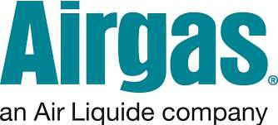**SAFETY DATA SHEET**

Ammonia



**Section 1. Identification**

**GHS product identifier** **:** Ammonia

**Chemical name** **:** ammonia

**Other means of** **:** ammonia; anhydrous ammonia

**identification**

**Product type** **:** Gas.

**Product use** **:** Synthetic/Analytical chemistry.

**Synonym** **:** ammonia; anhydrous ammonia

**SDS #** **:** 001003

**Supplier's details** **:** Airgas USA, LLC and its affiliates

259 North Radnor-Chester Road

Suite 100

Radnor, PA 19087-5283

1-610-687-5253

**24-hour telephone** **:** 1-866-734-3438



**Section 2. Hazards identification**

|  |  |  |  |  |
| --- | --- | --- | --- | --- |
| **OSHA/HCS status** | | **:** This material is considered hazardous by the OSHA Hazard Communication Standard | | |
|  |  | (29 CFR 1910.1200). | | |
| **Classification of the** | | **:** FLAMMABLE GASES - Category 2 | | |
| **substance or mixture** | | GASES UNDER PRESSURE - Liquefied gas | | |
|  |  | ACUTE TOXICITY (inhalation) - Category 4 | | |
|  |  | SKIN CORROSION - Category 1 | | |
|  |  | SERIOUS EYE DAMAGE - Category 1 | | |
|  |  | AQUATIC HAZARD (ACUTE) - Category 1 | | |
| **GHS label elements** | |  |  |  |
|  |  |  |  |  |
| **Hazard pictograms** | | **:** |  |  |
|  |  |  |  |  |



|  |  |  |
| --- | --- | --- |
| **Signal word** | | **:** Danger |
| **Hazard statements** | | **:** Flammable gas. |
|  |  | May form explosive mixtures with air. |
|  |  | Contains gas under pressure; may explode if heated. |
|  |  | May displace oxygen and cause rapid suffocation. |
|  |  | Harmful if inhaled. |
|  |  | Causes severe skin burns and eye damage. |
|  |  | Very toxic to aquatic life. |
| **Precautionary statements** | |  |
| **General** |  | **:** Read and follow all Safety Data Sheets (SDS’S) before use. Close valve after each use |
|  |  | and when empty. Use equipment rated for cylinder pressure. Do not open valve until |
|  |  | connected to equipment prepared for use. Use a back flow preventative device in the |
|  |  | piping. Use only equipment of compatible materials of construction. Always keep |
|  |  | container in upright position. Approach suspected leak area with caution. |
| **Prevention** | | **:** Wear protective gloves. Wear eye or face protection. Wear protective clothing. Keep |
|  |  | away from heat, hot surfaces, sparks, open flames and other ignition sources. No |
|  |  | smoking. Use only outdoors or in a well-ventilated area. Avoid release to the |
|  |  | environment. Avoid breathing gas. Wash hands thoroughly after handling. |



***Date of issue/Date of revision*** **:** *2/15/2018* ***Date of previous issue*** ***:*** *2/15/2018* ***Version :*** *1.04* *1/12*

*Ammonia*



**Section 2. Hazards identification**

|  |  |  |  |  |  |
| --- | --- | --- | --- | --- | --- |
|  | **Response** | **:** Collect spillage. IF INHALED: Remove person to fresh air and keep comfortable for | | | |
|  |  | breathing. Immediately call a POISON CENTER or physician. IF SWALLOWED: | | | |
|  |  | Immediately call a POISON CENTER or physician. Rinse mouth. Do NOT induce | | | |
|  |  | vomiting. IF ON SKIN (or hair): Take off immediately all contaminated clothing. Rinse | | | |
|  |  | skin with water or shower. Wash contaminated clothing before reuse. Immediately call | | | |
|  |  | a POISON CENTER or physician. IF IN EYES: Rinse cautiously with water for several | | | |
|  |  | minutes. Remove contact lenses, if present and easy to do. Continue rinsing. | | | |
|  |  | Immediately call a POISON CENTER or physician. Leaking gas fire: Do not extinguish, | | | |
|  |  | unless leak can be stopped safely. Eliminate all ignition sources if safe to do so. | | | |
|  | **Storage** | **:** Store locked up. Protect from sunlight. Store in a well-ventilated place. | | | |
|  | **Disposal** | **:** Dispose of contents and container in accordance with all local, regional, national and | | | |
|  |  | international regulations. | |  |  |
|  | **Hazards not otherwise** | **:** In addition to any other important health or physical hazards, this product may displace | | | |
|  | **classified** | oxygen and cause rapid suffocation. | |  |  |
|  |  | |  |  |  |
|  | **Section 3. Composition/information on ingredients** | | |  |  |
|  |  |  |  |  |  |
|  | **Substance/mixture** | **:** Substance | |  |  |
|  | **Chemical name** | **:** ammonia | |  |  |
|  | **Other means of** | **:** ammonia; anhydrous ammonia | |  |  |
|  | **identification** |  |  |  |  |
|  | **Product code** | **:** 001003 |  |  |  |
|  | **CAS number/other identifiers** |  |  |  |  |
|  | **CAS number** | **:** 7664-41-7 |  |  |  |
|  |  |  |  |  |  |
|  | **Ingredient name** |  | **%** | **CAS number** |  |
|  |  |  |  |  |  |
|  | ammonia |  | 100 | 7664-41-7 |  |
|  |  |  |  |  |  |



Any concentration shown as a range is to protect confidentiality or is due to batch variation.

**There are no additional ingredients present which, within the current knowledge of the supplier and in the concentrations applicable, are classified as hazardous to health or the environment and hence require reporting in this section.**

**Occupational exposure limits, if available, are listed in Section 8.**



**Section 4. First aid measures**

**Description of necessary first aid measures**

**Eye contact** **:** Get medical attention immediately. Call a poison center or physician. Immediately flusheyes with plenty of water, occasionally lifting the upper and lower eyelids. Check for and remove any contact lenses. Continue to rinse for at least 10 minutes. Chemical burns must be treated promptly by a physician.

**Inhalation** **:** Get medical attention immediately. Call a poison center or physician. Remove victim to

fresh air and keep at rest in a position comfortable for breathing. If it is suspected that fumes are still present, the rescuer should wear an appropriate mask or self-contained breathing apparatus. If not breathing, if breathing is irregular or if respiratory arrest occurs, provide artificial respiration or oxygen by trained personnel. It may be dangerous to the person providing aid to give mouth-to-mouth resuscitation. If unconscious, place in recovery position and get medical attention immediately. Maintain an open airway. Loosen tight clothing such as a collar, tie, belt or waistband. In case of inhalation of decomposition products in a fire, symptoms may be delayed. The exposed person may need to be kept under medical surveillance for 48 hours.

**Skin contact** **:** Get medical attention immediately. Call a poison center or physician. Flush

contaminated skin with plenty of water. Remove contaminated clothing and shoes. To avoid the risk of static discharges and gas ignition, soak contaminated clothing thoroughly with water before removing it. Continue to rinse for at least 10 minutes. Chemical burns must be treated promptly by a physician. Wash clothing before reuse. Clean shoes thoroughly before reuse.

**Ingestion** **:** As this product is a gas, refer to the inhalation section.



***Date of issue/Date of revision*** **:** *2/15/2018* ***Date of previous issue*** ***:*** *2/15/2018* ***Version :*** *1.04* *2/12*

*Ammonia*



**Section 4. First aid measures**

**Most important symptoms/effects, acute and delayed**

**Potential acute health effects**

|  |  |  |
| --- | --- | --- |
| **Eye contact** | **:** Causes serious eye damage. | |
| **Inhalation** | **:** Harmful if inhaled. | |
| **Skin contact** | **:** Causes severe burns. | |
| **Frostbite** | **:** Try to warm up the frozen tissues and seek medical attention. | |
| **Ingestion** | **:** As this product is a gas, refer to the inhalation section. | |
| **Over-exposure signs/symptoms** | | |
|  |  |  |
| **Eye contact** | **:** Adverse symptoms may include the following:, pain, watering, redness | |
| **Inhalation** | **:** No specific data. | |
| **Skin contact** | **:** Adverse symptoms may include the following:, pain or irritation, redness, blistering may | |
|  | occur | |
| **Ingestion** | **:** Adverse symptoms may include the following:, stomach pains | |

**Indication of immediate medical attention and special treatment needed, if necessary**

**Notes to physician** **:** In case of inhalation of decomposition products in a fire, symptoms may be delayed.

The exposed person may need to be kept under medical surveillance for 48 hours.

**Specific treatments** **:** No specific treatment.

**Protection of first-aiders** **:** No action shall be taken involving any personal risk or without suitable training. If it is

suspected that fumes are still present, the rescuer should wear an appropriate mask or

self-contained breathing apparatus. It may be dangerous to the person providing aid to

give mouth-to-mouth resuscitation. Wash contaminated clothing thoroughly with water

before removing it, or wear gloves.

**See toxicological information (Section 11)**



**Section 5. Fire-fighting measures**

|  |  |  |
| --- | --- | --- |
| **Extinguishing media** |  |  |
| **Suitable extinguishing** | | **:** Use an extinguishing agent suitable for the surrounding fire. |
| **media** | |  |
| **Unsuitable extinguishing** | | **:** None known. |
| **media** | |  |
| **Specific hazards arising** | | **:** Contains gas under pressure. Flammable gas. In a fire or if heated, a pressure |
| **from the chemical** | | increase will occur and the container may burst, with the risk of a subsequent explosion. |
|  |  | This material is very toxic to aquatic life. Fire water contaminated with this material |
|  |  | must be contained and prevented from being discharged to any waterway, sewer or |
|  |  | drain. |
| **Hazardous thermal** | | **:** Decomposition products may include the following materials: |
| **decomposition products** | | nitrogen oxides |
| **Special protective actions** | | **:** Promptly isolate the scene by removing all persons from the vicinity of the incident if |
| **for fire-fighters** | | there is a fire. No action shall be taken involving any personal risk or without suitable |
|  |  | training. Contact supplier immediately for specialist advice. Move containers from fire |
|  |  | area if this can be done without risk. Use water spray to keep fire-exposed containers |
|  |  | cool. If involved in fire, shut off flow immediately if it can be done without risk. If this is |
|  |  | impossible, withdraw from area and allow fire to burn. Fight fire from protected location |
|  |  | or maximum possible distance. Eliminate all ignition sources if safe to do so. |
| **Special protective** | | **:** Fire-fighters should wear appropriate protective equipment and self-contained breathing |
| **equipment for fire-fighters** | | apparatus (SCBA) with a full face-piece operated in positive pressure mode. |



***Date of issue/Date of revision*** **:** *2/15/2018* ***Date of previous issue*** ***:*** *2/15/2018* ***Version :*** *1.04* *3/12*

*Ammonia*



**Section 6. Accidental release measures**

**Personal precautions, protective equipment and emergency procedures**

**For non-emergency** **:** Accidental releases pose a serious fire or explosion hazard. No action shall be taken

**personnel** involving any personal risk or without suitable training. Evacuate surrounding areas.

Keep unnecessary and unprotected personnel from entering. Shut off all ignition sources. No flares, smoking or flames in hazard area. Do not breathe gas. Provide adequate ventilation. Wear appropriate respirator when ventilation is inadequate. Put on appropriate personal protective equipment.

**For emergency responders :** If specialized clothing is required to deal with the spillage, take note of any information in

Section 8 on suitable and unsuitable materials. See also the information in "For non-

emergency personnel".

**Environmental precautions :** Ensure emergency procedures to deal with accidental gas releases are in place to avoid

contamination of the environment. Inform the relevant authorities if the product has

caused environmental pollution (sewers, waterways, soil or air). Water polluting

material. May be harmful to the environment if released in large quantities. Collect

spillage.

**Methods and materials for containment and cleaning up**

**Small spill** **:** Immediately contact emergency personnel. Stop leak if without risk. Use spark-prooftools and explosion-proof equipment.

|  |  |  |
| --- | --- | --- |
|  | **Large spill** | **:** Immediately contact emergency personnel. Stop leak if without risk. Use spark-proof |
|  |  | tools and explosion-proof equipment. Note: see Section 1 for emergency contact |
|  |  | information and Section 13 for waste disposal. |
|  |  | |
| **Section 7. Handling and storage** | | |
|  |  |  |
| **Precautions for safe handling** | |  |
|  | **Protective measures** | **:** Put on appropriate personal protective equipment (see Section 8). Contains gas under |
|  |  | pressure. Do not get in eyes or on skin or clothing. Do not breathe gas. Avoid release |
|  |  | to the environment. Use only with adequate ventilation. Wear appropriate respirator |
|  |  | when ventilation is inadequate. Do not enter storage areas and confined spaces unless |
|  |  | adequately ventilated. Store and use away from heat, sparks, open flame or any other |
|  |  | ignition source. Empty containers retain product residue and can be hazardous. Do not |
|  |  | puncture or incinerate container. Use equipment rated for cylinder pressure. Close |
|  |  | valve after each use and when empty. Protect cylinders from physical damage; do not |
|  |  | drag, roll, slide, or drop. Use a suitable hand truck for cylinder movement. |
|  | **Advice on general** | **:** Eating, drinking and smoking should be prohibited in areas where this material is |
|  | **occupational hygiene** | handled, stored and processed. Workers should wash hands and face before eating, |
|  |  | drinking and smoking. Remove contaminated clothing and protective equipment before |
|  |  | entering eating areas. See also Section 8 for additional information on hygiene |
|  |  | measures. |



**Conditions for safe storage,**

**including any**

**incompatibilities**

* Store in accordance with local regulations. Store in a segregated and approved area. Store away from direct sunlight in a dry, cool and well-ventilated area, away from incompatible materials (see Section 10). Store locked up. Eliminate all ignition sources. Keep container tightly closed and sealed until ready for use. Cylinders should be stored upright, with valve protection cap in place, and firmly secured to prevent falling or being knocked over. Cylinder temperatures should not exceed 52 °C (125 °F).

Refer to ANSI/CGA G-2.1, Section 5.13 for electrical classification of anhydrous ammonia storage and handling areas. Where anhydrous ammonia is stored indoors, use electrical (ventilating, lighting and material handling) equipment with the appropriate electrical classification rating and use only non-sparking tools.



***Date of issue/Date of revision*** **:** *2/15/2018* ***Date of previous issue*** ***:*** *2/15/2018* ***Version :*** *1.04* *4/12*

*Ammonia*



**Section 8. Exposure controls/personal protection**

**Control parameters**

**Occupational exposure limits**



|  |  |  |  |
| --- | --- | --- | --- |
|  | **Ingredient name** |  | **Exposure limits** |
|  |  |  |  |
|  | ammonia |  | **California PEL for Chemical Contaminants (** |
|  |  |  | ***Table AC-1*) (United States).** |
|  |  |  | PEL: 25 ppm 8 hours. |
|  |  |  | STEL: 35 ppm 15 minutes. |
|  |  |  | **ACGIH TLV (United States, 3/2017).** |
|  |  |  | TWA: 25 ppm 8 hours. |
|  |  |  | TWA: 17 mg/m³ 8 hours. |
|  |  |  | STEL: 35 ppm 15 minutes. |
|  |  |  | STEL: 24 mg/m³ 15 minutes. |
|  |  |  | **OSHA PEL 1989 (United States, 3/1989).** |
|  |  |  | STEL: 35 ppm 15 minutes. |
|  |  |  | STEL: 27 mg/m³ 15 minutes. |
|  |  |  | **NIOSH REL (United States, 10/2016).** |
|  |  |  | TWA: 25 ppm 10 hours. |
|  |  |  | TWA: 18 mg/m³ 10 hours. |
|  |  |  | STEL: 35 ppm 15 minutes. |
|  |  |  | STEL: 27 mg/m³ 15 minutes. |
|  |  |  | **OSHA PEL (United States, 6/2016).** |
|  |  |  | TWA: 50 ppm 8 hours. |
|  |  |  | TWA: 35 mg/m³ 8 hours. |
|  |  |  |  |
| **Appropriate engineering** | | **:** Use only with adequate ventilation. Use process enclosures, local exhaust ventilation or | |
| **controls** | | other engineering controls to keep worker exposure to airborne contaminants below any | |
|  |  | recommended or statutory limits. The engineering controls also need to keep gas, | |
|  |  | vapor or dust concentrations below any lower explosive limits. Use explosion-proof | |
|  |  | ventilation equipment. | |
| **Environmental exposure** | | **:** Emissions from ventilation or work process equipment should be checked to ensure | |
| **controls** | | they comply with the requirements of environmental protection legislation. In some | |
|  |  | cases, fume scrubbers, filters or engineering modifications to the process equipment | |
|  |  | will be necessary to reduce emissions to acceptable levels. | |



**Individual protection measures**

**Hygiene measures** **:** Wash hands, forearms and face thoroughly after handling chemical products, beforeeating, smoking and using the lavatory and at the end of the working period. Appropriate techniques should be used to remove potentially contaminated clothing. Wash contaminated clothing before reusing. Ensure that eyewash stations and safety showers are close to the workstation location.

|  |  |  |
| --- | --- | --- |
| **Eye/face protection** | | **:** Safety eyewear complying with an approved standard should be used when a risk |
|  |  | assessment indicates this is necessary to avoid exposure to liquid splashes, mists, |
|  |  | gases or dusts. If contact is possible, the following protection should be worn, unless |
|  |  | the assessment indicates a higher degree of protection: chemical splash goggles and/ |
|  |  | or face shield. If inhalation hazards exist, a full-face respirator may be required instead. |
| **Skin protection** | |  |
|  |  |  |
| **Hand protection** | | **:** Chemical-resistant, impervious gloves complying with an approved standard should be |
|  |  | worn at all times when handling chemical products if a risk assessment indicates this is |
|  |  | necessary. Considering the parameters specified by the glove manufacturer, check |
|  |  | during use that the gloves are still retaining their protective properties. It should be |
|  |  | noted that the time to breakthrough for any glove material may be different for different |
|  |  | glove manufacturers. In the case of mixtures, consisting of several substances, the |
|  |  | protection time of the gloves cannot be accurately estimated. |
| **Body protection** | | **:** Personal protective equipment for the body should be selected based on the task being |
|  |  | performed and the risks involved and should be approved by a specialist before |
|  |  | handling this product. When there is a risk of ignition from static electricity, wear anti- |
|  |  | static protective clothing. For the greatest protection from static discharges, clothing |
|  |  | should include anti-static overalls, boots and gloves. |



***Date of issue/Date of revision*** **:** *2/15/2018* ***Date of previous issue*** ***:*** *2/15/2018* ***Version :*** *1.04* *5/12*

*Ammonia*



**Section 8. Exposure controls/personal protection**

|  |  |  |  |  |  |  |
| --- | --- | --- | --- | --- | --- | --- |
|  | **Other skin protection** | | | **:** Appropriate footwear and any additional skin protection measures should be selected | | |
|  |  |  |  |  | based on the task being performed and the risks involved and should be approved by a | |
|  |  |  |  |  | specialist before handling this product. | |
|  | **Respiratory protection** | | | **:** Based on the hazard and potential for exposure, select a respirator that meets the | | |
|  |  |  |  |  | appropriate standard or certification. Respirators must be used according to a | |
|  |  |  |  |  | respiratory protection program to ensure proper fitting, training, and other important | |
|  |  |  |  |  | aspects of use. Respirator selection must be based on known or anticipated exposure | |
|  |  |  |  |  | levels, the hazards of the product and the safe working limits of the selected respirator. | |
|  |  |  |  | | | |
| **Section 9. Physical and chemical properties** | | | | | | |
|  |  |  |  |  |  |  |
|  | **Appearance** |  | |  |  |  |
|  | **Physical state** | | | **:** Gas. [Compressed gas.] | | |
|  | **Color** | | | **:** Colorless. | | |
| **Odor** | | | | **:** Pungent. | | |
| **Odor threshold** | | | | **:** Not available. | | |
| **pH** | | | | **:** Approx. 11.6 | | |
| **Melting point** | | | | **:** -77.7°C (-107.9°F) | | |
| **Boiling point** | | | | **:** -33°C (-27.4°F) | | |
| **Critical temperature** | | | | **:** 132.85°C (271.1°F) | | |
| **Flash point** | | | | **:** Not available. | | |
| **Evaporation rate** | | | | **:** Not available. | | |
| **Flammability (solid, gas)** | | | | **:** Extremely flammable in the presence of the following materials or conditions: oxidizing | | |
|  |  |  |  |  | materials. | |
| **Lower and upper explosive** | | | | **:** Lower: 16% | | |
| **(flammable) limits** | | | |  | Upper: 25% | |
| **Vapor pressure** | | | | **:** | 114.1 | (psig) |
| **Vapor density** | | | | **:** | 0.59 | (Air = 1) |
| **Specific Volume (ft 3/lb)** | | | | **:** | 20.79 |  |
| **Gas Density (lb/ft 3)** | | | | **:** | 0.0481 (32°C / 89.6 to °F) | |
| **Relative density** | | | | **:** SPECIFIC GRAVITY (AIR=1): @ 70°F (21.1°C) = 0.59 | | |
| **Solubility** | | | | **:** Soluble in water. Soluble in alcohol and ether. | | |
| **Solubility in water** | | | | **:** | 540 g/l | |
| **Partition coefficient: n-** | | | | **:** | Not available. | |
| **octanol/water** | | | |  |  |  |
| **Auto-ignition temperature** | | | | **:** 651°C (1203.8°F) | | |
| **Decomposition temperature** | | | | **:** Not available. | | |
| **Viscosity** | | | | **:** Not applicable. | | |
| **Flow time (ISO 2431)** | | | | **:** Not available. | | |
| **Molecular weight** | | | | **:** | 17.03 g/mole | |
|  | **Aerosol product** | |  |  |  |  |
|  | **Heat of combustion** | | | **:** -18589392 J/kg | | |
|  | | | | | | |
| **Section 10. Stability and reactivity** | | | | | | |
|  | | | |  | | |
| **Reactivity** | | | | **:** No specific test data related to reactivity available for this product or its ingredients. | | |
| **Chemical stability** | | | | **:** The product is stable. | | |
| **Possibility of hazardous** | | | | **:** Under normal conditions of storage and use, hazardous reactions will not occur. | | |
| **reactions** | | | |  |  |  |
| **Conditions to avoid** | | | | **:** Avoid all possible sources of ignition (spark or flame). Do not pressurize, cut, weld, | | |
|  |  |  |  |  | braze, solder, drill, grind or expose containers to heat or sources of ignition. | |



***Date of issue/Date of revision*** **:** *2/15/2018* ***Date of previous issue*** ***:*** *2/15/2018* ***Version :*** *1.04* *6/12*

*Ammonia*



**Section 10. Stability and reactivity**

**Incompatible materials** **:** Oxidizers and Yellow Metals (brass & copper)

**Hazardous decomposition** **:** Under normal conditions of storage and use, hazardous decomposition products should

**products** not be produced.

**Hazardous polymerization** **:** Under normal conditions of storage and use, hazardous polymerization will not occur.



**Section 11. Toxicological information**

**Information on toxicological effects**

**Acute toxicity**



|  |  |  |  |  |  |  |  |  |  |
| --- | --- | --- | --- | --- | --- | --- | --- | --- | --- |
| **Product/ingredient name** | | | | | | **Result** | **Species** | **Dose** | **Exposure** |
|  | | | | | |  |  |  |  |
| ammonia | | | | | | LC50 Inhalation Gas. | Rat | 7338 ppm | 1 hours |
|  | | | | | |  |  |  |  |
| **Irritation/Corrosion** | | | |  | |  |  |  |  |
| Not available. | | | | | |  |  |  |  |
| **Sensitization** | | | | | |  |  |  |  |
|  |  | | | | |  |  |  |  |
| Not available. | | | | | |  |  |  |  |
| **Mutagenicity** |  | | | | |  |  |  |  |
| Not available. | | | | | |  |  |  |  |
| **Carcinogenicity** | | | | | |  |  |  |  |
| Not available. | | |  | | |  |  |  |  |
| **Reproductive toxicity** | | | | | |  |  |  |  |
| Not available. | | | | |  |  |  |  |  |
| **Teratogenicity** | |  | | | |  |  |  |  |
| Not available. | | | | | |  |  |  |  |



**Specific target organ toxicity (single exposure)**

Not available.

**Specific target organ toxicity (repeated exposure)**

Not available.

**Aspiration hazard**

|  |  |  |
| --- | --- | --- |
| Not available. |  |  |
| **Information on the likely** | **:** Not available. | |
| **routes of exposure** |  |  |
| **Potential acute health effects** |  |  |
| **Eye contact** | **:** Causes serious eye damage. | |
| **Inhalation** | **:** Harmful if inhaled. | |
| **Skin contact** | **:** Causes severe burns. | |
| **Ingestion** | **:** As this product is a gas, refer to the inhalation section. | |
| **Symptoms related to the physical, chemical and toxicological characteristics** | | |
|  |  |  |
| **Eye contact** | **:** Adverse symptoms may include the following:, pain, watering, redness | |
| **Inhalation** | **:** No specific data. | |
| **Skin contact** | **:** Adverse symptoms may include the following:, pain or irritation, redness, blistering may | |
|  | occur | |



***Date of issue/Date of revision*** **:** *2/15/2018* ***Date of previous issue*** ***:*** *2/15/2018* ***Version :*** *1.04* *7/12*

*Ammonia*



**Section 11. Toxicological information**

**Ingestion** **:** Adverse symptoms may include the following:, stomach pains

**Delayed and immediate effects and also chronic effects from short and long term exposure Short term exposure**

|  |  |  |  |
| --- | --- | --- | --- |
| **Potential immediate** | | **:** Not available. | |
| **effects** | |  |  |
| **Potential delayed effects** | | **:** Not available. | |
| **Long term exposure** |  |  |  |
| **Potential immediate** | | **:** Not available. | |
| **effects** | |  |  |
| **Potential delayed effects** | | **:** Not available. | |
| **Potential chronic health effects** | | | |
| Not available. | |  |  |
| **General** | | **:** No known significant effects or critical hazards. | |
| **Carcinogenicity** | | **:** No known significant effects or critical hazards. | |
| **Mutagenicity** | | **:** No known significant effects or critical hazards. | |
| **Teratogenicity** | | **:** No known significant effects or critical hazards. | |
| **Developmental effects** | | **:** No known significant effects or critical hazards. | |
| **Fertility effects** | | **:** No known significant effects or critical hazards. | |

**Numerical measures of toxicity**

**Acute toxicity estimates**

Not available.

|  |  |  |  |  |  |  |
| --- | --- | --- | --- | --- | --- | --- |
|  | **Other information** | | **:** IDLH : 300 ppm |  |  |  |
|  |  |  |  |  |  |  |
|  | **Section 12. Ecological information** | | |  |  |  |
|  |  |  |  |  |  |  |
|  | **Toxicity** |  |  |  |  |  |
|  |  | |  |  |  |  |
|  | **Product/ingredient name** | | **Result** | **Species** | **Exposure** |  |
|  |  | |  |  |  |  |
|  | ammonia | | Acute EC50 29.2 mg/l Marine water | Algae - Ulva fasciata - Zoea | 96 hours |  |
|  |  |  | Acute LC50 2080 µg/l Fresh water | Crustaceans - Gammarus pulex | 48 hours |  |
|  |  |  | Acute LC50 0.53 ppm Fresh water | Daphnia - Daphnia magna | 48 hours |  |
|  |  |  | Acute LC50 300 µg/l Fresh water | Fish - Hypophthalmichthys nobilis | 96 hours |  |
|  |  |  | Chronic NOEC 0.204 mg/l Marine water | Fish - Dicentrarchus labrax | 62 days |  |
|  |  |  |  |  |  |  |



**Persistence and degradability**

Not available.

**Bioaccumulative potential**

|  |  |  |
| --- | --- | --- |
| Not available. | |  |
| **Mobility in soil** | |  |
|  |  |  |
| **Soil/water partition** | | **:** Not available. |
| **coefficient (KOC)** | |  |
| **Other adverse effects** | | **:** No known significant effects or critical hazards. |



***Date of issue/Date of revision*** **:** *2/15/2018* ***Date of previous issue*** ***:*** *2/15/2018* ***Version :*** *1.04* *8/12*

*Ammonia*



**Section 13. Disposal considerations**

|  |  |
| --- | --- |
| **Disposal methods** | **:** The generation of waste should be avoided or minimized wherever possible. Disposal |
|  | of this product, solutions and any by-products should at all times comply with the |
|  | requirements of environmental protection and waste disposal legislation and any |
|  | regional local authority requirements. Dispose of surplus and non-recyclable products |
|  | via a licensed waste disposal contractor. Waste should not be disposed of untreated to |
|  | the sewer unless fully compliant with the requirements of all authorities with jurisdiction. |
|  | Empty Airgas-owned pressure vessels should be returned to Airgas. Waste packaging |
|  | should be recycled. Incineration or landfill should only be considered when recycling is |
|  | not feasible. This material and its container must be disposed of in a safe way. Empty |
|  | containers or liners may retain some product residues. Do not puncture or incinerate |
|  | container. |
|  | |
| **Section 14. Transport information** | |
|  |  |

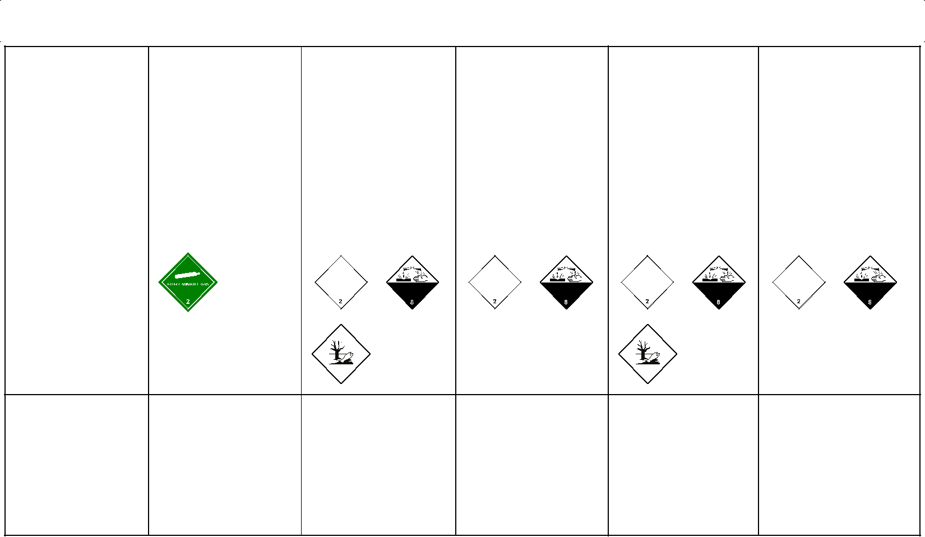

|  |  |  |  |  |  |
| --- | --- | --- | --- | --- | --- |
|  | **DOT** | **TDG** | **Mexico** | **IMDG** | **IATA** |
|  |  |  |  |  |  |
| **UN number** | UN1005 | UN1005 | UN1005 | UN1005 | UN1005 |
|  |  |  |  |  |  |
| **UN proper** | AMMONIA, | AMMONIA, | AMMONIA, | AMMONIA, | AMMONIA, |
| **shipping name** | ANHYDROUS | ANHYDROUS; | ANHYDROUS | ANHYDROUS | ANHYDROUS |
|  |  | OR ANHYDROUS |  |  |  |
|  |  | AMMONIA |  |  |  |
|  |  |  |  |  |  |
| **Transport** | 2.2 | 2.3 (8) | 2.3 (8) | 2.3 (8) | 2.3 (8) |
| **hazard class(es)** |  |  |  |  |  |

|  |  |  |  |  |  |
| --- | --- | --- | --- | --- | --- |
| **Packing group** | - | - | - | - | - |
|  |  |  |  |  |  |
| **Environmental** | Yes. | Yes. | Yes. The | Yes. | Yes. The |
| **hazards** |  |  | environmentally |  | environmentally |
|  |  |  | hazardous |  | hazardous |
|  |  |  | substance mark is |  | substance mark is |
|  |  |  | not required. |  | not required. |

**“Refer to CFR 49 (or authority having jurisdiction) to determine the information required for shipment of the product.”**

|  |  |  |  |  |  |  |  |  |  |
| --- | --- | --- | --- | --- | --- | --- | --- | --- | --- |
| **Additional information** |  |  |  |  |  |  |  |  |  |
| **DOT Classification** | **:** Inhalation hazard | | | | | | | | |
|  |  | This product is not regulated as a marine pollutant when transported on inland | | | | | | | |
|  |  | waterways in sizes of ≤5 L or ≤5 kg or by road, rail, or inland air in non-bulk sizes, | | | | | | | |
|  |  | provided the packagings meet the general provisions of §§ 173.24 and 173.24a. | | | | | | | |
|  |  | **Reportable quantity** 100 lbs / 45.4 kg. Package sizes shipped in quantities less than | | | | | | | |
|  |  |  |  |  |  |  |  |  |  |
|  |  | the product reportable quantity are not subject to the RQ (reportable quantity) | | | | | | | |
|  |  | transportation requirements. | | | | | | | |
|  |  | **Limited quantity** Yes. | | | | | | | |
|  |  |  |  |  |  | |  |  |  |
|  |  | **Quantity limitation** Passenger aircraft/rail: Forbidden. Cargo aircraft: Forbidden. | | | | | | | |
|  |  |  |  | |  | |  |  |  |
|  |  | **Special provisions** 13,T50 | | | | | | | |
|  |  |  |  | |  | |  |  |  |
| **TDG Classification** | **:** Product classified as per the following sections of the Transportation of Dangerous | | | | | | | | |
|  |  | Goods Regulations: 2.13-2.17 (Class 2), 2.40-2.42 (Class 8), 2.7 (Marine pollutant | | | | | | | |
|  |  | mark). | | | | | | | |
|  |  | The marine pollutant mark is not required when transported by road or rail. | | | | | | | |
|  |  | **Explosive Limit and Limited Quantity Index** 0 | | | | | | | |
|  |  | **ERAP Index** 3000 | | | | | | |  |
|  |  |  |  | | | |  |  | |
|  |  | **Passenger Carrying Ship Index** Forbidden | | | | | | | |
|  |  |  | | | | |  |  | |
|  |  | **Passenger Carrying Road or Rail Index** Forbidden | | | | | | | |
|  |  |  |  |  |  |  |  |  |  |



***Date of issue/Date of revision*** **:** *2/15/2018* ***Date of previous issue*** ***:*** *2/15/2018* ***Version :*** *1.04* *9/12*

*Ammonia*



**Section 14. Transport information**

|  |  |  |  |
| --- | --- | --- | --- |
|  |  | **Special provisions** | |
|  |  |  |  |
| **Mexico Classification** | **:** Toxic Inhalation Hazard Zone D | | |
| **IMDG** | **:** The marine pollutant mark is not required when transported in sizes of ≤5 L or ≤5 kg. | | |
| **IATA** | **:** The environmentally hazardous substance mark may appear if required by other | | |
|  |  | transportation regulations. | |
|  |  | **Quantity limitation** Passenger and Cargo Aircraft: Forbidden. Cargo Aircraft Only: | |
|  |  |  |  |
|  |  | Forbidden. Limited Quantities - Passenger Aircraft: Forbidden. | |

**Special precautions for user** **:**

**Transport in bulk according : to Annex II of MARPOL and the IBC Code**

**Transport within user’s premises:** always transport in closed containers that areupright and secure. Ensure that persons transporting the product know what to do in the event of an accident or spillage.

Not available.



**Section 15. Regulatory information**

|  |  |  |  |  |  |  |  |  |  |  |  |  |  |  |  |  |
| --- | --- | --- | --- | --- | --- | --- | --- | --- | --- | --- | --- | --- | --- | --- | --- | --- |
| **U.S. Federal regulations** | | | | |  | **: TSCA 8(a) CDR Exempt/Partial exemption**: Not determined | | | | | | |  |  |  |  |
|  |  |  |  |  |  | **Clean Water Act (CWA) 311**: ammonia | | | | |  |  |  |  |  |  |
|  |  |  |  |  |  | **Clean Air Act (CAA) 112 regulated toxic substances**: ammonia | | | | | | | |  |  |  |
| **Clean Air Act Section 112** | | | | |  | **:** Not listed | | |  |  |  |  |  |  |  |  |
| **(b) Hazardous Air** | | | | |  |  |  |  |  |  |  |  |  |  |  |  |
| **Pollutants (HAPs)** | | | | |  |  |  |  |  |  |  |  |  |  |  |  |
| **Clean Air Act Section 602** | | | | |  | **:** Not listed | | |  |  |  |  |  |  |  |  |
| **Class I Substances** | | | | |  |  |  |  |  |  |  |  |  |  |  |  |
| **Clean Air Act Section 602** | | | | |  | **:** Not listed | | |  |  |  |  |  |  |  |  |
| **Class II Substances** | | | | |  |  |  |  |  |  |  |  |  |  |  |  |
| **DEA List I Chemicals** | | | | |  | **:** Not listed | | |  |  |  |  |  |  |  |  |
| **(Precursor Chemicals)** | | | | |  |  |  |  |  |  |  |  |  |  |  |  |
| **DEA List II Chemicals** | | | | |  | **:** Not listed | | |  |  |  |  |  |  |  |  |
| **(Essential Chemicals)** | | | | |  |  |  |  |  |  |  |  |  |  |  |  |
| **SARA 302/304** | | | | |  |  |  |  |  |  |  |  |  |  |  |  |
|  |  |  | |  | | |  |  |  |  |  |  |  |  |  |  |
|  |  | **Composition/information on ingredients** | | | | | | |  |  |  |  |  |  |  |  |
|  |  |  |  |  |  |  |  |  |  |  |  |  |  |  |  |  |
|  |  |  |  |  |  |  |  |  |  | **SARA 302 TPQ** | | | **SARA 304 RQ** | | |  |
|  |  |  | | |  | |  |  |  |  |  | |  |  |  |  |
|  |  | **Name** | | |  |  | **%** | | **EHS** | **(lbs)** | **(gallons)** | | **(lbs)** |  | **(gallons)** |  |
|  |  |  | | |  | |  |  |  |  |  | |  |  |  |  |
|  |  | ammonia | | |  | | 100 | | Yes. | 500 | - | | 100 |  | - |  |
|  |  |  | | |  |  |  |  |  |  |  |  |  |  |  |  |
|  |  | **SARA 304 RQ** | | |  | **:** 100 lbs / 45.4 kg | | |  |  |  |  |  |  |  |  |
| **SARA 311/312** | | | | |  |  |  |  |  |  |  |  |  |  |  |  |
|  |  |  | |  |  | | | | | | | | | | |  |
|  |  | **Classification** | | | **:** Refer to Section 2: Hazards Identification of this SDS for classification of substance. | | | | | | | | | | |  |
| **SARA 313** | | | | |  |  |  |  |  |  |  |  |  |  |  |  |
|  |  |  |  |  |  |  |  |  |  |  |  |  |  |  |  |  |
|  |  |  |  |  |  | **Product name** | | |  |  |  | **CAS number** | | **%** |  |  |
|  |  |  |  |  |  |  |  |  |  |  |  |  |  |  |  |  |
|  |  | **Form R - Reporting** | | |  | ammonia | | |  |  |  | 7664-41-7 |  | 100 |  |  |
|  |  |  |  |  |  |  |  |  |  |  |  |  |  |
|  |  | **requirements** | | |  |  |  |  |  |  |  |  |  |  |  |  |
|  |  |  |  |  |  |  |  |  |  |  |  |  |  |  |  |  |
|  |  | **Supplier notification** | | |  | ammonia | | |  |  |  | 7664-41-7 |  | 100 |  |  |
|  |  |  |  |  |  |  |  |  |  |  |  |  |  |
|  |  |  |  |  |  |  |  |  |  |  |  |  |  |  |  |  |



SARA 313 notifications must not be detached from the SDS and any copying and redistribution of the SDS shall include copying and redistribution of the notice attached to copies of the SDS subsequently redistributed.

**State regulations**

**Massachusetts** **:** This material is listed.



***Date of issue/Date of revision*** **:** *2/15/2018* ***Date of previous issue*** ***:*** *2/15/2018* ***Version :*** *1.04* *10/12*

*Ammonia*



**Section 15. Regulatory information**

|  |  |
| --- | --- |
| **New York** | **:** This material is listed. |
| **New Jersey** | **:** This material is listed. |
| **Pennsylvania** | **:** This material is listed. |
| **International regulations** |  |

**Chemical Weapon Convention List Schedules I, II & III Chemicals**

Not listed.

**Montreal Protocol (Annexes A, B, C, E)**

Not listed.

**Stockholm Convention on Persistent Organic Pollutants**

Not listed.

**Rotterdam Convention on Prior Informed Consent (PIC)**

Not listed.

**UNECE Aarhus Protocol on POPs and Heavy Metals**

Not listed.

|  |  |  |
| --- | --- | --- |
| **Inventory list** |  |  |
| **Australia** | | **:** This material is listed or exempted. |
| **Canada** | | **:** This material is listed or exempted. |
| **China** | | **:** This material is listed or exempted. |
| **Europe** | | **:** This material is listed or exempted. |
| **Japan** | | **: Japan inventory (ENCS)**: This material is listed or exempted. |
|  |  | **Japan inventory (ISHL)**: This material is listed or exempted. |
| **Malaysia** | | **:** This material is listed or exempted. |
| **New Zealand** | | **:** This material is listed or exempted. |
| **Philippines** | | **:** This material is listed or exempted. |
| **Republic of Korea** | | **:** This material is listed or exempted. |
| **Taiwan** | | **:** This material is listed or exempted. |
| **Thailand** | | **:** Not determined. |
| **Turkey** | | **:** This material is listed or exempted. |
| **United States** | | **:** This material is listed or exempted. |
| **Viet Nam** | | **:** Not determined. |



**Section 16. Other information**

**Hazardous Material Information System (U.S.A.)**

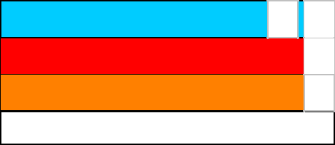

|  |  |  |  |
| --- | --- | --- | --- |
| **Health** | / | 3 |  |
|  |  |  |
| **Flammability** |  | 1 |  |
| **Physical hazards** |  | 2 |  |

**Caution: HMIS® ratings are based on a 0-4 rating scale, with 0 representing minimal hazards or risks, and 4 representing significant hazards or risks. Although HMIS® ratings and the associated label are not required on SDSs or products leaving a facility under 29 CFR 1910.1200, the preparer may choose to provide them. HMIS® ratings are to be used with a fully implemented HMIS® program. HMIS® is a registered trademark and service mark of the American Coatings Association, Inc.**

**The customer is responsible for determining the PPE code for this material. For more information on HMIS® Personal Protective Equipment (PPE) codes, consult the HMIS® Implementation Manual.**

**National Fire Protection Association (U.S.A.)**



***Date of issue/Date of revision*** **:** *2/15/2018* ***Date of previous issue*** ***:*** *2/15/2018* ***Version :*** *1.04* *11/12*

*Ammonia*



**Section 16. Other information**

1. **Flammability**



**Health** 3 0 **Instability/Reactivity**

**Special**

**Reprinted with permission from NFPA 704-2001, Identification of the Hazards of Materials for Emergency Response Copyright ©1997, National Fire Protection Association, Quincy, MA 02269. This reprinted material is not the complete and official position of the National Fire Protection Association, on the referenced subject which is represented only by the standard in its entirety.**

**Copyright ©2001, National Fire Protection Association, Quincy, MA 02269. This warning system is intended to be interpreted and applied only by properly trained individuals to identify fire, health and reactivity hazards of chemicals. The user is referred to certain limited number of chemicals with recommended classifications in NFPA 49 and NFPA 325, which would be used as a guideline only. Whether the chemicals are classified by NFPA or not, anyone using the 704 systems to classify chemicals does so at their own risk.**

**Procedure used to derive the classification**



|  |  |  |  |  |  |
| --- | --- | --- | --- | --- | --- |
|  |  |  |  | **Classification** | **Justification** |
|  | | | | |  |
| FLAMMABLE GASES - Category 2 | | | | | Expert judgment |
| GASES UNDER PRESSURE - Liquefied gas | | | | | Expert judgment |
| ACUTE TOXICITY (inhalation) - Category 4 | | | | | Expert judgment |
| SKIN CORROSION - Category 1 | | | |  | Expert judgment |
| SERIOUS EYE DAMAGE - Category 1 | | | | | Expert judgment |
| AQUATIC HAZARD (ACUTE) - Category 1 | | | | | Expert judgment |
|  | | |  |  |  |
| **History** | | |  |  |  |
|  |  |  |  |  |  |
| **Date of printing** | | | **:** | 2/15/2018 |  |
| **Date of issue/Date of** | | | **:** | 2/15/2018 |  |
| **revision** | | |  |  |  |
| **Date of previous issue** | | | **:** 2/15/2018 | |  |
| **Version** | | | **:** | 1.04 |  |
| **Key to abbreviations** | | | **:** ATE = Acute Toxicity Estimate | |  |
|  |  |  |  | BCF = Bioconcentration Factor |  |
|  |  |  |  | GHS = Globally Harmonized System of Classification and Labelling of Chemicals | |
|  |  |  |  | IATA = International Air Transport Association |  |
|  |  |  |  | IBC = Intermediate Bulk Container |  |
|  |  |  |  | IMDG = International Maritime Dangerous Goods |  |
|  |  |  |  | LogPow = logarithm of the octanol/water partition coefficient | |
|  |  |  |  | MARPOL = International Convention for the Prevention of Pollution From Ships, 1973 | |
|  |  |  |  | as modified by the Protocol of 1978. ("Marpol" = marine pollution) | |
|  |  |  |  | UN = United Nations |  |
| **References** | | | **:** Not available. | |  |
| **Notice to reader** | |  |  |  |  |



**To the best of our knowledge, the information contained herein is accurate. However, neither the above-named supplier, nor any of its subsidiaries, assumes any liability whatsoever for the accuracy or completeness of the information contained herein.**

**Final determination of suitability of any material is the sole responsibility of the user. All materials may present unknown hazards and should be used with caution. Although certain hazards are described herein, we cannot guarantee that these are the only hazards that exist.**



***Date of issue/Date of revision*** **:** *2/15/2018* ***Date of previous issue*** ***:*** *2/15/2018* ***Version :*** *1.04* *12/12*

XIII Index



Index

, 296

Confined space, 272

Advantages and disadvantages of surface water vs groundwater , 52

Aeration, 148

Aesthetic quality, 71

Air Valves, 238

Alkalinity, 74

Anion, 67

Annual water quality report, 116 Aquifer, 45

Aquiclude, aquitard, 47

Confined and unconfined, 47

Piezometeric surface or potentiometric

surface, 47

Recharging, 47

Safe yield, 47

Arsenic Rule, 113

Backflow, 241

Back siphonage, 241

Back-pressure, 241

Backflow preventer, 241

Indirect cross-connection, 241

Prevention devices

Air gap, 242

Atmospheric Vacuum Breaker Assembly (AVB) , 242

Double check valve assembly, 243

Reduced pressure zone (RPZ), 243

Spill resistant vacuum breaker, 242

Swing check valve, 242

Background, 133, 172

baffling factors, 183

Best Available Technology (BAT), 154

Inorganics, 154

Microbiological contaminants, 156

Radionuclides, 157

Biological contaminants, 66

Blue baby syndrome/Infant

methemoglobinemia, 99 Breakpoint chlorination, 180

Calcium, 74

480 INDEX

Carbonate hardness or temporary hardness, 74

Categories of Treatment Methods, 134

Cation, 67

Cavitation, 249

Centrifugal pump

Maximum suction lift, 211 Centrifugal pump components

Backing plate, 206

Gland, 208

Lantern ring, 208

Packing gland, 208

Packing/mechanical seals, 207

Shaft, 206

Shaft sleeve, 207

Stuffing box, 206

Volute case, 206

Wear rings, 206

Centrifugal pumps

Frame mounted, 199

Impeller types, 199

Operating principle, 199

Split case, 200

Types, 199

Chapter 2, 329

Chemical contaminants, 66

Chemical feed systems, 157

Components, 157

Accessories, 159

Delivery, 157

Storage, 159

Control systems, 161

Types, 160

Chloramines, 178

Advantages, 179

Disadvantages, 180

Chlorination, 173 Byproducts, 177 Chlorine application, 177

Chlorinator, 177

Hypochlorinator, 177

Chlorine reactions, 176

Hypochlorite ions, 176

Hypochlorous acid, 176

Factors affecting disinfection, 176

Forms of chlorine, 176

Calcium hypochlorite or high-test hypochlorite (HTH), 176

Sodium hypochlorite (NaOCl), 176 Chlorine cylinder, 174

Fusible plug, 175

Chlorine dioxide, 184

Advantages, 185

Disadvantages, 185

Chlorine disinfection

Chlorine measurement

Amperometric, 77

DPD, 77

Free chlorine, 77

Total chlorine, 77

Chlorine dosing terms, 181

Chlorine demand, 181

Chlorine dose, 181

Combined residual, 181

Free chlorine, 181

Total chlorine residual, 181

Chlorine properties, 173

Chlorine residual, 76

Chlorine storage and safety, 174

Emergency kits, 175

Chloroamination, 178

Clarification/Sedimentation, 139

Clarifier Zones, 140

Coagulation and Flocculation, 137

Coliform bacteria, 78

Color, 72

Combined filter effluent (CFE), 103 Community Confidence Reports, 100 Computer based controls and monitoring,

252

|  |  |
| --- | --- |
| INDEX | 481 |
|  |  |

Contact time (CT), 182

Control of cyrptosporidium, 103 Corporation stop, 228 Corrosion

Cathodic protection, 255

Corrosion coupons, 254

Galvanic corrosion, 253

Corrosion control, 152, 253

curb stop, 228

Density, 77, 296

Destratification, 52

Detection limit for reporting (DLR), 115

Disinfectant MRDLs, 110

Disinfecting New and Existing Wells, 247

Disinfecting water mains, 247

Disinfecting water storage tanks, 248

Disinfection, 172

Primary disinfection, 172 Secondary disinfection, 172

Distribution mains, 226

Distribution of earth’s water, 41, 42

Distribution system map, 251

Comprehensive map, 251

Plat map, 251

Distribution system operation and maintenance elements, 247

Distribution system record-keeping, 251 Distribution systems

Dead-end or tree type, 227

Grid iron type, 227

Radial type, 227

Ring type, 227

Drinking water regulations, 97

Earth’s water, 43

EDTA, 75

Epilimnion, 52

Eutrophic, 51

Eutrophication, 68

Filter backwash recycle rule, 108 Filtration, 141, 313 Fire hydrants, 244

Dry barrel, 244

Wet barrel, 244

Fires class/classifications, 271 Fluoridation and Defluoridation, 149

Glossary of Pump Calculations Terms, 305

grain per gallon, 75

Ground water rules, 108

Groundwater, 45

Groundwater under the direct influence of surface water (GWUDISW), 50 Groundwater under the direct influence of surface water (GWUDISW), 100

Hardness, 74

Carbonate hardness, 74

Non-carbonate hardness, 74

Testing, 75

Hardness Removal, 150

HAZPOWER, 265

Heterotrophic plate count, 104

Human body component, 38

Hypolimnion, 52

Individual filter effluent (IFE), 103 Infant Methemoglobinemia or blue-baby

syndrome, 69

Inorganics, 67

Interim Enhanced Surface Water Treatment Rule, 102

Iron and Manganese Sequestration, 148

Lake thermal stratification, 52

Lake turnover, 52

Langelier index, 76

Lead and Copper Rule, 111

Lock-Out/Tag-Out, 270

Long-Term 1 Enhanced Surface Water

Treatment Rule, 102

482 INDEX

Long-Term 2 Enhanced Surface Water

Treatment Rule, 102

Magnesium, 67, 74

Maintaining distribution system pressure, 247

Map scale, 251

Math

Area and volume, 290

Averages, 288

Blending and dilution calculations, 301 Chemical dosing, 299 Concentration, 294

Contaminant removal efficiency, 297 Decimals and powers of ten, 284 Filtration

Backwashing rates, 315 Backwashing rinse rates, 315 Filter flow rates, 313 Filtration rates, 314 Percent product water for

backwashing, 315

Flow and velocity, 291

Force, pressure and head, 303

Fractions, 283

Percentage, 287

Pounds formula, 298

Pumping

Power requirements for pumping, 309

Pumping rate calculations, 308 Ratio and proportion, 288 Rounding and significant digits, 284 Sedimentation, 311

Detention time, 312

Surface overflow rate, 312

Tank volume, 311

Weir loading/overflow rate, 313 Unit conversions, 292

Temperature conversion, 294

Well hydraulics calculations, 310 Math practice

Area and volume, 320

Blending and dilution, 323

Chemical dosing, 322

Concentration, 321

Decimals and powers of ten, 317 Density and specific gravity, 322 Filtration, 325

Flow and velocity, 321

Percentage, 319

Pounds formula, 322

Pressure, force and head relationships, 323

Pumping power requirements, 324 Pumping rates, 323

Ratio and proportion, 320 Rounding and significant digits, 317 Sedimentation, 325 Totalizing and averages, 318

Unit conversions, 321

Well hydraulics, 324

Math solutions

Area and volume, 360

Blending and dilution, 371

Chemical dosing, 368

Concentration, 366

Decimals and powers of ten, 354

Density and specific gravity, 366

Fractions, 354

Percentage, 357

Pounds formula, 367

Pressure, force and head relationship, 372

Ratio and Proportion, 358 Rounding and significant digits, 355 Totalizing and averages, 356 Unit Conversions, 365

Filtration, 377

Flow and velocity, 362

|  |  |
| --- | --- |
| INDEX | 483 |
|  |  |

Pumping power requirements, 373 Pumping rates, 371 Sedimentation, 376 Well hydraulics, 375

Maximum contaminant level goal (MCLG), 98

Maximum contaminant levels (MCLs), 98 Maximum residual disinfectant levels

(MRDLs), 110

Mesotrophic, 51

Metals, 67

Health hazards, 68

Microbial and disinfection byproducts rules, 110

Microbial contaminants, 70

Microbial testing, 78

Colilert, 82

Heterotrophic plate count (HPC), 81

Membrane filtration method, 82

Pour plate method, 82

Spread plate method, 82

Membrane filtration, 82

Multiple-tube fermentation (MTF), 78

Presence-absence (P-A) method, 81

Quanti-trays tests, 82

Minimum certification requirements for distribution systems’ chief and shift operators, 29

Minimum certification requirements for treatment plants’ chief and shift operators, 28

National Institute for Occupational Safety and Health (NIOSH), 272

National Primary Drinking Water

Regulations, 98

Nephelometric Turbidity Units (NTU), 71

Notification levels, 118

Nutrients, 68

Nitrogen and phosphorous, 68

Oligotrophic, 51

Operation, 146

Operator

Operational activities, 22

Advanced treatment/water reuse, 23

Distribution, 22

Treatment, 22

Wastewater, 23

Operator license

Qualifications and eligibility, 24 Water systems operator certifications,

21

Organics, 66

Quantification

Biochemical oxygen demand (BOD), 66

OSHA, 265, 269, 270, 272 Other Drinking Water Rules, 111 Other Treatment Processes, 147 Ozonation, 186

Advantages, 186

Disadvantages, 186

Packed Tower Air Stripping, 147

Pathogens

Bacteria, 70

Parasites, 70

Cryptosporidium, 71

Giardia, 70

Viruses, 70

pH, 75

pH measurement, 76

Physicochemical tests, 71

Pipelines, 226

Piping Material, 228

Plat map, 251

Polar, 38

Pre-chlorination, 147

Process Basics, 141

Properties of water, 38

484 INDEX

Public health goal, 118 Public Notification Rule, 114

Tiers 1, 2 and 3, 114

Public water system, 97

Community water system (CWS), 97 Non-community water system (NCWS),

97

Transient non-community water system

* 97 Water systems

Non-transient non-community water system , 97

Pump type

Axial-flow pumps, 201

Centrifugal pumps, 198

Mixed-flow pumps, 201

Positive displacement pumps, 201

Rotodynamic pumps, 198

Turbine pumps, 204

Pumping

Total dynamic head (TDH), 211 Cavitation, 212

Dynamic pressure or Velocity head, 210 Factors contributing to headloss, 210 Force, 208

Glossary of pump calculations terms, 208

Head, 209

Headloss, 210

Horsepower, 211

Pressure, 208

Pump calculations, 208

Pumping calculations, 305

Pumping heads illustration, 213

Static head, 211

Static pressure, 210

Suction lift, 211

Velocity, 210

Velocity head, 212

Pumps

Background, 197

Centrifugal pump components, 206 Choosing between positive

displacement and centrifugal pumps, 205

Mechanical parts of rotodynamic pumps, 206

Radiological contaminants, 66 Radionuclides, 70

Measurement

picocuries per liter (pCi/L), 70 Radionuclides Rule, 112 Recycled water, 53

Recycled Water Regulations, 118 Response level, 118

Revised total coliform rule (RTCR), 106 Rotating and moving equipment, 269

Safe Drinking Water Act (SDWA), 97 National Primary Drinking Water

Regulations, 98

Safety

Chemicals, 265

Hazards, 266

Protection, 266

Chemicals storage, 267

Confined space

Permit required confined space, 272 Electrical hazards, 267 Falls, 267

Fire safety, 270

Hazard control, 265

Hazardous energy, 270

Heat stress, 270

Lockout-Tagout (LOTO), 270

Lower explosive limit (LEL), 272

Machine guarding, 270

Material handling ergonomics, 273

Noise, 267

|  |  |
| --- | --- |
| INDEX | 485 |
|  |  |

Personal protective equipment (PPE), 265, 272

Safety Data Sheets (SDS), 265, 266 Trench slope, 268

Trenching & excavation, 268 Access and egress, 268 Protective systems, 268 sidewalls slope, 268

Upper explosive limit (UEL), 272 Water treatment hazards, 265

Safety Practices, 270

Salts, 67

Salts constituents, 68

Salts found in water and/or used in water treatment, 69

Sampling, 82

Composite Samples, 84

Grab samples, 84

Holding time, 87

Lead and copper sampling, 252 Microbial sampling, 85 Precautions and protocols, 84 Preservative, 87 Sampling methods, 84

Summary of requirements, 87

Summary of sampling requirements, 87

Sanitary survey, 115

Elements, 115

Frequency, 115

Significant deficiency, 115

SCADA, 252

Screening, 136

SDWA Monitoring, Reporting and Recordkeeping Requirements, 115

Secondary Drinking Water Regulations, 100 Service laterals, 228

Significant consumer notification violations, 116

Significant monitoring violations, 115 Source Management, 135

Source Water Treatment, 135

Specific conductance, 73

Specific Gravity, 296

Specific gravity, 77

Spoils, 269

Springs, 47

Storage tank maintenance, 251

Summary of disinfectants’ attributes, 187

Surface water, 51

Lakes and reservoirs classification, 51 Surface Water Treatment Processes, 135 Surface Water Treatment Rule (SWTR), 101

Pathogen inactivation, 102 Pathogen removal, 101 Reporting and recordkeeping, 103 Requirements, 102

Surface Water Treatment Rules, 100 System Disinfection Program, 247 System flushing program, 249

Taste and odor, 72

Temperature, 72

Thermocline, 52

Threshold odor number (TON), 72

Total coliform rule (TCR), 106

Total dissolved solids, 73

Secondary standard, 74

Trace constituents, 69

Boron, hormones, EDCs, PCPs, CECs, PFAS/PFOA, 70

Transmission Mains, 226

Trench safety, 269

Tuberculation, 253

Turbidity, 71, 72

Typical surface water treatment process, 135

Ultraviolet (UV) disinfection, 185

Advantages, 185

Disadvantages, 186

Unregulated Contaminant Monitoring Rule (UCMR), 100

486 INDEX

US Environmental Protection Agency (USEPA), 97

Valves, 235

Valves operation and maintenance, 249 Valves used in water distribution, 234

Wastewater treatment plant classification, 30

Water cycle, 40, 41

Water hammer, 250

Water main installation, 231 Water meters, 245

Compound meter, 246

Electronic meter, 246

Mag-meter, 246

Positive displacement or nutating disc type, 246

Velocity meter, 246

Water Operator

Certification renewal, 31 certification requirements, 28

Water rights, 54

Appropriative rights, 55

Prescriptive rights, 55

Riparian rights, 54

Water sources, 44

Water storage, 233

Types of reservoirs, 233

Water supplies, 40

Water usage records, 251

Water use, 39

Water wells, 48

Wells, 46

Cone of depression, 48

Drawdown, 48

Pumping level, 48

Radius of influence, 48

Recovery time, 49

Specific capacity, 48

Static level, 48

Types of wells, 49

Dug,driven,drilled wells, 49 Well construction, 49

Gravel packer, 50

Ground seal, 50

Sanitary seal, 50

Well casing, 49

Well screen, 50

Well terms, 48

Well types, 49

Wells construction

Borehole, 49

Grout, 50

Zone of influence, 48



Shabbir Basrai, PE (Chemical) has an exten-

sive background in the water industry. Shabbir

spent over 30 years as a wastewater process

engineer and has taught courses preparing stu-

dents for the California state water operator li-

cense exams for over ten years at a community

college and for a Career Technical Education

(CTE) program at an adult school. Shabbir is a

dedicated advocate for the One Water approach

which emphasizes a holistic method to man-

age all water resources. Recognizing water as

a critical yet finite resource for all life forms

on earth, he advocates for conservation based,

sustainable and integrated water management

practices.

